There is different impact of the human in caves : the destructive speleology, the planning and the pollution of the caves by water.

- The speleology is the study of caves by exploration and scientific research. For exploration speleologists destroy some parts of the rock for discover all the caves. But some people destroy parts of the rock in a cave completely explored or smear it. So the caves destroyed in several place. Other people, tag walls, littered garbage or break stalactites and stalagmites for memory.

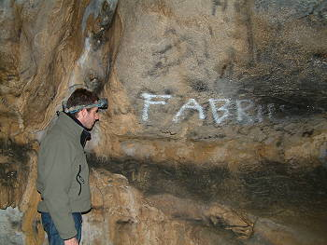Illustration 3: Tag in Trou de la Louve cave
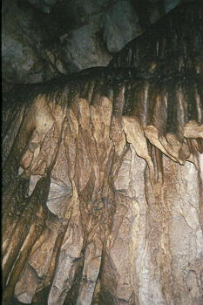Illustration 1: Stalactites broke in Trou de l'Eglise cave
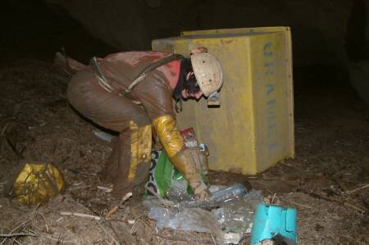Illustration 2: Garbage in a cave

-For the accessibility and the comfort of the visitors, the caves are construct. We build stairs, cement walkways, bridge, etc. So the people can't break the stalagmites for example. But the building of infrastructures in caves cause the destruction of the cave. For do a cement walkways we have to break stalagmites, for a bridge you have to destroy the support of this equipment, for stairs you have to fix it. The most important problem when you do a build is that you import material and change the structure of the cave.

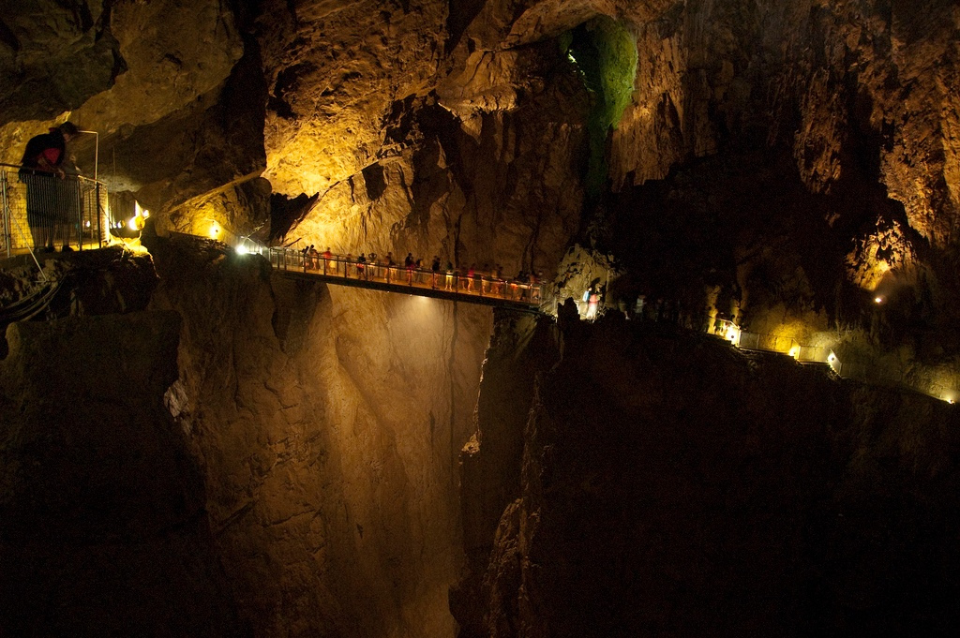Illustration 4: A bridge in the Skocjanske cave
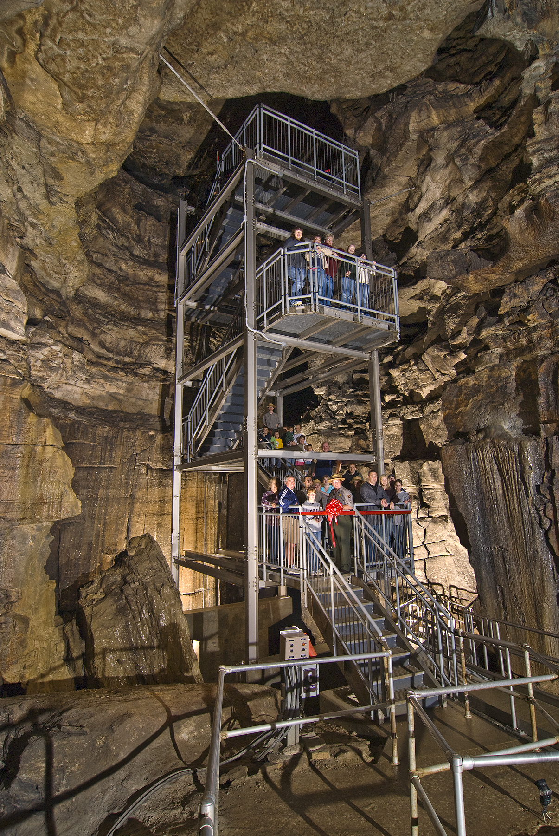Illustration 6: Stairs in Mammoth Cave National Park

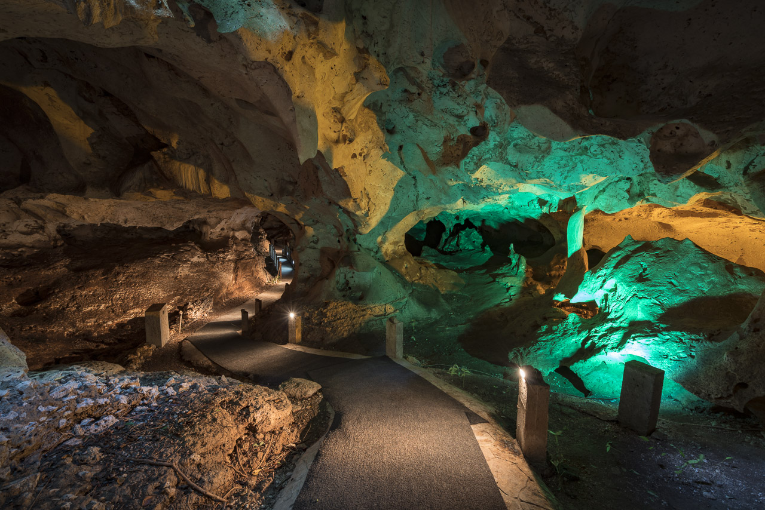Illustration 5: A path in Green Grotto cave
- Human activities pollute the ground. In fact the water polluted in surface infiltrate and go to the caves the water is polluted in the cave.

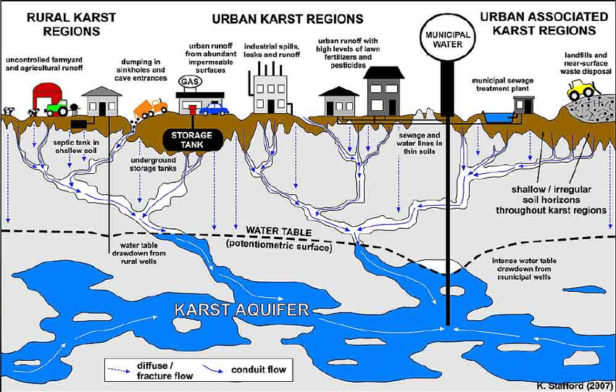Illustration 6: Scheme who explain the pollution of the water in caves due to the human activities in surface

In America, authority make classical sampling of fish in the Bluestone River ( river which separate the Virginia-West and the Virginia). After analysis, they discovered that there was a high concentration of polychlorinated biphenyls (or PCB), a industrial and dangerous compound. The authority search the source of this problem. They find that the water of this river run in a cave which in surface present a company who use this compounds. The water of this cave was polluted by a human activity in surface.

