
User Guide
Food Insecurity Risk Forecasting System for Region IV-A (CALABARZON)

Table of Contents
1. Introduction 3
2. Accessing the System 3
3. Overview & Navigation 3
3.1 Main Menu 3
3.2 Guided Tour 4
3.3 Reading the Colours 5
4. Main Features 5
4.1 Mapping Tab 5
4.1.1 Regional Summary 6
4.1.2 Province Details 6
4.1.3 News Articles Analyzed 7
4.1.4 Search 7
4.1.5 Choosing a Quarter 8
4.2 Data Tab 9
4.3 Visualization Tab 10
4.3.1 Province Risk Level Trend 10
4.3.2 Feature Contribution Breakdown 10
4.4 About & Methodology and Feedback 11
5. Admin Access (DA CALABARZON Staff) 12
5.1 Admin Dashboard 13
5.2 Reviewing Forecasts 13
5.3 Feedback 15
5.4 Accounts 16

1. Introduction
The purpose of this manual is to provide simple, step-by-step instructions for aiPHeed, a web-based geospatial system that estimates the food insecurity risk of the five CALABARZON provinces (Batangas, Cavite, Laguna, Quezon and Rizal) one quarter ahead. It is intended for planning staff of the Department of Agriculture Regional Field Office IV-A.
aiPHeed shows a risk score from 0 to 1 for each province. A score of 0.50 or higher is shown as High risk. The score is a model estimate, not an official statistic.

2. Accessing the System
You may access the aiPHeed web application directly through the following link:
- Application Link: https://aipheed-frontend.vercel.app
The app works best on a desktop or laptop computer. It also works on phones and tablets, where the panels move into a sheet at the bottom of the screen.
On the home page, click Explore the map to open the dashboard, or How it works to read how the forecasts are made.
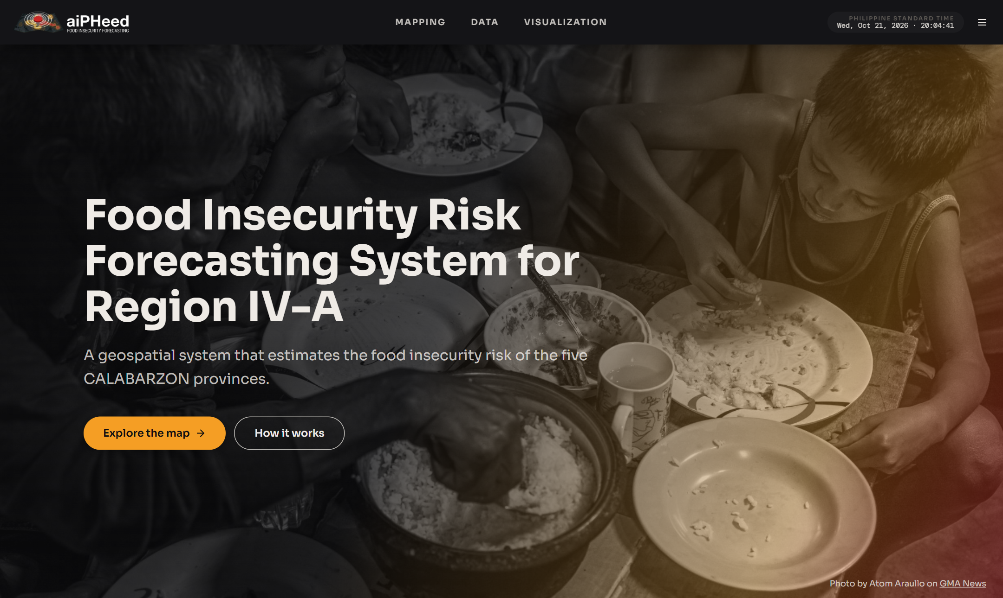

3. Overview & Navigation

3.1 Main Menu
The top bar lets you access all the main features of the system:
- Mapping: View the risk map of CALABARZON and the details of each province.
- Data: View all provinces in a table that you can filter and export.
- Visualization: Draw trend and contribution charts that you can download.
The menu button (☰) in the upper right corner has the following options:
- Dark mode: Switch between dark and light mode.
- Display preferences: Show or hide province labels, municipality boundaries and risk numbers on the map.
- Take the tour: Replay the guided tour of the page you are on.
- Admin sign in: Sign-in for Department of Agriculture CALABARZON staff only (see Section 5).
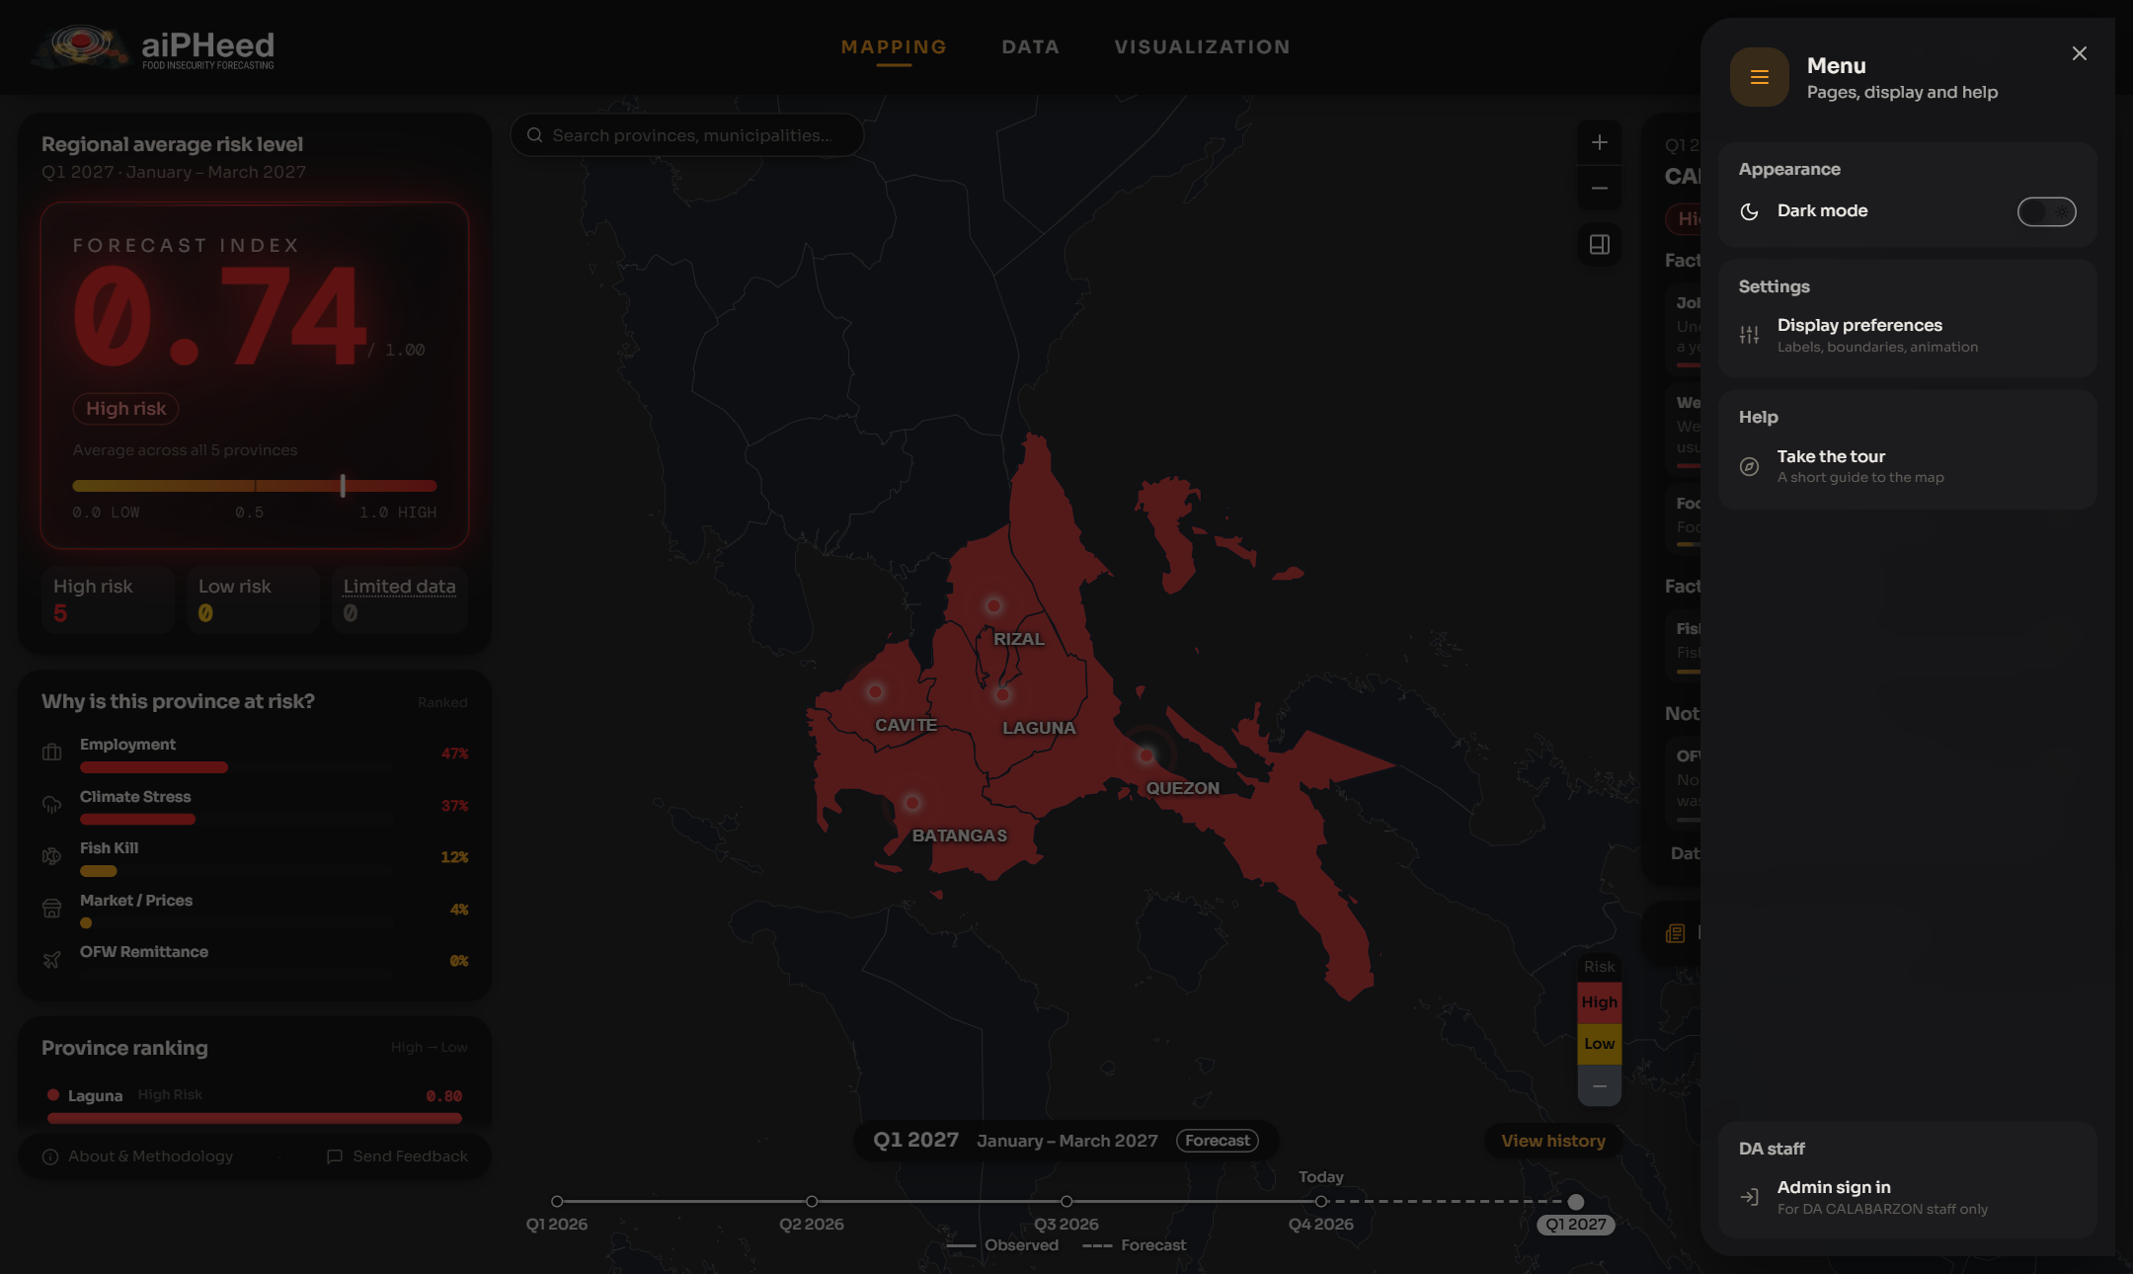
The menu opened from the upper right corner

3.2 Guided Tour
The first time you open the Mapping, Data or Visualization page, a short guided tour explains each part of the page.
- Click Next to go to the next step, or Skip to close the tour.
- You can replay the tour any time from the menu (Take the tour).
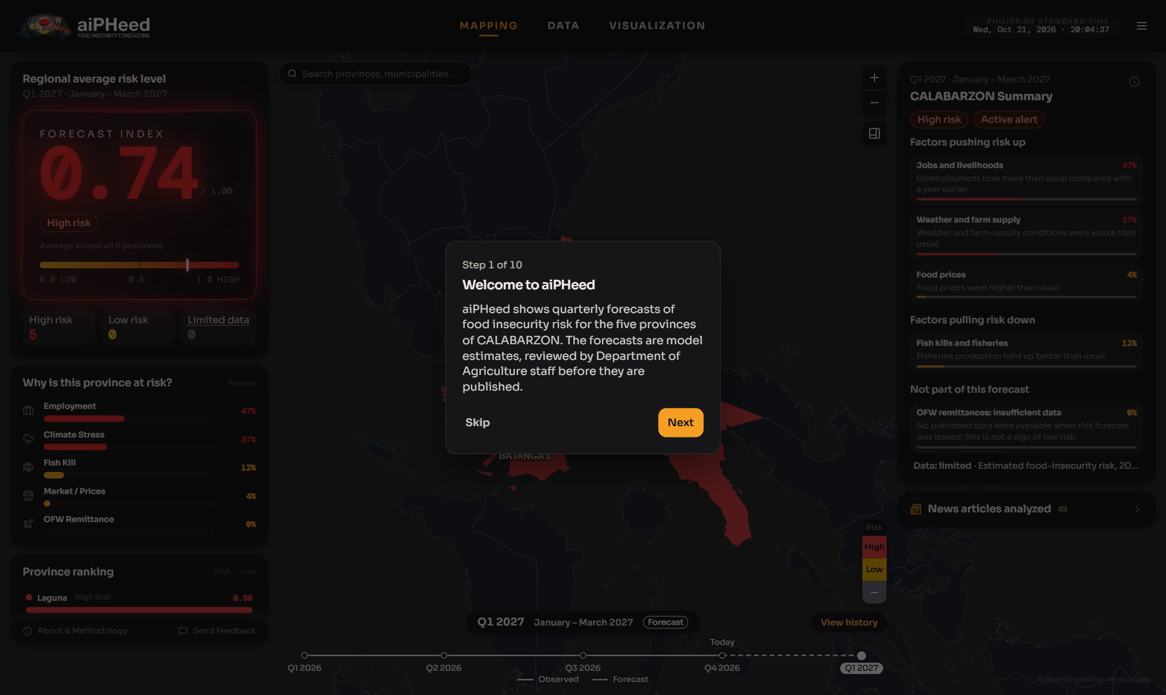

3.3 Reading the Colours
Each province on the map is coloured by its forecast risk level:
- Red – High risk: a risk score of 0.50 or higher.
- Yellow – Low risk: a risk score below 0.50.
- Grey – No forecast: no forecast for that province this quarter (for example, a forecast withheld after review).
An Active alert label means the score is high enough to call for early action.

4. Main Features

4.1 Mapping Tab
The Mapping tab is the main dashboard. It shows the CALABARZON map in the middle, a summary panel on the left and the reasons behind the risk on the right.
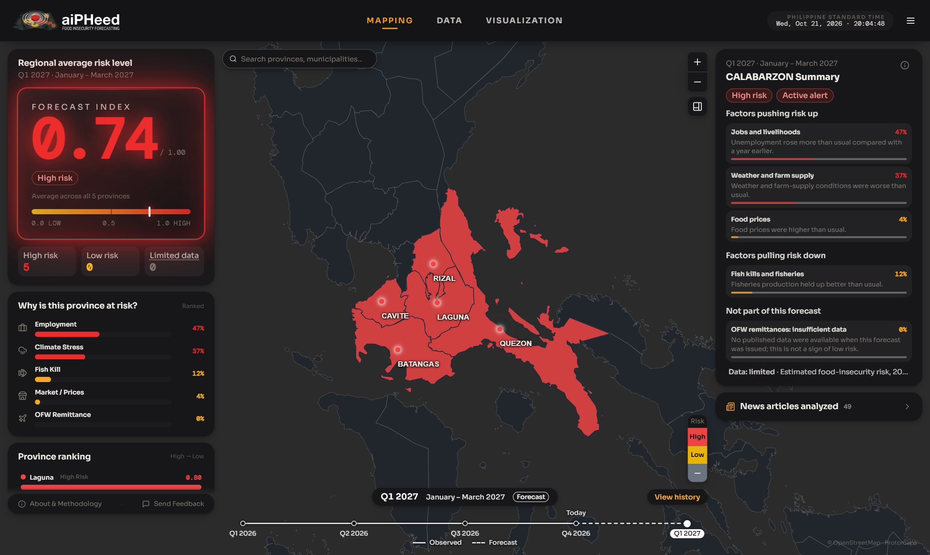

4.1.1 Regional Summary
When no province is selected, the left panel shows the whole region:
- Regional average risk level: the average score of the five provinces.
- High risk / Low risk / Limited data: the number of provinces that are High risk, Low risk or have limited data.
- Why is this province at risk?: the factors that raise the region's risk, such as employment, climate or prices.
- Province ranking: the provinces ordered from highest to lowest risk.

4.1.2 Province Details
- Click a province on the map (or in the Province ranking) to open its details.
- The left panel shows its Risk level score, Quarter-on-quarter change, Population and Trigger composition (the share of each factor in the risk).
- Cities and municipalities lists every city and municipality in the province, ranked by priority. These are relative priorities based on poverty and population density, not separate forecasts for each city or municipality.
- The right panel lists the Factors pushing risk up, the Factors pulling risk down, and data Not part of this forecast (data that was not yet published).
- Click Back to CALABARZON to return to the whole region.
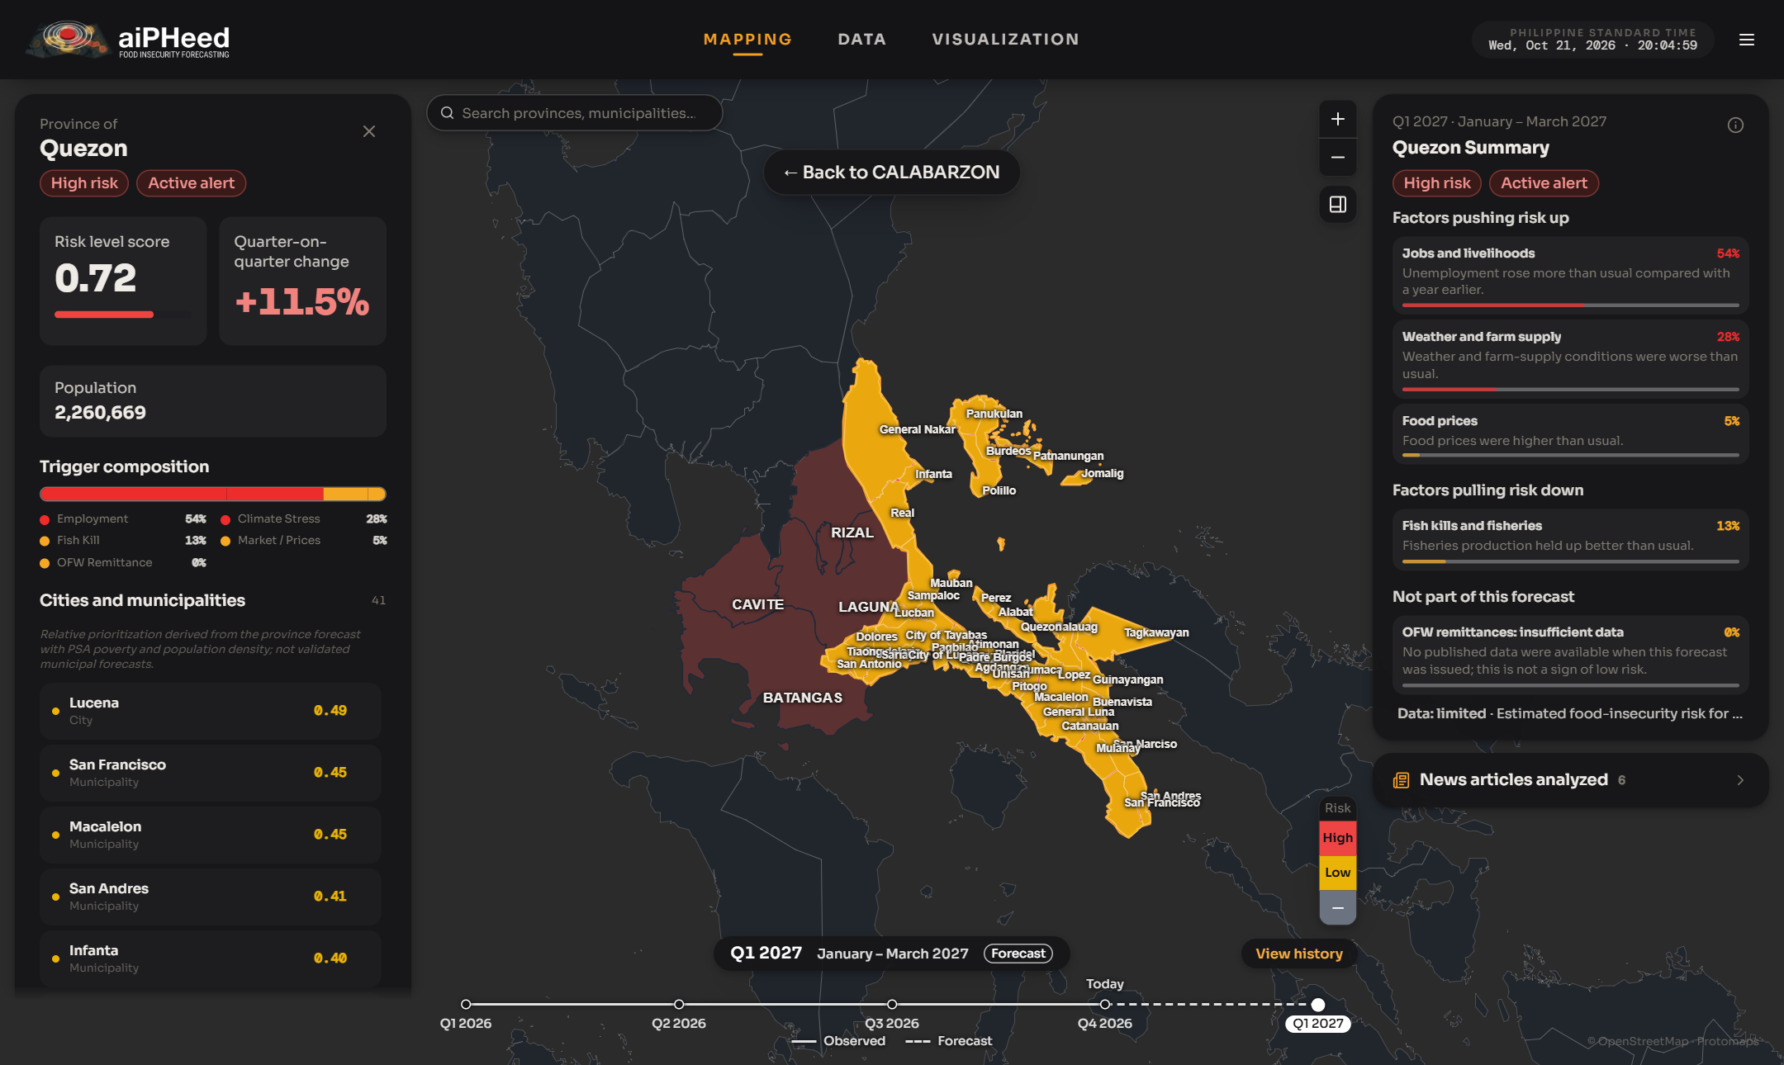

4.1.3 News Articles Analyzed
- Click News articles analyzed in the right panel to open it.
- It shows how many news articles were analyzed for the province and the share of each topic, such as climate stress or fish kill.
- The list below shows the news headlines the forecast was built from. Click a headline to open it.
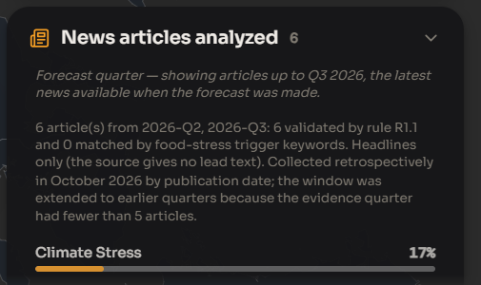

4.1.4 Search
- Type the name of a province, city or municipality in the search box at the top of the map.
- Click a result (or press Enter) to zoom in on that place and open its details.
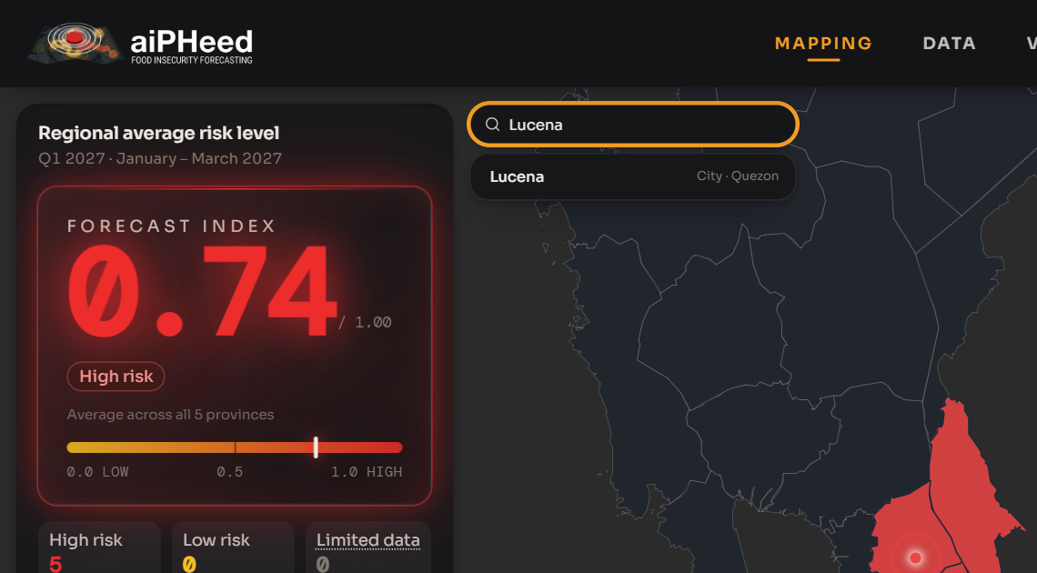
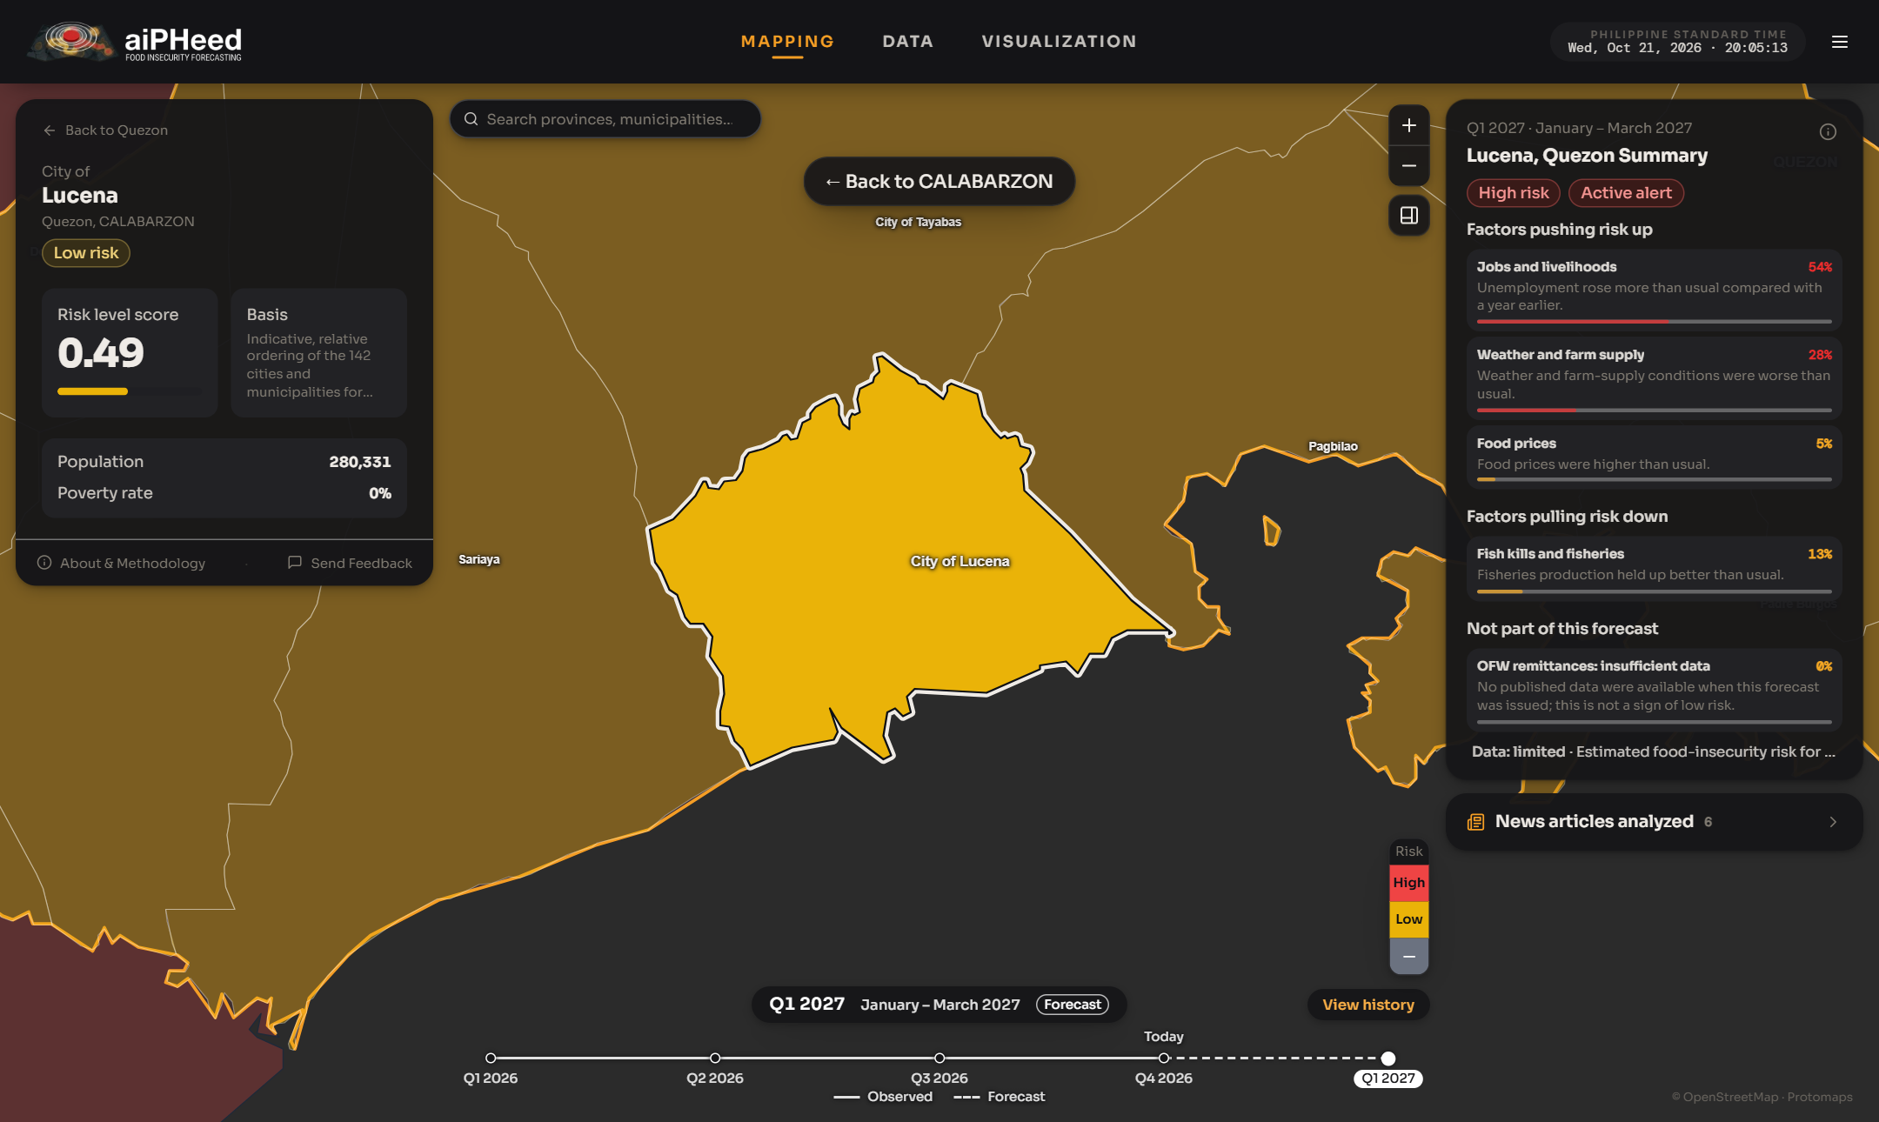
A city selected from the search (Lucena, Quezon)

4.1.5 Choosing a Quarter
- Use the timeline at the bottom of the map to pick a quarter. The solid line marks observed quarters, the dashed line marks forecasts, and Today marks the current quarter.
- Click View history to see the forecasts of every quarter in a list.
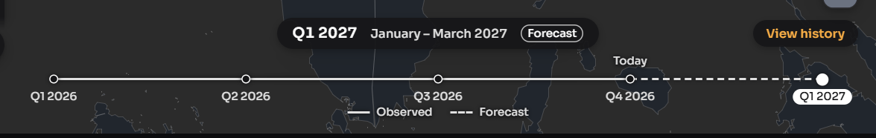
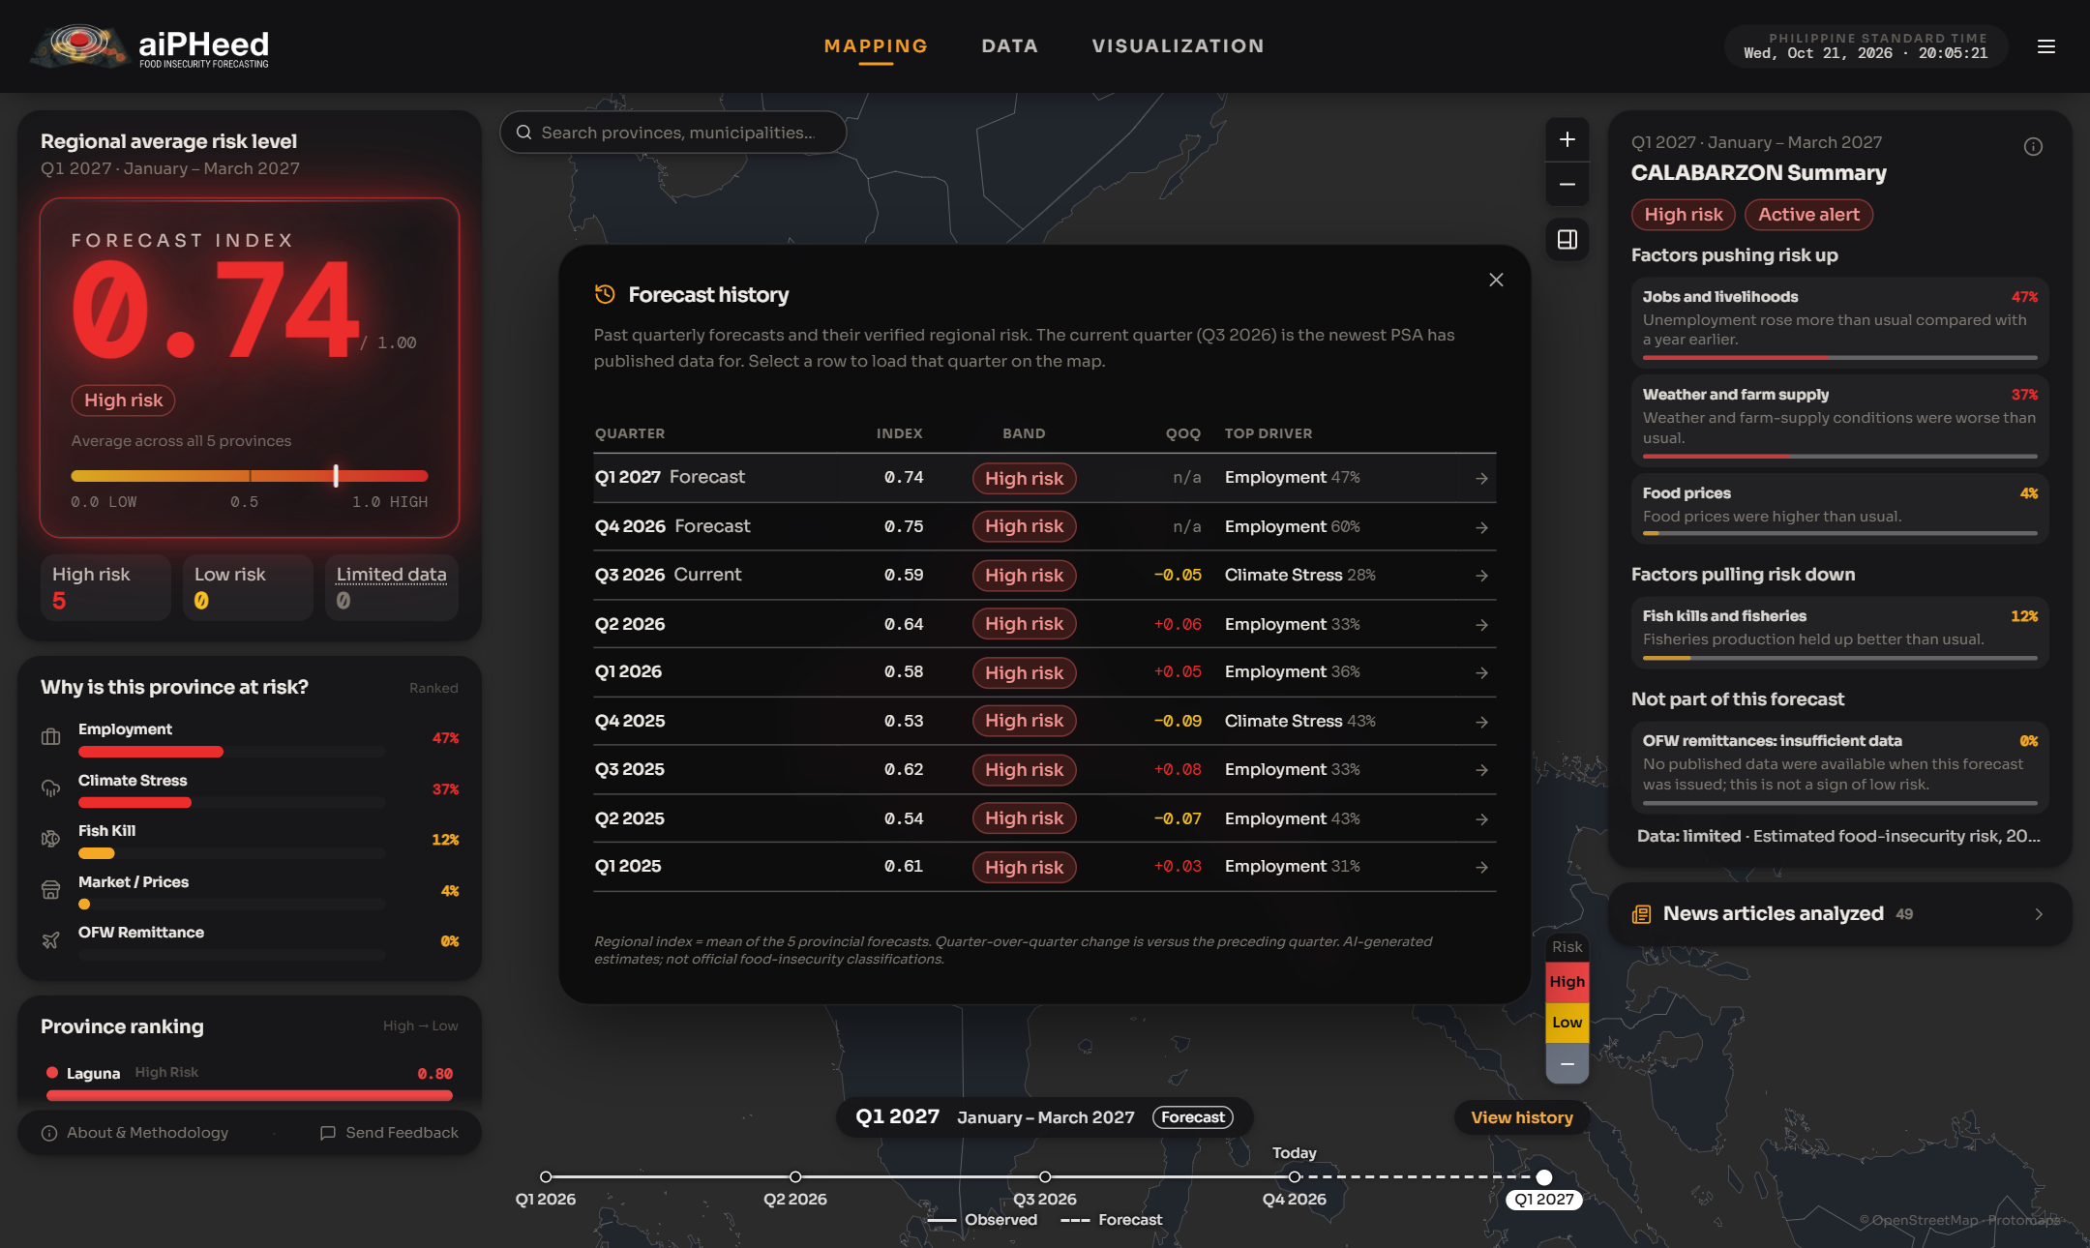

4.2 Data Tab
The Data tab lists every province in a table for the chosen quarter.
- Filter the table by province, risk level or quarter, or type a province name in the search box.
- Click a column heading to sort the table. Click it again to reverse the order.
- Click a row to open that province on the map.
- Click Export CSV to download the rows shown as a file for a spreadsheet.
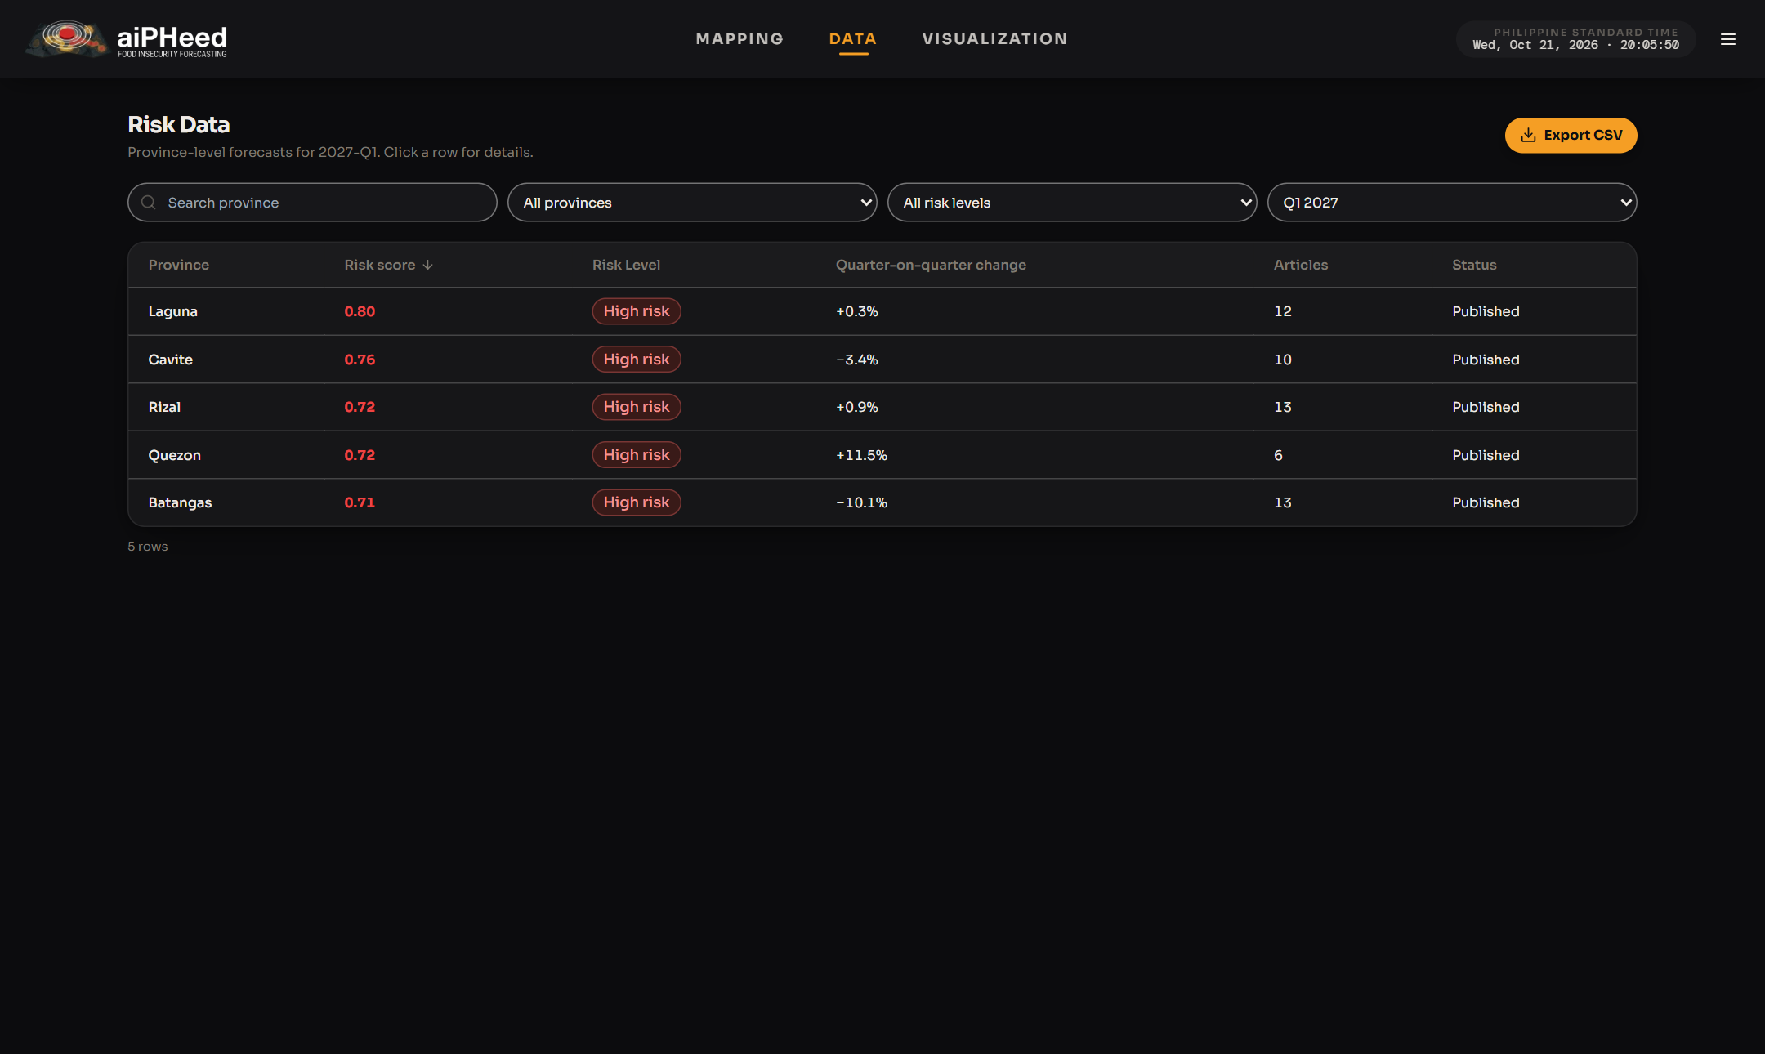

4.3 Visualization Tab
The Visualization tab draws charts that you can download for reports.

4.3.1 Province Risk Level Trend
- Pick a province (or all five), a city or municipality, and the range of quarters (From and To).
- Click Generate Chart to draw the chart, or Clear Filters to start again.
- Each line is a risk score from 0 to 1. A line at or above the High risk line is high risk.
- Click Download PNG to save the chart as an image, or Download PDF for a printable report.
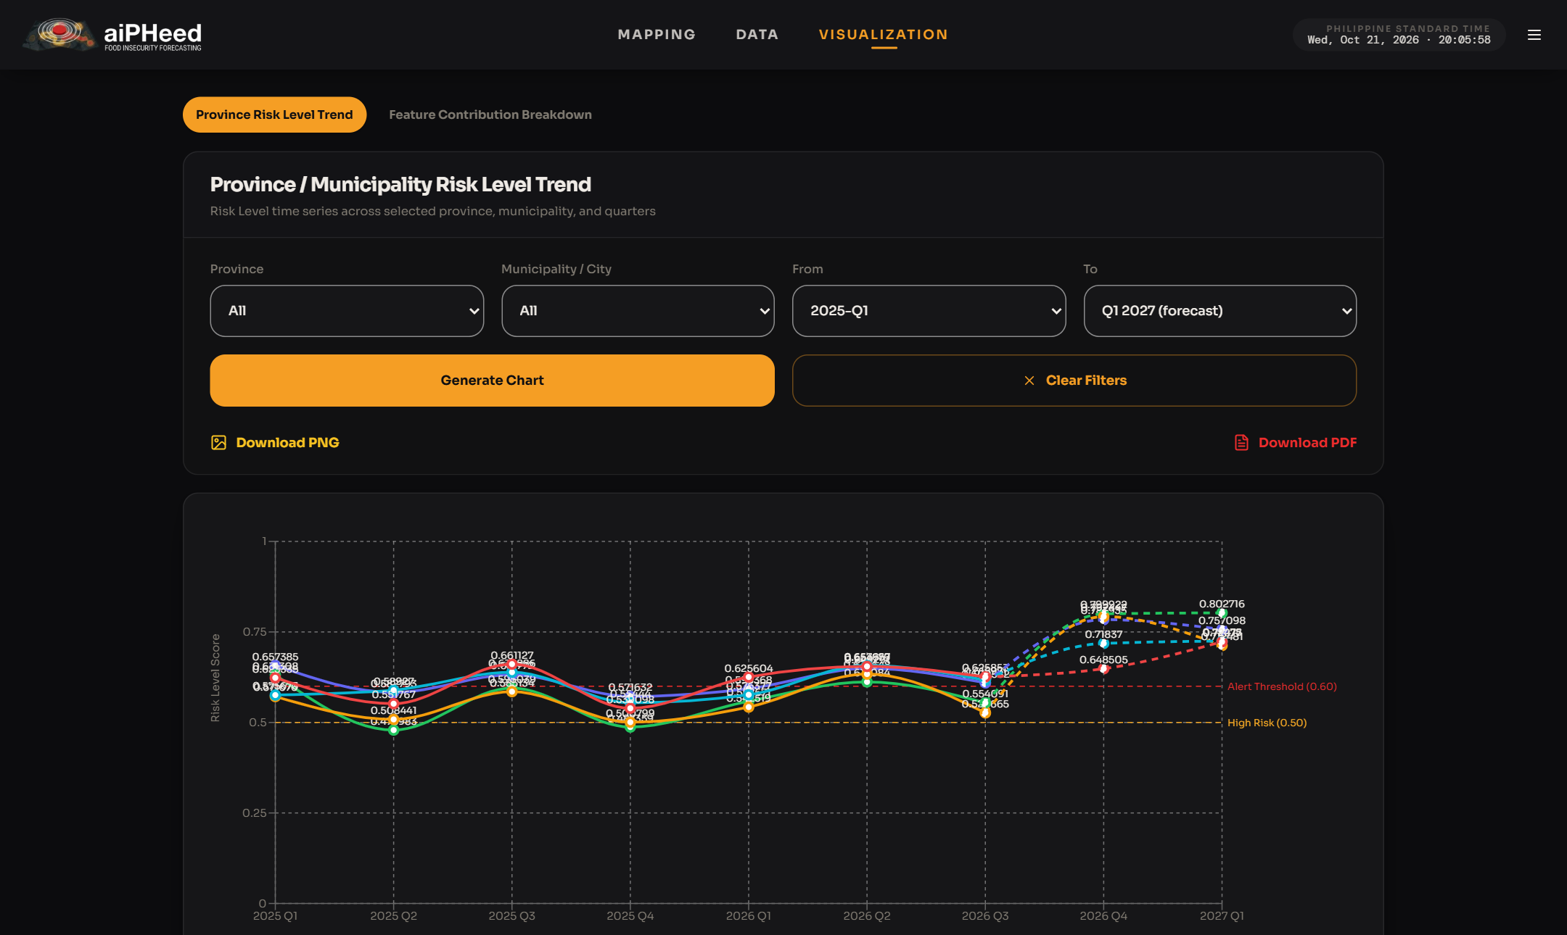

4.3.2 Feature Contribution Breakdown
- Pick a province and a quarter, then click Generate Chart.
- The chart shows how much each group of factors, such as employment, climate or prices, added to the province's risk in that quarter.
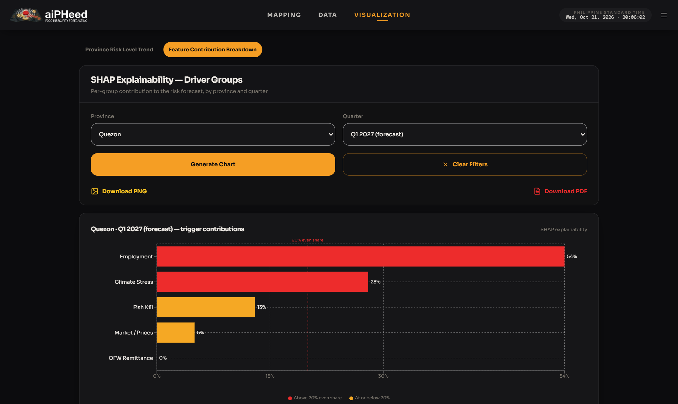

4.4 About & Methodology and Feedback
- Click About & Methodology (bottom of the left panel) to read how the forecasts are made, the data sources used and their limits.
- Click Send Feedback to answer a short usability survey about the system. Fill in the details, rate each statement from 1 to 5, then submit.
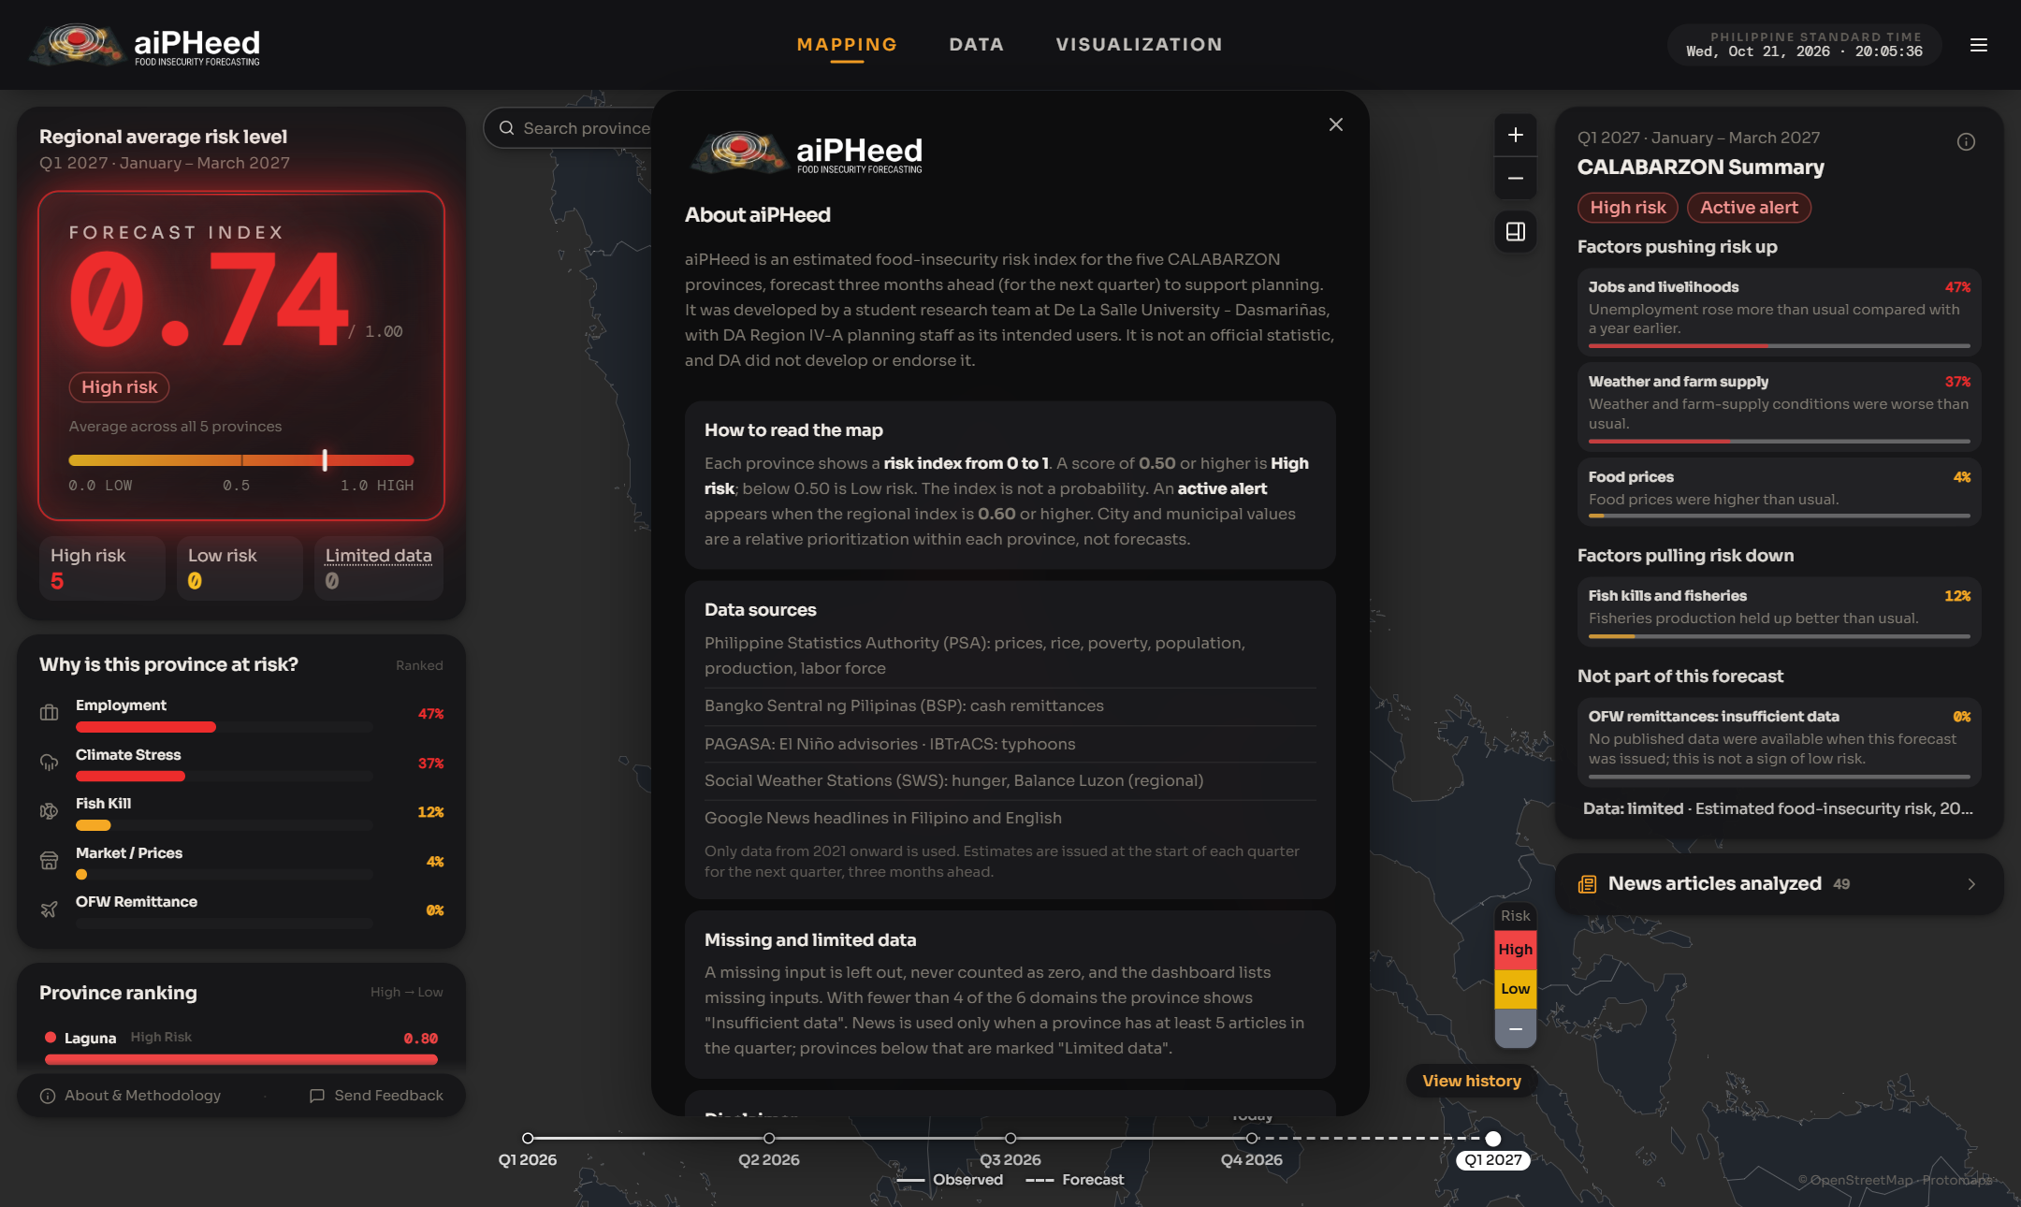
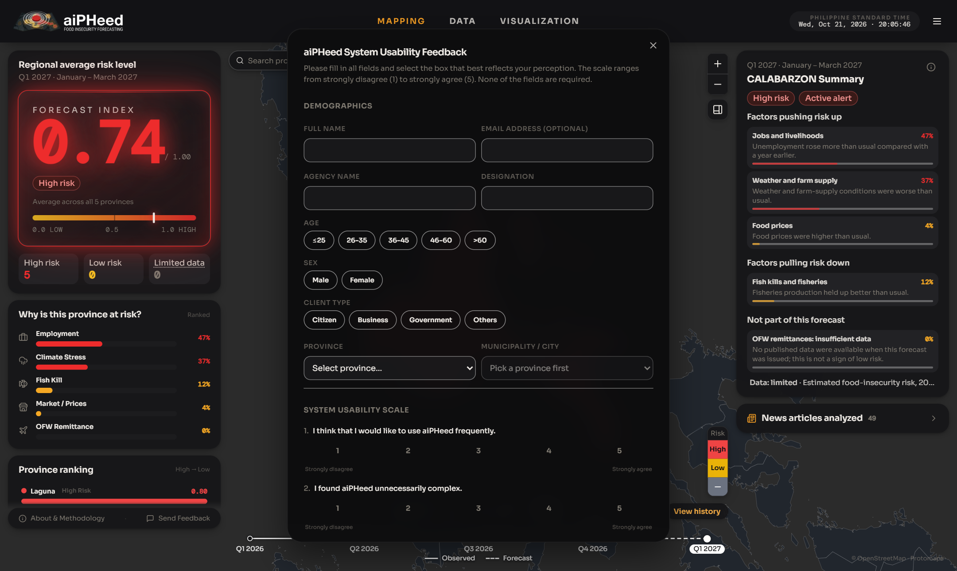

5. Admin Access (DA CALABARZON Staff)
Administrators review each forecast before it is published. Only email addresses ending in @calabarzon.da.gov.ph can have an administrator account.
- Open the menu (☰) and click Admin sign in, then enter your email and password.
- New users click Request access. An existing administrator must approve the account before you can sign in.
- Click Forgot password? to receive a password reset link by email.
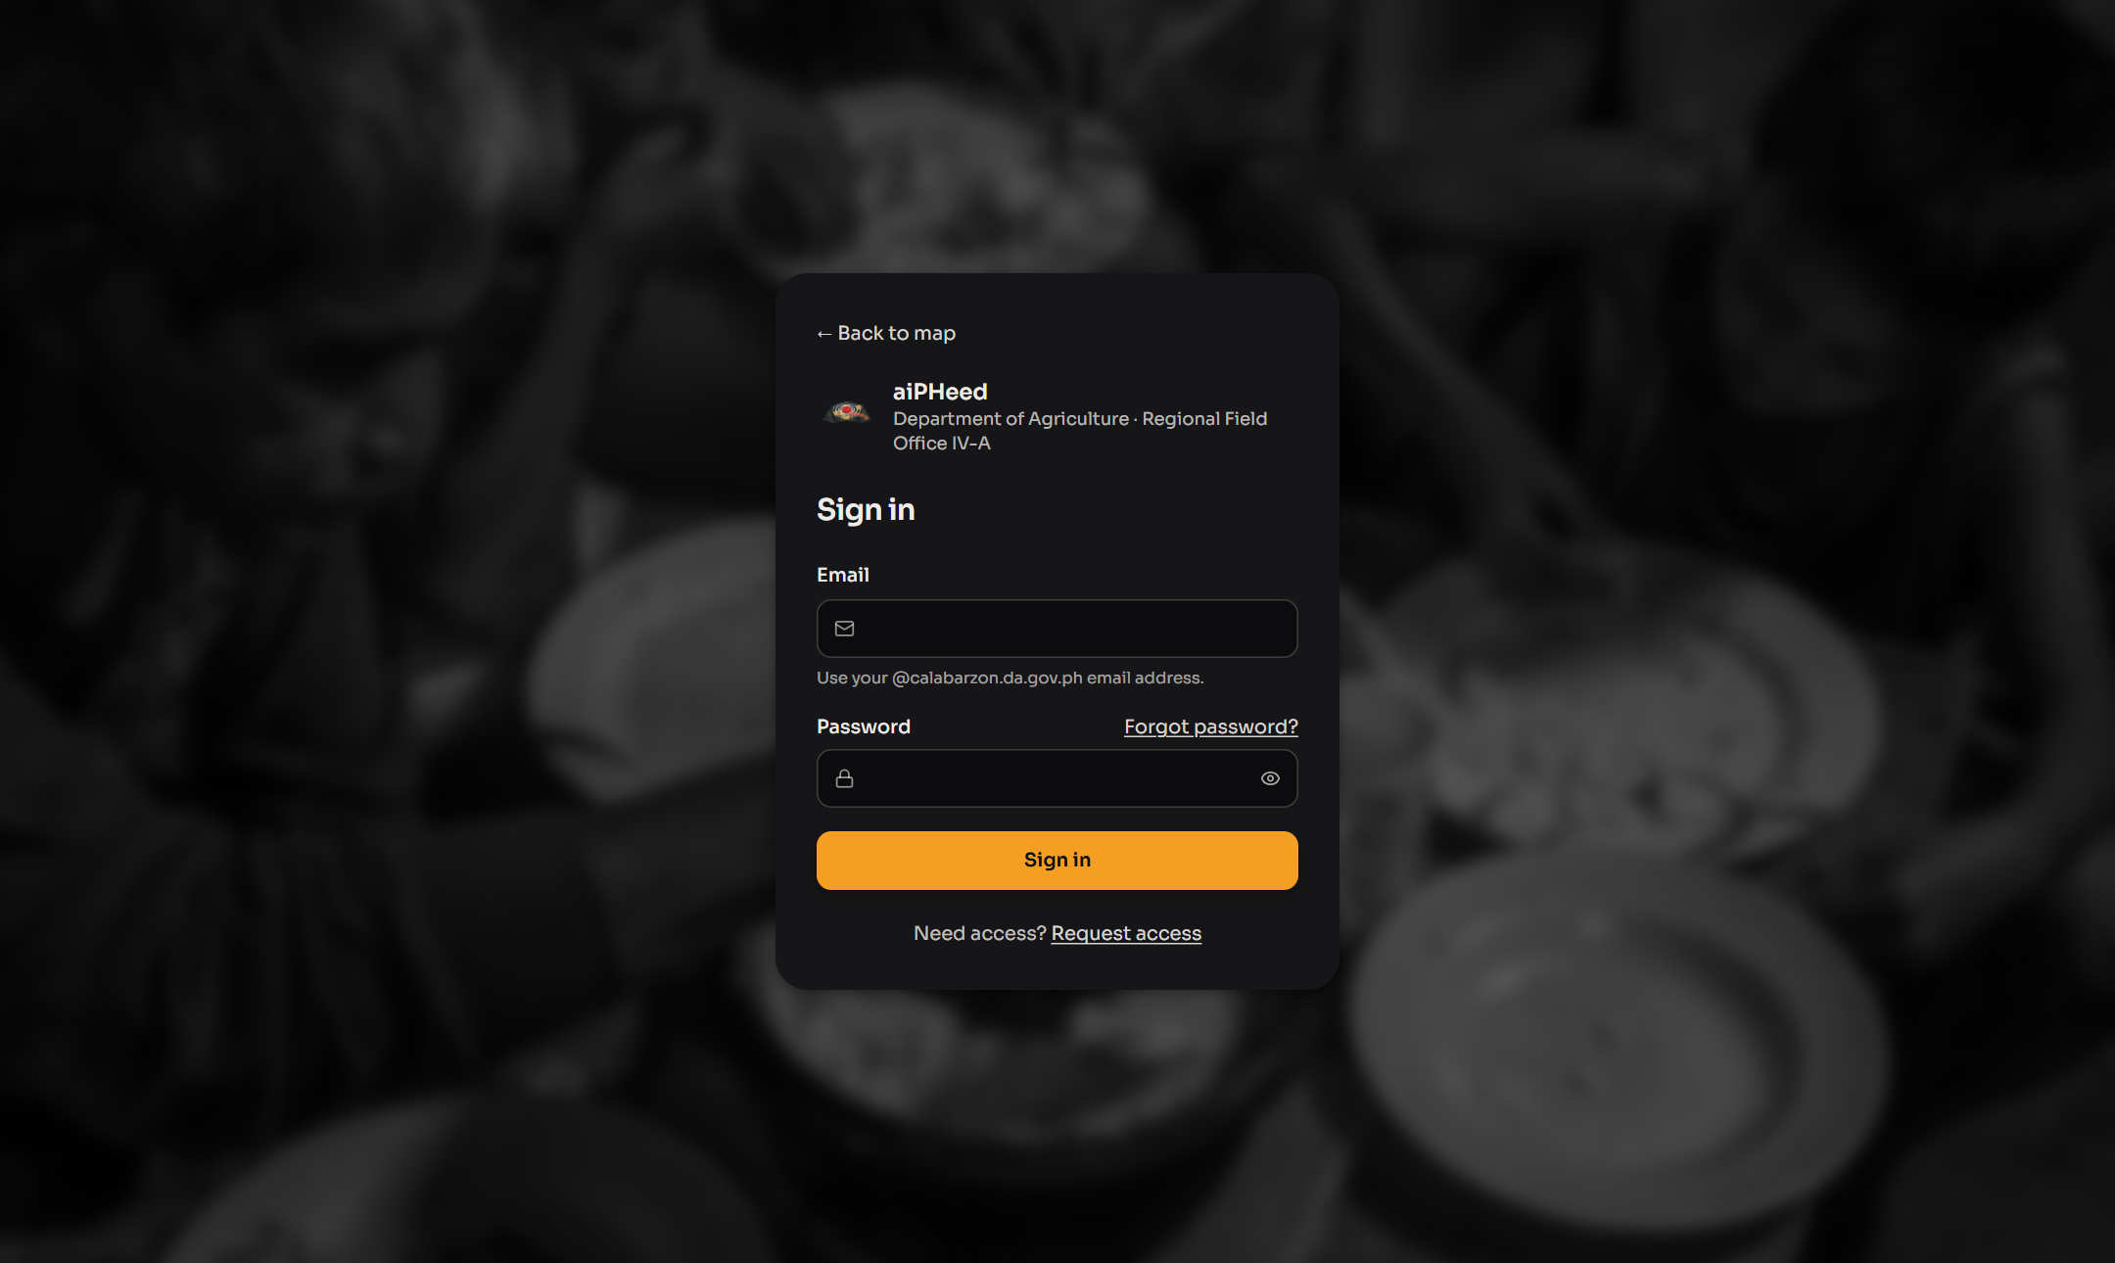

5.1 Admin Dashboard
After signing in, an ADMIN label appears beside the logo and the top bar adds two pages, Review and Feedback:
- Mapping, Data and Visualization: the same map as the public dashboard, with all its features (see Section 4.1).
- Early warning: a red bar at the top warns when a province is forecast as high risk and how many forecasts are waiting for review. Click Review on the bar to open them.
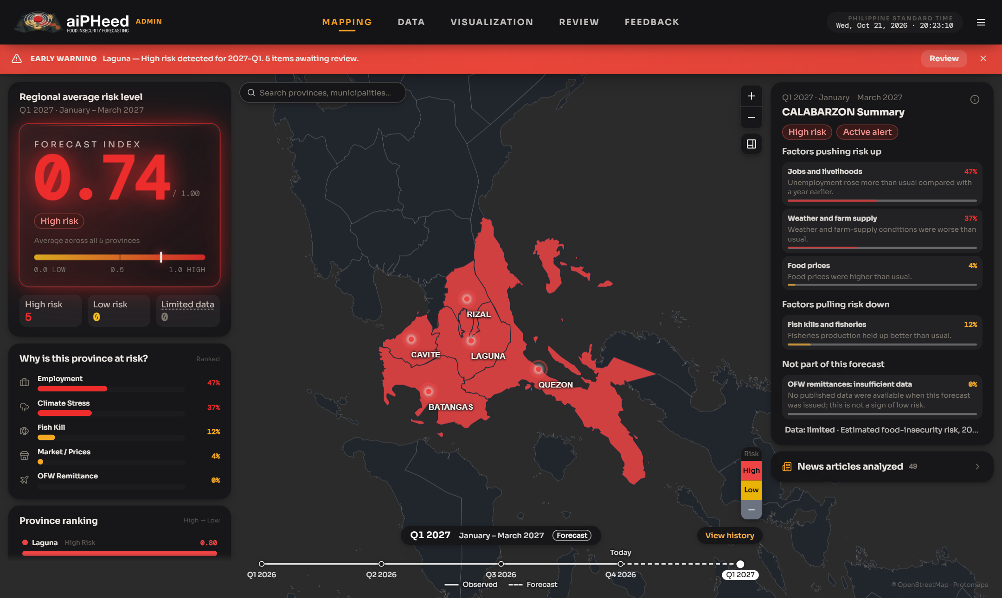

5.2 Reviewing Forecasts
Every province forecast is shown to the public only after it is reviewed.
- Click Review in the top bar. The Review Queue lists each province forecast with its risk level, score and status (Staged, Approved or Rejected).
- Use the Year and Quarter filters to find a forecast.
- Click View Details to open the risk review of a province.
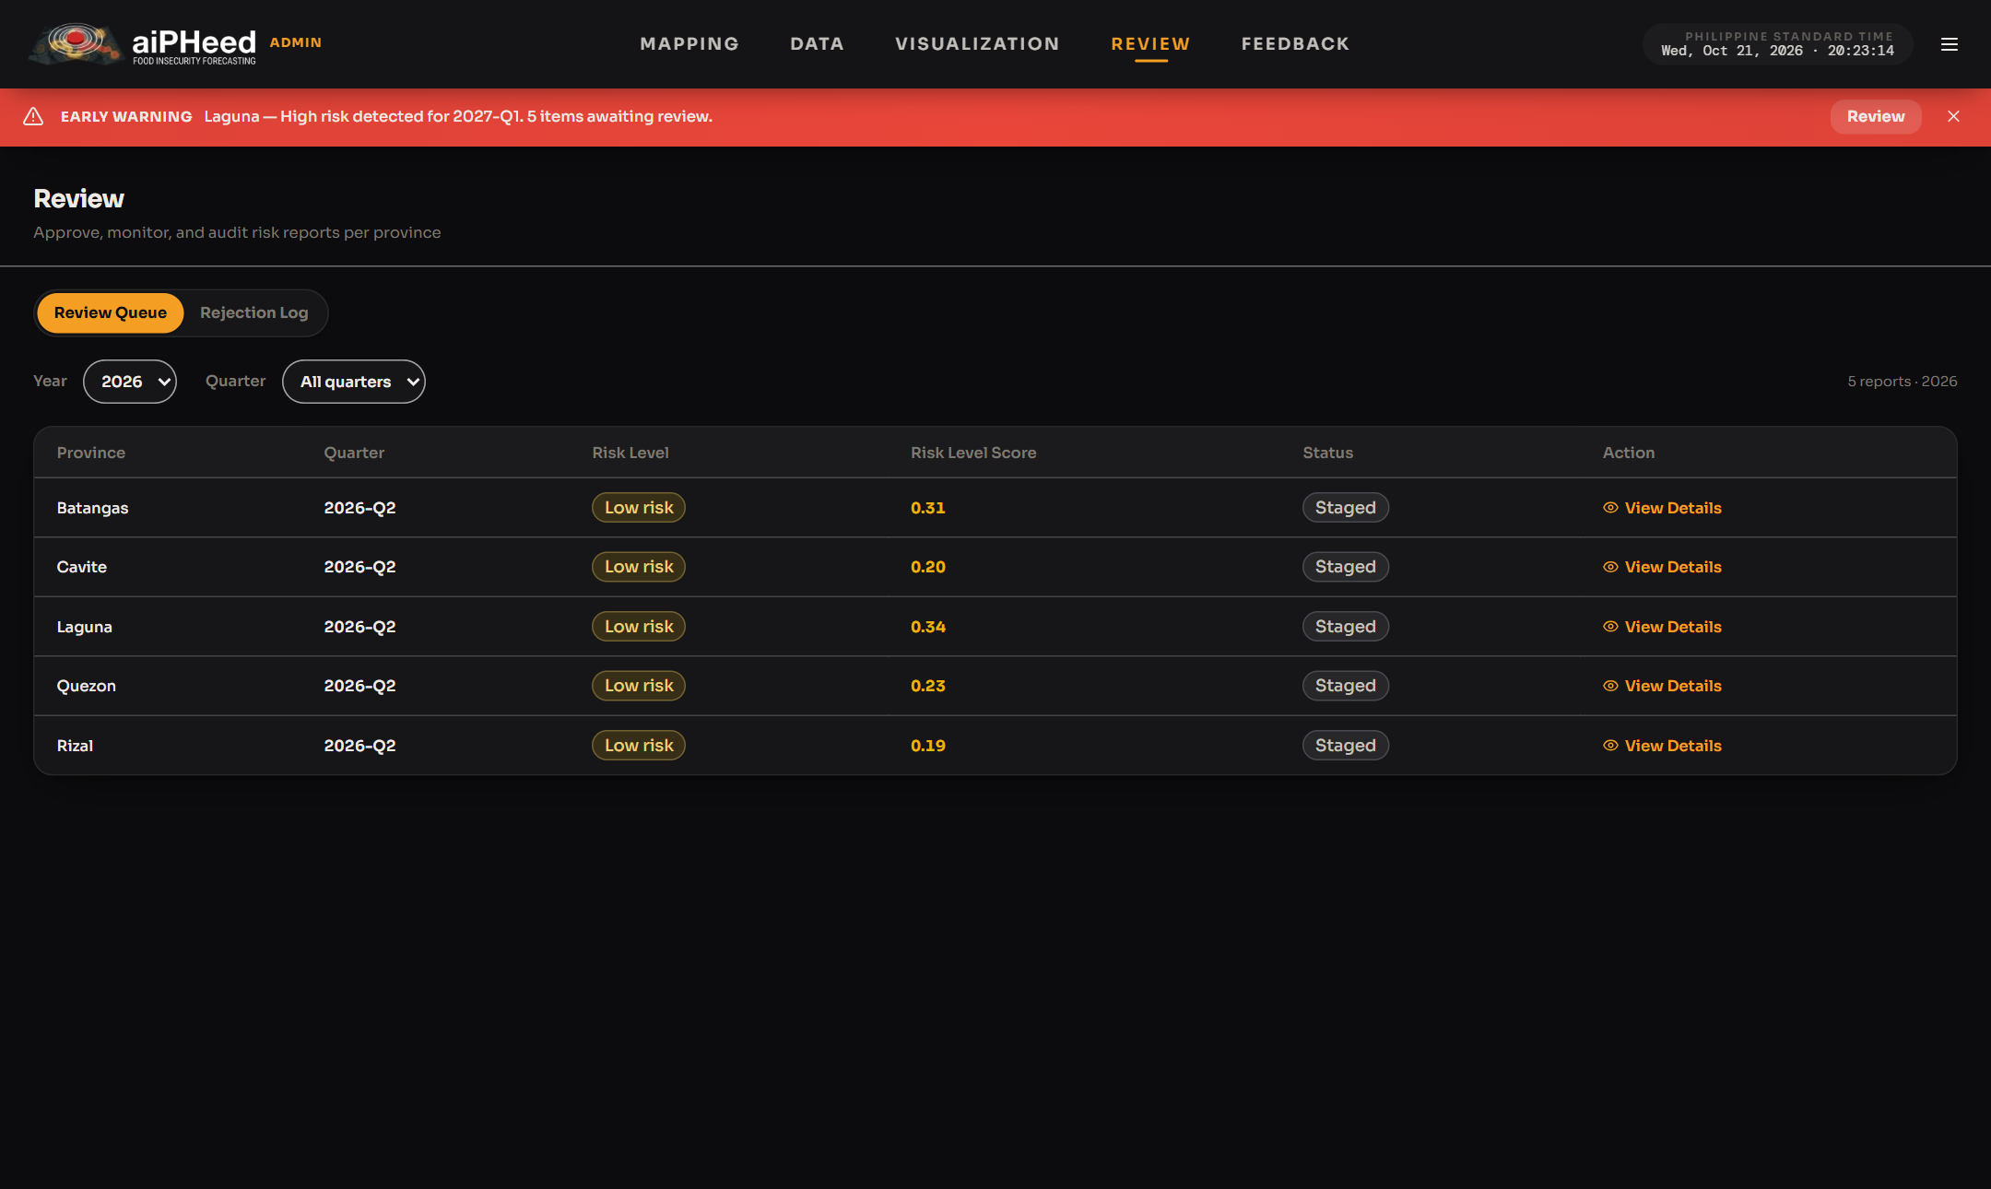
- The risk review shows the score of each city and municipality and the factors (SHAP driver contributions) behind the forecast.
- Click Approve & Publish to show the forecast to the public, or Reject to withhold it. Undo Publishing takes back an approved forecast.
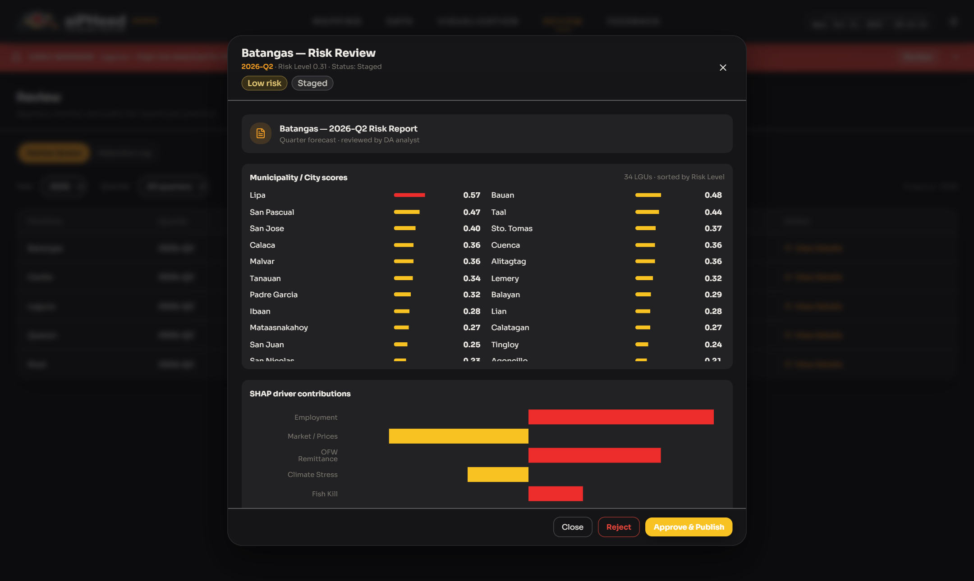
- When rejecting, choose a Rejection reason, add notes if needed, then click Confirm rejection. A rejected province is shown in grey on the public map.
- The Rejection Log tab lists every rejected forecast with its reason and time. Click Restore to send a forecast back for review.
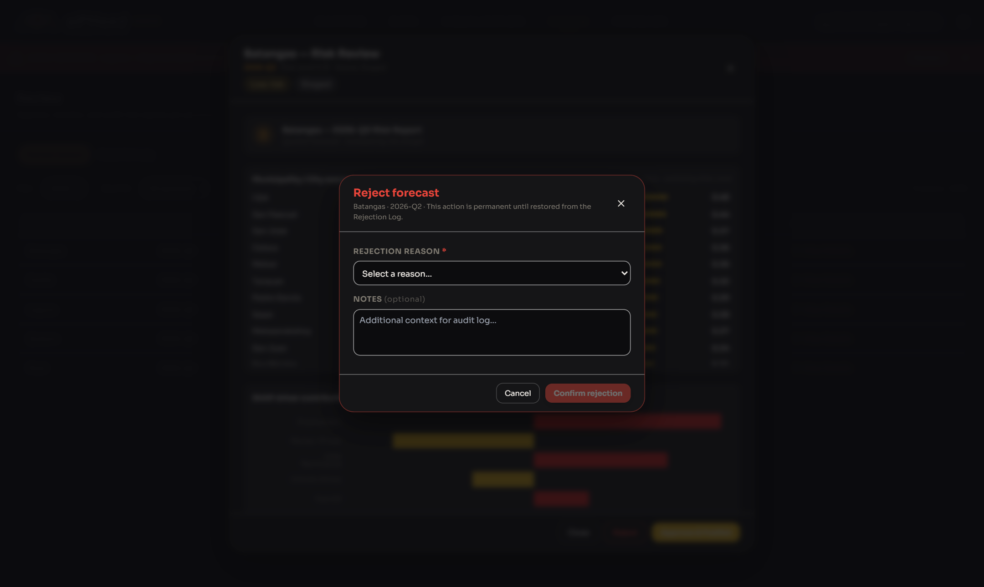

5.3 Feedback
- Click Feedback in the top bar to see the usability survey answers sent by users, with the number of submissions and the average SUS score.
- Click View on a row to read all the answers of that submission.
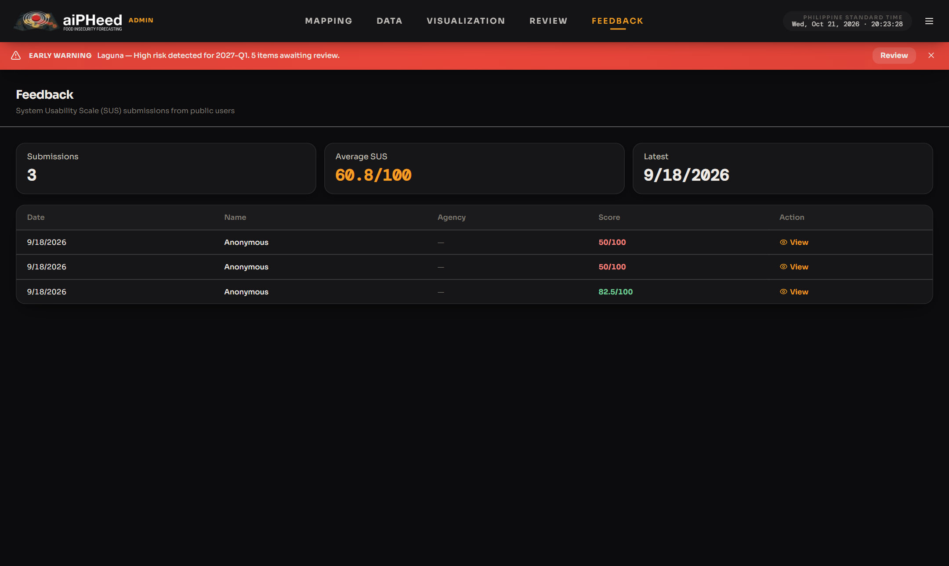

5.4 Accounts
- Open the menu (☰) and click Accounts. A number beside it shows how many requests are waiting.
- Under Waiting for approval, click Approve or Reject on each request for a new administrator account.
- Under Active admins, click Deactivate to switch off an account that is no longer needed.
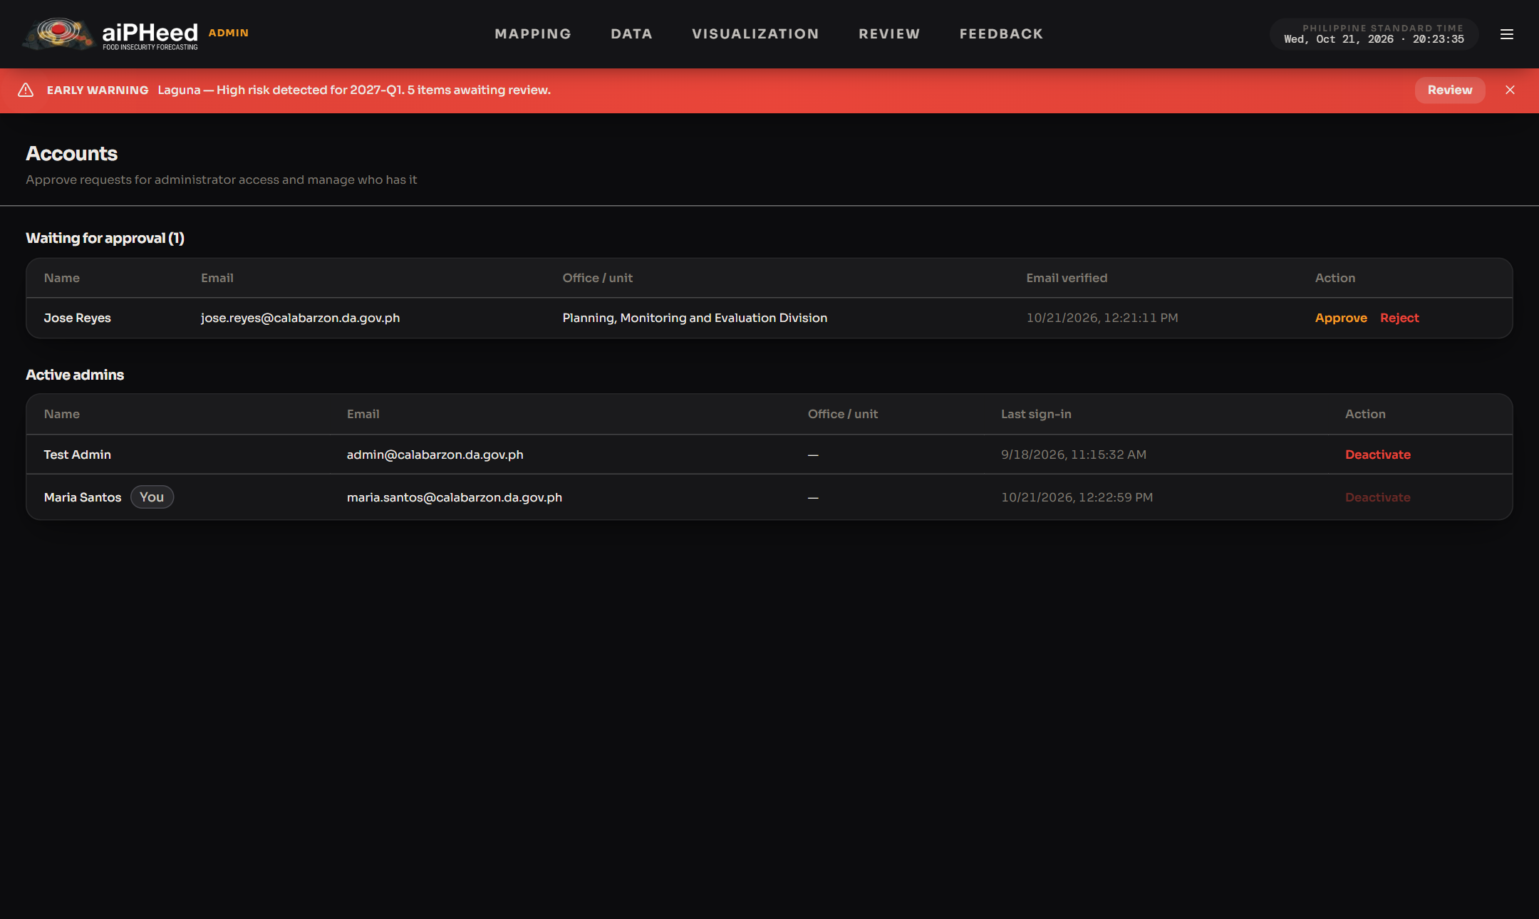
- To leave the admin view, open the menu (☰) and click Sign out.

