
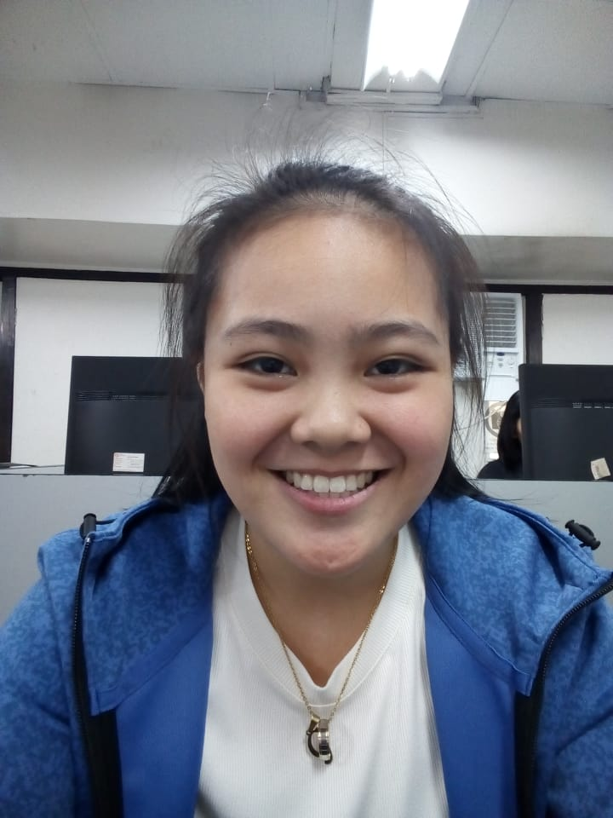
GWEN AUDREY A. RIVERA
B1 L2 PH6E Chico Street, Greenwoods Executive Village
Cainta, Rizal
+639064178504
gwen_rivera@dlsu.edu.ph

OBJECTIVE
To join an organization where I can use my skills in personnel administration and attain a high level of performance in personnel recruitment and training.

EDUCATION

2018 DE LA SALLE UNIVERSITY
Industrial Engineering

2016 st. paul college, pasig
Senior High School Diploma, April 2018. Awards: Academic Excellence, 2016; 2017; 2018. Deportment Excellence, 2018. GIFT Excellence, 2018.

2007 ST. PAUL COLLEGE, PASIG
High School Diploma, March. Awards: Academic Excellence, 2007; 2008; 2009; 2010; 2011; 2012; 2013; 2014; 2015. GIFT Excellence, 2015. GIFT Leadership Award, 2015.

CO-CURRICULAR ACTIVITIES

2018 MEMBER INDUSTRIAL MANAGEMENT ENGINEERING SOCIETY

2015-2018 MEMBER OF YOUTH FOR FAMILY AND LIFE (YFL)

Gwen Audrey A. Rivera
page 2

SEMINARS ATTENDED

July 2009 leadership seminar
Student Development Office, De La Salle University

March 2009 EFFECTIVE PRESENTATION SKILLS SEMINAR
Student Development Office, De La Salle University

SEMINARS CONDUCTED

August 2009 FACILITATOR, RELATIONSHIPS SEMINAR
Student Development Office, De La Salle University

May 2009 CO-FACILITATOR, LEADERSHIP TRAINING
Student Development Office, De La Salle University

RESEARCH PAPERS PREPARED

March 2018 EFFECT OF POLYETHYLENE TEREPHTHALATE (PET) AS AN ADDITIVE ON THE QUALITY AND STRENGTH OF ASPHALT ROADS
Performed experiments on a sample of asphalt roads with the addition of different amouunts of polyethylene terepthalate to determine the quality and strength of asphalt roads

PERSONAL BACKGROUND

Born on January 14, 2000. Fluent in English and Filipino. Knowledgeable in Microsoft programs. Interests: Books and mind games. Adaptable, goal-oriented and quality oriented.

REFERENCES

pamela S. santos
Psychology Professor
987-6543; +639179876543; pamela.santos@dlsu.edu.ph
2401 Taft Ave, Malate, Manila, 1004 Metro Manila.

jericho salvacion
Thesis Adviser
234-5678; +639172345678; jericho.salvacion@dlsu.edu.ph
2401 Taft Ave, Malate, Manila, 1004 Metro Manila.

