Editorially Speaking

September 1926

**DRAFT:** *Please do not share without permission of the author. Typeset versions in* [*web*](http://gernsback.wythoff.net/192609_editorially_speaking.html) *|* [*pdf*](https://github.com/gwijthoff/perversity_of_things/blob/gh-pages/typeset_drafts/192609_editorially_speaking.pdf?raw=true) *|* [*doc*](https://github.com/gwijthoff/perversity_of_things/blob/gh-pages/typeset_drafts/192609_editorially_speaking.docx)

*Extravagant Fiction Today . . . . . . . . Cold Fact Tomorrow*

**A** NUMBER of letters have reached the Editor’s desk recently from enthusiastic readers who find fault with the name of the publication, namely, AMAZING STORIES.

These readers would greatly prefer us to use the title *“Scientifiction”* instead. The message that these letters seem to convey is that the name really does not do the magazine justice, and that many people get an erroneous impression as to the literary contents from this title.

Several years ago, when I first conceived the idea of publishing a scientifiction magazine, a circular letter was sent to some 25,000 people, informing them that a new magazine by the name “Scientifiction” was shortly to be launched. The response was such that the idea was given up for two years. The plain truth is that the word “Scientifiction” while admittedly a good one, scares off many people who would otherwise read the magazine.

Before the name of AMAZING STORIES was first decided upon, a prize contest was held, but no better name than AMAZING STORIES, out of a list of some 200 names, could be found. The name “Scientifiction” would undoubtedly frighten many readers who would perhaps otherwise be interested in this new type of fiction. After mature thought, the publishers decided that the name which is now used was after all the best one to influence the masses, because anything that smacks of science seems to be too “deep” for the average type of reader.

We knew that once we could make a new reader pick up AMAZING STORIES and read only one story, our cause was won with that reader, and this is indeed what happened. Although the magazine is not as yet six months old, we are already printing 100,000 copies per month, and it also seems that whenever we get a new reader we keep him. A totally unforeseen result of the name, strange to say, was that a great many women are already reading the new magazine. This is most encouraging. We know that they must have picked up AMAZING STORIES out of curiosity more than anything else, and found it to their liking, and we are certain that if the name of the magazine had been “Scientifiction,” they would not have been attracted to it at a newsstand.

And after all, we really need not make any excuses for AMAZING STORIES, because the title represents exactly what the stories really are. There is a standing rule in our editorial offices that unless the story is *amazing,* it should not be published in the magazine. To be sure, the amazing quality is only *one* requisite, because the story must contain science in *every* case.

A great many letters are also received, from readers who wish to contribute material to AMAZING STORIES. The formula in all cases is that first the story must be frankly amazing; second, it must contain a scientific background; third, it must possess originality. At the present time we are booked far ahead for long stories of the novel type, and therefore can only accept short new stories. Stories that do not run more than six to eight pages when printed are most welcome providing they fill the above requirements. We believe the era of scientifiction is just commencing. We are receiving a great many fine short stories, and as time goes on we will publish more and more new material besides the classics which we are publishing now, and for which we have many requests from readers.

The Editors also wish it to be understood that this is *your* magazine in all respects; they will always be guided by the wishes of the majority. We will publish from time to time a sort of voting blank in which you may show your preference as to the type of stories published in the various issues. You will find such a blank elsewhere in this issue.

At this point we wish to say that the voting contest we conducted several months ago has now been closed. The vote stood as follows:

Leave the magazine monthly as it is now—498.

Make it a semi-monthly—32,644.

We will probably accede to the wishes of the readers as soon as the circulation of the magazine has become stabilized, which will probably be some time before the end of this year.

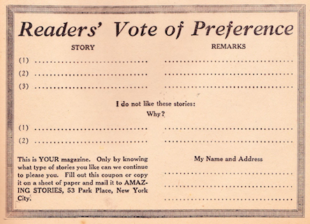

Mr. Hugo Gernsback speaks every Monday at 9 P. M. from WRNY on various scientific and radio subjects.