Television and the Telephot

December 1909

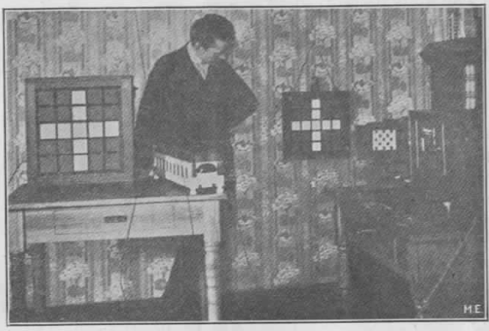

Every now and then we see newspaper reports that Mr. So and So has discovered the real secret of television, only to be told again a few weeks afterwards that it has not been realized after all.[1]

For 25 years almost, inventors all over the world have been working strenuously to solve the problem, but so far none succeeded, apparently because they all seem to work along wrong lines.

The principle of television may be briefly stated thus: A simple instrument should be invented which should reproduce objects placed in front of a similar instrument (called a Telephot) at the other end of the line. In simple language, it should be possible to connect two mirrors electrically, so that one would show whatever object is placed before the other one and vice versa.

As in a mirror, the objects must be reproduced in motion (at the far-off station). The theory further requires that both instruments (one at each end) must be reversible, that is, each instrument must receive as well as transmit.[2]

A good parallel of this requirement is found in the ordinary Bell telephone receiver. As is known, the Bell receiver (without the use of a microphone transmitter) will receive as well as transmit, that is, one can talk in a receiver and also hear the other party, using one and the same instrument.

In the Telephot it should be possible to see the party at the other end while that party should see you, both through the medium of your Telephot.

Unlike the mirror, however, you should not be able to see your own picture in your own Telephot. In this the Telephot differs from the mirror analogy.

From this it will be seen immediately how difficult the problem becomes, as if you could see yourself in your own Telephot, as well as the picture of your friend, it is obvious that there would be a ‘mix-up’ of personalities, the consequence being that you could not recognize your friend nor yourself, while your friend at the other end could of course not recognize you nor himself.

In the telephone the case is not so difficult, as it is absolutely necessary that one party talks while the other listens; if both talk and listen, none can understand, as the voices mix up.

In the Telephot this parallel does not hold good, as there is nothing to restrain you from looking at your friend at the same time he is looking at you.

Of course the problem can be simplified by getting the true parallel of the telephone, thus: When you wish to see A you keep in the dark, while A stands in full light. If A wants to see you he turns off his light while you switch on yours.

However, this would be impracticable and is not the true solution of the Telephot.

So far most inventors seem to think that the problem can only be solved by means of the selenium cell, which being sensitive to light, can send out electrical impulses in the same ratio as the light falling upon the cell. Thus, if a strong light is thrown on a selenium cell a strong electric impulse is sent over the line which when operating a light relay (described below) can be made to throw a strong light upon a screen.

As a picture is made up of nothing but light and dark points it is easily to be seen that if several thousand very [Fig. 2] small selenium cells were arranged in a plane and just as many light relays at the other end, a good picture could be projected upon a screen––in theory. The trouble is that it is practically impossible to make two selenium cells with equal sensitiveness and just this is the most important part, as if one is not as sensitive as the other, it will of course not transmit the same impulse as the former. It can be imagined easily what kind of a picture a station would transmit having several thousand selenium cells, all of a different sensitiveness!

Then the next trouble is that each cell at best requires one wire (the ground might be used as return).[3] Think of two stations which, in order to work, require 3,000 to 5,000 separate wires! This seems to be as bad or worse than Sömmering’s first telegraph (in 1809), which required 27 wires to operate. In Morse’s subsequent telegraph only one wire is required, which unquestionably will be the case with the perfect Telephot.

Another great trouble with the selenium cell is that it works sluggishly, that is, its resistance will not drop instantaneously from the highest value to the lowest, which is ab ad feature, as it would necessarily blur the picture at the other end. Furthermore, to work anywhere satisfactorily the selenium cell requires strong light.

The writer does not wish to throw cold water on selenium and selenium cells, as it is quite possible that the latter may be improved to such an extent as to do entirely away with the shortcomings mentioned above, although the greatest difficulty, the one that each cell requires at least one wire, is and will be the far greatest stumbling block.

[…]

1. This article contains the first mention of television in the Gernsback magazines, a favorite topic of his writers over the next few decades. Surveying the latest technical approaches to transmitting images across a distance, Gernsback introduces a system by Berlin-based technologist Ernst Ruhmer, one which bears more of a technical resemblance to today’s liquid crystal displays (LCDs) than the electromechanical Nipkow disk scanners common at the time. In the photograph, Ruhmer displays a crude prototype with a 5x5 pixel cross transmitted from one display to another. Ruhmer’s system used light-sensitive selenium cells arranged in a mosaic, transmitting differences in light intensity through variable current strengths. **For more on Ruhmer, see the Archie Collins 1905 book Wireless Telegraphy, with a section on Ruhmer’s [“photo-electric telephone”](http://books.google.com/books?id=RR4PAAAAYAAJ&pg=PA288#v=onepage&q&f=false)
2. Though Gernsback claims in his autobiography that this article “may have been the first to explain television in simple terms for the layman” (64), the technology had been envisioned much earlier and explained in similarly non-technical terms. Most historians date the earliest depiction of television avant la lettre to a George Du Maurier cartoon in the December 9, 1878 issue of *Punch.* The cartoon, “Edison’s Telephonoscope” was a prediction for the following year, part of Punch’s “Almanack for 1879.” The caption reads, “Every evening, before going to bed, Pater- and Materfamilias set up an electric camera-obscura over their bedroom mantel-piece, and gladden their eyes with the sight of their children at the Antipodes, and converse gaily with them through the wire.” Friedrich Kittler dates the coinage of a name for this medium to Raphael Eduard Liesegang’s 1891 book *Beitrage zum Problem des elektrischen Fernsehen* [Contributions to the Problem of Electrical Television]. For more on the 19th century origins of electric image scanning techniques, see Kittler, Friedrich. *Optical Media: Berlin Lectures 1999.* Trans. Anthony Enns. Cambridge: Polity Press, 2002. pp. 208-12. Further explications of the principle of television for a popular audience in the German context can be found in the writings of the technologist Eugen Nesper, *Das elektrische Fernsehen und das Telehor* (Berlin: Verlag von M. Krayn, 1923). Nesper was a frequent contributor to the magazine *Der Radio-Amateur* and reviewed several of Gernsback’s devices in this publication.
3. The greatest benefit of this set up is that the entire image is transmitted across a single wire, as opposed to one wire for each individual pixel, referred to in the article as “raster.” This multiplexing was a unique solution to the problem of translating a two dimensional image into a one-dimensional electrical current, which was seen as the biggest stumbling block to television at that point.