*The Scientific Adventures of Baron Münchhausen,* Part 5:  
“Münchhausen Departs for the Planet Mars”

October 1915

*“THERE are more things in heaven and earth, Horatio, than are dreamt of in your philosophy.”*

*So sings Shakespeare. One of these “things in heaven” is the Planet Mars, the most fascinating, the most astounding revelation to the feeble human intelligence. Shakespeare, the master of the drama, never conceived anything like a drama of an entire world—millions of intelligent beings—fighting a heroic battle, a battle for existence. Yet this drama was going on right before his very eyes, but 35 million miles away; for the Martians have been fighting for water ages ago, and the available supply becomes smaller each year.*

*There is nothing more inspiring, nothing more gripping to the imagination, than this wonderful battle between organized intelligence on one side and unrelenting nature on the other.*

*Mr. Münchhausen’s scientific lecture gives you the latest facts—now almost universally believed—about Mars. You can spend no better half hour than turning your mind from your humdrum existence towards a subject which is as absorbing as it is lofty in its grandeur.*[1]

**O**NCE upon a time, a grouchy old gentleman with a grievance for fiction writers, presumably because the latter received more emoluments for their stuff than the former for his poetry, thus vented his resentment in immortal song:

*“’Tis strange, but true; for truth is always strange—stranger than fiction.”*

From this, some coarse soul, totally oblivious of any poetic infection whatsoever, took it upon himself to mutilate the above passage of one of Lord Byron’s poems and taught us unsuspecting mortals to hawk, parrot-wise, ever after until the end of fiction, thusly: “Truth is stranger than fiction!”

With all due regard to the memory and genius of Byron, I, I. M. Alier, a citizen of a free country, take it upon myself to correct his Lordship at this late and quarrelsome date, to wit:

*“There is no fiction.”*

If, as often—no, always—has been proved that the most violent fiction at some time or other invariably comes true, then by all proceeds of modern logic, there cannot be such thing as fiction. It simply does not exist. This brings us face to face with the startling result that if fiction always comes true some time or other, why then, bless their dear souls, all fiction writers must be prophets!! Hurrah for the F. W.!! But hold on, boys; don’t let our enthusiasm run away with us on a Ford. The spark plug has run afoul somewhere. While it’s nice to be a prophet, don’t forget that a prophet is never, never recognized in his own country. Thus the New Testament teaches; so I think it will be safer for all F. W. to remain F. W., rather than to be honorless prophets.

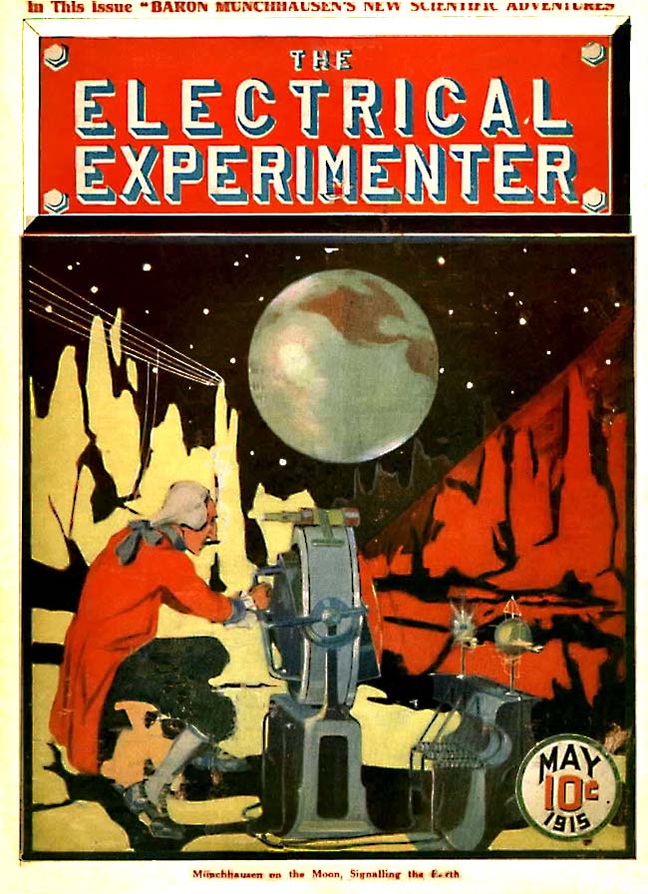

However, that is not what I had in mind when I started—it’s so hard for me to say what I mean, and a good deal harder for me to keep my thoughts running on the track. They ramble from one nothingness into another. My mind in that respect is a good deal like a one-eyed, religious old cow on a pasture. She eats up whatever she sees alongside of her, but when she finally turns around she perceives with astonishment that there is still a lot to graze on the other side; so she steers around to starboard and returns to her original starting point.

But I am rambling again. So let’s return to the original starting point.

Seriously speaking, and by way of emphasizing how much stranger truth is than fiction, I have but to point to Jules Verne’s famous stories. When 45 years ago he wrote *“Twenty Thousand Leagues Under the Sea,”* no one took him serious. It is doubtful whether he himself believed that the submarine which he invented in that story would ever become practical. It was just fiction. Yet 45 years later we see how a submarine, almost exactly as his vivid as well as prophetic mind conceived it, down to the most minute detail, emerges from a German harbor and travels under its own power over a distance of 4,000 miles, through the North Sea, the English Channel, down the Atlantic, through the entire length of the Mediterranean and up through the Dardanelles to Constantinople! And by way of diversion it manages to sink several battleships of the enemy by means of its torpedoes. Now, bold as he was, Jules Verne never conceived such an “impossible thing,” and while his famous *Nautilus* was equipped with almost every other modern submarine necessity, the infernal automobile-torpedo was missing. Truth is indeed very much stranger than fiction. Hundreds of similar instances could be cited, but lack of space prohibits it; besides, I mustn’t ramble![2]

Münchhausen, as will be remembered, had explained the mysteries of the moon to me, and he bad also mentioned the great danger of falling meteors, which had been increasing alarmingly in number for some time. ✝The moon’s attenuated atmosphere offers no protection from meteors, as did the earth’s thick air. But few meteors ever reach the surface of the earth; the colossal friction between the meteor and the air ignites the former, and most of it falls down on the earth as a fine dust. The burning of the meteors represents the shooting stars we see. On the moon, however, the meteors crash down bodily, causing tremendous havoc, and this terrible bombardment goes on forever, without let-up.✝ Consequently, when Baron Münchhausen stopped short that evening in the midst of a sentence, I naturally was alarmed not a little. Great, therefore, was my joy when, sitting before my radio set the next evening, ’phones clapped tight over my ears, my eyes glued on the clock, the familiar high, whining spark suddenly reverberated in my ears at the stroke of 11 o’clock.

It was Münchhausen. But his usual sonorous voice to-night had an unfamiliar metallic timbre that puzzled me greatly; in a short time, however, the mystery was cleared, and this is what poured in my astonished ears:

“My dear Alier. No doubt you thought I had been killed by a meteor last night. Well, as you Americans put it, I certainly had ‘a close shave.’ A meteor crashed down on my aerial 50 feet from where I was sitting; of course it went up in smoke—metallic vapor, to be correct—due to the tremendous heat generated by the impact of the meteor on the granite rucks. The whole meteor itself went up in a fiery cloud of red vapor and I was blown headlong a distance of over 50 feet, right down into the mouth of a giant crater, by the colossal resulting blast of the concussion.

“Now, this long-extinct crater is a very deep one; how deep, I was soon to learn! I went down head first and kept on falling at a terrible rate of speed. I must have been falling down that awful abyss what seemed to me like hours. As I kept on plunging down, I was gloomily reflecting what an inglorious death it was to die at the bottom of an unromantic crater on a dead and dried-up moon. I thought of many things, when I suddenly became conscious of a terrific cold. Call it instinct or presence of mind, as soon as I had started on my downward journey I had jerked my body in such a manner as to righten it; in other words, after a few attempts, I succeeded in falling feet down. It was indeed a fortunate circumstance that the sun was almost directly over the crater, for it saved me the anguish of plunging into a pitch-black abyss. While it was not nearly as light as it was at the top, still I could see where I was falling, and that was some consolation. Thus, when I glanced down toward my feet after a while, I am sure that my heart, which had stopped beating, stood still entirely for some seconds. It took me a few seconds to collect my bewildered senses, for this is what I had seen:

“*The crater had no bottom at all,* but went right through to the center of the moon, where it connected with another crater, *which went to the opposite side of the moon.* I knew this must be so because when I had looked down I had seen several stars shining through brilliantly from the night side of the moon. Then the awful truth flashed through me and I almost swooned. *I was falling through the whole length of the moon!* I had been in many tight quarters before during my somewhat exciting career, but this experience indeed bade well to he the inglorious end of my adventurous life. However, my far-famed presence of mind and my cool head soon asserted themselves, as was naturally to be expected of me.

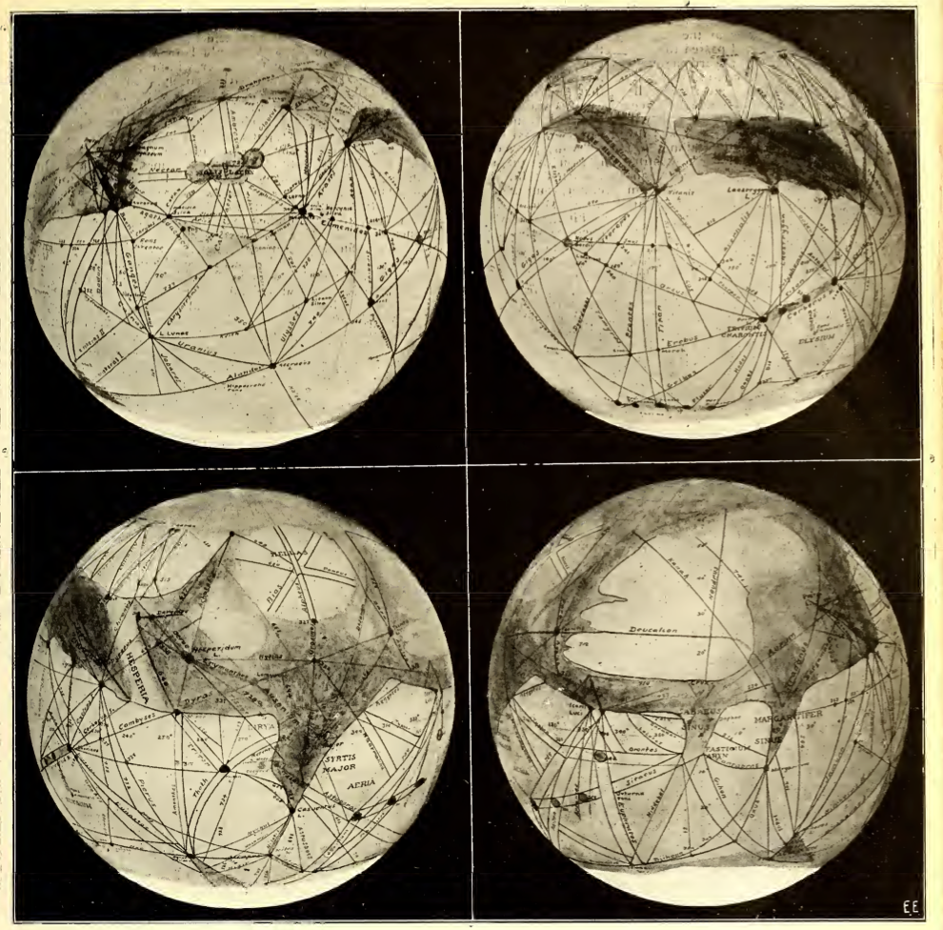

Four different views of the planet Mars. As Mars turns on its axis once every 24 hours the same as the earth, we are enabled to see the entire surface of the Martian globe during that time. The four views, as shown, are therefore taken six hours apart from each other. These pictures were made during the last “opposition” in 1911, when Mars was some 47 million miles distant from the earth. It never comes nearer than 35 million miles to the earth. In 1924 the two planets will be but 35 million miles apart. In the views shown, *the top is south, the botton north,* for through the telescope all objects are turned upside down. The white patch at the bottom is the north Polar snow cap, the southern cap is not in evidence for it has melted already. The melted water has been conducted equatorward by the “canals.” Note that the canals run through the dark areas, which are not oceans therefore, but land with vegetation. The light areas are deserts. Nearly all canals are perfectly straight, the ones near the edges of the pictures appear curved only because we are looking on a globe and not on a plane surface. Photos courtesy of Prof. Percival Lowell, Flagstaff Observatory, Flagstaff, Ariz.

“I knew the diameter of the moon to be 2,164 miles. A quick mental calculation proved that it would take my falling body about 24 minutes to reach the center of the moon. As there was nothing to stop my fall. I must naturally continue to fall, due to the tremendous momentum acquired, till my body would *almost* emerge at the opposite side of the moon at the mouth of the other crater. At this point my speed would be zero and I would have fallen for 48 minutes. If I could not manage then to grasp a projecting rock, I would commence to fall back again toward the center of the moon. I reasoned that once more my momentum would carry me past the center and I would then be almost carried to the mouth of the opposite crater—my original starting point.

“I say almost, for the friction of my body against the air would tend to retard my fall. If at this point, where my speed was again zero, I could not succeed in taking hold of a projecting rock of the crater’s side I would begin to fall down once more, the same as before. I would then continue falling hack and forward exactly like a bouncing ball, each time, however—just like a rubber ball—a little less than on the previous plunge. Thus my drops would become of shorter and shorter duration, and finally I would fail no more.

“As I had mentioned before, the sun was almost overhead, shining down into the crater. I also remembered that it was almost exactly 12 o’clock midnight, terrestrial time, when the meteor smashed my aerial; this, then, was the lime I started on my re- markable journey into the bowels of the moon. With a tremendous effort I pulled out my chronometer and noted that it was 12.23 a. m. In another minute I would fly past the center of the moon. Looking about, I saw in the uncertain light that I went whizzing through an immense hollow, proving to me that the center of the moon was far from solid, due no doubt to the centrifugal force of the moon at the time when it had not solidified, some millions of years ago. I estimated later that the moon was an immense hollow sphere with a solid crust about 500 miles thick. By way of a homely comparison, the moon therefore must be a hollow globe like a rubber ball. Like the latter, it is filled inside with air, while its crust can be compared to the rubber of the ball.

“In another minute I had passed the center and was now dropping toward the other side of the moon. If I continued falling in my present position, I must naturally emerge at the opposite side with my feet toward the sky, as a little reflection will reveal to you. So once more I jerked my body about, and I was falling *‘up,’* with my head at the top, my feet pointing to the sun. At the end of another 24 minutes I could feel my body slowing up from the terrific speed. As the crater at this side of the moon was fortunately rather narrow, I found little difficulty in reaching for a projecting rock as soon as my plunge had come to a dead stop. I held on for dear life and clambered up a narrow ledge, where I fell down exhausted and panting from my dreadful experience.

“My sensations in falling through 2,164 miles of space, going over 16 miles per second at the center of the moon, you would, of course, like to know. Well, the first minute it is rather unpleasant. Highly so. The place where your stomach should he by right is one vast area of nausea. But once you become accustomed to it, it becomes bearable, for there is nothing else to do. You might think that the rush of air would kill you in a few seconds, or else draw all the air out of your lungs, and thus asphyxiate you. But neither is the case, for the air is so thin on the moon that the rush is not as terrific as it would be on earth. Also, by keeping the mouth tightly shut and breathing—with difficulty, it is true—through the nose, one does not die in 48 minutes. The friction of the air against my body did not ignite either, for, as I told you some time ago, the temperature inside the moon is near the absolute zero, the awful cold of the stellar world. But neither did I freeze to death, for the simple reason that the friction of my body through the attenuated air was just sufficient to keep me comfortable. Thus you see that if it had not been so cold, I would have burned up; and vice versa, if the friction of the air against my body had not heated it, I would have frozen to death long before I reached the center of the moon. Then, too, another important point to consider is that on the moon, as explained previously, my body weighed 27 pounds, against 170 pounds on earth.[3] This is, of course, a rather small weight, and for that reason my fall was not as terrible as it would have been if my body had weighed 170 pounds, as on earth. For that reason, too, I was not attracted so much to the sides of the crater as I would have been if my weight had been greater. Also it was fortunate that the two craters widened out considerably the further down they went into the moon’s interior. As a matter of fact, the ‘hole’ of each crater at no point was less than three miles in diameter. This was indeed very lucky for me, for the following reason:

✝“If we drop a stone into a very deep and narrow shaft, as has been shown experimentally on earth, this stone will never reach the bottom. Instead, *it will bury itself in the eastern wall* of the shaft long before reaching bottom, providing the shaft is deep enough. The explanation is that the earth rotates on its axis from west to east at a speed of 1,524 feet per second at the equator. Thus, it is apparent that the earth revolves quicker than the stone can fall in a few seconds.[4] It therefore intercepts the stone’s flight, with the result that the stone must of necessity strike the eastern wall of the shaft. This phenomenon is termed ‘the falling of a body toward east.’✝

“Now, precisely the same condition exists on the moon, of course. Fortunately, I started falling at the western side of the crater, but as the latter was so wide I never came near enough to its eastern wall to hit it. Likewise the other crater, at the opposite side of the moon, measured some four miles in diameter and, while I finally did reach the eastern wall, my flight had come to an end as explained already. Indeed, nature favored me all through, for the moon rotates with a velocity of but 15 1/3 feet per second at its equator, against a speed of 1,524 feet of the earth. For this reason there was no danger that my body would collide with the sides of the crater somewhere in the interior of the moon, for my flight was far more rapid than the speed of the moon’s rotation on its axis.

“But in the meanwhile my troubles were far from being terminated. No sooner had I regained my breath than I became conscious of the terrible cold; for I was now but a few feet from the surface of the moon, but on that side which was turned away from the sun, where nothing but icy cold, darkness and desolation reign. Aside from this, I was some 2,160 miles away from Flitternix, my companion, and our ‘Interstellar.’ Walking around half of the moon was out of the question; neither could I stay where I was without freezing to death. So I climbed up to the surface of the moon with considerable effort. Then by the aid of the starlight I ran rapidly around to the western side of the crater, for I had to run in order to keep warm. After having obtained my bearings by the aid of the stellar constellations, to make sure that I was at the western side of the crater, I took a deep breath, looked down in the abyss through which the sun was shining from the other side, and dived head down into space once more.

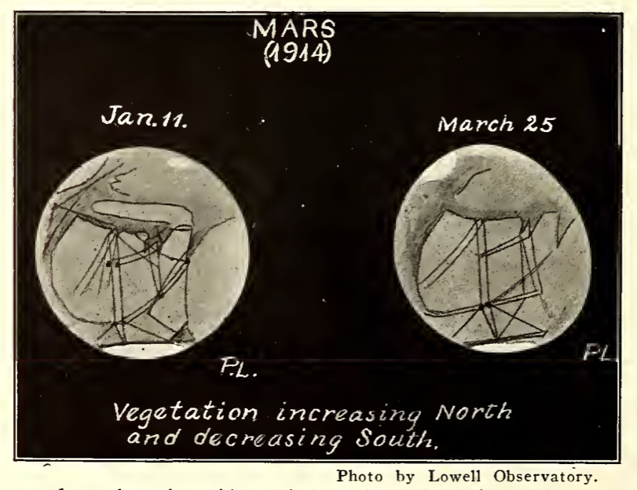

“You see, I had reasoned that it was far better to attempt the flying journey through the moon once more than to perish with the cold on the dark side of the moon. Besides, I had experience now and having been successful once, it was natural for me to expect success again. I had nothing whatever to lose, and everything to gain.

“My first experience was repeated without any incident; furthermore, I calculated that I should land at the eastern wall of the far crater within 48 minutes if everything ran smoothly. But I had left our good old sun out of my calculations. You see, the gravitational attraction of the sun controlled the fall of my body in the same proportion as it controls the rotation of the moon and the earth. I mentioned how in my former flight I had risen to the top of the moon; as a matter of fact, somewhat higher, for the opening of this crater was higher than the surface of the moon. But now I was falling *toward* the sun, and the sun was aiding and accelerating my flight; for I moved constantly nearer to it.

“For this reason at the end of 48 minutes I did not strike the eastern end of the crater. Instead, I whizzed right past the eastern wall, almost brushing it, and continued to rise up into the air about 100 feet before my speed was spent. I promptly prepared myself to plunge down into the crater again. Indeed, before I realized it, I had begun to fall down once more when the unexpected happened.

“I suddenly felt a rope encircling my body, and before I had time to think, I was jerked sideways, and in another second I had fallen on a heap of sand and looked with astonishment into Professor Flitternix’s eyes, who stood over me grinning sheepishly!

“This is what had happened: Flitternix had, of course, seen me fall into the crater, and as he had rushed to the edge, he had seen how I dropped down with lightning speed. Looking closer, he also noticed what I saw, namely, that the crater went right through the entire mass of the moon, for he could see the stars shining through from the other end. He was loath to believe that the fall would kill me, and, as a scientist of note, he calculated exactly in advance what was likely to happen to me. He reflected that it would take me some two hours to make the round trip, as he knew that I could not possibly stay at the other side of the moon. He reasoned, correctly, that in case I was not killed I would come swinging through the crater in due time. Unperturbed as he is by such mere details, he went to the ‘Interstellar’ and had his lunch. Within two hours he returned to the crater, armed with a telescope and a long rope. It did not take him long to locate me down in the abyss by means of his glass, for I was rapidly coming to the surface then. Attaching one end of the rope to a near-by rock, he fashioned a sliding noose on the other side and waited.

“Now it must be said to the credit of Flitternix that in his younger days he had lived in the West on a ranch, and there had become an expert in the science of lassoing. He boasted that once he lassoed a common sparrow by its left hind leg, but this I believe to be somewhat exaggerated. Be that as it may, when I finally emerged to the surface, a living piece of lava ejected out of an extinct crater, Flitternix bad little trouble in lassoing me as I came whizzing up. Whereupon I thanked him and asked him if lunch was ready, for the trip had given me quite an appetite, as you may well imagine. Luncheon over, we decided right then and there to quit the moon, for Flitternix, as well as myself, were of the opinion that there was little further to be explored on this dead world. Besides, the meteors had become so alarmingly frequent that it would be only a matter of time when one of us would be killed.

“Flitternix wanted to return to earth at once, for he itched to give a lecture before the American Astronomical Society, whose honorary president he was. I, however, had more ambitious plans. I once had looked through the great telescope of the Lowell Observatory at Flagstaff, Ariz. If I live to be a thousand years old I will never forget the glorious sight which then presented itself to my eyes.

✝“I saw a ball, lighted up dazzlingly at both extremities. I saw great patches of an ochre red scattered over the surface of the sphere and I had seen dark blue areas among the vast ochre patches. Over the latter runs a mass of fine lines, nearly all of them connecting with the white caps at each extremity. Moreover, these fine lines cause one to gasp involuntarily, for they are as straight and true as if laid out with a rule and pencil. More astonishing yet, some of these lines run absolutely parallel with other ones for the whole length of their extent. And more wonderful yet, whenever two or more lines meet in a junction there is invariably a round black point.

“The ball I had been looking at transfixed for a long time was Mars, the nearest planet to earth, then 37,000,000 miles distant from the latter. The late Prof. Percival Lowell, the great authority on Martian research work, had convinced the scientific world that the dazzling white caps at the poles of this planet are the polar snow fields. The great ochre patches are desert land, while the dark blue areas represent large tracts of fertile land and its resulting vegetation.

“Now, according to well-known physical laws, proved beyond discussion, the smaller a body, the quicker it will cool off. All planets and their moons once were white-hot like our sun. The smaller ones cooled off first and the larger ones are not cold yet. Thus the earth, which measures 7,912 miles in diameter, is still red-hot in its interior, as is proved by its active volcanoes. The moon, which is but 2,164 miles across, cooled off ages ago. The oceans once filling their beds then filtered down into its bowels, there to freeze solid, for there was no heat to keep the water fluid. Its atmosphere, which was formerly as dense as that of our earth, was gradually thrown off into space, til to-day practically no atmosphere remains. Thus the moon to-day rolls on through space a dead world.

“The planet Mars, measuring 4,363 miles in diameter, as will be seen, is only twice the diameter of our moon and much smaller than the earth. Consequently it must be rapidly Hearing its extinction, the same as the moon. Its oceans are already dry, while most of its land is desert. The atmosphere has nearly all gone too, proved by the fact that we seldom observe clouds on Mars through the telescope. But there must still be water on the planet as yet, this being irrefutably proved by its polar snow caps. This view is further strengthened by the fact that these caps undergo seasonal changes. As the sun beats down upon them, we see first the one, then the other, grow smaller in size, till at the end of the Martian mid-summer, the northern one has disappeared almost entirely. During the next hot season, the same happens to the southern one. Where has this water—*the only remaining water on Mars*—gone? It cannot have filtered into the interior, for if it had, we could not possibly witness the reappearance of the polar snow fields every Martian year, as we actually do. Where, then, does the water go?

“Dr. Lowell solved the problem in a brilliant as well as ingenious manner.

“His view—and it is shared by most of our scientists to-day—was that Mars is inhabited by a thinking people, fighting a heroic battle for their existence. Without water, life, as we know it, cannot exist. Now, ages ago, the shortage of water had made itself felt on Mars. Long before the first cave man appeared on earth Mars had been an old world, where civilized peoples had reigned for centuries. While our ancestors were still jumping from limb to limb among the trees in primordial forests and jungles, the water problem on Mars had become acute. The fertile lands were fast turning into deserts, for rains had become more and more infrequent, until they had stopped almost entirely. Furthermore, as Mars is flat without mountains or elevations of any sort, there could not be any natural rivers to convey the water to the plains and valleys as is the case on our world. The Martians, seeing utter extermination staring them in the face, proceeded to save their race. They did precisely the same thing that we are doing in Western America and the Egyptians are doing in Egypt, namely effecting the irrigation of deserts, or semi-deserts on a large scale. Our recent Roosevelt dam in Arizona offers, a good example of this. Our engineers on earth have to bring the water to the deserts, precisely as the Martian engineers must have been doing for centuries past.

“On earth, however, this is a comparatively simple matter, for here we have rivers and lakes in abundance which can be tapped with ease. Not so on Mars. The only remaining water there is found around the poles; by sheer necessity, therefore, the Martians had to go to the poles for their water supply, and this is exactly what our telescopes reveal that the r did. For the long unswerving straight lines which we see are part of the canals bringing the water down from the poles to the desert land there to irrigate it. So far the Lowell observatory has discovered almost 600 canals, but there are doubtless many more. They criss-cross the entire surface of the planet in every conceivable direction, most of them, however, running due north and south in the direction of the poles. Not only do the canals cross the desert lands, but we see them carried bodily across the dark blue areas which we know to be irrigated vegetation tracts. The fact that the canals run across these areas is another proof that they are not oceans, as had been thought at one time.

“Now the lines which we see running over the planet are really not the canals themselves, but are simply wide strips of vegetation fertilized and kept alive by the water from the canals. The average width of the canals proper Dr. Lowell estimates to be about six miles. There are some of them, however, which are thought to be much wider than this. The length of these canals, however, is stupendous. There are some canals which actually measure 3,400 miles in length. A great many are over 2,000 miles long. Dozens of them run for 1,000 miles, and nearly all of the canals run in absolutely straight lines.

“The circular black points, mentioned above, which we see almost invariably at the juncture of one or more canals, are termed oases. They also represent vast tracts of vegetation and probably contain large cities, farms and so forth.

“It must convince the strongest opponent of Dr. Lowell’s theory, when viewing Mars and its canals through a first class telescope, that these wonderfully straight lines cannot by any possible chance be the work of Nature. Its counterpart is found nowhere on earth, nor in the heavens. And if by any chance, for argument’s sake, these lines should be of a natural origin, it is inconceivable that so many of them could join and meet as they do and form these exact circular areas. Their artificial origin is too apparent and cannot be otherwise considered to-day. Dr. Lowell’s theory has so far withstood the onslaughts of nearly all opponents, as a matter of fact, his explanation is to-day accepted almost universally.

“But how do the Martians move the tremendous masses of water through their canals? Mars is entirely level, and water does not flow on a level surface without a ‘head.’ Moreover, during one season it must needs flow from the north towards the equator, when the northern polar snow cap melts under the influence of the sun’s heat. *During the next season, however, this flow must be reversed* for now the south polar snow cap melts with a resulting flow of the water from the south to the north.

“But how do the Martians succeed in moving the water? We don’t know. Even Professor Lowell could tell us nothing on this point. Terrestrial science simply has as yet not advanced enough to offer an explanation.✝

“Well, to make a long story short, Flitternix and I decided to voyage to Planet Mars. My little astronomical lecture was given solely for the purpose of refreshing your mind as to Mars in order that future reports which I shall make to you from the planet will be better understood by you and your friends.

“As long as our ‘Interstellar’ was able to succeed in reaching the moon without mishap, I felt sure that the trip to Mars would not be an unduly difficult undertaking. Flitternix was of the same opinion. We calculated that the intervening 50 million miles separating the moon from Mars should be negotiated by our space flyer within 30 days, barring accidents. While this may seem like a short time to cover such an immense distance, our speed of 1,600,000 miles a day, or 66,666 miles an hour, is only a trifle greater than ✝the speed of the earth (65,533 miles an hour) as it travels in its orbit around the sun.✝

“We immediately made our preparations and within six hours after I had emerged from the crater, the ‘Interstellar’ had left the moon.

“And now for a little surprise! No doubt you noted that my voice does not sound the same as usual. You will have observed, furthermore, that I did not stop talking since I started. To break the news gently to you, I am not talking at all! While you are listening to my voice at this minute, I will be some 1,100,000 miles distant from the moon, heading towards Mars!

“The explanation? Simple as usual!

“Before leaving in our ‘Interstellar,’ we stretched an immense aerial inside of the canyon, the one of which I spoke to you several days ago. As you will remember, I told you then that it was open but a few feet across its opening at the top. It thus formed a long, narrow slit at the top, into which there was little likelihood of any meteor dropping, which could destroy the aerial. We stretched four wires in all along the inside of the canyon, spacing the strands six feet apart. Each strand is 6,000 feet long in order to give the required long wave length in transmitting as well as receiving impulses between Mars and the Moon, as well as between the latter and the Earth.

“To this aerial I connected my latest invention, my *Interplanetarian Radiotomatic.* It is nothing but an ingenious adaptation of modern tele-mechanics and works as follows:

“When the aerial receives a certain number of equally spaced dashes, an ultra-sensitive detector is actuated upon which in turn operates a gas-valve relay. This relay then closes its contacts, which sets in motion the well-known telegraphone, invented by [Valdemar] Poulsen. A second ultra-sensitive detector, also connected to the aerial, is in series with the registering electro-magnets of the telegraphone; in front of these magnets runs the moving steel wire, on which are then recorded the impulses coming in over the aerial. You will observe that no message can thus be recorded unless the original *key dashes* unlock the telegraphone mechanism. At the end of the message the same number of equally spaced dashes will lock the telegraphone mechanism. The recorded message is now ready for re-transmission at any time desired. This is accomplished in a simple manner too.

“I took our 300-day clock and fastened upon it a contact which would be closed at exactly 11 p. m. every night and would be opened again at 12 o’clock midnight. This contact closes a circuit in which is included the telegraphone mechanism. As soon as it starts, the steel wire with its recorded message begins to reel off in front of the two *reproducing* electromagnets, which in turn are connected with a special telephone receiver. Thus the telephone receiver will begin to talk its message (if one was sent during the day) every evening at 11 o’clock.

“But connected to the telephone receiver are several amplifiers, arranged in cascade. The last amplifier is attached to the mouthpiece of the transmitter of my wireless telephone. Thus the weakest recorded talk on the telegraphone wire will cause the telephone of the last amplifier to talk into the wireless transmitter louder than myself.

“Now my 300-day clock every night at 11 o’clock also closes the contacts of a powerful relay, which in turn operates the generating plant of my wireless telephone, disconnecting it at midnight. Therefore when the amplifier with its telephone begins to talk into the transmitter of the wireless telephone, there will always be enough power to transmit it to you on Earth.

“As soon as we arrive on Mars we will in ail probability find all the necessary materials to erect a giant Radio telephone plant, and if we succeed we will send daily messages to the Moon, and my radio-tomatic relaying plant will transmit the messages to you every night. I might also mention that my ultra-sensitive detector contains two radio-active substances, making the detector such a marvelously sensitive instrument that it will work a set of amplifiers in cascade *when an electric pocket buzzer is operated one hundred and fifty miles away from it, connected to the ground only and using no aerial!*

“You might say: ‘Why use the relaying plant on the Moon at all? Why not transmit from Mars to the Earth directly?’

“The reason is that when the weak impulses arrive from Mars, after having traveled from 50 to 60 million miles, they cannot be sufficiently strong to pass through the Earth’s thick atmosphere. It is far better that the weak impulses should operate the relaying plant first and send out from it very strong impulses which have to travel only some 238,000 miles to Earth.

“We tested the plant thoroughly and after we had satisfied ourselves that it would work for at least 300 days I opened the telegraphone circuit and began to register this message to you. It will be the last one which you will receive for 30 days or more. As it must needs take us from five to 10 days to build a transmitting plant on Mars, you need not expect to hear from us for from 35 to 40 days. You might, therefore, commence to ‘listen in’ beginning with the 35th day from to-night. No message can ever be repeated, for the *‘wiping’* electro-magnets of the telegraphone wipe out the magnetic impulses from the steel wire as quickly as they pass the transmitting magnets. Neither can you transmit a message to me, for no provisions were made to relay your messages to us while on Mars.

“I will now bid you adieu, my boy. Think of us during the next 30 days! Good-bye—good-bye . . . . .!”

There was a silence for some seconds, and as I was still listening awestruck, I was suddenly startled by another voice breaking in:

“Hallo, there Alier, this is Professor Flitternix. How’s Yankton? Beastly old town! Was once forced to sleep on a billiard table in the Palace Hotel, as all the rooms were full. The robbers charged me $2.50 for the ‘room’ plus the regulation rate of 50 cents an hour for the use of the billiard table! Mean town, that Yankton! Well, good-bye . . . . .”

There was a snapping noise and the rhythmic, low, sizzling sound stopped abruptly. All was quiet once more.

*(To be continued.)*

1. The character of Baron Munchausen was inspired by the real-life Hieronymus Karl Friedrich, Freiherr von Münchhausen (1720-1797). Rudolf Erich Raspe created a series of fictionalized accounts of Baron Munchausen’s life in the 1780s, a series of tall tales about “Singular Travels, Campaigns, Voyages, and Sporting Adventures.” After Raspe, the character was picked up by a number of other artists in various media, including Terry Gilliam’s 1988 film *The Adventures of Baron Munchausen.* Gernsback uses the original spelling of the real Baron’s name.
2. Gernsback: “In order to distinguish facts from fiction in this installment, all statements containing actual scientific facts will be enclosed between two ✝ marks.—AUTHOR
3. Gernsback: “✝An object weighing 1 lb. on Earth weighs 0.167 lb. on the Moon.✝”
4. Gernsback: “✝The speed of a falling body at the surface of the earth after the first second is 16 1-12 feet. In 6 seconds a stone would have traveled but 579.✝”