10,000 Years Hence

February 1922

**I**F we go back but 100 years, and contemplate how the world looked as, for instance, in the days of Napoleon, we are apt to be amazed at the way in which the world has progressed in a technical sense since then. We believe we need not call attention to the fact that steam, electricity, and up-to-date technic have completely altered not only the face of the globe, but our very lives as well.[1] If such a tremendous change has been possible in a short century, how then will the world appear in a thousand years, or ten thousand years, hence? The imagination fairly staggers at the attempt to picture what our civilization, if it still exists, will look like in the future ages.

The up-to-date scientist has little difficulty in predicting certain things that will happen in ten or fifty years, but ten centuries hence is a large order, even for the most intrepid imagination. That practically nothing of our present civilization will be left after ten thousand years may be safely predicted. We may also prophesy that the human beings, ten centuries hence, will live in entirely altered circumstances from those they now exist in. Captain Lawson, of aerial fame, for instance, not so long ago made the prediction that 10,000 years hence the human race will not live on the surface of the globe at all, but will live far above it. His reasoning is as follows:

He states that at the present time we are living at the bottom of a vast sea—the sea of air—our present atmosphere. We all know that on the surface of the globe this air presses upon every square inch at the rate of 14.7 pounds with a lightly varying pressure. The weight that the human body, for instance, has to sustain is approximately 30,000 pounds, a tremendous figure. We do not come to harm, of course, for the simple reason that the pressure is even in all directions, but our lungs have been accustomed to this pressure and if we suddenly should take this pressure away, our lungs would burst. Even aviators rising only two miles above the surface of the earth have great difficulty in breathing. It is the same with the other great sea, the ocean, which is also but a fluid, just like the atmospheric sea, with the difference that the water is of greater density, otherwise there is little difference, even chemically, between the two seas.

The fish living at great depth (the so-called deep-sea fish) sustain gigantic pressures upon their bodies, and if suddenly brought to the surface, burst like balloons. This is the exact counterpart of the human who wishes to rise to the top of the atmosphere.

Captain Lawson, following his analogy, predicts that centuries hence we will be living at the top of the atmospheric sea instead of at the bottom. In other words, the future human being will not be a deep-sea atmospheric animal, but will reside at the top of the atmosphere, comparatively speaking.

Captain Lawson does not state the advantage of this living miles up, away from the surface of the globe, but we may cite several apparent ones. Most of the human diseases probably are due to bacteria and small micro-organisms floating in our dense air. It may be doubted that such micro-organisms will be found two or three miles above the surface of the earth. Nearly all our diseases, such as tuberculosis, and all other infectious disease arise from micro-oranisms, which are carried in the dense air, so by making our future abode two miles above the surface of the earth we would at once remove one of the greatest causes of death that humanity has to contend with.

Another change for the better in the upper atmospheric plane is the obvious one, that we will have continuous sunlight. No rain, no clouds, no thunder storms, no snow are to be contended with, once we rise above the highest clouds; and the latter never rise higher than two miles above the earth. More sunlight, as we all know, is most beneficial to human beings, and having 100 per cent of it all of the time we naturally will be far better off.

It would also seem that the race would be greatly benefited by the rarefied atmosphere as we would be able to move around better, and would not be oppressed by the atmosphere as we are now, particularly on hot days, when the air seems to feel like a thousand tons on our bodies.

These are only a few of the obvious advantages, but there are many more. Thus, for instance, at high altitudes there is no dust to be considered, and dust, as we all know, is highly detrimental to us. We, therefore, may surmise that the human race centuries hence instead of living upon the surface of the globe will live far above it in cities as we have them today, if cities they will then be called.

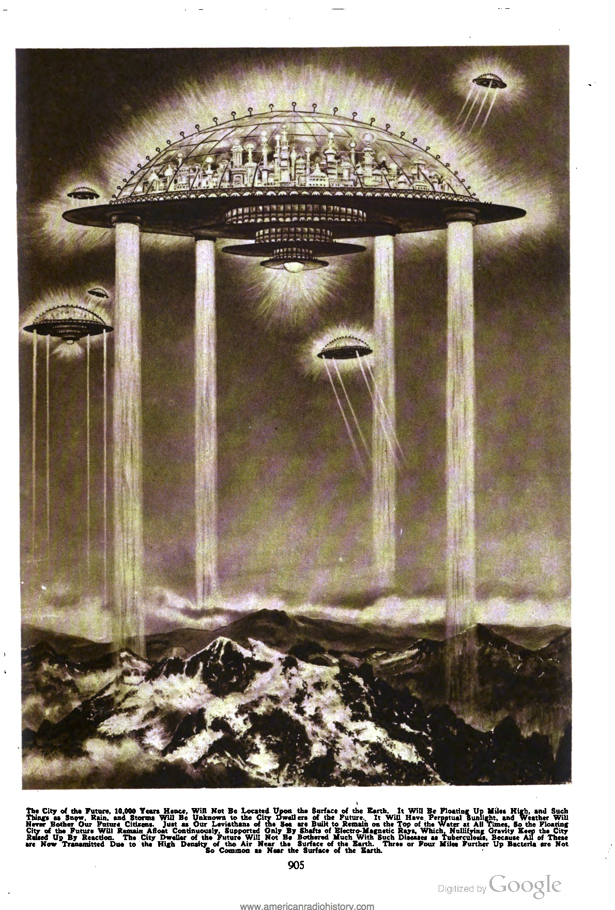

The city of the future, 10,000 years hence, will not be located upon the surface of the Earth. It will be floating up miles high, and such things as snow, rain, and storms will be unknown to the city dwellers of the future. It will have perpetual sunlight, and weather will never both our future citizens. Just as our leviathans of the sea are built to remain on the top of the water at all times, so the floating city of the future will remain afloat continuously, supported only by shafts of electro-magnetic rays, which, nullifying gravity keep the city raised up by reaction. The city dweller of the future will not be bothered much with such diseases as tuberculosis, because all of these are now transmitted due to the high density of the air near the surface of the earth. Three or four miles further up bacteria are not so common as near the surface of the earth. [The illustration is by Howard V. Brown.]

Our illustration depicts one of the future cities of about the size of New York floating high up in the air, several miles above the earth. The question of sustaining such a large body in a rarefied atmosphere will prove to be of little difficulty to our future electrical engineers. Just as we construct leviathans of the sea today, some of them weighing as much as 50,000 tons, we will construct entire cities weighing billions of tons, which cities will be held in space not by gas balloons, propellers, or the like antiquated machinery, but by means of gravity-annulling devices. Already experiments have been made whereby it has become possible to reduce the weight of substances by electrical forces.

Thus Professor Majorana, in an article printed in this journal three years ago, made it possible to produce negative gravity by reducing the gravitational pull on a lead sphere.[2] Of course, this is but a crude beginning. Centuries hence, when we wish to raise the city of the future high up in the air, we will rely upon an electro-magnetic stream of force which by reaction upon the ether and the earth, lifts the entire city high above the clouds.

Our illustration is but a feeble attempt to show how it may be worked out. Four gigantic generators distributed among equidistant points thru the city shoot earthward electric rays of a nature which as yet we can only imperfectly imagine. These rays, which are not light rays by any means, but are tremendous lines of force, impinge upon the surrounding ether with such stress and speed that the entire city is lifted up to the height desired. These rays may be likened to water streams, which by reaction would hold up the city illustrated. In other words, if we imagine the four rays as shown to be substituted by tremendous jets of water pouring earthward, and provided these jets were continuous, we can easily understand that they would support the entire city by counter-action of the force of inertia of water pressing against the lower part of the city.[3]

By increasing or decreasing the electrical energy of this future floating city it can be lowered or raised as we desire. By directing the rays sideways we will go in the opposite direction. Thus the “captain” of the future city will have a means to steer the city with all its millions of inhabitants to any part of the globe.

Where does this tremendous conglomerate take its energy from? The sun, of course. The city of the future is not dependent at all upon the earth for its power. Solar energy, which is merely another form of electrical energy, will be converted into electricity and stored away covering all the needs of the vast machinery, and that of the populace as well. Also, we should not forget that atmospheric electricity is a power that we only dimly understand today. This power in the future will be turned to the use of mankind, and we will then tap a practically unlimited amount of electrical energy.

As our illustration shows, the city of the future will be entirely roofed over with a substance that is neither glass nor metal. It will be transparent, but as strong as metal and unbreakable. Over this dome-like structure, gigantic towers are placed, which suck in the static electrical energy as well as the solar energy. Within the covered city the atmospheric pressure will perhaps not be more than four or five pounds per square inch, instead of 14.7, as we have it today. That means that humanity will have to accustom itself to such a change, and there is no question that it is possible to do so if the change is made gradually, as it probably will be. It means that the future humanity will have larger chests than they have now.

Naturally it would not do for the future city to descend upon the surface of the earth, as this would be disastrous, not only to the inhabitants, but to the machinery as well. For one thing, the human beings would probably suffocate as they could not stand the high pressure of the present atmosphere. This need not worry us any more than does the present ocean steamer, which is not expected to land on the floor of the ocean, because when it does, all is lost. The steamship has been designed and constructed to stay upon the surface of the ocean, and the future floating city will be designed in the like manner, to stay up; not to go down.

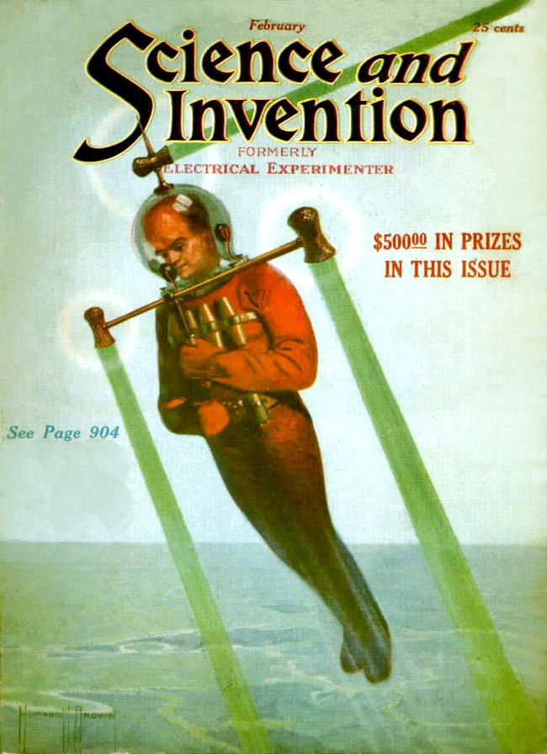

As for flying in 10,000 years, the aeroplane and the flymg machine will have disappeared. We will have the individual flyer as depicted on our front cover. The future flying man will be encased in warm fabrics electrically heated and kept hot comfortably. Upon his head he will have a sort of a diver’s helmet made of flexible glass, unbreakable. The little atmosphere that he needs—remember he only needs five pounds per square inch—is carried by him in a few small tanks that do not contain air, but chemicals, which are slowly converted into air when required. The power is derived directly from the atmosphere—static electricity converted directly into electro-energy. No wings are used by him, but he propels himself just exactly as the city of the future is propelled, namely, by power rays, as shown. As before mentioned, the energy for these rays is obtained from static electricity reconverted into suitable high potential force, by means of a small converter strapped around the body.

If the flying man wishes to rise, he operates his future “joy” stick in such a way that the rays point downward. He then rises upward with a speed all dependent on how much energy he furnishes his ray generator. If he wishes to go sideways, or laterally, the ray projector shown on top of his head is put into operation, which moves him sideways at any speed desired. If he wishes to descend, all he needs to do is to reduce the power. The more he reduces it the quicker his descent will be.

Thus the future flying man will be able to travel at prodigious speed without the necessity of using ponderous machinery or heavy apparatus. The future man will also be in touch with his friends or his office, or whatever it may be called then, by means of radio. He will be able to converse with them just as he can do today in a more modest manner, as when speaking to his friends from aboard ship, or in his auto of today. That, however, is not all. He will even be able to eat and drink, not from food which he has brought with him, but from food and drink sent to him through space. It will be possible to de-materialize and re-materialize matter, sending it at any distance desired with the speed of light.

We admit that all of this sounds extremely fantastic, but the truths of tomorrow will surpass wildest fiction.

1. The usage of the word *technic* where we might expect something like *technology* reflects an important terminological confusion at the time. While Google Ngram shows *technic* being used over three times more often than *technology* in 1922, this situation changes rapidly over the next decade. In nineteenth-century English, according to Eric Schatzberg, *technology* referred to “a field of study concerned with the practical arts; except in anomalous usage, [it] did not refer to industrial processes or artifacts.” Just as sociology names the study of society, technology was the science of technique, making, the useful or practical arts. Somewhere around 1930, Schatzberg argues, “new meanings derived primarily from the writings of American social scientists who imported elements of the German discourse of *Technik* into the English term technology, thus shifting the latter from its original definition as the science or study of the useful arts to a new one that embraced the industrial arts as a whole, including the material means of production” (487). This masterful history of the interrelated concepts of *Technik,* technology, and technique, is highly recommended. Eric Schatzberg, “Technik Comes to America: Changing Meanings of Technology Before 1930,” *Technology and Culture*, 47, no. 3, (2006): 486–512, doi:[10.1353/tech.2006.0201](http://dx.doi.org/10.1353/tech.2006.0201).
2. Quirino Majorana was an Italian physicist who published articles from 1918 to 1922 describing how he had successfully used lead and mercury shields to absorb the effects of gravity in a laboratory setting. See Roberto de Andrade Martins, “The Search for Gravitational Absorption in the Early 20th Century,” in *The Expanding Worlds of General Relativity*, ed. Jürgen Renn et al., 1998 edition., (Boston: Birkhäuser, 1998), 3–44.
3. Mike Ashley writes that Gernsback’s floating city is “a concept one might believe inspired two later noted works of science fiction, Edmond Hamilton’s ‘Cities in the Air’ (1929) and James Blish’s *Earthman, Come Home* (1955), were it not that neither author knew of the article.” Michael Ashley, *The Time Machines: The Story of the Science-Fiction Pulp Magazines from the Beginning to 1950*, The History of the Science-Fiction Magazine Volume I, (Liverpool: Liverpool University Press, 2000), p. 34.