Sediment transport in non-linear skewed oscillatory flows: Transkew experiments
Paulo A. Silva, Assistant Professor, Cesam & Department of Physics, University of Aveiro, 3810-193 Aveiro, Portugal. Tel.: +351234370822; fax: +351234378197; Email: psilva@ua.pt (author for correspondence)

Tiago Abreu, Teaching Assistant, Department of Civil Engineering, Polytechnic Institute of Viseu, ESTGV Campus de Repeses, Viseu, 3504-510, Portugal. Tel.: +351232480500; fax: +351232424651; Email: tabreu@estv.ipv.pt

Dominic A. van der A, Research Fellow, School of Engineering, King’s College, University of Aberdeen, United Kingdom. Tel.: +441224272806; fax: +441224272497; Email: d.a.vandera@abdn.ac.uk

Francisco Sancho, Researcher, LNEC-DHA, National Civil Engineering Laboratory, Av. do Brasil, 101, Lisboa, 1700-066, Portugal. Tel.: + 351218443664; fax: + 351218443016; Email: fsancho@lnec.pt

B. G. Ruessink, Associate Professor, Department of Physical Geography, Faculty of Geosciences, Institute for Marine and Atmospheric Research Utrecht, Utrecht University, Utrecht, The Netherlands. Tel.: +31302532780; fax: +31302531145; Email: g.ruessink@geo.uu.nl

Jebbe van der Werf, Researcher, Morphology & Sedimentary Systems, Deltares, Delft, The Netherlands. Tel.: + 31883358273; fax: + 31883358582; Email: Jebbe.vanderWerf@deltares.nl

Jan S. Ribberink, Associate Professor, Faculty of Engineering Technology, Water Engineering and Management, University of Twente, Enschede, AE, The Netherlands. Tel.: +31534892767 fax: +31534895377; Email: J.S.Ribberink@utwente.nl

Abstract
New experiments under sheet flow conditions were conducted in an oscillating water tunnel to study the effects of flow acceleration on sand transport. The simulated hydrodynamic conditions considered flow patterns that drive cross-shore sediment transport in the nearshore zone: the wave nonlinearities associated with velocity and acceleration skewness and a negative mean current, the undertow. Net transport rates were evaluated from the sediment balance equation and show that (i) the acceleration skewness in an oscillatory flow produces a net sediment transport in the direction of the highest acceleration; (ii) the net transport in presence of an opposing current is negative, against the direction of the highest acceleration, and reduces with an increase in flow acceleration; and (iii) velocity skewness increases the values of the net onshore transport rates.

Keywords: Flow acceleration, sediment transport, sheet flow, wave asymmetry, wave skewness

1 Introduction
The short, sharp crests and shallow, long wave troughs have long been recognized to have an important role in nearshore sediment transport (e.g. Ribberink and Al-Salem 1994) and therefore in beach morphodynamics (Roelvink and Stive 1989). Recent studies have shown that, apart from this wave skewness, wave asymmetry, as in sawtooth-shaped waves with a steep front face and a gently sloping rear face, play a key role in sediment transport and sand bar migration under mild wave conditions (Elgar et al. 2001, Hoefel and Elgar 2003). The skewed and asymmetric wave shape induces a near-bed horizontal oscillatory flow with both non-zero velocity and acceleration skewness, 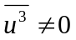and 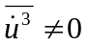, respectively.
Studies under controlled experimental conditions that consider the effect of wave asymmetry and fluid acceleration on sediment transport are scarce. King (1991) performed a series of tests in the oscillatory flow tunnel of the Scripps Institute of Oceanography under half-cycle sawtooth waves. Dibajnia and Watanabe (1998) and Watanabe and Sato (2004) conducted tests in the oscillatory flow tunnel of the University of Tokyo with irregular and regular oscillatory flows, respectively. The data of the former study included combined velocity- and acceleration-skewed oscillatory flow while the latter involved sawtooth-shaped oscillatory flow with and without a net current superimposed. These tests were performed with relatively short flow periods between 3 and 5 s. Longer periods were not considered because of limitations of the facility. Recently, van der A et al. (2010) have conducted a test series at the Aberdeen Oscillatory Flow Tunnel (AOFT) with sawtooth oscillatory flows of varying degrees of acceleration skewness, three sand sizes and wave periods ranging from 5 to 9 s. All these were performed in the sheet flow (flat-bed) regime.
Among the existing data only these from the AOFT provide detailed measurements of flow velocities and sediment concentrations enabling the study of small-scale sediment transport processes (van der A et al. 2008, 2009). Furthermore, only the AOFT data are representative for the typical wave periods found in the energetic shoaling and surf zones.
The existing experimental data show that acceleration-skewed oscillatory flows result in a net sediment transport in the direction of the largest acceleration (shorewards) and that its magnitude increases with acceleration skewness (Watanabe and Sato 2004, van der A et al. 2010). The key mechanism driving the net transport is believed to be the larger bed shear-stress under the rapidly accelerating half cycle compared with the slowly accelerating half cycle, which results from time limitation on the boundary layer growth, as suggested by Nielsen (1992) and shown by van der A et al.’s (2008) fixed bed tests. The numerical study of Ruessink et al. (2009) with a 1DV bottom boundary layer model also suggests that the time-dependent sediment transport can be parameterized in terms of the instantaneous bed shear-stress for grain sizes larger than 0.2 to 0.25 mm. For finer sediments, however, their modelling results indicate that phase lag effects between flow velocities and sediment concentrations enhance the net transport in the wave direction, in contrast of what was found for velocity-skewed oscillatory flows (Dohmen-Janssen et al. 2002, Hassan and Ribberink 2005). The potential importance of phase lag effects for acceleration-skewed flows and fine sands was already stated by Dibajnia and Watanabe (1998) and Silva et al. (2007), but only found recently in mobile bed tests by van der A et al. (2009). Furthermore, results of the two-phase model of Hsu and Hanes (2004) also suggest that sediment fluxes are correlated with the flow acceleration and are enhanced when bed failure occurs.
Herein, results of the experimental project sand TRANsport induced by SKEWed waves and currents (TRANSKEW) carried out at the Large Oscillating Water Tunnel (LOWT) of Deltares are presented. The test conditions were selected to simulate the near-bed cross-shore sediment motion in various flow conditions representative of the upper shoreface, that mimic the degree of velocity and acceleration skewness found before and after wave breaking, and the mean flow associated (e.g. undertow). Both net sediment transport rates and detailed time-dependent sediment concentrations and flow velocity were measured. These tests extend the conditions of Watanabe and Sato (2004) and van der A et al. (2010) by considering oscillatory flows with longer periods (of 7 to 10 s), with an additional net current and the combined effect of velocity and acceleration skewnesses.
The research starts with a description of the test program and the methodology in Section 2. In Section 3, the measured time-averaged sediment transport rates are presented and their dependence on velocity skewness, acceleration skewness and net currents is discussed. Also, these findings are compared with other data sets under similar hydraulic conditions. Section 4 states the main conclusions.

2 Transkew experiments: setup, measuring program and methodologies
2.1 Large Oscillating Water Tunnel
The LOWT is a U-tube with a rectangular horizontal test section 14 m long, 0.3 m wide and 1.1 m high with a 0.3 m thick sand bed, and two cylindrical risers at either end (Fig. 1). A steel piston system housed in one of the cylinders drives the flow in the test section over the sand bed. The other cylinder is open to the atmosphere. The LOWT is fitted with a recirculation system enabling the generation of a mean current that is superimposed on the oscillatory flow. Sediment traps beneath both cylinders and at the recirculation system allow capturing the eroded sand transported out of the test section during a run. The LOWT allows the simulation of near-bed horizontal oscillatory flow at full scale (1:1) over a sand bed, representative for a wide range of flow conditions found in the nearshore zone. Scale effects, typical of sediment-transport studies in smaller laboratory wave flume facilities, are therefore avoided. It has been used since 1988 within extensive studies, improving the knowledge of the bottom boundary layer structure and sediment transport mechanisms in wave and combined wave-current conditions (Ribberink et al. 2008, van der Werf et al. 2009).
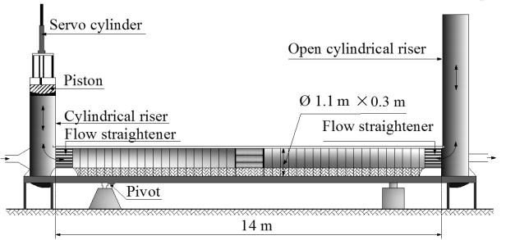
Figure 1 General outline of LOWT
2.2 Steering signal
The steering signal of the piston has to be formulated to reproduce the desired hydraulic conditions in the test section. Herein a regular sawtooth-oscillatory flow of various degrees of acceleration skewness was devised (with or without a net current) as well as an oscillatory flow with both velocity and acceleration skewness. The velocity and acceleration skewness are defined using
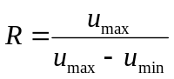 (1)
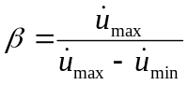 (2)
where u is the horizontal flow velocity, u_{max} and u_{min} are the maximum positive and maximum negative velocities, respectively, and _{max} and _{min} have the same meaning as in Eq. (1), but for the horizontal fluid acceleration . The oscillatory velocity for the sawtooth wave is symmetric with respect to the horizontal axis in a time series graph (velocity skewness is zero, i.e. R = 0.5) but is asymmetric with respect to the vertical axis within each wave cycle, giving rise to skewed accelerations (i.e. β > 0.5).
Previous experimental and theoretical work on sawtooth-shaped waves considered different expressions for the velocity (e.g. Watanabe and Sato 2004, Silva et al. 2007, van der A et al. 2010, Abreu et al. 2010). Silva et al. (2007) assumed that the sawtooth wave velocity time-series is represented by a wave with an acceleration time series similar to a first-order cnoidal wave as
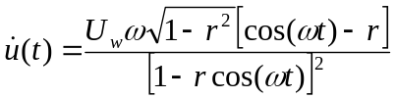 (3)
The corresponding velocity-time series is given by
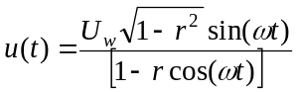 (4)
In Eqs. (3) and (4) r (−1 < r < +1) is a parameter directly related with β (Eq. 2)
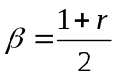 (5)
Abreu et al. (2010) showed that Eqs. (3) and (4) are particular cases of the more general expressions for velocity- and acceleration-skewed oscillatory flows
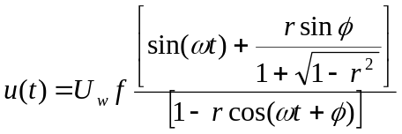 (6)
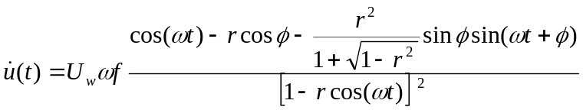 (7)
with f = (1 − r²)^{1/2}. It was demonstrated that Eq. (6) represents a wide range of nearshore nonlinear wave orbital velocity shapes, depending on the waveform parameter φ (−π/2 ≤φ ≤+π/2). Equation (3) is obtained for φ = 0, corresponding to a purely acceleration-skewed flow (i.e. sawtooth wave). A pure velocity-skewed flow (e.g. cnoidal wave) results for φ = −π/2. Values of between 0 and −π/2 yield wave forms with both velocity and acceleration skewnesses (R≠0.5 and β≠0.5).
A corresponding piston displacement derived from Eq. (4) was imposed to simulate the oscillatory flow corresponding to a sawtooth wave shape. For the particular conditions of combined oscillatory-current flow, a net current was added to the oscillatory signal imposed. Further, for oscillatory flow with both velocity and acceleration skewness, the more general Eq. (6) with = −π/4 was considered to drive the LOWT piston.

2.3 Experimental test conditions
The hydraulic conditions consisted of a repetition of regular oscillatory flows. Three major flow categories were considered: Series A (4 conditions) consisted of regular oscillatory flows with different degrees of acceleration skewness; Series B (4 conditions) considered acceleration-skewed oscillatory flows with an opposing collinear net current U₀ that mimics the undertow; and Series C (3 conditions) consisted of oscillatory flows with both velocity and acceleration skewness. The test parameters were planned to obtain the flat-bed sheet flow regime, and to satisfy the working limits of LOWT (Ribberink and Al-Salem 1994). The sand used was well-sorted with a median grain diameter of d₅₀ = 0.20 mm, a geometric standard deviation of σ_{g}=1.18, and porosity of ε₀ = 0.4. Table 1 lists the test flow characteristics measured 30 cm above the bed. The root-mean-square value of u_{rms} was maintained nearly constant at ≈0.88 m/s. The maximum opposing current magnitude of U₀=−0.44 m/s is representative of the conditions found in nature with large waves (Masselink and Black 1995, Reniers et al. 2004). The values of the (effective) Shields parameter θ were computed from Nielsen (2006). The maxima are θ_{max}>0.8, confirming that plane-bed sheet flow conditions always resulted, as was visually observed.

Table 1 Experimental conditions and measured net transport rates
Condition | u_{rms} (m/s) | U₀ (m/s) | T  (s) | β  (-) | R  (-) | N  (-) | θ_{max}  (-) | q_{s}  (kg/m/s) | σ (%)
A1 | 0.90 | 0 | 7 | 0.64 | 0.50 | 5 | 2.11 | 0.0539 | 21.6
A2 | 0.88 | 0 | 10 | 0.63 | 0.49 | 2 | 1.83 | 0.0443 | 2.9
A3 | 0.88 | 0 | 7 | 0.72 | 0.50 | 5 | 2.14 | 0.1137 | 8.3
A4 | 0.86 | 0 | 10 | 0.72 | 0.49 | 4 | 1.88 | 0.0847 | 4.7
B1 | 0.89 | −0.22 | 7 | 0.64 | 0.50 | 7 | 2.05 | −0.1133 | 21.0
B2 | 0.88 | −0.44 | 7 | 0.64 | 0.50 | 3 | 2.00 | −0.3826 | 24.0
B3 | 0.86 | −0.22 | 7 | 0.71 | 0.50 | 4 | 2.09 | −0.0489 | 21.0
B4 | 0.86 | −0.44 | 7 | 0.71 | 0.51 | 3 | 2.06 | −0.2241 | 9.3
C1 | 0.86 | 0 | 7 | 0.61 | 0.59 | 4 | 1.94 | 0.1845 | 3.4
C2 | 0.94 | 0 | 10 | 0.60 | 0.59 | 2 | 2.06 | 0.2797 | 3.6
C3 | 0.87 | 0 | 7 | 0.53 | 0.59 | 4 | 1.85 | 0.1244 | 9.4
2.4 Measuring plan and instruments
The measuring program was divided in two phases: Part 1 (M1) reported here consisted of net sand transport rate tests, whereas Part 2 (M2) consisted of time-dependent sand concentrations and flow velocities tests (Ruessink et al. 2011).
In M1, a total of 43 runs corresponding to the 11 hydraulic conditions were conducted (Table 1, including the number of runs N). The free stream velocity was measured with an ElectroMagnetic Flow meter (EMF). The sampling frequency was 100 Hz and the signals were collected 30 cm above the bed. Figure 2 shows the target velocity time series according to Eq. (6) for conditions A1 and C1 against the ensemble-averaged and low-pass filtered measured velocities. The good agreement illustrates that the target velocities were accurately reproduced in the LOWT tunnel test section. The corresponding local acceleration time series in Fig. 2 were obtained by numerical differentiation of the filtered velocity time series. The bed profiles before and after a run were measured at each centimetre along the tunnel with a Laser Bed level Profiler (LBP) (van der A et al. 2010), which has a vertical resolution of 1 mm. The sand collected from the sediment traps were weighed underwater.
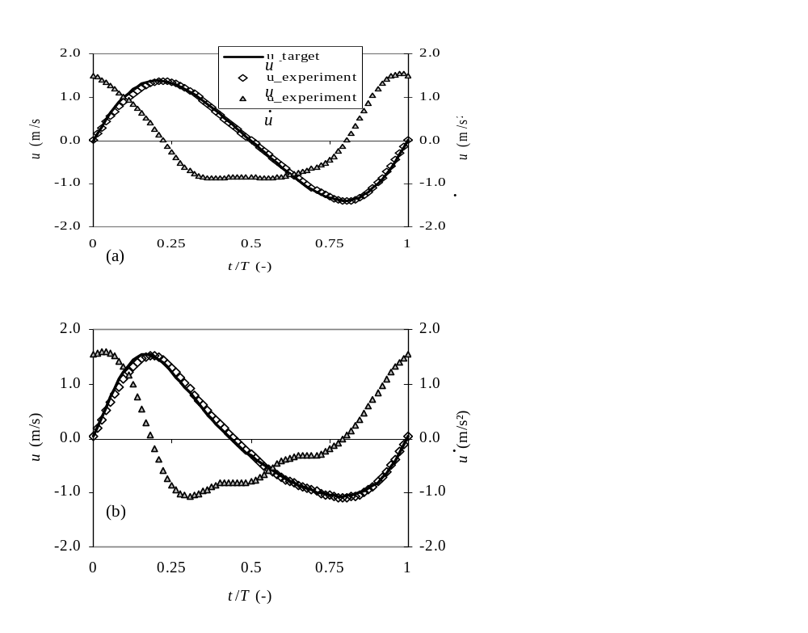
Figure 2 Time-series of target and measured velocities and corresponding accelerations for test conditions (a) A1, (b) C1

2.5 Computation of net transport rates
A mass conservation method was used to compute the net transport rates. The sediment continuity equation was integrated along the test section from the LBP data with the sand masses collected in the traps of the two cylindrical risers on both ends of LOWT and in the recirculation pipe for a net current as boundary conditions. Since two boundary conditions are available, the sediment continuity equation can be integrated from the left and the right sides, giving the net transport rates based on
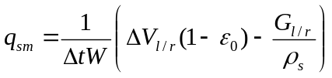 (8)
where ΔV_{l/r} is the total eroded volume (including pores), G_{l/r} the total sand weight on the left/right traps, ρ_{s} the sand density, W = 0.30 m the tunnel width, Δt test duration, and q_{sm} the net transport rate without pores per unit width and time. Figure 3a shows the bed levels measured before and after one of the C3 runs. The oscillations near the extremities of the test section are end effects. Between x = 2 and 9 m both bed levels are almost equal denoting a constant transport rate not influenced by end effects. Figure 3b shows the computed net mass transport rates. Between x = 2 and 4 m these are constant and therefore representative of q_{sm} within the tunnel.
Generally the right and left estimates of q_{sm} did not match precisely because of measurement errors: uncertainty or change in porosity (due to sand compaction following the removal and refilling of sand after each new test), error in the bed level measurement and loss of sand from the system during the emptying of sand traps. Figure 3c indicates that the net estimates are sensitive to porosity if the boundary condition is based on the trap with the least amount of sand (here the right end). The net transport rates are based on ε₀ =0.4 and use the largest of the weights as boundary condition. For most conditions the difference between this estimate and the transport rate is less than 5%, except for Runs B1, B3 and C3, with 11.5%, 40% and 15%, respectively.
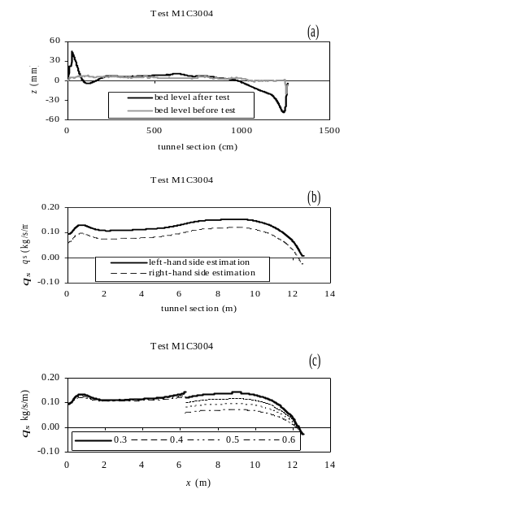
Figure 3 (a) Bed levels measured before and after Test C3, (b) left- and right-computed net transport rates along tunnel, (c) Sensitivity of q_{sm/l} and q_{sm/r} for change of porosity (Test M1C3004)

As described by Koelewijn and Ribberink (1994), measurements of the velocity profile across the tunnel (with a sinusoidal wave and a net current) show that the oscillating flow component is almost constant over the cross-section, while the mean velocity changes due to a thicker side wall boundary layer. The effect of the lateral boundary layers means that in combined-oscillatory flow-current tests the bulk measurements of net transport rates, as they are width-averaged values, have to be corrected to obtain equivalent transport rates without the presence of the lateral walls (Koelewijn and Ribberink 1994, Dohmen-Janssen et al. 2002). Koelewijn and Ribberink describe a method to correct the net sediment transport rates based on the hypothesis that the net transport rate q_{s} is proportional to the third-order velocity moment, <u³>. For Series B tests, proportionality between q_{s} and <τ ^{3/2}> was assumed following Nielsen’s (2006) bed load formulation, with τ as bed shear-stress. Accordingly, the expression between the corrected q_{sc} and measured q_{sm} net transport rates is
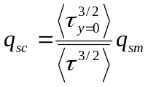 (9)
where the over-bar denotes averaging over the cross-section, the angle brackets denote time-averaging, and τ_{y=0} represents the bed shear-stress at the tunnel axis. The ratio in Eq. (9) represents a correction factor C. Assuming that τ(t) = (1/2)ρ f_{cw} u(t)² with u(t)=U₀+ũ(t) and ũ(t) given by Eq. (4) and that the wave-current friction factor f_{cw} is basically constant in time and space, the expression for C in Series B is equal to that obtained by Koelewijn and Ribberink (1994)
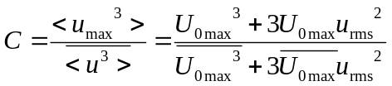 (10)
with U_{0max} as maximum velocity at the tunnel axis and u_{rms} the root-mean-square of the oscillatory flow (Table 1). Assuming a net current velocity distribution over the tunnel width as Koelewijn and Ribberink (1994), C = 1.16 for B1 and B3, and C = 1.17 for B2 and B4 from Eq. (10). Below, the corrected q_{sc} is denoted q_{s}.

3 Net transport rate results and comparison with other experiments
Table 1 presents the test-averaged net transport rates q_{s} and the relative standard deviation
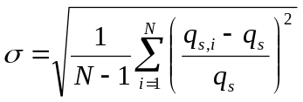 (11)
Figure 4a shows that an increase in the acceleration skewness β leads to a larger q_{s} in the (positive) implied wave direction. Figure 4b shows a similar behaviour, only the transport rates are much larger due to the added effect of velocity skewness, which is better seen in Fig. 4c, showing q_{s}(R). Note that in Fig. 4a the net transport rates are lower for the largest flow period. However, the conditions with R≈0.6 in Fig. 4c show an increase in transport rate with increasing flow period, possibly due to the 9% larger u_{rms} for T=10 s than for T=7 s (Table 1). Figure 4d shows q_{s}(U₀) for β ≈0.64 and ≈0.71 corresponding, respectively, to the two sets of conditions (A1, B1, B2) and (A3, B3, B4), all with the same flow period T=7 s. The results for U₀<0 have a net negative transport rate, i.e. against the direction of maximum acceleration. Also, an increase in acceleration skewness reduces the amount of sediment transported in the negative direction.
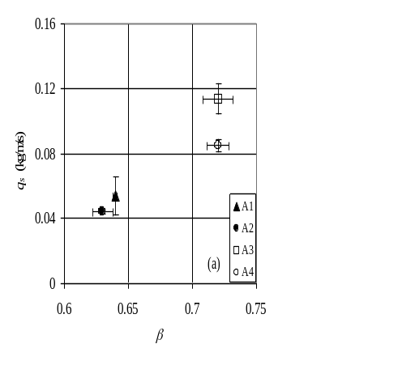 | 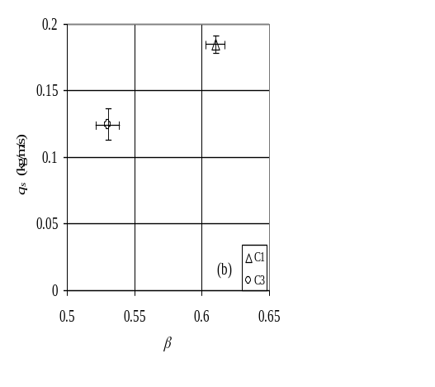
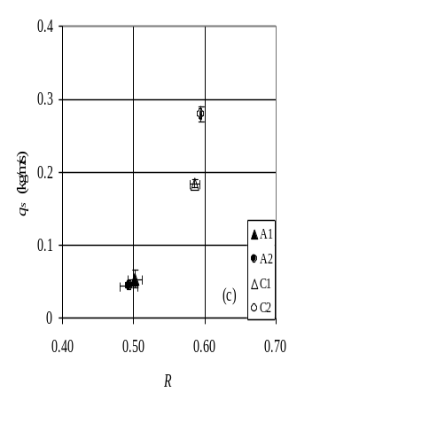 | 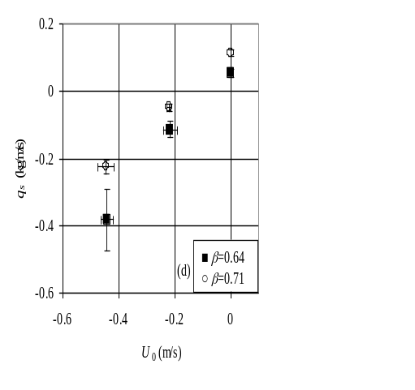
Figure 4 Measured net transport rates for conditions (a) A1-A4, (b) C1, C3, (c) A1, A2, C1, C2, (d) A1, A3, B1-B4. The error bars correspond to standard deviation

Figure 5 compares the previous experimental net transport rates with acceleration-skewed oscillatory flows in sheet-flow conditions (WS04: Watanabe and Sato 2004, AOFT10: van der A et al. 2010) with the Series A data as a function of the maximum Shields parameter. The values of θ_{max} were computed from Nielsen (2006). The WS04 data corresponding to β = 0.6 and 0.7 collapse well while β = 0.8 show a different behaviour, probably because the effect of acceleration in Nielsen’s bed shear-stress calculations is overestimated resulting in unrealistic high θ_{max} values. Furthermore, the WS04 data corresponds to d₅₀ = 0.2 and 0.74 mm. However, the coarser sediment data was not considered because the q_{s} values show an unexpected trend with θ (Gonzalez-Rodriguez and Madsen 2007). For the AOFT10 data three median grain sizes of 0.15, 0.27 and 0.46 mm were considered. The net transport rates have corresponding values of β within 0.56 < β < 0.78, whereas the Series A data have corresponding values of 0.63 < β < 0.72. All data show an increase in q_{s} with θ_{max} and these of Series A are consistent with the AOFT10 and WS04 data for the same range of β.
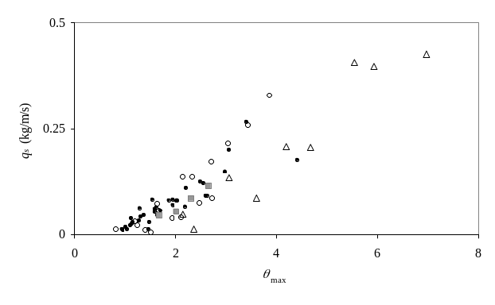
Figure 5 Measured net transport rates q_{s} in purely acceleration-skewed oscillatory flows: WS04 data ( β = 0.6, 0.7;  β = 0.8), () AOFT10 data and (○) present results in Series A, versus maximum Shields parameter

The mechanism causing a net transport in the wave direction in sawtooth waves was first described by Nielsen (1992) due to an enhancement of the bed shear-stress τ when the flow evolves rapidly from the maximum negative to the maximum positive velocity, and therefore has a limited time available for the bottom boundary layer to develop. Figure 6b shows the time series of τ(t/T) computed with the momentum integral method from the Acoustic Doppler Velocimeter Profiler (ADVP) data for the A3 condition (Ruessink et al. 2011). The largest absolute bed shear-stresses result under the rapidly-accelerating half cycle, when the velocity changes from the offshore negative maximum to the onshore positive maximum. Figure 6c shows q_{s} values versus the bed shear-stress skewness β_{τ} (defined as in Eqs. (1) and (2) for τ) for conditions A1 and A3. The result for C1 is also displayed, although β_{τ} then is also determined by the velocity skewness. Note that the net transport rates correlated well with β_{τ}.
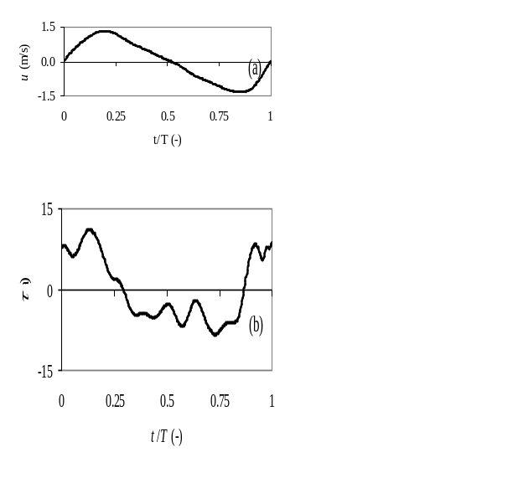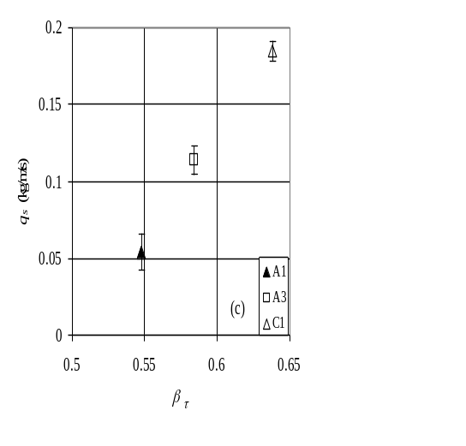
Figure 6 Typical time-series of (a) velocity, (b) bed shear-stress for test condition A3, (c) Measured net transport rates versus bed shear-stress skewness β_{τ} for conditions A1, A3 and C1

Visual observations of the sand motion during the tunnel runs and the analysis of the detailed measurements of the sediment concentration with a conductivity concentration meter (Silva et al. 2009) suggest that the sediment particles that are mobilized during the negative velocity phase have not settled completely at the negative-to-positive flow reversal and are still available to be transported by positive velocities in the next half-cycle. This occurs because the time between maximum negative flow and the negative-to-positive flow reversal is small compared with the time needed for sand to settle. In contrast, at the positive-to-negative flow reversal the sediment particles have settled, now because the time between the maximum positive flow and the positive-to-negative flow reversal is larger due to wave asymmetry. This supports the existence of phase-lag effects between the sediment particles and the flow at the moment of negative-to-positive flow reversal and its smaller importance at the positive-to-negative flow reversal, which also contributes to onshore net transport. Thus, the increase in q_{s} in Fig. 4 (a,b) with β is likely not due to more skewed τ alone, but also due to an increase in phase lag effects at the negative-to-positive flow reversal. Note that as β increases the time for sand to settle between maximum negative flow and the subsequent flow reversal reduces. The differences in q_{s} for T=7 and 10 s is also due to phase-lag effects. Although lower bed shear-stresses are expected for T=10 s because of the larger orbital excursion amplitude, the settling time between maximum negative flow and the negative-to-positive flow reversal is larger than for T=7 s. Hence, phase-lag effects are smaller and q_{s} reduces. For the combined oscillatory flow-current tests this mechanism when combined with an enhanced stirring effect during the negative flow phase contributes to increase the positive transport during the positive flow phase, therefore decreasing the negative net transport rate as β increases (Fig. 4d). The analysis of the intra-wave sediment fluxes provides more insight on the role of the phase lag effects on sediment transport (Ruessink et al. 2011).
The LOWT data also allows to establish the relative importance of the velocity and acceleration skewness in the net transport rates. The difference between q_{s} in conditions C1 and C3 (≈0.06 kg/m/s, Fig. 4b) is nearly equal to the measured value in condition A1. This result suggests that in the present experiments the contribution of velocity skewness to the total net transport rate is larger than that of the acceleration skewness.

4 Conclusions
A reliable dataset of the net sand transport rates under sheet-flow conditions generated by full-scale, regular, acceleration- and velocity-skewed oscillatory flows combined with opposing net currents was obtained. This allows analyzing the effect of velocity and acceleration skewness and of a net current, typical of shoaling and surf zones waves, on the sediment transport processes.
The obtained net transport rate measurements are consistent with earlier experimental data sets but extend the hydrodynamic conditions, particularly considering longer wave periods, a net current representative of the undertow, and the combined effect of acceleration and velocity skewness. The present results for purely acceleration-skewed oscillatory flows are consistent with previous studies: acceleration-skewed oscillatory flows produce a net sand transport in the direction of the largest acceleration (onshore) and the net transport rates increase with the acceleration skewness. The added effect of velocity skewness increases the net transport rates. The addition of an opposing net current to the acceleration-skewed oscillatory flow results for all cases in a negative (seaward) net transport rate, but for increasing values of acceleration skewness the magnitude of the net transport rate decreases.
In the present experiments, two mechanisms play a key role in the sediment transport of acceleration skewness flows, namely the skewed bed shear-stress and the phase lag effects between the sediment concentration and flow velocity observed at flow reversal, when the flow acceleration attains its maximum. They both drive a positive net transport in the wave propagation direction.
Additional experimental data comprising different sediment grain sizes in similar hydraulic conditions comparable to these in the field, involving undertow, wave skewness and wave asymmetry, will enlarge the already existing data base and allow for further development of more accurate predictive sediment transport models.

Acknowledgements
This work was supported by the European Community's Sixth Framework Programme through the grant to the budget of the Integrated Infrastructure Initiative HYDRALAB III, Contract no. 022441 (RII3). All participants in the Transkew experiments are gratefully acknowledged: André Temperville, Tom O’Donoghue, Hervé Michallet, Paula Freire, Sandra Plecha, Kate Steenhauer, Gustaaf Kikkert and Noureddine Ait Lafkih. We are also grateful to John Cornelisse and the technical support from Deltares. The ADVP data were provided by Hervé Michallet. The second author was supported by Fundação para a Ciência e a Tecnologia (FCT) through PhD grant SFRH/BD/41827/2007. The work was also carried out within the scope of the research projects SANDEX - PTDC/ECM/70428/2006 and BRISA - PTDC/ECM/67411/2006. Finally, BGR acknowledges additional funding by the Netherlands Organisation for Scientific Research NWO under project 864.04.007.

Notation
d₅₀ = median grain size
f_{cw} = wave-current friction coefficient
C = correction factor
G_{l/r} = total (dry) weight of sand collected in trap
N = number of runs for each experimental condition
q_{s} = net transport rate
q_{sc} = corrected net transport rate
q_{sm} = measured net transport rate
r = acceleration skewness index
R = velocity skewness coefficient
t = time
T = flow period
u = horizontal flow velocity
u_{rms} = root-mean-square-value of oscillatory velocity
u_{max} and u_{min} = maximum positive and negative velocities
= horizontal flow acceleration
_{max} and _{min} = maximum positive and negative accelerations
U₀ = mean current velocity
U_{0max} = maximum velocity at tunnel axis
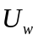= oscillatory velocity amplitude
x = distance along test section
W = width of tunnel test section
z = vertical coordinate
β = acceleration skewness coefficient
β_{τ} = bed shear-stress skewness
ΔV_{l/r} = total eroded volume
Δt = duration of run
ε₀ = sand porosity
θ = Shields parameter
θ_{max} = maximum Shields parameter
ρ = water density
ρ_{s} = sediment density
σ = relative standard deviation of net transport rates
σ_{g} = sand geometric standard deviation
τ = bed shear-stress
= wave form factor
ω = angular frequency

References
Abreu, T., Silva, P.A., Sancho, F., Temperville, A. (2010). Analytical approximate wave form for asymmetric waves. Coastal Eng. 57(7), 656-667 doi:10.1016/j.coastaleng.2010.02.005.
Dibajnia, M., Watanabe, A. (1998). Transport rates under irregular sheet flow conditions. Coastal Eng. 35(3), 167-183.
Dohmen-Janssen, M., Kroekenstoel, D., Hassan, W., Ribberink, J.S. (2002). Phase lags in oscillatory sheet flow: experiments and bed load modelling. Coastal Eng. 46(1), 61-87.
Elgar, S., Gallagher, E.L., Guza, R.T. (2001). Nearshore sand bar migration. J. Geophysical Res. 106(C6), 11623-11627.
Gonzalez-Rodriguez, D., Madsen, O.S. (2007). Seabed shear stress and bedload transport due to asymmetric and skewed waves. Coastal Eng. 54(12), 914–929.
Hassan, W.N., Ribberink, J.S. (2005). Transport processes of uniform and mixed sands in oscillatory sheet flow. Coastal Eng. 52(9), 745-770.
Hoefel. F., Elgar, S. (2003). Wave induced sediment transport and sand bar migration. Science 299(5614), 1885-1887.
Hsu, T.J., Hanes, D.M. (2004). Effects of wave shape on sheet flow sediment transport. J. Geophysical Res. 109, C05025, doi:10.1029/2003JC002075.
King, D.B. (1991). Studies in oscillatory flow bed load sediment transport. PhD Thesis. University of California, San Diego.
Koelewijn, H., Ribberink, J.S. (1994). Sediment transport under sheet flow conditions. Delft University of Technology, Department of Civil Engineering, WL|Delft Hydraulics.
Masselink, G., Black, K.P. (1995). Magnitude and cross-shore distribution of bed return flow measured on natural beaches. Coastal Eng. 25(3-4), 165-190.
Nielsen, P. (1992). Coastal bottom boundary layers and sediment transport. Advanced Series on Coastal Eng. 4. World Scientific Pub., Singapore.
Nielsen, P. (2006). Sheet flow sediment transport under waves with acceleration skewness and boundary layer streaming. Coastal Eng. 53(9), 749-758.
Reniers, A.J.H.M., Thornton, E.B., Stanton, T.P., Roelvink, J.A. (2004). Vertical flow structure during Sandy Duck: observations and modeling. Coastal Eng. 51(3), 237-260.
Ribberink, J.S., Al-Salem, A. (1994). Sediment transport in oscillatory boundary layers in cases of rippled bed and sheet flow. J. Geophysical Res. 99(C6), 12707-12727.
Ribberink, J.S., van der Werf, J.J., O'Donoghue, T., Hassan, W.N.M. (2008). Sand motion induced by oscillatory flows: Sheet flow and vortex ripples. J. Turbulence 9(20), 1-32.
Roelvink, J.A., Stive, M.J.F (1989). Bar-generating cross-shore flow mechanisms on a beach. J. Geophysical Res. 94(C4), 4785–4800.
Ruessink, B.G., den Berg, T.J.J., van Rijn, L.C. (2009). Modeling sediment transport beneath skewed asymmetric waves above a plane bed. J. Geophysical Res. 114, C11021, doi:1029/2009JC005416.
Ruessink, B.G., Michallet, H., Abreu, T., Sancho, F., van der A, D.A., van der Werf, J.J., Silva, P.A. (2011). Observations of velocities, sand concentrations, and fluxes under velocity-asymmetric oscillatory flows. J. Geophys. Res. 116, C03004, doi:10.1029/2010JC006443.
Silva, P.A., Abreu, T., Sancho, F., Temperville, A. (2007). A sensitivity study of sediment transport rates in accelerated skewed waves. Proc. 5th IAHR Symp. River, coastal and estuarine morphodynamics, Enschede NL, M. Dohmen- Janssen, S. Hulscher, eds., 337-343.
Silva, P.A., Abreu, T., Michallet, H., Hurther D., Sancho, F. (2009). Sheet flow layer structure under oscillatory flows. Proc. 6th IAHR River, Coastal and Estuarine Morphodynamics RCEM 2009, C.A. Vionnet, M.H., Garcia, E.M. Latrubesse, G.M.E. Perillo, eds., 1057-1062.
van der A, D.A., O’Donoghue, T., Davies, A.G., Ribberink, J.S. (2008). Effects of acceleration skewness on rough bed oscillatory boundary layer flow. Proc. 31st Int. Conf. Coastal Engineering Hamburg, 1583-1595.
van der A, D.A., O’Donoghue, T., Ribberink, J.S. (2009). Sheet flow sand transport processes in oscillatory flow with acceleration skewness. Proc. Coastal Dynamics 2009 (133), 1-13. World Scientific, Singapore.
van der A, D.A., O’Donoghue, T., Ribberink, J.S. (2010). Measurements of sheet flow transport in acceleration-skewed oscillatory flow and comparison with practical formulations. Coastal Eng. 57(3), 331-342.
van der Werf, J.J., Jolanthe, J.L.M. Schretlen, J., Ribberink, J.S., O'Donoghue, T. (2009). Database of full-scale laboratory experiments on wave-driven sand transport processes. Coastal Eng. 56(7), 726-732.
Watanabe, A., Sato, S. (2004). A sheet flow transport formula for asymmetric forward-leaning waves and currents. Proc. 29th Int. Conf. Coastal Engineering Lisbon, 1703-1714.

