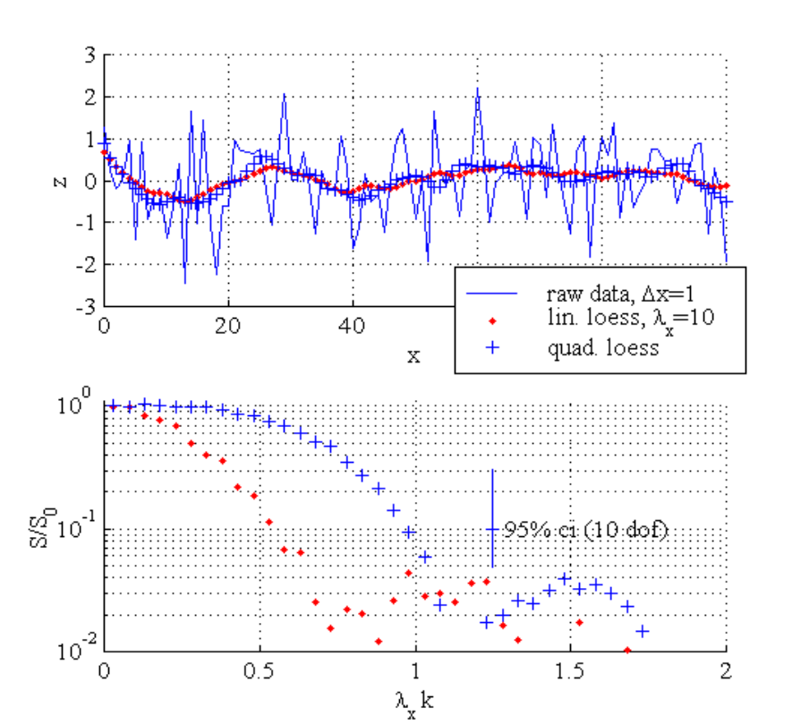
Figure 1. (top) A white-noise time series, sampled at Δx=1 and interpolated with Loess-filtered linear and quadratic models, λ_{x}=10. (bottom) Spectra of the interpolated time series, normalized by the input spectrum, S₀.

Loess Filter Characteristics
- Linear model removes (gain < 0.01 and at least 90% loss in amplitude) variations with wavenumbers higher than about λ_{x}/L_{remove}=1.5 (where k= 1/L_{Fourier}) and quadratic model removes variations having wavenumbers higher than λ_{x}/L_{remove}=2.
- Linear model damages (gain < 0.1 and at least 30% loss in amplitude) variations with wavenumbers higher than about λ_{x}/L_{damage}=0.5 and quadratic model damages variations having wavenumbers higher than λ_{x}/L_{damage}=1.
- Linear model preserves (gain > 0.8 and at most 10% loss in amplitude) variations with wavenumbers lower than about λ_{x}/L_{preserve}=0.2 and quadratic model preserves variations having wavenumbers lower than λ_{x}/L_{preserve}=0.5.

Sampling Constraints
Sample requirements are that Nyquist wavenumber (λ_{x}k = 0.5λ_{x}/Δx) must be higher than, at least, the damage criteria so that the interpolator has some signal that comes from the resolved part of the spectrum. For linear model, 0.5λ_{x}/Δx>0.5 or Δx<λ_{x}. For quadratic model, 0.5λ_{x}/Δx >1 or Δx<0.5λ_{x}. A more conservative choice is that Nyquist coincides with the removed scales. For linear model, 0.5λ_{x}/Δx>1.5 or Δx<λ_{x}/3. For the quadratic model, 0.5λ_{x}/Δx>2 or Δx<λ_{x}/4.

Summary
If L_{preserve} is an important length scale to resolve and Δx is a sample spacing then the guidelines for choosing the smoothing scale, λ_{x}, are
linear model: (3 Δx) < λ_{x} < (L_{preserve}/5)
quadratic model: (4 Δx) < λ_{x} < (L_{preserve}/2)

Example
A beach has cusps with L_{preserve}=30 m. A linear model requires λ_{y}<6 m, which requires Δy<2 m. A quadratic model requires λ_{y}<15m and Δx<4 m. The quadratic model is our choice for efficient sampling.

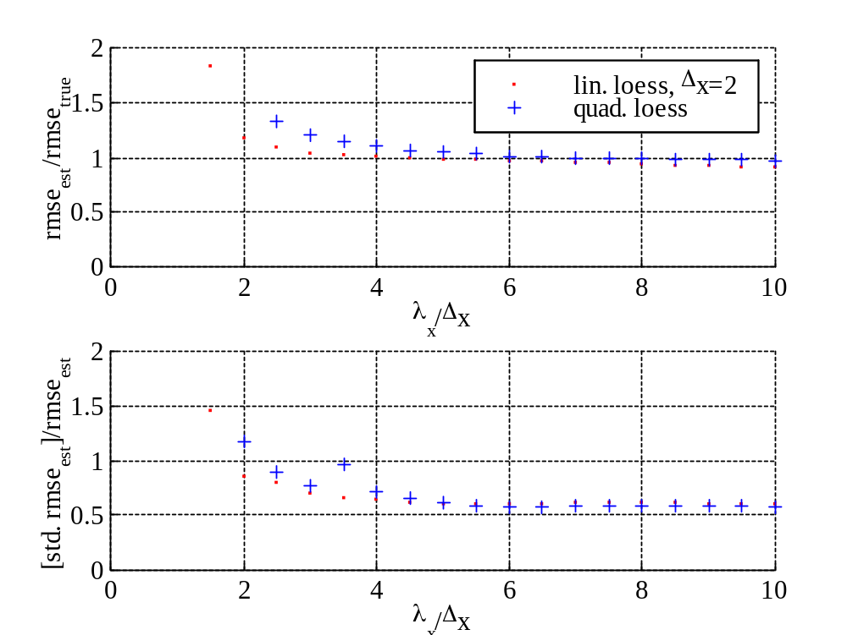
Figure 2. (top) Ratio of mean estimated to actual interpolation error, plotted against the ratio of the smoothing scale to the sample interval. (bottom) Ratio of the variation of the error estimate to the mean error estimate.

When the normalized smoothing scale is too short (λ_{x}/Δx<2), there are not enough obervations to fit the model and the error approximation is not robust and over-estimate error. The error is underestimated for large smoothing scales (λ_{x}/Δx>6-10), since the passed noise bands are interpreted as the signal and are not allowed to contribute to the error. The point of perfect agreement is λ_{x}/Δx=4 for the linear model and λ_{x}/Δx=6 for the quadratic model. Note that the dof is 1.5λ_{x}/Δx, so stability is reached when dof exceeds 3*m, where m is number of model parameters (or λ_{x}/Δx>2*m).

When the smoothing scale exceeds about 6, the error field is as flat as it will get.

