User guide for the Quick View functionality
To configure the Quick View functionality, please log in to the Shopify admin panel, go to Online Store → Themes, and click on the Customize button.
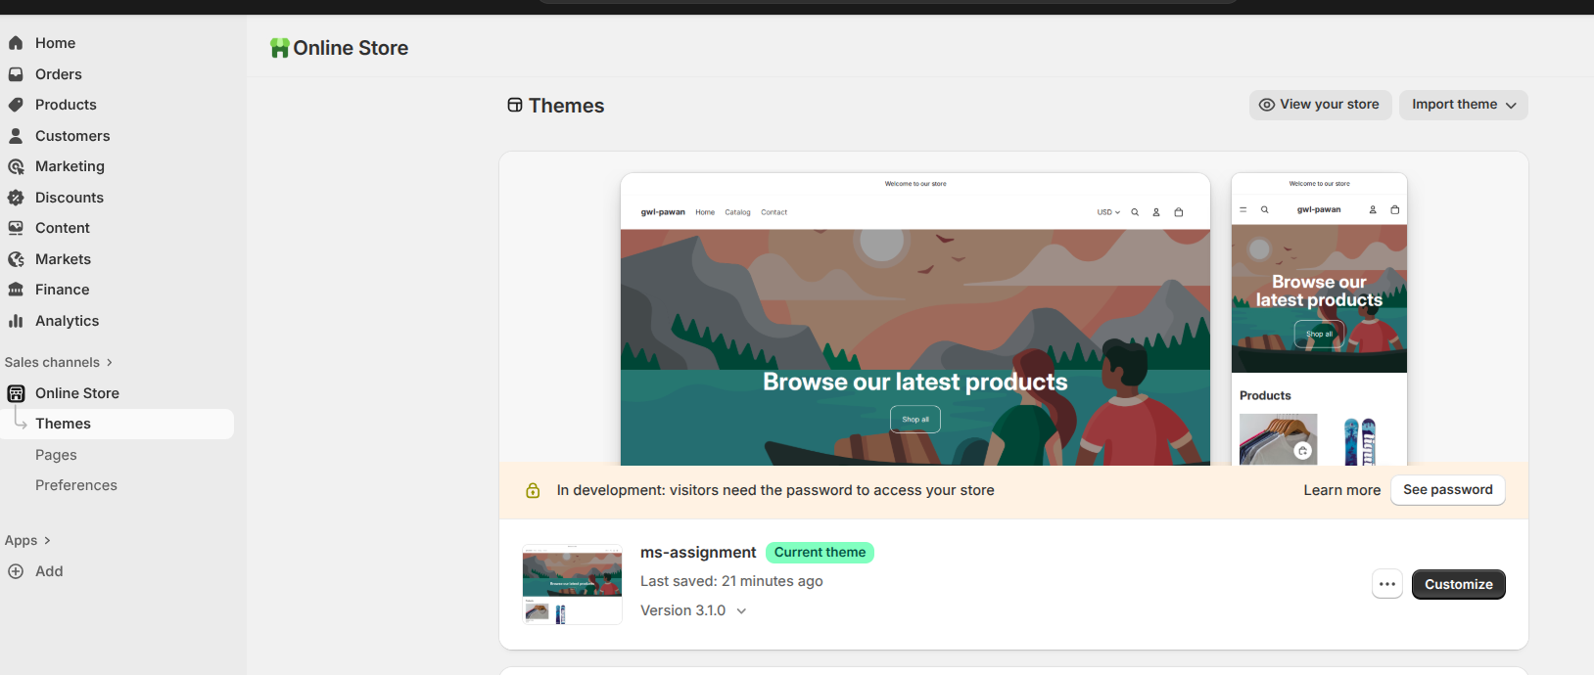
After that, you’ll reach the Theme Editor page. From the left sidebar, click the Settings icon and then select Product Cards. Here, you’ll find all the configurable options related to the Quick View functionality.
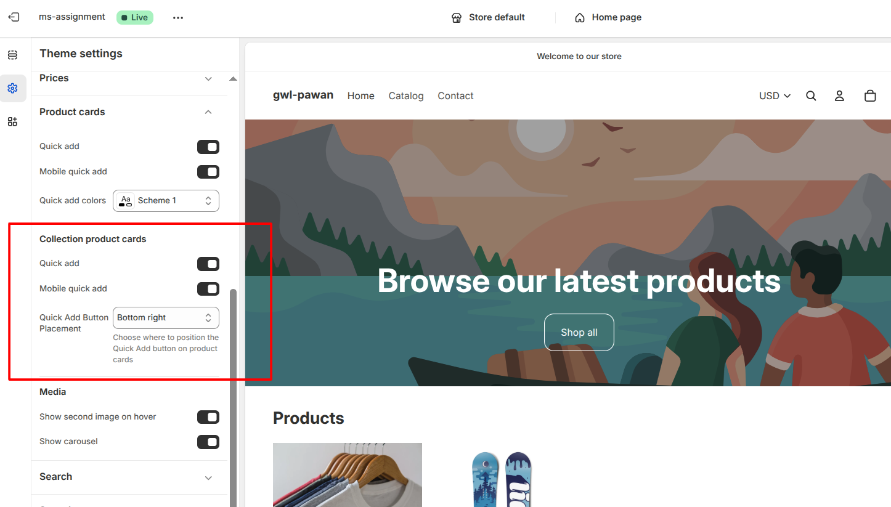
From the theme settings, you will be able to enable/disable quick view on product cards for PLP page and also you can choose quick add button placement from here
To configure the elements order you can do that from collection page section settings in theme customizer
You will be able to configure elements order and typography from here
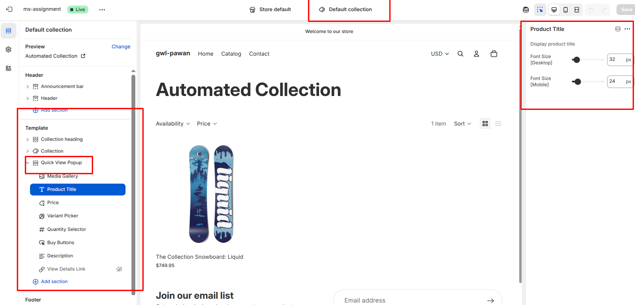

We’ll implement variant color filtering on the Product Detail Page (PDP). To enable this functionality, alt tag values need to be added to the product images. This will allow users to filter the image gallery based on color.
The process to add alt text (where you can include the color value) is straightforward. Please follow these steps:
- Log in to your Shopify admin panel at shopify.com/login using your store's credentials
- From the main sidebar on the left, click on Products, This will take you to the list of all your products.
- Click on the title of the product you want to edit.
- On the product details page, scroll down to the Media section. Here you will see all the images uploaded for this product.
- Click on the image you want to edit. A pop-up window will appear allowing you to edit the image details.
- In the pop-up window, look for a field labeled Alt text (alternative text). Click into this field and enter variant title here like Red, Green or Blue
- Once you have entered the text, click Save to apply the changes to that image.
You will need to repeat steps 5 and 6 for every image and every product where you want to set the alt text.
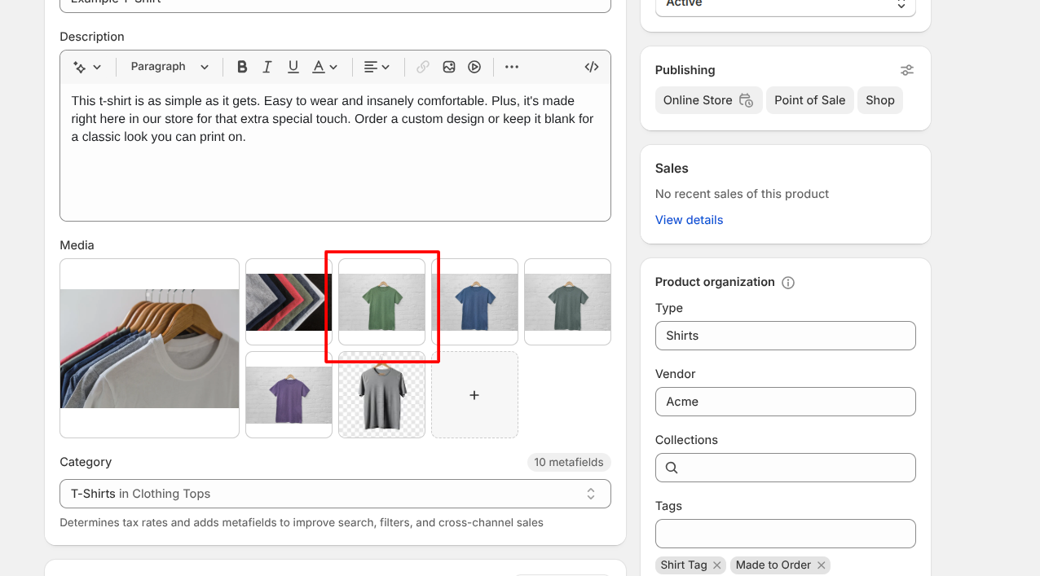
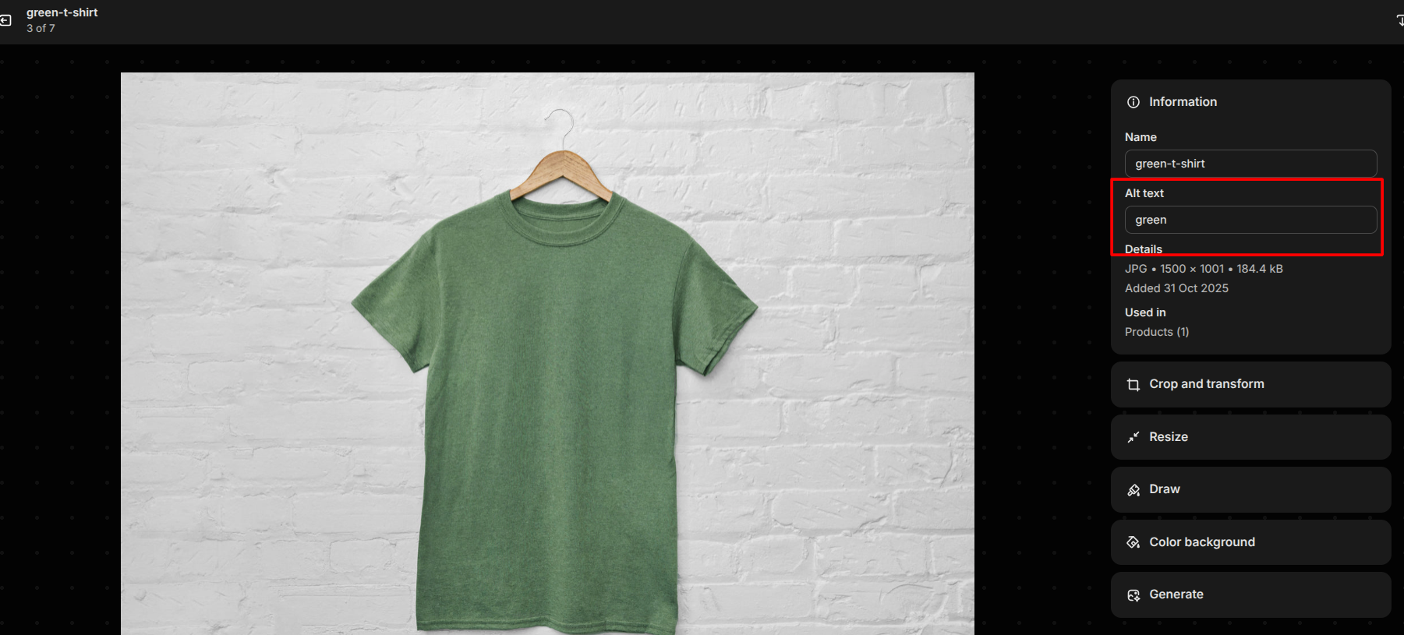
Also, you will need to select product template to make it work, as this functionality will work only for products with color-variants template
On the product backend, from right panel, you can update the product template
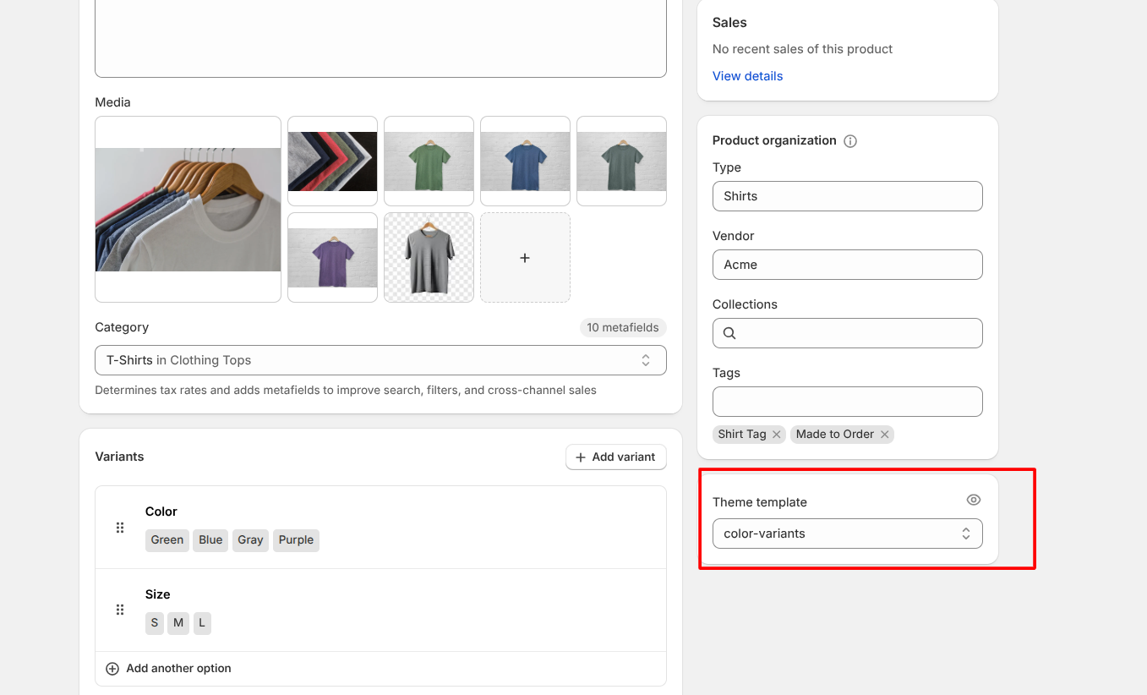
Thanks,
Pawan

