Garrett Woods
Module 4.2
4/13/2026

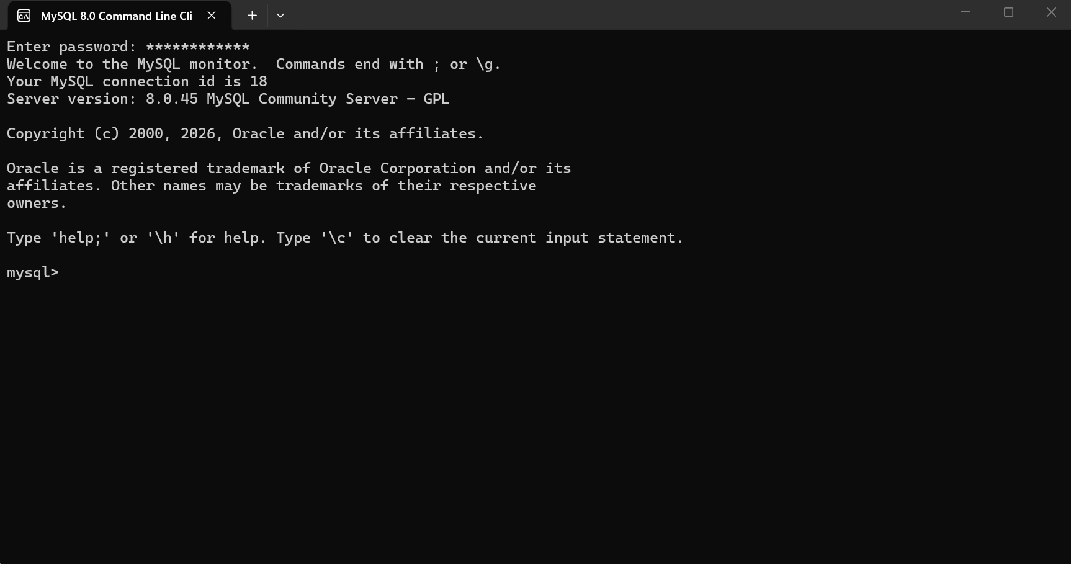
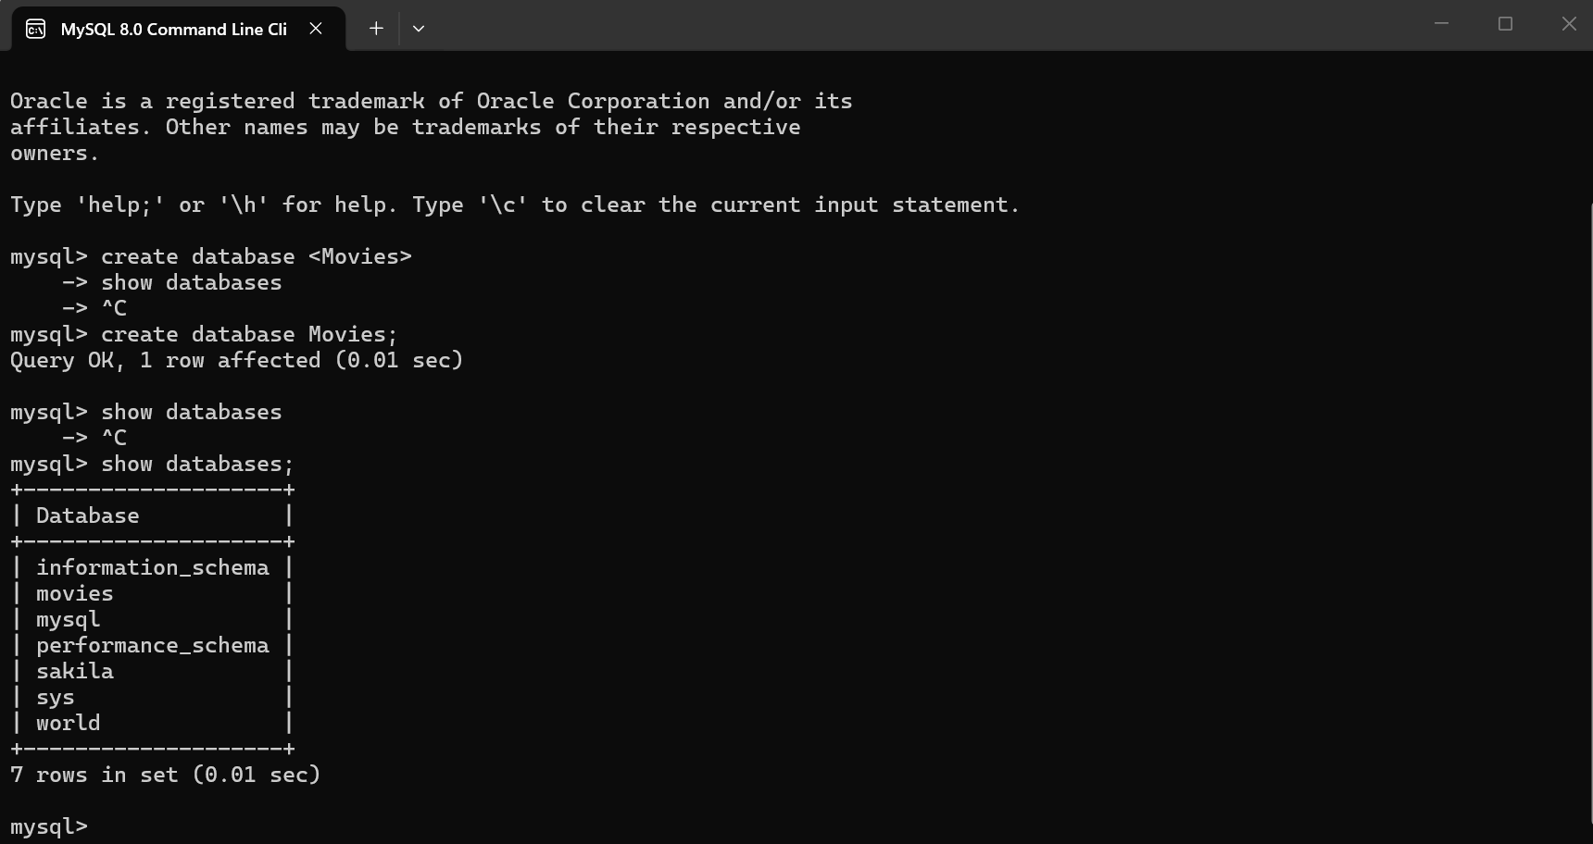

Locate Function:
If you’re wanting to show just sequels you can use a locate function to find all the movies with a “2” in the title. For an alias you can have the Movie_Tite column show as Movie, making it more readable.
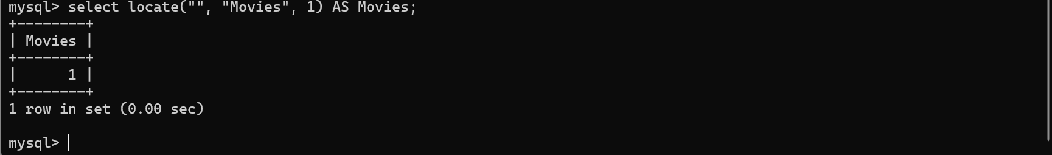

Upper/Lower Function:
If you need something in a certain case, then you’ll be able to change entire columns at once to either upper or lower case. This is also useful if you need everything to be the same case. You can just set the alias as Upper or Lower Movie Title from the Movie_Title column

Replace Function:
If you need to switch letters or anything really with something else, the replace function will be able to change those around for you. If instead of displaying Movies, you wanted it to be Hovies for a hoofed theme movie night you could replace the M with an H
