**Case Study Question**  
  
Our client is a ski company. At one of their ski parks, they are facing long queues at the ski lifts. They would like us to reduce the amount of time their customers spend waiting. In order to do so, the company would like us to investigate two ski lift alternatives:

1. Installing a Faster Ski Lift
2. Installing a 2nd Ski Lift, which is exactly like the current ski lift

We can recommend no change if the existing setup is most efficient.  
  
**Data**

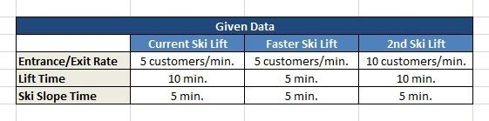

**Additional Information**

* There are three components to the ski park: the lift, the slope, and the queue
* All customers must be in one of these 3 locations.
* Customers go up the lift, ski down the slope, wait in the queue, and keep repeating this cycle. (Lift, Slope, Queue, Lift, Slope, Queue, Lift, Slope, Queue, etc.)