**Targets : (On the basis of given data)**1. Analyzing the movement of the CTR on the basis of dates.  
2. Comparing how the revenue has differed for the 3 Models : CPA, CPC, CPM for the given duration.  
3. Which type of day is serving as the best for the Click through rate, and for Revenue comparison of CPA, CPC, CPM.  
4. Categorizing different ads on basis of Level-2 and then comparing their Reach, Revenues Models on category basis.   
5. Analyzing which is the Target market segment for generating the revenues. This is done on the basis of the revenue models on Weekdays/Weekends by each genders’ different age groups on separate dates.  
6. Ordering the data in proper format, to review while running either of CPC or CPA model, and simultaneously checking the CTR of the data.  
  
  
  
  
INDEX :  
1. **Analysis done on basis of Time series  
 Plot :** Dates vs CTR  
 **Plot :** Dates vs Revenue from 3 models  
2. **Analysis done on basis of Days** (Sun,Mon,…,Sat) **Plot :** Days vs CTR  
 **Plot :** Days vs Revenue from 3 models  
3. **Analysis done on the basis of different Advertisements**  
 Group 1:  **Plot 1** : Unique Level-2 Type Ads in ‘ca’ category vs Reach.  
 **Plot 2** : Unique Level-2 Type Ads in ‘bi’-‘au’ category vs Reach.  
 **Plot** 3: Plot shows the comparison of 3 Revenue models on the basis of different Ads in Level-2 of Group 1  
 Group 2:  
 **Plot 4** : Unique Level-2 Type Ads in ‘et’-‘hl’-‘mb’ category vs Reach. **Plot** 5: Plot shows the comparison of 3 Revenue models on the basis of different Ads in Level-2 of Group 2  
 Group 3:   
 **Plot 6** : Unique Level-2 Type Ads in ‘jb’-‘pc’ category vs Reach. **Plot** 7: Plot shows the comparison of 3 Revenue models on the basis of different Ads in Level-2 of Group 3 Group 4:   
 **Plot 8** : Unique Level-2 Type Ads in ‘re’-‘br’ category vs Reach.  
 **Plot** 9: Plot shows the comparison of 3 Revenue models on the basis of different Ads in Level-2 of Group 4  
4. **Analysis done on the basis of Customer Data : Weekday/Weekend, Gender, Age Group, Dates**  
 Done for Males on Weekends  
 **Plot 1a :** Reach among Males on Weekends for different Age Groups  
 **Plot 2a** : Revenue from CPC model on weekend by Male customers of different Age Groups.  
 **Plot 2b** : Revenue from CPA model on weekend by Male customers of different Age Groups.  
 **Plot 2c** : Revenue from CPM model on weekend by Male customers of different Age Groups.  
 **Plot 2d** : CTR(*10^3) on weekend by Male customers of different Age Groups.  
5. **Analysis done on the basis of CTR, Reach, Clicks  
6. Suggestions  
  
  
  
  
  
  
  
  
Definitions** :   
**CTR** (Click Through Rate) : Basically tells about the percentage of success received on the basis of the no. of clicks got out of the no. of Impressions shown. **Different types of Revenue Models (**Depending on what client is ready to pay**)**  
CPC : Cost Per Click = Spend/Clicks  
CPA : Cost Per Action (or Cost Per Acquisition) = Spend/Actions  
CPM : Cost Per Mile = (Spend*1000)/Impressions **Revenue_CPA =**(No. of success)*(Margin decided for each success) + ((Amount given to us) – (CPA*Total actions happening))  
**Revenue_CPC =** (No. of success)*(Margin decided for each success) + ((Amount given to us) – (CPC*Total clicks happening)) **Revenue_CPM =** (No. of success)*(Margin decided for each success) + ((Amount given to us) – (CPC*Total clicks happening)) **Note** :   
1. Our aim to search for the ads which are giving us lower value of CPA or CPC, because it means that it needed lesser amount of money to convert a single customer for the desired parameter. **2. *Margin Decided for each success\*** : Thisparameter’s value differs for all the 3 cases, with mostly in the order of   
CPA_Margin > CPC_Margin > CPM_Margin **So, we can’t comment on the overall revenue generated by the three models, unless we know the Margin parameter.  
  
Assuming :** Margin parameter value is the same for all the 3 models, so we want to aim for the model which has the least value for the Cost Per Parameter(action/click/impression). **Processing of the Data : File** : InGraph.RFew columns have been added in the data which have helped in an in-depth analysis of the data.  
CTR : Click Through Rate  
CPC : Cost Per Click  
CPA : Cost Per Action  
CPM : Cost Per Mile  
Date_Type: Date column set to ‘Date’ type, date set to YYYY-MM-DD format  
Day_Type : Type of the day, Sunday/Monday/…. /Saturday  
Weekday_end : Weekday(Mon-Fri) or Weekend(Sat-Sun) **Analysis done on basis of Time series: File** : InGraph_TimeSeries.R*Steps Done* :   
Segmented data on the basis of unique dates; a broader picture of the Click Through Rate w.r.t Dates is shown, and then the comparison of the 3 types of revenue Models(CPC, CPA, CPM) is presented.   
1. Dates vs CTR_mile   
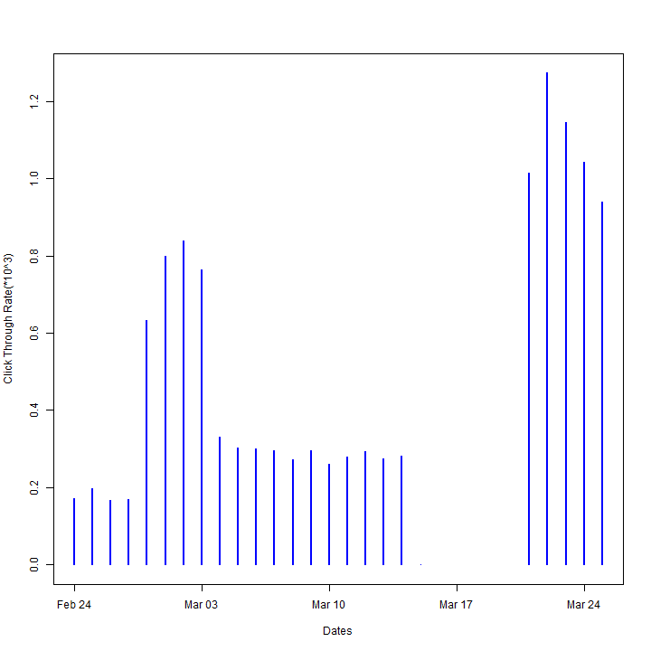  
*Data not given for the some of the dates in between.  
The Plot is between Dates v/s CTR(*10^3), as the value for CTR was coming quite small.  
  
  
**Conclusion** : The CTR shows the percentage of success we have gained in showing the impressions, i.e. the no. of clicks received out of the total impressions shown. The last days have shown improvement in the overall CTR.  
  
**Data** ‘dateWise_series’  
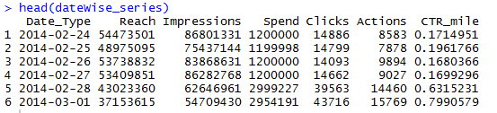  
  
  
2. Dates vs Revenue from 3 Models:  
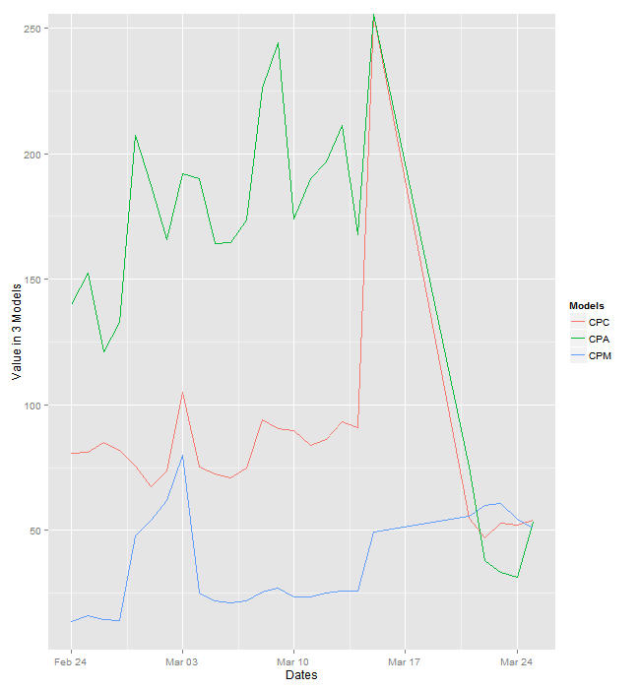  
 **Observation** : The revenues from the 3 models is consistently low for the starting days but has increased in the last few days, making one to take make a better approach for the display of advertisements for starting days of the campaign.  
 **Conclusion :** The better performer is CPC out of CPA and CPC in the terms of overall revenue, making one to opt for CPM and CPA model for the kind of advertisements shown in the starting days.   
 **Data** : ‘date_df’  
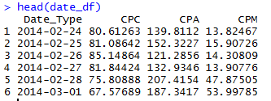  
15th March has shown abrupt behavior in CPA and CPC because of net value ‘0’ of Actions and Clicks on that day. This might be due to less no. of impressions shown or poor display of ads on that day.  
  
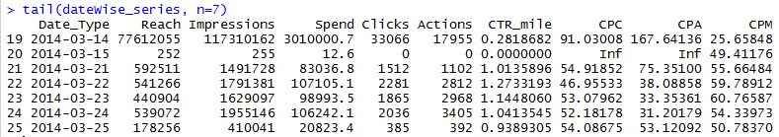

**Analysis done on basis of Days : File** : InGraph_DayWise.R*Steps Done* :   
Segmented data on the basis of unique days; a broader picture of the Click Through Rate w.r.t Days is shown, and then the comparison of the 3 types of revenue Models(CPC, CPA, CPM) is presented for the seven days.   
1. Days vs CTR_mile  
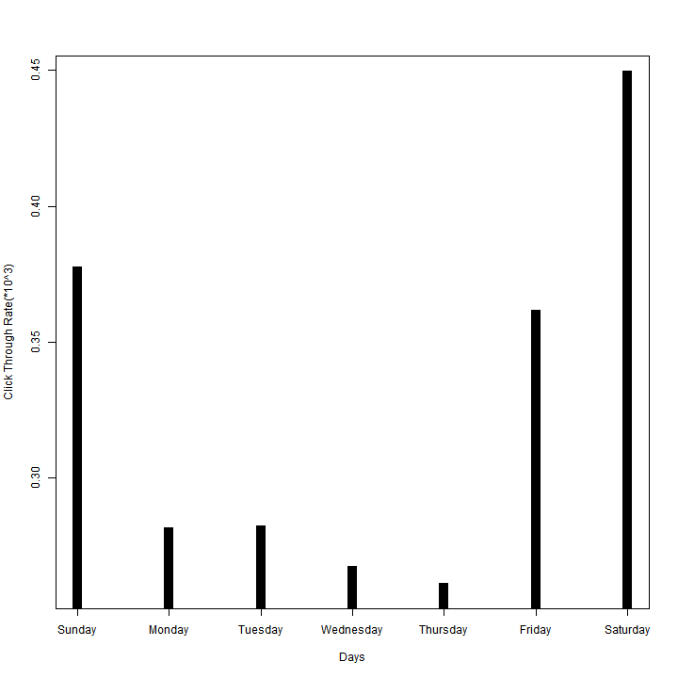  
**Observation** : The Plot shows a high CTR for Weekends, in which Saturday being with the major contributor to it, then Sunday followed by Firday.  
**Conclusion :** More ads should be shown on weekends so as to retain the market on Weekends. Apart from this, a better approach should be used to increase the flow of the traffic on the impressions shown on Weekday, with Thursday and Wednesday on high priority. On these days, proper websites giving Facebook ads can be chosen as an alternative or proper timing to show the ads has to be chosen when it is more likely for an ad to be seen by the user. **Data :**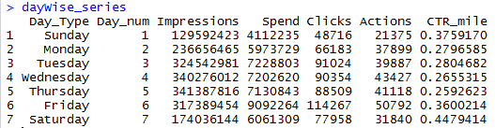  
2. Days vs Different Models:  
*Steps :* We have segmented the data on the basis of different days, and then for each of those day type we have calculated and compared the revenue generated by the 3 models.  
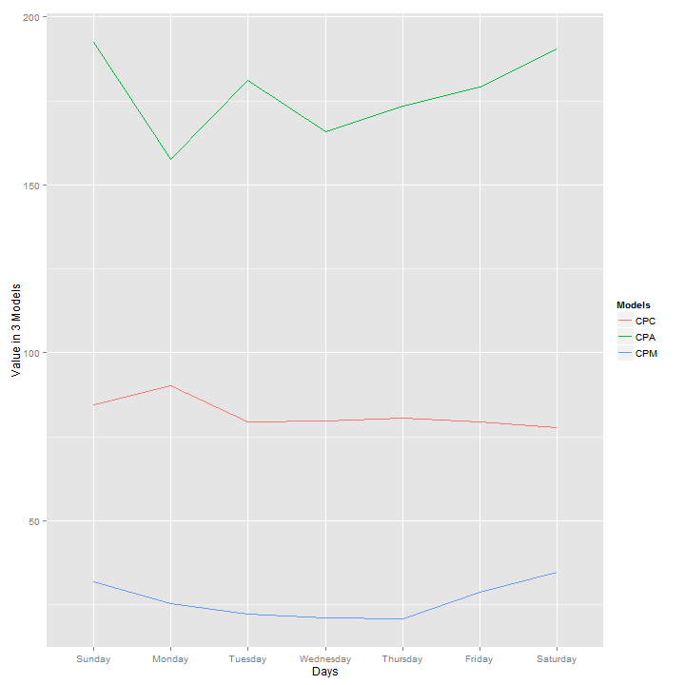  
**Observation** : The revenue generated by the CPM model is the highest, then CPC model and CPA model at last. CPM model has shown better performance on Weekends as compared to Weekdays, while for CPC better performance in reported in the week starting.  
 **Conclusion** : Considering only CPA, as the cost per acquisition is higher on weekends, it means ads which are leading to more conversions should be preferred on weekends, and the cost of acquisition can be dropped by limiting the impressions bought on weekends. High yielding advertisements should be shown to targeted customers only, so as to decrease the costs incurred for buying the impressions.  
  
Improvement can be done with CPC, by showing ads on weekdays on different mediums or with higher frequency, and on proper timings.  
 **Data** :   
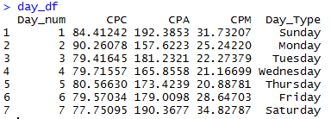  
  
* ‘Day_Type’ column in the above data frame has been added only for the above picture. In actual calculations, it has not been added to the ‘data_df’ data frame.  
  
  
  
  
  
  
  
  
  
  
  
  
  
  
  
  
  
  
  
  
  
  
  
  
  
  
  
  
  
  
  
  
  
  
  
  
  
  
  
  
**Analysis done on the basis of different Advertisements :** **File** : InGraph_AdWise.R   
*Steps Done* : Data has been segmented on the basis of the Level-1 of the Advertisements. The various 10 advertisements categories in Level-1 have been put into 4 major Groups :  
**Group1** : Vehicles : AU, BI, CA (au : Automobile, bi : Bike, ca : Cars)  
**Group2** : Electronic Accessories : ET, HL, MB (et : electronic items, hl : watches, mb: Mobile phones)  
**Group3** : Jobs s : JB (jb : job types)  
**Group4** : Other Sales : RE, BR, PC (re : rent-sale-land, br : mixed type, pc : pets - dog/cat)  
  
**Note** : For a better analysis, from the 4 data groups I have removed the rows corresponding to zero (0) Clicks. As these are the Impressions which are not the main target as of now and can be included in later stage.   
  
As of now, the targeted Ads should be the ones which have more **Reach, CTR,** and have given more revenue from **CPA, CPC, CPM** models, because this criteria gives us an overview of the major revenue driving advertisements.  
  
**Data** :  
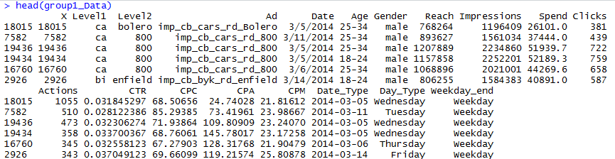  
  
  
  
Segmenting the Data on the basis of unique **Level2** Ads :  
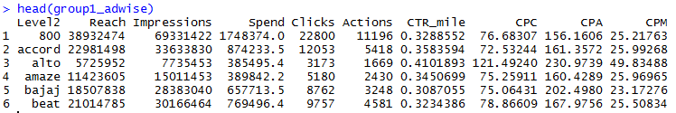  
  
  
  
For all the 4 Groups:   
1. Reach values have been displayed w.r.t. to the unique Level-2 Advertisements in them.  
2. Comparison of Revenue Model has been shown w.r.t. to the unique Level-2 Advertisements in them.

**GROUP-1 Analysis**CTR Comparison  
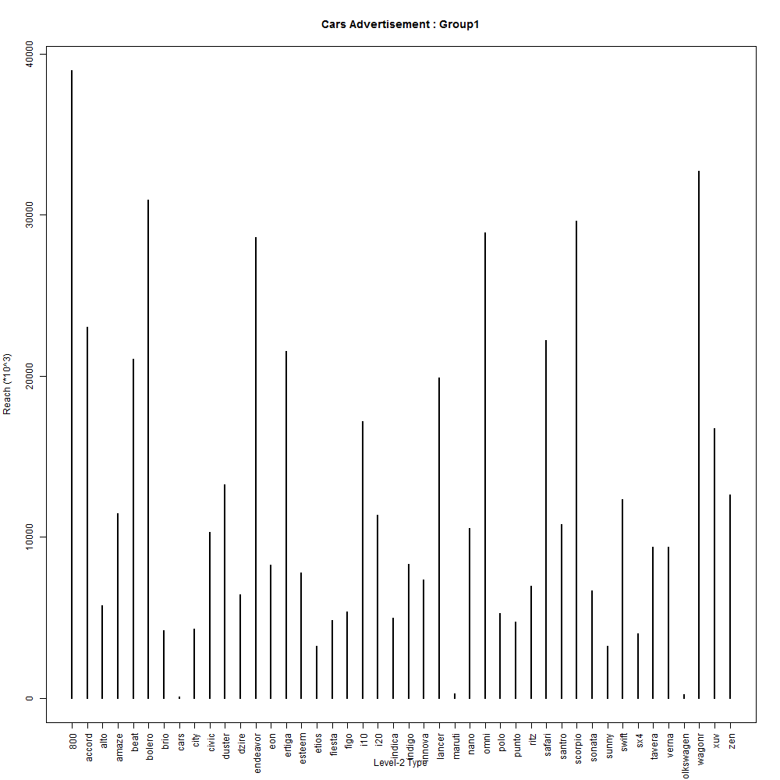  
**Plot 1** : Unique Level-2 Type Ads in ‘ca’ category vs Reach.  
*In the plot Reach value is 10^3 times the value shown.  
  
**Comments** : The graph shows the reach of various types of Advertisements, on the basis of the reach of the different types of ads of Cars, we see that : 800, Beat, endeavor, Omni, Scorpio and WagonR are among the top performers. So these kind of ads should be shown more as they aim unique customers.  
  
  
  
  
  
  
CTR Comparison  
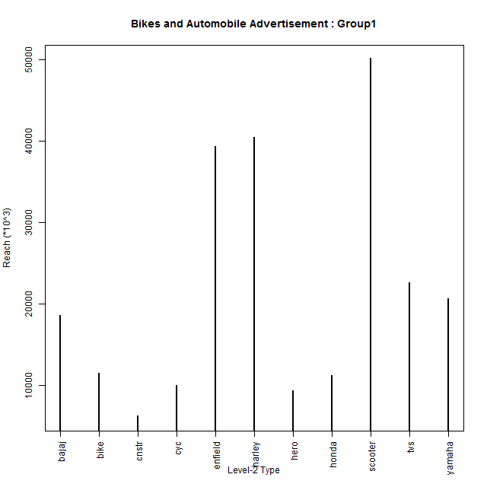  
**Plot 2** : Unique Level-2 Type Ads in ‘bi’-‘au’ category vs Reach.  
*In the plot Reach value is 10^3 times the value shown.  
  
**Comments** : The graph shows the reach of various types of Advertisements for Bikes and Automobiles, on the basis of the reach of the different types of ads of Cars, we see that : Enfield, Harley and Scooter are the top performers. So these kind of ads should be shown more as they aim unique customers.  
  
  
  
  
  
  
  
  
  
  
  
Revenue Models Comparison  
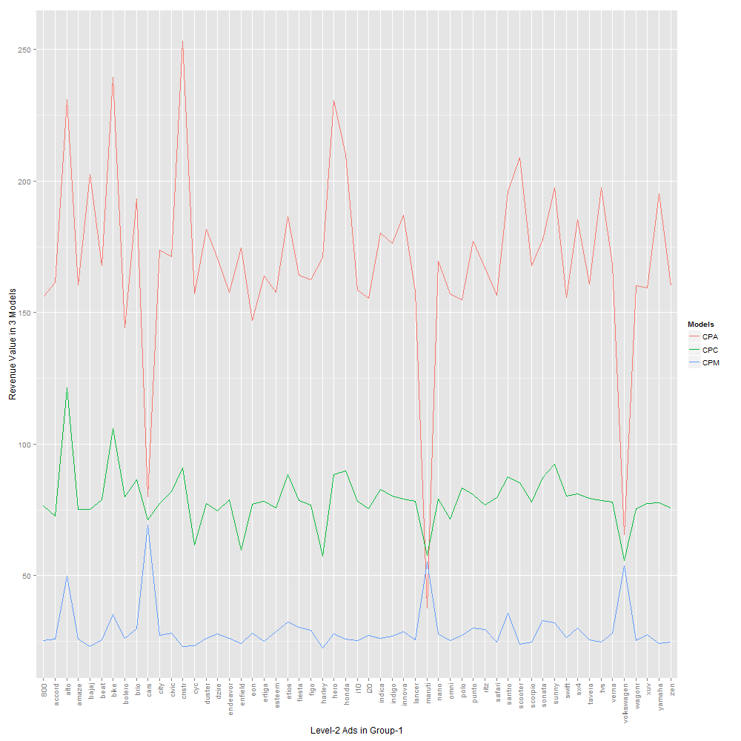  
**Plot** 3: Plot shows the comparison of 3 Revenue models on the basis of different Ads in Level-2 of Group 1  
  
**Comments** : The plot shows fall in CPA and CPC value for 3 types of ads with high values of CPM for them. This shows that the percentage of conversions happening for these 3 categories was very good (Actions/Impresssions, Clicks/Impressions )as compared to other advertisements. These 3 top performers are : Maruti, Cars, Volkswagen.  
  
Data for these 3 ads :  
  
 **GROUP-2 Analysis**CTR Comparison  
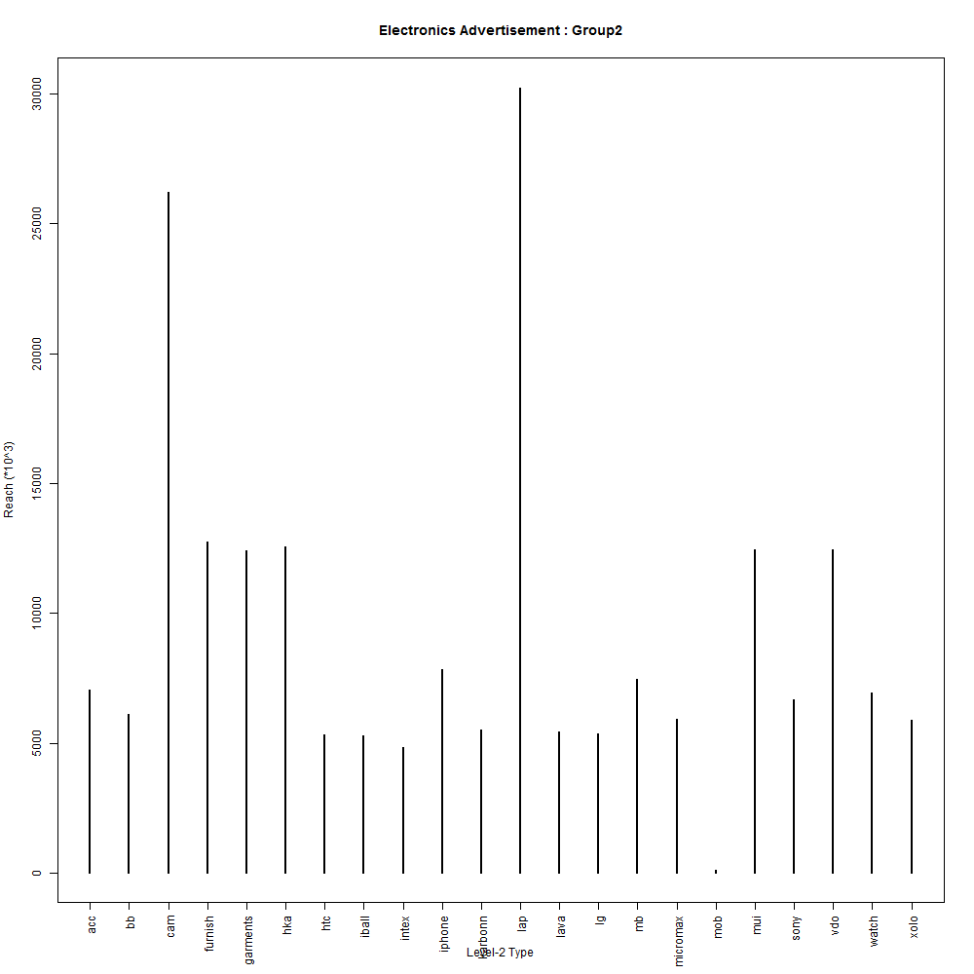

**Plot 4** : Unique Level-2 Type Ads in ‘et’-‘hl’-‘mb’ category vs Reach.

**Comments** : The graph shows the reach of various types of Advertisements for Electronic Items, on the basis of the reach of the different types of ads of electronics, we see that : lap(laptop) and cam(camera) are the top performers. So these kind of ads should be shown more as they aim unique customers.

Revenue Model Comparison  
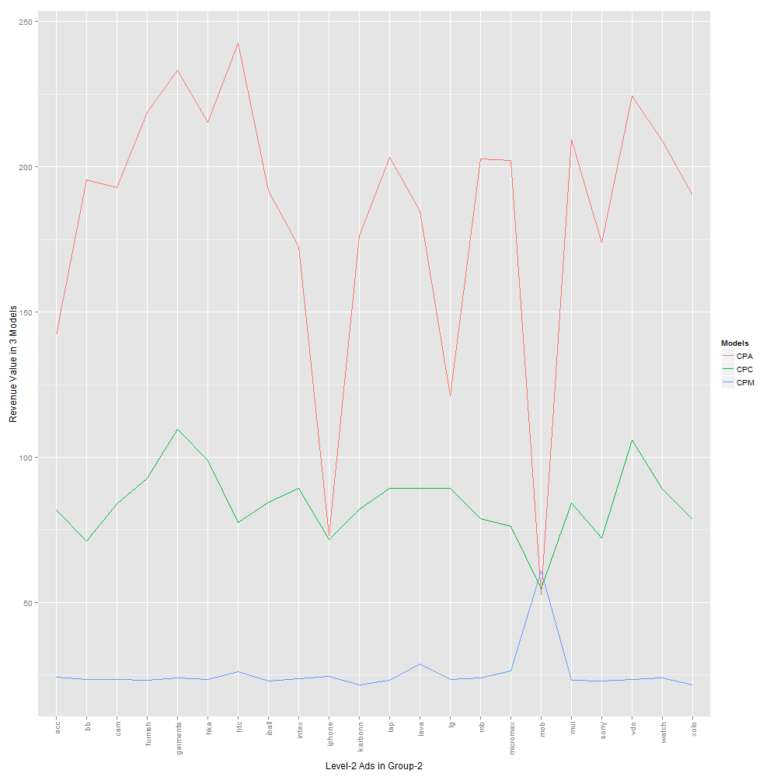

**Plot** 5: Plot shows the comparison of 3 Revenue models on the basis of different Ads in Level-2 of Group 2 **Comments** : The plot shows fall in CPA and CPC value for 2 types of ads with high values of CPM for them. This shows that the percentage of conversions happening for these 3 categories was very good (Actions/Impresssions, Clicks/Impressions )as compared to other advertisements. Next product in conversion was LG.   
These 2 top performers are : mob(Mobile) and iPhone, followed by LG.

**Group 3 Analysis**CTR Comparison

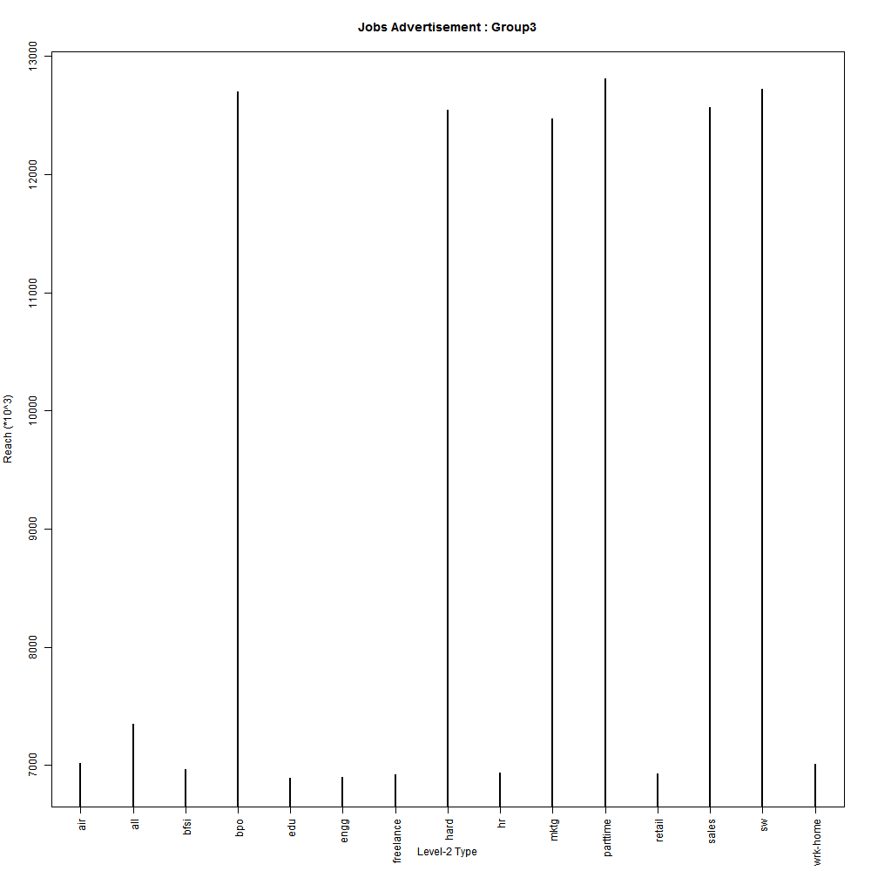

**Plot 6** : Unique Level-2 Type Ads in ‘jb’ category vs Reach.

**Comments** : The graph shows the reach of various types of Advertisements for Job. On the basis of the reach of the different types of ads of jobs, we see that :bpo, hardware, marketing, parttime, sales and software are the top performers. So these kind of ads should be shown more as they aim unique customers.

Revenue Model Comparison

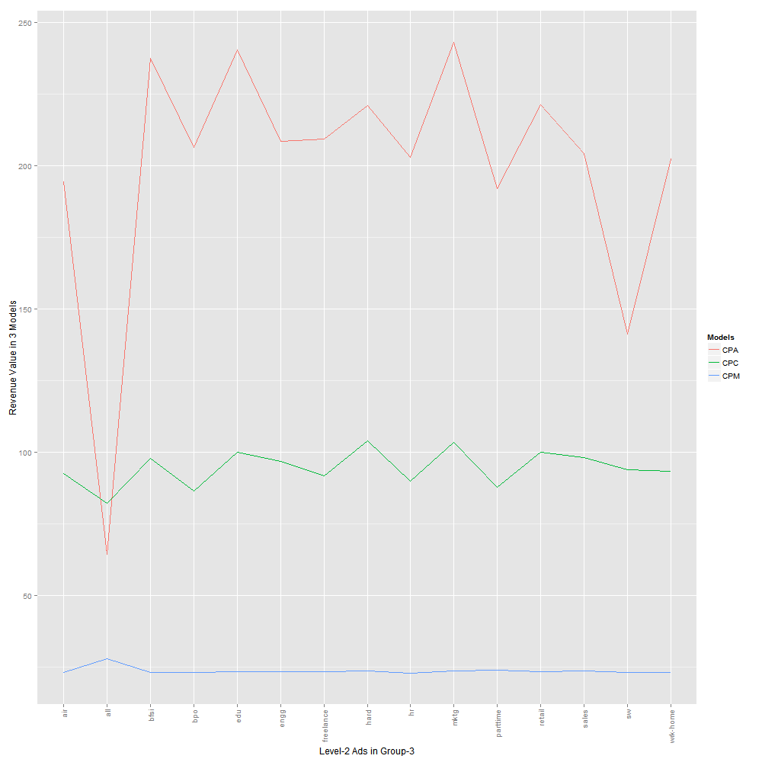

**Plot** 7: Plot shows the comparison of 3 Revenue models on the basis of different Ads in Level-2 of Group 3 **Comments** : The plot shows fall in CPA value for 2 types of ads with high values of CPM for 1 of them. This shows that the percentage of conversions happening for this 1 category was very good (Actions/Impresssions, Clicks/Impressions )as compared to other advertisements.   
These 2 top performers are : all, sw.

**GROUP-4 Analysis**CTC Comparison

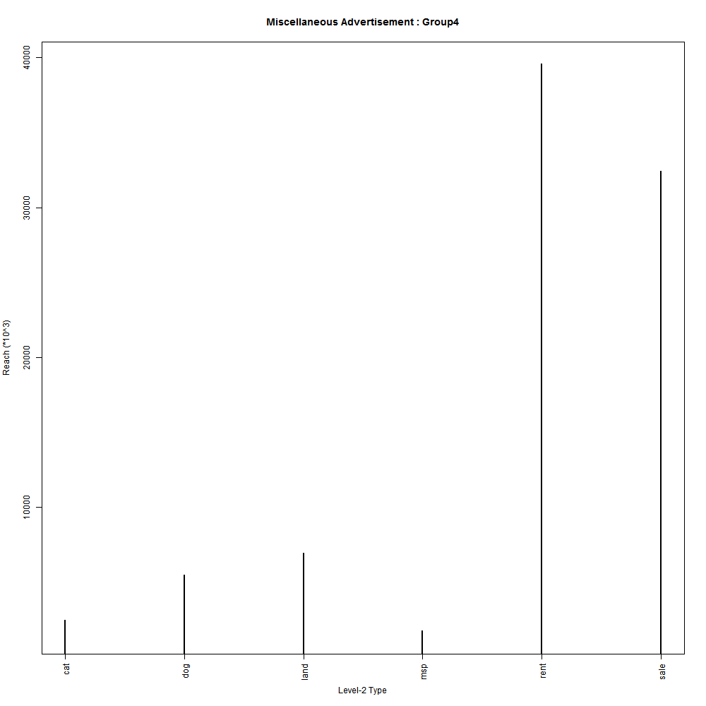

**Plot 8** : Unique Level-2 Type Ads in ‘re’-‘br’ category vs Reach.

**Comments** : The graph shows the reach of various types of Advertisements for Miscellaneous types. On the basis of the reach of the different types of ads of this category, we see that : rent and sale are the top performers.   
So these kind of ads should be shown more as they aim unique customers

Revenue Model Comparison

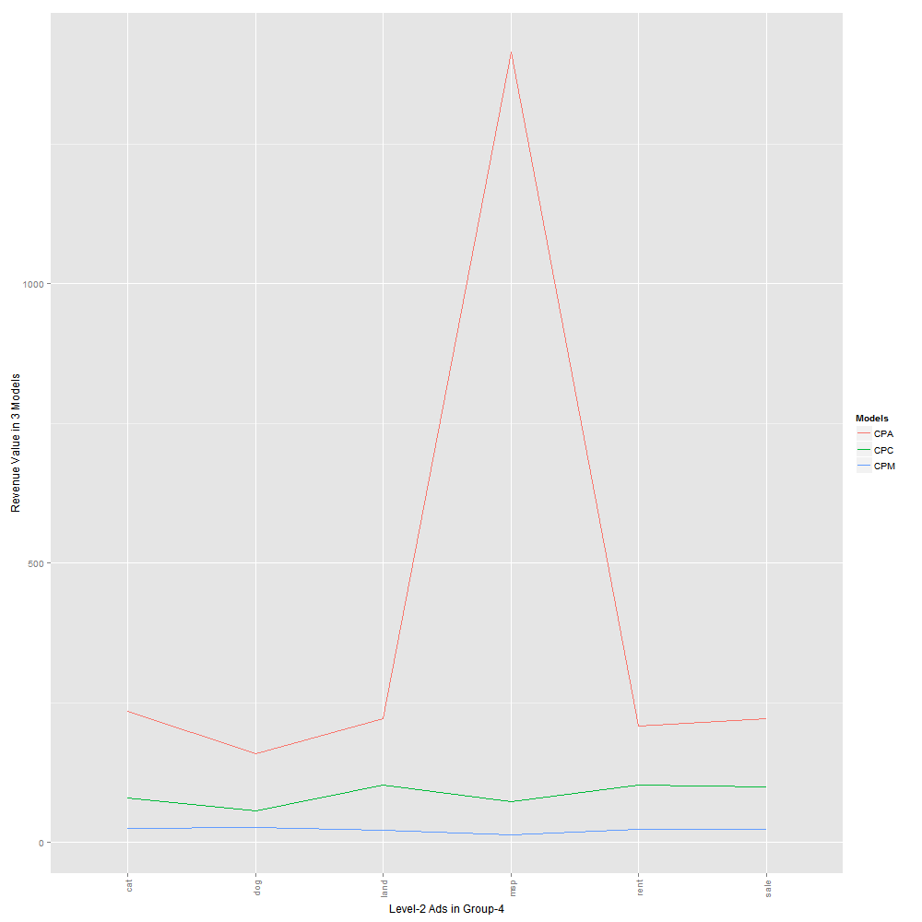

**Plot** 9: Plot shows the comparison of 3 Revenue models on the basis of different Ads in Level-2 of Group 4

**Comments** : The plot shows fall in CPA and CPC value for 1 types of ads. This shows that the percentage of conversions happening for this 1 category was very good (Actions/Impresssions, Clicks/Impressions )as compared to other advertisements.   
The top performer is : dog.  
The worst performer is : msp.

**Analysis on basis of Customers : Weekday/Weekend + Gender + Age Group + Dates File** : InGraph_Customers.R  
 *Steps Done* : Data has been initially segmented on the basis of Weekday or Weekend.   
Now after this it is divided on the basis of the 3 types of the gender (Male, Female, Unknown). For each type of Gender further analysis has to be performed.  
**Target** :   
1. To check the Reach, CTR, CPA, CPC, CPM on basis of what type of day (Weekday/Weekend), on which date, which Gender of the Customer, belonging to which Age Group have been recorded so far. This analysis is like checking the behavior of the customers on the basis of his/her age group on Weekends/Weekdays.  
  
**In short** : On which weekday/end -> For which gender -> Which age group -> Which date -> Plotting on basis of REACH, CPA, CPC, CPM.  
**Example is Shown for Male Customers on Weekends only.**  
Similarly can be done for Female and Unknown genders on Weekends, and for all genders on Weekdays.  
  
2. We want to see on which day(Weekday or Weekend with Dates), which Gender of the customer, belonging to which Age Group have gone through which types of unique Advertisements. This is done so that next time we can target the same type of customers with the similar advertisements, by checking out their CTR and Actions values from the 1st point data. For unique Ad Types, take the sum of their REACH, this will give the overall REACH achieved for a product's ad. Refer **Analysis done on the basis of different Advertisements**, for this.  
**Answer** :  
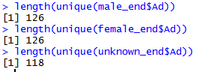Weekend 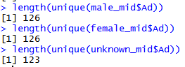Weekday  
This shows that both **male** and **female** have gone through all types of ads on weekends and weekdays, so we can continue showing all varieties of ads to them. For **Unknown** we can introduce other types of ads as well by checking their Dates vs Reach plot on both types of Days.  
  
**Data** :  
Finally ordered data frame :   
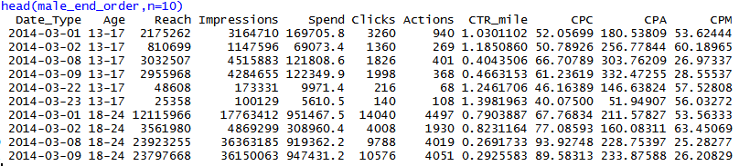There are total 6 unique dates corresponding to Weekends, in our cleaned data.  
  
* In the finally ordered data, we have removed the cases where **Clicks** and **Actions** value is '0', as these cases won't be useful for analysis, and will create problem while analyzing or plotting the data.  
** Due to big values of Reach in the below data frame, multiplied with 10^-5  
  
*^ Data can also be divided on the basis of the three genders, but then it will give the bigger picture, the type of analysis done here gives better and to the point analysis.

**Example shown below is for Male Customers on Weekends, both the Targets have been shown for them :  
Case 1** :   
*Part 1*:Depeding upon the Males customers on Weekends on different dates, for different Age Groups how the **Reach** has varied.  
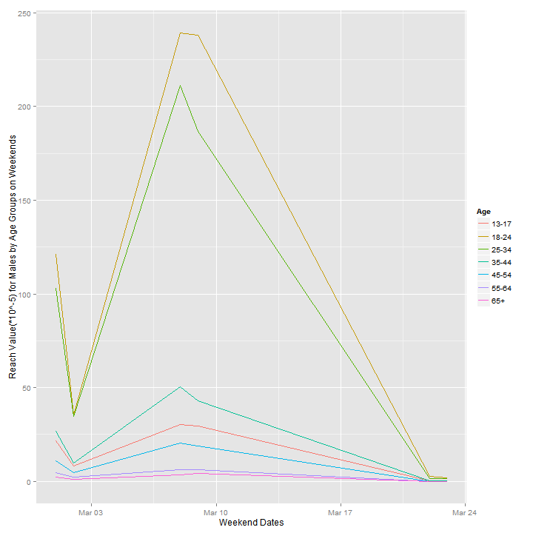  
**Plot 1a :** Reach among Males on Weekends for different Age Groups  
 **Comments** : We observe that the maximum reach has been achieved for customers from Age groups : 18-24 and 25-34. So we should adopt the same strategy for this group for other dates also which had been used for these age groups on the 03’Mar-10’Mar dates.  
Regarding the other age groups, we should introduce advertisements of their field of interest also, and enter their market as well.  
  
  
  
  
  
  
  
*Part 2* : Depending upon the Revenue Model, either **CPC, CPA, or CPM,** I have analyzed the 3 models on the basis of the Age Groups, for males on Weekends on different dates. Similar graphs can be plotted for other 2 Genders : Female, Unknown as well, and can be done for Weekdays as well.  
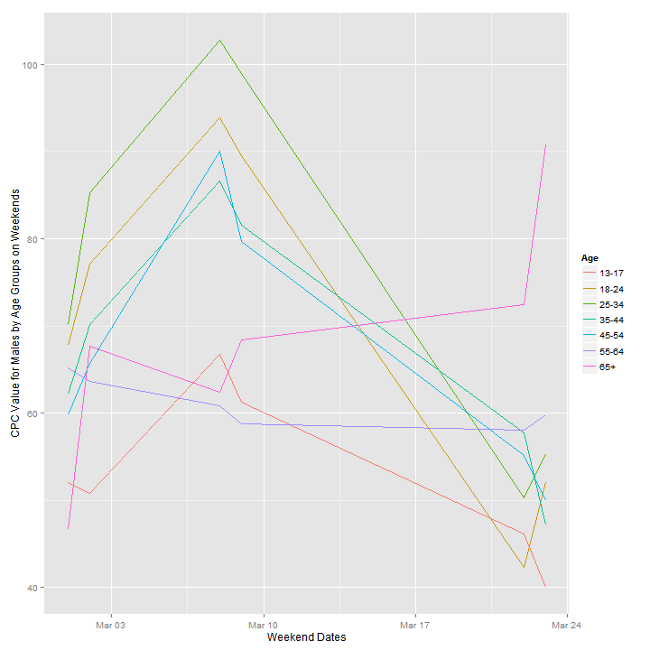**Plot 2a** : CPC value on weekend by Male customers of different Age Groups.  
  
**Comments** : The major contributors in the CPC model are the age groups : 13-17, 55-64, 65+. These age groups require lesser cost per clicks, and thus are profitable.  
**Conclusion**: Rest of the age groups are taking the biggest percent of the overall budget, so the Impressions shown to these groups should be optimized so as to have lower CPC values.   
Age group 65+ shows arbitrary trend but using the information from the next plot of CPA, we can infer that it might be a cause of lesser profit, as it has huge values for cost per acquisition.  
  
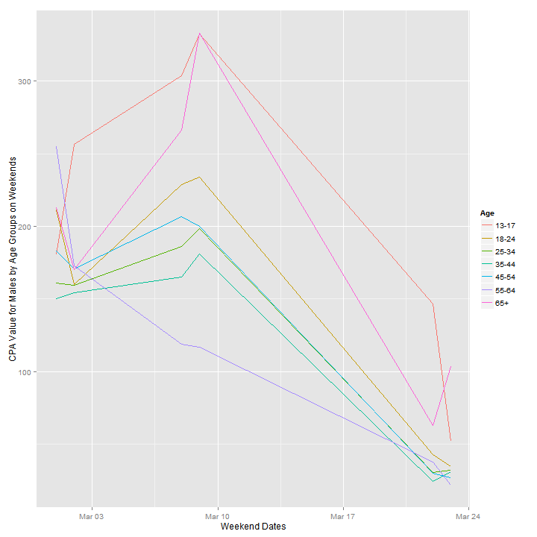 **Plot 2b** : CPA value on weekend by Male customers of different Age Groups.  
  
**Comments** : The major contributors to the high cost per conversion are the least and highest age groups: 13-17 and 65+ on most of the weekends.   
**Conclusion**: It means while aiming for these age groups on weekend s we have to optimized the buying and showing pattern of impressions. Different varieties of ads can be shown for a check or only converting varieties of ads can be shown to these groups.  
  
Age groups from 18-24, 25-34, 35-44, 45-54, 55-64 are having almost same value for cost per acquisition and follow same pattern on weekends. The strategy used on ending weekends should be emphasized for these groups.  
  
  
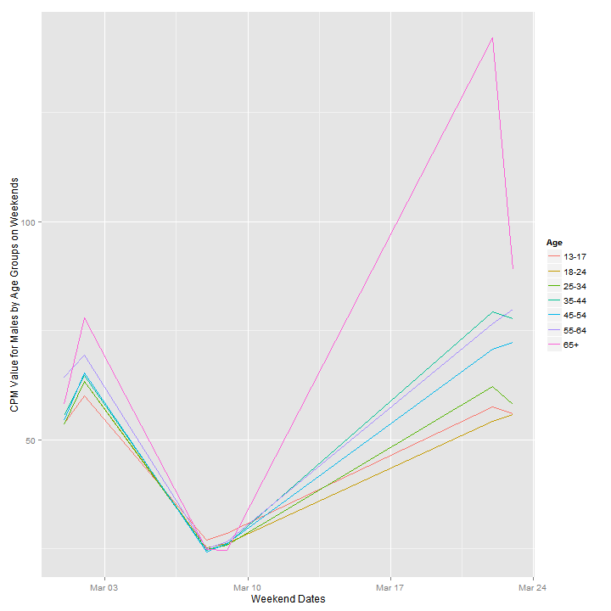  
**Plot 2c** : CPM value on weekend by Male customers of different Age Groups.  
  
**Comments** : CPM value has shown steep variation on weekends, but this behavior is common for all age groups so it means the reason for this change is independent of the age groups and depends on other factors.  
**Conclusion**: As we can observe from CPA and CPC graphs that for the period of 03’Mar-10’Mar there has been major conversions and clicks happening via our impressions, and CPM value is the least for this period, so it means that the either the campaign adopted for this period included a huge number of Impressions which have resulted in better Conversions and Clicks, or the Spend was less and the Clicks and Actions happening were even lesser.   
By observing the data, former case satisfies (Larger value of Impressions).  
**Conclusion** : To improve/increase the margin, buying of ad-spaces has to be more optimized, so that we have high CTR and Actions/Impressions. To analyze this properly we can see the Dates vs. CTR Plot. (On next page)  
**Target** : Optimized Impressions -> High Clicks or High Actions  
*CPM = Spend/Impressions.  
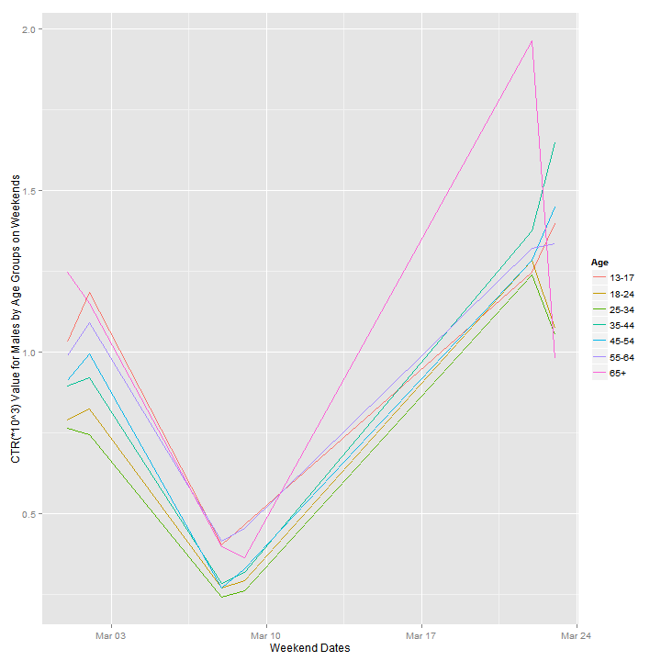  
**Plot 2d** : CTR(*10^3) on weekend by Male customers of different Age Groups.  
  
**Conclusion** : Checking out the CTR plot for the period 03’Mar-10’Mar shows that no. of Clicks done per Impression is very less (This value is CTR value multiplied by 1000). So it means Impressions have been flooded for this period, resulting in the more clicks and conversions. This proves our point that buying of Impressions was to be optimized for this period and lesser no. of impressions were to be shown, to reduce the expenses incurred by the company.  
  
The plot shows 65+ age group of males are clicking more on ending weekends of the data. Different impressions can be bought for this age group so as to convert these Clicks to Actions.  
  
  
  
  
  
**Analysis done on the basis of CTR, Reach, Clicks: File** : InGraph_ClearData.RWe have sorted first the data with CTR>0, and then ordered it on the basis of **Reach**, so that it can be used to target the Advertisements which have helped in reaching/converting maximum unique customers. Such advertisements can be displayed more. **Better Data** **arrangement** for comparison of models :  
Ordering the data on the basis of **Reach**, gives a better targeting of Advertisements and comparison among the revenues from the 3 models as compared to below ordering. Moreover, it helps us in checking the conversion of unique customers for the advertisement type.  
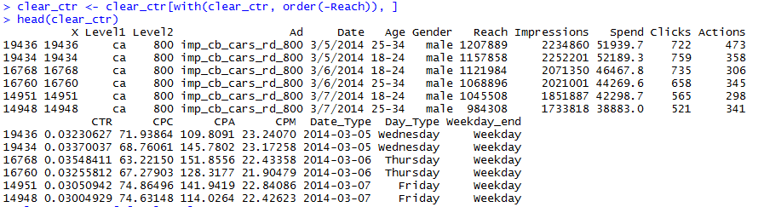  
Dimensions of this data :   
  
  
**Poor Data** **arrangement** for comparison of models :  
**Case 1** : Ordering on the basis of **Actions**, doesn’t give a proper picture of the CPA comparison with revenue from other models.  
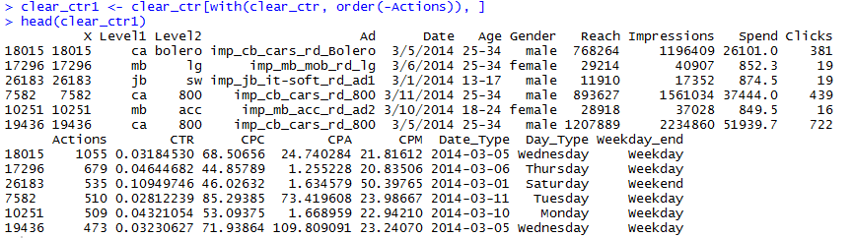  
  
**Case 2** : Below is the case of ordering of the data on the basis of the **CTR**, as we can see for the top row even if the CTR is high, still its corresponding value of **Reach** and **Impressions** is far less. So, this strategy to order the data proves unfruitful. As the main aim of the company is to reach out to maximum customers and then convert them.  
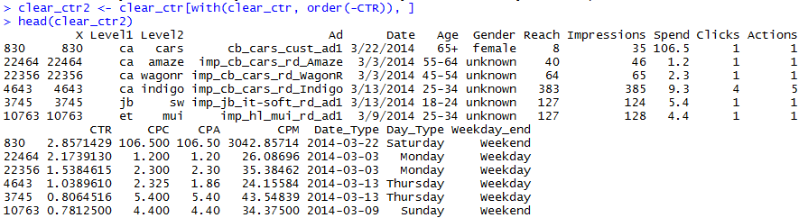  
The above better data has no rows with ‘0’ value in **Impressions** or **Actions** columns, so it means all of these cases are fit for the CPA and CPM models.  
  
  
There is no such case, which has Clicks=0 and Actions >0 : Verified  
  
  
To get the best fit data for the CPC model, we are removing the rows which have ‘0’ values for the **Clicks**:  
  
This data has around 800 lesser rows from the ‘clear_ctr’ data :  
  
  
We are now ordering the above data on the basis of **Clicks**, for better analysis of CPC :  
An overview of the data :   
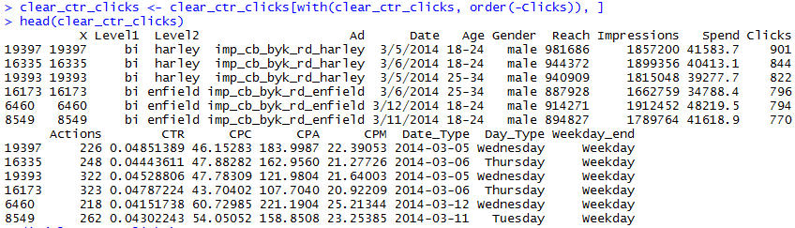  
  
This type of ordered data can be used for targeting the Advertisements when using the CPC model.  
  
Similarly ordering the above data on the basis of **Actions**, for better analysis of CPA :  
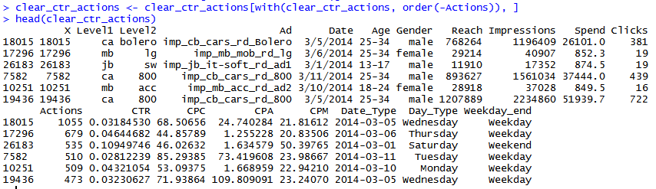  
This type of ordered data can be used for targeting the Advertisements when using the CPA model.  
 **Suggestions :**   
What More can be done :  
1. Analyzing by Advertisements can be done by segmenting the data on various levels and sub-levels, so as to gain a better insight of which Ads are revenue generating and on what days.  
  
2. Information on the Bid price won by the company for the Impressions shown will help in optimizing the no. of Impressions which are to be shown, as buying more Impressions will give higher probability of clicks and conversions but it has downside on the overall Margin for a specific campaign.  
  
3. Information on the ‘Recency’ value will give better insight on the customer’s behavior with the advertisement shown. This can help us to regulate the time period for which the ad has to be shown to the customer.  
  
4. Information on Cadence Modifier(factor based on user’s frequency) and the Fold position and Demographic Location will add better insight n prediction of the advertisements to be shown.

--------------XX--------------