

**维信书城系统**

［数据库设计报告］

|  |  |  |
| --- | --- | --- |
| 文件状态：  [ ] 草稿  [ √ ] 正式发布  [ ] 正在修改 | 文件标识 | Vision_Employment_1.0.0_2021/11/3 |
| 当前版本 | 1.0.0 |
| 作 者 | 杜少雄 |
| 发布日期 | 2021/11/03 |
| 文档密级 |  |

山西维信致远科技有限公司

版权属于维信科技所有，无维信科技的书面同意，任何个人或组织无权拷贝。

目录

1 SINER-维信书城 3

1.1 关系图 3

1.2 表清单 3

1.3 表字段明细 4

1.3.1 BOOK [书籍表] 4

1.3.2 ORDER [订单表] 4

1.3.3 ORDER_ITEM [订单项表] 4

1.3.4 USER [用户表] 4

1.3.5 TABLE_1 [数据表] 4

1.3.6 TABLE_2 [数据表] 5

# SINER-维信书城

## 关系图

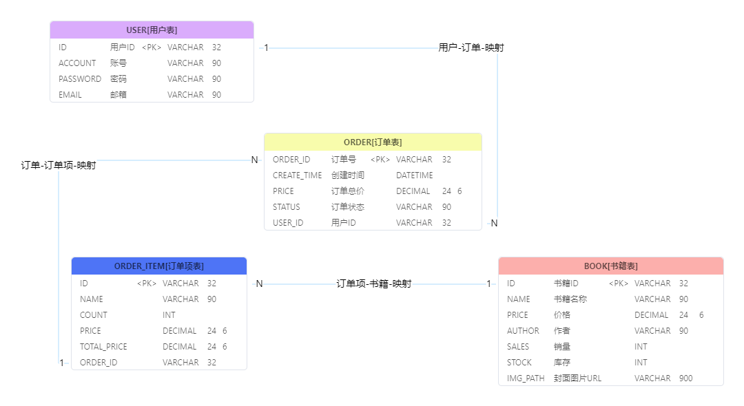

## 表清单

|  |  |  |  |
| --- | --- | --- | --- |
| **#** | **数据表** | **名称** | **备注说明** |
| 1 | BOOK | 书籍表 |  |
| 2 | ORDER | 订单表 |  |
| 3 | ORDER_ITEM | 订单项表 |  |
| 4 | USER | 用户表 |  |

## 表字段明细

### BOOK [书籍表]

|  |  |  |  |  |  |  |  |
| --- | --- | --- | --- | --- | --- | --- | --- |
| **#** | **字段** | **名称** | **数据类型** | **主键** | **非空** | **默认值** | **备注说明** |
| 1 | ID | 书籍ID | VARCHAR(32) | √ | √ |  | 书籍ID |
| 2 | NAME | 书籍名称 | VARCHAR(90) |  |  |  | 书籍名称 |
| 3 | PRICE | 价格 | DECIMAL(24,6) |  |  |  | 价格 |
| 4 | AUTHOR | 作者 | VARCHAR(90) |  |  |  | 作者 |
| 5 | SALES | 销量 | INT |  |  |  | 销量 |
| 6 | STOCK | 库存 | INT |  |  |  | 库存 |
| 7 | IMG_PATH | 封面图片URL | VARCHAR(900) |  |  |  | 封面图片URL |

### ORDER [订单表]

|  |  |  |  |  |  |  |  |
| --- | --- | --- | --- | --- | --- | --- | --- |
| **#** | **字段** | **名称** | **数据类型** | **主键** | **非空** | **默认值** | **备注说明** |
| 1 | ORDER_ID | 订单号 | VARCHAR(32) | √ | √ |  | 订单号 |
| 2 | CREATE_TIME | 创建时间 | DATETIME |  |  |  | 创建时间 |
| 3 | PRICE | 订单总价 | DECIMAL(24,6) |  |  |  | 订单总价 |
| 4 | STATUS | 订单状态 | VARCHAR(90) |  |  |  | 订单状态 |
| 5 | USER_ID | 用户ID | VARCHAR(32) |  |  |  | 用户ID |

### ORDER_ITEM [订单项表]

|  |  |  |  |  |  |  |  |
| --- | --- | --- | --- | --- | --- | --- | --- |
| **#** | **字段** | **名称** | **数据类型** | **主键** | **非空** | **默认值** | **备注说明** |
| 1 | ID | 订单项ID | VARCHAR(32) | √ | √ |  | 订单项ID |
| 2 | NAME | 商品名称 | VARCHAR(90) |  |  |  | 书籍名称 |
| 3 | COUNT | 数量 | INT |  |  |  | 数量 |
| 4 | PRICE | 单价 | DECIMAL(24,6) |  |  |  | 单价 |
| 5 | TOTAL_PRICE | 总价 | DECIMAL(24,6) |  |  |  | 总价 |
| 6 | ORDER_ID | 订单号 | VARCHAR(32) |  |  |  | 订单号 |

### USER [用户表]

|  |  |  |  |  |  |  |  |
| --- | --- | --- | --- | --- | --- | --- | --- |
| **#** | **字段** | **名称** | **数据类型** | **主键** | **非空** | **默认值** | **备注说明** |
| 1 | ID | 用户ID | VARCHAR(32) | √ | √ |  | 用户ID |
| 2 | ACCOUNT | 账号 | VARCHAR(90) |  |  |  | 账号 |
| 3 | PASSWORD | 密码 | VARCHAR(90) |  |  |  | 密码 |
| 4 | EMAIL | 邮箱 | VARCHAR(90) |  |  |  | 邮箱 |

### TABLE_1 [数据表]

|  |  |  |  |  |  |  |  |
| --- | --- | --- | --- | --- | --- | --- | --- |
| **#** | **字段** | **名称** | **数据类型** | **主键** | **非空** | **默认值** | **备注说明** |
| 1 | ID | 主键ID | VARCHAR(32) |  |  |  |  |
| 2 | CREATED_BY | 创建人 | VARCHAR(32) |  |  |  |  |
| 3 | CREATED_TIME | 创建时间 | DATETIME |  |  |  |  |
| 4 | UPDATED_BY | 更新人 | VARCHAR(32) |  |  |  |  |
| 5 | UPDATED_TIME | 更新时间 | DATETIME |  |  |  |  |

### TABLE_2 [数据表]

|  |  |  |  |  |  |  |  |
| --- | --- | --- | --- | --- | --- | --- | --- |
| **#** | **字段** | **名称** | **数据类型** | **主键** | **非空** | **默认值** | **备注说明** |
| 1 | ID | 主键ID | VARCHAR(32) |  |  |  |  |
| 2 | CREATED_BY | 创建人 | VARCHAR(32) |  |  |  |  |
| 3 | CREATED_TIME | 创建时间 | DATETIME |  |  |  |  |
| 4 | UPDATED_BY | 更新人 | VARCHAR(32) |  |  |  |  |
| 5 | UPDATED_TIME | 更新时间 | DATETIME |  |  |  |  |