**Stochastic Simulation of Associating Telechelic Polymers**

Gun Woo Park, Giovanni Ianniruberto, and Giuseppe Marrucci

DICMaPI, University of Naples Federico II

*gunwoo.park@unina.it*

**1. Introduction**

Hydrophobically modified ethoxylated urethane (HEUR) is made up by poly(ethylene oxide) (PEO) end-capped with short hydrophobic groups. Above the so-called critical micelle concentration, HEUR in aqueous solutions forms flower-like micelles where the core is composed of aggregated hydrophobic end-groups. Since the aggregation is physically reversible, chain ends can detach from the core, and attach to neighboring micelles (thus forming bridges). The probability of bridge formation increases with increasing HEUR concentration, and a transient network eventually builds up.

The linear viscoelastic behavior of HEUR systems is somehow simple since they exhibit a Maxwell like response with a dominant relaxation time (related to the association/dissociation dynamics), exhibiting a power-law dependence on HEUR concentration and molar mass [1]. On the contrary, HEUR solutions exhibit a complex nonlinear rheological behavior. The Cox-Merz rule is often violated since the steady shear viscosity can reveal shear thickening while the dynamic viscosity only shows shear thinning [2]. In the shear rate range of the viscosity thickening, the first normal stress coefficient remains at its LVE value [3]. As regards the transient startup response at high shear rates, strain hardening is often observed both for the viscosity and for the first normal stress coefficient [3].

Recently, a micelle interaction model has been suggested [4] based on a dumbbell-like model also accounting for flow-induced micelle interactions. The model successfully predicts (at least qualitatively) the observed behavior in transient startup flows, while in steady flows it predicts thickening both for the viscosity and the first normal stress coefficient, differently from data. This failure was attributed by the authors to the mathematical approximations adopted in the model [4]. We remove here those approximations by developing a simulation algorithm based on the micelle interaction model, in order to understand the detailed mechanisms of the observed rheological behavior of HEUR solutions.



Fig. 1 Calculated continuous relaxation time spectrum from dynamic moduli reported in [1, 3] using fixed-point iteration method [5].

**2. Simulation Method**

As mentioned above, the LVE response shows that in HEUR systems the association/dissociation dynamics is significantly slower than the ordinary friction-controlled dynamics [3]. This is emphasized in Fig. 1, where we report the continuous relaxation time spectrum of the HEUR solutions examined in [1, 3]. Figure 1 shows that the time gap between the two different dynamics is about 2 decades. This implies that the network dynamics can be decoupled into a friction-based network-node dynamics at fixed topology, followed by a network rearrangement process accounting for the association/dissociation kinetics.

The network node dynamics is ruled by the following Langevin equation:

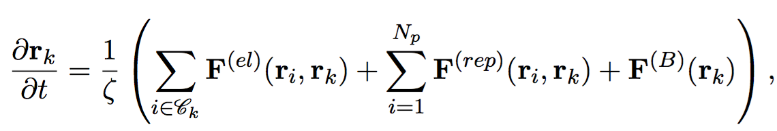

(1)

where the force contributions are divided into three parts: elastic contribution of bridge chains (el), repulsive contribution between micelles (rep) and Brownian motion (B). As regards topology renewal, we proceed as follows. For a given time interval, $δt$, the dissociation probability is given by



Fig. 2 Bridge chain fraction including (blue line) or excluding (red line) multiple connections. Node functionality and average multiplicity are indicated as f and w, respectively.

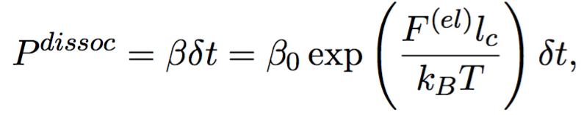 (2)

where $β$ is the chain detachment frequency, accounting for a thermal non-activated process (with frequency $β_{0}$) amplified by the elastic contribution ( $l_{c}$ being related to the length of the hydrophobic part). If the chain detaches, it immediately attaches to a neighboring flower (including the original one), randomly chosen with probability proportional to the Boltzmann distribution based on the elastic potential.



Fig. 3 Normalized stress autocorrelation function for different number densities of micelles. The stress autocorrelation at time zero is reported in the inset.

**3. Preliminary Results**

Figure 2 shows the effect of polymer concentration on several network properties, including the average node functionality. Figure 3 reports preliminary results for the stress autocorrelation function, confirming that relaxation slows down with increasing concentration. Because of noise in the stress autocorrelation in equilibrium simulations, the effective network relaxation time is difficult to catch quantitatively. For the same reason, the stress autocorrelation function at time zero is measured instead of the plateau modulus, which follows the scaling law reported in the inset of Fig. 3. This scaling is consistent with that of the plateau modulus obtained from the LVE response in [1]. Further simulations are currently in progress.

**References**

[1] T. Uneyama, S. Suzuki, and H. Watanabe, Physical Review E **86**, 031802 (2012).

[2] T. Annable, R. Buscall, and R. Ettelaie, *Journal of Rheology* **37**, 695 (1993).

[3]S. Suzuki, T. Uneyama, T. Inoue, and H. Watanabe, *Macromolecules* **45**, 888 (2012).

[4] G. Ianniruberto and G. Marrucci, *Macromolecules* **48**, 5439 (2015).

[5] K. S. Cho and G. W. Park, *Journal of Rheology* **57**, 647 (2013).