Folder Redirection Worksheet

# Instructions

1. Login to your Server 2022 Domain Controller. If not already done, create a standard user account for each member of your group (or yourself if not using ProxMox) in AD Users and Computers. Insert the user information for the user(s) you created in the table below. Create the user in the Users.

|  |
| --- |
| **Users** |
| **Name** | **Username** | **OU** | **Password** |
| Student 1 | Student1 | Users | MSPress#1 |

1. Login to your domain-joined Windows 11 VM using the user referenced above. Open the Documents folder and create some files. The content is not important but the Documents folder should be populated.
2. Return to your Domain Controller. Create a folder on the C: drive named “[fname]Redirection”. Share it with Everyone with Read / Write permissions. Do not set NTFS permissions. Note the UNC path to the folder in the Share properties. You will need this to set up folder redirection.

1. Open Group Policy Management and create a GPO and link it to the Domain. Call the GPO “Folder Redirection.” Edit the GPO to enable Folder Redirection on the Documents folder. Configure the following settings:
   1. Target
      1. Basic – Redirect everyone’s folder to the same location.
      2. Create a folder for each user under the root path
      3. Root Path (will vary by Server Name): \\IT125Server\Redirection

* 1. Settings
     1. Grant the user exclusive rights to Documents
     2. Move the contents of Documents to the new location
     3. Policy Removal – Redirect the folder back to the local userprofile location when policy is removed.

1. Open a command window on Server 2022 and type: gpupdate /force
2. Switch to the Windows 11 machine and sign out. Log back in using your user account. Open a command window and type: gpresult /v. See if there is a policy for Folder Redirection. If not, type gpupdate /force. After the command processes, you should be instructed to logoff again.
3. 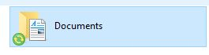Log back in using your user account and open File Explorer. The Documents icon should look like this:
4. Navigate to the Documents folder. You should see the files you previously saved in your Documents folder. Right-click on one of the files and select Properties. Location of files should reflect redirection to server location.

1. Switch back to Server 2022. Open File Explorer. Navigate to the “Redirection” folder. There should be a folder with your user’s name. Navigate to that folder and there should be a folder named “Documents”. Navigate to the Documents. You should receive an error that you don’t have permission to access this folder. Take a snip of the screen showing the path and error. It should look like this:

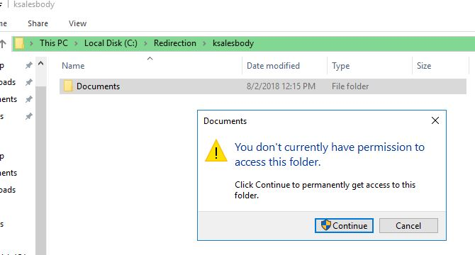

1. Submit this worksheet for assignment credit.