# Joining a Client to a Server 2022 AD

The purpose of this job aid is to guide you towards successfully installing a client computer on the Server 2022 Active Directory (AD) Domain that you created last week. This is not a server class so more help will be provided than you will get in future classes.

# Instructions

1. Open both your Windows 11 virtual machine and your individual or team server.
   1. If using ProxMox, verify the IP addresses of both VMs and confirm connectivity between the VMs using PING.
   2. If using VirtualBox, make sure the Windows 11 VM is on the same NAT Network as the server and verify connectivity using PING.
2. The steps to join a computer to an AD domain are few and simple. Here are the steps directly from Microsoft:

# To join a computer to a domain

1. On the **Start** screen, type **Control Panel**, and then press ENTER.
2. Select **System** and Navigate to **Advanced System Settings.**
3. Under **Computer name, domain, and workgroup settings**, click **Change settings**.
4. On the **Computer Name** tab, click **Change**.
5. Under **Member of**, click **Domain**, type the name of the domain that this computer will join, and then click **OK**.
6. Unless you anticipated the other steps your will need, your attempt to join the Domain will fail. You will probably get an error that the computer can’t find the domain. You might also be asked for administrator credentials that you might not have. Continue with the next step.
7. Additional items that must be completed include:
   1. You must have a domain admin account and password. It can be the default Administrator and whatever password you used when you set up the DC. You might consider creating an additional user with domain admin privileges. Put the credentials below.

|  |  |
| --- | --- |
| Administrator Account Name | Password |
| Admin | NotEnsign#125! |

* 1. You must change the DNS settings on the Windows 11 client to match the IP address of the domain controller. The DC is the authoritative DNS server for the domain. Any URL requests outside the domain will be forwarded to a public DNS server by the DC. It will be transparent to the client.
  2. If these steps are complete, when you complete step (e) from the instructions, you should be prompted for administrator credentials authorized as a domain admin. If you provide these credentials, the next pop-up box you receive should be a welcome to the domain message. You will then be prompted to restart the computer.

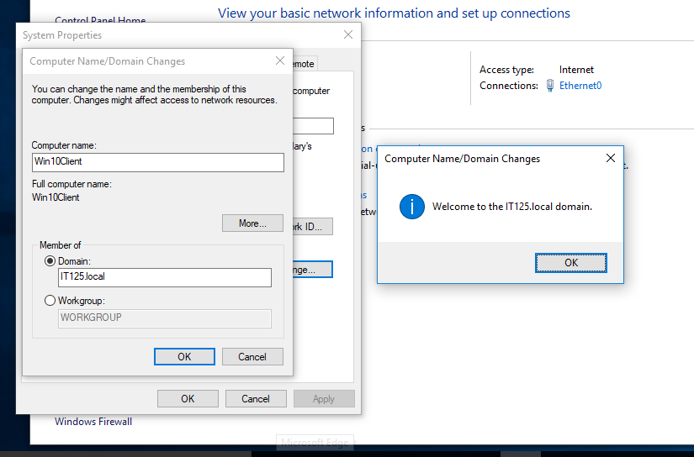

* 1. When the computer restarts, it will be a member of the domain!
  2. Switch to the Domain Controller. Open Active Directory Users and Computers. Expand the Domain. In the Users Container, create a standard user. Insert the credentials below:

|  |  |
| --- | --- |
| Standard Account Name | Password |
| Student1 | MSPress#1 |

* 1. Switch to the Windows 11 client and log into the domain with the standard account credentials. Make sure that the login screen is asking for a domain account.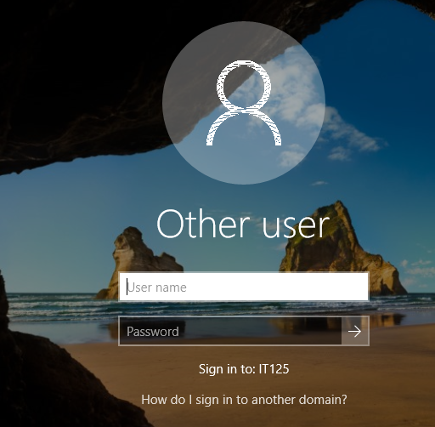
  2. If the login screen doesn’t reflect the domain, you will need to preface the username with the domain name. In this example, it would be:

**IT125\student1 (username of standard user)**

1. If you have any problems, please communicate with the instructor or fellow students!
2. After you have successfully logged into the domain, execute any command or go to any screen that shows domain membership. You can do this with PowerShell using this command: **Get-WmiObject -Namespace root\cimv2 -Class Win32_ComputerSystem | Select Name, Domain**. Take a screenshot of the domain membership.
3. Using Group Policy, select a wallpaper image and then create a Group Policy Object to deploy the image to client computers. When you have selected an image, take a screenshot of it for submission. Here is a link to one site that can guide you: <https://woshub.com/setting-desktop-wallpapers-background-using-group-policy/>.
4. Once you have created the GPO, take whatever additional steps are required to enforce the policy on the client. When the background image of your client desktop has changed to the selected wallpaper, take a screenshot.

# What to Submit

On the next page submit 3 screenshots as described in the instructions.



