A multiclass Q-NLP sentiment analysis experiment using DisCoCat

Victor Martinez IBM
victor.martinez@ibm.com
Guilhaume Leroy-Meline IBM
guilhaume@fr.ibm.com

Abstract
arXiv:2209.03152v1 [cs.CL] 7 Sep 2022
Sentiment analysis is a branch of Natural Lan- guage Processing (NLP) which goal is to assign sentiments or emotions to particular sentences or words. Performing this task is particularly use- ful for companies wishing to take into account customer feedback through chatbots or verbatim. This has been done extensively in the literature us- ing various approaches, ranging from simple mod- els to deep BERT neural networks. In this pa- per, we will tackle sentiment analysis in the Noisy Intermediate Scale Computing (NISQ) era, using the DisCoCat model of language. We will first present the basics of quantum computing and the DisCoCat model. This will enable us to define a general framework to perform NLP tasks on a quantum computer. We will then extend the two- class classification that was performed by Lorenz et al. (2021) to a four-class sentiment analysis ex- periment on a much larger dataset, showing the scalability of such a framework.

Introduction to Quantum Computing
For a more complete introduction to Quantum Computing, the reader is invited to read Nielsen and Chuang (2010). The base unit of any quan- tum computer is the qubit, which can be seen as a two-dimensional complex vector represented by its wave function |ψ⟩ = α |0⟩ + β |1⟩. α and β are complex numbers, which squared amplitude is the probability of measuring the wave function in the associated quantum state. In the same way, we may consider the system made of two uncor- related qubits |ψ₁⟩ = α₁ |0⟩ + β₁ |1⟩ and |ψ₂⟩ = α₂ |0⟩ + β₂ |1⟩. The joint system can be written
|ψ⟩ = α₁α₂ |00⟩ + α₁β₂ |01⟩ + β₁α₂ |10⟩ + β₁β₂ |11⟩, or equivalently |ψ⟩ = |ψ₁⟩ ⊗ |ψ₂⟩, where ⊗ repre- sents the tensor product.
Using this notation, we can generalize to n un- correlated qubits, which joint system’s is written
|ψ⟩ = |ψ₁⟩ ⊗ ... ⊗ |ψ_{n}⟩. The Born rule can be used to retrieve the probability of measuring the system
|ψ⟩ in state x by computing p(x) = | ⟨x|ψ⟩ |². Fur- thermore, one can perform elementary operations on those qubits through quantum gates. Those gates can be represented as linear algebra oper- ations on |ψ⟩ and correspond to instructions that will be physically performed on the quantum com- puter. The gates used along with their parameters is referred to as an Ansatz. An example of such Ansatz is given in Figure 1.
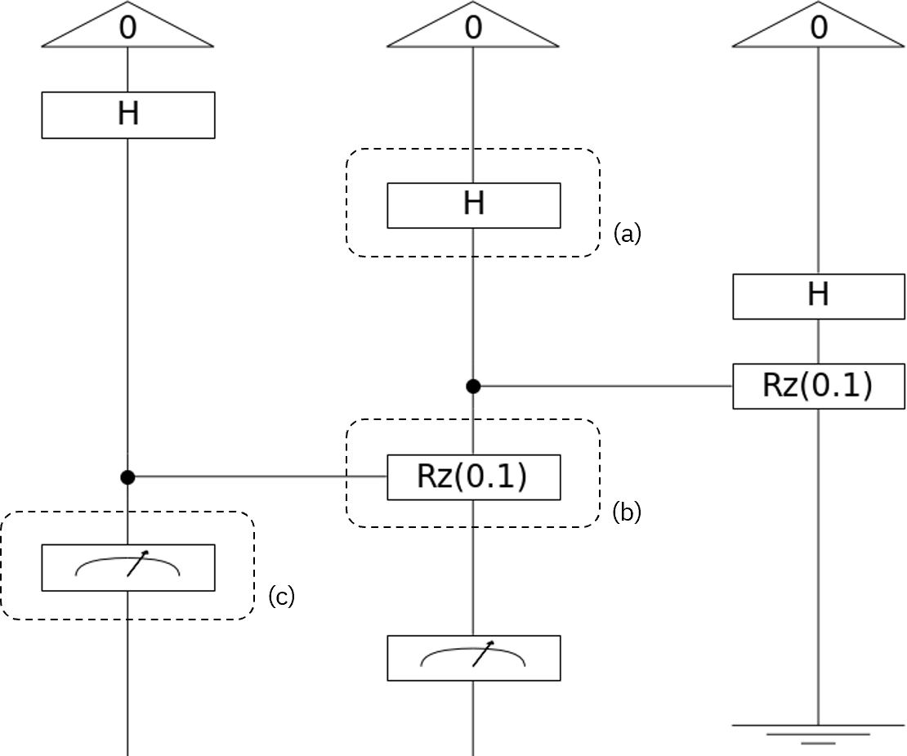
Figure 1: A three qubit quantum circuit U with different gates. (a) represents a Hadamard gate,
(b) a parameterized controlled Z-Rotation and (c) a measurement operation

This allows us to define a generic way of per- forming supervised machine learning tasks using variational quantum circuits. The data is first encoded in a quantum state |ψ₀⟩. We then ap- ply a parameterized quantum circuit U (θ) to |ψ₀⟩, where θ is trained with the labeled dataset. We measure the wave function |ψ⟩ = U (θ) |ψ₀⟩. The result being probabilistic by nature, we perform this operation multiple times to retrieve the out- come probabilities.
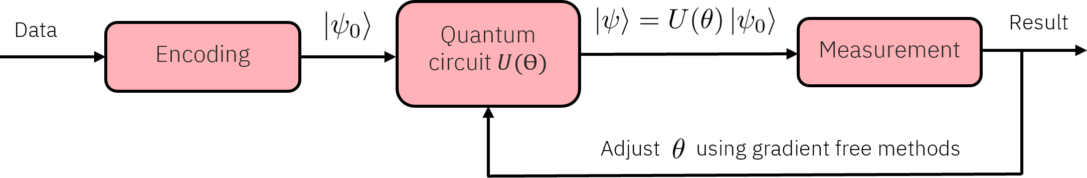

Figure 2: Pipeline to perform supervised machine learning tasks on a quantum computer

The choice of Ansatz for U is crucial, since the design of the circuit has to be chosen so that the result is a function of the outcome probabilities. In some cases, the result is not directly a function of the outcome probabilities of the n qubits, but a function of the outcome probabilities of n − r qubits under some conditions that have to satisfy the other r qubits. In Figure 1, we could expect the second and third qubits to be 0 for our run to be valid, the result only being given by the first qubit.
This requires some additional post-selection, forcing us to only keep the runs where the con- ditions on the r qubits are met. This will be par- ticularly important in the following, since we will expect 0 effects on many of our qubits.

The DisCoCat model
The categorical compositional distributional (Dis- CoCat) model of meaning is based on the frame- work of compact closed category, and the reader is invited to read Coecke et al. (2010) for a complete introduction. The main idea behind DisCoCat is to decompose the language into two components. We first associate each word a meaning, as com- monly done using word embedding. This word embedding can be done by projecting the words on a vector space made of basis vocabulary (for example 700 words). The second component of our language is the syntactic structure of the sen- tences, which is commonly represented by a syntax tree. How the words relate to each other tells us the global meaning of the sentence. An example of such syntax tree can be found in Figure 3
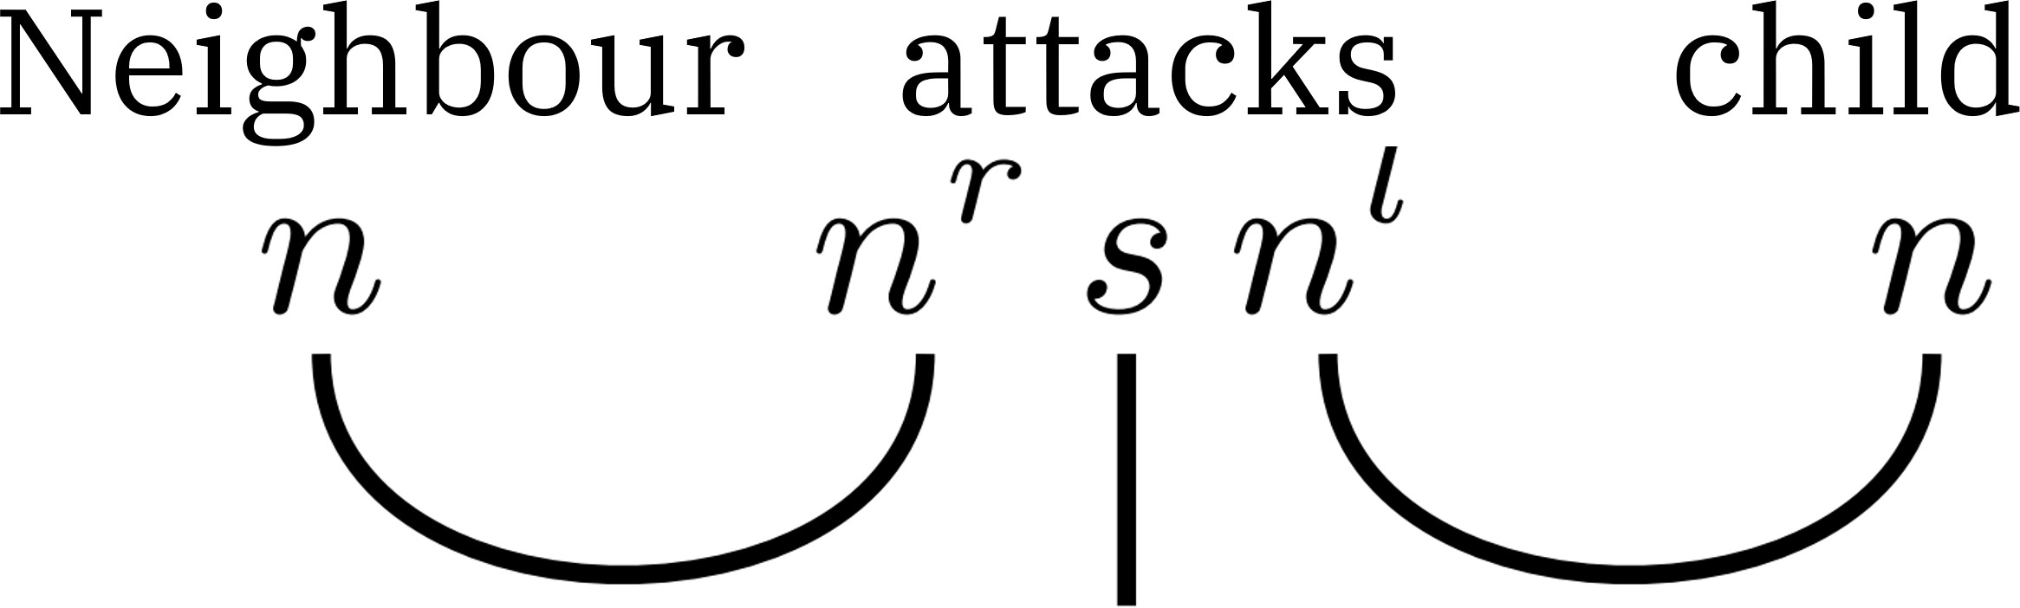

Figure 3: Syntax tree of a simple noun-verb-noun sentence
Taking into account both those aspects can be done through the use of tensor products by follow- ing the below steps.
  - Compose the tensor product of every word through their word embedding.
s = w₁ ⊗ w₂ ⊗ ... ⊗ w_{n}
  - Construct a linear map F corresponding to the sentence’s syntax tree.
  - Apply the linear map to the vector s, retriev- ing the meaning of the sentence S = F(s).
Why this DisCoCat model is particularly suited to quantum computing now becomes apparent. The Tensor Product Representation (TPR) requires to store the tensor product between n words, which scales exponentially in n. This makes this model unusable on classical computers, with several ter- abytes required to store a single sentence. How- ever, as seen in Section 1, storing the tensor prod- uct of n words will scale linearly in the number of qubits. A more convenient way of handling these TPR is through the direct use of DisCoCat dia- grams. This representation is illustrated in Fig- ure 4, where boxes denote tensors and links tensor contractions.
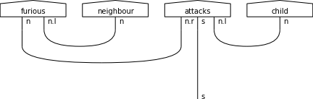

Figure 4: DisCoCat diagram of the sentence Furi- ous neighbour attacks child

Using this quantum-suited representation of lan- guage as our data encoding process, we can take a closer look on how to perform NLP tasks.

General pipeline for QNLP tasks
We can define a general framework for performing QNLP tasks with the steps below.
  - The sentence is parsed to obtain its syntax tree. For large datasets, this would require an automatic parser.
  - The syntax tree and the sentence are then combined to obtain the DisCoCat diagram which is written in an efficient way.
  - The DisCoCat diagram is mapped to a pa- rameterized quantum circuit, which param- eters are obtained through training.
  - The quantum circuit is compiled and exe- cuted on a quantum computer multiple times to retrieve the measurement statistics.
  - Post-processing is performed to select only runs where the r qubits have 0 effects. This gives us the final result.

Those steps are summarised in Figure 5. In Sec- tion 4, those steps will be detailed on a real senti- ment analysis task.
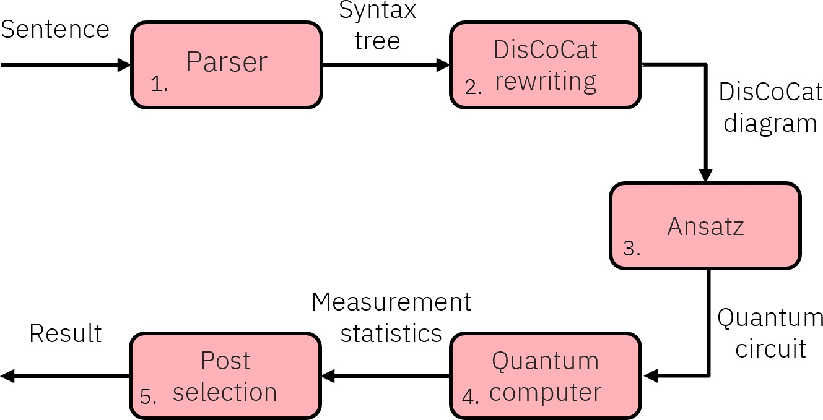

Figure 5: Pipeline to perform NLP tasks on a quantum computer

Sentiment analysis experi- ment
Lorenz et al. (2021) defined this framework and tested it on two-class meaning classification, yield- ing promising results. In this paper, we propose a similar approach to perform sentiment analysis on four emotions with a larger dataset. We restrict ourselves to the four most basic emotions: happi- ness, fear, anger, sadness. We will be using 3 and 4 words sentences, since we will be working with simulators or small size quantum computers.
To circumvent the absence of automatic parser at our disposition, we create the sentences based on their syntax. We first start by defining the nouns, adjectives, transitive and intransitive verbs that will constitute our dataset. For each syntax
- for example adjective-noun-verb-noun - we cre- ate every sentence possible matching this syntax. We therefore have access to the syntax of every sentence in our dataset.

Nouns | Adjectives | Verbs
neighbour child  boy | anxious  ecstatic irritated distressed blissful furious petrified frightened miserable young, blind  cheerful | attack  scare anger amuse demoralise cry  laugh dance scream

The second step, corresponding to the writing of the DisCoCat diagram, is done through Dis-
coPy, an open source toolbox for computing with monoidal categories developed by Felice et al. (2021). This allows us to efficiently write the diagrams and map them to quantum circuits. An example of
a DisCoCat diagram and its associated quantum circuit is depicted on Figure 6. The parametrisa- tion of the Ansatz was done following Lorenz et al. (2021) and led to using two qubits for verbs and nouns.
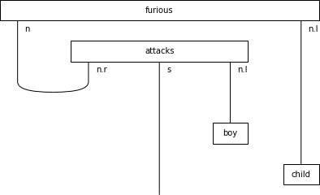
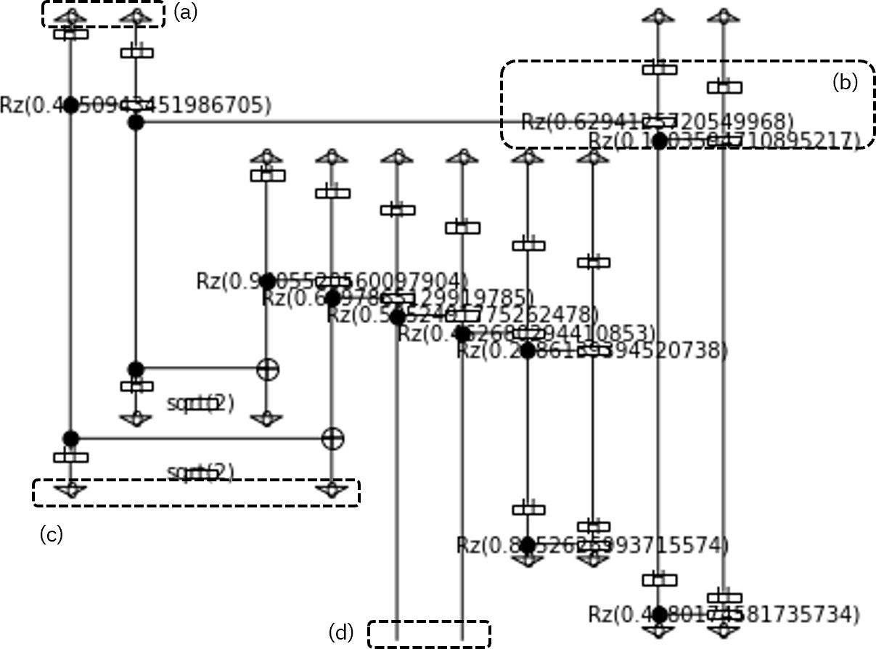

Figure 6: DisCoCat diagram and its associated quantum circuit. (a) Top qubits represent the ini- tial qubits. (b) Gates applied to the qubits. (c) Bottom qubits expected to be 0. (d) Measured qubits giving the result probabilities

We run the circuits multiple time with post- selection and measure the two qubits of interest to retrieve the outcome probabilities (|00⟩, |01⟩, |10⟩,
|11⟩). These outcome probabilities directly give us the emotion linked to our sentence. The pa- rameters of the Ansatz are trained using a Cross- entropy loss and the outcome probabilities. The optimiser chosen was COBYLA, a gradient free optimizer. We split our dataset into a training and test dataset and plot the evolution of the cost function on the training dataset in Figure 7.

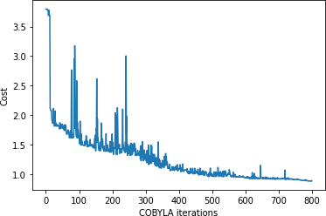

Figure 7: Evolution of the cross entropy on the training dataset

Once the training of our variational quantum circuits has converged, we measure our accuracy on the test dataset made of 180 sentences. We plot the results in the form of a normalized confusion matrix, comparing the ground truth and predic- tion.
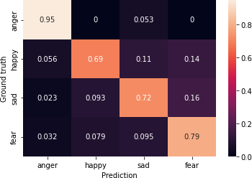

Figure 8: Normalized confusion matrix on the test dataset
We reach satisfying accuracy results with an F1-score of 78%, with a confusion matrix concen- trated on the diagonal.

Conclusion and prospects
The DisCoCat model of meaning, by its structure and the computations it entails, seems to be an adequate way of tackling NLP problems on quan- tum machines. The potential scalability of the presented experiment bodes well for the future. The sentence length, the number of sentences and the vocabulary basis all grow linearly or sublin- early in the number of qubits. Running inde- pendent evaluations of quantum circuits on mul- tiple quantum processors -if they become more accessible-, could be an adequate way of handling huge amount of sentences. With quantum pro- cessors of around 1000 qubits, performing NLP
experiments on whole texts could be possible. In this paper, we have started to show the potential scalability of this method, realising for the first time a sentiment analysis with four emotions with a dataset of over 800 sentences.
However, it is still important to remind that we are to this day still far from a quantum ad- vantage. For the experiment presented in this pa- per, a simple TF-IDF feature extractor coupled with a Naive Bayes classifier reached 95% accu- racy. This can be explained by the simplicity of the sentences used along with the small depth of the quantum circuits at hand. In a more general way, supervised learning can be directly linked to kernel methods, with the mapping to the higher dimensional Hilbert space corresponding to the en- coding of the data on the quantum computer. For a quantum advantage to arise, the kernel linked to this higher dimensional mapping has to be hard to simulate classically, as shown by Schuld (2021).

References
Coecke, B., Sadrzadeh, M., and Clark, S. (2010). Mathematical foundations for a compositional distributional model of meaning. CoRR.
Felice, G. D., Toumi, A., and Coecke, B. (2021). DisCoPy: Monoidal categories in python. Elec- tronic Proceedings in Theoretical Computer Sci- ence, 333:183–197.
Lorenz, R., Pearson, A., Meichanetzidis, K., Kart- saklis, D., and Coecke, B. (2021). QNLP in practice: Running compositional models of meaning on a quantum computer. CoRR.
Nielsen, M. A. and Chuang, I. L. (2010). Quantum Computation and Quantum Information. Cam- bridge University Press.
Schuld, M. (2021). Supervised quantum machine learning models are kernel methods.

