Quantitative Options Analysis Toolkit: A Containerized Platform for Front-Office Derivatives Analytics

Abstract
This paper presents the Quantitative Options Analysis Toolkit (QOAT), an integrated, containerized web application designed to support the full workflow of a front-office quantitative analyst on an options trading desk. The system encompasses six functional modules—options pricing, volatility surface modeling, strategy backtesting, scenario simulation, profit-and-loss attribution, and real-time risk monitoring—deployed within a Docker container for reproducible, environment-independent operation. Built entirely in Python with a Streamlit-based interactive dashboard, QOAT implements industry-standard quantitative models including Black-Scholes analytical pricing, the Heston stochastic volatility model via characteristic function integration, SABR volatility calibration (Hagan et al., 2002), and Taylor-expansion-based P&L decomposition. This paper describes the system architecture, the mathematical foundations underlying each module, the implementation methodology, and representative use cases drawn from options market-making and proprietary trading contexts.

1. Introduction
Modern options market-making and proprietary trading desks require a tightly integrated suite of quantitative tools that span the entire trade lifecycle—from pre-trade analytics and model calibration through real-time risk monitoring to post-trade performance attribution. Quantitative analysts (“quants”) operating in this environment must bridge the gap between theoretical derivatives pricing models and the practical demands of a live trading operation, including accurate volatility fitting, robust strategy backtesting, rapid scenario analysis, and rigorous P&L explanation.
Despite the availability of commercial platforms such as Bloomberg DLIB, Murex, and Calypso, there remains a persistent need for lightweight, customizable, Python-native toolkits that can be rapidly prototyped, iterated upon, and deployed alongside production C++ pricing libraries. Such tools serve as the research and prototyping layer that quants use to validate new models before handing them off to developers for productionization.
The Quantitative Options Analysis Toolkit (QOAT) addresses this need by providing a modular, Dockerized platform with six core functional areas:
- Options Pricer & Greeks Calculator — Multi-model pricing with full analytical and numerical Greeks
- Volatility Surface & SABR Calibration — 3D surface construction and stochastic volatility model fitting
- Strategy Backtester — Delta hedging simulation and multi-leg strategy evaluation
- Scenario Simulator & Stress Testing — Portfolio-level what-if analysis across multiple risk dimensions
- P&L Attribution — Greeks-based decomposition of daily profit and loss
- Risk Dashboard — Real-time portfolio monitoring with VaR, Greeks exposure, and configurable alerts
The remainder of this paper is organized as follows: Section 2 describes the system architecture and deployment model. Sections 3 through 8 detail each module’s mathematical foundations and implementation. Section 9 discusses the technology stack, and Section 10 concludes with directions for future development.

2. System Architecture

2.1 Deployment Model
QOAT is packaged as a single Docker container, ensuring environment-independent reproducibility. The docker-compose.yml configuration exposes the application on port 8501 with a volume mount for live code reloading during development:
services:
quant-tool:
build: .
container_name: quant-options-toolkit
ports:
- "8501:8501"
volumes:
- .:/app
environment:
- STREAMLIT_SERVER_RUN_ON_SAVE=true
The Docker image is based on python:3.11-slim with a health check endpoint to support orchestration and monitoring.

2.2 Application Structure
The codebase follows a clean separation between core quantitative logic and presentation:
quant-tool/
├── Home.py # Main entry point and navigation
├── pages/
│ ├── 1_Options_Pricer.py
│ ├── 2_Volatility_Surface.py
│ ├── 3_Strategy_Backtester.py
│ ├── 4_Scenario_Simulator.py
│ ├── 5_PnL_Attribution.py
│ └── 6_Risk_Dashboard.py
├── core/
│ ├── pricing.py # BS + Heston pricing engines
│ ├── greeks.py # Analytical and numerical Greeks
│ ├── volatility.py # SABR model + vol surface construction
│ ├── backtesting.py # Simulation and backtest engines
│ ├── scenarios.py # Scenario and stress testing
│ └── pnl.py # P&L attribution engine
├── Dockerfile
├── docker-compose.yml
└── requirements.txt
This separation ensures that the core/ modules can be independently tested, imported into Jupyter notebooks for ad hoc research, or compiled as a standalone library.

2.3 Home Page
The home page provides an overview of all available modules and their capabilities, serving as a central navigation hub.
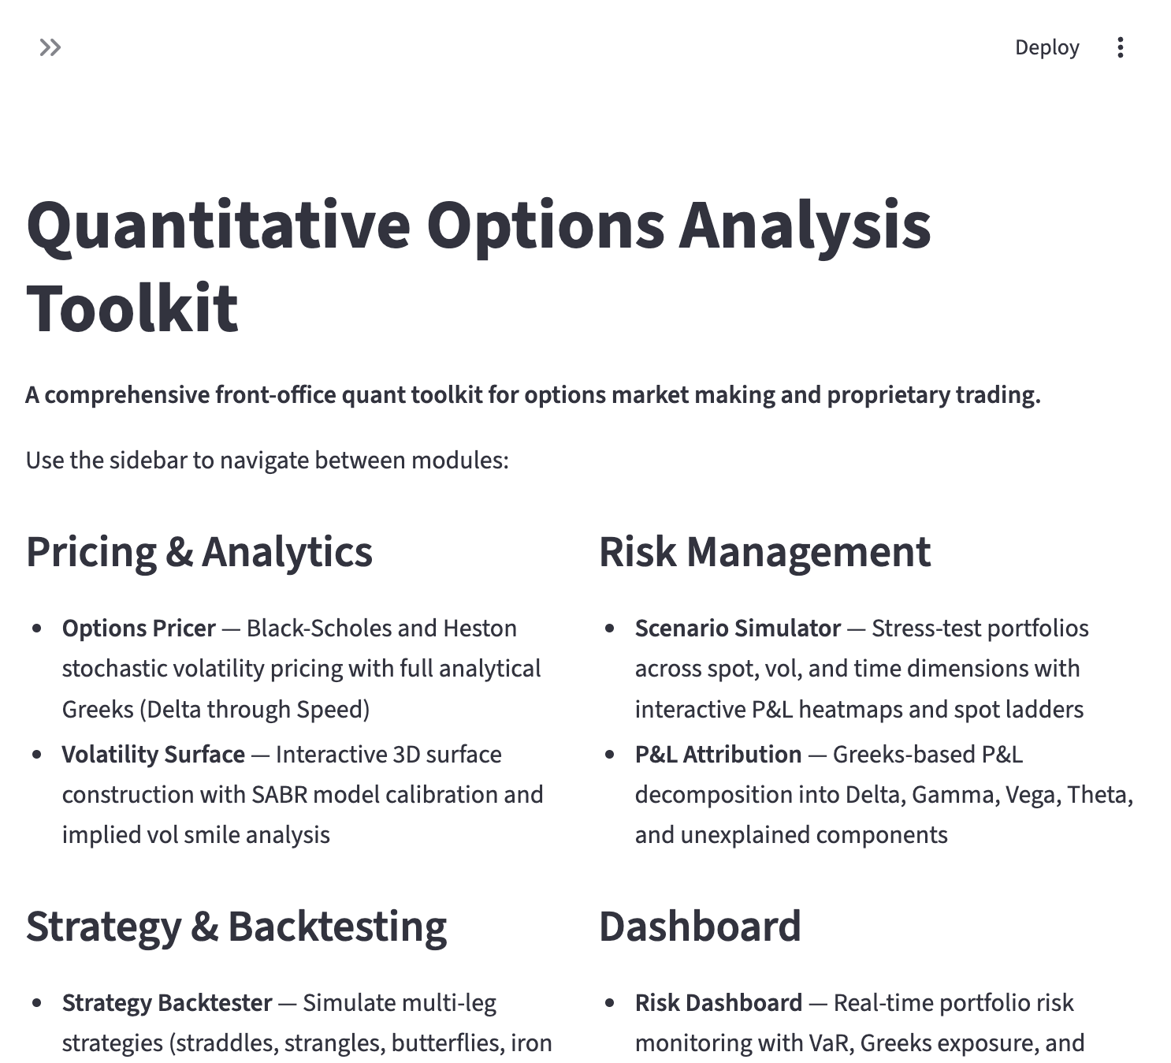
Figure 1: QOAT Home Page — Central navigation hub listing all six analytical modules and the underlying technical stack.

3. Module 1: Options Pricer & Greeks Calculator

3.1 Black-Scholes Pricing
The foundation of the pricing engine is the Black-Scholes (1973) closed-form solution for European options:
$$C=S Φ(d_{1})−Ke^{−rT}Φ(d_{2})$$
$$P=Ke^{−rT}Φ(−d_{2})−S Φ(−d_{1})$$
where:
$$d_{1}=\frac{ln(S/K)+(r+σ^{2}/2)T}{σ\sqrt{T}}, d_{2}=d_{1}−σ\sqrt{T}$$
Implied volatility is recovered via Brent’s root-finding algorithm over the interval $[ϵ,10]$.

3.2 Analytical Greeks
The system computes nine analytical Greeks:
Greek | Formula | Interpretation
Delta ($Δ$) | $Φ(d_{1})$ (call) | Sensitivity to spot price
Gamma ($Γ$) | $ϕ(d_{1})/(Sσ\sqrt{T})$ | Curvature of delta
Vega ($V$) | $Sϕ(d_{1})\sqrt{T}$ | Sensitivity to volatility
Theta ($Θ$) | $−Sϕ(d_{1})σ/(2\sqrt{T})−rKe^{−rT}Φ(d_{2})$ | Time decay
Rho ($ρ$) | $KTe^{−rT}Φ(d_{2})$ | Sensitivity to rates
Vanna | $−ϕ(d_{1})d_{2}/σ$ | Cross-sensitivity: delta to vol
Volga | $Sϕ(d_{1})\sqrt{T}⋅d_{1}d_{2}/σ$ | Convexity of vega
Charm | $∂Δ/∂T$ | Delta decay over time
Speed | $∂Γ/∂S$ | Rate of gamma change

3.3 Heston Stochastic Volatility Model
For a more realistic treatment of volatility dynamics, QOAT implements the Heston (1993) model:
$$dS=μS dt+\sqrt{v} S dW_{1}$$
$$dv=κ(θ−v) dt+σ_{v}\sqrt{v} dW_{2}$$
$$\text{Corr}(dW_{1},dW_{2})=ρ$$
Pricing is performed via numerical integration of the characteristic function using the Albrecher et al. formulation for numerical stability. The call price is obtained as:
$$C=SP_{1}−Ke^{−rT}P_{2}$$
where $P_{j}$ are probabilities computed via:
$$P_{j}=\frac{1}{2}+\frac{1}{π}\int_{0}^{∞}{\text{Re}}\left[\frac{e^{−iulnK}ϕ_{j}(u)}{iu}\right]du$$
The integral is evaluated using scipy.integrate.quad with adaptive quadrature up to 200 in the integration domain.
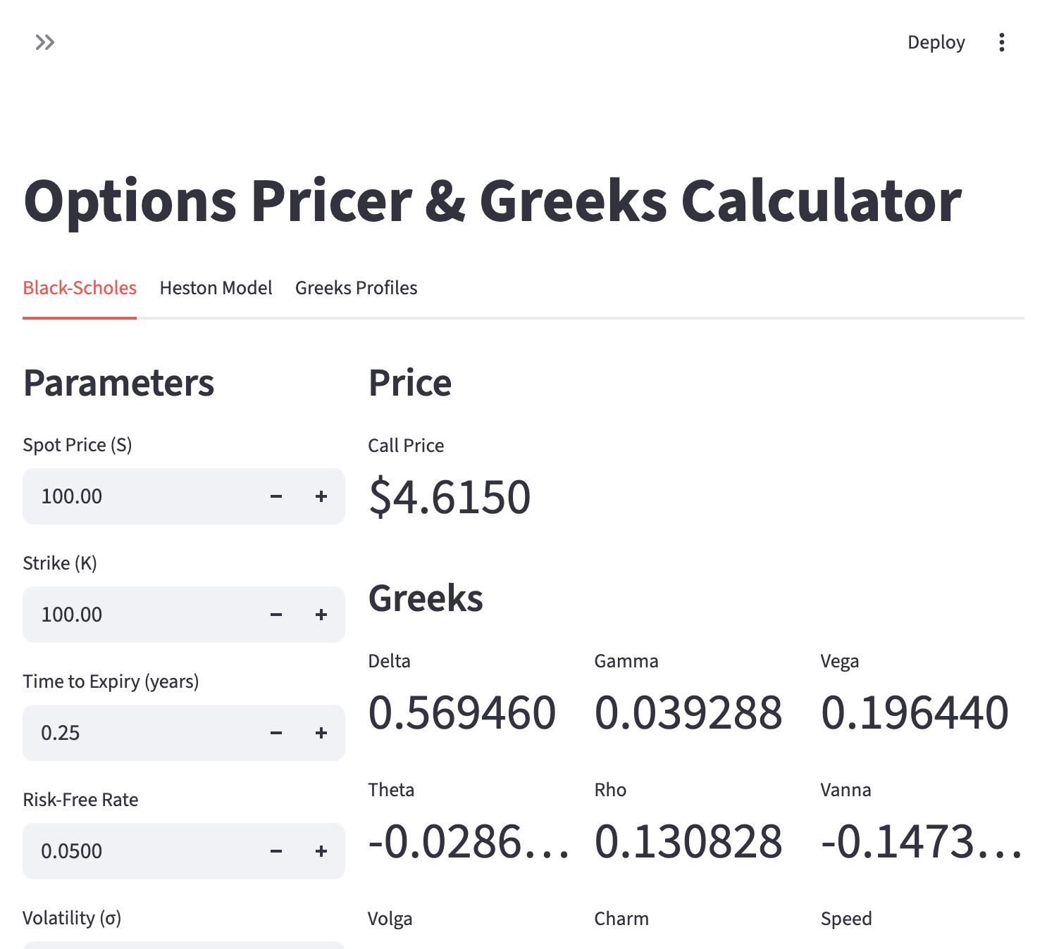
Figure 2: Options Pricer — Black-Scholes tab showing price ($4.6150 for an ATM 3-month call at 20% vol) with all nine analytical Greeks displayed. The interface includes tabs for Heston pricing with implied volatility smile visualization and interactive Greeks profiles.

4. Module 2: Volatility Surface & SABR Calibration

4.1 Surface Construction
The volatility surface is constructed from a matrix of implied volatilities across strikes and expiries. Interpolation is performed via scipy.interpolate.RectBivariateSpline using cubic spline basis functions in both dimensions.
For demonstration and testing, the system generates synthetic surfaces with realistic features:
$$σ_{impl}(K,T)=σ_{0}+αln(K/S)+β[ln(K/S)]^{2}−γ\sqrt{T}+ϵ$$
where $α$ controls the skew, $β$ the smile convexity, and $γ$ the term structure flattening.

4.2 SABR Calibration
The SABR model (Hagan et al., 2002) provides a parametric approximation for the implied volatility smile:
$$σ_{B}(K,F)≈\frac{α}{(FK)^{(1−β)/2}}⋅\frac{z}{x(z)}⋅\left[1+\left(\frac{(1−β)^{2}}{24}\frac{α^{2}}{(FK)^{1−β}}+\frac{ρβνα}{4(FK)^{(1−β)/2}}+\frac{2−3ρ^{2}}{24}ν^{2}\right)T\right]$$
The calibration routine minimizes the sum of squared differences between model and market implied volatilities using the Nelder-Mead simplex algorithm. The user can fix $β$ (commonly 0, 0.5, or 1) and calibrate $α$, $ρ$, and $ν$.
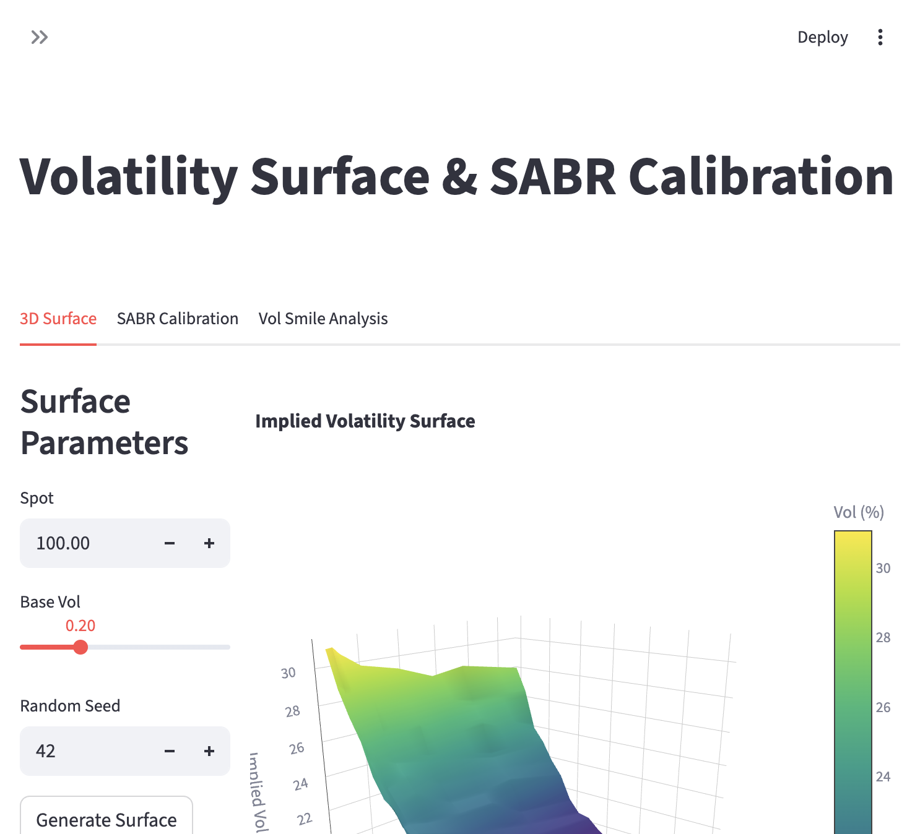
Figure 3: Volatility Surface — 3D implied volatility surface with realistic skew and term structure. The surface shows higher implied volatilities for out-of-the-money puts (left) and short-dated options.
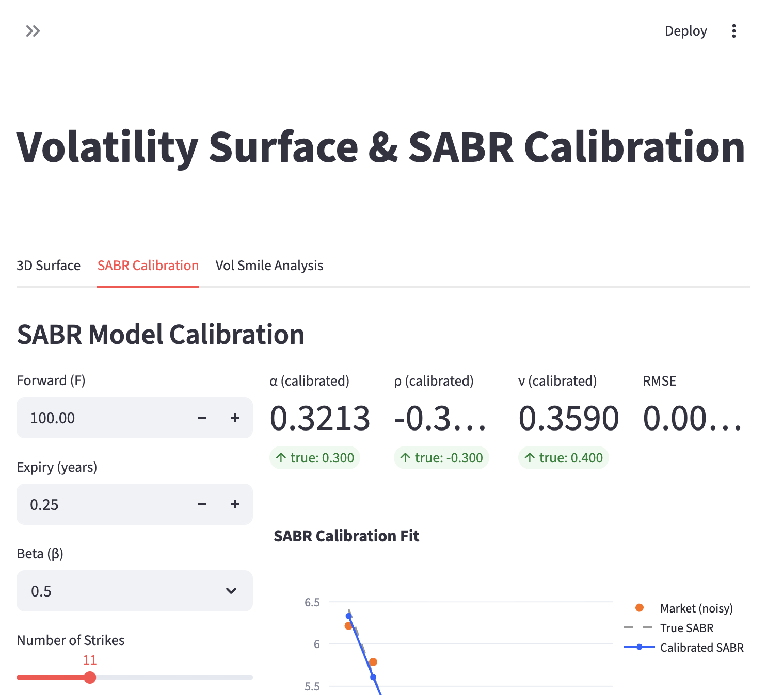
Figure 4: SABR Calibration — Calibrated SABR parameters ($α=0.3213$, $ρ=−0.3188$, $ν=0.3590$) closely match the true generating parameters. The chart overlays market data (noisy), true SABR curve, and calibrated fit with RMSE of 0.0016.

5. Module 3: Strategy Backtester

5.1 Delta Hedging Simulation
The backtester simulates a delta-hedging strategy for a short option position under Geometric Brownian Motion (GBM):
$$S_{t+Δt}=S_{t}exp\left[\left(μ−\frac{σ^{2}}{2}\right)Δt+σ\sqrt{Δt} Z\right]$$
At each rebalancing interval, the hedge portfolio is adjusted to match the current Black-Scholes delta. The simulation tracks daily P&L components:
- Hedge P&L: $Δ×dS$
- Option P&L: $−(V_{t+1}−V_{t})$
- Interest: $\text{Cash}×r×dt$
Users can vary the hedge frequency (daily, every 2, 5, 10, or 20 days) to observe the impact of discrete hedging on P&L variance.

5.2 Multi-Leg Strategy Evaluation
Seven pre-built strategy templates are available:
- Long/Short Straddle
- Long Strangle
- Bull Call Spread / Bear Put Spread
- Long Butterfly
- Iron Condor
Each strategy is simulated under GBM with full tracking of portfolio value, delta, gamma, theta, and vega over time, along with the terminal payoff diagram.
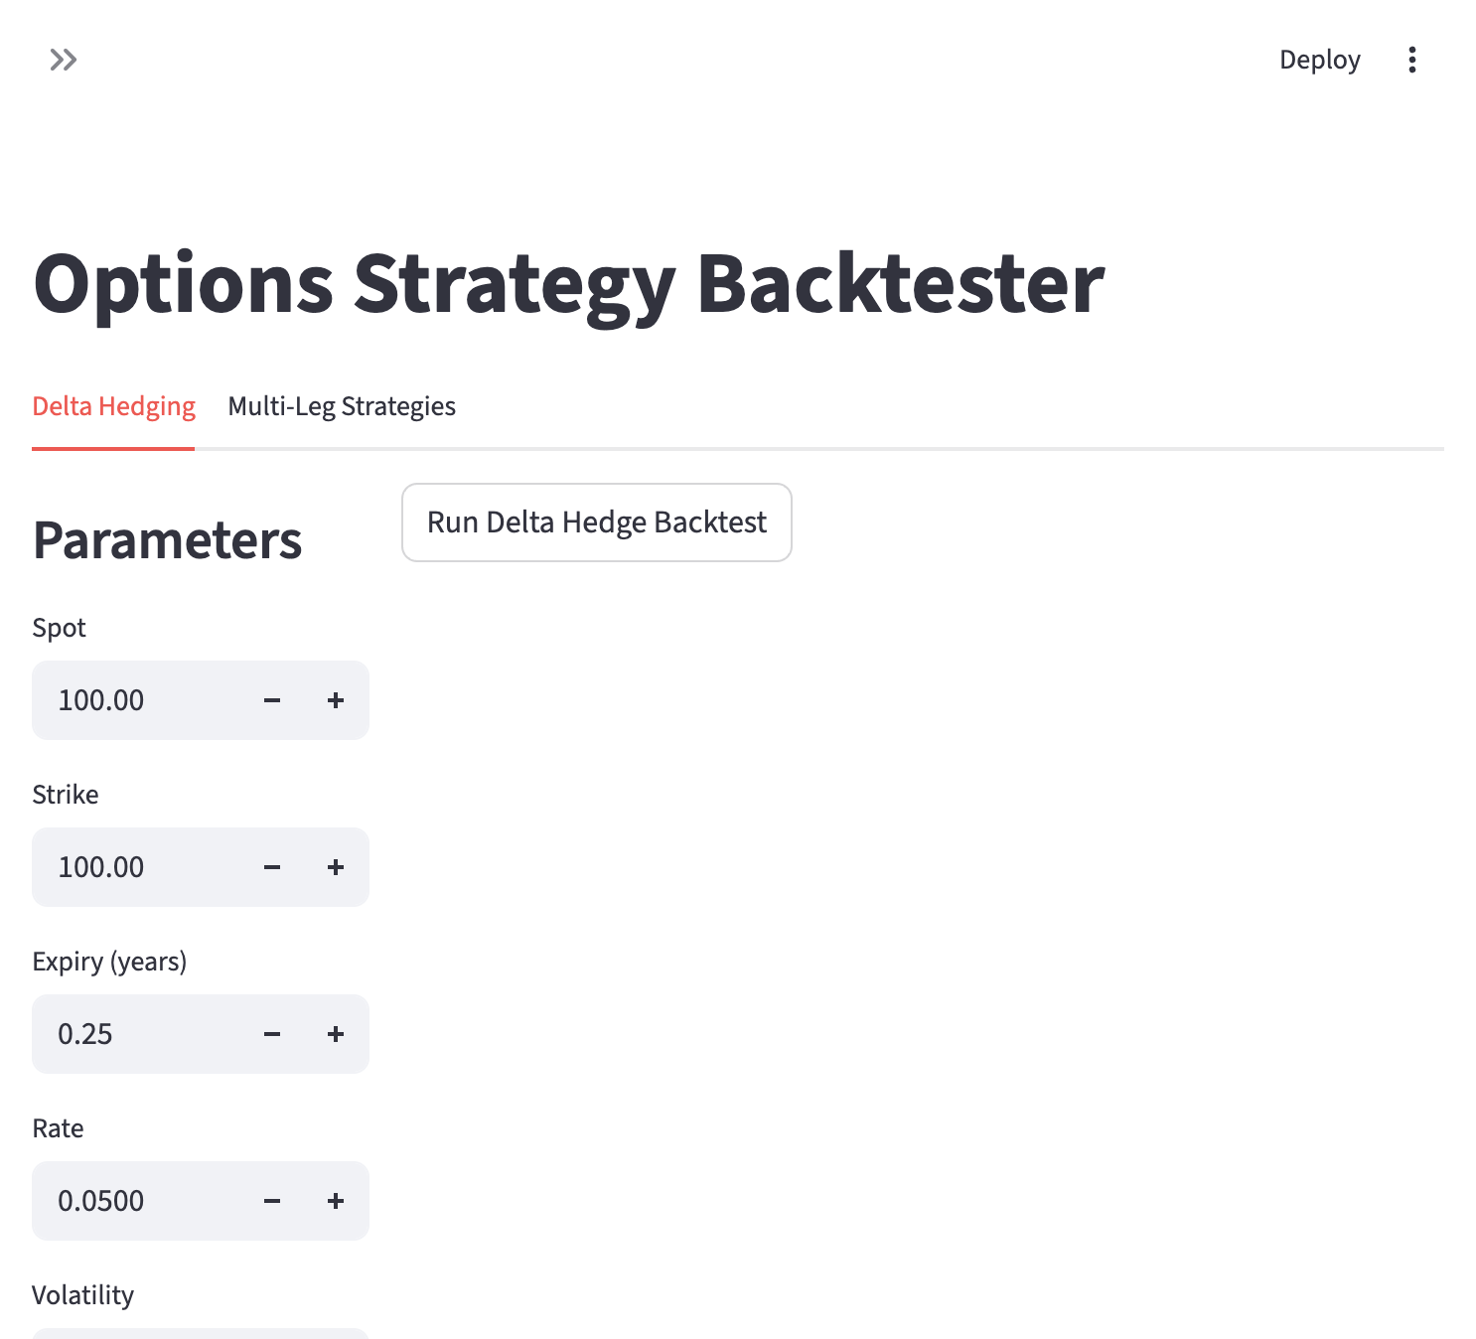
Figure 5: Strategy Backtester — Interface for configuring delta hedging parameters and multi-leg strategy simulations. Supports seven pre-built strategy templates with full P&L tracking.

6. Module 4: Scenario Simulator & Stress Testing

6.1 Spot × Vol P&L Heatmap
The core scenario analysis tool generates a two-dimensional grid of P&L outcomes by simultaneously bumping the spot price and implied volatility:
$$\text{P\&L}(ΔS,Δσ)=V(S+ΔS,σ+Δσ)−V(S,σ)$$
The resulting heatmap provides immediate visual insight into the portfolio’s directional and volatility exposure.

6.2 Stress Testing
Ten pre-configured stress scenarios cover a range of market conditions:
Scenario | Spot | Vol | Time
Crash | -20% | +15pp | 0
Rally | +20% | -10pp | 0
Tail Risk | -30% | +25pp | 0
1 Week Decay | 0% | 0pp | 7d
1 Month Decay | 0% | 0pp | 30d
For each scenario, the system reports the new portfolio value, P&L, and the resulting Greeks (delta, gamma, vega).

6.3 Spot Ladder and Theta Decay
Additional analysis tools include:
- Spot Ladder: P&L and Greeks as a function of the underlying price across a configurable range
- Theta Decay: Portfolio value and Greeks evolution over a forward-looking time horizon
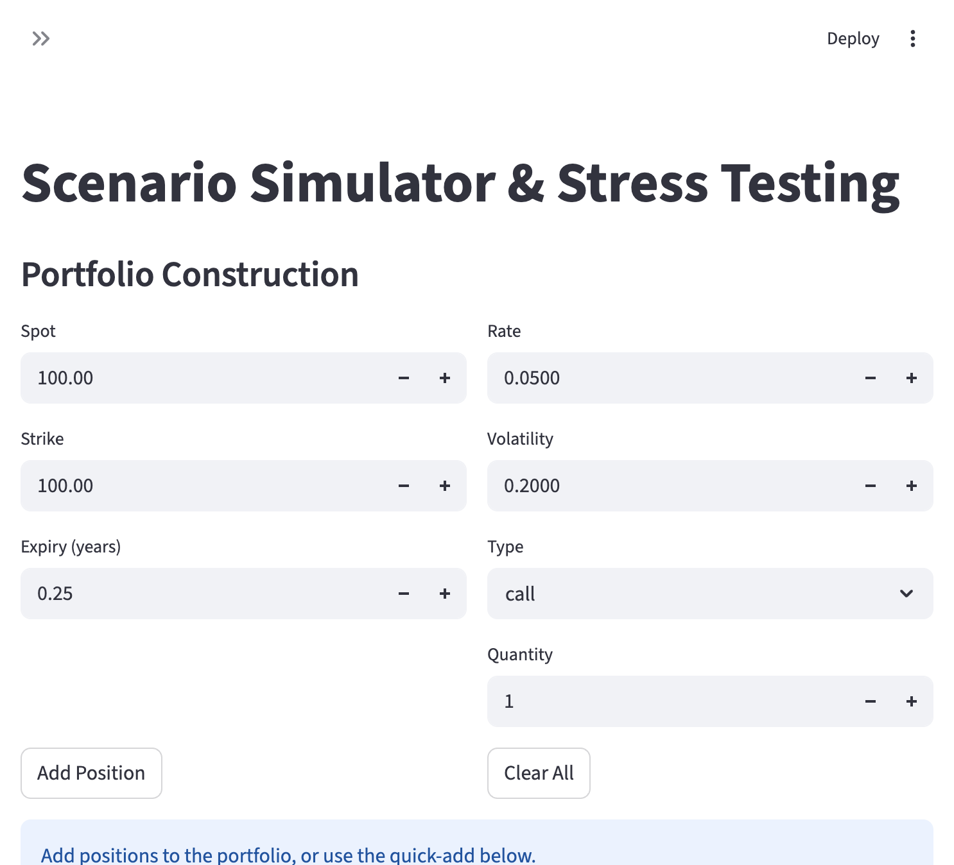
Figure 6: Scenario Simulator — Portfolio construction interface with Add/Clear functionality and a quick-load sample portfolio button. Supports interactive P&L heatmaps, spot ladders, theta decay analysis, and configurable stress tests.

7. Module 5: P&L Attribution

7.1 Greeks-Based Decomposition
P&L attribution decomposes the daily change in option value using a second-order Taylor expansion:
$$dV≈Δ⋅dS+\frac{1}{2}Γ⋅dS^{2}+V⋅dσ+Θ⋅dt+\text{Unexplained}$$
Each component is computed using the previous day’s Greeks and the observed changes in spot price and implied volatility. The “unexplained” residual captures higher-order effects, cross-gammas, and model error.

7.2 Simulation Framework
For demonstration purposes, the system generates synthetic spot and implied volatility paths:
$$S_{t+1}=S_{t}+S_{t}(r⋅dt+σ_{S}⋅Z_{1})$$
$$σ_{t+1}=max(σ_{t}+σ_{drift}⋅Z_{2}, 0.05)$$
where $Z_{1},Z_{2}$ are independent standard normal variates. Users control the daily spot volatility ($σ_{S}$) and the implied volatility drift ($σ_{drift}$).

7.3 Output
The module produces:
- Cumulative P&L stacked area chart — Delta, Gamma, Vega, Theta, and Unexplained components
- Daily P&L bar chart — Component-level breakdown per day with actual P&L overlay
- Greeks evolution — Time series of Delta, Gamma, Vega, and Theta
- Summary statistics — Total, mean, standard deviation, min, max, and annualized Sharpe ratio for each component
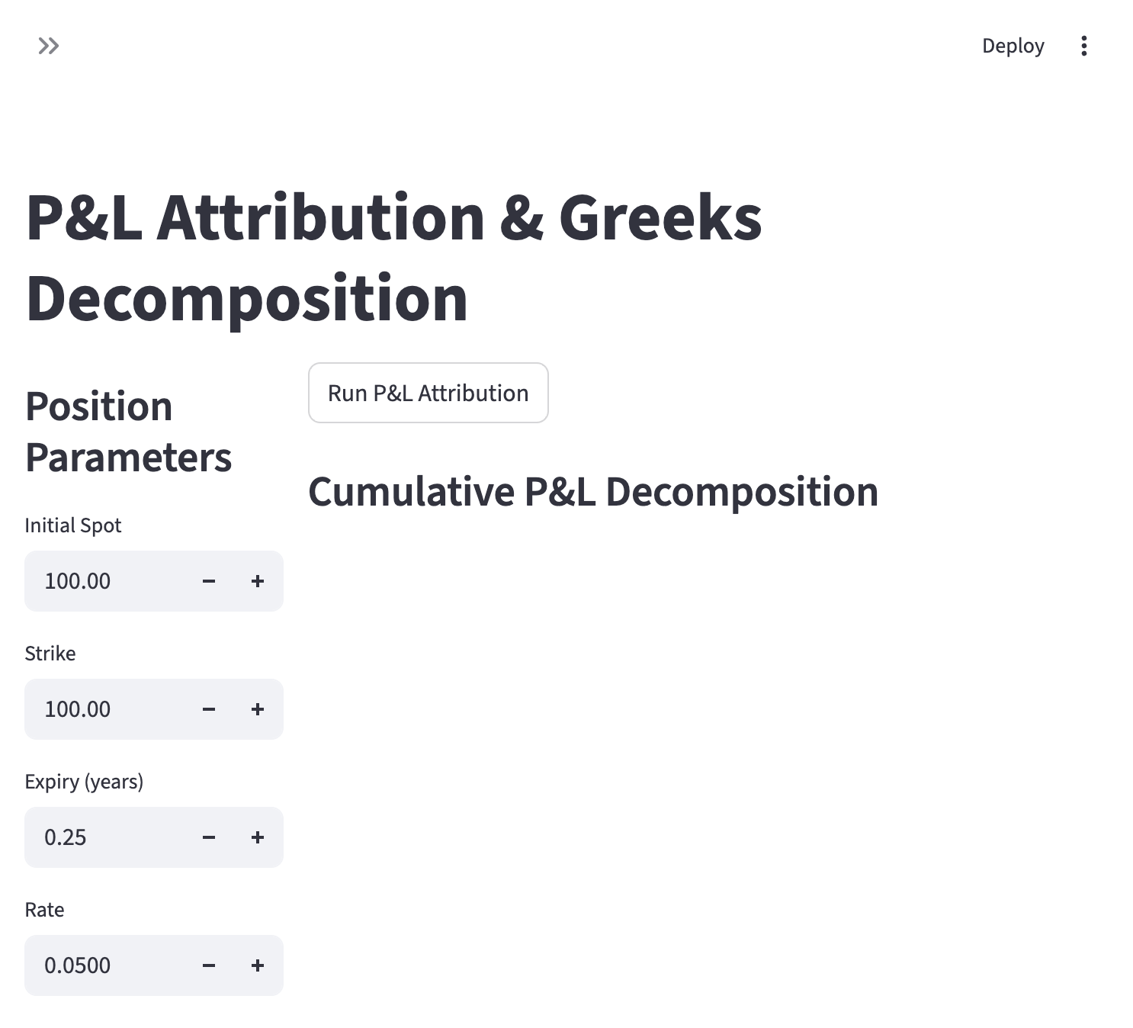
Figure 7: P&L Attribution — Position parameter configuration with cumulative P&L decomposition showing Delta, Gamma, Vega, Theta, and Unexplained contributions.

8. Module 6: Risk Dashboard

8.1 Portfolio Overview
The risk dashboard provides a real-time view of a multi-position options book. A pre-loaded sample book contains six positions spanning calls and puts across three expiry buckets (1M, 3M, 6M) with varying moneyness. The top-level metrics display:
- Total portfolio value
- Net Delta, Gamma, Vega, Theta, Vanna, and Volga

8.2 Value at Risk
Monte Carlo VaR is computed by simulating spot price returns over the specified horizon:
$$S_{T}=S_{0}exp\left(\overset{‾}{σ}\sqrt{Δt}⋅Z\right)$$
For each simulated terminal spot, the portfolio is repriced and the P&L distribution is constructed. VaR and CVaR (Expected Shortfall) are extracted at the user-specified confidence level (90%–99%).
The system also reports the full P&L percentile table (1st through 99th percentile).

8.3 Greeks Exposure Analysis
Portfolio-level Greeks are broken down by:
- Expiry bucket — Delta, Gamma, Vega, and Theta by time-to-maturity
- Strike bucket — Greeks grouped by option strike price

8.4 Risk Alerts
Configurable risk limits are applied to:
- Net Delta, Gamma, Vega, and Theta (absolute value thresholds)
- VaR (maximum loss threshold)
Breaches are highlighted with red (error) or yellow (warning) indicators and summarized in a risk status table.
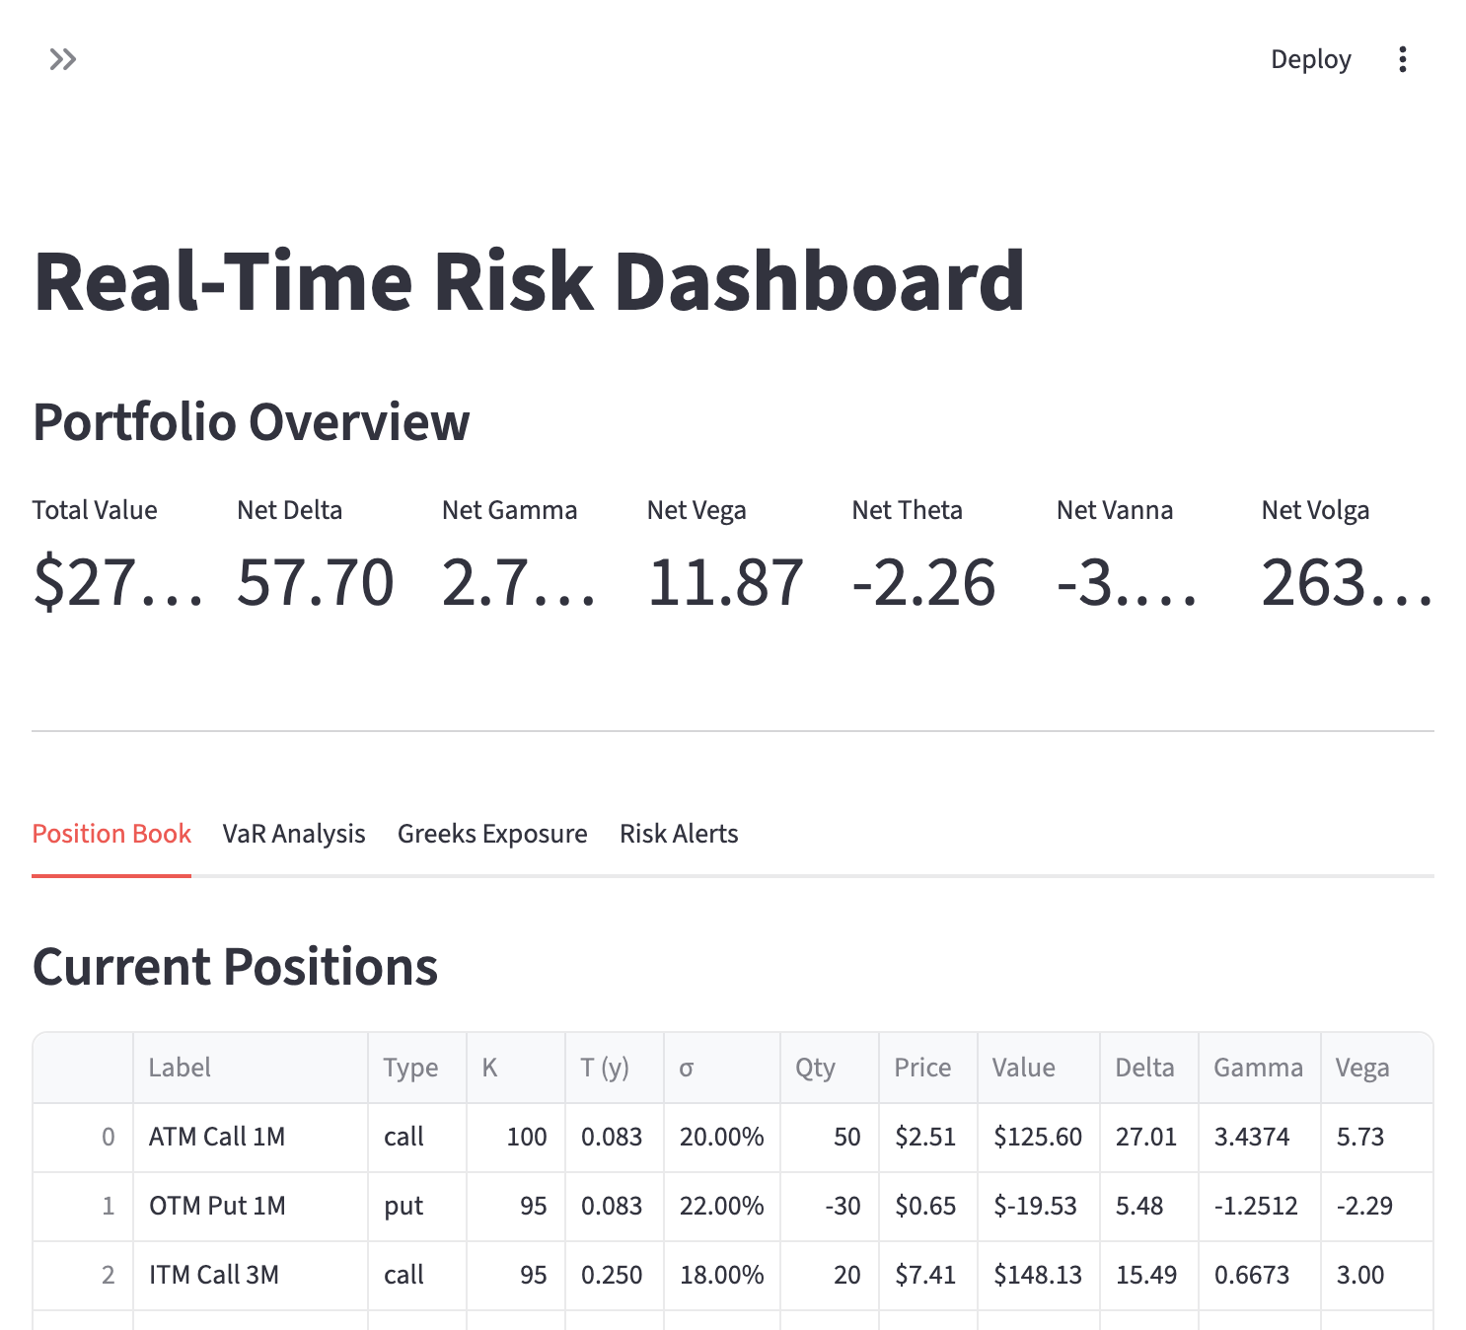
Figure 8: Risk Dashboard — Portfolio overview with net Greeks metrics, position book table (6 positions across 3 expiry buckets), VaR analysis, Greeks exposure breakdown, and configurable risk alerts with breach notifications.

9. Technology Stack
Component | Technology | Rationale
Language | Python 3.11 | Industry standard for quant prototyping
Web Framework | Streamlit | Rapid dashboard development, native Python
Numerical | NumPy, SciPy | Efficient numerical computation, optimization, integration
Data | Pandas | Time-series and tabular data management
Visualization | Plotly | Interactive 3D surfaces, charts, heatmaps
Containerization | Docker | Reproducible, portable deployment
All dependencies are managed via requirements.txt with version pinning. The total image size is approximately 500 MB, and the application starts within 10 seconds of container launch.

10. Limitations and Future Work

10.1 Current Limitations
- Synthetic data only: The current implementation uses generated data for demonstration. Integration with live market data feeds (e.g., via WebSocket APIs from exchanges or Bloomberg B-PIPE) would be required for production use.
- Single-threaded computation: Heston model pricing and Monte Carlo VaR are computed serially. Parallelization via multiprocessing or concurrent.futures would improve performance for large portfolios.
- No persistence layer: Portfolio positions and calibration parameters are stored in Streamlit session state and are lost on page refresh. A database backend (PostgreSQL or Redis) would provide persistence.

10.2 Planned Extensions
- Local volatility model (Dupire, 1994) and SLV (Stochastic Local Volatility) hybrid models
- C++ pricing kernel via pybind11 for latency-sensitive computations, reflecting the production environment where Python prototypes are handed off to C++ developers
- Real-time data integration with WebSocket streaming from cryptocurrency or equity options exchanges
- Historical backtesting on real data using options chain snapshots
- Greeks hedging optimizer for automated portfolio rebalancing
- Multi-asset correlation and cross-gamma analysis for portfolio-level risk

11. Conclusion
The Quantitative Options Analysis Toolkit demonstrates that a comprehensive, interactive front-office quant platform can be built entirely in Python and deployed as a single Docker container. By covering the full spectrum from model calibration through risk monitoring, QOAT provides a cohesive environment for the daily workflow of a quantitative analyst supporting an options market-making desk. The modular architecture ensures that individual components can be independently tested, extended, and ultimately migrated to production-grade C++ implementations.

References
- Black, F., & Scholes, M. (1973). The pricing of options and corporate liabilities. Journal of Political Economy, 81(3), 637–654.
- Dupire, B. (1994). Pricing with a smile. Risk, 7(1), 18–20.
- Hagan, P. S., Kumar, D., Lesniewski, A. S., & Woodward, D. E. (2002). Managing smile risk. Wilmott Magazine, 1, 84–108.
- Heston, S. L. (1993). A closed-form solution for options with stochastic volatility with applications to bond and currency options. Review of Financial Studies, 6(2), 327–343.
- Ho, T., & Stoll, H. R. (1981). Optimal dealer pricing under transactions and return uncertainty. Journal of Financial Economics, 9(1), 47–73.
- Hull, J. C. (2022). Options, Futures, and Other Derivatives (11th ed.). Pearson.
- Merton, R. C. (1973). Theory of rational option pricing. Bell Journal of Economics and Management Science, 4(1), 141–183.

Appendix A: Running the System

Prerequisites
- Docker Desktop installed and running

Quick Start
cd quant-tool/
docker compose up --build -d
The application will be available at http://localhost:8501 within approximately 10 seconds.

Stopping the System
docker compose down

Development Mode
The volume mount in docker-compose.yml enables live code reloading. Edit any .py file and the Streamlit application will automatically refresh.

