Project: Website Should Compatible with (Desktop browsers, Android /iPhone Browsers, Tablets.)
Technology: Latest Stable Html, Tailwind CSS, GitHub Respiratory.
Website Name: www.nahdasafety.com
Address : South Mabalah, Muscat Sultanate of Oman.
Email : contact@nahdasafety.com
WhatsApp : +968 92500747

We have to built world class css website like a Tailwind and best world class UI/UX designs for Nahda Safety & Health Website for suites all type of Web browsers, Mobiles (Android & iPhone) and Tablets support responsiveness and compatibility etc for customers.
Please note that this is first customer we have to give the best output and work like senior architect developer
Actually, someone else designed this but client is not happy, we need to redesign and need to give 2 or 3 versions of web designs.
Existing web developer used html and global css design I think, but we need to redesign with better version which is will be much more better professional and eye catch colorful alignment and Google SEO competitive health safety environment content to reach Oman and international customers.
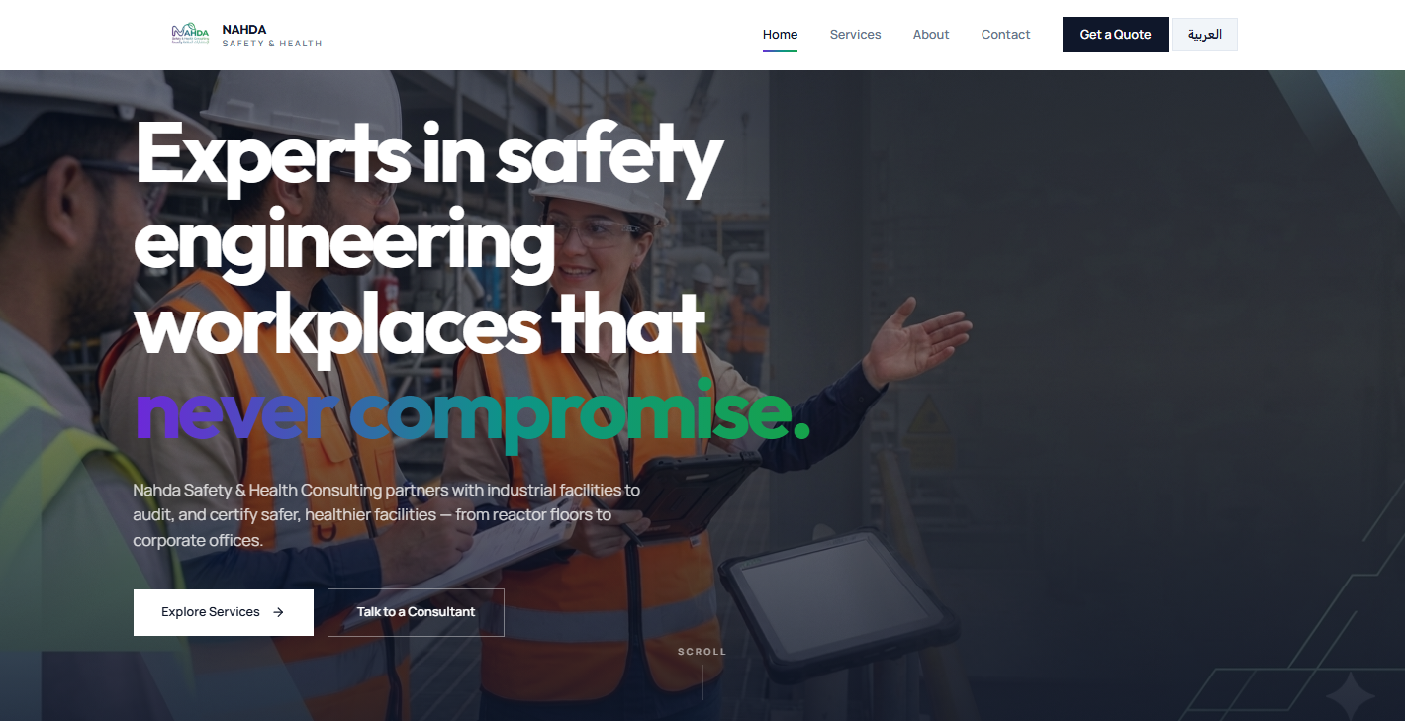

Main Customer Requirements
- Webpage English and Arabic and by default English version only Organic Google SEO wordings to easy to show up website on google first page.
- Website homepage navigation buttons like, Home, About Us, Projects, Services, Ai Consultant, Contact, CEO Talks, Useful Apps, English/Arabic
- Website homepage bottom navigations like catalogue or brochure, social media url icons, WhatsApp assistant click to direct business WhatsApp mobile to communicate. Email address click to connect easily.
- Home page: I am giving my ideas but you can make better suggestions and you can brainstorm and advise to make better website.
  - Google SEO competitive content regarding the business concept
  - Sliding images
  - WhatsApp assistance button
  - Welcome Ai popup sticker that should tell small warm welcome note visiting website and suggest them services based on them google searching related health safety services or consultants
  - Ai health safety sliding sticker based on the space and design fitting not make clumsier.
  - Customers reviews.
  - What are Frequently Asked and Search Questions (put some 10 to 15 Q & A) which can be more useful for visitors and even Google SEO organic listing.
  - Visitor counts, happy customers count, projects count.
- CEO Talk:
  - CEO Photo placeholder
  - Professional wording content regarding his vision and work experience, safety gaps to fulfilling for his business, goals and targeting sectors like schools, hospitals, constructions companies, oil and gas companies, small grade companies etc. content should not be more, user-friendly, Google SEO competitive.
- Useful Apps:
  - Kindly add some important Android/Apple Safety App for customers to know to use for their business. And get some inbound traffic to visit our website even.
  - Useful weblinks and YouTube links.
- About Us:
  - Kindly focus and try to mention the content on what are our core business regarding the Nahda Safety Services company does.
  - Achievements, Awards, Certificates placeholders etc.
- Projects:
  - Need to show up current project like some oil & Gas and schools, hospitals projects etc projects as this business is new, need to provide proper information but visitor should not get doubt about it.
- Services Page:
  - This page like a product of services list what kind of services Nahda Safety & Health company does. So we need to provide the some health and safety service list like schools, hospitals, small grade companies, hotels, restaurant, Oil & Gas companies, Constructions companies those who can not afford the safety advisor, Nahda safety team will help them all areas like legal and documentations and inspections and coordinate with govt officials behalf of the companies, sort term and log terms contracts or project to project consultations etc.
  - Best Product icons with worldclass grids, shape inside the service product useful and SEO based content.
- Ai Consultant:
  - Brainstorm the Ai Consultant would like to use this feature for next level for this business to helping out brainstorm properly and make this feature ultimate to attract the customers.

