Object Detection

Test 1:
A simple subtraction of A – B = C results in poor images. Pixels channels range from 0-255. If a pixel in B is greater than its corresponding pixel in A, the result will be a negative pixel in C. The pixel will be rounded to 0, which is the full intensity of that color channel. Minute differences in images will result in very noisy images.
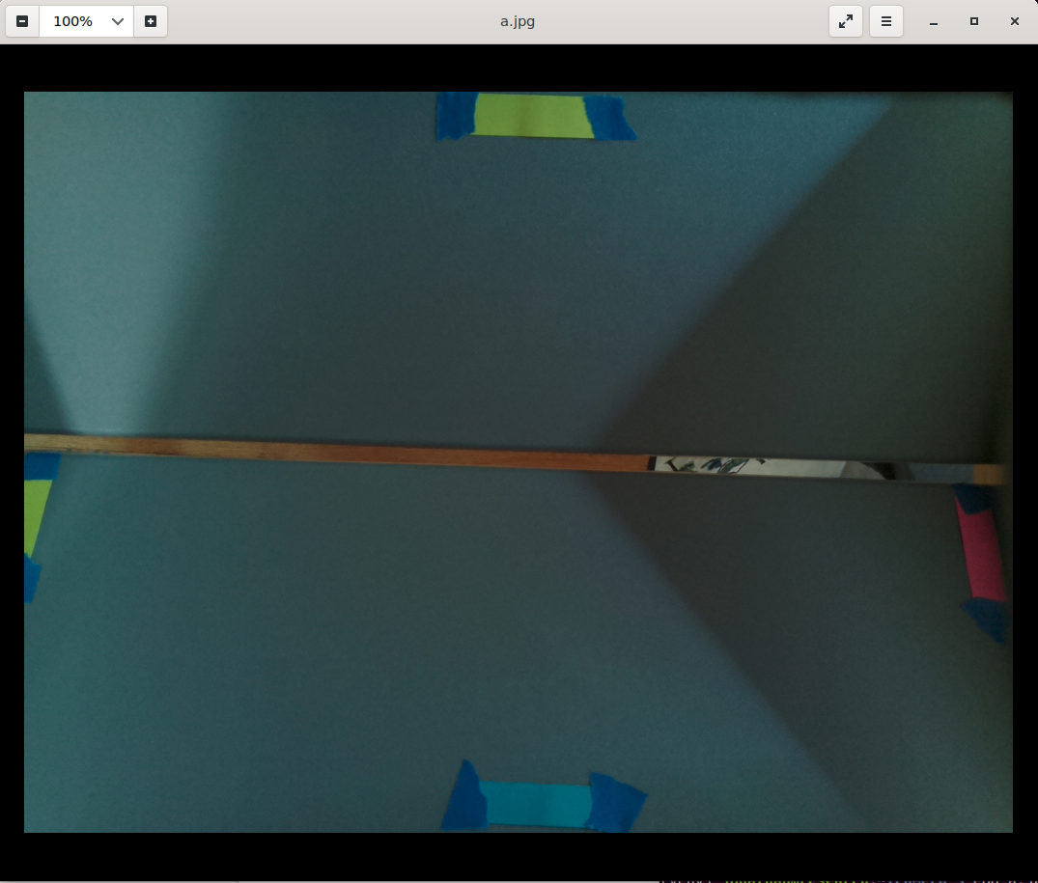Background
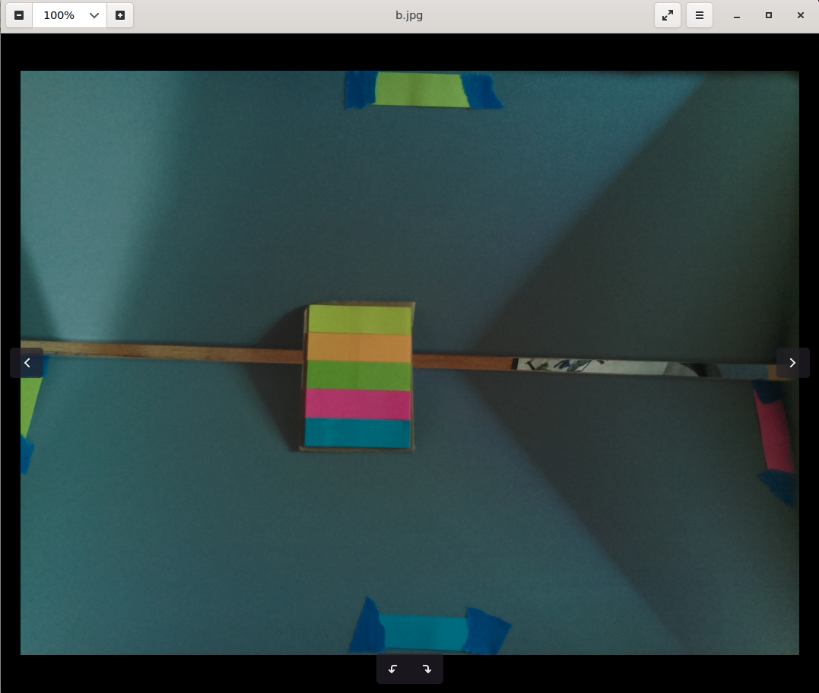Current Frame
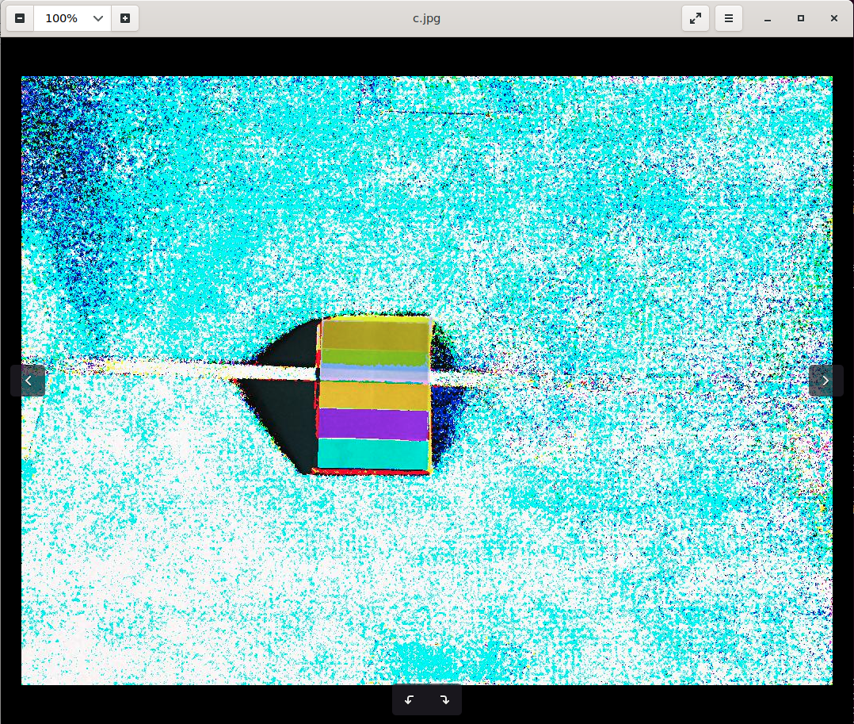Result

Test 2:
Use absolute difference between pixels. This guarantees that every pixel channel will be from 0-255.
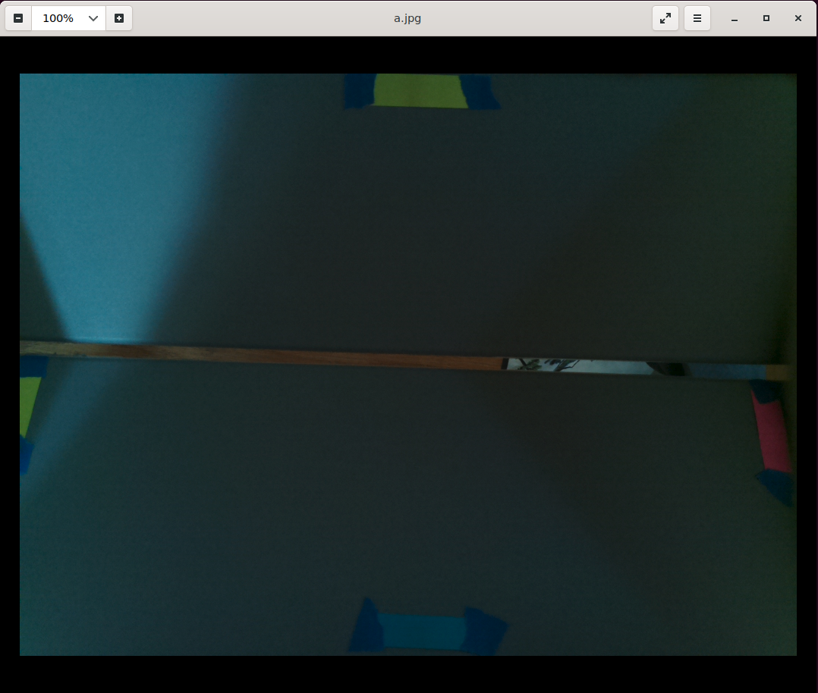Background
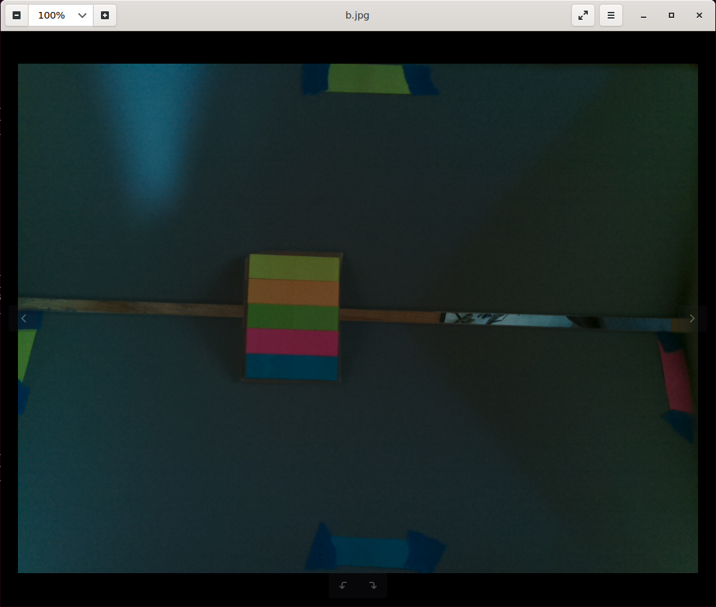Current Frame

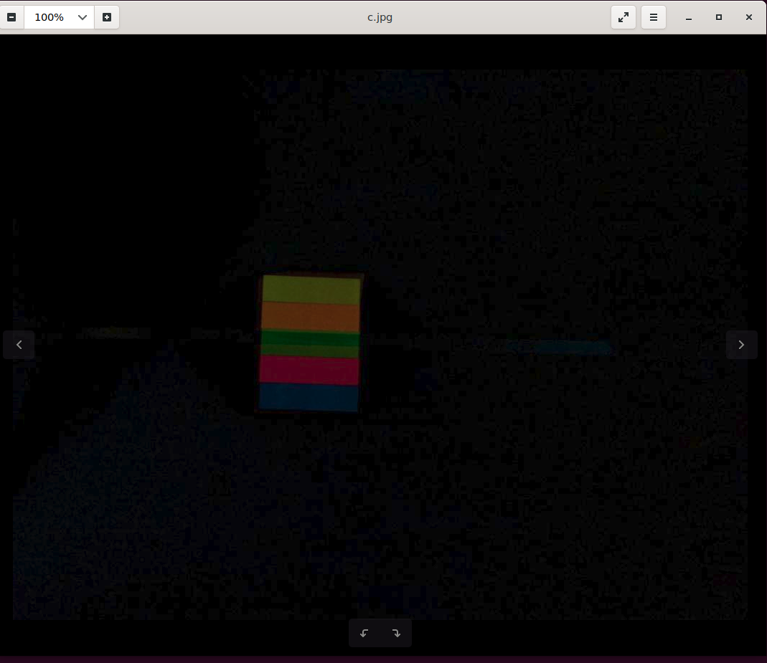Result

However, changes in lighting and shadows can mess up results.
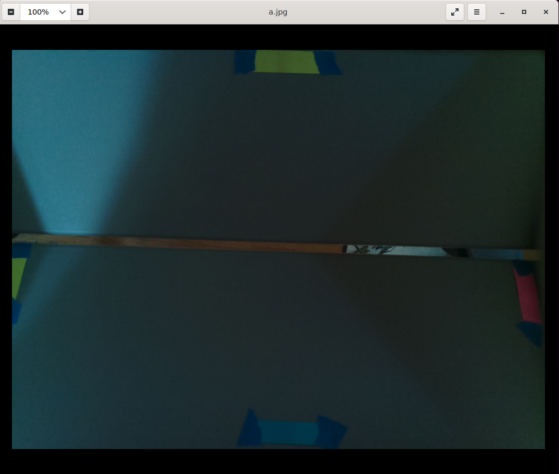Background
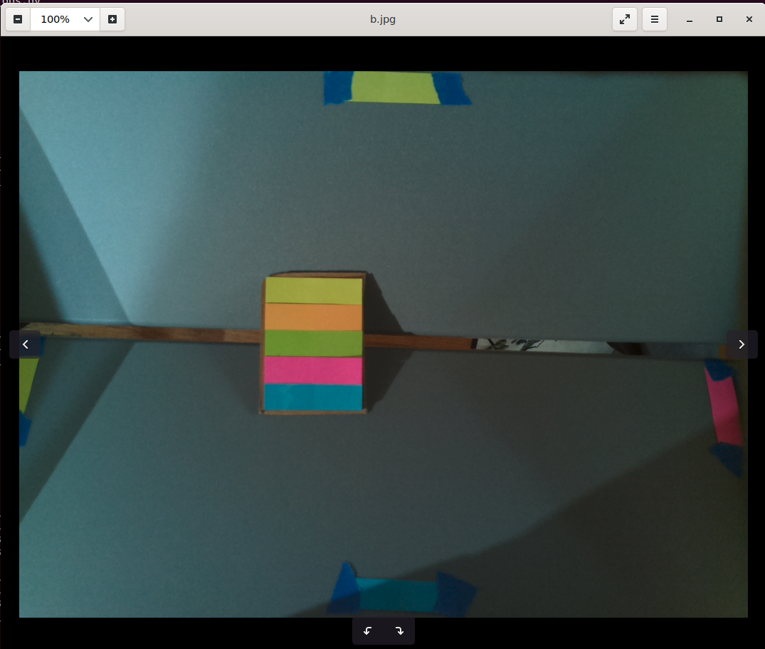Current Frame

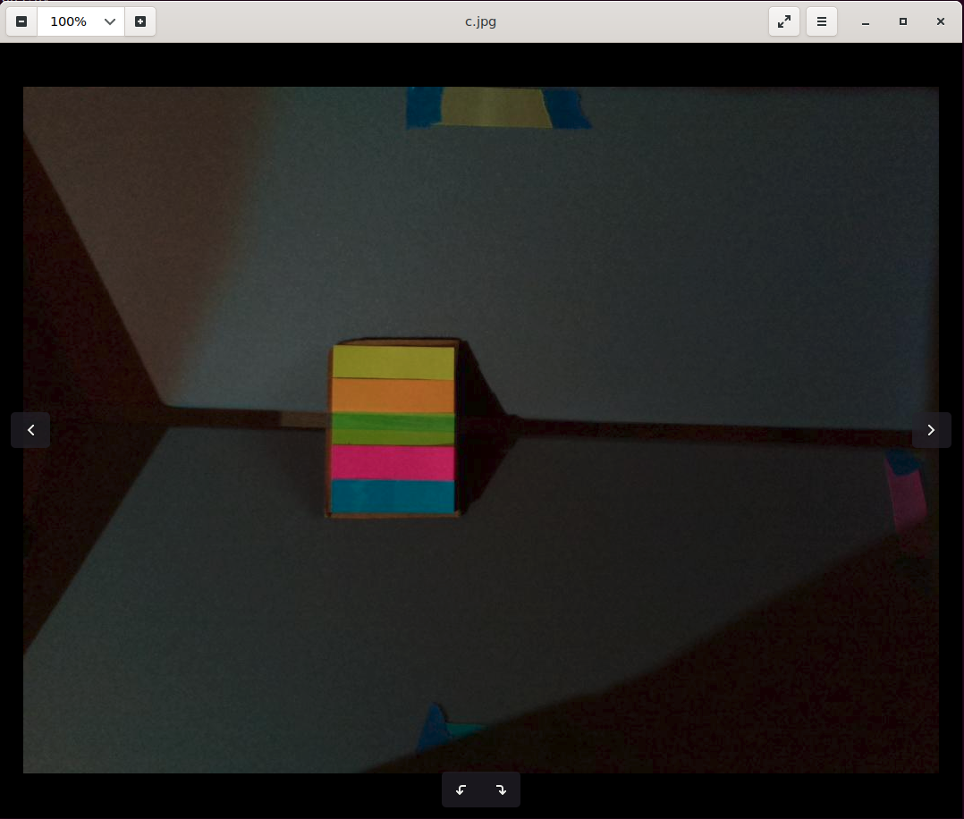Result

The result of the subtraction contains the object and the areas where the lighting changed. It does not segment the image.

