PI Web Control

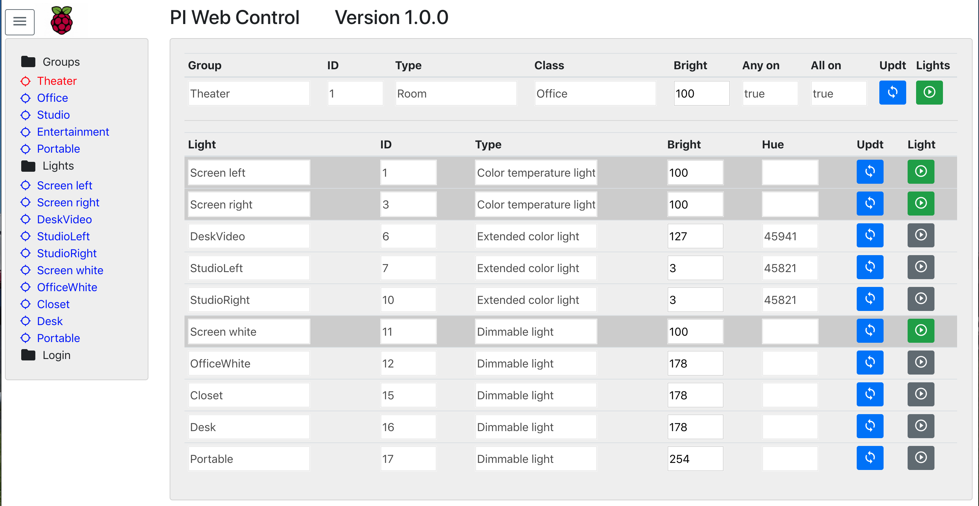
PI Web Control is a web app for controlling IOT devices from a Raspberry PI. Strictly speaking it should run on any computer but the PI is a convenient choice as its low power and also has access to additional sensors and devices directly connected. Initially we target the Philips HUE as it is a typical hub and i actually have one. Plans are to include additional hubs in the future.

Installation instructions are in the README on the github repo.
When you connect to your PI with your browser, you should see the screen above.

The left side shows a list of your groups and lights.

By clicking on a group, it shows the group attributes in the top line of the display as well as highlighting the lights in that group. The group changes to red on the side to show which group is selected.

You can click on a light but no behaviour has been wired to it yet other than the color change.

The blue button on the right labeled “Updt” allows you to update group attributes without changing the state of the group. Currently only the brightness is supported.

The other button labeled “Lights” shows the state of the group lights and changes to green when the group is on. Clicking the button will toggle the state.

Similarly the blue and green/gray buttons perform the same actions on an individual light.
The light state is not immediately updated as no feedback is provided from the hub.
Refreshing the screen will update the light stated.

