Assignment 3

1. **Introduction**

As a pet owner living in Hong Kong, it has come to my attention that there isn’t one single website that centralizes information on pet friendly locations (i.e. restaurants, hotels, events, parks) for dog lovers like me to browse and stay informed. Information are currently fragmented and limited to lifestyle blogs and company websites that provide such information. Search results are also quite limiting with overlapping recommendations which takes me a long time to find what I need and be happy with my result.

1. **Interview Questions**

Introduction

* Do you spend a lot of time with your dog? What’s your daily routine like? Walking schedules?
* How often do you go out with your dog?
* Do you spend time researching new locations to go to?

The search

* Do you find it hard to gather information on pet friendly locations in Hong Kong?
* Where do you usually get hold of such information? (e.g. WOM, websites)
* Is there a specific website/app that you use to keep yourself informed on new and trendy locations?
* Can you guide me through your research process?
* Do you take your dog out often? If so, where do you prefer to go?
* What do you think is the biggest trouble going out with your dog in Hong Kong?
* How do you usually get informed (when you are not actively seeking) on a new/existing pet friendly location?

The experience

* Have you ever attended a pet exhibition/convention? How did you find out about it?
* What are some events you know about currently? How did you know about it?
* Have you ever missed out on pet events because you were not informed?
* Have you ever gone on a staycation with your dog? Would you be interested to go in the future? Do you know which hotels in Hong Kong are pet friendly?
* What are some factors that affects your decision-making process when choosing a location to visit? (e.g. why choose a restaurant over the other?)
* Are pet owners review valuable to you? Would you review a location after an experience?
* Have you and your dog been rejected entry at any location?
* Did you know that most malls in Hong Kong are actually pet friendly as long as your pet doesn’t touch the ground?

1. **Persona types (type chosen in bold)**
2. **Young, adventurous and tech savvy pet owners**
3. Working class pet owners who are busy but is willing to spend money

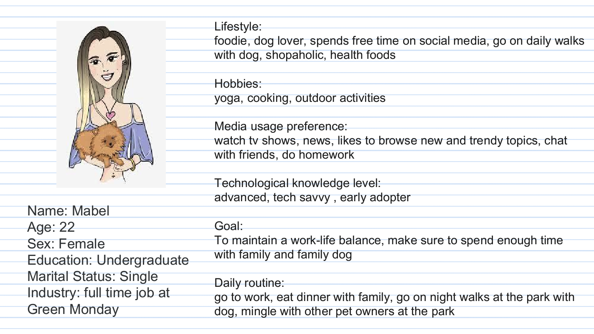

1. **Journey Map and rationale**



Rationale for persona: I chose ‘Young, adventurous and tech savvy pet owners’ as my persona type because these are the people who are more enthusiastic about the experience and has more time to research on this topic. They are open to new experiences and relies heavily on online information when in doubt.

1. **Problem statement**

How might we make a young and adventurous pet owner address the problem of not knowing where to go with her pet on the weekends to achieve the goal of making quick and easy decision on a pet friendly location to visit and make the most out of the day.

1. **Story Map**

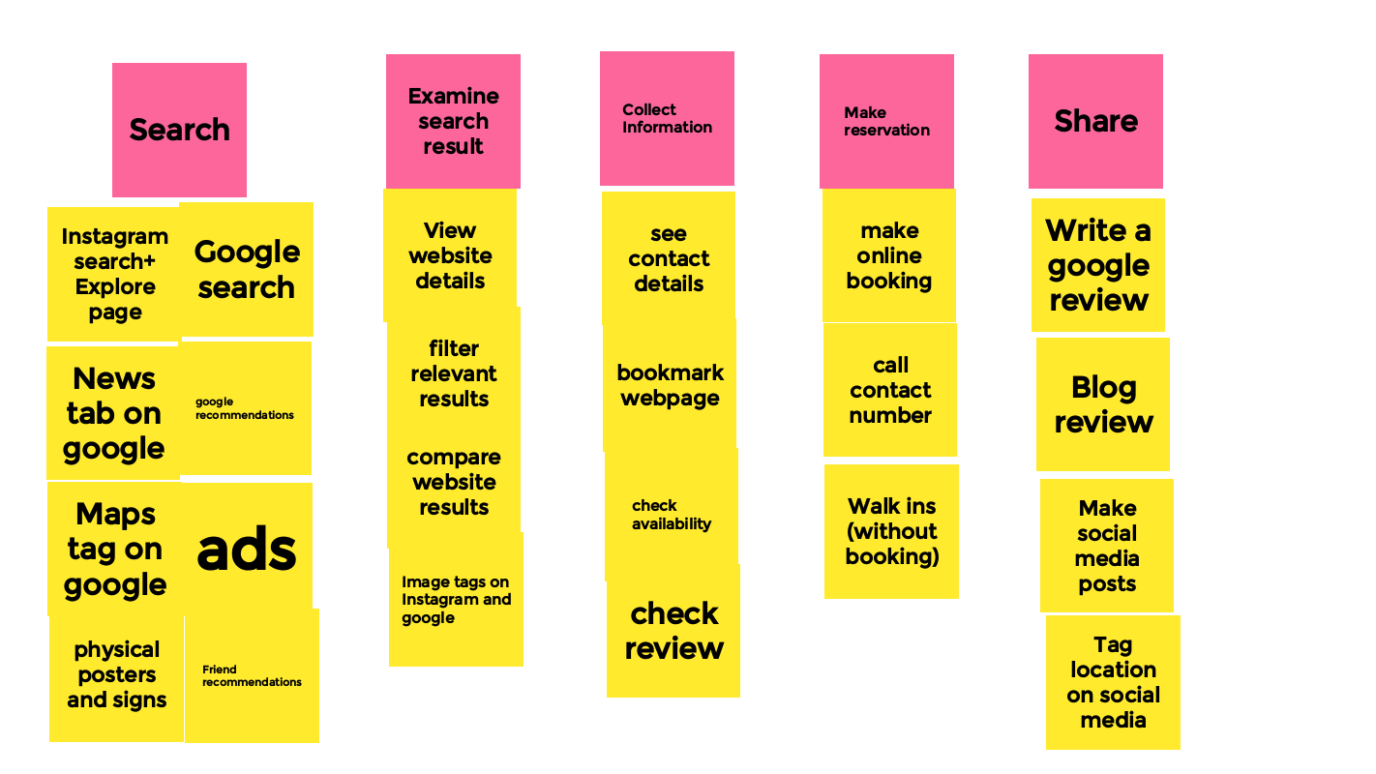

1. **Open card sort**



1. **Position Map**



Appendix 1 (Mabel)

|  |  |
| --- | --- |
| Introduction | Mabel. Has a 3-year-old Shiba. 22 years old. Working at Green Monday. |
| Do you spend a lot of time with your dog? What’s your daily routine like? Walking schedules? | Yes, bring dog to balcony to pee and poo in the morning then take dog for a walk before work. After coming home from work, she walks her dog again at night. |
| Do you spend time researching new locations to go to? | Yes, if the weather is nice and is not too hot. Especially in the winter time. |
| Do you find it hard to gather information on pet friendly locations in Hong Kong? | It is hard. Need to specifically look for it (e.g. dog friendly restaurants in HK). Need to do a lot of scrolling and searching. |
| Where do you usually get hold of such information? (e.g. WOM, websites) | Google, online magazines, friends, pet Instagram account |
| Is there a specific website/app that you use to keep yourself informed? | Facebook groups: Mei Foo dog group, Hong Kong Shiba group, dog pages |
| Can you guide me through your research process? | Refer to video |
| Do you take your dog out often? If so, where do you prefer to go? | Dog park near home. Weekends to The D2 place because it is dog friendly. |
| What do you think is the biggest trouble going out with your dog in Hong Kong? | Weather if the floor is too hot for the dog. Bringing a stroller is difficult. How other people act around her, dog get scared in crowded place. Need a suitable location. |
| How do you usually get informed (when you are not actively seeking) on a new/existing pet friendly location? | Occasionally on social media about dog accessories but not much |
| Have you ever attended a pet convention? How did you find out about it? | Yes. See it on life style apps (U life style), WOM, Instagram post |
| What are some events you know about currently? How did you know about it? | Not right now. It is hard to find. |
| Have you ever gone on a staycation with your dog? Would you be interested to go in the future? Do you know which hotels in Hong Kong are pet friendly? | No. But I have friends who did. I will be if there are good facilities and not simply stuck in a room with the dog. I only know the Ritz Carlton is. |
| What are some factors that affects your decision-making process when choosing a location to visit? | Ease of getting there. Limited outdoor seating at restaurants for dogs. |
| Are pet owners review valuable to you? Would you review a location after an experience? | Yes, they are helpful as they give more information that may not be on the website. And they give tips and recommendations |

Appendix 2 (Cassandra)

|  |  |
| --- | --- |
| Introduction | Cassandra. Fresh grad. 9 years old dog. He is a toy poodle. |
| Do you spend a lot of time with your dog? What’s your daily routine like? Walking schedules? | I don’t bring him out often but he is with me a lot at home. He only eats once a day. |
| Do you spend time researching new locations to go to? | I do. It is nice to take him out when the weather is nice, not rainy or too hot. |
| Do you find it hard to gather information on pet friendly locations in Hong Kong? | Not really, I normally look for restaurants and I can find on their website or call to ask. It is not particularly difficult. |
| Where do you usually get hold of such information? (e.g. WOM, websites) | WOM from friends, Social media (Instagram) |
| Is there a specific website/app that you use to keep yourself informed? | Refer to above |
| Can you guide me through your research process? | Refer to video |
| Do you take your dog out often? If so, where do you prefer to go? | I take him on walks at hiking trails. |
| What do you think is the biggest trouble going out with your dog in Hong Kong? | Crowded streets and people might step on my dog since he is so small. I am also worried that other dogs especially big ones would attack him. Ticks and fleas are another problem. |
| How do you usually get informed (when you are not actively seeking) on a new/existing pet friendly location? | Social media when other pet owners post about something, friends. |
| Have you ever attended a pet convention? How did you find out about it? | No. I didn’t know pet conventions existed at all |
| Have you ever missed out on pet events because you were not informed? | Yes. The convention for sure. |
| Have you ever gone on a staycation with your dog? Would you be interested to go in the future? Do you know which hotels in Hong Kong are pet friendly? | I haven’t but I will be down for it. I know the Murray allow dogs. Rosewood as well. |
| What are some factors that affects your decision-making process when choosing a location to visit? | Good reviews from other pet owners online. If it is convenient for the dog (e.g. are bathroom for dogs provided) |
| Are pet owners review valuable to you? Would you review a location after an experience? | I think they are really useful but I am not the type to review myself. I heavily rely on other people for information. And I would post on social media as well |
| Did you know that most malls are pet friendly in Hong Kong? | I didn’t know that! |

Appendix 3 (Monique)

|  |  |
| --- | --- |
| Introduction | Monique. 23 years old. I live in Hong Kong and I have a 9-year-old Shiba. |
| Do you spend a lot of time with your dog? What’s your daily routine like? Walking schedules? | Not lately because school. But my dog gets taken out at least 3 times a day. Usually walk around the neighborhood but during weekends my family like to take him out to further places like Repulse bay or Stanley. |
| Do you spend time researching new locations to go to? | My family are more proactive but we do bring him out to a few parks in Kowloon sometimes. And even the pulse as they have dog menus are restaurants. |
| Do you find it hard to gather information on pet friendly locations in Hong Kong? | Yes, I do find it a bit difficult as there aren’t that many pet friendly locations in Hong Kong. I live far away from such places and the location usually doesn’t advertise that much so I have to search manually |
| Where do you usually get hold of such information? (e.g. WOM, websites) | Parents, Instagram, google search engine, friends, restaurants tags on Instagram, forwarded messages on WhatsApp |
| Is there a specific website/app that you use to keep yourself informed? | Refer to above |
| Can you guide me through your research process? | Refer to video |
| Do you take your dog out often? If so, where do you prefer to go? | Usually prefer seaside because it is nice. The city doesn’t seem as clean and too crowded |
| What do you think is the biggest trouble going out with your dog in Hong Kong? | Bringing the dog out itself is hard as you have to drive. And not all taxi likes to board dogs |
| How do you usually get informed (when you are not actively seeking) on a new/existing pet friendly location? | Targeted ads on Instagram when I see a picture of dog sitting at a restaurant, Instagram explore page |
| Have you ever attended a pet convention? How did you find out about it? | A dog show but that was more than 10 years ago and my mom told me about it |
| Have you ever missed out on pet events because you were not informed? | For sure, I see people bring their dog for ‘bring your dog day’ at restaurants and I wouldn’t know about it. I think you will need to be actively following the restaurant page to find out. Or when went to Stanley for their open market (without my dog) stalls and saw booths selling dog treat. |
| Have you ever gone on a staycation with your dog? Would you be interested to go in the future? Do you know which hotels in Hong Kong are pet friendly? | I haven’t yet but I’ve seen people bring dogs to hotels. I would be interested if the hotel wouldn’t charge me if my dog ruins anything. I know Ovolo is pet friendly they advertise it quite a lot. I’ve seen a poster as well. I didn’t get any external ads other than seeing it myself at the physical location. |
| What are some factors that affects your decision-making process when choosing a location to visit? | Observation: Compare the amount of dogs at restaurants, more available seating and better dog service (water bowl served), dog menu |
| Are pet owners review valuable to you? Would you review a location after an experience? | Yes they are useful as I read openrice and google reviews on the restaurant service. I personally do not review unless it stood out positively or negatively. I usually post om social media if restaurants give me incentive (discount after posting) |
| Have you been rejected entry to any location? | No, I like to triple check before going because the trip is usually quite far. |
| Did you know that most malls are pet friendly in Hong Kong? | I didn’t know that. I think my dog is too big to be in a stroller. |

Appendix 4 (Kelly)

|  |  |
| --- | --- |
| Introduction | Kelly. 28 years old. Has a chowchow. |
| Do you spend a lot of time with your dog? What’s your daily routine like? Walking schedules? | Other than work she spends most of her time with the dog, walk him once a night. Wake up feed him, have a pet sitter watch over him and go to work. |
| Do you spend time researching new locations to go to? | Only when she has time. Mainly on social media |
| Do you find it hard to gather information on pet friendly locations in Hong Kong? | Hong Kong is evolving but at times it is still hard to find specific information |
| Where do you usually get hold of such information? (e.g. WOM, websites) | Through WOM from colleagues and friends. Websites and Instagram. Facebook communities: Hong Kong Chow Chow to exchange information and learn from them |
| Is there a specific website/app that you use to keep yourself informed? | Refer to above |
| Can you guide me through your research process? | Refer to video |
| Do you take your dog out often? If so, where do you prefer to go? | Weekends. I drive to Penfold park these days. It is accessible, and the area is quite spacious. I meet a lot of dog owners too. |
| What do you think is the biggest trouble going out with your dog in Hong Kong? | Transportation. You cannot bring your dog on the train and limiting to driving yourself or calling a van as some taxi drivers doesn’t like big dogs in their car. |
| How do you usually get informed (when you are not actively seeking) on a new/existing pet friendly location? | Ads come quickly on social media. And I follow a lot of dog accounts too. I see some signs on the streets as well but not a lot. |
| Have you ever attended a pet convention? How did you find out about it? | Not yet. It is a little tight on time sometimes during the weekend. Exhibitions are too crowded as well especially with Covid I refrain from going. Sometimes I’ve seen on MTR or Hong Kong Dog rescue social media. Colleagues. |
| What are some events you know about currently? How did you know about it? | I saw ad of Hong Kong Dog rescue and they do a weekend of adoption at the Murray. |
| Have you ever missed out on pet events because you were not informed? | Yes. I’ve seen photos afterwards from friends who has been to some events. And that happens quite often just because I did not get that information |
| Have you ever gone on a staycation with your dog? Would you be interested to go in the future? Do you know which hotels in Hong Kong are pet friendly? | I’ve brought my dog to Rosewood. They provided a lot of amenities for me dog. Treats, toilet station, dog bed was provided. Pretty good service. I’ve heard Ritz Carlton also had and Murray. |
| What are some factors that affects your decision-making process when choosing a location to visit? | For restaurants I prefer a restaurant with air conditioning rather than just outdoor. Or find a place that allow my chow chow to sit beside me. |
| Are pet owners review valuable to you? Would you review a location after an experience? | Owners reviews are the most valuable even though its personal preference they give the most reliable source of information on whether or not the restaurant is pet friendly or not. It also shows if your dog can have a good time. I would only leave a review if it was a bad experience. |
| Did you know that most malls are pet friendly in Hong Kong? (with stroller) | I’ve been rejected entry because I did not have a stroller. I knew a few malls were pet friendly only |

Appendix 5 (Denise)

|  |  |
| --- | --- |
| Introduction | Denise. 27 years old. French bull dog called vouge |
| Do you spend a lot of time with your dog? What’s your daily routine like? Walking schedules? | I try my best to spend as much time as I can but I do need to go to work. So I usually spend time with him on the weekends. I take my dog on a walk once a day when I come back from work. But in the day my dog sitter comes in and brings him out in the morning as well. On the weekends I go on hikes with my dog. |
| Do you spend time researching new locations to go to? | Yes. Most of the time it’s through my friends as they are pet owners too. I see ads on Instagram and Facebook as well. Google search |
| Do you find it hard to gather information on pet friendly locations in Hong Kong? | It is not too hard but it is quite tedious as there is so much information and I don’t have that much time. A lot of the time I have to manually search or I call the restaurant up to ask |
| Where do you usually get hold of such information? (e.g. WOM, websites) | Instagram and Facebook groups: Hong Kong dog owner groups are very insightful. Friends. |
| Is there a specific website/app that you use to keep yourself informed? | Refer to above |
| Can you guide me through your research process? | Google search engine: “Pet friendly restaurants near me” I live near repulse bay so I would go to the pulse. It is a really pet friendly area and a lot restaurants are pet friendly and there’s a few pet salons, shops and trails are nearby as well. I’ve also been to a few events at the pulse you meet a lot of owners |
| Do you take your dog out often? If so, where do you prefer to go? | I go on hikes as there are many trails near me. If I meet with other dog owner friends we would go to sai ying pun as there are a lot of cafes that are pet friendly. Tamar park is really nice as well |
| What do you think is the biggest trouble going out with your dog in Hong Kong? | There’s not a lot of space for dogs in general. There’s also not a lot of parking spaces if I have to drive my dog out. Also people in Hong Kong are quite scared of dogs so you need to be cautious and make sure your dog is on a leash. |
| How do you usually get informed (when you are not actively seeking) on a new/existing pet friendly location? | Normally through friends really. They post about it on their Instagram stories and I would ask. |
| Have you ever attended a pet convention? How did you find out about it? | No, I haven’t but I would love to go to one. I’ve seen posters at MTR stations but I am quite busy most of the time |
| What are some events you know about currently? How did you know about it? | Adoption events that I hear about from friends. And pet fairs at the Murray. The pulse as events too. |
| Have you ever missed out on pet events because you were not informed? | Yes. They don’t really advertise it much. I see it on social media after the event. |
| Have you ever gone on a staycation with your dog? Would you be interested to go in the future? Do you know which hotels in Hong Kong are pet friendly? | Yes I have. I went to the Murray and rosewood. My dog was welcomed with good service (treats, bed). I think Ritz Carlton is pet friendly. At the Murray, I dined with my dog and he had a piece of steak for dinner. |
| What are some factors that affects your decision-making process when choosing a location to visit? | Definitely if I can park my car. Obviously public transport is not pet friendly I always have to drive. I also look at positive reviews online |
| Are pet owners review valuable to you? Would you review a location after an experience? | Yes, they are. I wouldn’t write one myself but I would post a picture and tag the restaurant location. |
| Have you been rejected entry? | I haven’t because I would always call the restaurant up before going there. |
| Did you know that most malls are pet friendly in Hong Kong? | I do know that a friend of mine had told me. So, I’ve been doing that. I bring him to pacific place and IFC. |