# Day 4-Angular Basics

**Create Angular Application**

>ng new <project name>

(it connects to internet to download node modules)

>npm install [bootstrap@3.4.1](mailto:bootstrap@3.4.1) –save;

Here –save means installing locally.

**Folders**

* E2e->end to end testing.

(Karma tool, unit as jasmine)

* Node-modules->local repo for library.
* Src->source code(has .ts files)
* Package.json, Angular.json->config files for angular tool to work

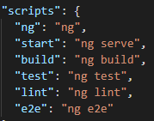

Linting ->check spacing

Refer Tslint.json

@angular/core->has most of library features.

* Package-lock.json->locks the version

Ng tool is creating project structure.

Adv of angular is **Single Page Application(index.html)**

Next point is **main.ts(start bootstrapping)**

**Angular.json has** "src/styles.css" (global style)

Here refer bootstrap to be used.

“scripts”[]->has .js files

**Index.html**  has custom tag

->Behind this tag ,we have wiring of view,controller,Model(MVC)

View-html,css

Controller->ts

Model->ts

Presentation+Business logic=>index.html

**Main.ts**

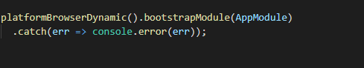

Launch angular application is server,browser.here it is browser platform(platformBrowserDynamic)

bootstrapModule->bootstrap the root module(here its “AppModule) means start the AppModule while lanching angular application in browser platform.[ AppModule.ts is in src/app

.spec.json->means test file

(Only one component)App->css(style),html(skeleton),ts(behaviour)

In app.component.ts has

@->decorators/annotation(metadata)eg:-@ngmodule .

Before mthod->method decorator

Before class->class decorator

@Component,@Injectable,@Output are decorators

In App.module.ts,AppComponent is bootstrapped) 

Main.ts->AppModule->AppComponent(visible in browser)

In main.ts->we can bootstrap only 1 module,but in AppComponent,we can bootstrap any number of component in array

"styles": [

"src/styles.css",

"./node_modules/toastr/build/toastr.min.css",

"./node_modules/ngf-bootstrap/dist/bootstrap.mi.css"

],

"scripts": [

"./node_modules/jquery/dist/jquery.min.js",

"./node_modules/toastr/dist/toastr.min.js",

"./node_modules/tether/dist/js/tether.min.js",

"./node_modules/bootstrap/dist/js/bootstrap.min.js"

Create a new Component->(ts code+hmtl+css)->Register the component(inside the module)->3.Apply the selector onto your component