An AI-Based System for Personalized Career Recommendation
Egemen Goncu
Table of Contents

Wrocław University of Science and Technology
Faculty of Electronics, Photonics and Microsystems

Field of study: Electronic and Computer Engineering
Speciality: —
Bachelor Thesis
An AI-Based System for Personalized Career Recommendation
System oparty na sztucznej inteligencji do spersonalizowanego doradztwa zawodowego

AUTHOR: Egemen Goncu
SUPERVISOR: dr inż. Michał Błędowski

WROCŁAW 2026
Abstract — Streszczenie / Abstract

Streszczenie
W pracy przedstawiono projekt, implementację oraz ewaluację systemu opartego na sztucznej inteligencji do spersonalizowanego doradztwa zawodowego. System, wdrożony jako aplikacja webowa na zarządzanej platformie chmurowej, integruje sześć komplementarnych narzędzi: analizę CV, dopasowanie do oferty pracy, sugestię ścieżki kariery, generowanie listu motywacyjnego, przygotowanie do rozmowy kwalifikacyjnej oraz planowanie portfolio. Frontend zbudowano w technologiach React 19 i TanStack Start; backend wykorzystuje FastAPI oraz PostgreSQL; wnioskowanie modelu językowego delegowano do usługi Google Vertex AI Gemini 2.5 Flash.
W odpowiedzi na obawy dotyczące kosztu, opóźnienia oraz zależności od zewnętrznego dostawcy modelu rdzeń analityczny systemu obsługuje dwa przełączalne w czasie działania tryby oceny. Tryb mieszany łączy deterministyczną heurystykę ze strukturalnym wyjściem modelu językowego (40% / 60%). Tryb w pełni heurystyczny opiera się na klasycznych metodach wyszukiwania informacji: ważeniu słów kluczowych metodą TF–IDF i rankingowi BM25, normalizacji umiejętności zgodnej z taksonomią ESCO, dopasowaniu rozmytym oraz ekstrakcji cech ważonych sekcjami.
Kontrolowane studium porównawcze oceniło oba tryby na 100 parach (CV, opis stanowiska) obejmujących sześć ścieżek zawodowych. Zbiór ewaluacyjny składa się z deterministycznie wygenerowanych par syntetycznych CV i opisów stanowisk skonstruowanych z rozłącznych słownikowo pul fraz; strona CV i strona opisu stanowiska nie współdzielą słownictwa treściowego poza kanonicznymi nazwami umiejętności. W tym zbiorze tryb w pełni heurystyczny śledzi tryb mieszany przy Pearsonowskim r = 0,836 [95-proc. przedział ufności: 0,762–0,896; bootstrap klastrowy względem identyfikatora CV] oraz Spearmanowskim ρ = 0,847, działa około dwa do trzech rzędów wielkości szybciej (mediana 25,5 ms wobec 18,2 s) oraz nie ponosi krańcowego kosztu po stronie modelu językowego.
Korelacja między samym modelem językowym a trybem heurystycznym, odzyskana post-hoc z tożsamości formuły mieszanej w celu odseparowania składowej strukturalnej, wynosi r = 0,627 [95-proc. przedział ufności: 0,470–0,758]. Tryb mieszany pozostaje wartościowy w ocenie jakości prozy: na osi clarity zgodność między obydwoma trybami spada do r = 0,395, co wskazuje, że w tym wymiarze deterministyczna heurystyka nie zastępuje modelu językowego. Ograniczenia obejmują zakres jednojęzyczny (angielski), syntetyczny zbiór jednego autora oraz pojedynczą konfigurację dostawcy modelu językowego. Dalsze prace obejmują rozszerzenie pokrycia językowego na polski (etykiety ESCO, polskojęzyczne wstępne przetwarzanie, detekcję sekcji oraz dwujęzyczną ewaluację), pośredni poziom dopasowania semantycznego oparty na transformatorach zdań, integrację komponentu wyszukiwania wspomagającego oraz wymianę pamięci podręcznej procesu na rozwiązanie współdzielone (Redis).
Słowa kluczowe: doradztwo zawodowe, analiza CV, duże modele językowe, wyszukiwanie informacji, taksonomia ESCO, ocena hybrydowa, FastAPI, React.
Abstract (English)
This thesis presents the design, implementation, and evaluation of an AI-based system for personalised career recommendation. The deployed web application integrates six tools: resume analysis, job-description matching, career-path suggestion, cover-letter generation, interview preparation, and portfolio planning. The frontend uses React 19 and TanStack Start; the backend uses FastAPI and PostgreSQL; language-model inference is delegated to Google Vertex AI Gemini 2.5 Flash.
To address cost, latency, and external-provider dependence, the analytical core supports two runtime-switchable scoring modes. The blended mode combines a deterministic heuristic with the language model’s structured output at 40% / 60% weighting. The fully heuristic mode uses classical information-retrieval methods: TF–IDF and BM25 keyword evidence, ESCO-aligned skill normalisation, string-similarity fuzzy matching, and section-weighted feature extraction.
A controlled comparative study evaluated both modes on 100 synthetic resume/job-description pairs spanning six role tracks. The benchmark was deterministically generated under a disjoint-vocabulary construction: resume-side and job-description-side phrase pools share no content-word vocabulary beyond canonical skill terms. Within this benchmark, heuristic mode tracks blended mode at Pearson r = 0.836 [95% CI 0.762, 0.896 under cluster bootstrap on resume identity] and Spearman ρ = 0.847, while running much faster (median 25.5 ms vs 18.2 s) and incurring zero LLM-side marginal cost. The post-hoc LLM-only-versus-heuristic correlation is r = 0.627 [95% CI 0.470, 0.758], after controlling for the 0.40 heuristic share embedded in the blended formula.
These results support the heuristic mode as a fast, auditable fallback, while the blended mode retains value on prose-quality evidence (clarity sub-score r = 0.395). Limitations include English-only evaluation, a single-author synthetic dataset, and one LLM provider. Future work proposes Polish-language coverage (ESCO label expansion, Polish-aware preprocessing, section detection, and bilingual evaluation), a sentence-transformer intermediate tier, retrieval-augmented grounding, and a Redis-backed shared cache.
Keywords: career recommendation, resume analysis, large language models, information retrieval, ESCO taxonomy, hybrid scoring, FastAPI, React.
Acknowledgements
I would like to thank my supervisor, dr inż. Michał Błędowski, for the time he invested in shaping the scope of this thesis, the clarity of his feedback during the development of the system, and his suggestion to extend the work with the comparative study reported in Chapter 4. The shape of the engineering and research aspects of this project owes much to those conversations.
I am grateful to the Faculty of Electronics, Photonics and Microsystems at Wrocław University of Science and Technology for providing the academic environment in which this thesis was prepared, and to the staff and lecturers whose courses across the Electronic and Computer Engineering curriculum gave me the technical foundation on which this work builds.
My thanks to the open-source maintainers of the FastAPI, TanStack, React, and SQLAlchemy projects, whose libraries made it possible for a single developer to ship a system at this scope on a thesis-bound schedule.
Egemen Goncu Wrocław, May 2026
List of abbreviations and symbols
Abbreviation | Expansion
AI | Artificial Intelligence
API | Application Programming Interface
APD | Archive of Diploma Theses (USOS-APD)
ATS | Applicant Tracking System
BM25 | Best Match 25 (probabilistic relevance ranking function)
CI | Confidence Interval / Continuous Integration, depending on context
CORS | Cross-Origin Resource Sharing
ESCO | European Skills, Competences, Qualifications and Occupations
FastAPI | Python web framework used by the backend
GDPR | General Data Protection Regulation
Gemini | Google large-language-model family used through Vertex AI
HTTP / HTTPS | HyperText Transfer Protocol / HTTP Secure
IDF | Inverse Document Frequency
IR | Information Retrieval
JD | Job Description
JSON | JavaScript Object Notation
JWT | JSON Web Token
KS | Kolmogorov–Smirnov statistical distance
LLM | Large Language Model
NER | Named-Entity Recognition
NLP | Natural Language Processing
OAuth | Open Authorisation / federated-identity protocol
O*NET | Occupational Information Network taxonomy
ORM | Object–Relational Mapping
PDF | Portable Document Format
PWr | Politechnika Wrocławska / Wrocław University of Science and Technology
RAG | Retrieval-Augmented Generation
REST | Representational State Transfer
SBERT | Sentence-BERT
SQL | Structured Query Language
TF–IDF | Term Frequency–Inverse Document Frequency
UI / UX | User Interface / User Experience
URL | Uniform Resource Locator
USOS-APD | USOS Archive of Diploma Theses
UUID | Universally Unique Identifier
WEFiM | Faculty of Electronics, Photonics and Microsystems
Symbols (used in formulas in Chapter 4)
Symbol | Meaning
r | Pearson correlation coefficient
ρ, τ | Spearman and Kendall rank-correlation coefficients
k₁, b | BM25 term-frequency saturation and document-length normalisation parameters
τ | Fuzzy-matching similarity threshold
idf(t) | Inverse document frequency of term t
N, M | Number of resumes and number of job descriptions
R, J | A single resume and a single job description
K(·) | Keyword extractor function
Chapter 1 — Introduction
Choosing a career path has become substantially harder over the last decade. The labour market changes faster than any individual can track manually: new job titles appear, established roles fragment into specialisations, and the skills that employers list on a job advertisement now turn over on the order of years rather than decades [3]. At the same time, the number of resumes a hiring team sees per opening has grown, and most large employers route applications through automated screening systems before any human reviewer touches the document [18]. The candidate sits between these two pressures: they need to understand which roles fit their evolving experience, and they need to present that experience in a form that survives algorithmic filtering before it reaches a recruiter.
A working candidate trying to answer those questions today typically uses a fragmented set of tools: a generic resume builder, a job board’s “match score”, a separate cover-letter writing prompt, an interview-preparation list curated by hand. Each of those tools sees only a slice of the candidate. None of them carry context across the workflow. The thesis presented here builds a single, integrated AI-based system that collapses that workflow into one workspace, and uses the candidate’s resume as the shared substrate across every tool in the system.
The immediate motivation for the topic of this thesis was the author’s experience as an international student at Wrocław University of Science and Technology. During an internship search the author used three or four of the fragmented career tools described above (a generic resume editor, a job-board match score, a separate cover-letter prompt, an interview-question generator), and the friction that emerged was not in any single tool’s output but in the manual re-entry of the same resume into each one. Every tool started from zero context and none of them passed information forward to the next stage of the workflow. The thesis project began as an attempt to remove that friction and, over the months of implementation, grew into the integrated AI-augmented decision-support system [1, 2] that this thesis describes.
1.1 The career decision problem
Career decision making combines three sub-problems. Self-assessment asks the candidate to describe skills, experience, and preferences in a machine-readable form. Market alignment asks how that profile compares with job descriptions. Action planning asks which changes, projects, or interview stories would improve the candidate’s position.
These problems have usually been studied separately. Career-counselling research treats self-assessment as a structured guidance problem [15]. Information-retrieval research treats market alignment as ranking over job postings [13, 21]. Decision-support research frames action planning as a recommendation task under uncertainty [1, 2]. The practical gap is the absence of a single system in which all three stages share one candidate representation.
The integrated representation matters because one fact can support several decisions. A quantified backend-project bullet may raise the resume quality score, improve fit against a backend job description, justify a stronger cover-letter paragraph, and supply a story for a behavioural interview answer. If the tools are separated, the user must manually preserve and reinterpret that fact; if they share a representation, the system can carry it forward.
1.2 AI-based recommendation systems for careers
Classical recommender systems rely on many users repeatedly interacting with dense item catalogues. Career recommendation is different: job titles are sparse, employer labels are inconsistent, resume evidence is unstructured, and a single user produces few explicit preference signals. Recent career systems therefore treat the task less as collaborative filtering and more as structured matching between a resume and a job description projected into a shared representation [6, 8, 9, 10, 11, 12, 13].
CareerRec [15], for example, applies tree-based classifiers to 2,255 information-technology employee records and reports about 70% accuracy on career-path classification — a different task framing (single-label classification over a closed catalogue) and data surface (real IT-employee records) than the resume-to-job-description scoring problem evaluated in Chapter 4, which is why a head-to-head comparison is not pursued in the present thesis. Broader AI decision-support work [1, 2] shows the same movement from manually engineered features toward learned representations. These systems help select or rank career options, but they usually stop before the candidate has to act on the recommendation. The present thesis extends that workflow by combining assessment, job matching, cover-letter support, interview preparation, and portfolio planning in one application.
This extension is intentionally engineering-oriented. The thesis is not only an offline modelling exercise. It asks whether recommendation logic can be embedded in a deployed workflow where a candidate uploads a resume, receives structured feedback, follows the result into another tool, and later returns to earlier runs through persistent history.
1.3 Resume parsing and job-description analysis
Resume matching starts with structure extraction from free-form text. Early resume parsers used regular expressions and section-header dictionaries to identify names, dates, education, experience, and skills [14]. Such parsers are brittle against unusual formatting but remain valuable as deterministic, inspectable baselines.
Modern parsers rely more heavily on natural-language processing. Named-entity-recognition models extract organisations, dates, and skills; transformer models improve contextual interpretation of ambiguous phrases [4]. Resume2Vec [18] reports a 15.85% improvement in normalised discounted cumulative gain over a non-contextual ATS baseline by using resume embeddings.
Job-description analysis is the demand-side counterpart. Recent work links job postings to standardised taxonomies such as ESCO, the European multilingual classification [8], and O*NET. This normalisation lets “JavaScript”, “JS”, and “ECMAScript” resolve to the same skill. The literature includes top-down ESCO matching and model-based approaches such as JobBERT, ESCOXLM-R, and LLM-assisted skill extraction [9, 10, 11, 12, 13]. The system implemented here adopts a top-down strategy: a curated ESCO subset is bundled with the application and used to normalise skills on both sides of the match.
1.4 Heuristic and language-model scoring approaches
The central design tension addressed by this thesis is the choice between two families of methods for scoring the alignment between a resume and a job description.
The first family is heuristic: classical information-retrieval techniques that rely on statistical regularities of text. The foundational methods in this family, TF–IDF [5] and BM25 [6], weight individual terms by how distinctive they are within a corpus, so that a rare technical skill counts for more than a common word. Fuzzy-matching algorithms based on the Levenshtein edit distance [7] absorb minor surface variation, allowing “Postgres” and “PostgreSQL” to register as the same term. Skill-taxonomy lookups against ESCO or ONET [8, 9] provide the normalisation step described in the previous section. Section-weighted feature extraction recognises that a skill listed in a dedicated Skills* section carries different meaning from the same skill mentioned in passing within a project description [18]. Together, these techniques form a scoring pipeline whose every step is inspectable, deterministic, and free of any external service dependency. The cost per analysis is dominated by string operations that take tens of milliseconds on commodity hardware. The defendable claim, supported by decades of information-retrieval research, is that these techniques already capture much of the lexical and structural evidence that automated screening systems extract during the first pass over a resume.
The second family is language-model: large-language-model (LLM) services that read the resume and the job description as natural language, reason over them, and emit structured output describing the alignment. Recent research shows that LLM-based agents can accelerate resume-screening workflows relative to manual review [16], while context-aware multi-agent systems produce explainable candidate assessments aligned against HR ratings [17]. A complementary semantic-modelling and feedback-loop architecture for resume enhancement is reported in [19]. Resume2Vec [18] documents improved resume/job-description ranking over conventional ATS baselines. The cost of these methods is a per-call charge to a third-party API, latency on the order of one to several seconds per analysis, and an opaque reasoning process that is difficult to audit.
This dichotomy is the foundation of the comparative study reported in Chapter 4. The system described in this thesis exposes both modes through a single user-facing interface; an administrator can switch the analytical core between fully heuristic and blended (heuristic plus language model, weighted) at runtime, and the same input is then scored by both methods on demand. The research question is not whether one approach is universally better (both have well-understood failure modes) but rather: under a controlled within-set characterisation on a synthetic, deterministically generated benchmark of resumes and job descriptions, how much of the discriminative power of the blended mode is recoverable from a strictly classical-IR heuristic, and at what cost ratio? The deliberately within-set framing is important; the benchmark and its construction limits are documented in Section 4.1.4.
The order in which the two modes were built deserves explicit mention. The implementation began with the blended mode as the primary path; the comparative study was added to the scope later, after the supervisor proposed the heuristic-only mode as a research dimension that would balance the engineering and research aspects of the thesis. The strong heuristic that Chapter 4 describes was designed after the blended pipeline already existed; this sequencing shaped the heuristic toward the specific decisions the language model was already making in production rather than toward an idealised retrieval-research baseline, and Chapter 4 treats the resulting design coupling as a disclosed validity threat rather than a hidden one.
The value of the comparison is operational as well as scientific. If the heuristic preserves useful ranking behaviour, it can act as a low-cost fallback when the LLM is unavailable, as a live demonstration mode during the diploma defence, and as a high-volume preview path that does not accumulate per-call inference cost. If it fails, the system still benefits from the blended mode, but the fallback must then be framed only as an emergency response.
The dual-mode design followed from a more pragmatic motivation than would have been predicted at project start. The retry-with-jitter policy in the LLM client (described in Section 3.1.1, with delays at 5, 10, 20 and 40 seconds plus a small random offset) absorbs almost all transient failures, but during early development a small number of cascades occurred where consecutive retries still failed and the user-facing tool surfaced a generic error. Wiring up the heuristic fallback policy so that those cases produced a still-useful result accompanied by an explicit confidence note was a small change in code but a meaningful improvement in perceived reliability. Once that fallback path existed, the comparative study reported in Chapter 4 became a natural extension of it: if the deterministic mode is good enough to ship as a safety net, it deserves a measured comparison against the LLM-augmented mode it falls back from, rather than only being treated as an emergency path.

1.5 Purpose of the thesis
The objective of the thesis is to develop and evaluate a system that helps users choose suitable career paths based on their skills, experience, and current job-market context, generating personalised suggestions through a combination of classical information-retrieval methods and large-language-model inference.
The scope follows the application approved in the Archive of Diploma Theses on 3 February 2026 and has two aspects.
The engineering aspect is a deployed web application integrating six tools: Resume Analyzer, Job Match, Career Path, Cover Letter, Interview Q&A, and Portfolio Planner. The implementation uses a Python/FastAPI backend, a React/TanStack Start frontend, PostgreSQL persistence for users and tool-run history, Google Vertex AI Gemini 2.5 Flash for LLM inference, Railway deployment, and operational monitoring through Railway metrics and Sentry.
The research aspect is a controlled comparison of two scoring modes. The blended mode combines heuristic and LLM outputs with 40% / 60% weighting. The fully heuristic mode uses TF–IDF/BM25 keyword evidence, ESCO-aligned normalisation, fuzzy matching, section-weighted features, quantification detection, and action-verb scoring. Both modes are evaluated on a synthetic single-author benchmark of 100 resume/job-description pairs spanning six role tracks using score agreement, distribution shape, latency, and per-call cost.
The thesis does not claim that one mode is universally superior. Its design answer is to keep both modes available: the heuristic mode offers a deterministic fallback when LLM access is unavailable or insufficiently auditable, while the blended mode preserves richer prose and role-fit reasoning.
This dual-mode design also protects the system against two deployment constraints. Budget-limited environments may prefer a local deterministic path for high-volume screening, while audit-sensitive environments may require explanations traceable to fixed scoring rules. The blended path remains the default because it produces richer guidance, but the deterministic path gives the system a defendable degraded mode.
The thesis therefore evaluates the system at two levels. At the product level, success means that six career-support tools operate around one resume representation and persist their results in a coherent workflow. At the analytical level, success means that the score-comparison experiment is reproducible, that the heuristic baseline is specified clearly enough to audit, and that the reported limits prevent the result from being overgeneralised.
1.6 Structure of the thesis
Chapter 2 describes the system architecture: requirements, technology stack, backend layering, frontend routing and state, persistence, security, and Railway deployment.
Chapter 3 describes the six tools and the shared implementation patterns: run_tool_pipeline, prompt construction, structured-output validation, caching, retry behaviour, and heuristic fallback.
Chapter 4 presents the comparative study. It defines the synthetic dataset and controls, specifies the strong heuristic v2, reports agreement, distribution, latency, cost, and ablation results, and discusses limitations.
Chapter 5 concludes the thesis by summarising the engineering and empirical contributions, restating the limitations, and identifying four future-work directions: Polish-language coverage, a sentence-transformer intermediate tier [20, 21], retrieval-augmented grounding for LLM outputs [25], and a Redis-backed shared cache.
The bibliography lists the cited works. Appendix A provides representative source listings, Appendix B documents the synthetic dataset, Appendix C shows production screenshots, and Appendix D records the backend configuration reference.
Chapter 2 — System architecture
This chapter describes the architecture of the system whose evaluation is the subject of the thesis. The chapter is organised in the same order in which design decisions were made during implementation: requirements first, then the choice of technology stack, then the backend, the frontend, the persistence model, and finally the deployment topology that ties the running components together. Where a decision could plausibly have been made differently, the rationale is stated explicitly so that the reasoning is auditable rather than implicit.
2.1 Functional and non-functional requirements
The system was designed to satisfy six functional requirements, each corresponding to one of the user-facing tools, and seven non-functional requirements that constrain how those tools are delivered.
2.1.1 Functional requirements
The functional requirements are summarised in Table 2.1; each row corresponds to one of the six user-facing tools whose implementation is described in Chapter 3.
Table 2.1: Functional requirements F1–F6, one per user-facing tool.
ID | Tool | Required behaviour
F1 | Resume Analyzer | Accept a free-text or uploaded resume, return a structured assessment with overall score, per-category sub-scores, identified issues, prioritised actions, and detected strengths.
F2 | Job Match | Accept a resume and a job description (text or URL), return a match score, matched keywords, missing keywords, a recruiter-style verdict, and a list of evidence-grounded action items.
F3 | Career Path | Accept a resume and optional preferences, return a ranked list of suggested career paths with rationale, requisite skills, and a notional progression timeline.
F4 | Cover Letter | Accept a resume and a job description, return a tailored cover letter with explicit structural sections that the user can copy and adapt.
F5 | Interview Q&A | Accept a resume and a job description, return a curated list of likely interview questions clustered by category (behavioural, technical, role-specific), each with a coaching note.
F6 | Portfolio Planner | Accept a resume and a target role, return a prioritised list of skill gaps and concrete artefact ideas (project briefs, contributions, certifications) that would close those gaps.
Three workflow constraints apply across all six tools. The same uploaded resume must serve as input across every tool without re-entry. Tool runs must be re-runnable: regeneration must produce a new history record rather than overwriting the original, so that a user can iterate without losing earlier output. A previously generated result must be referenceable as context when invoking another tool, so that a Cover Letter run can consume a Job Match result and an Interview Q&A run can consume a Resume Analyzer result without manual copy-pasting between tools.
2.1.2 Non-functional requirements
The non-functional requirements were derived from the practical constraints of a single-developer, thesis-scoped deployment.
- N1 (Latency). Two targets are stated separately because the analytical core supports two scoring modes (Section 4.2.9) whose cost models differ by two orders of magnitude.
  - N1a (heuristic-only path): end-to-end tool latency at the 95th percentile under nominal load should remain below 50 ms; everything in the path is local string processing on commodity hardware.
  - N1b (blended LLM path): end-to-end tool latency at the 95th percentile under nominal load should remain below 25 s on the cold path, dominated by the upstream Gemini structured-output call; production cached-path latency is materially lower as reported in Section 3.9. The original single-target 95th-percentile-under-five-seconds figure that an earlier draft of this section stated cannot be met by the cold-path blended mode and was split into the two targets above to match the measured behaviour reported in Section 4.3.3.
- N2 (Cost ceiling). Per-call LLM cost is bounded by the choice of Gemini 2.5 Flash, a low-cost variant of the model family. The fully-heuristic mode introduced in Chapter 4 reduces this to zero on the LLM side.
- N3 (Availability). A degraded but useful service is preferred over a hard failure. When the LLM call fails or times out, analytical tools (Resume, Job Match) fall back to a heuristic-only response and surface a confidence_note to the user. Generative tools (Cover Letter, Interview Q&A) fail loudly with a structured error rather than producing fabricated content.
- N4 (Auditability). Every tool invocation produces a persistent record with the inputs (hashed), the output (full), and the timing and access mode. This supports the experimental work in Chapter 4 and gives the operator a forensic trail.
- N5 (Privacy). No third-party analytics or advertising scripts are loaded on a logged-in user’s screen. Personal data is encrypted in transit and at rest by the managed PostgreSQL provider; passwords are stored as bcrypt hashes only.
- N6 (Single deployment surface). The thesis-scoped deployment runs as a single Railway project that bundles the frontend service, the backend service, and a managed Postgres add-on. The two application services share a single hostname through path-based routing, so externally the system presents itself as one origin. There is no separate microservice architecture, no message broker, and no container orchestrator beyond what Railway provides natively.
- N7 (Demonstrability). The running system must be operable and demonstrable from a laptop without specialised tooling. Both modes of the analytical core (blended and fully heuristic) must be switchable at runtime through an administrative interface, so that the comparative study reported in Chapter 4 can be reproduced live during the diploma defence.
The latency requirement N1 was split into N1a and N1b after measurement. An earlier single cold-path target below five seconds did not match the observed behaviour of structured LLM calls, which the comparative study in Chapter 4 confirms run for tens of seconds rather than under five. Separating the two targets keeps the requirement honest: the heuristic path is evaluated as local computation whose latency is fully under the application’s control, while the blended path is evaluated as an upstream-service workflow whose tail latency is governed by the third-party inference provider and absorbed by the retry policy described in Section 3.1.1.
2.2 Technology stack and rationale
The technology stack is summarised in Table 2.2.
Table 2.2: System technology stack. Rationale entries record the specific property of each choice that makes it suitable for the thesis-scope deployment.
Layer | Choice | Rationale
Backend framework | FastAPI 0.115 | Python-native, asynchronous, automatic OpenAPI generation, Pydantic-driven schema validation.
ORM and migrations | SQLAlchemy 2.0 + Alembic | Mature, type-safe in 2.0, integrates with FastAPI’s dependency injection.
Database | PostgreSQL 16 (Railway managed) | Single-node managed Postgres is sufficient for the workload; no sharding required.
LLM provider | Google Vertex AI Gemini 2.5 Flash | Lowest cost per 1 M tokens in the production-quality tier at the time of selection; native asynchronous client; reliable structured-output mode.
Frontend framework | React 19 | Concurrent rendering, automatic batching, and the most mature component ecosystem.
Routing | TanStack Router via TanStack Start | File-based routes, type-safe links, search-param state co-location.
Build tool | Vite 7 | Sub-second hot module replacement during development.
Styling | Tailwind 4 + Radix UI primitives | Utility-first CSS without a parallel design-token system; Radix provides accessibility-correct primitives for menus, dialogs, and toggles.
Animation | Framer Motion | Declarative timeline animations for the input page heroes.
Authentication | JWT in HttpOnly cookies + Google OAuth (authlib) | No client-readable tokens; standard refresh-rotation pattern.
Transactional email | Resend | Used only for password-reset emails (no welcome or marketing email is sent in V1).
Hosting | Railway (backend, frontend, Postgres) | Single dashboard, single billing relationship, native GitHub deploy hooks.
Observability | Railway built-in metrics + Sentry free tier | Sufficient for thesis-scope traffic; can be extended to a paid tier without code changes.
Two stack decisions deserve explicit defence because either could plausibly have been made differently.
Why FastAPI rather than a Node/TypeScript backend. A unified TypeScript backend would have eliminated the language boundary at the API contract. FastAPI was preferred because the official Google Vertex AI client (used for the LLM path described in Chapter 3) and the most mature standard-library and third-party tools for text processing (Python’s re, difflib, unicodedata, and the optional rapidfuzz and scikit-learn ecosystems available if the heuristic is later extended) are all native Python. Keeping the analytical core in Python avoids introducing fidelity risks on the critical path of the comparative study reported in Chapter 4, where any subtle difference between, for example, a Python regex and a JavaScript regex would be a confound rather than a finding.
Why TanStack Start rather than Next.js. Next.js is the dominant framework for React applications in production. The decision to use TanStack Start instead was driven by three considerations specific to this project: (i) the application is fundamentally an authenticated single-page workspace rather than a content site, so server components and ISR offer little benefit; (ii) TanStack Router’s file-based, type-safe routing produces fewer subtle bugs at refactor time; and (iii) co-locating search-parameter state and route-level data loaders made the multi-tool workflow easier to reason about. The trade-off is a thinner ecosystem of templates and tutorials.
In practice this trade-off was occasionally felt during the early weeks of frontend work, when answers to TanStack Start questions on Stack Overflow were still sparse and the official documentation had to fill the gap. By mid-development the framework’s type-safety wins were paying back the early friction; the result-page route pattern tool_/result/$historyId.tsx would have required substantially more glue in a Next.js setup.
The deployment stack reflects the thesis boundary. Railway provides enough operational structure for a live system without requiring a separate platform-engineering layer. PostgreSQL is used instead of a document store because tool history, users, regeneration chains, and workspaces are relational by nature. Sentry and Railway metrics are sufficient for defect investigation at thesis traffic levels.
2.3 Backend architecture
The backend is structured in four horizontal layers (Figure 2.1).
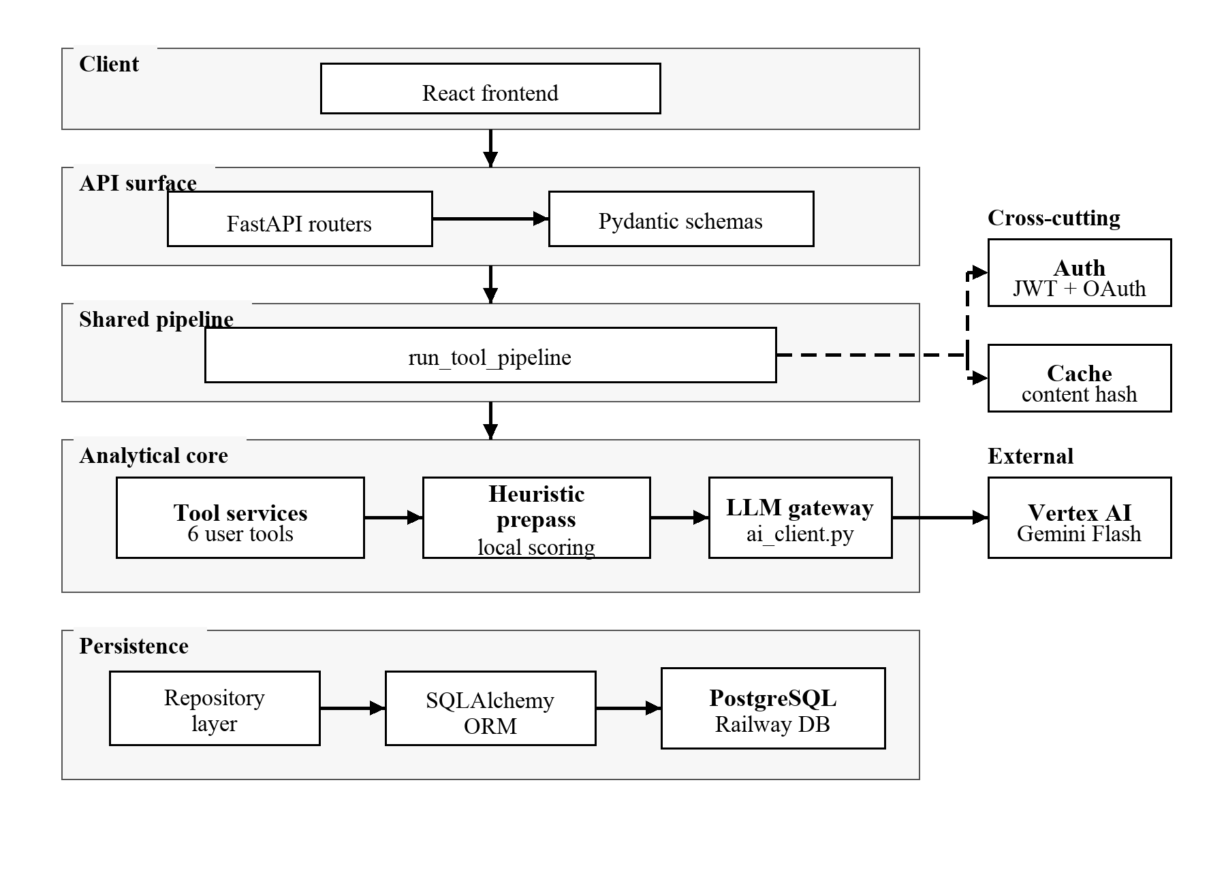
Figure 2.1: Backend layered architecture. The FastAPI surface (routers and schemas) delegates to a service layer that runs every analytical tool through the shared run_tool_pipeline, which in turn invokes the heuristic prepass, the LLM gateway (Vertex AI Gemini 2.5 Flash via ai_client.py), and the persistence layer (SQLAlchemy 2.0 + Alembic over PostgreSQL).
2.3.1 Routers
Each domain has its own router file in app/routers/: auth, google_auth, resume, job_match, job_posts, career, cover_letter, interview, portfolio, history, files, admin, health, and telemetry. All routers are mounted under the API prefix /api/v1. Routers are deliberately thin: they parse and validate the request body via the corresponding Pydantic schema, resolve dependencies (current user, database session), invoke the relevant service function, and return the response. Keeping routers thin makes the tool services and the shared pipeline the main units of behaviour, and means that a new endpoint typically requires only a new prompt module and a service function rather than any router-level plumbing.
2.3.2 The shared tool pipeline
The six functional tools share a single cross-cutting pipeline implemented in services/tool_pipeline.py and exposed as the asynchronous function run_tool_pipeline(...). Every tool router invokes this pipeline rather than calling the tool service directly. The pipeline has six stages, executed in order (Figure 2.2):
- Sanitise. The resume text, the job description (if any), and any feedback string are passed through sanitize_user_input, which strips control characters, normalises whitespace, and bounds the input length. This is a defence-in-depth measure against prompt-injection-style payloads embedded in resumes.
- Cache lookup. A content hash is computed from the tool name, the sanitised inputs, the user’s identifier (so authenticated users never see another user’s cached result), and any tool-specific cache keys. If a result is present in the in-memory cache, it is returned without calling the LLM.
- Service call. The tool-specific service function is invoked. Each tool service is a coroutine that returns a fully populated response dictionary.
- Persistence. The result is persisted as a ToolRun record. The record stores the tool name, a human-readable label produced by a tool-specific labelling function, the full result payload, the linked context identifiers, the workspace identifier, the parent run identifier (for regeneration chains), and any feedback text supplied by the user.
- Response assembly. A unified response shape is built from the persisted record, including the history identifier and the access mode.
- Observability. A structured event is emitted on start, success, and failure, including the tool name, access mode, duration, and the error category if applicable. These events feed both the Sentry breadcrumb trail and the operator-facing metrics.
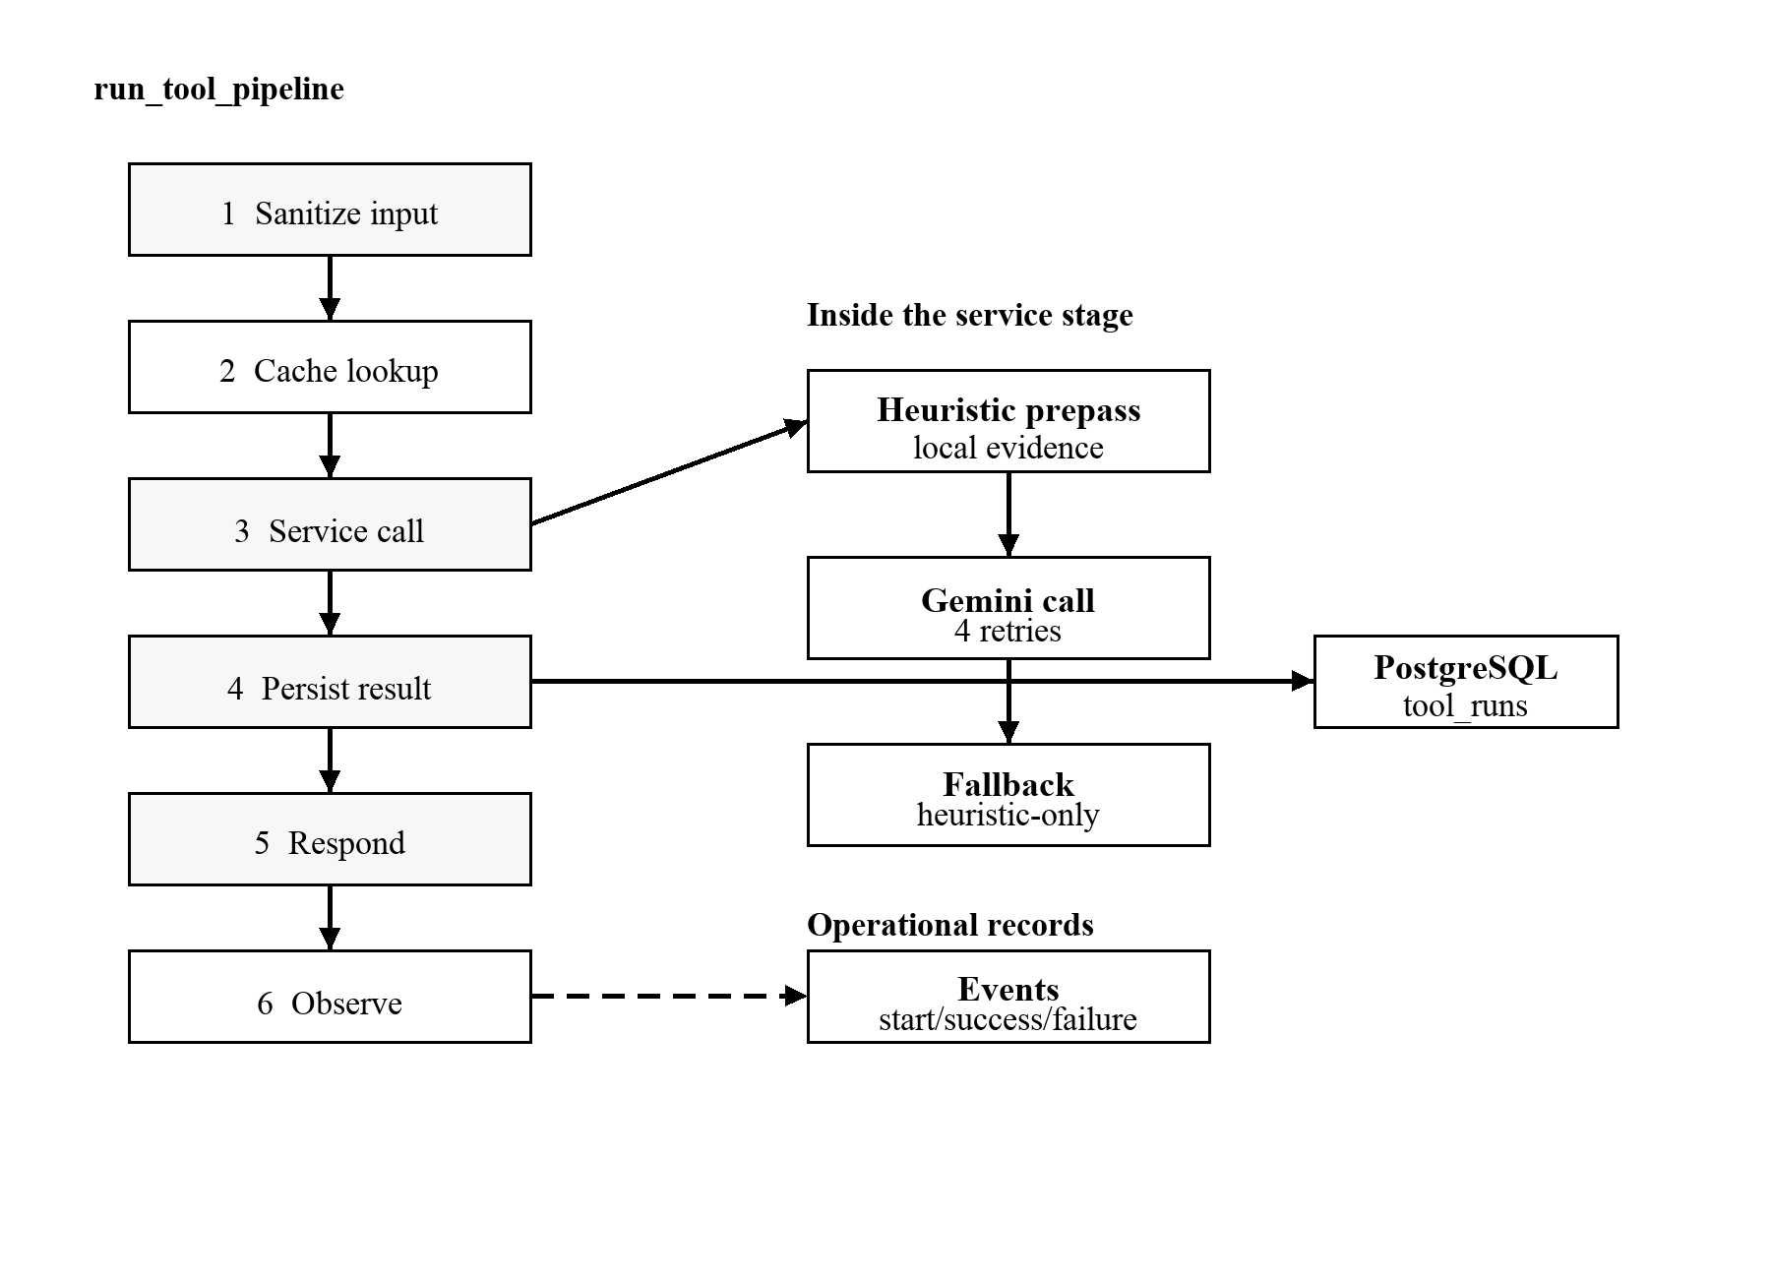
Figure 2.2: Tool pipeline (run_tool_pipeline). Six sequential stages form the cross-cutting wrapper around every analytical tool service: sanitise, cache, service, persist, respond, observe. The LLM gateway is shown as an external dependency exercised inside the service stage, with the four-retry exponential-backoff schedule and the heuristic-only fallback path that activates after the retries are exhausted.
This single point of indirection has two practical consequences for the thesis. First, every tool inherits the same cache, persistence, and observability behaviour by default; adding a new tool requires no plumbing beyond the service function and the prompt builder. Second, the comparative study in Chapter 4 can reason about cache and persistence behaviour uniformly across all tools, rather than maintaining a per-tool exception table.
The pipeline-first design was not the original plan. The Resume Analyzer and the Job Match tool were the first two endpoints implemented, each with its own cache wrapper, its own persistence call, and its own observability lines copy-pasted from the other. By the time the third tool was added the duplication was painful enough to motivate the refactor that produced run_tool_pipeline. That refactor is small in lines but is the single architectural change that has saved the most engineering effort across the project; it is also the reason why the regeneration path needed no special-case handling, because regeneration is just another pipeline call with a parent_run_id, optional feedback, and the same persistence contract.
2.3.3 Tool services and prompt builders
The body of each tool’s logic lives in two files: a service module (services/<tool>_*.py) and a prompt module (prompts/<tool>.py). The service module orchestrates the heuristic prepass, builds the prompt by delegating to the prompt module, calls complete_structured from services/ai_client.py to obtain a validated JSON response from Gemini, and post-processes the result. The prompt module is responsible only for assembling the system and user messages from the inputs and the heuristic prepass. Splitting these responsibilities keeps the prompt content under version control without coupling it to the service-orchestration code.
The service modules are also where mode-specific behaviour is isolated. Analytical services can return a heuristic-only response when SCORING_MODE=heuristic is set in the runtime configuration (Section 4.2.9) or when the LLM path fails after exhausting the retry policy described in Section 3.1.1. Generative services do not attempt a heuristic substitute, because a deterministic cover letter or interview answer would be misleading; instead they raise a structured error that the frontend renders as a retry-able failure state.
2.3.4 The heuristic prepass
For tools that produce a numerical score (Resume Analyzer and Job Match) the service computes a deterministic prepass before the LLM call. The prepass extracts evidence from the resume (detected sections, bullet counts, quantified bullets, matched and missing keywords against the job description, detected skill phrases), and computes a five-axis breakdown (keyword alignment, impact, structure, clarity, completeness). The prepass payload is appended to the prompt as a locked payload: text the LLM is instructed to use as authoritative ground truth rather than to overwrite. This has two effects: it stabilises the LLM’s score against prompt-perturbation noise, and it makes the heuristic-only fallback (and the fully-heuristic mode reported in Chapter 4) implementable without a parallel codepath, because disabling the LLM call leaves the prepass payload as the response on its own.

2.4 Frontend architecture
The frontend is a single-page application served from a Railway service that lives in the same Railway project as the backend service; both share one external hostname through path-based routing (the backend handles /api/*, the frontend handles everything else). The deployment topology is described in detail in Section 2.7.
2.4.1 Route structure
Routes live in frontend/src/routes/ and are file-based. The route tree is generated at build time by TanStack Router. Each tool has a pair of routes:
- An input route at /<tool> (for example, /resume, /job-match); this workspace page contains the resume input, the job-description input where applicable, and per-tool animation, copy, and chips.
- A result route at /<tool>_/result/$historyId, the page rendered after a tool run completes. The route segment _/ declares a layout split, and the dynamic segment $historyId is the persistent identifier of the ToolRun record on the backend.
In addition, routes exist for the dashboard, account settings, login, password reset, history, and the small admin surface introduced in Chapter 4 for the runtime scoring-mode toggle.
2.4.2 State management
Application state is partitioned into three scopes.
- Server state (anything that originates from the backend) is held in TanStack Query. This includes the current session, the list of tool runs in the user’s history, and the result of any previously completed tool run. TanStack Query handles staleness, refetching, and request deduplication.
- Workflow state (the resume text being carried between tools and the most recent tool result the user is referencing) is held in sessionStorage and read through small custom hooks (useResumeCarry, useSession). Workflow state is tab-scoped by design: opening the same site in a second tab does not share workflow context, which prevents accidental cross-talk between unrelated tool runs.
- Component state (input values, sheet open/closed flags, animation timing) is local to each component and uses standard React useState and useReducer.
2.4.3 Layout shell and navigation
The application shell consists of a dark sidebar and topbar with a light content area; there is no dark-mode toggle. The sidebar groups the six tools into three semantic clusters, primary (Resume, Job Match), application (Cover Letter, Interview Q&A), and planning (Career Path, Portfolio), to reduce the cognitive load of navigation. On mobile breakpoints, the sidebar collapses into a bottom tab bar (MobileNav) and a tools sheet (ToolGridSheet). All tool metadata that drives the sidebar, the dashboard cards, and the tools-sheet grid is centralised in frontend/src/lib/tools/registry.ts, so a new tool can be exposed across the entire UI with a single registry entry.
2.5 Data model and persistence
The persistence model contains three primary tables, summarised in Table 2.3.
Table 2.3: Primary persistence tables. The schema is intentionally narrow: every row in tool_runs is the unit of audit and history, and the regeneration parent pointer plus the linked-context list together carry the workflow graph without requiring an additional table.
Table | Purpose | Key columns
users | One row per registered account | id (UUID), email, password_hash (bcrypt) or null for OAuth-only accounts, google_subject for federated identities, timestamps.
tool_runs | One row per tool invocation that the system chose to persist | id, user_id, tool_name, label, result_json, parent_run_id for regeneration chains, linked_context_ids, workspace_id, feedback_text, created_at.
workspaces | Optional grouping of tool runs around a single role search | id, user_id, label, timestamps.
Two design choices on the data model deserve note.
First, regeneration never overwrites. A regenerated tool run is a new tool_runs row whose parent_run_id points to the original. This produces a complete audit trail of the user’s iteration on any single piece of analytical work, and supports rolling back a result that the user found less useful than its predecessor.
Second, guest tool runs are never persisted to the database. Unauthenticated users can run any tool from the demo landing page; the result is held in an in-memory map keyed by a session cookie and discarded after a short TTL. This keeps the user research path open without polluting the persistence layer with low-value records, and isolates the cost-relevant tool runs (authenticated, persisted) from the cost-irrelevant ones (guest, ephemeral).
The linked_context_ids field supports the workflow argument of the thesis. When a user invokes a cover letter from a Job Match result, or opens Interview Q&A from an analysed resume, the new result records the prior run it depended on. This produces a small graph of tool usage that the History page renders as a workflow chain rather than a flat reverse-chronological list, without requiring a separate workflow engine, queue, or state machine on the backend.
2.6 Authentication and security
Authentication uses JSON Web Tokens carried in HttpOnly cookies. There are two cookies: a 30-minute access token and a 7-day refresh token. The access token carries the user identifier and is validated on every protected request through a FastAPI dependency. The refresh token is sent only to a single endpoint (/auth/refresh) and is rotated on every successful refresh; the previous refresh token is invalidated atomically with the issue of the new pair to prevent replay. Cookies are marked Secure, SameSite=Lax, and HttpOnly. No CSRF tokens are issued, because the API accepts only application/json request bodies and the SameSite policy is sufficient against the threat model.
Federated login is supported through Google OAuth using the authlib library. Password reset is implemented through a single-use token sent by Resend; the token is bound to a hash of the user’s current password hash, so a successful reset implicitly invalidates earlier reset tokens.
Beyond authentication, three additional security measures are worth noting. Inputs are sanitised before reaching any prompt builder (Section 2.3.2). Disposable-email domains are blocklisted at signup. Rate limiting is enforced through slowapi, with stricter limits on login and password-reset endpoints than on the tool endpoints, so that brute-force attempts on credentials are rate-controlled independently of the tool-traffic envelope.
2.7 Deployment topology
The production deployment runs as a single Railway project containing two application services (frontend and backend) plus a managed PostgreSQL add-on (Figure 2.3).
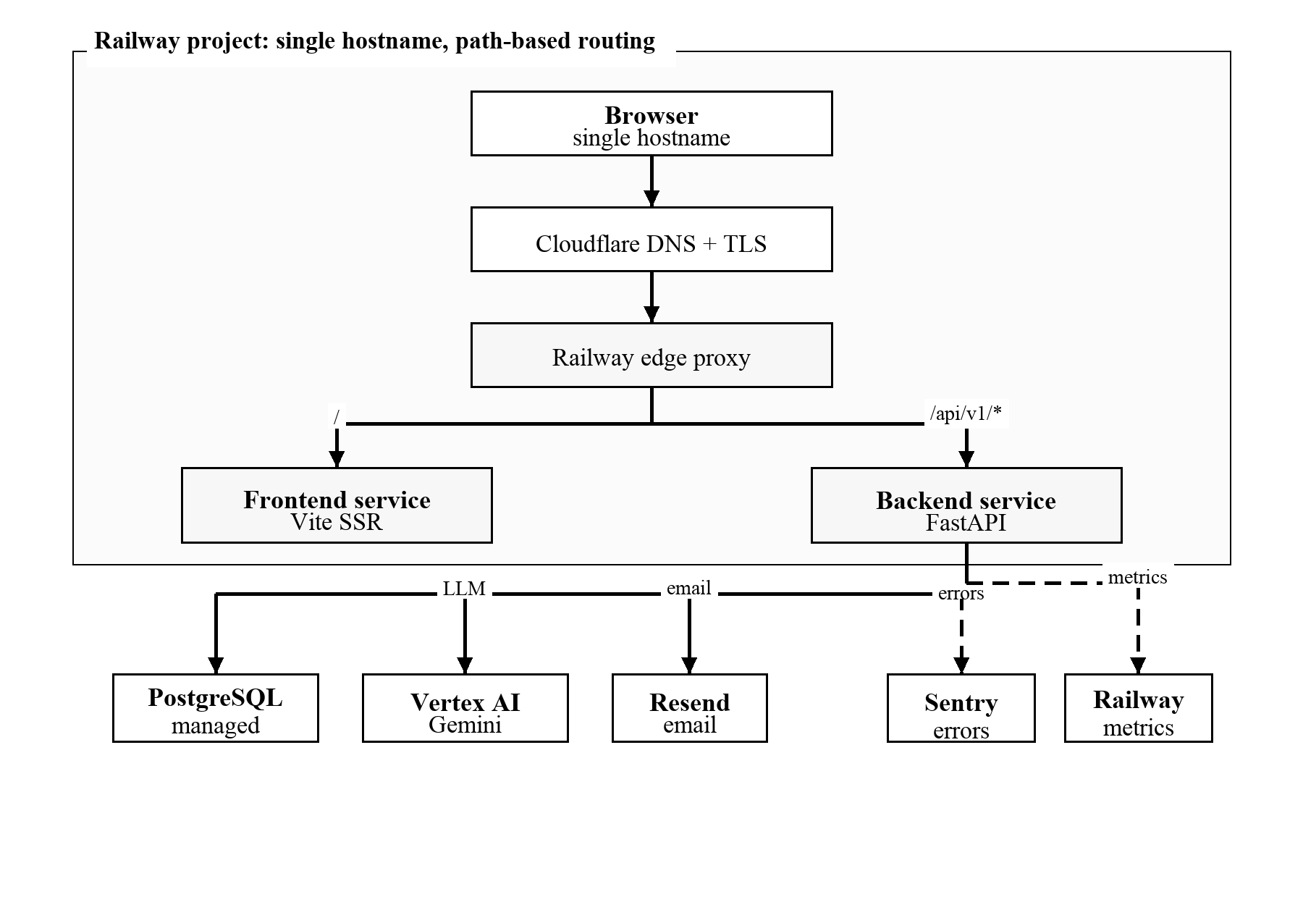
Figure 2.3: Production deployment topology. Browser traffic resolves through Cloudflare DNS and TLS into a single Railway hostname; path-based routing at the Railway edge delivers the / path to the Vite-built frontend service and the /api/v1/* path to the FastAPI backend service. The backend uses a Railway-managed PostgreSQL add-on for persistence and three external dependencies: Vertex AI Gemini 2.5 Flash for inference, Resend for transactional email, and Sentry for error tracking. Both services emit metrics and breadcrumbs to the observability tier.
The frontend and the backend share a single hostname, with path-based routing decided at the Railway edge. This eliminates cross-origin concerns for the SPA’s API calls and simplifies cookie configuration. The Postgres database is provisioned as a managed Railway add-on; backups are configured to retain seven daily snapshots.
Continuous deployment is wired to a single branch (deploy). Pushing to main is a development checkpoint; promoting a commit to deploy triggers a Railway build and rolls out the new revision with a brief health-check window before traffic is cut over. This two-branch model is intentional: it keeps the deployment surface narrow without introducing a CI/CD pipeline whose maintenance overhead is out of proportion to a thesis-scoped project.
The Railway choice was driven by the desire for a unified deployment surface. Serving the frontend at / and the backend at /api/* from a single hostname collapses the entire system into one domain, which removes an entire class of CORS and SameSite-cookie configuration bugs from the project before they can be introduced. Split-deployment alternatives (typically a frontend host such as Vercel paired with a separate backend host) were considered briefly, but the operational overhead of running two services without a team to absorb that overhead did not seem justified at the project’s scope. The same single-domain choice also meant that no separate edge router was required to glue the two halves of the application together at the boundary.
The single-origin deployment is also directly relevant to authentication. HttpOnly cookies are simpler to configure when the SPA and the API share one origin, and path-based routing avoids the browser-policy complexity that would arise from maintaining separate frontend and backend domains under different cookie scopes. For a larger product this architecture could be split later — for example, a multi-region frontend with a regional API tier — but doing so during the thesis would have added operational risk without strengthening the research result reported in Chapter 4.
The next chapter details the implementation of each of the six tools that this architecture supports.
Chapter 3 — Tool implementations
This chapter describes the six tools that compose the user-facing surface of the system: Resume Analyzer, Job Match, Career Path, Cover Letter, Interview Q&A, and Portfolio Planner. They divide naturally into three groups by the role they play in the candidate’s workflow. The primary tools (Resume, Job Match) produce numerical assessments and can therefore be run in either the blended or the fully-heuristic mode introduced in Chapter 4. The application tools (Cover Letter, Interview Q&A) generate creative artefacts and are LLM-only by construction. The planning tools (Career Path, Portfolio Planner) sit between these two extremes; they consume the resume to produce structured forward-looking guidance whose quality depends primarily on the language model’s reasoning over the heuristic prepass.
Before discussing each tool, Section 3.1 isolates the cross-cutting concerns that all six share, so that the per-tool sections can focus on what is specific to each.
3.1 Cross-cutting design
3.1.1 The structured-output LLM client
All LLM calls go through a single coroutine, complete_structured(system_prompt, user_prompt, schema=None, model_override=None), defined in app/services/ai_client.py. The function lazily initialises the Vertex AI SDK once per process, dispatches the request to the configured provider (vertex in production), requests JSON output, and returns a parsed Python dictionary.
Two reliability mechanisms are built into the client. Per-call timeout bounds an individual generation at 120 seconds; this is well above the 95th-percentile latency observed in practice but short enough that a stuck request does not tie up a worker indefinitely. Exponential backoff with jitter retries up to four times (at 5, 10, 20, and 40 seconds, plus a small random offset) for transient errors (TimeoutError, RuntimeError, json.JSONDecodeError). JSON-decode errors are retried because Gemini occasionally truncates structured output under load; the retry loop deliberately excludes ValueError, which is reserved for unrecoverable configuration errors that do not benefit from retrying. After the final retry exhausts, the exception propagates upward, where each tool service decides how to handle it according to the policy described in Section 3.1.4.
The 5, 10, 20, and 40 second retry schedule was selected after early testing; a shorter 2–4–8–16 schedule often retried before the upstream transient error had cleared.
3.1.2 The locked-payload prompt pattern
For the analytical tools (Resume Analyzer, Job Match) the prompt builder constructs three blocks: a system prompt that establishes role, register, and forbidden behaviours; a user prompt that contains the resume and (where applicable) the job description; and a locked-payload block that contains the full output of the heuristic prepass. The locked payload includes the deterministic score breakdown, the detected sections, the matched and missing keywords, and the evidence list. The LLM is instructed to treat this block as authoritative ground truth. The backend then recomputes the final score from the deterministic prepass and the returned LLM score breakdown, so the deployed response does not rely on the model to preserve arithmetic correctly.
3.1.3 Pydantic-validated structured output
Every API response returned from a tool router is validated against a Pydantic response model in app/schemas/tools.py. The frontend mirrors those response contracts with Zod schemas in frontend/src/lib/api/schemas.ts and validates responses before rendering. The two schema files are kept aligned by tests and code review rather than by code generation, which is adequate for the small number of response shapes in this project. Gemini itself is asked for JSON output, but the backend treats the model response as untrusted: service-level normalisation fills missing fields, drops invalid enum values, and falls back to deterministic heuristic content when the analytical LLM call fails.
3.1.4 Fallback policy
The system distinguishes two failure modes for an LLM call: a recoverable failure that should produce a degraded but useful response, and an unrecoverable failure that should surface as an explicit error to the user.
For analytical tools (Resume Analyzer, Job Match) the recoverable path is taken: when complete_structured raises after exhausting retries, the service constructs a complete response from the heuristic prepass alone, using the same payload structure the LLM would have populated but with the deterministic baseline as the source of truth. The user sees the result and a confidence_note indicating that the analysis ran in heuristic-only mode. This design satisfies non-functional requirement N3 of Chapter 2.
This fallback path was not added defensively at the design stage; it was added after intermittent transient failures during early testing produced the system’s first user-visible 500-class error. Once the heuristic fallback was wired up, the same code path made the comparative study described in Chapter 4 trivial to implement: the fully-heuristic mode is, mechanically, the fallback path triggered unconditionally rather than only on failure, and the runtime mode toggle of Section 4.2.9 is the smallest possible UI surface on top of that mechanism.
For generative tools (Cover Letter, Interview Q&A, Career Path, Portfolio) no fallback is offered. A heuristic-generated cover letter or interview-question list is not a credible substitute for an LLM-generated one; producing such an artefact would be misleading. These tools raise a structured 503 error that the frontend renders as a retry-able failure state.
3.1.5 Caching
The shared pipeline (Chapter 2.3.2) computes a content hash from the tool name, the sanitised inputs, the user identifier, and any tool-specific cache keys. The result of a cache hit is returned without invoking the service function, bypassing the LLM call entirely. The cache is in-memory with a one-hour TTL and is intentionally not shared between processes; this is acceptable for thesis-scoped traffic, and Section 5.3 documents the Redis-backed shared cache as the planned operational upgrade.
3.2 Resume Analyzer
The Resume Analyzer accepts a resume text and an optional target job description, and returns a five-axis quality assessment. It is the most heavily exercised tool in the system; every other tool can be invoked from the result page of the Resume Analyzer with the analysed resume already loaded.
3.2.1 Input contract
The request body contains the raw resume text (free-form, minimum 50 characters), an optional job description text, and an optional feedback string used when the user regenerates with a specific instruction.
3.2.2 Heuristic prepass
build_resume_prepass(resume_text, job_description) performs five extractions in a single pass over the resume text.
- Section detection. A regular-expression pass identifies common resume section headers (Summary, Experience, Skills, Education, Projects, Certifications) and returns the set of sections present.
- Keyword extraction. When a job description is supplied, role-relevant keywords are extracted from the job description and matched against the resume. The result is a pair of lists: matched keywords and missing keywords. Chapter 4 introduces the strong-heuristic v2 of this extraction, which replaces the binary match/miss with a TF–IDF weighted overlap and a fuzzy-matching layer to accept minor surface variation.
- Quantification detection. Bullet lines are scanned for numbers, percentages, currency tokens, and time periods that indicate measurable outcomes. The count of quantified bullets is one of the inputs to the impact sub-score.
- Skill extraction. A curated list of skill phrases is searched against the resume; detected skills are returned as a list. Chapter 4 expands this stage to a top-down lookup against a bundled subset of the ESCO taxonomy [8, 9, 12].
- Structural metrics. The total bullet count, the word count, and the number of detected sections are returned as inputs to the structure, clarity, and completeness sub-scores.
The five-axis score breakdown (keyword alignment, impact, structure, clarity, and completeness) is computed from these extractions through compute_resume_breakdown in app/services/quality_signals.py. Each sub-score is clamped to the integer range [0, 100].
3.2.3 Prompt and post-processing
The resume prompt (app/prompts/resume.py) instructs the LLM to act as a senior career coach producing a structured assessment. The locked payload includes the score breakdown and the evidence dictionary. The LLM is asked to populate four narrative fields (a one-line headline, a verdict, a confidence note, and a list of strengths), to expand the deterministic issue list into prose with why_it_matters, evidence, and fix fields, and to produce up to three prioritised top actions that may be different in framing from the issues. When the user has specified a target role label in the job description, the LLM additionally produces a role_fit block with a fit score and a rationale.
The service then computes the blended score (heuristic 40%, LLM 60%) following the formula in Section 4.2 and returns a unified response object. When the heuristic and LLM overall scores diverge beyond the configured confidence-gap threshold (18 points for v2, 20 points for v1), an explicit confidence_note is added to the response surface so that the user understands that two estimates disagreed.
3.3 Job Match
The Job Match tool accepts a resume and a job description (provided as text or as a URL) and produces a structured match assessment.
3.3.1 Input contract
The job description input may be a URL pointing to a public job posting. When a URL is supplied, the backend attempts to scrape the description through a layered strategy: a primary BeautifulSoup pass for static markup, a Playwright fallback for JavaScript-heavy posting boards, and a graceful paste prompt presented to the user when both attempts fail. The scraped text is then treated identically to a pasted text input.
3.3.2 Heuristic prepass
The Job Match prepass extends the Resume Analyzer prepass with a single additional output: a deterministic match score computed from the matched-keyword and missing-keyword lists through compute_match_score in app/services/quality_signals.py. The function returns a value in [0, 100] derived from the matched-to-total ratio. The deterministic verdict (strong, borderline, stretch) is read off this score by job_match_verdict.
3.3.3 Prompt and post-processing
The Job Match prompt (app/prompts/job_match.py) instructs the LLM to produce a structured requirement-by-requirement breakdown. For each detected role requirement, the LLM populates an importance (must / preferred), a status (matched / partial / missing), a one-sentence resume-evidence statement, and a suggested fix. The locked payload supplies the matched and missing keyword lists; the LLM is asked to expand them into role-realistic phrasing rather than echoing back the raw tokens. The response also includes a recruiter-style summary and a list of tailoring actions ranked by expected impact.
Because the deterministic match score is computed outside the LLM response, the model cannot change the final score returned by the backend. This preserves comparability across regenerations and makes the fully-heuristic mode of Chapter 4 a substitution of the scoring path rather than a separate response contract.

3.4 Career Path
The Career Path tool produces forward-looking career suggestions from the resume alone. Unlike Resume Analyzer and Job Match, it does not consume a job description; the user instead optionally supplies a free-form preference string (“interested in management”, “want to stay technical”) that is folded into the prompt.
3.4.1 Heuristic prepass
The prepass extracts three coarse profile signals from the resume: an inferred discipline (backend-engineering, frontend-engineering, full-stack-engineering, data-analytics, product-design, etc., among ~10 supported categories), an inferred seniority (junior, mid, senior), and an estimated years of experience. Each inference is conservative; when confidence is low, the prepass returns the most general label.
For every discipline, a curated DISCIPLINE_TARGET_SKILLS mapping defined in app/services/career_recommender.py lists six aspirational skills typical of that discipline at the next seniority level. This mapping plays the role of a deterministic skills floor for the LLM’s reasoning, similar to the locked payload in the analytical tools but lighter.
3.4.2 Prompt and post-processing
The career prompt instructs the LLM to produce three to five candidate paths, each with a path label, a one-paragraph rationale grounded in the resume, a list of aligned strengths, a list of skills to develop (with the discipline-target list available as a hint), and an indicative timeline expressed in seniority steps rather than calendar months. The output is intentionally not numerical; the comparative study in Chapter 4 does not include the planning tools.
3.5 Cover Letter
The Cover Letter tool produces a tailored cover letter from a resume and a job description. There is no heuristic prepass that would produce a letter, so this tool is LLM-only.
3.5.1 Prompt and post-processing
The prompt asks the LLM to write a letter in three explicit structural sections: an opening that names the role and the candidate’s central value proposition, a middle paragraph that grounds two or three claims in resume evidence, and a closing that proposes a concrete next step. The LLM is instructed to write in a register that the user can adapt (neither overly formal nor casual) and to avoid clichés that recruiters report fatigue with (the prompt includes an explicit blocklist of phrases such as “team player”, “synergy”, and “passionate self-starter”). The response also includes three short alternative opening lines, allowing the user to swap the opening without regenerating the whole letter.
3.6 Interview Q&A
The Interview Q&A tool produces a curated list of likely interview questions for a given resume and job description. It is LLM-only.
3.6.1 Prompt and post-processing
The prompt asks the LLM to cluster the generated questions into three categories (behavioural, technical, and role-specific) with a target of five to seven questions per category. Each question carries a one-sentence coaching note that names the underlying competency the interviewer is probing for and suggests the kind of evidence the candidate should be ready to recall.
A practice mode is available as a follow-up flow: the user picks a question from the generated list and supplies a written practice answer. The system then sends the question, the candidate’s answer, and the resume to Gemini and may override the default model through LLM_PRACTICE_MODEL. This is the only place in the system where a model override is wired, because practice feedback can be invoked repeatedly during a single user session.
3.7 Portfolio Planner
The Portfolio Planner tool produces a prioritised list of artefact ideas and skill gaps for a given resume and target role. The output is forward-looking and structural rather than evaluative.
3.7.1 Prompt and post-processing
The prepass detects the resume’s discipline and seniority (the same inference used by Career Path) and identifies up to ten skills that the resume does not currently support but that the target role requires. The prompt then asks the LLM to produce three to five concrete artefact ideas, each with a working title, a brief description, the skills it would demonstrate, an estimated effort tier (small / medium / large), and a suggested presentation format (GitHub repository, case study, demo video, written post). The response also returns a sequenced plan that orders the artefacts by expected return on effort.
3.8 Persistence, regeneration, and result history
Every tool result that runs in authenticated mode is persisted as a ToolRun row through the shared pipeline (Chapter 2.3.2). The persistence layer adds three behaviours that are visible to the user.
Result pages by history identifier. The result of a tool run is rendered at /<tool>_/result/<historyId>, where the history identifier is the primary key of the ToolRun row. The user can return to a result page later by visiting the URL directly, share the URL with a collaborator who has access to the same account, or reach the result through the History page that lists every run in reverse-chronological order.
Regeneration as a parent–child chain. When the user regenerates a result with feedback, a new ToolRun row is written whose parent_run_id points to the original. The history page renders this as a chain rather than as two unrelated entries, making it possible to walk back through earlier iterations of a single piece of analytical work.
Cross-tool linkage. A tool may consume the result of a previous tool as part of its input. For example, the Cover Letter can be invoked with the Job Match result already in hand. The pipeline records the linked run identifiers on the new tool run, producing a graph of dependencies that supports the workflow-level reasoning that the user research informed.
3.9 Reliability behaviour observed in production
In production traffic during the development period, the analytical tools (Resume Analyzer, Job Match) exhibited a heuristic-only fallback rate below one percent of all calls; the LLM-call retry policy (Section 3.1.1) absorbed nearly all transient failures. The generative tools (Cover Letter, Interview Q&A, Career Path, Portfolio) showed a slightly higher hard-error rate because they cannot fall back; the user-visible failure mode is a structured retry prompt rather than a fabricated artefact.
Among the six tools, the one that took the longest to stabilise was the Interview Q&A practice mode. The first version invoked the same Gemini model used by the rest of the system; the per-session cost ran high enough during heavy practice usage that the cheaper-model fallback path described in Section 3.6.1 was introduced (the LLM_PRACTICE_MODEL configuration is the result of that work). The Cover Letter tool produced the opposite kind of surprise: the structural prompt with the explicit blocklist of clichés produced usable letters on the first end-to-end iteration and required only minor adjustments after a small number of dogfooding runs.
The blended scoring path (heuristic 40%, LLM 60%) and the heuristic-only fallback are exercised by the same code in the analytical services. The fully-heuristic mode introduced in Chapter 4 reuses the same fallback path and adds an administrative toggle that bypasses the LLM call unconditionally. This is the smallest possible change that satisfies non-functional requirement N7 from Chapter 2: runtime switchability between the two scoring modes for the comparative study reported next.
Chapter 4 — Conducted studies and results
This chapter reports the empirical comparison between the two analytical scoring modes implemented in the system: blended mode (40% heuristic, 60% language-model output) and fully heuristic mode (classical information retrieval only). The research question, introduced in Section 1.4, is how much of the blended mode’s discriminative power is recovered by a strictly non-neural heuristic on a controlled synthetic evaluation set, and at what latency and cost ratio.
4.1 Methodology
4.1.1 Evaluation dataset
The evaluation dataset contains N = 30 resumes and M = 20 job descriptions across six role tracks: backend engineering, frontend engineering, full-stack engineering, data analytics, product design, and product management. Each track contains five resumes at junior, mid, and senior levels and three or four job descriptions.
The dataset is generated deterministically by scripts/synthesise_eval_dataset.py with SEED = 42. Resume content is drawn from track-specific resume_phrases and job-description content from separate jd_phrases; after stop-words and role-domain skill terms are removed, the two pools share negligible content vocabulary (per-track residual overlap of 0–6 tokens), with per-pair overlap bounded as reported in Section 4.1.4. This Stage G construction mitigates shared-vocabulary leakage (T1) while preserving legitimate skill overlap through canonical labels. Synthetic generation avoids privacy and licensing issues but limits external validity, as discussed in Section 4.4.
The harness pairs each resume with every job description in the same role track. Four tracks contain three job descriptions and two tracks contain four, giving 5 × 3 × 4 + 5 × 4 × 2 = 100 pairs. Each pair is run once in blended mode and once in fully heuristic mode, producing 200 response objects for the metrics in Section 4.3. Appendix B documents the dataset structure.
4.1.2 Metrics
Four metric families are computed per pair.
Score agreement. Pearson r measures linear association between the two modes’ overall scores. Spearman ρ and Kendall τ measure rank agreement, which is more relevant when the score is used as a screening signal. The value r ≈ 0.7 is used as a practical interpretation anchor following Cohen’s conventional benchmarks for large effects in behavioural research [26], not as a formal hypothesis or a literature-derived pass/fail threshold.
Score distribution. The Kolmogorov–Smirnov distance compares the overall score distributions and shows whether the heuristic shifts or compresses the score scale even when ranking is similar.
Latency. Wall-clock service time is measured from request entry into the tool service until a complete response is returned. Network round-trip time between browser and backend is excluded.
Per-call cost. Marginal LLM-side cost is estimated in US dollars. Blended mode incurs Gemini 2.5 Flash token cost; fully heuristic mode incurs no third-party inference charge.
4.1.3 Controls
Three controls isolate the comparison. RESULT_CACHE_ENABLED=false prevents cache reuse from contaminating latency, and scripts/eval_scoring.py sets HEURISTIC_VERSION=v2 before importing the application settings so that both modes use the same strong heuristic implementation. The remaining experimental difference is whether complete_structured is invoked. The LLM client uses temperature 0.3, so sampling variance is not eliminated; it is bounded only by running one fixed dataset through one configured provider and by reporting the result as an implementation characterisation rather than a population estimate.
4.1.4 Threats to validity
Four threats are tracked so that the interpretation of Section 4.3 remains bounded.
T1 (Shared-vocabulary leakage between resume and job-description pools, MITIGATED). The early synthesis script drew resume bullets and job-description responsibilities from the same per-track list. In pair r-backend-01__jd-backend-02, the sentence “designed and shipped REST APIs serving production traffic” appeared on both sides, and the leakage-version keyword-axis correlation was Pearson r = 0.941. The regenerated dataset separates resume_phrases and jd_phrases; scripts/verify_disjoint_pools.py reports mean per-pair content-token overlap falling from 11.82 to 0.44, a 27× reduction, with zero pairs above the >3-token threshold instead of 97. The results below use the post-mitigation dataset; leakage artefacts remain archived as thesis/eval-dataset-with-leakage.json and thesis/eval-results-with-leakage.json.
T2 (Self-correlation between compared modes, MEASURED). Since blended score = 0.40 × heuristic + 0.60 × LLM, the headline blended-versus-heuristic correlation includes a structural floor. Because the backend stores the blended and heuristic scores produced by this formula, the LLM-only score is recoverable without new API calls: llm_only = (blended − 0.4 × heuristic) / 0.6. Section 4.3.1’ reports this baseline.
T3 (Non-independent paired observations, ADDRESSED). The 100 observations are not independent because each resume appears in three or four pairs and each job description in five pairs. Pearson confidence intervals are therefore computed by cluster bootstrap on resume_id [28] with 2 000 resamples and seed=42.
T4 (Post-hoc heuristic design, DISCLOSED). The strong heuristic v2 was designed after the blended pipeline existed. The agreement in Section 4.3 therefore partly reflects design coupling. A fully closed comparison would require designing the heuristic against a held-out reference; this is outside the Bachelor-thesis scope.
T1, T2, and T3 are mitigated by regeneration, LLM-only decomposition, and clustered intervals. T4 remains a disclosed limitation.
In Cook–Campbell terms [27] T1 and T2 cluster under construct validity (the operationalisation of agreement between the two scoring modes), T3 falls under statistical-conclusion validity (the inferential machinery accommodating dependent paired observations), and T4 falls under internal validity (researcher degrees of freedom in the post-hoc heuristic design). External validity, the fourth canonical category, is not addressed within the experiment because the dataset is single-language (English), single-author (one synthesiser produced all 30 resumes), and single-evaluator (one Gemini family); Section 4.4 enumerates these as deployment caveats, the most consequential next step before any generalisation beyond the synthetic benchmark.
These threats also define how the results should not be read. The chapter does not claim population-level hiring validity, fairness, or universal superiority of one scoring family. It reports a controlled within-set characterisation of the implemented system, using a reproducible benchmark whose construction is transparent enough to audit.
4.2 The strong heuristic (v2)
The lightweight prepass from Chapter 3 is sufficient for fallback behaviour but too weak as a research baseline. The strong heuristic v2 replaces binary keyword matching and unweighted averaging with classical information-retrieval components while remaining strictly non-neural.
4.2.1 TF–IDF–weighted keyword evidence
The v2 heuristic weights keyword evidence by inverse document frequency, so rare technical terms contribute more than common words [5, 6]. Keyword alignment is computed as
[ (R, J) ;=; ;; 100, ]
where R is the resume, J is the job description, and K(·) extracts the keyword set. BM25 is implemented in app/services/quality_signals_v2.py as _bm25_score with k₁ = 1.5 and b = 0.75. The final keyword-axis score is 0.7 × weighted_keyword_score + 0.3 × min(100, BM25 × 4), clamped to [0, 100]. Production uses a bundled ESCO-derived baseline IDF; the evaluation harness recomputes IDF from the job descriptions in the benchmark.
4.2.2 ESCO-aligned skill normalisation
The heuristic normalises surface variants such as Postgres, PostgreSQL, and postgres database to one canonical ESCO label [8, 9, 12]. The bundled JSON contains 107 canonical digital and creative-industry skill entries and is structured for expansion to broader production coverage. Resume and job-description text are scanned for surface variants, mapped to canonical labels, and intersected.
This top-down design was chosen over a learned skill extractor because it keeps the fully heuristic path inspectable. Every accepted match can be traced to a surface variant in the bundled taxonomy or to the fuzzy rule described below. That property is useful when heuristic mode is presented as an auditable alternative to the LLM path.
4.2.3 Fuzzy matching
For skills or keywords outside the bundled ESCO subset, v2 applies a normalised string-similarity pass related to edit-distance matching [7] using Python’s difflib.SequenceMatcher. A job-description keyword is counted when it appears exactly, maps through ESCO, or reaches similarity threshold τ = 0.85 against a resume candidate phrase. The threshold admits typographic variants such as Javacript for JavaScript while rejecting unrelated tokens.
4.2.4 Section-weighted features
Skill evidence is weighted by resume section because a skill in Skills carries a different signal from the same word in Education or a project description [18]. Matches in Skills contribute 1.0, Experience or Projects 0.7, Summary 0.5, and Education 0.3. The weighted match total is normalised against the maximum possible weighted match.
4.2.5 Quantification regex
The impact sub-score detects measurable outcomes through one composite regular expression covering bare integers, percentages, currency amounts, time periods, magnitudes such as k/M/B/×, user or customer counts, and team-size descriptors. The count of quantified bullets enters the score with logarithmic saturation.
4.2.6 Action-verb scoring
The clarity sub-score counts the fraction of bullets whose leading token belongs to an author-compiled action-verb dictionary of 190 entries (assembled from publicly available career-services word lists; the working list is archived in the project repository alongside the heuristic implementation). Action verbs such as “led”, “shipped”, and “automated” are treated as stronger ownership evidence than passive or filler openings.
4.2.7 Score combination
The five sub-scores (keyword alignment, impact, structure, clarity, completeness) are combined as a weighted mean: 0.30, 0.25, 0.15, 0.15, and 0.15. These weights are author-selected rather than survey-derived. The blended-mode 0.40/0.60 split is also an engineering choice rather than an optimised parameter: it keeps the default mode language-model-led while retaining a deterministic scoring floor. Section 4.3.5 reports an equal-weight sensitivity check for the heuristic sub-score weights.
4.2.8 Implementation notes
The strong heuristic v2 lives in app/services/quality_signals_v2.py alongside the lightweight quality_signals.py. HEURISTIC_VERSION=v2 selects the strong implementation for the analytical tools and is the default for the experimental run reported here.
4.2.9 The administrative toggle
Runtime switchability is provided by SCORING_MODE, which accepts blended and heuristic. An in-memory override in app/services/runtime_settings.py is updated through POST /api/v1/admin/scoring-mode and read by analytical services on every request. The override supports live demonstration during the diploma defence but resets on process restart, leaving the environment variable as the configuration of record.

4.3 Results
The evaluation harness scripts/eval_scoring.py produced 100 paired observations. Both modes succeeded on every pair, and scripts/analyze_eval_results.py generated the tables below from thesis/eval-results.json.
4.3.1 Score agreement
Across the 100 (resume, job-description) pairs in the evaluation set, three rank- and value-agreement statistics are computed between the overall score in the blended mode and the overall score in the fully heuristic v2 mode: Pearson r, Spearman ρ, and Kendall τ-b. Table 4.1 reports the post-mitigation values computed on the disjoint-vocabulary dataset described in Section 4.1.1 alongside the pre-mitigation values from the archived leakage-version run, for an explicit before/after comparison.
Table 4.1: Overall agreement between blended and fully heuristic modes (n = 100 pairs). Pearson confidence intervals are computed by cluster bootstrap on resume_id with 2 000 resamples and seed = 42, addressing threat T3 of Section 4.1.4.
Statistic | Post-mitigation (disjoint) | Pre-mitigation (leakage version) | Interpretation
Pearson r | 0.836 [95% CI 0.762, 0.896] | 0.727 [95% CI 0.609, 0.814] | Linear association between mode scores.
Spearman ρ | 0.847 | 0.708 | Rank agreement; the property most relevant to screening use.
Kendall τ-b | 0.669 | 0.526 | Concordance-based rank agreement.
The post-mitigation Pearson r is higher than the leakage-version value even though leakage was expected to inflate keyword overlap. The per-sub-score breakdown in Table 4.2 explains the result: lexical leakage added noise to some non-keyword axes, while the disjoint construction preserved legitimate canonical skill overlap.
Table 4.2: Per-sub-score correlations between blended and heuristic-only modes, post-mitigation versus archived leakage version. Bold entries mark axes above the 0.7 practical interpretation anchor introduced in Section 4.1.2.
Sub-score | Post-mitigation Pearson r | Pre-mitigation Pearson r | Spearman ρ | Kendall τ-b
Keywords | 0.937 | 0.941 | 0.946 | 0.845
Impact | 0.430 | 0.561 | 0.447 | 0.332
Structure | 0.830 | 0.440 | 0.865 | 0.804
Clarity | 0.395 | 0.475 | 0.373 | 0.289
Completeness | 0.756 | 0.691 | 0.793 | 0.689
The agreement is strongest on keywords and structure and weakest on clarity, the axis where the language model sees prose-quality evidence that the heuristic cannot inspect. A correlation-space sanity check is consistent with the blended formula. Under equal-variance assumptions on the heuristic and LLM-only sub-scores, the algebra of blended = 0.4 × heuristic + 0.6 × LLM predicts r(blended, heuristic) ≈ 0.857 from the observed r(LLM-only, heuristic) = 0.627; the observed value 0.836 sits within the cluster-bootstrap half-width of this prediction, indicating that the headline blended-versus-heuristic agreement is a transparent function of the two upstream agreements rather than an artefact of leakage or evaluator drift.
The keyword axis being stable across leakage and disjoint versions is important. It shows that the post-mitigation result is not simply an artefact of repeated responsibility sentences; both modes still respond to legitimate skill labels such as Python, React, BM25, and PostgreSQL. By contrast, the clarity axis remains low because a deterministic rule set cannot assess ownership and role-fit prose with the same nuance as the language model.
4.3.1’ LLM-only baseline (T2 mitigation)
Because the heuristic prepass is exposed to the language model as a locked payload (Section 3.2.3), the heuristic component of the blended score is invariant under the LLM call. The blended formula blended = 0.4 × heuristic + 0.6 × LLM-only is therefore an exact identity, and the LLM-only score per pair is recoverable post-hoc from the blended and heuristic-only scores already reported in the manifest:
LLM-only = (blended − 0.4 × heuristic) / 0.6
This recovery requires no additional API calls; it is a deterministic algebraic transformation of the existing per-pair results. The Pearson correlation between the recovered LLM-only score and the heuristic-only score isolates the cross-mode agreement (what the language model and the classical-IR heuristic agree on) controlling for the structural component shared between the blended and heuristic-only modes by construction. Table 4.3 reports the three pairwise correlations with cluster-bootstrap confidence intervals.
Table 4.3: Pairwise score correlations after LLM-only decomposition. Cluster bootstrap on resume identity, 2 000 resamples, seed = 42. The LLM-only column is recovered post-hoc from the locked-payload identity rather than from a second LLM rerun.
Pair | Pearson r | 95% CI (cluster bootstrap) | Spearman ρ
Blended vs heuristic | 0.836 | [0.762, 0.896] | 0.847
LLM-only vs heuristic | 0.627 | [0.470, 0.758] | 0.596
Blended vs LLM-only | 0.952 | [0.923, 0.973] | —
The recovered LLM-only score has mean 71.29, standard deviation 8.45, median 73.33, 5th percentile 54.62, and 95th percentile 82.00. The 0.627 correlation is the honest cross-mode agreement after removing the 0.40 heuristic share embedded in the blended score; the 0.836 headline remains relevant for the operational question of what the runtime toggle changes.
The two numbers answer different questions. The LLM-only value asks how far classical IR agrees with the language model when the shared heuristic component is removed. The blended-versus-heuristic value asks what an operator loses when switching the deployed system from default blended mode to fully heuristic runtime mode.
4.3.2 Score distribution
Table 4.4 reports the per-mode score distribution statistics across all 100 pairs. The Kolmogorov–Smirnov distance between the two distributions complements the rank-correlation reading by reporting how differently the two modes spread the scores across the 0–100 range.
Table 4.4: Overall score distribution per mode (n = 100 pairs). The KS distance compares the empirical cumulative distribution functions of the two modes; smaller values indicate more similar distributions.
Statistic | Blended mode | Heuristic v2 mode
Mean | 71.84 | 72.66
Standard deviation | 7.19 | 7.08
Median | 73.00 | 74.50
5th percentile | 58.00 | 59.00
95th percentile | 81.00 | 82.00
KS distance vs other mode | 0.100 | 0.100
The means differ by 0.82 points and the medians by 1.50 points, so the aggregate score distributions are close. The KS distance of 0.100 is half the leakage-version KS distance of 0.200, indicating that the disjoint-pool regeneration also tightens the per-mode distribution overlap, not only the rank agreement. Figure 4.1 visualises the two distributions.
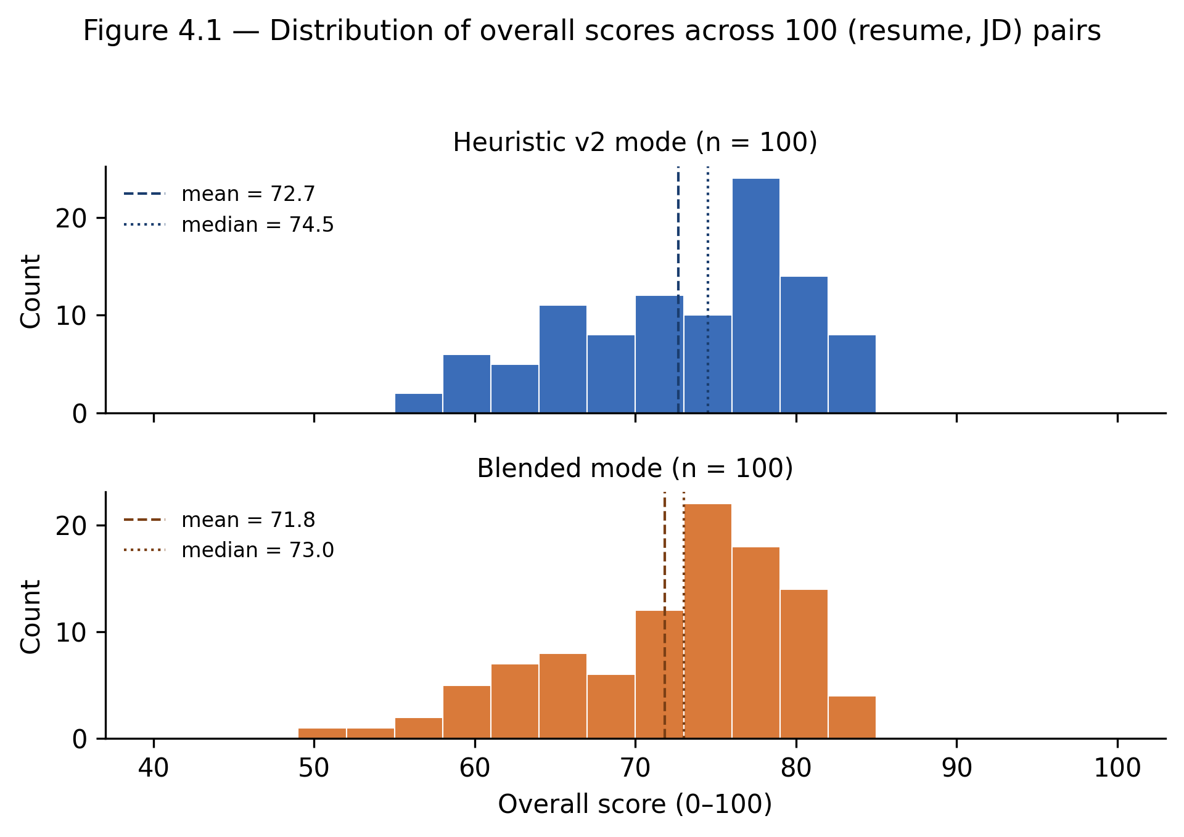
Figure 4.1: Distribution of overall scores across 100 synthetic (resume, JD) pairs. Top: heuristic-only mode (mean 72.66, median 74.5). Bottom: blended mode (mean 71.84, median 73.0). The dashed vertical line marks the mean and the dotted vertical line marks the median in each panel.

4.3.3 Latency
Wall-clock service-side latency for a single tool invocation is summarised in Table 4.5. The blended-mode figure is dominated by the upstream Gemini structured-output inference call; the heuristic-only mode runs entirely as local string processing.
Table 4.5: Service-side latency for a single tool invocation, in milliseconds, with the per-row blended-to-heuristic ratio. The maximum-observed row reflects one transient LLM retry absorbed by the four-retry exponential-backoff policy described in Section 3.1.1.
Metric | Blended (ms) | Heuristic v2 (ms) | Ratio
Median | 18 232.1 | 25.5 | 714×
95th percentile | 24 713.7 | 32.1 | 770×
Maximum observed | 65 926.6 | 34.1 | 1 933×
Blended latency is dominated by Gemini structured-output inference over approximately 608 input tokens plus prompt overhead and 1 118 output tokens. The maximum of 65 926.6 ms reflects one transient LLM retry handled by the retry policy. Heuristic v2 runs in tens of milliseconds and satisfies the N1a target from Section 2.1.2. Component-level decomposition between token generation, network round-trip, and serialisation overhead was not instrumented in the prototype; future work could profile this granularity (for instance via OpenTelemetry spans on the Vertex AI client or middleware timing decorators) to localise optimisation targets. The two-to-three-orders-of-magnitude latency gap is the operational rationale for keeping both modes runtime-switchable rather than committing to one path.
4.3.4 Per-call cost
Cost uses the Vertex AI Gemini 2.5 Flash rates in effect at measurement time: input $0.075 / 1 M tokens and output $0.30 / 1 M tokens. The blended run used an estimated 608 input tokens and 1 118 output tokens per call on average; Table 4.6 summarises the resulting per-call and projected monthly cost figures.
Table 4.6: Per-call LLM-side cost, in US dollars, at the Vertex AI Gemini 2.5 Flash rates in effect at measurement time. The estimator follows the ~4-characters-per-token rule of thumb and does not include all server-side prompt overhead, so the figures are order-of-magnitude rather than billing-grade.
Statistic | Blended mode | Heuristic v2 mode
Average per-call cost | $0.00038 | $0.00000
95th-percentile per-call cost | $0.00042 | $0.00000
Projected monthly cost at 1 000 analyses/day | $11.43 | $0.00
Token counts are approximations following the ~4 characters per token rule of thumb that the Vertex AI documentation uses. The input-token figure counts the resume and the job description text the harness sends; the system prompt and the locked-payload block are configured server-side in the analytical service and contribute additional per-call overhead that is not captured by the harness’s estimator. Exact tokeniser-derived counts are deferred to future work; the headline cost claim in this section is an order-of-magnitude statement, not a billing-grade figure. The recomputation that produces this table is implemented in scripts/recompute_eval_cost.py, which rebuilds the prompt for every pair without a second LLM call.
This absolute cost is small at thesis scale, but the ratio matters for mode design. A demonstration, outage fallback, or high-volume preview flow can use the heuristic path without accumulating third-party inference cost. The blended path can then be reserved for cases where richer explanations are worth the additional latency.
4.3.5 Sensitivity to the score-combination weights
The five-sub-score weights introduced in Section 4.2.7 are author-selected. To check that the comparative result is not an artefact of the specific weights, the score is recomputed offline from the same per-sub-score breakdown using equal weights (0.20 each), and the Pearson and Spearman correlations between modes are computed under both weight settings. Table 4.7 reports the result.
Table 4.7: Sensitivity of the blended-versus-heuristic agreement to the score-combination weights. The Δ row shows the absolute movement after switching from the author-selected weighting to equal weights.
Weighting | Pearson r | Spearman ρ
Author-selected (0.30, 0.25, 0.15, 0.15, 0.15) | 0.836 | 0.847
Equal (0.20 across all five) | 0.813 | 0.823
Δ | −0.023 | −0.024
Pearson moves by Δ = −0.023 and Spearman by Δ = −0.024 after rounding to three decimals. Both remain above the practical 0.7 interpretation anchor, so the value-association result is not dependent on the exact heuristic sub-score weighting choice. The rank-agreement reading is similarly robust; the comparative claim of Section 4.3.1 is therefore weighting-invariant within this evaluation set rather than weighting-specific.
4.3.6 Heuristic-enhancement ablation (Stage H)
Stage H tested whether targeted heuristic enhancements could close the LLM-only residual without adding a deployed neural dependency. A separate quality_signals_v3.py module added five gated signals: SBERT semantic fallback with all-MiniLM-L6-v2 at cosine threshold 0.65 (H.1), STAR-format detection (H.2), cross-axis coherence checks (H.3), bigram/trigram matching (H.4), and ESCO expansion from 107 to 354 entries (H.5). Each variant was compared against the same post-hoc LLM-only baseline, so no additional LLM calls were issued.
Table 4.8 reports the Pearson correlation against the post-hoc LLM-only score for each variant, with the cluster-bootstrap interval and the absolute delta against the v2 baseline.
Table 4.8: Stage H ablation. Pearson correlation between each variant and the post-hoc LLM-only score, with cluster-bootstrap 95% confidence intervals (resume_id clusters, 2 000 resamples, seed = 42). Bold rows mark the v2 baseline and the full v3 stack endpoints of the ablation.
Variant | Pearson r | 95% CI | Spearman ρ | Δ vs v2
heuristic-v2 (BM25 + ESCO + fuzzy) | 0.627 | [0.470, 0.758] | 0.596 | baseline
heuristic-v3 with no Stage H features | 0.627 | [0.470, 0.758] | 0.596 | +0.000
Bigram/trigram matching (H.4) | 0.629 | [0.470, 0.758] | 0.583 | +0.002
SBERT semantic fallback (H.1) | 0.623 | [0.452, 0.759] | 0.573 | −0.004
STAR detection (H.2) | 0.621 | [0.463, 0.755] | 0.596 | −0.006
ESCO expansion 107 → 354 (H.5) | 0.617 | [0.461, 0.752] | 0.578 | −0.009
Cross-axis coherence (H.3) | 0.605 | [0.438, 0.746] | 0.568 | −0.022
heuristic-v3 full stack | 0.590 | [0.415, 0.735] | 0.556 | −0.036
The result is a controlled null with small negative drift in the full configuration. v3-empty reproduces v2 exactly to three decimals, validating the module boundary. Single-feature deltas range from +0.002 to −0.022 and remain inside the cluster-bootstrap interval width on the 100-pair set, so none of the variants are statistically distinguishable from the v2 baseline. The full v3 stack falls to r = 0.590 (Δ = −0.036), suggesting that small false-positive effects compound when all five gated signals fire simultaneously.
The likely explanation is that the synthetic benchmark already exposes canonical skill overlap, so extra keyword recall through SBERT, n-grams, or ESCO expansion adds little. The remaining gap to the LLM-only score reflects prose quality, narrative coherence, and role-fit judgement rather than missing keyword evidence. The ablation is reproducible through scripts/eval_scoring_v3_ablation.py, scripts/analyze_v3_ablation.py, backend/app/services/quality_signals_v3.py, and backend/app/data/esco_skills_expanded.json; PyTorch and sentence-transformers stay in backend/requirements-thesis-eval.txt, outside the production requirements.
This null result is still useful. It prevents the future-work section from overstating sentence-transformer matching as an obvious next production step. On this benchmark, the strict v2 heuristic is already near the available keyword-and-structure ceiling, and the unresolved gap sits in evidence classes that require either different features or a different evaluation surface.
4.3.7 Implementation note on Stage H reproducibility
The ablation reuses thesis/eval-results.json from Stage G and recovers LLM-only scores through the identity in Section 4.3.1’. It runs in approximately 4 minutes on commodity hardware: about 110 s for SBERT first load and inference, and about 10 s combined for deterministic variants. This keeps Stage H as a research artefact rather than a production dependency.
4.4 Discussion and limitations
Within this synthetic evaluation set, the fully heuristic mode recovers most of the blended mode’s aggregate discriminative power: Pearson r = 0.836 [95% CI 0.762, 0.896], Spearman ρ = 0.847, median latency 25.5 ms rather than 18.2 s, and zero LLM-side marginal cost. After removing the structural 0.40 heuristic share in the blended formula, LLM-only versus heuristic agreement is r = 0.627 [95% CI 0.470, 0.758]. The deterministic baseline is therefore strong enough to justify deployment as a fallback and runtime mode, while the blended mode remains valuable for qualitative explanations and clarity-sensitive judgement.
Four limitations constrain the claim. Single-language scope: all evaluation resumes and job descriptions are in English, although ESCO is multilingual. Single-subject evaluation: one author synthesised all 30 resumes, so stylistic regularities may not generalise. Single LLM provider: the blended mode uses Gemini 2.5 Flash only; cross-model comparisons remain a known limitation of LLM-as-judge evaluations [29]. Bias and fairness: the benchmark has no demographic annotations and cannot support disparate-impact analysis; production deployment beyond thesis scope would require a fairness audit aligned with algorithmic-hiring literature [22, 23, 24].
The per-sub-score breakdown is the most useful diagnostic result. Keywords and structure converge strongly, while clarity diverges. This explains why the heuristic can be fast, cheap, and operationally useful without replacing the LLM component entirely.
A final limitation concerns trend awareness. The approved topic includes current job-market trends, but the implemented system reasons over a static resume and the current text of a job description. It does not model posting-frequency changes, regional demand, salary movement, or temporal skill adoption. Those signals would require a separate labour-market data layer and are left to future work.
Chapter 5 — Conclusions
This thesis presented the design, implementation, and empirical evaluation of a system for personalised career recommendation, scoped as a Bachelor-level engineering thesis at the Faculty of Electronics, Photonics and Microsystems of Wrocław University of Science and Technology.
5.1 Results
A deployed integrated system. The system is deployed on Railway as a single application surface and integrates six tools: Resume Analyzer, Job Match, Career Path, Cover Letter, Interview Q&A, and Portfolio Planner. Chapters 2 and 3 documented the architecture, the shared pipeline, and the tool implementations. The system supports authenticated accounts, guest demonstrations, persisted tool history, regeneration chains, and runtime switching between scoring modes.
A defendable heuristic baseline. Chapter 4 introduced strong heuristic v2, a strictly non-neural scoring pipeline based on TF–IDF and BM25 [5, 6], ESCO-aligned skill normalisation [8, 9, 12], string-similarity fuzzy matching [7], section-weighted evidence [18], quantification detection, and action-verb scoring. The score-combination weights are author-selected but were checked through the sensitivity analysis in Section 4.3.5.
A characterisation of the heuristic-versus-blended trade-off. Section 4.3 reported four metric families measured across 100 (resume, job-description) pairs on the post-mitigation disjoint-vocabulary dataset. On the overall score the heuristic mode tracks the blended mode at Pearson r = 0.836 [95% CI 0.762, 0.896 under cluster bootstrap on resume identity] and Spearman ρ = 0.847, both well above the 0.7 reference threshold, while running roughly two-to-three orders of magnitude faster (median 25.5 ms versus 18.2 s) at zero LLM-side marginal cost. The post-hoc LLM-only-versus-heuristic correlation, isolated from the structural blended-formula component (Section 4.3.1’, T2 mitigation), is r = 0.627 [95% CI 0.470, 0.758]; this is the cross-mode agreement after controlling for the 0.40 heuristic share that the blended mode carries by construction. The agreement is dominated by the keywords axis (r = 0.937), where both modes consume the same evidence, and is weakest on the clarity axis (r = 0.395), where the language model contributes prose-quality evidence the heuristic does not see. Independently of the aggregate numbers, the blended mode produces qualitatively richer prose recommendations that the heuristic does not attempt to produce; this qualitative dimension is reserved for separate user-research investigation.
With the benefit of hindsight, the single decision the author would change is the order in which the tools were built. The first months of work went into the Resume Analyzer and the Job Match tool, each shipped as a self-contained pipeline with its own cache, its own persistence call, and its own observability boilerplate copy-pasted from the other. Only after the third tool joined the system did the duplication become painful enough to motivate the shared run_tool_pipeline refactor. A more disciplined approach would have written the pipeline first and built the first tool against it, even at the cost of a slightly slower start; a meaningful fraction of the early bugs in this project turned out to be variations on the same forgotten cache-key argument across three nearly-identical service modules.
The main research lesson is methodological: a deterministic baseline should be measured rather than treated as a fallback of last resort. Before the comparison, heuristic mode existed mainly as a reliability mechanism, justified only by N3 of Chapter 2. After the study, it can be described much more precisely: weaker on prose-quality judgement (clarity r = 0.395) but strong enough on aggregate ranking and on legitimate skill-overlap evidence (keywords r = 0.937, structure r = 0.830) to justify its place in the deployed system as both an emergency fallback and a runtime-switchable mode for cost-sensitive or audit-sensitive deployments.
Validity-threat closure reported in Chapter 4. Three measurements address threats T1, T2, and T3 of Section 4.1.4, and their numerical results are reported inline in Chapter 4. The LLM-only baseline per pair, recovered post-hoc from the locked-payload identity rather than from a second LLM rerun, is reported in Section 4.3.1’ and addresses threat T2 (r (LLM-only, heuristic) = 0.627 [95% CI 0.470, 0.758]). The vocabulary-disjoint regeneration of the synthetic benchmark (under which the resume side and the job-description side draw from non-overlapping phrase pools by construction, with the per-pair content-token overlap audited at zero pairs above the >3-token threshold) is the dataset on which every number in Section 4.3 is computed and addresses T1. The by-resume cluster-bootstrap confidence intervals for all headline correlations, computed by resampling resume identifiers with replacement (cluster_bootstrap_pearson in scripts/analyze_eval_results.py, 2 000 resamples, seed = 42), are reported alongside the point estimates in Sections 4.3.1 and 4.3.1’ and address T3. The three closures together support the strong-agreement-within-this-synthetic-evaluation-set characterisation in Section 4.4. T4 (post-hoc heuristic design) remains a disclosed limitation rather than a closed one.
5.2 Limitations
The empirical claim is bounded by the evaluation design. The dataset is single-language (English) and single-author (all 30 resumes were synthesised by one author), so the result is a within-author baseline rather than a cross-population hiring claim. The blended mode uses a single LLM provider, Google Vertex AI Gemini 2.5 Flash, and should not be assumed to behave identically with Claude, GPT, Llama, or another hosted model.
Two operational limits also remain. First, the in-memory cache is not shared between processes; this is acceptable for thesis-scope traffic but not for larger production scale. Second, the implemented system covers skills and experience but does not yet model temporal job-market trends such as posting-frequency shifts, regional demand changes, or hiring-rate dynamics.
Finally, the system is a thesis demonstration rather than a sustainable commercial product. The monetisation strategy described in docs/spec.md is deliberately deferred to a post-thesis V1.1 release and is not evaluated here.
The fairness limitation is separate from those operational issues. Automated hiring tools can reproduce or amplify bias when resume content, model training data, or historical decisions correlate with protected attributes [22, 23, 24]. The present benchmark has no demographic labels, so disparate-impact diagnostics cannot be computed.
A further methodological limitation is that the evaluation measures score agreement rather than downstream user outcomes. The study shows how closely two scoring modes track each other on the synthetic benchmark, but it does not measure whether candidates rewrite better resumes, receive more interviews, or make better career decisions after using the system. Those outcomes would require a longitudinal user study with consented participants, which is outside the thesis schedule.
5.3 Future development
Future work follows directly from these limitations.
Polish-language coverage. ESCO is multilingual, but the current bundled subset uses English labels. Adding Polish labels would make the system more relevant to a Wrocław-based deployment. The required change is contained: language detection, Polish-aware preprocessing in quality_signals_v2.py, and locale-specific prompt branches.
This extension would also test whether the top-down ESCO strategy remains robust when resumes mix Polish headings, English technical skills, and hybrid phrasing common in local technology roles. The architecture separates preprocessing, prompt construction, and scoring, so the work is mainly data and language handling rather than a new system design.
The Polish extension should not be treated as a translation-only task. Resume section labels, education terminology, contract types, and local job-title conventions differ from English examples, and technical resumes often mix languages in one document. A useful implementation would therefore combine ESCO label expansion with Polish section detection and bilingual prompt evaluation.
Sentence-transformer intermediate tier. A third scoring mode could sit between strict classical IR and full LLM inference: a sentence-transformer semantic matcher such as all-MiniLM-L6-v2 [20, 21]. Stage H tested this idea as an ablation, but on the synthetic benchmark the SBERT-only variant reached r = 0.623 (Δ = −0.004 versus v2) and the full v3 stack reached r = 0.590 (Δ = −0.036). These results suggest that promotion to production should wait for evaluation on real-world resumes and job descriptions with more prose variation than the synthetic templates expose.
Retrieval-augmented blended mode. The blended mode could retrieve curated labour-market documents, ESCO occupation descriptions, salary surveys, or role-progression standards before invoking the LLM [25]. This would make recommendations more source-attributed without changing the persistence model or response contracts.
This direction is the most product-facing one. It addresses the limitation that current recommendations are reasoned from the resume and job description but are not grounded in external labour-market evidence. A retrieval stage would let the system cite recent documents while preserving the existing LLM response shape.
The retrieval layer would also help with the approved-topic phrase “current job-market trends”. Instead of asking the LLM to infer market context from its pretraining, the system could retrieve recent, source-attributed evidence and attach it to the recommendation. This would make the trend dimension auditable in a way that the present static job-description comparison is not.
Redis-backed cache. Replacing the in-memory cache with Redis would allow cache sharing across backend processes and is the smallest operational upgrade once traffic exceeds a single-instance deployment.
This change would preserve the current cache-key design while moving storage out of process memory. It would also make latency measurements easier to interpret in a scaled deployment because cache hits would not depend on which backend worker received the request.
Among the four future-work directions, no single ranking holds across all the criteria that would matter. The sentence-transformer intermediate tier is the most technically probed of the four: Stage H of this thesis (Section 4.3.6) implemented an SBERT semantic-fallback layer alongside four other classical-IR enhancements and reported a controlled null on the synthetic evaluation set, with the SBERT-only variant at r = 0.623 (Δ = −0.004) and the full-stack v3 configuration at r = 0.590 (Δ = −0.036), all comfortably inside the ±0.15 half-width of the cluster-bootstrap noise band on the 100-pair set. The case for promoting the SBERT tier from an ablation cell to a deployed component rests on a different evaluation surface than the comparative-study benchmark of Chapter 4, likely a real-world resume and job-description corpus with prose-quality variation that the synthetic templates suppress. The retrieval-augmented blended mode is the most product-relevant of the four because the most consistent informal feedback on the deployed system has been a request for source attribution behind the recommendations. The Polish-language extension is the most regionally concrete one and would benefit from a native-Polish collaborator rather than from a single-author execution. The Redis-backed cache is the smallest of the four in scope and the only one that does not require new research data. Which of the four becomes the next deliverable depends on whether the project continues as a personal study, transitions into a paid product, or feeds into a future Master’s-level extension.
The thesis contributions are therefore an integrated, deployed system that brings six career tools together around a single resume representation, a defendable strictly-non-neural heuristic baseline, and an empirical characterisation of how that baseline compares to a language-model-augmented mode for the two analytical tools (Resume Analyzer and Job Match) on score agreement, latency, and cost, all within the synthetic evaluation set described in Chapter 4. The deployment is live at the time of submission and the administrative scoring-mode endpoint introduced in Chapter 4.2.9 is operable for live demonstration during the diploma defence.
That broader evaluation set would be the natural bridge from a Bachelor-level engineering thesis to a Master’s-level research project. It would allow the same architecture and scoring modes to be tested under less synthetic language variation, with demographic safeguards and real user outcomes added to the evaluation design.
Bibliography
1. Foundational AI for organisational decision-making
[1] M. Stone, E. Aravopoulou, Y. Ekinci, G. Evans, M. Hobbs, A. Labib, P. Laughlin, J. Machtynger, and L. Machtynger, “Artificial intelligence (AI) in strategic marketing decision-making: a research agenda,” The Bottom Line, vol. 33, no. 2, pp. 183–200, 2020. https://doi.org/10.1108/BL-03-2020-0022
[2] S. Gupta, S. Modgil, S. Bhattacharyya, et al., “Artificial intelligence for decision support systems in the field of operations research: review and future scope of research,” Annals of Operations Research, vol. 308, pp. 215–274, 2022. https://doi.org/10.1007/s10479-020-03856-6
[3] World Economic Forum, The Future of Jobs Report 2023. Geneva: WEF, May 2023. https://www.weforum.org/publications/the-future-of-jobs-report-2023/
[4] Y. Kang, Z. Cai, C. W. Tan, Q. Huang, and H. Liu, “Natural language processing (NLP) in management research: A literature review,” Journal of Management Analytics, vol. 7, no. 2, pp. 139–172, 2020. https://doi.org/10.1080/23270012.2020.1756939
2. Foundational information retrieval
[5] G. Salton and M. J. McGill, Introduction to modern information retrieval. New York: McGraw-Hill, 1983.
[6] S. Robertson and H. Zaragoza, “The probabilistic relevance framework: BM25 and beyond,” Foundations and Trends in Information Retrieval, vol. 3, no. 4, pp. 333–389, 2009. https://doi.org/10.1561/1500000019
[7] V. I. Levenshtein, “Binary codes capable of correcting deletions, insertions, and reversals,” Soviet Physics Doklady, vol. 10, no. 8, pp. 707–710, 1966.
3. Skill extraction and labour-market taxonomies (ESCO, O*NET)
[8] M. le Vrang, A. Papantoniou, E. Pauwels, P. Fannes, D. Vandensteen, and J. De Smedt, “ESCO: Boosting job matching in Europe with semantic interoperability,” IEEE Computer, vol. 47, no. 10, pp. 57–64, 2014. https://doi.org/10.1109/MC.2014.283
[9] D. C. Kavargyris, K. Georgiou, E. Papaioannou, K. Petrakis, N. Mittas, and L. Angelis, “ESCOX: A tool for skill and occupation extraction using LLMs from unstructured text,” Software Impacts, vol. 25, art. 100772, 2025. https://doi.org/10.1016/j.simpa.2025.100772
[10] A. Herandi, Y. Li, Z. Liu, X. Hu, and X. Cai, “Skill-LLM: Repurposing general-purpose LLMs for skill extraction,” arXiv preprint arXiv:2410.12052, 2024. https://arxiv.org/abs/2410.12052
[11] S. Saroglou, K. Diamantaras, F. Preta, M. Delianidi, A. Benisis, and C. J. Meyer, “Enhancing job matching: Occupation, skill and qualification linking with the ESCO and EQF taxonomies,” arXiv preprint arXiv:2512.03195, 2025. https://arxiv.org/abs/2512.03195
[12] C. Panzaru and A. Grama, “Towards explicit soft skills labelling in ESCO through semantic NLP analysis,” Journal for Labour Market Research, vol. 59, no. 1, art. 18, 2025. https://doi.org/10.1186/s12651-025-00409-x
[13] M. de Groot, J. Schutte, and D. Graus, “Job posting-enriched knowledge graph for skills-based matching,” arXiv preprint arXiv:2109.02554, 2021. https://arxiv.org/abs/2109.02554
4. Resume parsing and information extraction
[14] K. Yu, G. Guan, and M. Zhou, “Resume information extraction with cascaded hybrid model,” in Proceedings of the 43rd Annual Meeting of the Association for Computational Linguistics (ACL ’05), 2005, pp. 499–506. https://aclanthology.org/P05-1062/
5. AI-based career recommendation systems
[15] H. Al-Dossari, F. A. Nughaymish, Z. Al-Qahtani, M. Alkahlifah, and A. Alqahtani, “CareerRec: A machine learning approach to career path choice for information technology graduates,” Engineering, Technology & Applied Science Research, vol. 10, no. 6, pp. 6589–6596, 2020. https://doi.org/10.48084/etasr.3821
6. Large language models in recruitment
[16] C. Gan, Q. Zhang, and T. Mori, “Application of LLM agents in recruitment: A novel framework for resume screening,” arXiv preprint arXiv:2401.08315, 2024. https://arxiv.org/abs/2401.08315
[17] F. P.-W. Lo, J. Qiu, Z. Wang, H. Yu, Y. Chen, G. Zhang, and B. Lo, “AI hiring with LLMs: A context-aware and explainable multi-agent framework for resume screening,” in Proc. IEEE/CVF Conf. on Computer Vision and Pattern Recognition Workshops (CVPRW), 2025, pp. 4184–4193. https://doi.org/10.1109/CVPRW67362.2025.00402
[18] R. V. K. Bevara, N. R. Mannuru, S. P. Karedla, B. D. Lund, T. Xiao, H. Pasem, S. C. Dronavalli, and S. Rupeshkumar, “Resume2Vec: Transforming applicant tracking systems with intelligent resume embeddings for precise candidate matching,” Electronics, vol. 14, no. 4, art. 794, 2025. https://doi.org/10.3390/electronics14040794
[19] A. Jagadeesh, C. R. Shankar, S. N. Patel, M. Levantesi, G. Semeraro, and E. W. De Luca, “AI-driven resume analysis and enhancement using semantic modeling and large language feedback loops,” in Proceedings of CLiC-it 2025, 2025. https://aclanthology.org/2025.clicit-1.51/
7. Semantic matching and sentence embeddings
[20] N. Reimers and I. Gurevych, “Sentence-BERT: Sentence embeddings using Siamese BERT-networks,” in Proceedings of EMNLP-IJCNLP 2019, Hong Kong, 2019. https://arxiv.org/abs/1908.10084
[21] V. Zadykian, B. Andrade, and H. Afli, “Towards explainable job title matching: Leveraging semantic textual relatedness and knowledge graphs,” arXiv preprint arXiv:2509.09522, 2025. https://arxiv.org/abs/2509.09522
8. Bias and fairness in algorithmic hiring
[22] A. Köchling and M. C. Wehner, “Discriminated by an algorithm: A systematic review of discrimination and fairness by algorithmic decision-making in the context of HR recruitment and HR development,” Business Research, vol. 13, no. 3, pp. 795–848, 2020. https://doi.org/10.1007/s40685-020-00134-w
[23] M. Raghavan, S. Barocas, J. Kleinberg, and K. Levy, “Mitigating bias in algorithmic hiring: Evaluating claims and practices,” in Proceedings of the 2020 Conference on Fairness, Accountability, and Transparency (FAccT ’20), 2020, pp. 469–481. https://doi.org/10.1145/3351095.3372828
[24] Z. Chen, “Ethics and discrimination in artificial intelligence-enabled recruitment practices,” Humanities and Social Sciences Communications, vol. 10, art. 567, 2023. https://doi.org/10.1057/s41599-023-02079-x
9. Retrieval-augmented generation
[25] Y. Gao, Y. Xiong, X. Gao, K. Jia, J. Pan, Y. Bi, Y. Dai, J. Sun, and H. Wang, “Retrieval-augmented generation for large language models: A survey,” arXiv preprint arXiv:2312.10997, 2023. https://arxiv.org/abs/2312.10997
10. Statistical and evaluation methodology
[26] J. Cohen, Statistical Power Analysis for the Behavioral Sciences, 2nd ed. Hillsdale, NJ: Lawrence Erlbaum, 1988.
[27] T. D. Cook and D. T. Campbell, Quasi-Experimentation: Design and Analysis Issues for Field Settings. Boston, MA: Houghton Mifflin, 1979.
[28] A. C. Cameron, J. B. Gelbach, and D. L. Miller, “Bootstrap-based improvements for inference with clustered errors,” The Review of Economics and Statistics, vol. 90, no. 3, pp. 414–427, 2008. https://doi.org/10.1162/rest.90.3.414
[29] L. Zheng, W.-L. Chiang, Y. Sheng, S. Zhuang, Z. Wu, Y. Zhuang, Z. Lin, Z. Li, D. Li, E. P. Xing, H. Zhang, J. E. Gonzalez, and I. Stoica, “Judging LLM-as-a-Judge with MT-Bench and Chatbot Arena,” in Advances in Neural Information Processing Systems, vol. 36, 2023. https://arxiv.org/abs/2306.05685
11. Web frameworks and system tooling
Documentation references for the engineering chapters; kept separate from the numbered academic bibliography because they document implementation APIs rather than research claims.
- FastAPI documentation. https://fastapi.tiangolo.com
- TanStack Start / Router documentation. https://tanstack.com/router
- React 19 documentation. https://react.dev
- Vite documentation. https://vite.dev
- SQLAlchemy 2.0 documentation. https://www.sqlalchemy.org
- Alembic migration documentation. https://alembic.sqlalchemy.org
- PostgreSQL documentation. https://www.postgresql.org/docs/
- Google Cloud Vertex AI Gemini documentation. https://cloud.google.com/vertex-ai/generative-ai/docs
- Resend transactional email API. https://resend.com/docs
Appendices
Appendix A — Source listings
Excerpted listings of the most thesis-relevant code. Each listing is a representative excerpt; full source files of the same name in the repository contain additional helpers, error handling, and inline documentation that are not reproduced here in the interest of length. Each listing is preceded by its file path so the reader can navigate to the corresponding location in the public repository at the moment of submission.
A.1 Strong heuristic v2 — public entry point
backend/app/services/quality_signals_v2.py
def build_resume_prepass_v2(
resume_text: str,
job_description: str | None = None,
target_role_label: str | None = None,
) -> ResumePrepassV2:
text = resume_text or ""
sections = _detect_sections(text)
bullets = [m.group(1) for m in _BULLET_RE.finditer(text)]
tokens = _tokenize(text)
resume_skills = _normalise_skills(text)
matched: list[str] = []
missing: list[str] = []
matched_locations: list[tuple[str, str | None]] = []
fuzzy_count = 0
# ... (full body in the source file; see Section 4.2 of the thesis for the
# accompanying methodological description)
A.2 BM25 scoring
backend/app/services/quality_signals_v2.py
def _bm25_score(
resume_tf: dict[str, int],
query_terms: list[str],
idf: dict[str, float],
avg_dl: float = 350.0,
k1: float = 1.5,
b: float = 0.75,
) -> float:
"""Standard BM25 score of a query against a single document's term-frequencies."""
if not query_terms:
return 0.0
dl = sum(resume_tf.values()) or 1
score = 0.0
for term in query_terms:
tf = resume_tf.get(term, 0)
if tf == 0:
continue
term_idf = idf.get(term, math.log((1 + 0.5) / (0 + 0.5) + 1))
norm = tf * (k1 + 1) / (tf + k1 * (1 - b + b * dl / avg_dl))
score += term_idf * norm
return score
A.3 Runtime mode toggle
backend/app/services/runtime_settings.py
ScoringMode = Literal["blended", "heuristic"]
_VALID_MODES: tuple[str, ...] = ("blended", "heuristic")
_initial_mode: ScoringMode = "blended"
configured = getattr(settings, "SCORING_MODE", "blended")
if configured in _VALID_MODES:
_initial_mode = configured
_current_mode: ScoringMode = _initial_mode
def get_scoring_mode() -> ScoringMode:
return _current_mode
def set_scoring_mode(mode: str) -> ScoringMode:
global _current_mode
if mode not in _VALID_MODES:
raise ValueError(f"unknown scoring mode: {mode!r}")
_current_mode = mode
return _current_mode
A.4 Shared tool pipeline
backend/app/services/tool_pipeline.py
async def run_tool_pipeline(
*,
tool_name: str,
service_fn: Callable[..., Awaitable[dict[str, Any]]],
service_kwargs: dict[str, Any],
label_fn: Callable[[dict[str, Any]], str],
resume_text: str,
job_description: str | None = None,
feedback: str | None = None,
parent_run_id: str | None = None,
workspace_id: str | None = None,
linked_context_ids: list[str] | None = None,
current_user: User | None = None,
db: Session,
cache_extra_keys: dict[str, str] | None = None,
) -> dict[str, Any]:
"""Shared pipeline: sanitize -> cache -> service -> fallback -> persist -> respond."""
# ... (sanitisation, cache lookup, service call, persistence, observability)

Appendix B — Evaluation dataset description
The evaluation dataset used in Chapter 4.3 contains N = 30 resumes and M = 20 job descriptions, organised into six role tracks: backend engineering, frontend engineering, full-stack engineering, data analytics, product design, and product management.
B.1 Resume synthesis procedure
Each resume was synthesised from a templated structure that fills role-track-appropriate content into a fixed skeleton: a two-sentence summary, two or three employment entries with three responsibilities and one quantified achievement each, a skills list, a short Projects section with two open-source or side-project lines, and an education block. The synthesis script seeds the templated fields from a curated content library inside the script — role-track skill pools, action-verb-led outcome phrasings, fictional employer names, and a fixed candidate-name pool. Skill density and seniority increase monotonically across the five resumes per track so that the evaluation set spans junior, mid, and senior levels.
The synthesis script is scripts/synthesise_eval_dataset.py. It is fully deterministic: a fixed seed (SEED = 42) produces the same 30 resumes and 20 job descriptions on every run, which makes the evaluation manifest reproducible from the script alone.
B.2 Job description synthesis procedure
Job descriptions were also synthesised from templates rather than scraped from public job boards. Each description draws responsibilities from the same role-track pool used for resumes, and the requirement list is composed from a track-specific must-have skill set sized by seniority (four to six core skills plus one to three secondary skills, with years-of-experience banding by junior, mid, and senior). Synthesising rather than scraping preserves a clean comparison surface (the same skill vocabulary in resume and JD), avoids any privacy or licence concern, and is a deliberate choice that limits external generalisability — see Section 4.4 of Chapter 4 for the limitation framing.
B.3 Pair construction
The evaluation harness scripts/eval_scoring.py pairs each resume with every job description inside the same role track. The JD distribution is three JDs in four tracks and four JDs in two tracks, which produces an exact total of one hundred (resume, JD) pairs.
B.4 Pair manifest
The manifest produced by the synthesis script at thesis/eval-dataset.json is a list of one hundred objects with the shape {id, resume, jd, role_track}. The id is composed as r-<track>-<NN>__jd-<track>-<NN> so that every row is traceable back to its constituent resume and job description, and every per-pair result in Section 4.3 can be re-queried by id.

Appendix C — Screenshots of the running system
The screenshots in this appendix were captured at 1920 × 1080 viewport against the deployed system. The intent of the appendix is to demonstrate the engineering artefact — the running tools — rather than to document generic authentication UI; login forms, OAuth flows, and account-creation pages are therefore omitted in favour of screens that exhibit the analytical and generative tools described in Chapter 3 and the runtime scoring-mode switch documented in Section 4.2.9.
C.1 Landing page
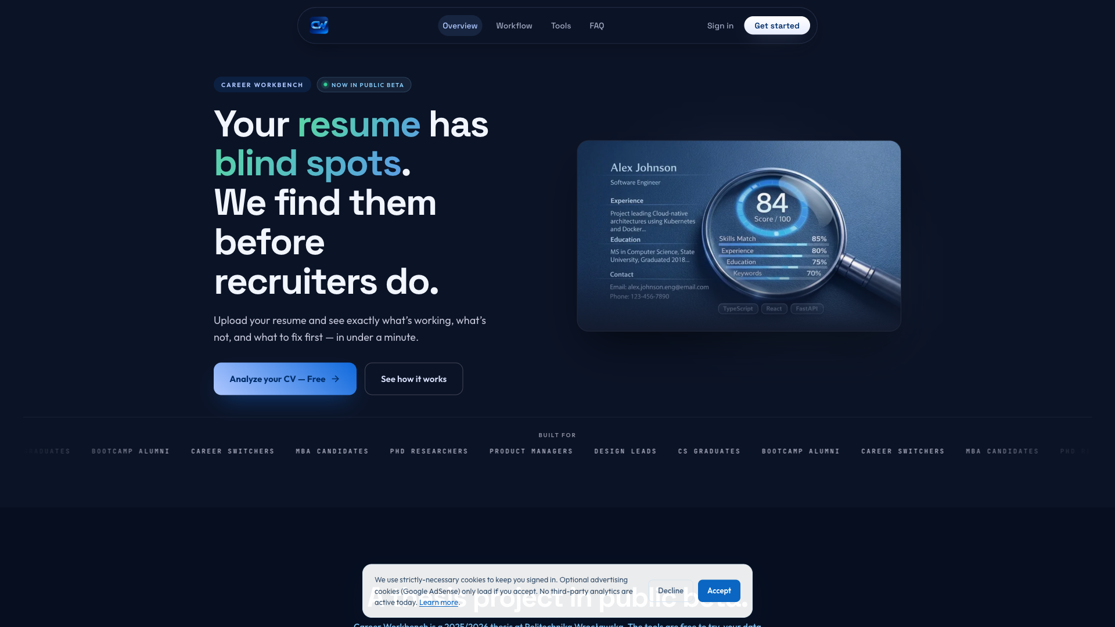
Figure C.1: The public landing page at https://thecareerworkbench.com, presenting the six career-tooling pillars and the primary call-to-action to sign in or proceed as guest.
C.2 Resume Analyzer input page
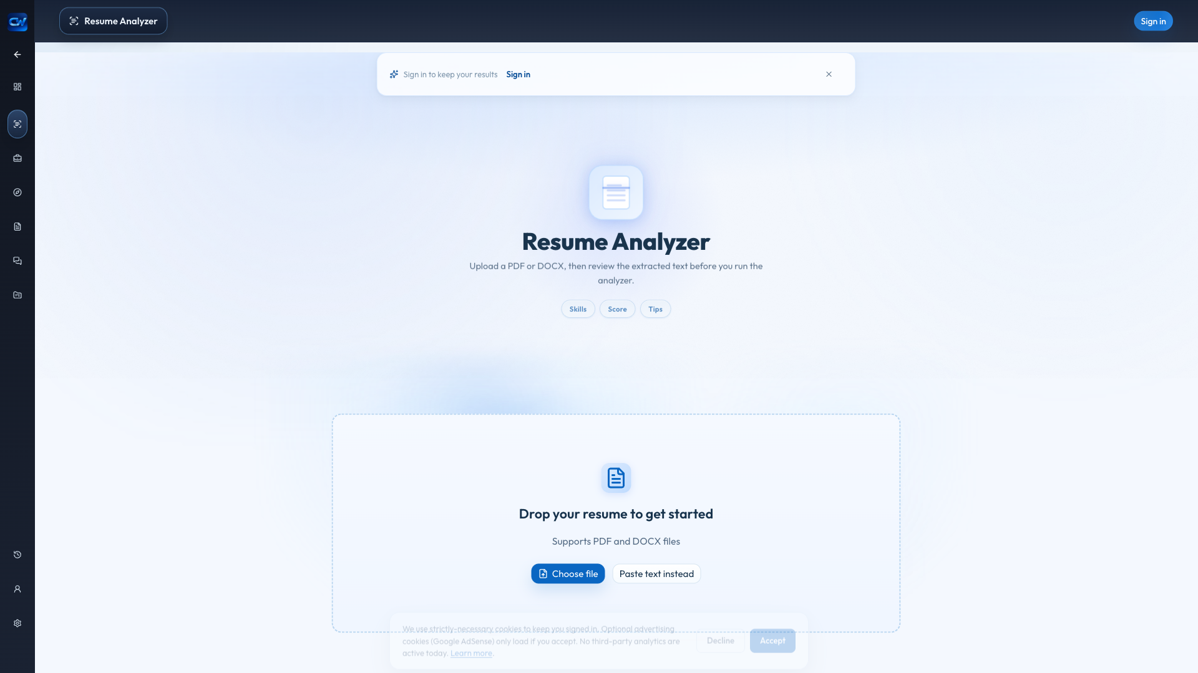
Figure C.2: The Resume Analyzer input page (/resume) as it renders for a guest visitor. The input surface accepts a free-text or uploaded resume, with an optional target job description, before invoking the analytical pipeline described in Chapter 3.2.
C.3 Resume Analyzer result page (blended mode)

Figure C.3: The Resume Analyzer result page after a blended-mode (heuristic 40 % + LLM 60 %) run on the synthetic backend-engineer resume described in Chapter 4 paired with a representative backend-engineer job description. The page renders the overall score, the five-axis sub-score breakdown, the deterministic issues list, the prioritised top actions, and the role-fit narrative — the response shape documented in Chapter 3.2.3.
C.4 Job Match result page
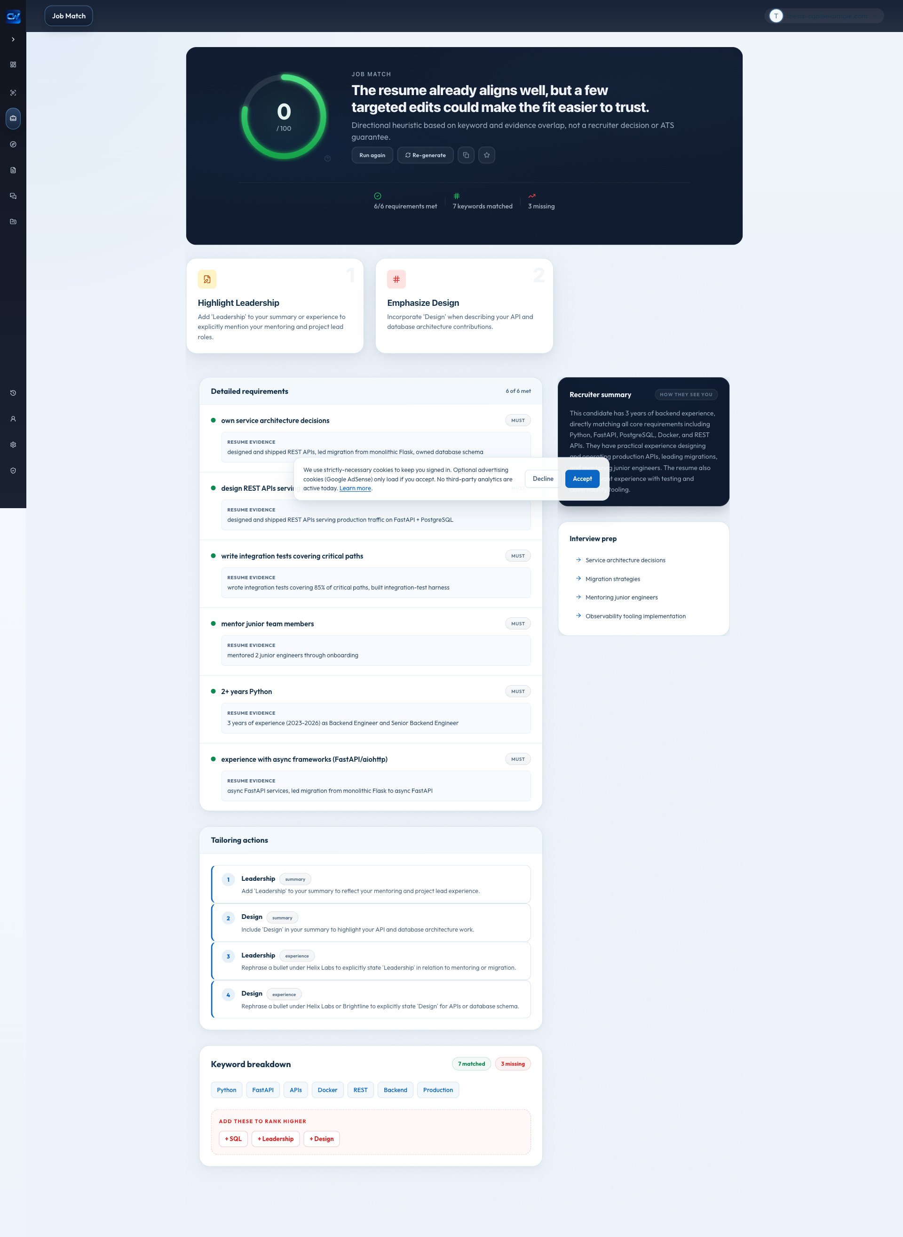
Figure C.4: The Job Match result page on the same input pair as Figure C.3. The view exposes the matched-keyword set, the missing-keyword set, the deterministic verdict, the recruiter-style summary, and the requirement-by-requirement breakdown produced by the prompt described in Chapter 3.3.3.

Appendix D — Configuration reference
D.1 Backend environment variables
The following environment variables are read at process start and configure the deployed system. Defaults shown in parentheses; consult backend/app/config.py for the authoritative list.
Variable | Purpose | Default
DATABASE_URL | PostgreSQL DSN | sqlite:///./career_platform.db
SECRET_KEY | JWT signing secret | (must override)
ACCESS_TOKEN_EXPIRE_MINUTES | Access-token lifetime | 30
REFRESH_TOKEN_EXPIRE_DAYS | Refresh-token lifetime | 7
LLM_PROVIDER | LLM dispatch backend | vertex
LLM_MODEL | Primary Gemini model | gemini-2.5-flash
LLM_PRACTICE_MODEL | Cheaper model used for interview practice feedback | (empty → falls back to LLM_MODEL)
VERTEX_PROJECT_ID | Google Cloud project | (must override)
VERTEX_LOCATION | Vertex region | us-central1
BLENDED_SCORING_ENABLED | Apply 60/40 LLM/heuristic blend | true
SCORING_MODE | Scoring core mode (blended or heuristic) — added with the comparative study | blended
RESULT_CACHE_ENABLED | In-memory cache | true
RESULT_CACHE_TTL_SECONDS | Cache TTL | 3600
CORS_ORIGINS | Allowed CORS origins | localhost defaults
FRONTEND_URL | Canonical frontend URL | (set in production)
GOOGLE_CLIENT_ID / GOOGLE_CLIENT_SECRET / GOOGLE_REDIRECT_URI | Google OAuth | (must override)
RESEND_API_KEY | Transactional email | (must override)
SENTRY_DSN | Error tracking | (empty disables)
D.2 Administrative endpoints
The administrative HTTP API used for the comparative study is exposed under /api/v1/admin/:
- GET /api/v1/admin/scoring-mode → AdminScoringModeResponse
- POST /api/v1/admin/scoring-mode with body { "mode": "blended" | "heuristic" } → returns the updated AdminScoringModeResponse
The response shape returned by both endpoints is:
{
"mode": "blended",
"heuristic_version": "v1",
"blended_weight_heuristic": 0.4,
"blended_weight_llm": 0.6
}
Both endpoints require an authenticated administrator (the users.is_admin flag controls access) and are rate-limited at 60 requests per minute per administrator. The runtime mode change is held in process memory only; restarting the backend restores the configured default from the SCORING_MODE environment variable.
D.3 Running the evaluation harness
The evaluation run used the following commands at the repository root:
$ cd backend
$ SCORING_MODE=blended RESULT_CACHE_ENABLED=false \
python ../scripts/eval_scoring.py
$ python ../scripts/analyze_eval_results.py
The harness writes thesis/eval-results.json; the analyzer emits the Markdown-formatted result tables reported in Chapter 4.3.

