Report
- Problem statement

Dota2 is a online PC game of 10 people, each person control one hero to fight and goal is to destroy the base of their opponent.Our project is focused on the statics of each match,what we want to do is collect every player and every match’s data, analyze it and give the result back to the player so they can see how they are performed and what they contributed to the game.
Depends on the goal of our project, the main problem is how to retrieve data from the officials, cause there are too many match data for us to store if we want to get all the match information. The second problem is that player’s only unique thing is their steamid, since player can change their in-game name, so steamid would be only thing for track a user. It is unreasonable because normally people will remember the in-game name,not the long string steamid.

- Proposed solution
Since the data is too big for us , so we didn’t store match information, we send request to the official server and get the instant data from their public APIs, for instance, a user can search his match histories and detail of every match in our project, these data will retrieve from the official server every time, but like I said , he has to provide his steamid. For second problem, I think in the future when we could store much more data, we can do a statics of name matches with steamid, in this case, we can give back the result if user is providing name instead of steamid.
Beside online data, we also have local data too, we ask user to register in our site and bind their name with the steamid, and also provide some other information about them, so we can easier manage them in our own database.Also, registered user can write articles about heros,items, everything to share they thoughts to other register user, they can also up load videos as well. Users can add friends between, if you are interested of someone, you can follow him and see how he performed in the game, but you have to register.

- Architecture
From the general perspective, we have two parts, the online part and the local part,like a mentioned above, the match information we have too get it through apis because its too large to store.First we get one’s match history, and according to the matchid, we can get details of the match.One thing I wanna mentioned here is that we put all the hero and item information in our local database,because all these are constant.
- For the local part, we have register function which allow them to create,delete,update,find articles and replays on our site, the unregistered user can also read and watch the article and the replays,they can’t comment unless they register. The connection between the online part and the local part is too store the match information into our local database, make matches,players(users) together.

4. APIs Discuss the APIs you used
We primarily use three APIs.
Firstly, we use
http://api.steampowered.com/IDOTA2Match_570/GetMatchDetails/v1/?key=9D05B768ABC6B9BC07614564FD100542&format=json&match_id=<match_id> to get information of every match. What we need to do is just give a match id and then we can gain data about this match. This api is used in our search match function. We can see ten players’ information in this match, including hero they used, items they had, number of kills, deaths and assists, etc.
Secondly,
http://api.steampowered.com/IDOTA2Match_570/GetMatchHistory/v1/?key=9D05B768ABC6B9BC07614564FD100542&account_id=<account_id> is used to search some specific player’s match history. We can use this api to all matches his or her had played, but we just gain latest 10 matches data and put them into our player information web page.
Thirdly, api
http://api.steampowered.com/ISteamUser/GetPlayerSummaries/v0002/?key=9D05B768ABC6B9BC07614564FD100542&steamids=76561198065847991 could response information about players steam state, including steam id, player name, account create time, avatar.

5. Technology stack that you used.
JPA
We use JPA entity to create tables such as User, FriendList, Replay, GameMode, Item, Hero, Comment and Article. And we use persistence to link local database with server and take many operations like create, update, select and delete.
Javascript
We use javascript to make our web page show information dependent what we want it to show. For example, before we login, the button for login and register will show “login” which link to login page and the other button shows “register” which link to register page. While after user login, login button becomes a button that show the username that you use to login, and it will go to update your profile page if you click this button. And the register button will become logout button. When you click this button, you will logout and go to login page.
CSS
We use css to make our web page looks more professional. We use penal for comment part and create different type tables like striped table, hover table to show our data. And button in different colors have different meanings. Besides that, we set font color, type and size to make our web page look better.
JS&JWS
JS(ajax) are used to manage data, like create,update,delete, find data through database.It is used with JWS, this function is a little bit simple than using java, the parameter can be passed by js to DAO, its convenient.

6. User cases. List and discuss the use cases.
1. Register account and associate with Dota2 Steam ID.
Users could register an account and fill information including username, password, first name, last name, e-mail, date of birth and steam account ID which is game ID that players used in Dota2 game. User should provide valid steam ID. Otherwise it could not register successful.
2. Upload your profile.
After register, if users want to update their information like e-mail, steam ID or change their password, date of birth, they could click on their username and get into edit page to change their information and then save. But they cannot change username because we set username is primary key and require it to be unique.
3. Login
Once users have registered, they could login with the username and password. When the username and password they typed matches record stored in our database, they could login successfully. Otherwise there will be an alert which says “Please type right username and password.”
4. Follow players
Users could add friends after they login if their friends had also register for our system. They can search their friends by steam id and in the player information page, there is a button. If their friends also registered and have not been added as friend, it will show “follow” on the button, and you can click this button to add this account as a friend and button will become un-clickable and show “followed” on it. And now we can find this friend in our friend list. And we can click friends’ username to see their information whenever we want. While if he or she had not registered, the button will show “not registered” on it and cannot click, too.
5. Write articles for strategies
For registered users, they can write articles to share their experience about heroes, items, games. Other users could find whole articles wrote by all users in article list page. And if we search a register user who had write articles, we could see all articles he or she wrote before in his or her article list.
6. View articles and write commends
Every one could view the articles while only registered users can write commends to share their experience and viewpoints about topic in articles. If an unregistered user wants to post his or her comment, there will be an alert which says “You have to login first if you want to post a comment.”
7. Liking articles
Every user could click on “like” button in article page if they like this article after reading. And the total number of “like” clicks will show up inform other whether the article is popular or not.
8. Upload replays and videos.
For registered users, they can upload replays and store URL in our system to share their experience about heroes, items, games. Other users could find whole replays upload by all users in replay list page. And if we search a register user who had upload replays, we could see all replays he or she uploaded before in his or her replay list.
9. Watch videos and write commends
Every one could watch replays while only registered users can write commends to share their experience and viewpoints about this video. If an unregistered user wants to post his or her comment, there will be an alert which says “You have to login first if you want to post a comment.”
10. Liking videos
Users could click on “like” button if they like some video after watching. And the total number of “like” clicks will show up inform other whether the replay is popular or not.
11. View match history
Users can search some specific match to get information about this match such as player list, hero played list, result, etc. by match id.
12. Search of players’ information.
Users could search other players using steam ID and see their basic information such as steam id, when he or she last logoff, the states of his or her game account, latest 10 match information.

7. Data model. Discuss the UML class diagram.
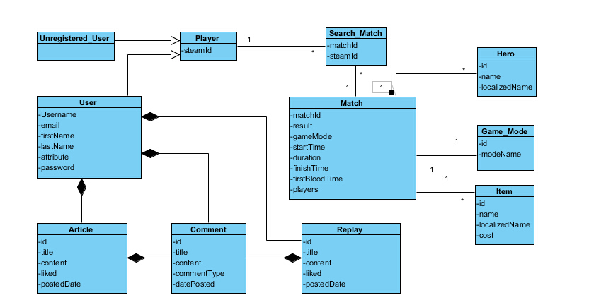

This is the ideal uml diagram, the user part is well implemented in our project, if the heavy data of match and players can be stored, we will create relations like this. Match and user are two main parts of our model, every other info should related with them, match consist of ten players, user provide steamid to find their match information and get their own data through it.In a short sentence, our data model is built based on the game model and user need.

- Future
The user functions are not fully implemented, some delete or update function of article and replay may add depends on needs. These can be handled really quick, the most import thing we need to approve is what I mentioned at the first, the big match and player data, it need to be well stored in local for further use,
With all these heavy data download into local, we can achieve more function for user and response more quickly than send request to official api every time.
Other functions like administrator, user’s feedback are also important, we can setup administrator account and store feedback to database to improve our function of Website.

