Lithium Battery Label
From IATA DG Regulations, 50th Ed., Figure 7.4I

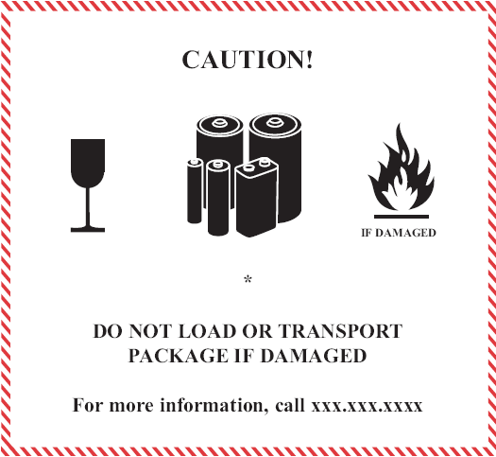
*

If the quality of the label is not the same specifications as the regulations, you may be in violation
You can click on the picture above to add the battery type and telephone number
- Place for “Lithium ion battery” or “Lithium metal battery”, as applicable
Name: Lithium Battery Label
Minimum dimensions: 120 x 110 mm
Color: The border of the label must have red diagonal hatchings. Text and symbols black on a white background.

The border color must be red and the minimum dimensions must be 120 x 110 mm

