System V0.5 Cross-Pilot Benchmark Report V0.1

AI-Aided Recoverability Analysis and Hierarchical Operational Performance Improvement for Hybrid Beamforming
Research Track: AI-Aided Hybrid Beamforming for 6G FR3
Version: V0.1
Date: October 2026

1. Executive Summary
This report documents a cross-pilot validation study of an AI-aided operational failure-management framework built on top of a reproduced model-driven deep-learning hybrid beamforming system.
The objective is not to modify the original statistical outage setting or retrain the underlying beamforming model. Instead, the study asks a different operational question:
Given the same underlying statistical conditions, how many observed failure events can be recovered with lightweight intervention, how many justify stronger escalation, and how many should be treated as severe failures?
Four pilot-power conditions were evaluated:
- P10: 10 dB
- P14: 14 dB
- P17: 17 dB
- P24: 24 dB
The simulator, trained checkpoint, mobility scenarios, trajectory construction, frame count, random seeds, QoS settings, FAST repair logic, and recoverability definitions were frozen across the four cases. Pilot power was the experimental variable.
No retraining, LLM inference, pilot-specific threshold tuning, or change to the underlying beamforming mathematics was introduced.
The principal cross-pilot findings are:
- FAST recovery resolves 15.52–30.25% of failure episodes.
- The MODERATE population requiring possible stronger escalation represents only 8.76–20.25% of failure episodes.
- The HARD population represents 49.50–69.68% of failure episodes.
- Increasing pilot power reduces the number of observed failure episodes, but does not monotonically improve the recoverability of the remaining failures.
- The results support a hierarchical operational strategy based on selective recovery rather than applying increasingly expensive repair to every failure.
These results establish the first cross-pilot benchmark for System V0.5 and provide quantitative evidence that the research direction from statistical outage toward recoverability-aware operational reliability is technically viable.

2. Research Motivation
Traditional outage evaluation primarily asks whether a frame satisfies a required QoS condition.
This work extends that viewpoint from statistical outage toward operational reliability.
The central research question is:
When failure occurs, should every failure be treated in the same way?
A second question concerns computational efficiency:
Can recoverable failures be handled with lightweight intervention while avoiding unnecessary computation on severe failures?
The resulting research path is:
Statistical Outage → Failure-State Capture → Failure Episodes → Recoverability Analysis → Hierarchical Recovery
This approach does not redefine the underlying outage condition. It investigates what can be done operationally after failure behavior is observed.

3. Experimental Principle
Cross-pilot validation follows a strict frozen-protocol principle.

Frozen components
The following components remain unchanged across P10, P14, P17 and P24:
- underlying hybrid-beamforming simulator;
- trained checkpoint;
- mobility definitions;
- number of trajectories;
- frames per trajectory;
- random-seed construction;
- QoS/outage criterion;
- FAST repair settings;
- failure-episode construction;
- recoverability classification definitions.

Experimental variable
Only pilot power is changed:
[
P_{\mathrm{pilot}}\in{10,14,17,24}\ {\rm dB}
]

Explicitly disabled
The benchmark uses:
- NO retraining
- NO LLM inference
- NO pilot-specific tuning
- NO algorithm/math change
Each pilot condition contains 4,000 simulated frames distributed across static, slow, medium and fast mobility conditions.

4. From Failure Frames to Failure Episodes
Frame-level outage alone does not fully describe operational failure behavior.
Consecutive or related failure frames are therefore organized into failure episodes.
A failure episode represents one contiguous operational failure event and may contain multiple consecutive failure frames. Therefore, failure-frame count and failure-episode count are not alternative estimates of the same quantity.
For example, at P17, 930 failure frames are contained within 331 failure episodes, corresponding to an average of approximately 2.81 failure frames per episode. A sequence such as PASS → F → F → F → PASS therefore contains three failure frames but one failure episode.
The captured statistics are:
Pilot | Total Frames | Failure Frames | Failure Rate | Failure Episodes
P10 | 4000 | 1006 | 25.15% | 400
P14 | 4000 | 935 | 23.38% | 351
P17 | 4000 | 930 | 23.25% | 331
P24 | 4000 | 895 | 22.38% | 277
The number of failure episodes decreases from 400 at P10 to 277 at P24.
However, frame count and episode count do not change identically. For example, P14 and P17 have almost identical failure-frame counts, 935 and 930 respectively, while their episode counts differ, 351 versus 331.
This demonstrates why operational analysis benefits from episode-level characterization in addition to conventional frame-level outage statistics.
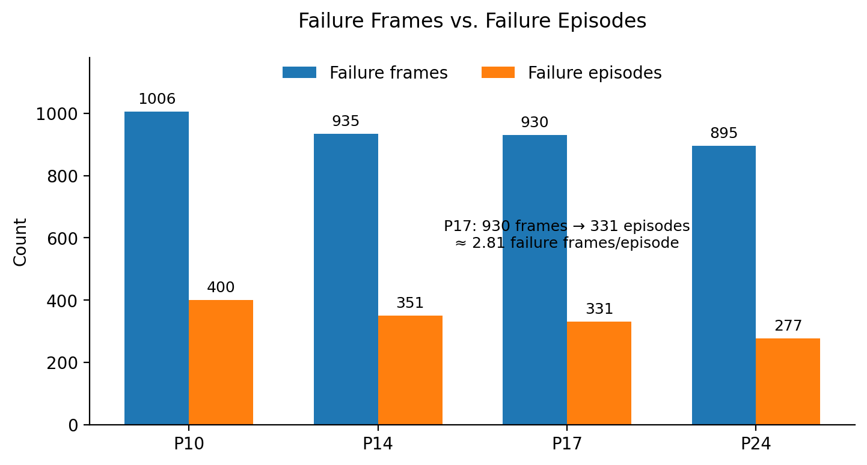
Figure 1. Failure-frame and failure-episode counts across P10/P14/P17/P24. At P17, 930 failure frames are organized into 331 distinct failure episodes.

5. Lightweight FAST Recovery
The first recovery layer is the frozen FAST mechanism.
Cross-pilot results are:
Pilot | Failure Frames | Failure Episodes | FAST Frame Recovery | FAST Episode Recovery
P10 | 1006 | 400 | 17.59% | 30.25%
P14 | 935 | 351 | 15.08% | 25.93%
P17 | 930 | 331 | 15.91% | 29.31%
P24 | 895 | 277 | 7.15% | 15.52%
Across all four pilot conditions, the same frozen FAST mechanism recovers:
[
\boxed{15.52%-30.25%}
]
of failure episodes.
The P10, P14 and P17 cases show episode-level recovery between approximately 26% and 30%.
P24 differs significantly, with an episode recovery rate of 15.52%.
Therefore, FAST recovery is useful across all tested pilot conditions, but recoverability is pilot-dependent.
Frame-level and episode-level recovery measure different operational quantities. At P17, FAST recovers 148 of 930 failure frames (15.91%), while 97 of 331 failure episodes are recovered at the episode/onset level (29.31%).
Episode-level recovery is emphasized in the present operational analysis because it measures the fraction of distinct failure events for which lightweight intervention is successful. Frame-level recovery is retained as a complementary conventional metric.
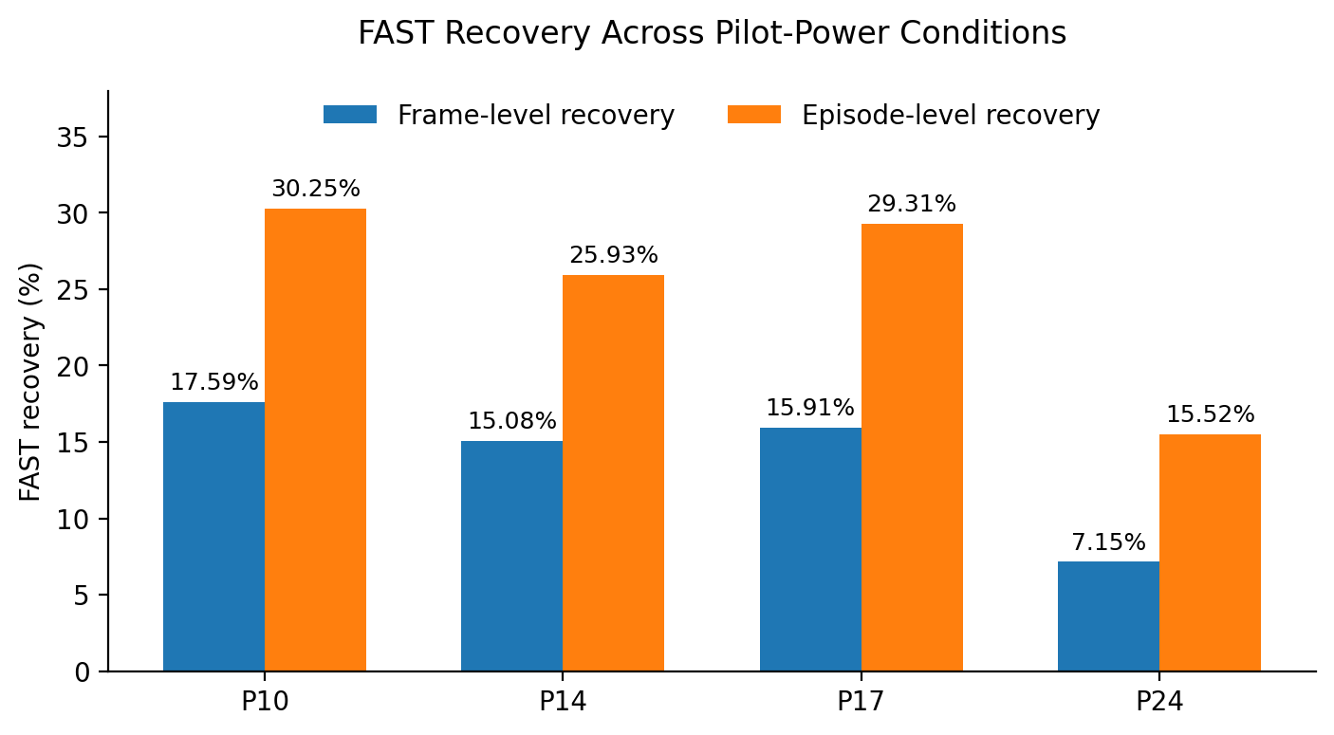
Figure 2. FAST recovery benchmark. Episode-level recovery ranges from 15.52% to 30.25% across the four frozen pilot-power conditions.

6. Recoverability-Aware Failure Stratification
Failure episodes are separated into three operational categories:

EASY
Episodes successfully handled by the existing FAST recovery mechanism while satisfying the defined lightweight-recovery constraint.

MODERATE
Residual episodes that are not classified as EASY or HARD.
These episodes form the candidate population for future stronger recovery mechanisms such as digital repair, RF reselection, or intelligent exception supervision.
MODERATE does not currently imply that such stronger recovery has been demonstrated successfully.

HARD
Episodes exhibiting evidence of severe failure behavior according to the frozen System V0.5 criteria.
These cases are treated as candidates for abandonment rather than unlimited recovery attempts.
The resulting cross-pilot populations are:
Pilot | Episodes | EASY | MODERATE | HARD
P10 | 400 | 121 | 81 | 198
P14 | 351 | 91 | 41 | 219
P17 | 331 | 97 | 29 | 205
P24 | 277 | 43 | 41 | 193

7. Escalation and Abandonment Loads
The MODERATE population determines the fraction of failure episodes potentially requiring stronger intervention.
Pilot | Escalation Load
P10 | 20.25%
P14 | 11.68%
P17 | 8.76%
P24 | 14.80%
Therefore:
[
\boxed{\text{Escalation Load}=8.76%-20.25%}
]
Only a minority of failure episodes need to enter a potentially more computationally expensive recovery path.
The HARD population is:
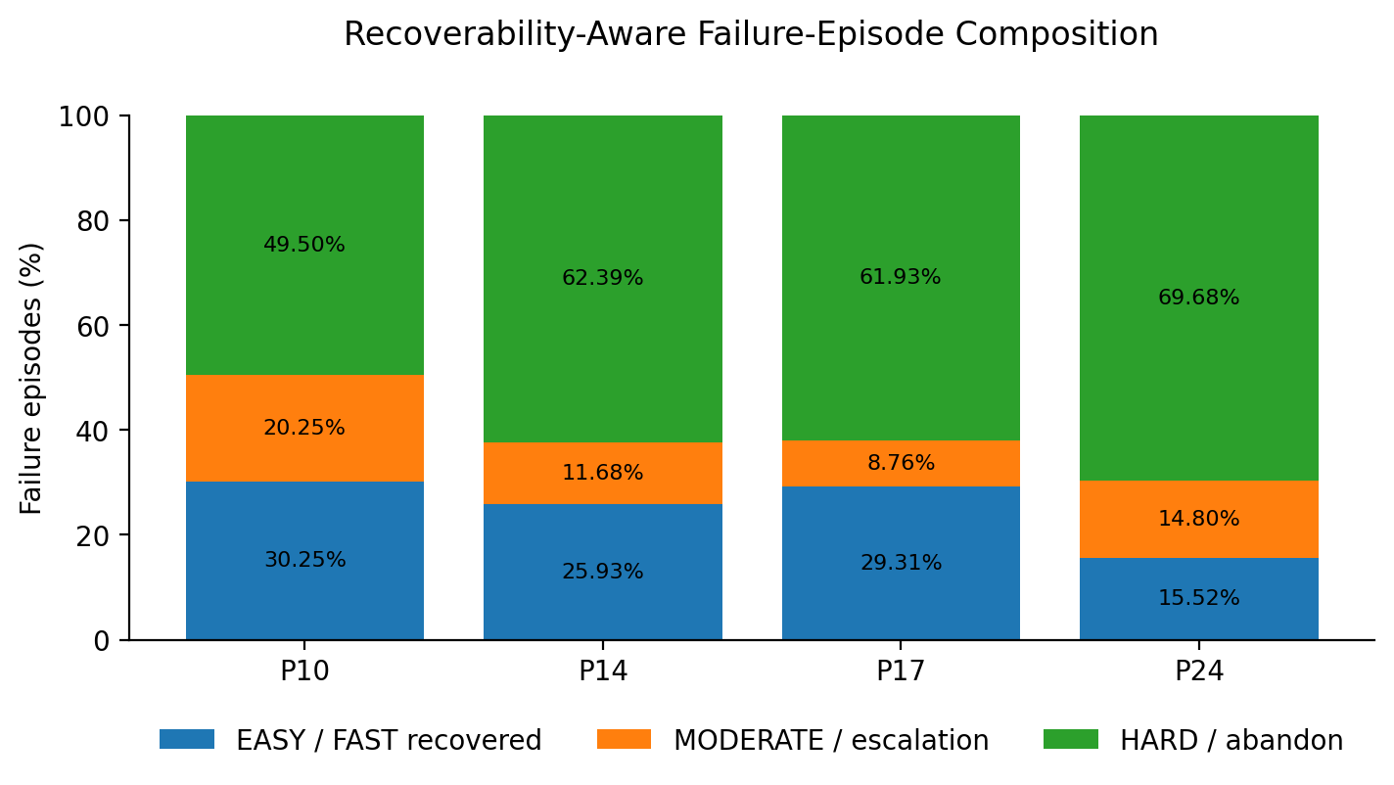
Figure 3. Recoverability-aware composition of failure episodes. MODERATE cases form the selective-escalation population, while HARD cases motivate abandonment/outage handling.
Pilot | HARD Load
P10 | 49.50%
P14 | 62.39%
P17 | 61.93%
P24 | 69.68%
Thus:
[
\boxed{\text{HARD Load}=49.50%-69.68%}
]
This result motivates avoiding increasingly expensive recovery attempts for every observed failure.

8. Emerging Hierarchical Recovery Architecture
The cross-pilot results support the following operational architecture:
[
\text{Failure Episode}
\rightarrow
\begin{cases}
\text{Lightweight recoverable} &\rightarrow \text{FAST recovery}\
\text{MODERATE} &\rightarrow \text{Selective escalation}\
\text{HARD} &\rightarrow \text{Abandon / outage handling}
\end{cases}
]
The design principle is:
Use the lightest sufficient intervention rather than the strongest available intervention.
This architecture reduces the population requiring expensive decision-making.
Under the present benchmark, only 8.76–20.25% of failure episodes enter the MODERATE escalation population.

9. Pilot Power and Residual Failure Severity
An important cross-pilot observation is that increasing pilot power reduces the overall number of failure episodes:
[
400\rightarrow351\rightarrow331\rightarrow277
]
for P10, P14, P17 and P24 respectively.
However, FAST recoverability does not improve monotonically:
[
30.25%,\ 25.93%,\ 29.31%,\ 15.52%
]
The P24 case has the fewest failure episodes but also the lowest FAST episode recovery rate and the largest HARD fraction:
[
69.68%.
]
A plausible interpretation is that improved pilot conditions may remove some marginal failures, leaving a residual failure population containing a larger fraction of severe cases.
This interpretation is currently a research hypothesis supported by the observed population statistics; it should not yet be interpreted as a demonstrated causal mechanism.

10. Pre-Failure Early-Warning Result
A separate P17 pre-failure study investigated whether lightweight indicators can identify approaching failures.
A simple one-frame-ahead power-based rule achieved approximately:
[
FAR=4.77%
]
while identifying:
[
28/93=30.11%
]
of the defined CLEAN-EASY population.
The corresponding frozen threshold was:
[
P_{t-1}\ge 12.9020.
]
This demonstrates lightweight early-warning feasibility.
However, subsequent transition analysis showed that 21 of the 28 captured CLEAN-EASY cases exhibited decreasing power between the warning frame and failure onset.
Therefore, high pre-failure power should currently be interpreted as a possible system-stress indicator rather than direct evidence that proactive power boosting is the appropriate corrective action.
For this reason, proactive power intervention has not been adopted in System V0.5.

11. Methodology Guardrail
An important methodological limitation must be stated explicitly.
The EASY definition includes successful FAST repair as part of its construction.
Consequently:
[
\text{EASY}\rightarrow\text{FAST success}=100%
]
is outcome-derived.
It must not be interpreted as independent predictive-classification accuracy.
The meaningful cross-pilot validation quantities are instead:
- observed FAST recovery rate;
- failure-class composition;
- escalation load;
- HARD load;
- stability of the frozen operational stratification across different pilot-power conditions.
This distinction is retained throughout the System V0.5 interpretation.

12. Role of AI and LLMs
No LLM is used in the real-time path of the present benchmark.
The current results suggest that this is the appropriate architecture.
A future intelligent supervisor would not need to evaluate every frame or every failure episode. Instead, it could potentially operate only on the relatively small MODERATE population:
[
8.76%-20.25%
]
of failure episodes in the current cross-pilot benchmark.
A possible future architecture is therefore:
[
\text{Real-Time Deterministic PHY}
\rightarrow
\text{Recoverability Triage}
\rightarrow
\begin{cases}
\text{FAST}\
\text{Exception Supervisor}\
\text{Abandon}
\end{cases}
]
where an AI/LLM-based exception supervisor, if eventually demonstrated to be useful, remains outside the per-frame deterministic critical path.
No performance benefit from such an LLM supervisor is claimed in V0.1.

13. What Has Been Demonstrated
System V0.5 currently demonstrates that:
- Frame-level statistical outages can be reorganized into operational failure episodes.
- A frozen lightweight FAST mechanism can recover 15.52–30.25% of observed failure episodes across P10/P14/P17/P24.
- Recoverability composition changes with pilot conditions.
- Only 8.76–20.25% of failure episodes form the MODERATE population considered appropriate for stronger escalation.
- 49.50–69.68% fall into the frozen HARD population, motivating selective abandonment rather than unlimited recovery attempts.
- These results are obtained without retraining, pilot-specific tuning, LLM inference, or modification of the underlying beamforming mathematics.
- A lightweight pre-failure signal has been demonstrated at P17, but proactive intervention based on that signal has not yet been shown to improve performance.

14. What Has Not Yet Been Demonstrated
The following are deliberately excluded from the current claims:
- successful DIGITAL recovery of the MODERATE population;
- successful RF reselection of the MODERATE population;
- LLM-based real-time recovery;
- independent predictive classification of EASY/MODERATE/HARD before the repair outcome is known;
- causal proof explaining the P24 residual-failure behavior;
- 20K+ frame cross-pilot statistical validation;
- statistically validated operational reliability improvement from a complete multi-stage recovery controller.
These remain future research topics.

15. Next Research Stage
The immediate research priorities are:
Large-scale statistical validation
Extend the current 4,000-frame-per-pilot benchmark toward the planned 20K+ frame regime to quantify confidence and stability of the observed cross-pilot behavior.
MODERATE-case recovery
Investigate whether the relatively small MODERATE population can be recovered through stronger deterministic methods, including digital-domain repair and RF reselection.
Predictive recoverability
Separate outcome-derived recoverability labels from pre-action observable features and investigate whether recoverability can be predicted before recovery is attempted.
Exception-level AI supervision
Only after deterministic action ground truth is available should AI/LLM-assisted supervision be evaluated for the MODERATE exception population.

16. Current Research Conclusion
The principal result of System V0.5 is not a new beamforming model.
It is an operational methodology layered on top of an existing reproduced model-driven hybrid-beamforming framework.
The emerging principle is:
Not every outage should trigger the same recovery action.
Instead, operational reliability can be studied through:
[
\boxed{
\text{Failure Detection}
\rightarrow
\text{Recoverability Analysis}
\rightarrow
\text{Lightweight Recovery}
\rightarrow
\text{Selective Escalation}
}
]
Across P10, P14, P17 and P24, the current frozen benchmark shows:
[
\boxed{\text{FAST episode recovery}=15.52%-30.25%}
]
[
\boxed{\text{Escalation population}=8.76%-20.25%}
]
[
\boxed{\text{HARD population}=49.50%-69.68%}
]
with no retraining and no pilot-specific tuning.
Accordingly, System V0.5 should be interpreted as a validated intermediate step from statistical outage analysis toward end-to-end operational reliability improvement, rather than as a completed reliability solution.
These results provide the first cross-pilot evidence supporting the broader research direction:
From statistical outage toward operational reliability.

