Project Documentation

RYTHAMIC TUNES

# Introduction

## Project Title: rythamic tunes

* + **Team ID**
  + **Team Leader:** N.GOKULSRIRAM [24bca09acas@gmail.com]

## Team Members:

* + - S NAVIN GANESAN [ 24bca33acas@gmail.com]
    - A MOHAMMED ASAN [[24bca29acas@gmail.com](mailto:24bca29acas@gmail.com)]
    - M NISHANTH [ [24bca34@gmail.com](mailto:24bca34@gmail.com)]

# Project Overview

* + **Purpose:** SB Works connects clients and freelancers through project postings, bidding, and real-time communication.

## Features:

* + - Project posting and bidding
    - Secure chat system
    - Feedback and review system
    - Admin control panel

# Architecture

* + **Frontend:** React.js with Bootstrap and Material UI
  + **Backend:** Node.js and Express.js managing server logic and API endpoints
  + **Database:** MongoDB stores user data, project information, applications, and chat messages

# Setup Instructions

## Prerequisites:

* + - Node.js
    - MongoDB
    - Git
    - React.js
    - Express.js **–** Mongoose **–** Visual Studio Code

## Installation Steps:

# Clone the repository git clone

# Install client dependencies cd client npm install

# Install server dependencies cd

../server npm install

# Folder Structure

SB-Works/

|-- client/ # React frontend

| components/ L pages/

| server/ # Node.js backend

| routes/

| models/

| controllers/

# Running the Application

## Frontend:

cd client npm start • **Backend:**

cd server npm start

* + **Access:** Visit [http://localhost:3000](http://localhost:3000/)

# API Documentation

## User:

* + - /api/user/register
    - /api/user/login

## Projects:

* + **Chats:**
* /api/projects/create
* /api/projects/:id • **Applications:** /api/apply
* /api/chat/send
* /api/chat/:userId

# Authentication

* + JWT-based authentication for secure login
  + Middleware protects private routes

# User Interface

* + Landing Page
  + Freelancer Dashboard
  + Admin Panel
  + Project Details Page

# Testing

* + Manual testing during milestones
  + Tools: Postman, Chrome Dev Tools

1. **Screenshots or Demo**

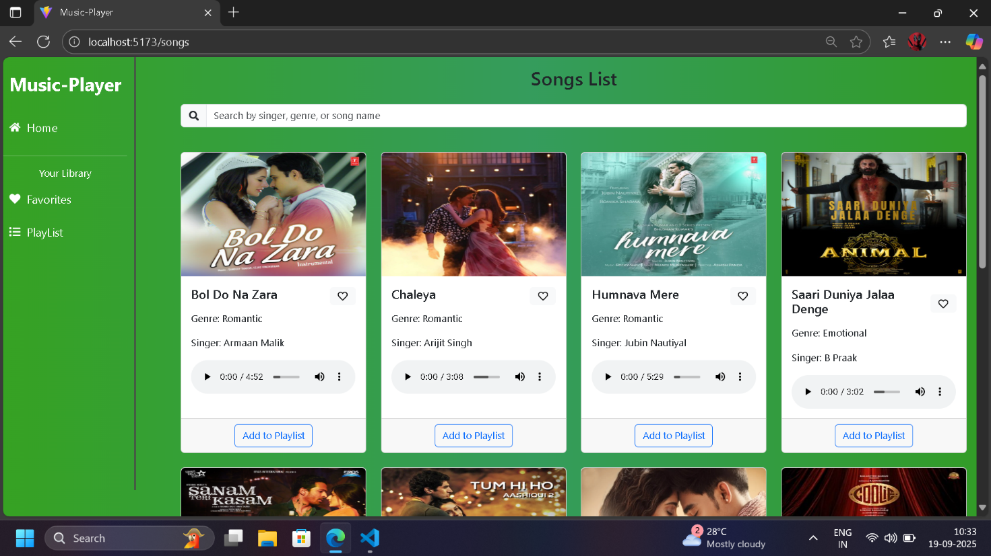

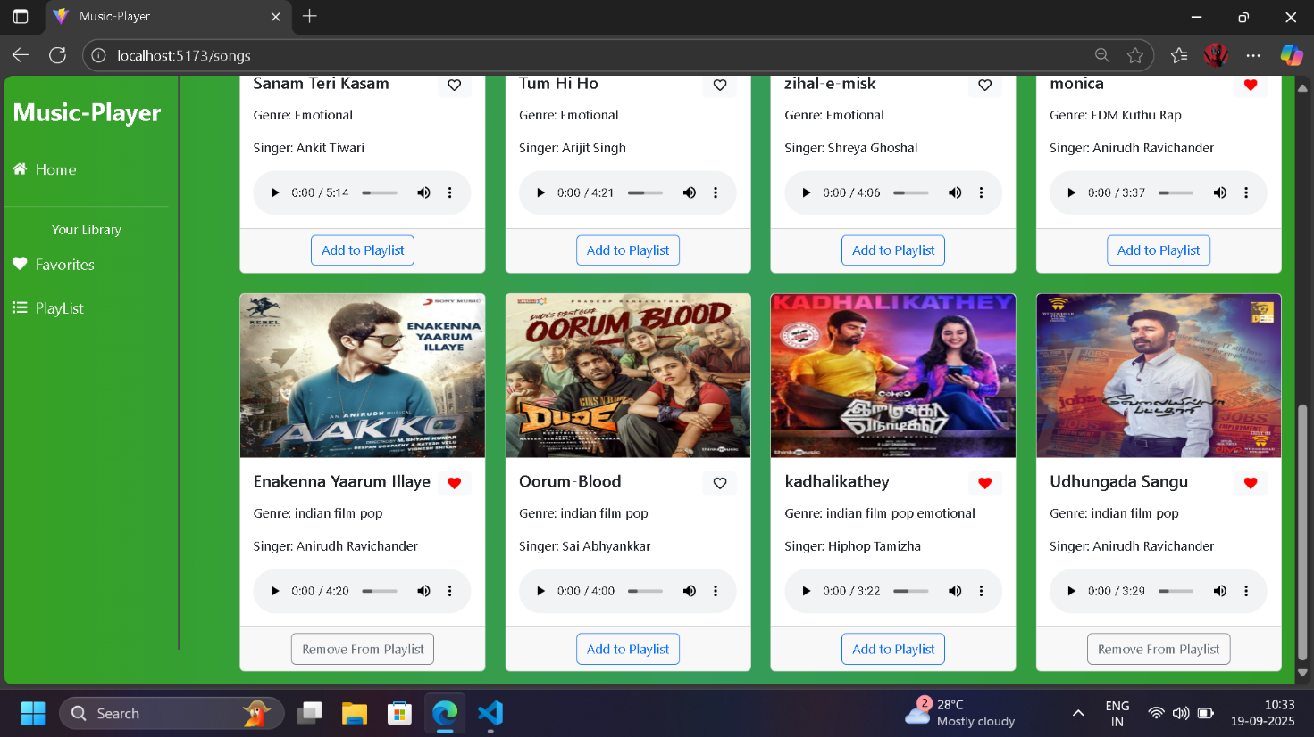

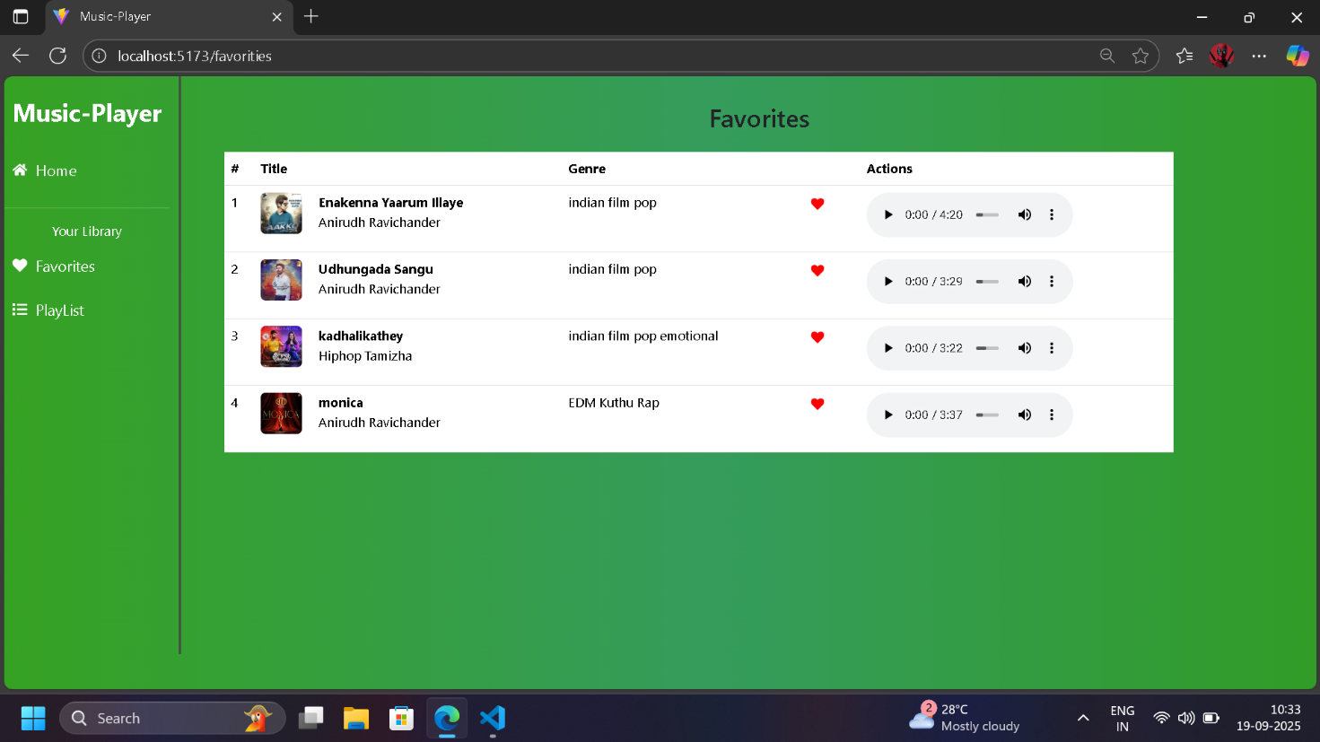

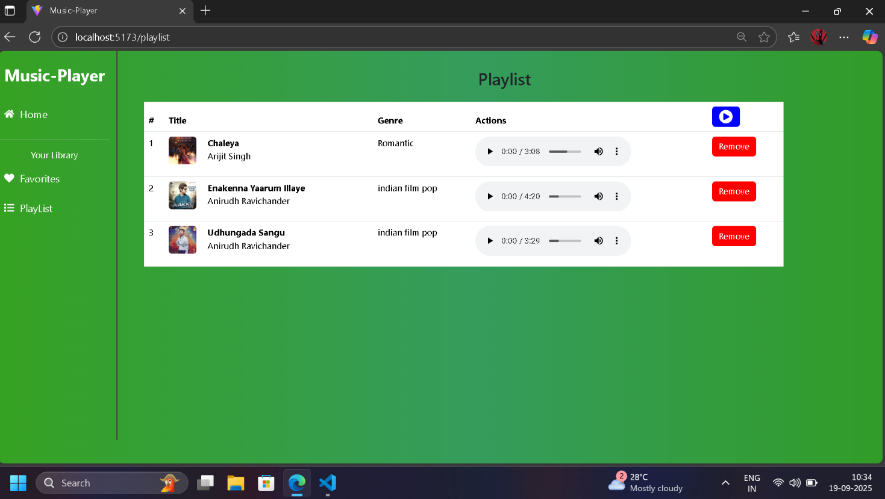

1. **Known Issues**

**NILL**

1. **Future Enhancements**

* **Advanced Features**

**Support offline listening and downloads to improve accessibility, especially for rural or low-bandwidth users**

* **User Engagement and Personalization**

**Add collaborative playlist building—users can co-create, edit, and share their playlists with friends or study groups**

* **Technology and Accessibility Enhancements**

**Enable multi-language interfaces and local content uploads to promote inclusivity and cultural diversity**

* **Data Visualization and Analytics**

**Provide dashboards for users to visualize listening patterns, progress in music learning modules, and collaborative project stats**