FreescaleMQX NAND BOOTLOADER User’s Guide

Document Number: MQXBLDUG Rev.1.1
04/2011



Chapter 1 Before You Begin 7
1.1 About This Book 7
1.2 Where to Look for More Information 7
1.3 Product Names 7
1.4 Typographic Conventions 7
Chapter 2 Using MQX bootloader 9
2.1 MQX Bootloader at a Glance 9
2.1.1 Bootloader organization in NAND Flash memory 9
2.2 Files in Bootloader application 10
2.2.1 config.h 10
2.2.2 boot.c 10
2.2.3 boot_cmd.c 10
2.2.4 bootloader.h 10
2.2.5 bootloader.c 11
2.3 Image header structure 11
2.4 Image information structure 12
Chapter 3 Reference: Functions 13
3.1 _bootloader_init_table 13
3.2 _bootloader_check_image 13
3.3 _bootloader_del_image 13
3.4 _bootloader_del_table 13
3.5 _bootloader_store_image 14
3.6 _bootloader_list_image 14
3.7 _bootloader_set_default 14
3.8 _bootloader_get_timeout 15
3.9 _bootloader_set_timeout 15
Chapter 4 Reference: Commands 16
4.1 loadbin 16
4.2 imglst 16
4.3 imgdel 16
4.4 tbldel 16
4.5 autoboot 16
4.6 imggo 16
4.7 atbtmo 17
Chapter 5: Preparing Binary file 18

Revision History

To provide the most up-to-date information, the revision of our documents on the World Wide Web will be the most current. Your printed copy may be an earlier revision. To verify you have the latest information available, refer to http://www.freescale.com/mqx.

The following revision history table summarizes changes contained in this document.

Revision  Number | Revision  Date | Description of Changes
Rev. 1.0 | 01/2011 | Draft coming with MQX 3.6
Rev. 1.1 | 04/2011 | Prototype coming with MQX 3.7.0 official release

Freescale™ and the Freescale logo are trademarks of Freescale Semiconductor, Inc.
© Freescale Semiconductor, Inc., 2010. All rights reserved.

Chapter 1 Before You Begin

1.1 About This Book

This book is a guide and reference manual for using the FSLMQX NAND Bootloader, which is a part of Freescale MQX Real-Time Operating System distribution.

1.2 Where to Look for More Information
• The release notes document accompanying the Freescale MQX release provides information that was not available at the time this user’s guide was published.
• The MQX User’s Guide describes how to create embedded applications that use the MQX RTOS.
• The MQX Reference Manual describes prototypes for the MQX API.

1.3 Product Names

In this book, we use BLD as the abbreviation for the Freescale MQX Bootloader Embedded File System.

1.4 Typographic Conventions

Throughout this book, we use typographic conventions to distinguish terms.

Font style | Usage | Example
Bold | Function families | The _io_mfs family of functions.
Bold | Function names | _io_mfs_install()
Italic | Data types (simple) | uint_32
 | Data types (complex) | See following example.
Constant-width | Code and code fragments | —
 | Data types in prototype definitions | See following example.
 | Directives | #include “mfs.h”
 | Code and code fragments
Italic | Filenames and path names | part_mgr.h
Italic | Symbolic parameters that you substitute with your values. | See following example.
UPPERCASE Italic | Symbolic constants | MFS_NO_ERROR

1.5 Other Conventions

1.5.1 Cautions

Cautions tell you about commands or procedures that could have unexpected or undesirable side effects or could be dangerous to your files or your hardware.

CAUTION If an application calls read and write functions with the partition manager, the file system will be corrupted.

Chapter 2 Using FSLMQX NAND Bootloader

2.1 FSLMQX NAND Bootloader at a Glance
This application note describes the procedures to perform NAND flash boot with the Freescale MPC5125
MPU. The hardware platform used in this example is a TWR-MPC5125 board.
You must verify that TWR-MPC5125 board is working. Bootloader should boot from NAND flash and give you a command prompt on the USB-to-serial port (J19). The port is configured to 115,200 baud, 8 data bits, 1 stop bit, and no hardware handshaking.
The factory default setting for SW1 is 0b010011 (RST_CONF_LPCMX = 0, RST_CONF_LPCWA = 1,
RST_CONF_LPC_DBW1 = 0, RST_CONF_LPC_DBW0 = 0, RST_CONF_BMS = 1,
RST_CONF_ROMLOC0 = 1). To make the board boot from NAND flash, you must turn SW1 position 1
and 2 to ON. See the schematics of MPC5125 for further information.
The TWR-MPC5125 board uses a Micron M29F32G08CFABA 4GB NAND flash that has 8-bit bus width and it is arranged into (2048 + 112 bytes) pages.
When Bootloader is not already available in the memory and you want to re-program it, you will need
CodeWarrior 9.2 and USB-TAP. CodeWarrior 9.2 can be downloaded from http://www.freescale.com.
USB-TAP can also be bought from Freescale website.

Setup Ethernet network and TFPT server before using Boot loader application. The bootloader can get binary image file through TFTP protocol.

2.1.1 Bootloader organization in NAND Flash memory
FSLMQX Bootloader application was stored in Block 1 of NAND Flash.
Default bootloader organization as figure below. Image data and image table location can be changed in bootloader.h
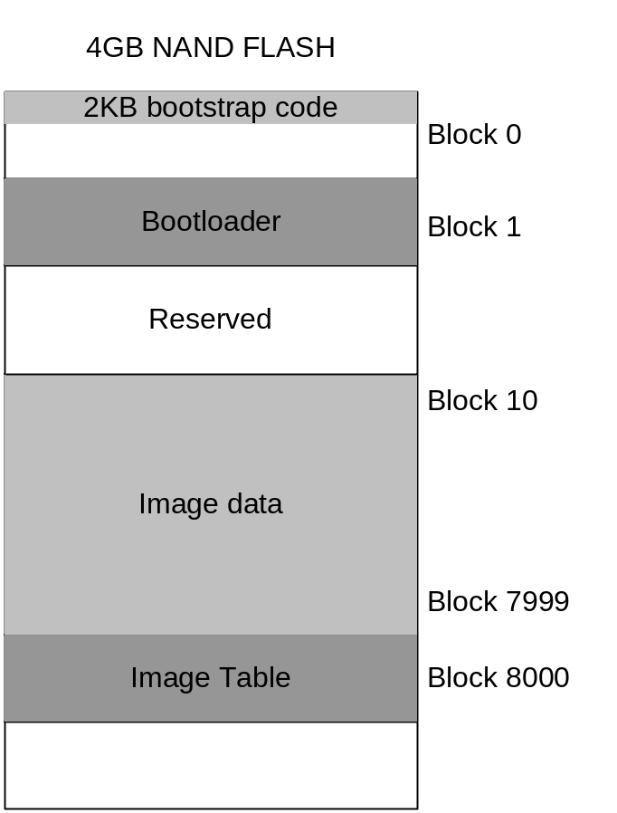
Figure1: Bootloader organization

2.2 Files in NAND Bootloader application

2.2.1 config.h
This file contains common configurable information for the RTCS.

2.2.2 boot.c
This file contains main application, initializing RTCS, image table, command.

2.2.3 boot_cmd.c
This file contains extending Shell commands for Bootloader.

2.2.4 bootloader.h
The TWR-MPC5125 board uses a Micron M29F32G08CFABA 4GB NAND therefore all definition should compatible with M29F32G08CFABA datasheet.

NAND_FLASH_PAGE_SIZE
- NAND Flash Page size in Byte
NAND_FLASH_BLOCK_SIZE
- NAND Flash Block size in Byte
IMAGE_TABLE_PAGE_LOCATION
- Table location in Page
IMAGE_TABLE_BLOCK_LOCATION
- Table location in Block
IMAGE_START_BLOCK
- Location of the first image was stored in NAND Flash
IMAGE_TABLE_SIZE
- Size of table in Byte
IMAGE_MASK_AS_DELETE
- Images masked as deleted
ERASE_BLOCK_SUCCESS
- Return code for erase block
ERASE_BLOCK_FAILED
- Return code for erase block
IMAGE_IN_TABLE_MASK
- Images masked in table
IMAGE_IN_TABLE_UNMASK
- Images unmasked in table
CHECK_SUM_OK
- Return code for Check sum
CHECK_SUM_FAIL
- Return code for Check sum
AUTOBOOT_TIMEOUT
- Default timeout value in second for each image.

2.2.5 bootloader.c
This file contains functions for controlling table and images.

2.3 Image header structure
typedef struct image_header{
uint_32 IMAGIC;
uint_32 LEN;
uint_32 HEADERFLAG;
uint_32 CHECKSUM;
} IMAGE_HEADER, _PTR_ IMAGE_HEADER_PTR;
Description
IMAGIC and HEADERFLAG
- Numeric to identify existing image.
LEN
- Length in byte of image
CHECKSUM
- Image Check sum value

2.4 Image information structure
typedef struct image_info {
uint_32 UNUSED;
uint_32 INDEX;
uint_32 ADDR;
uint_32 SIZE;
uint_32 BLOCK;
uint_32 BLOCK_NUM;
uint_32 IS_IMAGE;
boolean BOOT_DEFAULT;
uchar NAME[15];
uint_32 BOOT_TIMEOUT;
} IMAGE_INFO, _PTR_ IMAGE_INFO_PTR;
Description
UNUSED
- Unused value should be 0xFFFFFFFF to avoid bad block
INDEX
- Image index
ADDR
- Image address
SIZE
- Image size in byte
BLOCK
- Image location in Block
BLOCK_NUM
- Image size in block
BOOT_DEFAULT
- Autoboot when timeout expire
NAME
- Image name
BOOT_TIMEOUT
- Timeout value in second

Chapter 3 Reference: Functions

3.1 _bootloader_init_table
Initialize image table
Synopsis
int_32 _bootloader_init_table(void)
Description
- Initialize image table. Create a blank table if does not exists.
- Calculate check sum all image. Image stored in NAND Flash may be deleted by another application, therefore it should calculate checksum before using.
Return Codes
MQX_OK – No error occurs
IO_ERROR – IO error occurs

3.2 _bootloader_check_image
Synopsis
boolean _bootloader_check_image
( boolean autoboot,
uint_32 index)
Description
Checking autoboot image
Return Codes
TRUE - If image index is set to autoboot image
FALSE - If image index not set to autoboot image

3.3 _bootloader_del_image
Synopsis
uint_32 _bootloader_del_image(uint_32 index)
Description
Delete image with index specified
Return Codes
MQX_OK – No error occurs
IO_ERROR – IO error occurs

3.4 _bootloader_del_table
Synopsis
int_32 _bootloader_del_table(void)
Description
Delete all images
Return Codes
MQX_OK – No error occurs
IO_ERROR – IO error occurs

3.5 _bootloader_store_image
Synopsis
int_32 _bootloader_store_image
(
uint_32 addr,
uint_32 size,
uchar_ptr buff,
uchar_ptr name
)
Description
Store image in NAND Flash. Bootloader find images was masked delete, overwrite this one if new image size equal or smaller than old image. Otherwise store new image in the end of table.
Addr - [IN] Start address refer
Size - [IN] Image size
Buff - [IN] Pointer to image data
Name - [IN] Name of image will be store in table.
Return Codes
MQX_OK – No error occurs
IO_ERROR – IO error occurs

3.6 _bootloader_list_image
Synopsis
void _bootloader_list_image(void)
Description
Print out all images stored in NAND Flash
Return Codes
NA

3.7 _bootloader_set_default
Synopsis
int_32 _bootloader_set_default(uint_32 index)
Description
Set image as autoboot image after bootloader startup with timeout value.
Return Codes
MQX_OK – No error occurs
IO_ERROR – IO error occurs

3.8 _bootloader_get_timeout
Synopsis
int_32 _bootloader_get_timeout(void)
Description
Get timeout value of autoboot image
Return Codes
-1 – No image found or no timeout value found.

3.9 _bootloader_set_timeout
Synopsis
int_32 _bootloader_set_timeout(uint_32 index, uint_32 timeout)
Description
Set image timeout value
Return Codes
MQX_OK – No error occurs
IO_ERROR – IO error occurs

Chapter 4 Reference: Commands

4.1 loadbin

This command used to load a file *.bin from TFTP server and store to NAND flash immediately.
This image is set as auto boot when transfer success.
Usage
loadbin [<host> ] [<source>] [<addr>] [<name>]
<host> - TFTP server ip address
<source> - Source file name
<add> - Start address (Rom address in Linker file)
[<name>] - Name of image will be stored in table (optional). Default source file name is stored in table.

4.2 imglst
This command has no argument.This command used to list all images in NAND flash.
Usage
This command doesn’t have argument

4.3 imgdel
This command used to delete a image in memory of NAND flash.
Usage
imgdel <index>
<index> - Index of image to delete

4.4 tbldel
This command used to delete all images in memory NAND flash.
Usage
This command doesn’t have argument

4.5 autoboot
This command used to select image auto boot when reset or power on.
Usage
autoboot [<index>]
<index> - Image index to boot.

4.6 imggo
This command jumps to image and runs application of this image.
Usage
imggo <index>
<index> - Image index in memory table.

4.7 atbtmo
This command sets autoboot timeout expire in second.
Usage
atbtmo <index> <timeout>
<index> - Image index to set timeout
<timeout> - Time out in second value.

Chapter 5: Preparing Binary file

Open examples project and chose target settings.
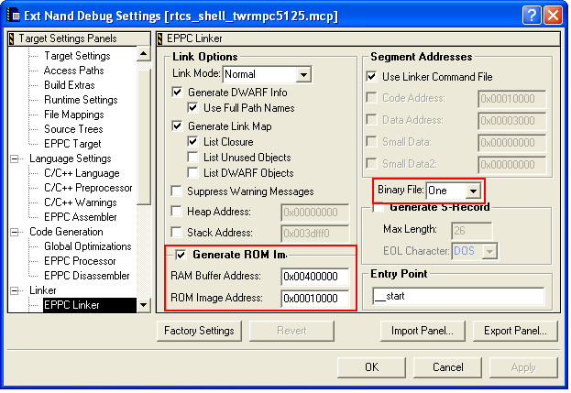
Chose Binary File is One and set the start address in Generate ROM Image check box.
RAM Buffer Address is Ram address in Linker file.
ROM Image Address is Rom address in Linker file.

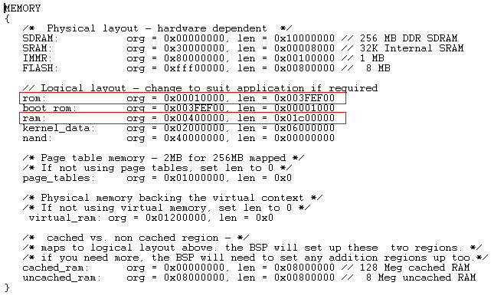

Note:
- CodeWarrior cannot program the board when enabling Binary file generation.
- Because Bootloader application use the memory form 0x01010000 to 0x03000000, rom and ram address should out of this range to make sure the program run correctly.

