HTMLayout支持CSS3的rgba颜色表示法，语法为：
background:rgba(red,green,blue,alpha ); 参数分别为
其中r,g,b 取值范围自0到255，而最后一位表过透明通道的alpha参数取值范围自0 到 1 之间.
也可以用一个单独的 opacity 属性表示透明度，例如：
div {
background-color:red;
opacity :0.75;
}

示例：
<html>
<head>
<style>
html { background: #FFFFFF; }
div { background-color:red; opacity :0.75; }
div.op25 { opacity :0.25; }
div.op50 { opacity :0.50; }
div.op75 { opacity :0.75; }
div.op100 { opacity:1.00; }
body { padding:11px; border:1px solid red;}
h1{ font-size:14px;}
</style>
</head>
<meta id="id_meta"></meta>
<body>
<h1>opacity: 表示透明度演示</h1>
<div class=op25> opacity:0.25</div>
<div class=op50> opacity:0.50</div>
<div class=op75> opacity:0.75</div>
<div class=op100> opacity:1.00</div>
<h1>rgba(r,g,b,opacity) 表示颜色透明度演示</h1>
<div style="background-color:rgba(255,0,0,0.25)"> background-color:rgba(255,0,0,0.25) </div>
<div style="background-color:rgba(255,0,0,0.50)"> background-color:rgba(255,0,0,0.50)</div>
<div style="background-color:rgba(255,0,0,0.75)"> background-color:rgba(255,0,0,0.75)</div>
<div style="background-color:rgba(255,0,0,1.0)"> background-color:rgba(255,0,0,1.0)</div>
<h1> rgba(r,g,b,opacity) 渐变背景色演示,用四组颜色分别表示左上,右上,右下,左下四角的渐变色(顺时针转一圈)</h1>
<div style="background-color:rgb(255,0,0) rgba(255,0,0,0.15) rgba(255,0,0,0.15) rgb(255,0,0)"> background-color:rgb(255,0,0) rgba(255,0,0,0.15) rgba(255,0,0,0.15) rgb(255,0,0)</div>

</body>
</html>

效果
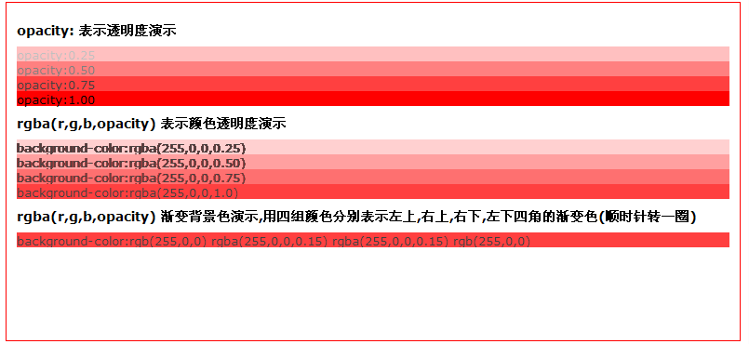

HTMLayout还可以使用四组十六进制( #RRGGBBOO ) 表示颜色
Red: 表示红色, 0x00...0xFF
Green: 表示绿色, 0x00...0xFF
Blue: 表示蓝色, 0x00...0xFF
Opacity：表示透明度, 0x00...0xFF
示例
<html>
<head>
<meta http-equiv="Content-Type" content="text/html; charset=gbk">

<style type="text\css">
<!--
#test1{
width: 100px;
height: 100px;
background: #0000FF30;
}

#test2{
width: 100px;
height: 100px;
background: #0000FF;
color:white;
}
-->
</style>
</head>
<body style="flow:horizontal;">
<div id="test1">半透明</div>
<div id="test2">不透明</div>
</body>
</html>
效果


