

Project Aim:
The purpose of this project was to create a secure chat client for the executive team of a small business. To implement this, we have made use of the Python, JavaScript, CSS and HTML programming languages. From this, we have made the objective to create a simplistic yet comprehensive user interface to allow users to send messages, files, and profiles to each other. We have been provided a set of minimum requirements which are mandatory, therefore we are required to decide extra features that we think are best suited for this application.

How the developed system has met the client’s requirements
As mentioned by the client, the project brief described the minimum requirements for the chat client. The following set of requirements were implemented.
- User can log in
- User can see who is currently online
- User can see and edit their profile page
- User can send, receive and view messages and files with someone online
In addition, the following extra features were implemented
- Automatically refreshing content
- Notifications
- Retrieve profiles for other users, provide profiles to other users
- Displays confirmation of message receipt
- Rate limiting of incoming messages, profile requests and files.
- Rate limiting of user authentication
- Use of threading for communicating with login server regularly
- Use of threading for retrieving other online users’ profiles in the background
- Excellent Page Templating with high modularity
- Commented code with documentation
- Simplistic yet comprehensive user interface
- Optimized for mobile phones without compromising on the user experience on desktop.
- Compatible on all browsers
- Secure SMS two factor authentication
- Defence against HTML injection attacks

A top-level view of how the system works
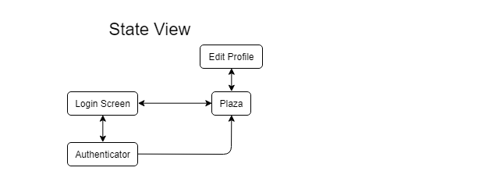
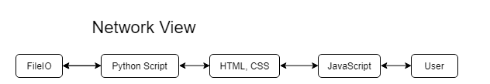

The system was designed to be simplistic when the user interacts with it, therefore the states screens have been reduced to four while maintaining user experience. The arrows indicate the direction in which the states can change. The network view describes the directions in which data exchange in the system.

Significant issues during development and how they were overcome
One of the issues encountered during development was how the user interface could be optimized for mobile phones while maintaining the full user experience on desktop. Mobile phones have significantly smaller screens, which causes the text to shrink to an unreadable size while viewing webpages optimized for desktops. This was overcome by splitting the page sections into three, where they align horizontally when loaded on a desktop and vertically while on a mobile.

Features that improve functionality of the system
- The user receives a notification when a message or file is received
- The user is able to retrieve all profiles from anyone who is online with a hit of a button
- The user can check if a message has been successfully send through
- The system rate limits external requests to protect itself from DDOS attacks
- The system automatically keeps the user logged in to the server.
- The system detects HTML and JavaScript injections from external clients and defends against them.
- The user can edit their profile easily from an edit profile page
- Optimized for all browsers and devices.
- SMS authenticator improves security of the sign in process

Peer-to-peer methods and their suitability for this application
Peer to peer allows communication from peer to peer without routing the data through a central server. This increases transfer speed and decreases latency, while also ensuring the files are stored locally. Assuming users are on the same local area network, the data will less likely have to route through the internet, decreasing the chance of it being intercepted by external action. Remote users will not have to route their data through a central server, so the data can take a shorter path to the recipient, also decreasing the chance for it to be intercepted. As opposed to having a central server, the data is decentralized, so not all of the data will be compromised if the login server is breached because not all users will have their systems on at the same time.

Project protocol and its suitability for the system
The project protocol was a set of rules for transmitting data between clients. This was important because without a protocol, clients would not be able to recognize what type of data was being sent to them. It was suitable in our system as multiple developers were creating differing clients for communication between each other. A common protocol would enable the clients to successfully send and receive data between each other and recognise the purpose of that data. Data can be encrypted by numerous types of encryption standards before being sent. As different developers could use different encryption standards, the protocol was useful for defining a standard encryption standard for encrypted data that was being sent.

Suitability of the suggested tools for the application
Python was quick and easy to use to develop small web applications such as this one. It lets developers build more functions with less lines of code, improving readability. This was important in our application, as our client was assessing the reliability of our client based on its security features. With improved code readability, the backend security of the features could be easily understood by anyone even with little programming experience. Python links well with other web languages such as HTML, CSS, JavaScript. This significantly improved the development time of the application. In addition, python provided a stepping stone to learning these other languages. This was incredibly useful in this project as we had to learn these web languages from scratch to develop our system.

Suggested improvements for future development of your application
In the future, the server can undergo substantial redevelopment to improve its functionality. As a developer, it will be highly recommended to improve knowledge on HTML for better formatting of the webpage.
- Multiple sessions could be supported if the global variables were not used to store data.
- Refreshing could be implemented better with AJAX instead of the JavaScript periodic refresh.
- Data security could be improved if data was encrypted before sending.
- Debugging could be made easier if the server writes error codes to an external file.

