Breaking RSA — CTF Writeup
Note: before doing anything, make sure you are connected via VPN.

How many services are running on the box?

Nmap (network reconnaissance)
First, I ran an Nmap scan to check which ports and services were open, using -sV and -v to get extra information.
We can see that 2 ports are open: 22 for SSH and 80 for HTTP/Nginx.
This tells us two things: we can connect to the machine via SSH if we know (or brute-force) the password, and we can browse the HTTP service to try to gather more information, such as hidden directories.
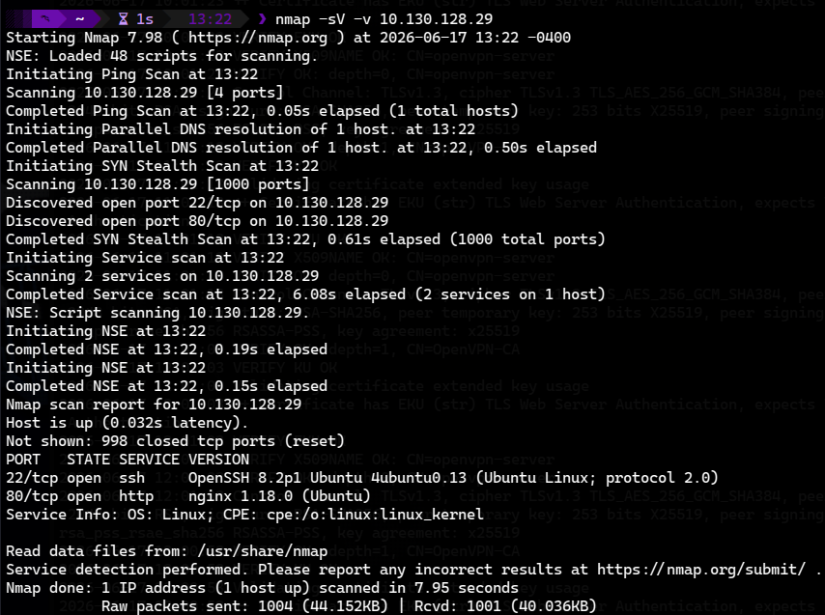

What is the name of the hidden directory on the web server? (without leading '/')

FFUF
If we don't have a wordlist to search for hidden directories, we need to install one first.
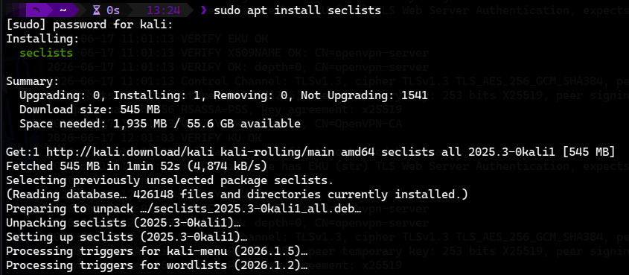
Now we can use ffuf to search for hidden directories.
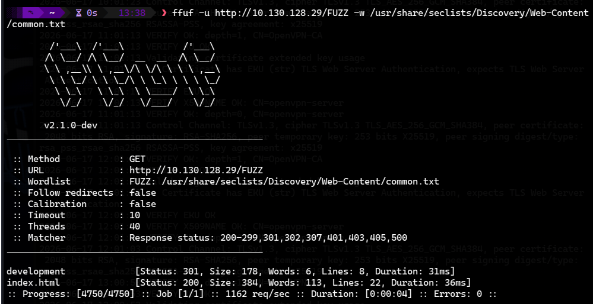
I tried using common.txt, and it was successful: we found the development directory, which contains the SSH public key.
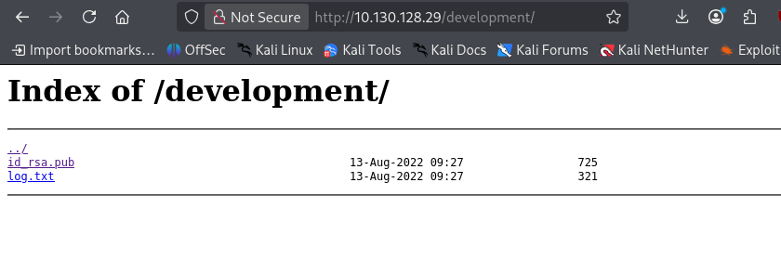

What is the length of the discovered RSA key? (in bits)
Now we can check the key length in bits using the following command.

What are the last 10 digits of n? (where 'n' is the modulus for the public-private key pair)
In my case, I installed pycryptodome inside a venv, due to PEP 668 restrictions on Debian/Kali.
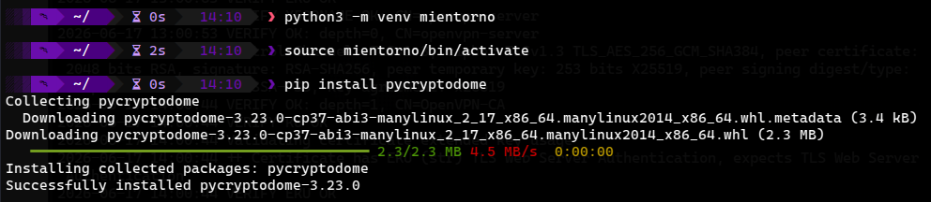
I then used this Python script to extract the last ten digits of n.
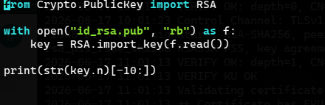
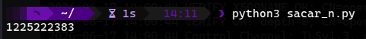

Factorize n into prime numbers p and q | What is the numerical difference between p and q?
I edited the previous script so it would print the full value of n.
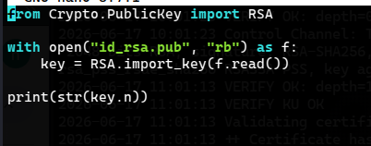
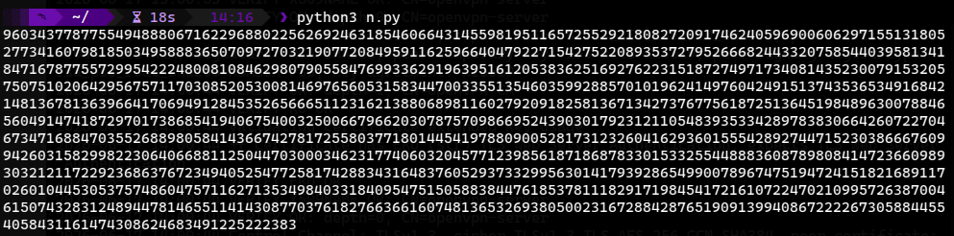
Using a site like FactorDB, we can see that n is already registered in their database, which directly gives us p and q.
As a sanity check, the 4096-bit key length is consistent with the 1233-decimal-digit modulus shown by FactorDB, confirming we're working with the correct number before proceeding with factorization.
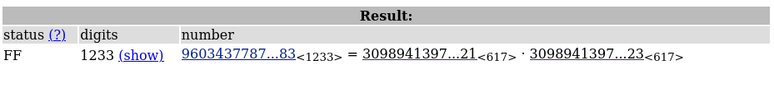
Once we have the full values of p and q, we calculate the difference between them:
p − q = −1502
The fact that the difference between p and q is this small (compared to their size, over 600 digits each) confirms that this RSA key is vulnerable to Fermat's factorization attack, where the two primes are deliberately chosen too close to each other, making n trivial to factorize.

Generate the private key using p and q (take e = 65537)
Now we need to write another Python script to generate the private key, based on the RSA concepts of how it's structured. We just need to plug in the values of p, q, and e, and run the script.
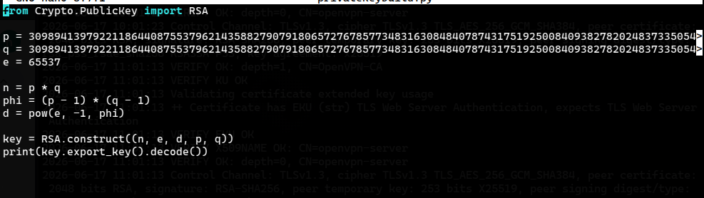
To generate the private key, we need to understand the underlying RSA math:
φ(n) (Euler's totient function) is calculated as (p − 1) × (q − 1). It represents how many integers smaller than n are coprime with n.
The private exponent d is the modular inverse of e with respect to φ(n), meaning the value that satisfies (e × d) mod φ(n) = 1.
Once we have n and d, we have the complete private key needed to decrypt any message encrypted with the corresponding public key.
In Python, this is straightforward thanks to the pow() function with three arguments — pow(e, -1, phi) — which computes the modular inverse directly without manually implementing the extended Euclidean algorithm.

What is the flag?
Once we have the private key, and knowing that the root user is enabled, we just need to create the private key file and set the correct permissions. Then we can connect using the private key and search for the flag.
Although I didn't keep a record of the contents of log.txt (found earlier alongside id_rsa.pub), I assumed the target user was root, since it's a common setup in TryHackMe machines of this type. This assumption turned out to be correct.
