Heated Bondhead Tip With bondforce measurement
Preliminary Specification
Dipl.-Ing. Martin Gyurkó info@engyneer.at
2025-06-05
Table of Contents

Goal
Purpose of the Heated Bondhead with bondforce measurement is to accurately monitor the force that is used during the bonding process in a pick and place machine. (for example in high-end machines, like Datacon APM machines etc.) and automatically start a heating profile to perform a bonding operation.
Bonding ICs to any substrate with any anisotropic conducting adhesive or tape shall be possible. Bonding shall be happening with heat. Either heat activates a chemical reaction, or just liquifies the adhesive.

Description
The bondhead is replacing the tip of the original bond head. So it is interchangeable with it. It needs heating and temperature measurement wiring led to it. If rapid cooling is needed, the cooling air carrying hoses are led directly to the target.
Heating is done with a 2 point control algorithm, hysteresis is 0.5°C.
The maximum temperature that shall be reached is 230°C.
A heating profile can be drawn and entered into the system with a tablet or mobile device.
The extreme small dimensions and mass of the heat spreading and tip elements allow for extreme fast heat profiles.
The low heat conducting titan plate prohibits flow of heat to the upper machine parts.
- Materials and dimensions used:
Assembly Part name | Material | Size
Adapter Rund | Steel | 20 mm diameter x 15 mm
Dehnhülse Rund | Steel | 20 mm diameter x 20 mm
Adapter Unten Rund | Titan | 20 mm diameter x 2 mm
FlachheizerHeatspreader | copper | 7 x 17 x 7.5 mm
Stempel | Steel or copper | 11 x 7 x 7 mm
The boring in the heat spreader is M6.
The assembly is built with M1 threaded screws.
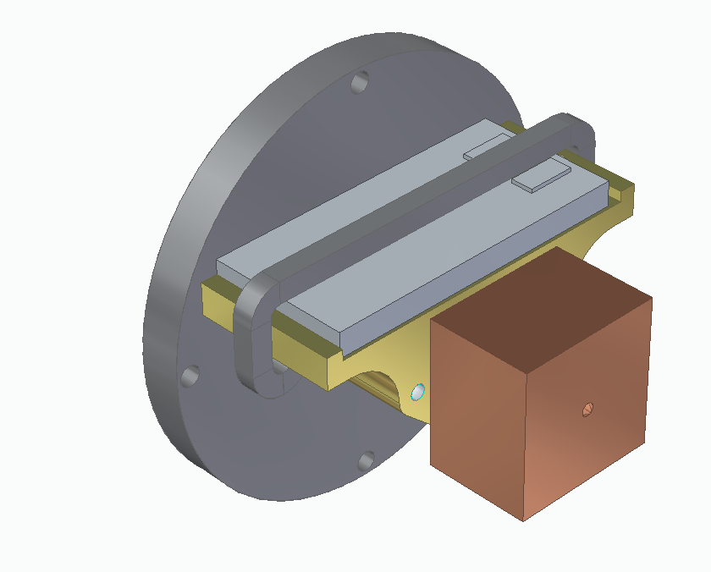
- Bondhead assembly with heating element
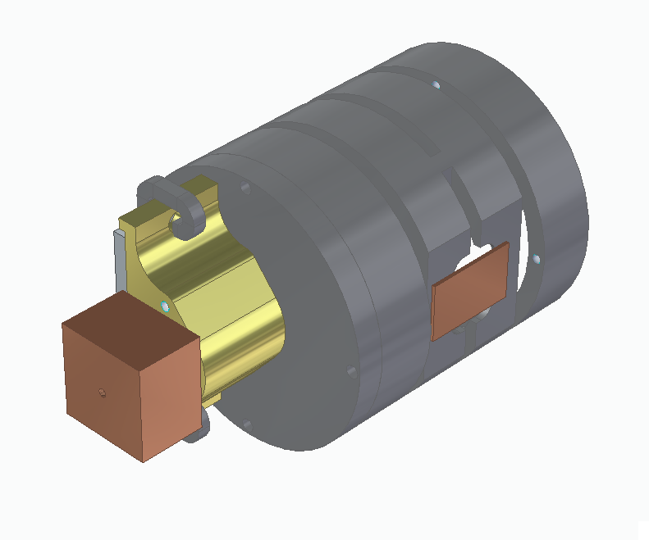
- Bondhead assembly with force sensor and heating element

Process
- The user sets with the app on the mobile device the temperature profile.
- The bondhead is attached to the Pick and place tip holder.
- The machine picks up a part with the help of vacuum.
- Machine puts the part to its target position.
- Machine starts to squeese down onto the part, and the force measurement in the head detects the used force.
- At a certain force the controller of the bondhead starts the temperature profile.
- when finished with the profile, after certain time, pressure is released, and waited, till adhesive solidifies.

Communication
The machine does not need to communicate with the controller. The controller measures the forces and decides when to start heat profile.

