Programming 3 Report

**Problem 1: Explain it!**

In this problem, I used diabete set from UCI Repository of machine learning databases (Newman et al. 1998).In this dataset, there are 8 Independent variables: pregnant, glucose, pressure, triceps, insulin, mass, pedigree, age, and 1 dependent variable: diabetes(positive/negative). As for the deep learning model, I implemented MLP classifier of sklearn. And as for the explainable model, I used LIME model.

* 1. **Binarizing the dependent variable**

In order to proceed to model fitting, digitizing the dependent variable is necessary. After that, the dependent variables became 0 for negative and 1 for positive.

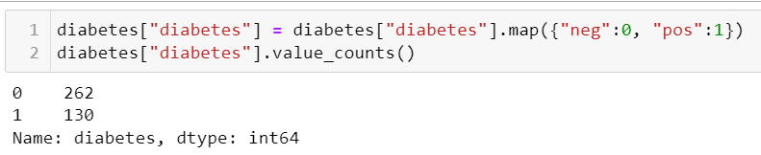

* 1. **Standardization and splitting the dataset**

In this part, I standardized the data and divide the dataset into two part: train and test.

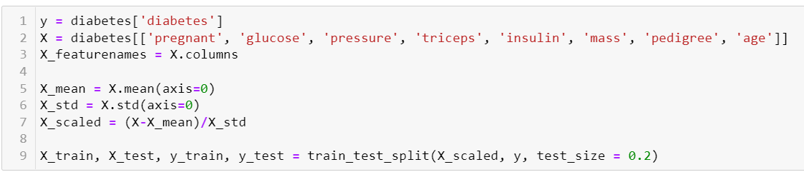

* 1. **MLPClassifier**

I used function MLPClassifier from sklearn, and set the maximum iteration 500 times. The accuracy of test set is 0.7722.

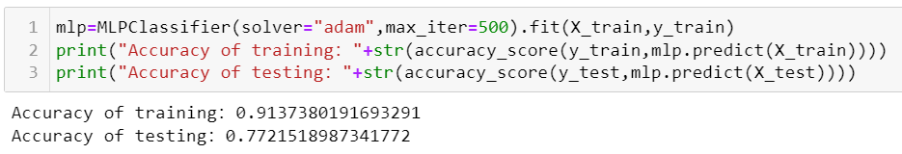

The number of layer is 3.

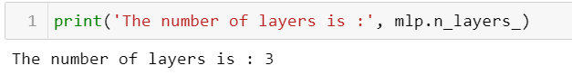

Here is the classification report.

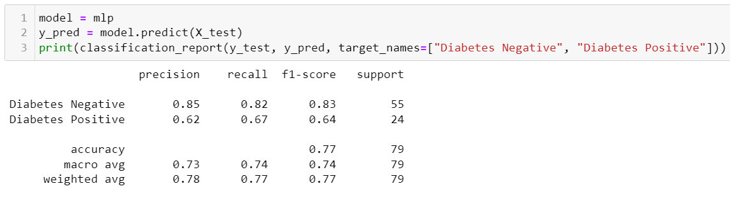

* 1. **Five examples of positive**

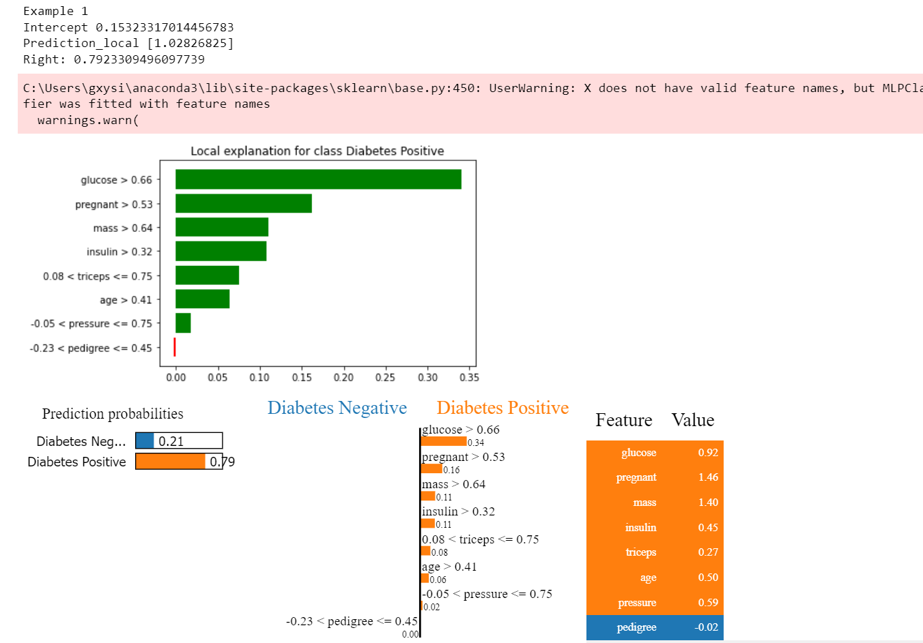

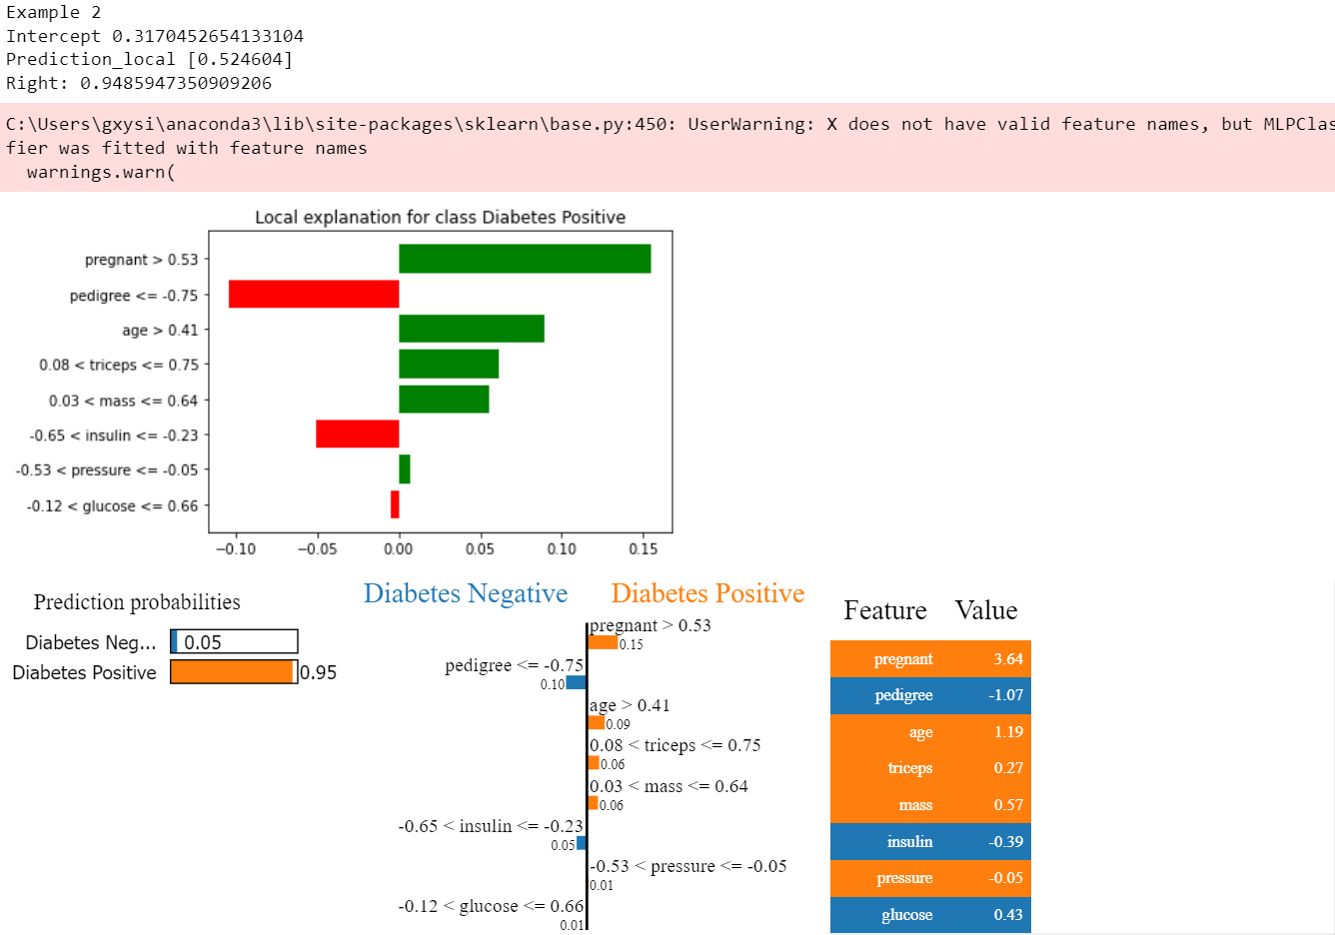

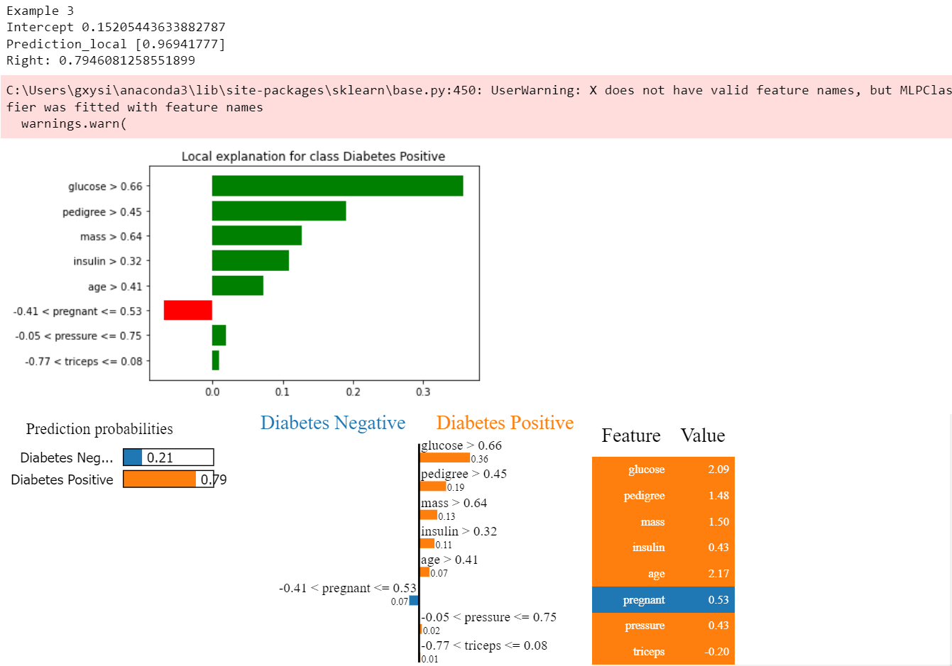

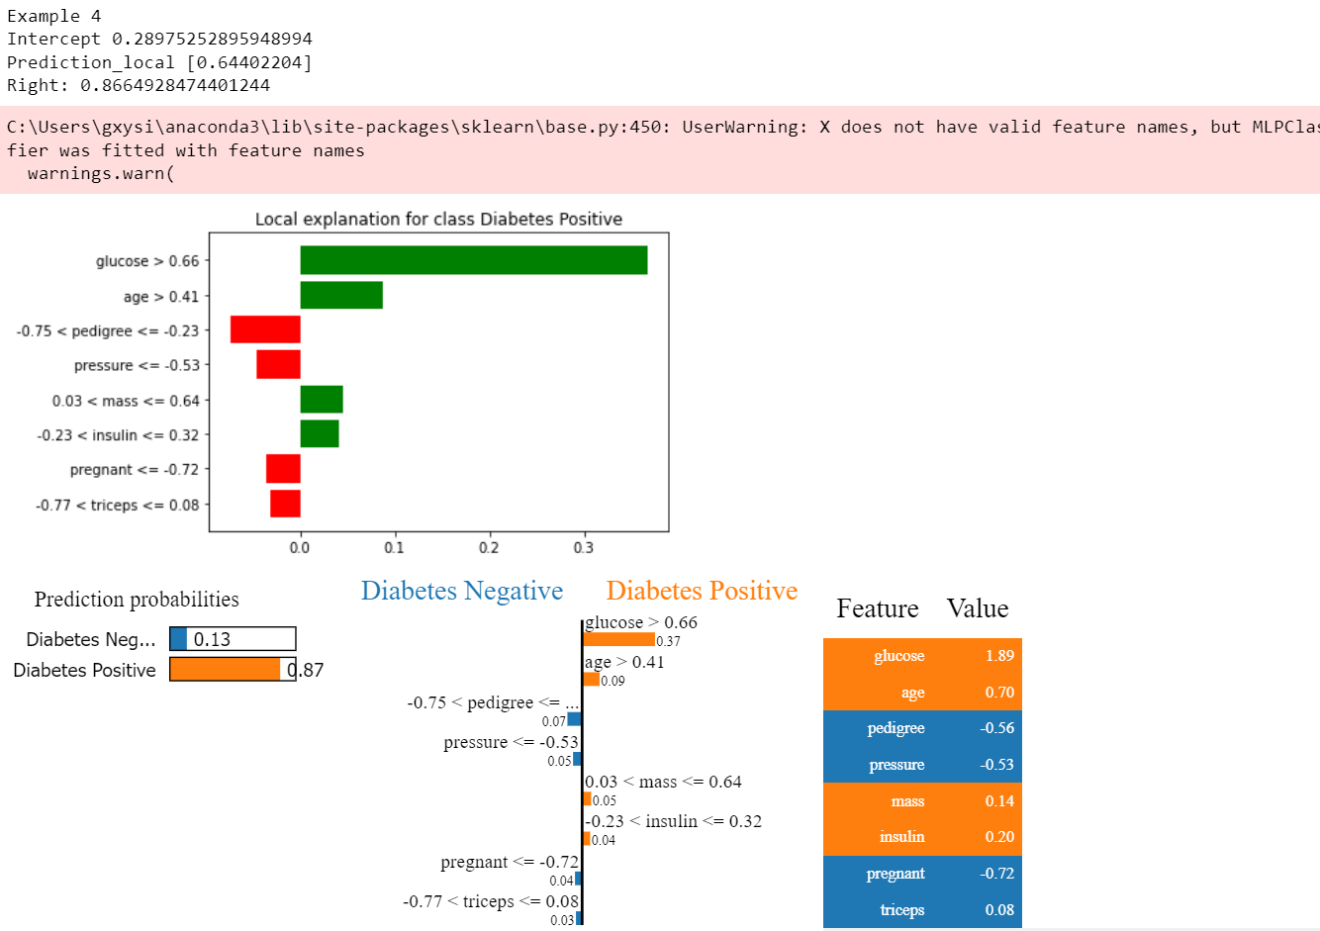

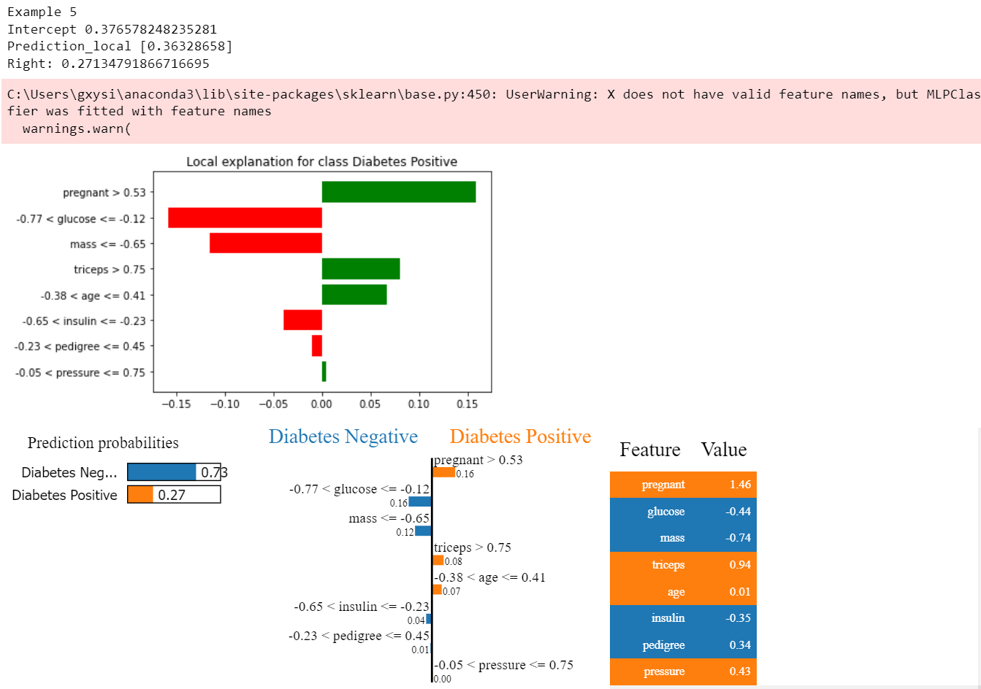

These five examples are positive explanations for the outcome of the MLPClassifer. Let the first one as an instance, the output shows that the LIME model has an intercept of 0.1532 and the LIME model predicted a value of 1.0283 (Prediction_local). The MLPclassifier model predicted positive probability of 0.7923. In this figure, the green bar on the right represents support for diabetes positive, while the red bar on the left represents support for diabetes negative. For selected examples of observations, 'glucose' > 0.66 (data after normalization) showed the highest support for diabetes positivity. In other words, for this example where 'glucose' > 0.66, it mostly leads to diabetes positive.

But I have to say that this model does not fit well. For example, in the last example, the model actually thinks that this example has an 73% probability of being negative, but it is completely positive.

* 1. **Five examples of negative**

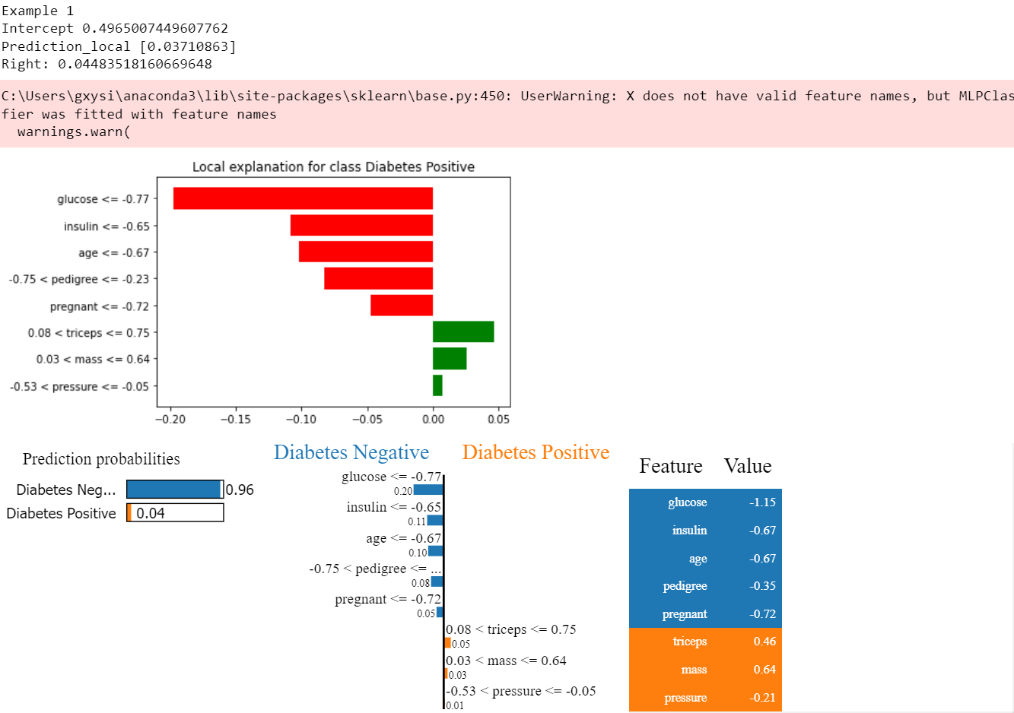

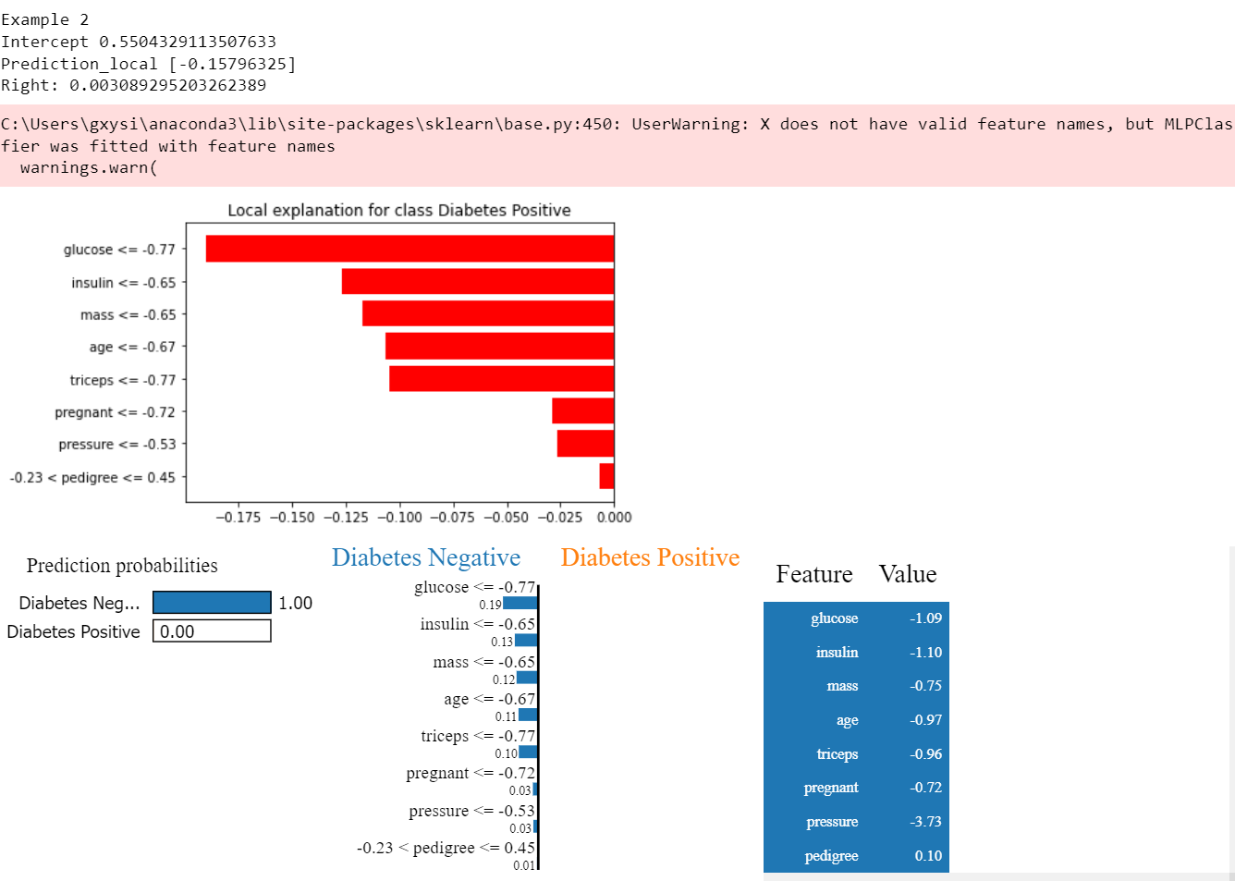

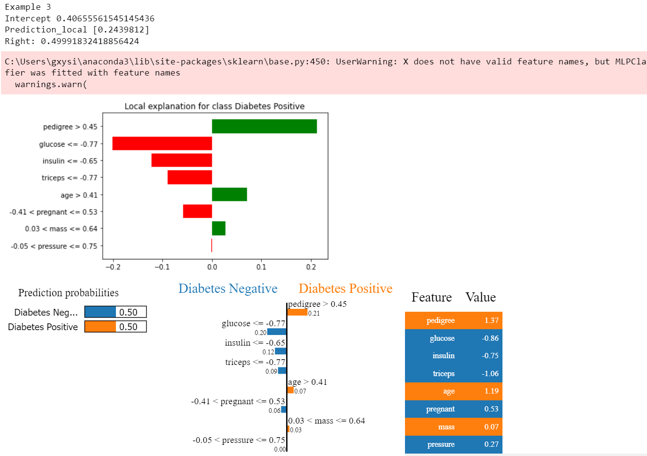

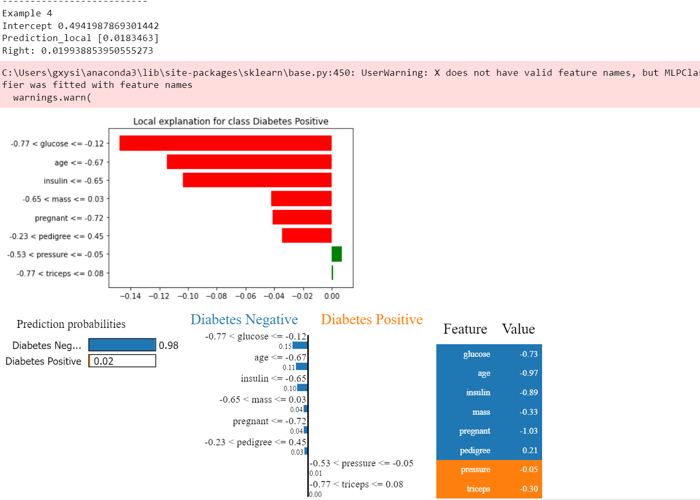

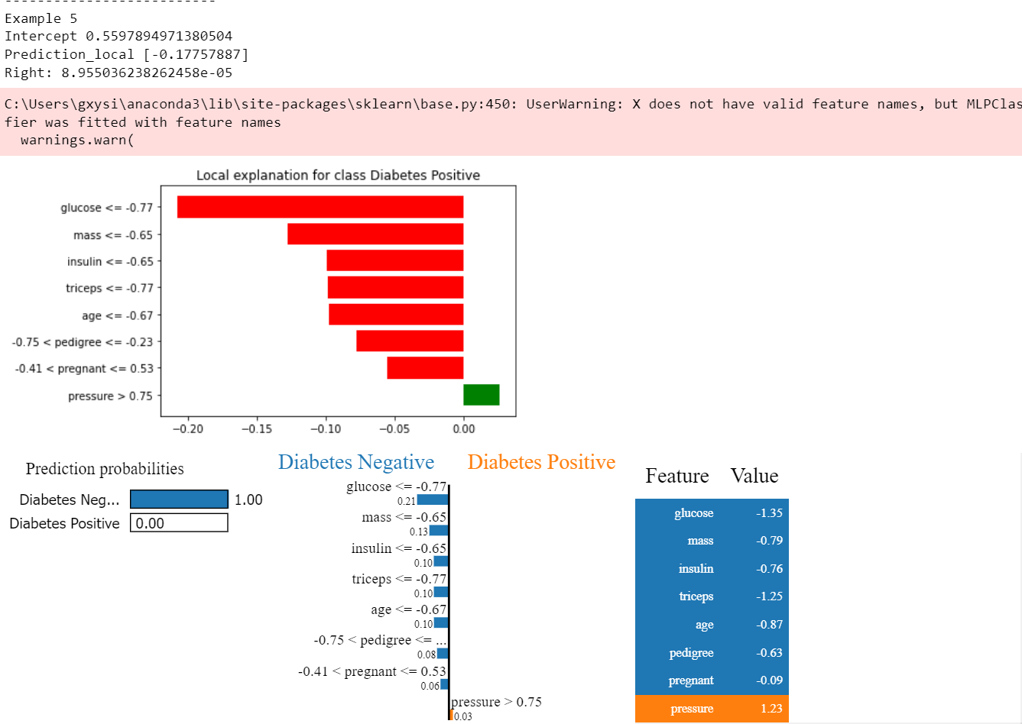

Similarly, these five examples are negative explanations. For the first one, the LIME model has an intercept of 0.4965 and the LIME model predicted a value of 0.0371 (Prediction_local). The MLPclassifier model predicted the positive probability of 0.0448. In this figure, the green bar on the right represents support for diabetes positive, while the red bar on the left represents support for diabetes negative. For selected examples of observations, 'glucose' <= -0.77 (data after normalization) showed the highest support for diabetes negativity. In other words, for this example where 'glucose' <= -0.77, it mostly leads to diabetes negative.

* 1. **Predictions**

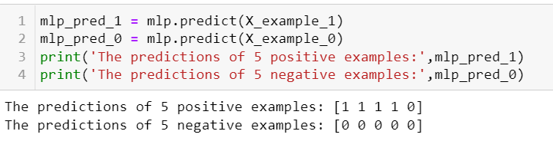

For the negatives instances, all of the examples are correct, while the positives examples have one incorrect prediction ,unfortunately.

**Problem 2: Random Forest**

In this section, I used RandomForestClassifier, and GridSearchCV from sklearn.

**2.1 GridSearchCV**

In order to get the best parameters, I implemented grid search cross validation.

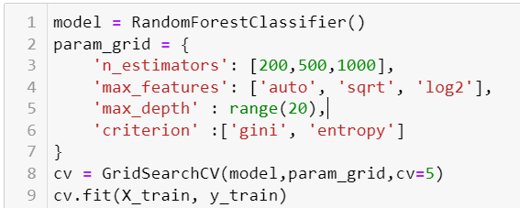

And I got the best parameters after fitting.

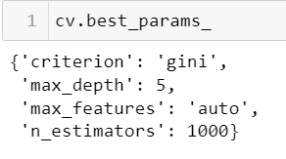

**2.2 RandomForestClassifier**

I used parameters obtained by grid searching, fitted the model and got the report. For testing, the accuracy is 0.83545, which is higherr than mlp.

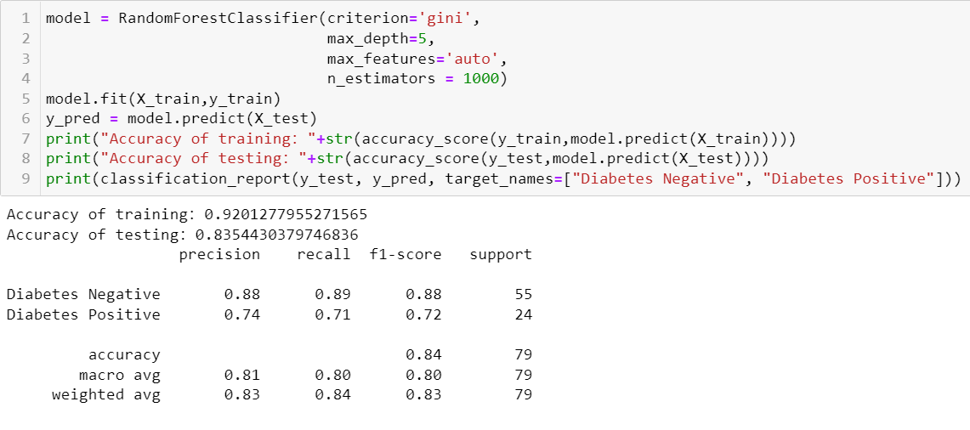

**2.3 The best tree**

I tried to find the best tree in forest and made predictions.

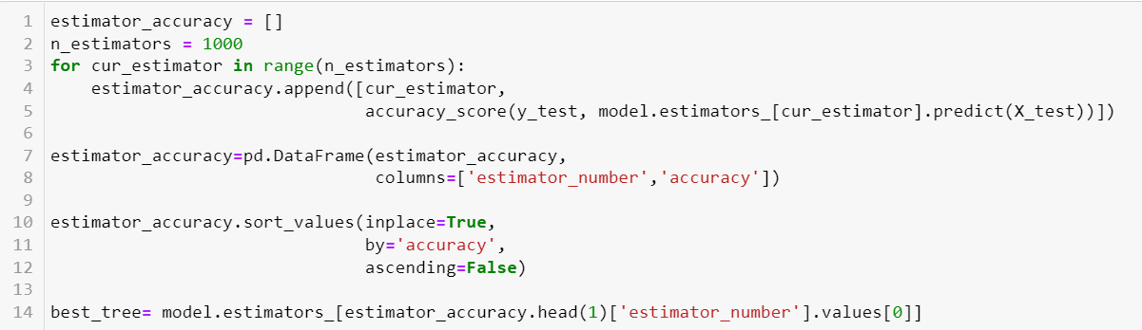

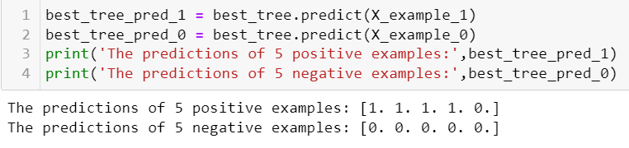

For the best decision tree in the random forest, I got the same result as MLP, which means the predictions of negativity are correct ,but the last one in positivity is wrong. It's kind of tricky, it seems to mislead the model to make a wrong judgment.

And the graph of the best tree:

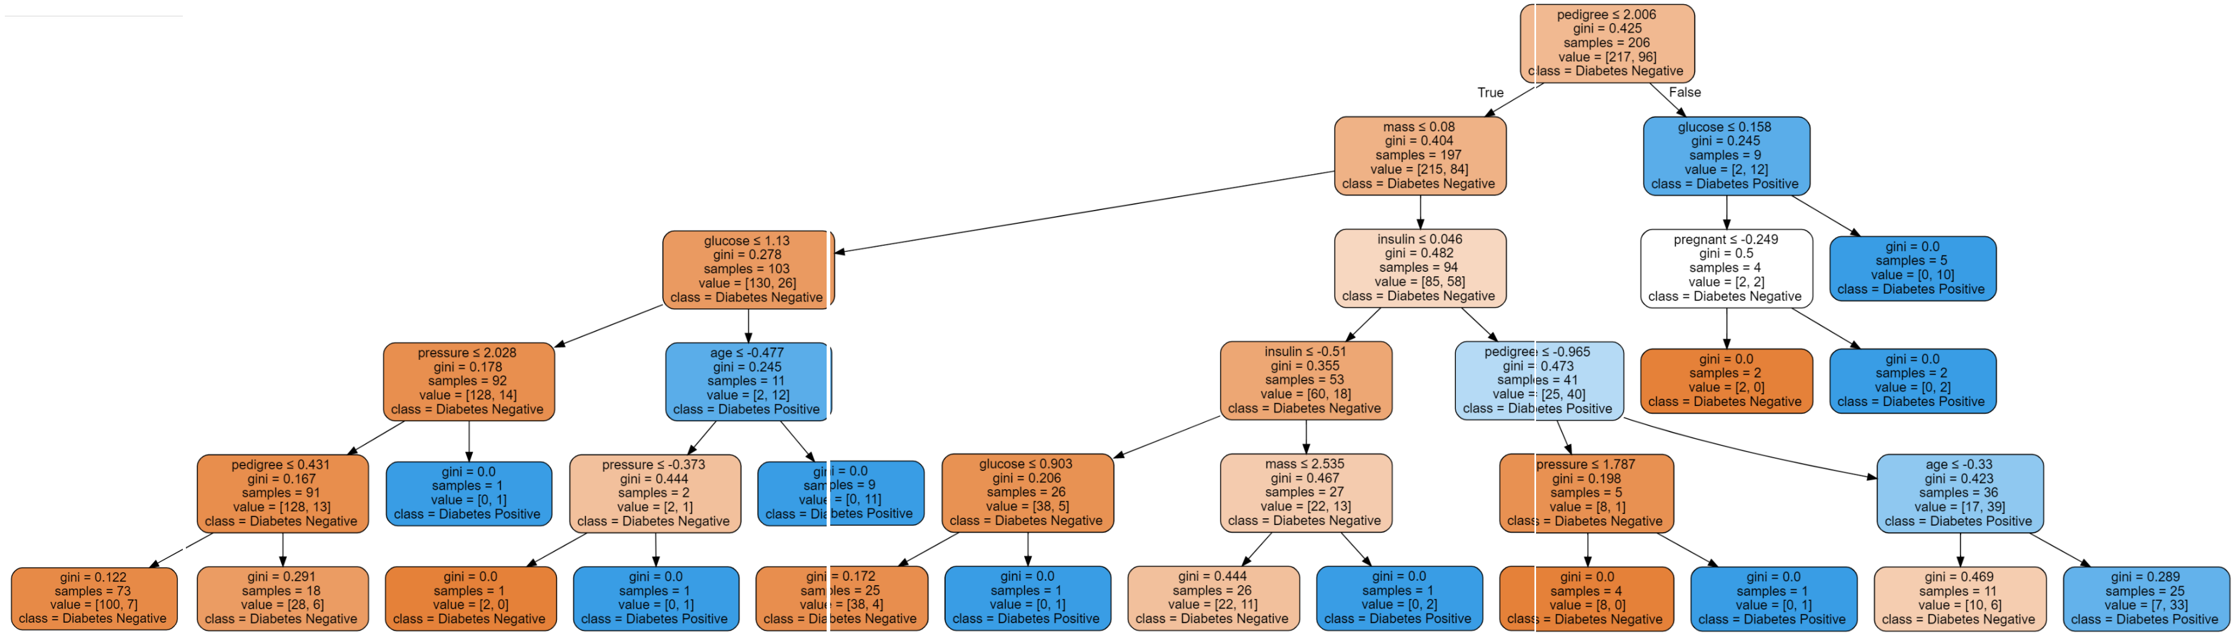

**Problem 3: Feature correlations**

Top 5 features are mass, pregnant, age, insulin, and glucose.I suppose this explanation is more readable and clear. We can visually see the importance comparison between features, and can also rank the importance of features. Such an intuitive concept map is very practical.

