|  |  |  |  |
| --- | --- | --- | --- |
|  | |  | |
|  | 201293155 |  | 1180 words |
|  | GEOG5870M |  |  |
|  | Assignment 2 |
|  |  |

|  |
| --- |
|  |
| 1. |
| 2. |
| 3. |

|  |
| --- |
|  |
|  |

|  |
| --- |
|  |
|  |

**Web GIS Map of Coronavirus disease 2019 (COVID-19) Pandemic in China**

**Introduction**

In December 2019 in Wuhan, China, an infectious disease caused by severe acute respiratory syndrome coronavirus 2 was identified and has spread globally, resulting in an ongoing pandemic (Mayo Clinic, 2020). As of 12th May 2020, the virus has caused 4,193,302 infections and 286,615 deaths all over 187 countries and regions (Johns Hopkins University, 2020).

During the past 20 years, the World Health Organization (WHO) and other health organizations have consistently used mapping and Geography Information System (GIS) for controlling and monitoring disease, such as SARS and Ebola (Esri, 2020). The South Korean authorities have implemented web GIS maps to track and monitor COVID-19 infected cases (Lee, 2020).

At the beginning of the COVID-19 outbreak, the Chinese government has stipulated more than 500 COVID-19 designated hospitals to centrally treat patients with COVID-19. This technical report aims to show the situation of Coronavirus disease 2019(COVID-19) pandemic and medical resources in each province of China through web GIS technologies. The main function of the web is to display the number of COVID-19 diagnoses and medical resources in various provinces of China by choropleth map and allow visitors to find designated hospitals by map markers. Another function of the web is to allow people who need medical assistance to contact the medical department by submitting forms containing their detailed information (like their address and physical conditions). The work of the present research mainly focuses on the client-side of the web.

**Method**

The present work was based on leaflet map and the data of the map include:

* The GeoJSON with Chinese province shapes
* Provincial COVID-19 epidemic data, including confirmed cases, deaths, the number of cases per 1M people and recovered cases.
* COVID-19 designated hospitals data, including coordinates and maximum capacity

The GeoJSON data is from website <https://www.gadm.org/country>, and the provincial COVID-19 epidemic data is from the statistical results of Chinese centre for disease control and prevention (CDC) as of 20/04/2020, which can be found by <http://2019ncov.chinacdc.cn/2019-nCoV/>. The designated hospital data comes from the National Health Commission of China, which can be found by <http://www.nhc.gov.cn/>.

The webpage mainly covers four parts. The first part is a choropleth map based on leaflet map showing the number of COVID-19 confirmed cases in each province of China (Fig.1). The provinces with deeper red correspond to the larger number of infected people. When the visitor hovers a province in the map, the info window in the upper right corner of the map will show the epidemic data of the province, including confirmed cases, recovered cases and deaths etc. The specific province will zoom in when clicked by the visitor.

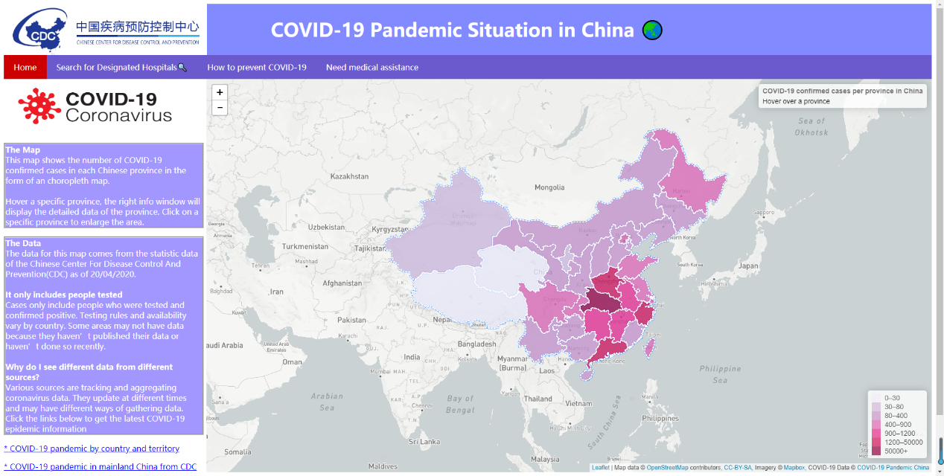

**Fig.1** **Choropleth map page showing the number of confirmed cases in each province**

The second page is the choropleth map showing the total maximum designated hospital beds of each province, province with deeper blue correspond to a larger number of beds, this page also allows visitors to search COVID-19 designated hospitals (Fig.2). COVID-19 designated hospitals are classified to five classes according to their maximum capacity, hospital with fewer than 500 beds, 500 to 1000 beds, 1000 to 1500 beds, 1500 to 2000 beds and more than 2000 beds. Different levels of hospitals are put into different layers and displayed with different icons, there are two benefits to do so. The first benefit is that this allows visitors to clearly distinguish the allocation of medical resources, which allows them to make the appropriate choice when they need treatment. The second benefit is that displaying all hospitals on different layers can reduce the degree of overcrowding of the map, though it still looks crowded when all layers are turned on. Click a specific province to enlarge the area can alleviate this problem to some extent.

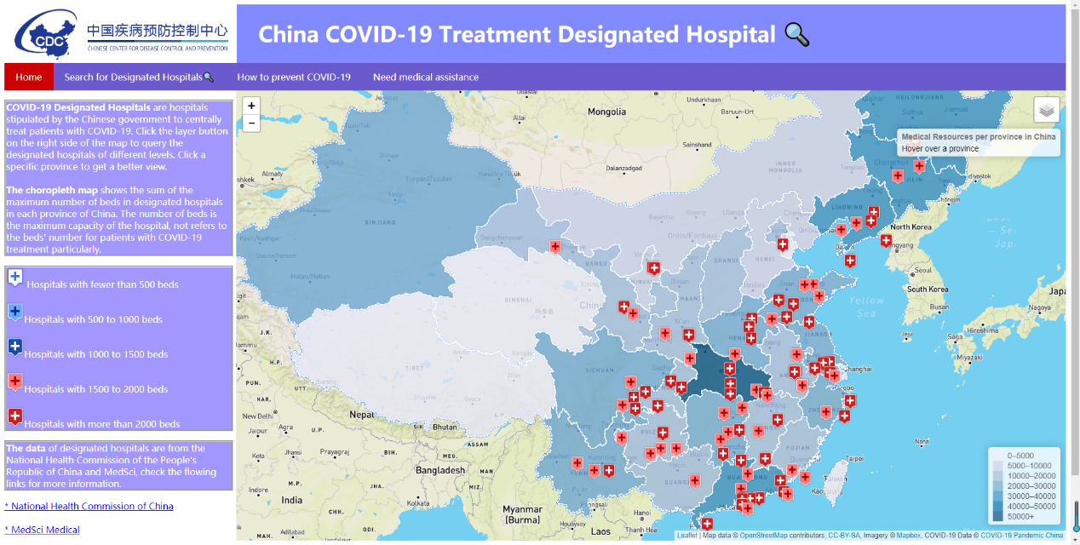

**Fig.2 Choropleth map page showing the number of hospital beds and hospital markers**

The third page contains advice from the World Health Organization (WHO) of how to protect yourself and others from the spread COVID-19 (Fig.3).



**Fig.3 The advice page of how to prevent COVID-19**

The last page (Fig.4) allows people who need medical assistance to contact the medical department by submitting a form with their detailed information, such as name, address, and physical conditions etc. In this page three radio buttons were designed to distinguish the age range of patients, so the medical department can quickly distinguish between patients in urgent need of medical services, such as the elderly.

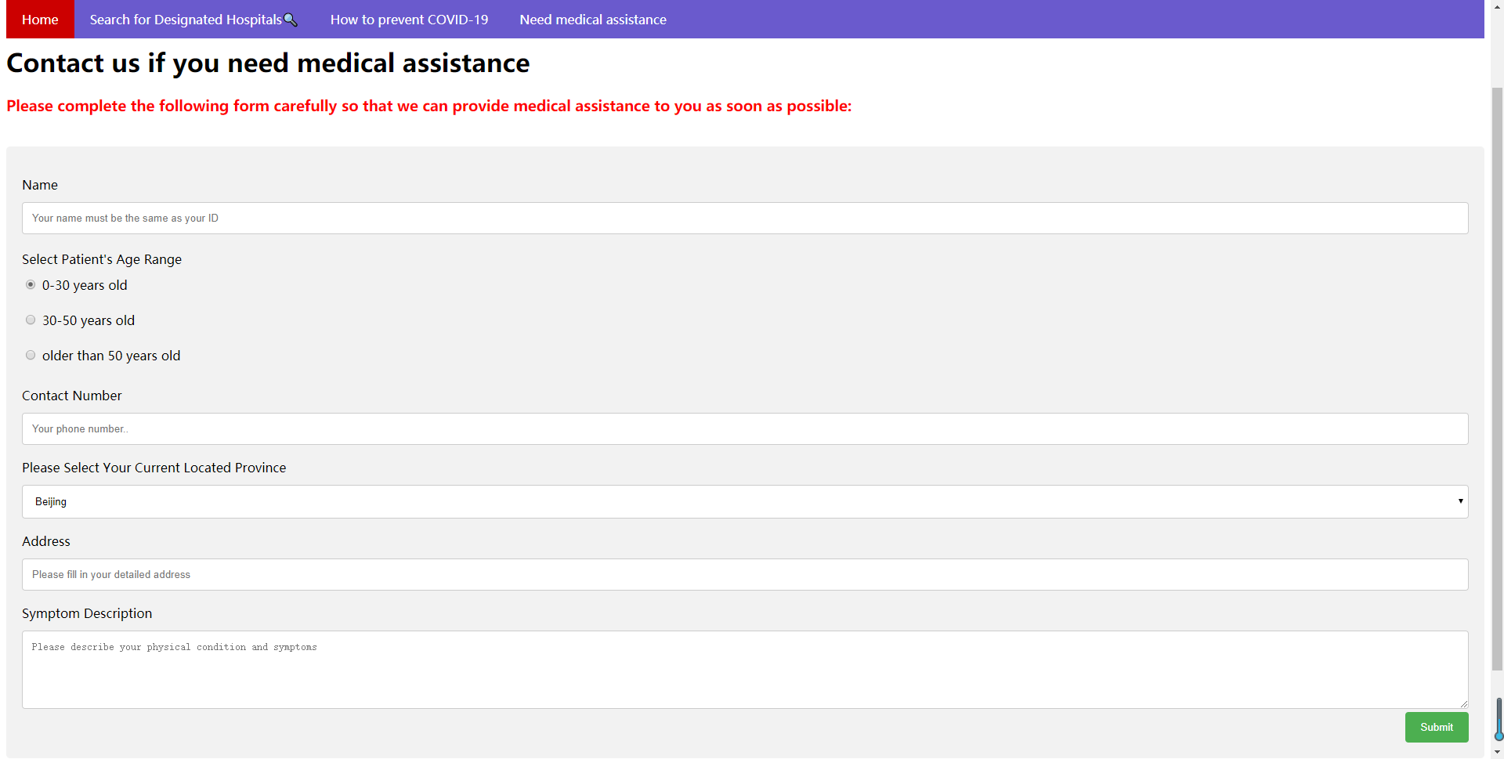

**Fig.4 The page allows visitors to submit a form to acquire medical assistance.**

**Discussion**

From the choropleth maps, we can see how does the number of diagnoses and the distribution of medical resources in various provinces of China. The number of infected people in Hubei province where Wuhan located is far ahead of other provinces without suspense, nearly 70,000 people diagnosed. Provinces adjacent to Hubei province such as Hunan, Henan and Jiangxi also have a larger amount of diagnoses. The COVID-19 designated hospitals are mainly distributed in the densely populated and economically developed areas on the southeast provinces. The information from the choropleth maps is important for how the government allocates medical resources and restricts population movement, while the web page designed in this research only focused on the client-side technologies. The lack of server-side database results in data not being updated quickly and the form information provided by the patient cannot be stored. Building the server-side database is an important aspect that needs further improvement.

Another area worth improving on the present work is the data of COVID-19 designated hospitals, the data only includes the maximum capacity of the designated hospital, the more effective data should be specific beds for the treatment of COVID-19 patients, while this takes a lot of time to collect.

A problem also needs further solution is that the display of the page on different size screen may be abnormal and leaving blank spaces at the edges, the proper display should be the same as the figures in this report. This is because the web page mostly used the absolute attribute in the CSS file when laying out the position of objects and adjusting the display ratio of web pages can help alleviate this problem.

**Conclusion**

Web GIS map can provide accurate location-based information (such as designated hospitals in this study) to citizens, and assist authorities, researchers and public health experts to make the best response strategies (Esri. 2020). The present work mainly focuses on the client-side technologies to display the COVID-19 pandemic situation in China，while there are still problems that need to be solved such as the objects layout and overcrowding of the map and the functions of the web need to be improved through building complete client and server side.

**Reference**

Mayo Clinic. 2020. Coronavirus disease 2019 (COVID-19)—Symptoms and causes. [Online]. Available from: [https://www.mayoclinic.org/diseases-conditions/coronavirus](https://www.mayoclinic.org/diseases-conditions/coronavirus/symptoms-causes/syc-20479963)

Johns Hopkins University. 2020. COVID-19 Dashboard by the Centre for Systems Science and Engineering (CSSE) at Johns Hopkins University (JHU). [Online] Available from: [https://gisanddata.maps.arcgis.com/apps/opsdashboard/index.html#](https://gisanddata.maps.arcgis.com/apps/opsdashboard/index.html#/bda7594740fd40299423467b48e9ecf6)

Esri. 2020. Mapping Epidemics. [Online] Available from: Esri (2020). Mapping Epidemics. Available from: https://www.esri.com/about/newsroom/blog/maps-that-mitigate-epidemics/

Lee Minji. 2020. Digital maps help S.Koreans track new coronavirus. [Online] Available from: <https://en.yna.co.kr/view/AEN20200204003700315#none>