ISQA: 4890

Name: Yu Guo

Professor: Yong Shi

Task1: For the task1, I used python to solve both questions.

The code has 6 parts include:

1. Read data

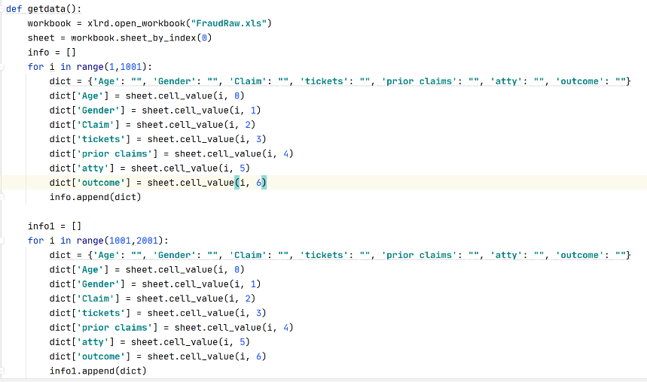

2. Process data

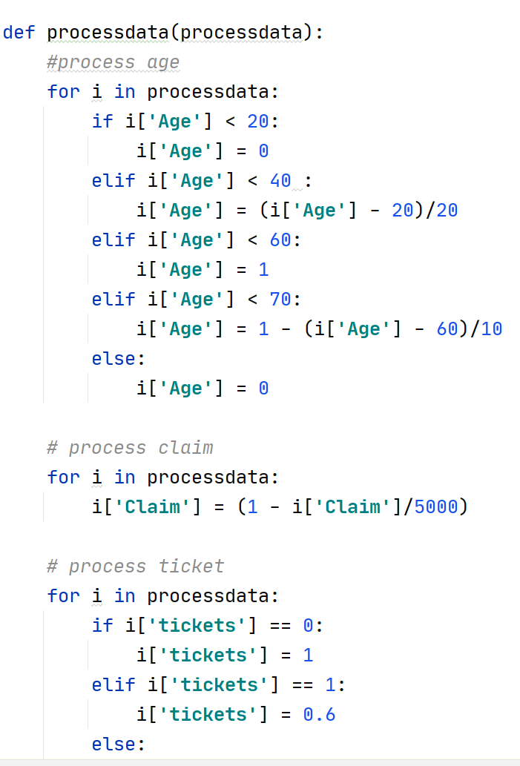

3.Trainning data

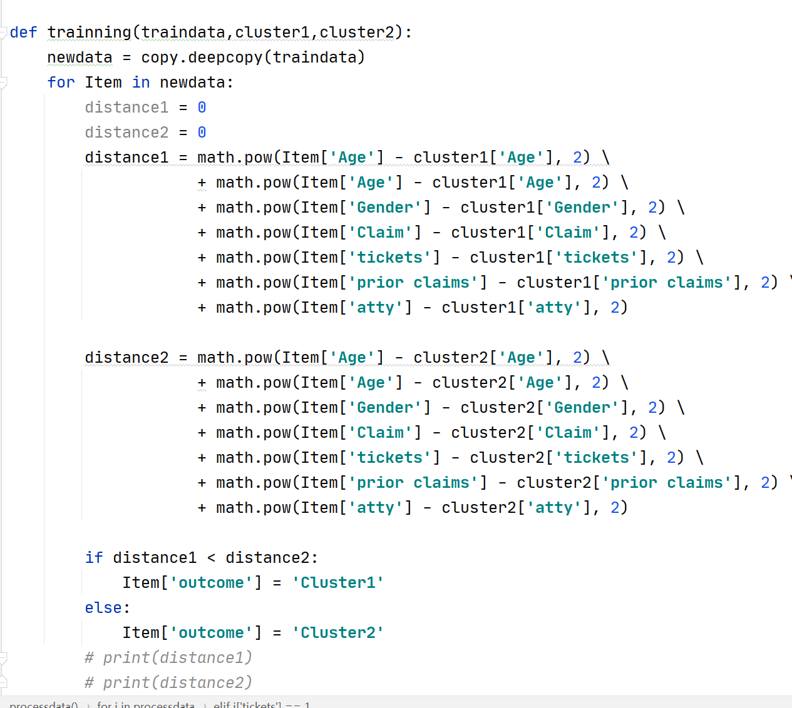

4.Getting new cluster

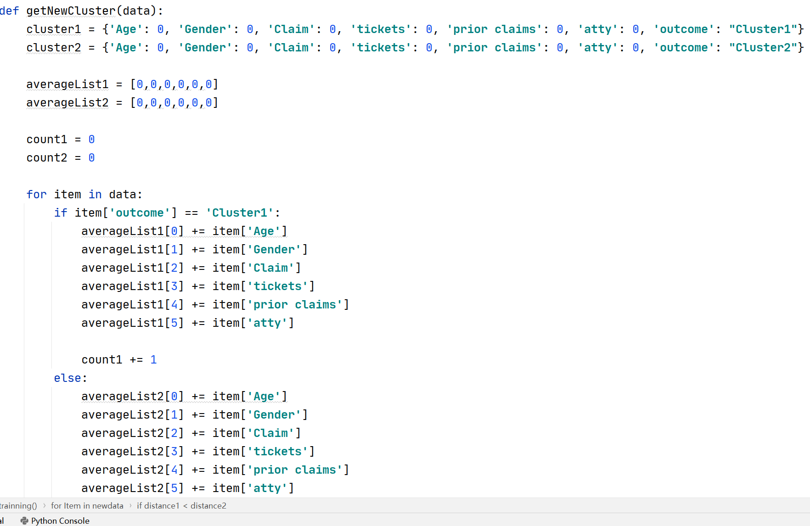

5.Compare two data result

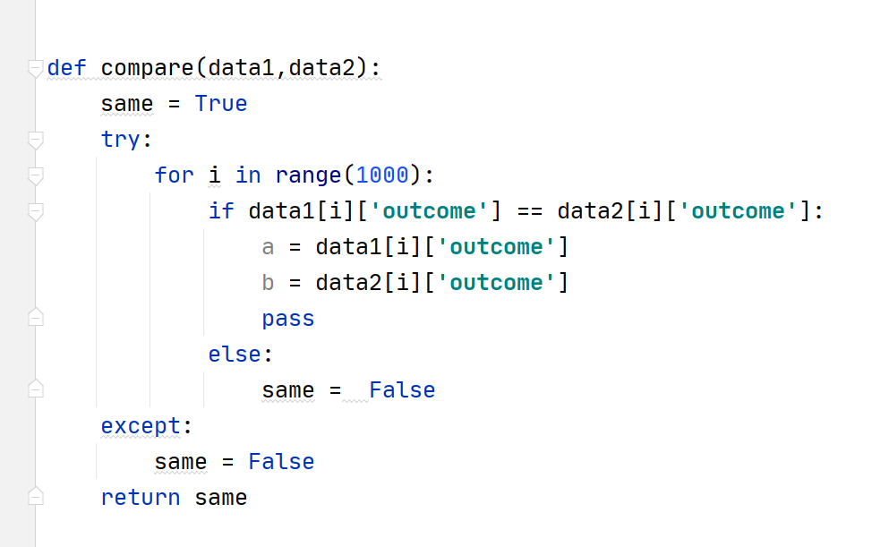

6. Main executive code

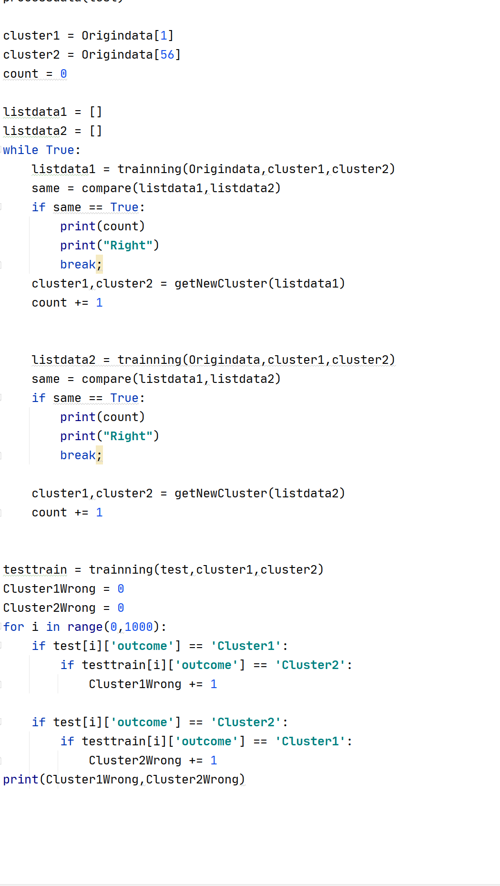

Question1:

For the Q1, I chose data in the first row, and data in the 56th row as the cluster1 and 2. 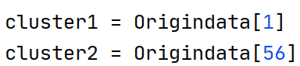

Then I used loop structure to training the data and generate the new cluster util two training data ge the same result of the cluster.

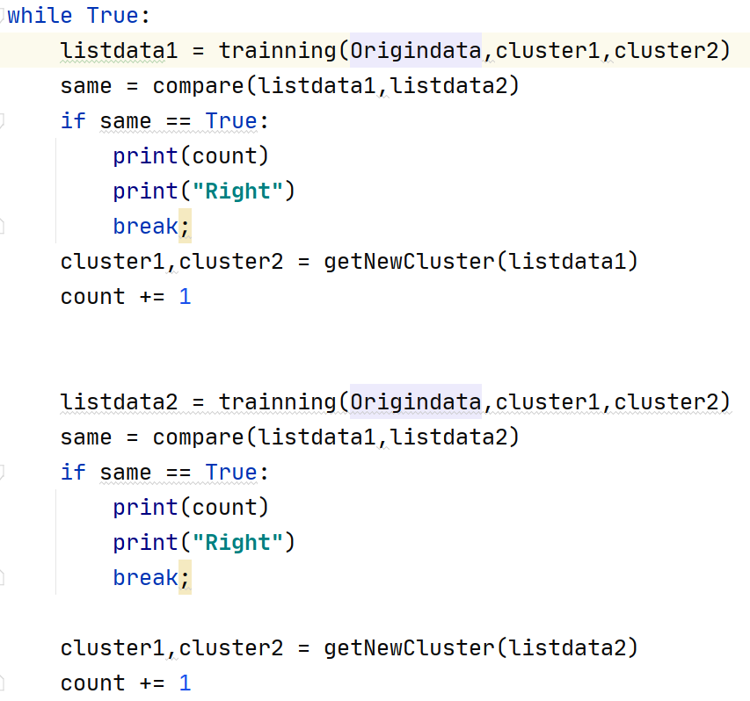

Then I used the latest clusters to continue training the other 1000 data and determine the difference between the real outcome and the mining outcome.

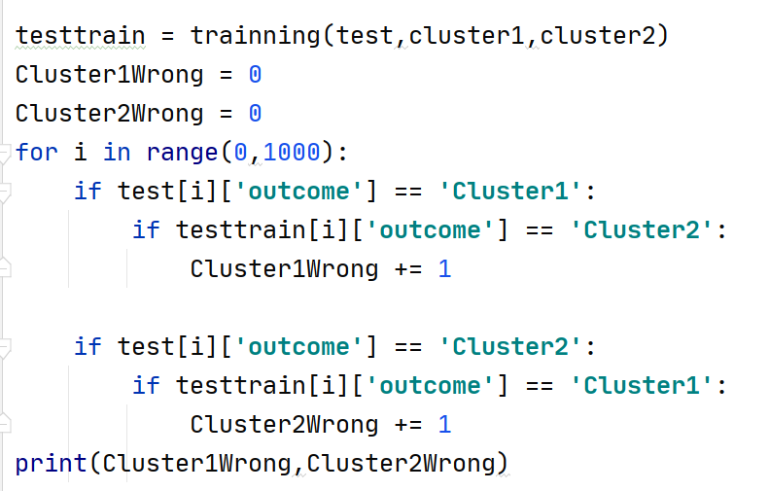

The result indicate that six loops have been executed to get the same result. And 351 + 12 errors. For the 351 errors, the model determine the real cluster1 as cluster2, and 12 errors the model determine the real cluster2 as the cluster1.

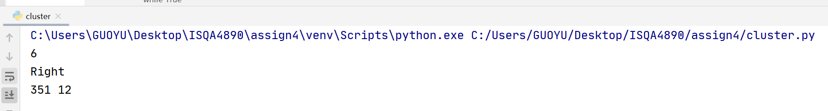

Question4:

The basic parts are the same also include six parts: Get data, process data, training data, get new cluster and determine result and main executive part. And the difference is the data is less dimensional than the question1. Since the data set itself has no tendency to compare, the main result of my validation process is to get the CLUSTER result of the test data and the center of the two CLUSTERs

.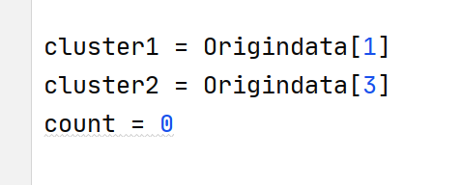

Because the data do not provide the two clusters at the beginning, So I chose data in the first row and the data in the third row as the two clusters.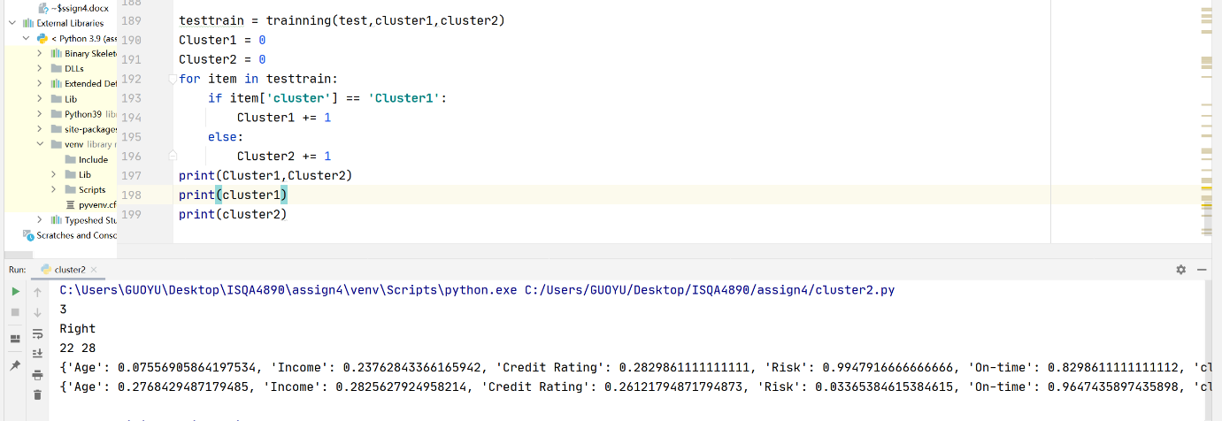

The result shows that it used 3 loops to finish the training to get the same cluster result. And in the test data, 22 data are cluster1, and 28 data are cluster2.

The latest clusters are:

{'Age': 0.07556905864197534, 'Income': 0.23762843366165942, 'Credit Rating': 0.2829861111111111, 'Risk': 0.9947916666666666, 'On-time': 0.8298611111111112, 'cluster': ''}

{'Age': 0.2768429487179485, 'Income': 0.2825627924958214, 'Credit Rating': 0.26121794871794873, 'Risk': 0.03365384615384615, 'On-time': 0.9647435897435898, 'cluster': ''}