Netflix Relational Database Schema Design

Capstone Project on Relational Database Design

Table of Contents
- Introduction
- Platform Overview
- Main Features of Netflix
- Real-World Problems Solved by Netflix
- Case Study: Real-World Problems and Netflix’s Solutions
- Database Schema Design
- Entity Descriptions
- Relationships Between Entities
- SQL Schema Creation
- Sample SQL Queries
- ER Diagram
- Rationale Behind the Design
- Conclusion
- Tools Used
- Future Enhancements

1. Introduction

About the Project
This project focuses on the relational database design of Netflix, one of the world’s leading streaming platforms. The objective of this project is to understand how real-world applications manage large-scale data using relational database systems.
The project includes:
- Product research
- Real-world problem analysis
- Relational schema design
- SQL table creation
- ER diagram design
- Relationship mapping
- Database rationale explanation
The database schema was designed using PostgreSQL concepts and visualized using an ER Diagram.

2. Platform Overview

Selected Platform: Netflix
Netflix is a subscription-based video streaming platform that allows users to watch movies, TV shows, documentaries, and original content online.
Users can access Netflix using multiple devices, such as:
- Smartphones
- Smart TVs
- Laptops
- Tablets
Netflix provides personalized recommendations based on user watch history, ratings, and viewing preferences.

3. Main Features of Netflix
Feature | Description
User Accounts | Users can create accounts using email and password
Profiles | Multiple profiles can exist under one account
Subscription Plans | Different plans based on pricing and video quality
Watch History | Tracks viewing activities
Ratings | Users can rate movies and shows
Content Management | Stores movies, shows, and documentaries
Device Management | Allows streaming across multiple devices
Genre Classification | Organizes content into categories
Recommendation System | Suggests content based on user behavior

4. Real-World Problems Solved by Netflix

Problem 1: Limited Access to Entertainment
Traditional television systems require fixed schedules and cable subscriptions.

Netflix Solution
Netflix provides on-demand streaming services that allow users to watch content anytime and anywhere.

Problem 2: Difficulty Finding Relevant Content
Users often struggle to find movies or shows that match their interests.

Netflix Solution
Netflix uses recommendation systems and watch history to provide personalized suggestions.

Problem 3: Shared Family Usage
Different family members usually prefer different types of content.

Netflix Solution
Netflix allows multiple profiles under a single account so that each user receives personalized recommendations.

Problem 4: Multi-Device Accessibility
Users want uninterrupted streaming across devices.

Netflix Solution
Netflix supports multiple devices, such as phones, TVs, and laptops, with synchronized viewing.

5. Case Study: Real-World Problems and Netflix’s Solutions

Problem 1: Limited Access to Entertainment

Real-World Challenge
Traditional cable television systems require fixed schedules and expensive subscriptions. Users cannot watch content anytime according to their convenience.

Netflix’s Solution
Netflix introduced on-demand streaming services where users can access movies, TV shows, and documentaries anytime and anywhere using internet-enabled devices. This flexibility improved accessibility and convenience for millions of users globally.

Problem 2: Difficulty Discovering Relevant Content

Real-World Challenge
Users often spend a lot of time searching for content matching their interests due to large content libraries.

Netflix’s Solution
Netflix uses recommendation systems based on watch history, ratings, and viewing behavior to provide personalized suggestions. This improves user engagement and enhances viewing experience.

Problem 3: Shared Family Accounts

Real-World Challenge
Family members usually prefer different genres and content types, making personalization difficult in shared accounts.

Netflix’s Solution
Netflix introduced multiple profile support under one account. Each profile stores separate watch history, recommendations, ratings, and preferences, allowing personalized viewing experiences for every family member.

Problem 4: Multi-Device Streaming

Real-World Challenge
Users expect uninterrupted entertainment across smartphones, laptops, tablets, and smart TVs.

Netflix’s Solution
Netflix supports synchronized streaming across multiple devices. Users can pause content on one device and continue watching on another device seamlessly.

Problem 5: Subscription and Payment Management

Real-World Challenge
Managing subscription plans, billing, and payment tracking can become complex for streaming platforms.

Netflix’s Solution
Netflix uses subscription plans and payment management systems that track active plans, billing history, payment methods, and subscription status efficiently.

Conclusion of Case Study
Netflix successfully addresses major entertainment industry challenges using scalable database-driven solutions. Its relational database structure supports personalized recommendations, subscription management, multi-profile usage, device synchronization, and efficient content organization. This demonstrates how strong schema design improves both platform performance and user experience.

6. Database Schema Design

Main Entities Used
The following entities were designed for the relational schema:
- Users
- Profiles
- Plans
- Subscriptions
- Content
- Genres
- ContentGenres
- WatchHistory
- Ratings
- Payments
- Devices

7. Entity Descriptions

Users
Stores user account information.

Attributes
- user_id (Primary Key)
- full_name
- email
- password_hash
- country
- created_at

Profiles
Stores profile information under a user account.

Attributes
- profile_id (Primary Key)
- user_id (Foreign Key)
- profile_name
- age_category

Plans
Stores subscription plan details.

Attributes
- plan_id (Primary Key)
- plan_name
- price
- video_quality
- screens_allowed

Subscriptions
Stores subscription information for users.

Attributes
- subscription_id (Primary Key)
- user_id (Foreign Key)
- plan_id (Foreign Key)
- start_date
- end_date
- status

Content
Stores movie and TV show details.

Attributes
- content_id (Primary Key)
- title
- content_type
- release_year
- duration_minutes
- language

Genres
Stores genre categories.

Attributes
- genre_id (Primary Key)
- genre_name

ContentGenres
Acts as a junction table between Content and Genres.

Attributes
- content_id (Primary Key, Foreign Key)
- genre_id (Primary Key, Foreign Key)

WatchHistory
Tracks viewing history.

Attributes
- history_id (Primary Key)
- profile_id (Foreign Key)
- content_id (Foreign Key)
- watched_at
- progress_percentage

Ratings
Stores ratings given by profiles.

Attributes
- rating_id (Primary Key)
- profile_id (Foreign Key)
- content_id (Foreign Key)
- rating_value

Payments
Stores payment details.

Attributes
- payment_id (Primary Key)
- user_id (Foreign Key)
- amount
- payment_date
- payment_method
- payment_status

Devices
Stores user device information.

Attributes
- device_id (Primary Key)
- user_id (Foreign Key)
- device_type
- device_name

8. Relationships Between Entities
Relationship | Type
One User → Many Profiles | One-to-Many
One User → Many Payments | One-to-Many
One User → Many Devices | One-to-Many
One User → Many Subscriptions | One-to-Many
One Plan → Many Subscriptions | One-to-Many
One Profile → Many WatchHistory Records | One-to-Many
One Profile → Many Ratings | One-to-Many
Many Content ↔ Many Genres | Many-to-Many

9. SQL Schema Creation
CREATE TABLE Users (
user_id SERIAL PRIMARY KEY,
full_name VARCHAR(100),
email VARCHAR(100) UNIQUE,
password_hash VARCHAR(255),
country VARCHAR(50),
created_at TIMESTAMP DEFAULT CURRENT_TIMESTAMP
);

CREATE TABLE Plans (
plan_id SERIAL PRIMARY KEY,
plan_name VARCHAR(50),
price DECIMAL(10,2),
video_quality VARCHAR(20),
screens_allowed INT
);

CREATE TABLE Subscriptions (
subscription_id SERIAL PRIMARY KEY,
user_id INT REFERENCES Users(user_id),
plan_id INT REFERENCES Plans(plan_id),
start_date DATE,
end_date DATE,
status VARCHAR(20)
);

CREATE TABLE Profiles (
profile_id SERIAL PRIMARY KEY,
user_id INT REFERENCES Users(user_id),
profile_name VARCHAR(50),
age_category VARCHAR(20)
);

CREATE TABLE Content (
content_id SERIAL PRIMARY KEY,
title VARCHAR(255),
content_type VARCHAR(20),
release_year INT,
duration_minutes INT,
language VARCHAR(50)
);

CREATE TABLE Genres (
genre_id SERIAL PRIMARY KEY,
genre_name VARCHAR(50)
);

CREATE TABLE ContentGenres (
content_id INT REFERENCES Content(content_id),
genre_id INT REFERENCES Genres(genre_id),
PRIMARY KEY(content_id, genre_id)
);

CREATE TABLE WatchHistory (
history_id SERIAL PRIMARY KEY,
profile_id INT REFERENCES Profiles(profile_id),
content_id INT REFERENCES Content(content_id),
watched_at TIMESTAMP,
progress_percentage INT
);

CREATE TABLE Ratings (
rating_id SERIAL PRIMARY KEY,
profile_id INT REFERENCES Profiles(profile_id),
content_id INT REFERENCES Content(content_id),
rating_value INT CHECK (rating_value BETWEEN 1 AND 5)
);

CREATE TABLE Devices (
device_id SERIAL PRIMARY KEY,
user_id INT REFERENCES Users(user_id),
device_type VARCHAR(50),
device_name VARCHAR(100)
);

CREATE TABLE Payments (
payment_id SERIAL PRIMARY KEY,
user_id INT REFERENCES Users(user_id),
amount DECIMAL(10,2),
payment_date DATE,
payment_method VARCHAR(50),
payment_status VARCHAR(20)
);

CREATE TABLE watchlist (
watchlist_id SERIAL PRIMARY KEY,
profile_id INT REFERENCES profiles(profile_id) ON DELETE CASCADE,
content_id INT REFERENCES content(content_id) ON DELETE CASCADE,
added_date TIMESTAMP DEFAULT CURRENT_TIMESTAMP
);

INSERT INTO Users (full_name, email, password_hash, country)
VALUES
('Rahul Sharma', 'rahul@gmail.com', 'abc123', 'India'),
('Priya Singh', 'priya@gmail.com', 'xyz456', 'India');

INSERT INTO Plans (plan_name, price, video_quality, screens_allowed)
VALUES
('Basic', 199, 'HD', 1),
('Standard', 499, 'Full HD', 2),
('Premium', 649, '4K', 4);

INSERT INTO Profiles (user_id, profile_name, age_category)
VALUES
(1, 'Rahul', 'Adult'),
(1, 'Kids', 'Kids'),
(2, 'Priya', 'Adult');

INSERT INTO Content (title, content_type, release_year, duration_minutes, language)
VALUES
('Stranger Things', 'Series', 2016, 50, 'English'),
('Money Heist', 'Series', 2017, 45, 'Spanish'),
('RRR', 'Movie', 2022, 180, 'Telugu');

10. Sample SQL Queries

Query 1: View Users
SELECT * FROM Users;

Query 2: User Profiles
SELECT u.full_name, p.profile_name
FROM Users u
JOIN Profiles p
ON u.user_id = p.user_id;
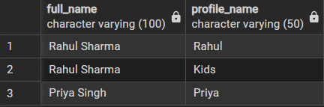

Query 3: Subscription Details
SELECT u.full_name, pl.plan_name
FROM Subscriptions s
JOIN Users u ON s.user_id = u.user_id
JOIN Plans pl ON s.plan_id = pl.plan_id;
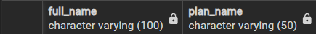

Query 4: Average Ratings
SELECT c.title, AVG(r.rating_value) AS avg_rating
FROM Ratings r
JOIN Content c
ON r.content_id = c.content_id
GROUP BY c.title;
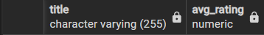

Query 5: Watch History
SELECT p.profile_name, c.title, w.watched_at
FROM WatchHistory w
JOIN Profiles p ON w.profile_id = p.profile_id
JOIN Content c ON w.content_id = c.content_id;

11. ER Diagram

Netflix Relational Database Schema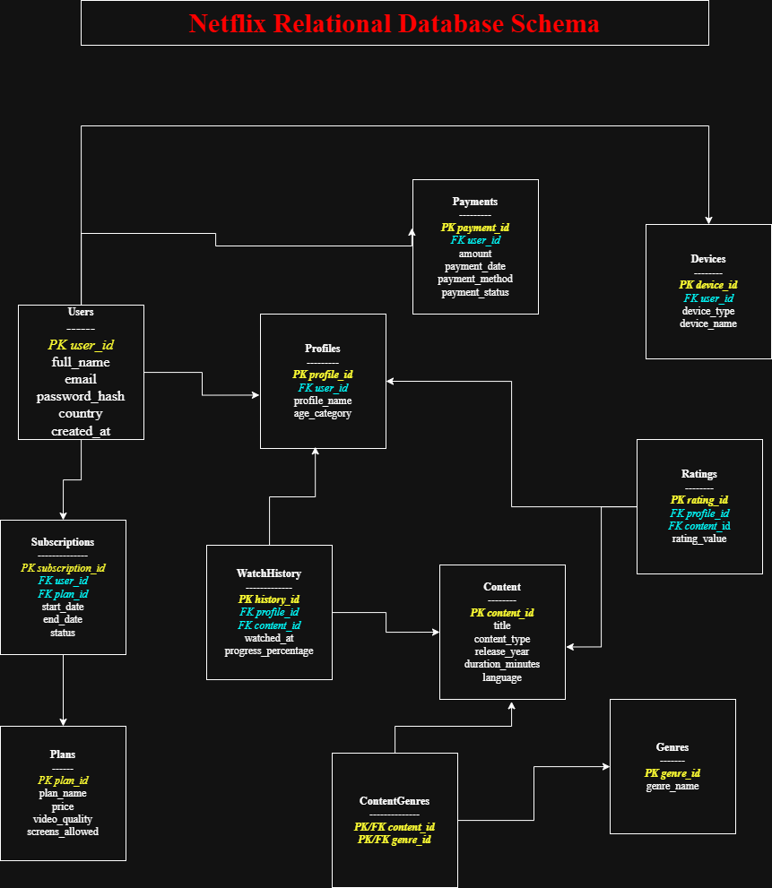

12. Rationale Behind the Design
The schema was designed to accurately represent Netflix's functionality.

Reasons Behind the Design
- Separate tables reduce data redundancy.
- Foreign keys maintain data integrity.
- Junction tables efficiently manage many-to-many relationships.
- Profiles support family-based personalized viewing.
- Watch history and ratings improve recommendation systems.
- Subscription and payment tables help manage billing operations.
The schema follows normalization principles:
- First Normal Form (1NF)
- Second Normal Form (2NF)
- Third Normal Form (3NF)
This improves consistency, scalability, and performance.

13. Conclusion
This project helped in understanding how relational databases are designed for real-world applications like Netflix.
The schema successfully represents:
- User management
- Content management
- Subscription handling
- Ratings and watch history
- Device tracking
- Genre classification
The project also improved knowledge of:
- Relational database concepts
- Primary and foreign keys
- Entity relationships
- SQL schema design
- ER diagram creation
Overall, this capstone project provided practical exposure to database architecture and schema modeling used in large-scale streaming platforms.
This project demonstrates how relational databases are used in modern streaming applications to efficiently manage millions of users, subscriptions, devices, and personalized entertainment experiences.

14. Tools Used
Tool | Purpose
PostgreSQL | Database schema creation
draw.io | ER Diagram creation
Google Docs | Documentation
Google Drive | Video presentation upload

15. Future Enhancements
The database schema can be further improved by adding:
- AI-based recommendation tracking
- Content download history
- Subtitle and audio language management
- User notifications
- Streaming analytics
- Content licensing information
- Parental control settings
- Search history tracking

