This is to demonstrate how the application was run.

1. The first figure shows the display of items for sale.

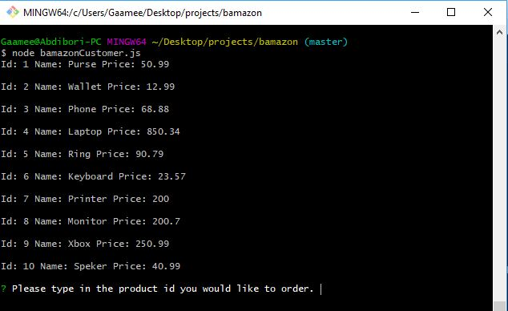

1. This figure shows the item number the customer ordered and amount purchased. It also displays the product ordered, from which department, total amount spent for the amount of products ordered and the remaining of product inventory.

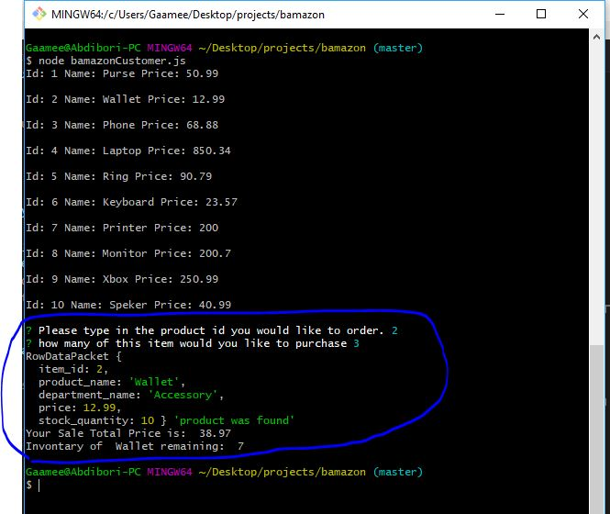

1. The image displays insuficiant amount when a customer tried to order product quantity more than what is available.

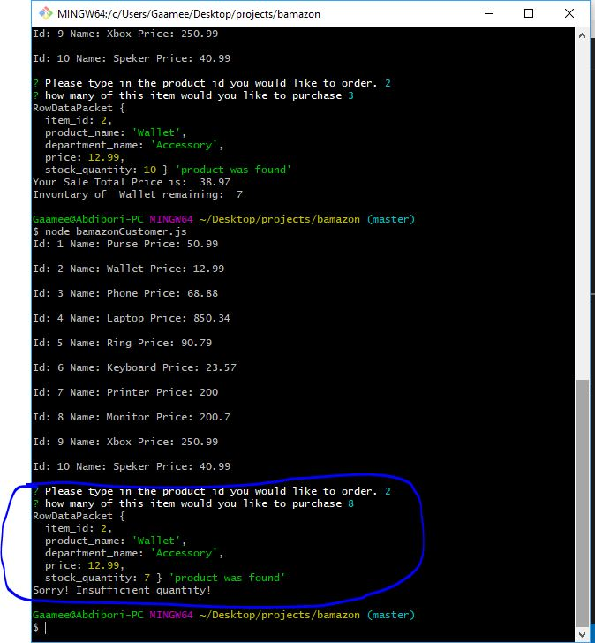

1. This image shows that after insufficient quantity the customer still ordered the amount that is available without any issues.

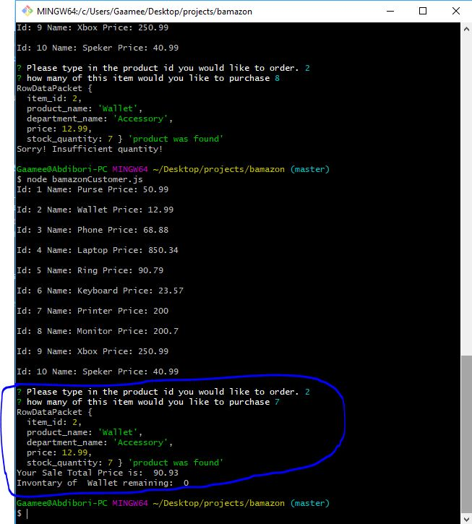

1. Showing customer can still order new items.

