Animation and Rigging Tools

Overview

Picker Tab

List View Tab

Rig Settings Tab

Joint Chain Rigs And Settings

Toolbar

Select & Reset

Import Motion

import mocap

import Animation

**Export Motion**

Export FBX

Export Animation

Space Switching

Pose Editor

Create Pose

Load Pose

Matching

Misc. Tools



OverView

This is the animation user interface:

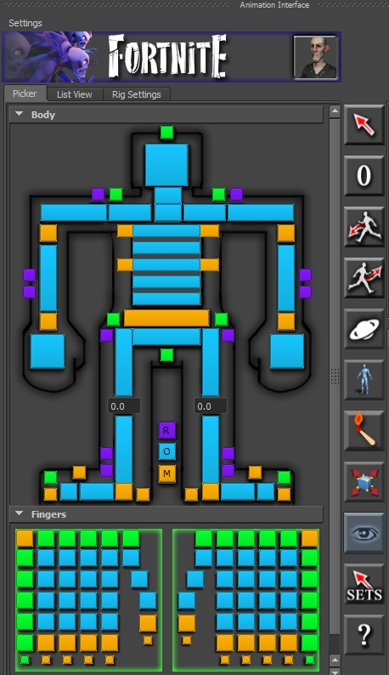

It is divided into 3 main tabs and has a toolbar along the right edge.

Here is a general overview of what’s what on the UI:

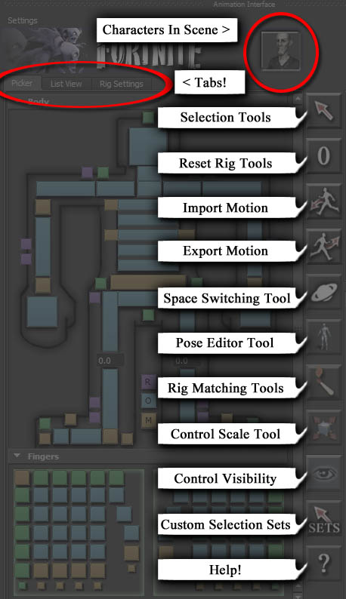

Character Picker Tab

The character picker is the default tab upon opening the UI. This is where you can select the majority of the controls in a clean, visual fashion. The controls not included on the character picker are any toes you may have, as well as custom controls (ponytails, accessories, etc.)

**Basic Selection Functions:**

-simply clicking on a button will select the control and replace whatever you had previously selected.

-Shift + LMB on a button will add that control to your current selection.

*You should notice, anytime you select a control, either by the picker or in the viewport, the corresponding picker buttons will turn white, showing you what you have selected:

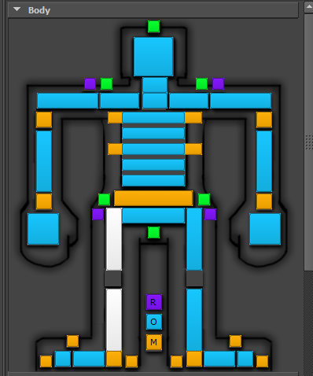

**Button Colors**

-Blue buttons are associated with FK controls

-Orange buttons are associated with IK controls

-Purple buttons are associated with twist controls and other special controls

-Green buttons select entire groups of controls.

-The green button above the left clavicle will select all arm controls, FK and IK.

**RMB Menus**

Body parts that can switch rig modes(FK/IK) will also have context menus which you can access by RMB on a button:

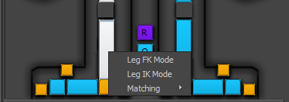

You can switch modes with this method, or by going to the Rig Settings tab and switching it there.

**Fingers**

The finger picker area is essentially the same as the body picker, but there are a few things to point out.

To select all finger controls, you can click on the large button that borders the chosen hand with the green border:

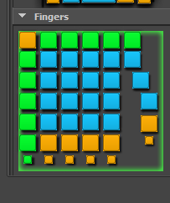

RMB on this large button will also bring up other global selection methods:

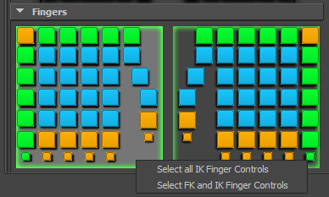

By default, LMB will select all of that hand’s FK controls. To select all finger controls for a given hand, RMB and select “Select FK and IK Finger Controls”.

The Green buttons surrounding the hand are for selecting rows and columns of fingers. To select columns, you would use the green buttons at the top of the picker, and for rows, you would use the green buttons to the sides of the picker.

**Switching Characters**

The interface will only work on whatever character is pictured in the top right of the UI:

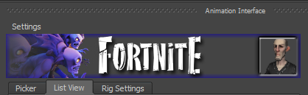

To change which character the UI will act on, simply press the thumbnail and a list of characters will appear:

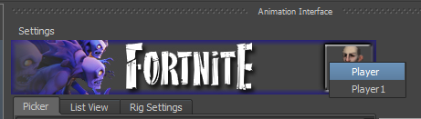

Just choose which character you want, and that character will now be controlled by an instance of the UI made just for him.

**Space Switching:**

Lastly, any node that has the ability to space switch will have its spaces listed in a RMB context menu as well:

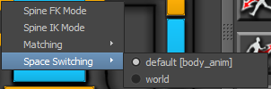

The current space the control is in is marked by the white circle next to the control. To learn more about the space switching toolset, visit the Tools section on Space Switching.

**Switching via RMB menu vs. Channel Box:**

Switching a mode or a setting in the channel box will not trigger any of the matching functionality. If you want to match a mode, say the head space, it is recommended you do so through the RMB menu or the rig settings tab:

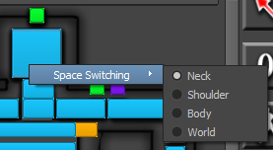

LIST View Tab

The list view tab is essentially a custom outliner that lists all of your rig’s controls, including any custom ones that have been added.

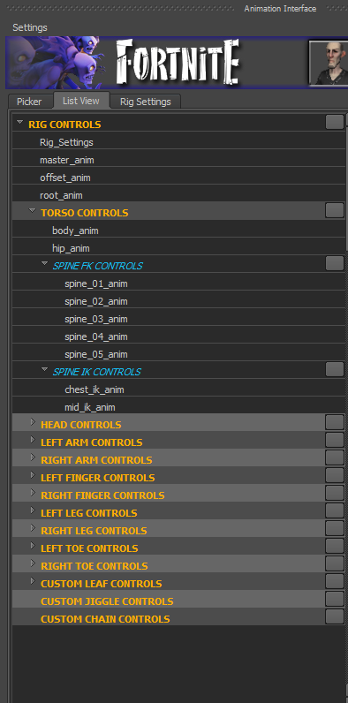

The large grey button next to each orange and blue title will select all controls under that item. So if you select the grey button to the right of “RIG CONTROLS”, you will select every control on the character rig. You can SHIFT + LMB to select multiple items in the list view. Just with the picker, anything you select, either in the viewport, picker, or the list view, will be shown across all three.

For example:

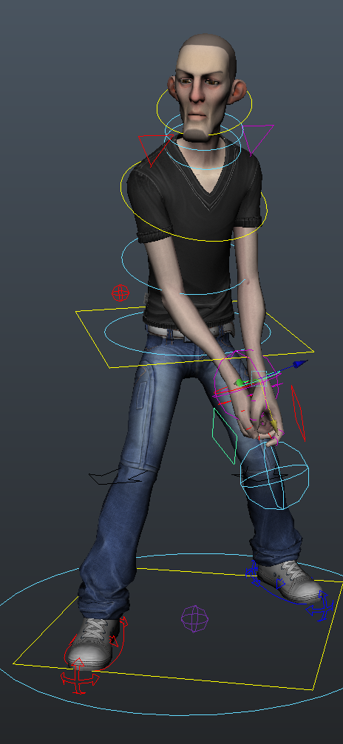 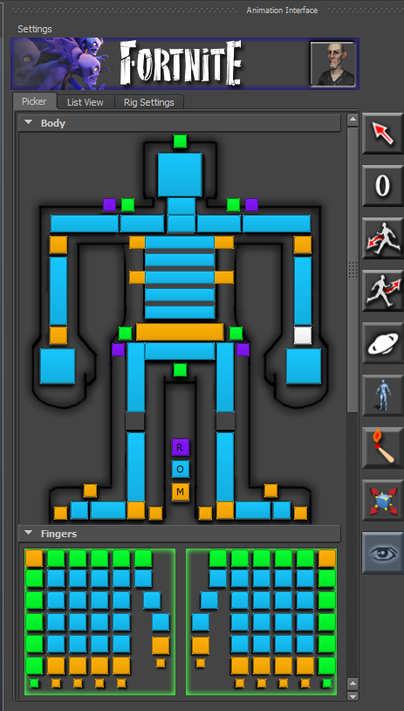 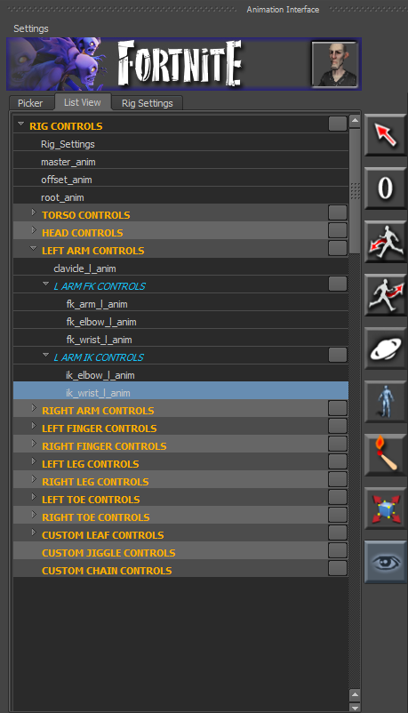

Rig Settings Tab

Any setting for any rig can be accessed in the rig settings tab. The tab is sectioned out by body parts for easy navigation. Each body part layout also has a RMB context menu for selecting all nodes of that part that contain the settings that can be animated.

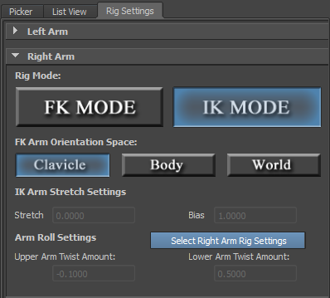

Any setting that can be set on a rig control can be found in this tab.

**Joint Chain Rigs and Settings:**

If you have custom joint chains on your character, the settings for those chains can be found in the rig settings tab under “Custom Joint Chains”.

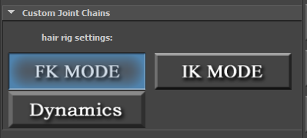

Here, you can switch between the different rig modes. By default, the joint chain will be in FK.

**FK Rig:**

The FK rig is what you’d expect, aside from one feature:Lag Mode.

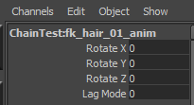

Lag Mode will take the rotations from the base of the chain, and send them down the rest of the chain with an offset of a few frames. Instead of having to animate all that overlap, just turn on lag mode!

**IK Rig:**

The stretchy spline IK Rig has the individual cluster controls off by default. To turn them on to get even more control over the rig, change the attribute on the top_anim:

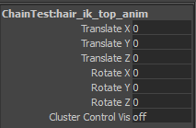

**Dynamics:**

Lastly, dynamics mode will put the joint chain into a physics simulation. There is only 1 control in dynamics mode, and it holds all of the physics settings:

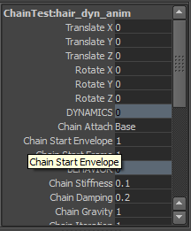

You should also add a gravity field to your scene if you want better simulations. The easiest way to do this is to find the group under the rig_grp named something like: *:dynHairChain. Select that group’s hierarchy and then add the field. You can also rotate and translate that control to influence the simulation.

TOOLBAR OVERVIEW

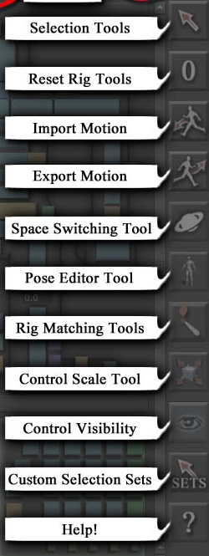

The toolbar occupies the right edge of the animation interface. The image on the left shows what each button represents. Some of these buttons, like the selection tools and reset rig tools, bring up a simple list of options upon clicking. Others will bring up new windows with many sub tools inside.

Control Visibility is simply a toggle for the visibility of the current character’s rig controls.

SELECT AND RESET TOOLS

To access various selection tools, simply LMB on this icon: . Upon doing so, a list of selection tools will popup:

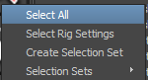**Select All** will select all rig controls and rig settings nodes for the current active character.

**Select Rig Settings** will only select the rig settings node which can be useful for viewing keys of rig modes and such.

**Create Selection Set** will take your currently selected controls, and create a selection set of those controls that will work with any character.

**Selection Sets**

Once you have created a selection set, the set will appear in the Selection Sets menu. Selection sets are permanently saved to disk and will always appear in the menu.

**Selection Set Options**

If you look at a selection set in the menu, you’ll notice there is an option box beside the set:

  
The options box will open a new window that will show you which controls are contained in the selection set as well as the option to permanently remove the selection set from the menu:

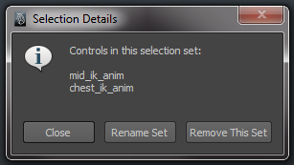

**Reset Tools:**

To access the reset tools, simply LMB on this icon: .

Doing so currently brings up two options: Reset All, and Reset Selection.

**Reset All** will reset every rig control back to its default state, as if you had just brought in a fresh rig.

No keyframes are deleted, just values are set. This means if you have autokey on, keys will be set on these controls in their default values.

**Reset Selection** does the same thing, but only on rig controls you have selected.

Import Motion

This button will bring up a new window with many options for importing motion.

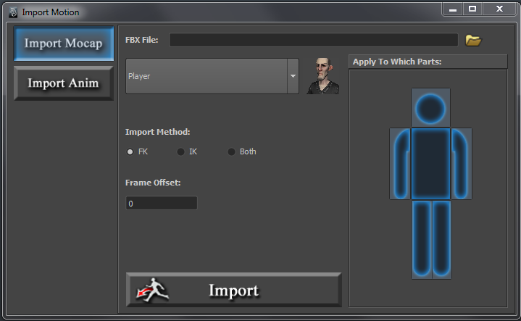

**Import Mocap:**

The import mocap method takes an FBX file that is the same as the base skeleton of the rig. This is the skeleton created using the Rigging Toolset.

Once you have listed the FBX you wish to import motion from, you can choose the character in your scene that will receive the motion, and choose which body parts to apply the motion to.

This means that you could import mocap only onto the lower body, and choose an entirely different animation to import mocap onto the upper body, or arms.

Then simply choose the **import method:**

**FK**: All motion will be imported and baked onto the FK rig controls.

**IK**: All motion will be imported and baked onto the IK rig controls.

**Both**: It will do each method listed above, giving you the option to switch rig modes per limb and still have all of the mocap data.

You can also choose to apply a frame offset if you like. That’s all there is to importing mocap onto the rig!

**Import Anim:**

The import animation method imports animation curve data. Currently, it imports that data as it was with no modifications. Future features will include importing animation onto selected controls, and importing mirrored animation.

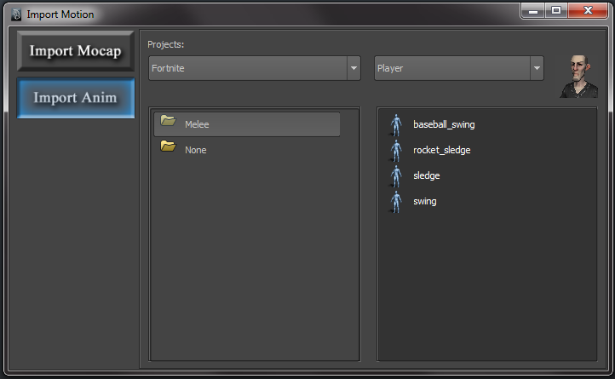

Export Motion

This button will bring up a new window with many options for exporting motion.

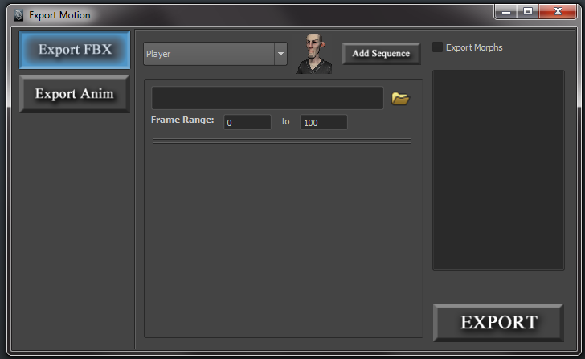

**Export FBX**

Export FBX is used to export your animation to the Unreal Editor. It will create a duplicate skeleton, and bake all of the data down onto those joints, leaving your current scene untouched.

You can choose whose motion you would like to export with the character dropdown menu.

If you want to export the entire animation, simply give it a path and name, as well as the frame range. If you would like to export your animation in multiple chunks, simply click ‘Add Sequence’ to add more sequences to export. This is useful for exporting an animation that has a start, loop, and an end.

To remove a sequence, right click on the sequence and select remove.

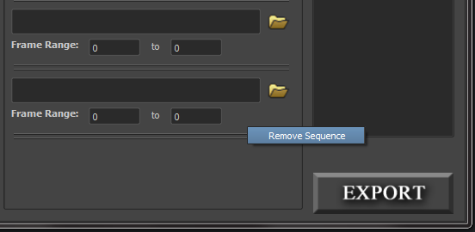

If your character has morph targets, and you would like to export the morph target animation, check the ‘Export Morphs’ checkbox to see a list of all of that character’s blendshape nodes. Select the ones you would like to export to have it included in the FBX file.

**Export Animation**

Export Animation will export out your character’s animation curves for all of that character’s rig controls.

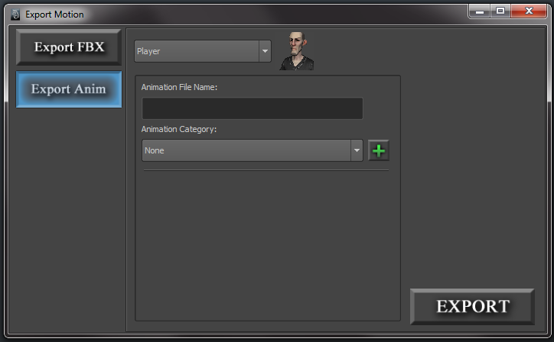

It is very straight-forward to use. Simply give your animation a name, and select a category to export to. You can add new categories by clicking on the ‘+’ button on the right.

If your scene has any custom spaces setup, or any controls with constraints, you will get asked upon export if you would like to bake this data down onto the controls, as it will not be exported. You can ignore if you wish, just know that any data on controls the tool warns you about will not be exported.

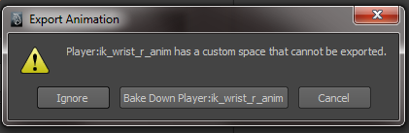

Exporting animation also will handle animation layers just fine and re-create them upon import.

Space Switching

Space switching is a toolset that allows the animator to forego the use of constraints. Instead they can put controls in custom spaces or preset spaces to have other objects drive a control.

For example, a classic example of this is space switching on IK hands, where the hand can be put in ‘hip space’ to follow the hip, or ‘head space’ to follow the head.

When you put a control in a space, you still have full access on that control. Any keys that were set to avoid a pop are set on a separate space switch node that each control has.

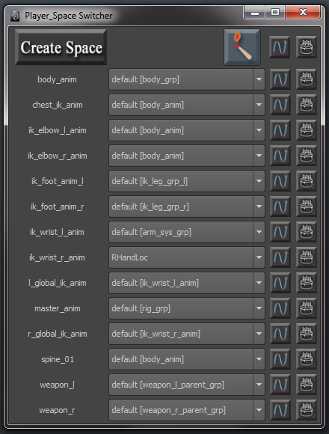

**\*Spaces will switch on whatever frame you are on when you change the space for a control. Keep that in mind. You can also switch spaces by right clicking on a valid control in the character picker UI.**

**Create Space**

To create a custom space, select the space object, and then the control, and hit ‘create space’. This is just like how you would setup a constraint. That newly created space will show under that control’s dropdown menu.

This button is the match button. It is selected by default. If it is on, anytime a user changes space, keys will be set on a space switch node so there is no pop. If for some reason, you would not like this behavior, simply turn match off.

 This button appears beside each control and is used to select the space switch node for that control. This button also exists at the top of the interface, and selecting it will grab all of the space switch nodes.

This button appears beside each control and is a toggle for marking that control for bake. Any controls that are marked for bake, when selecting the very top bake button, will bake all of the space switching on those controls down onto the default space. This is a good way to clean up your scene if things start getting confusing.

***CAUTION!***

Space switching, just like constraints, needs to be used with caution. If you change a pose after you have switched spaces, you will notice a pop. This is because that space switch matched a pose that is no longer the same. You definitely have to give it some thought when using space switching and keep track of what you are doing to not get yourself into a mess. Worst case scenario, you can just delete all space switch keys or bake everything down using the Bake button.

My advice to our animators here, is to nail down your poses first, not using any space switching, and use space switching at the end, during the polish phase of your animation. You’re much less likely to run into issues this way.

Pose Editor

This button on the toolbar will bring up the Pose Editor tool. However, holding down RMB over this button will bring up a few quick posing tools you may find useful.

**Quick Pose Tools**

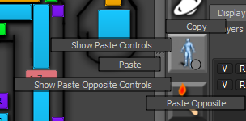With quick pose tools, you can copy a pose from a selection of controls, paste that pose on a later frame on the same set of controls, or paste it to the mirror of those controls. For example, if you have a nice hand pose, you can select all of your hand controls, copy the pose, and paste it onto the other hand using ‘**paste opposite’**.

The tooltip for the pose editor will also display what is in your pose clipboard.

**Pose Editor Interface**

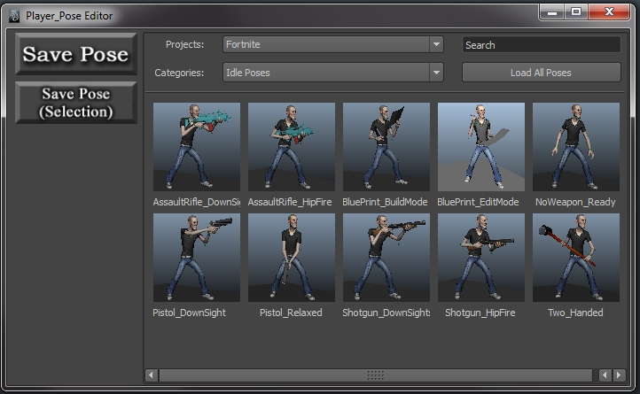

The pose editor is where you can save custom poses and load those poses on your characters. Saving a pose will always save the pose on all controls, no selection is required. Loading a pose can be done in many ways. You can load the pose as it was saved, load it onto selected controls, load a “ghost” of the pose to snap the rig to, load the pose mirrored, or load a mirrored “ghost”. More on the load pose functions later, but first let’s take a look at the creation of poses.

**Creating A Pose**

To create a pose, simply click the “Save Pose” button (or the “Save Pose (Selection) button for partial poses, like hand poses). The following interface will appear where you can give the pose a name, a category, and a custom thumbnail.

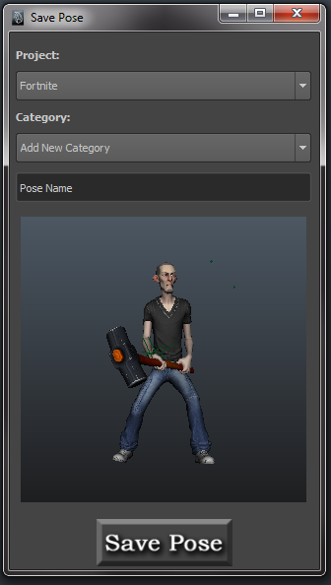

Once the pose has been saved, it will immediately appear in the interface.

**Caution!**

You will get a warning if you try to save a pose that has constraints or custom spaces set. Since it is a pose, everything should be in default spaces before saving. If you get this warning, open up the script editor to see the list of controls that are not compliant with the tool.

**Loading A Pose**

**Caution!**

If you are using source control, like Perforce, you will need to edit your client spec line endings setting to be unix instead of local. For some reason, having it set to local will break the text file formatting which will result in an error. You can force sync afterwards to apply those changes.

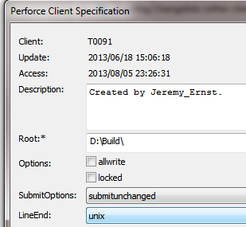

(in p4V, connection🡪edit current workspace)

There are five ways to load a pose. The first way is to simply click on the thumbnail, which will load the pose exactly as it was saved.

The other four ways of loading a pose can be accessed by RMB on the pose thumbnail:

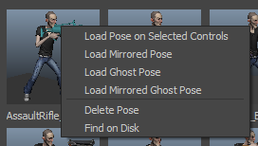

**Loading onto Selected Controls:** The second way to load a pose is to load it onto a selection. This means you could select just the legs for example, and load a given pose’s leg pose.

**Load Mirrored Pose**: The third method is to load the pose exactly as it was, except mirrored.

**Load Ghost Pose:** The ghost pose brings in a “ghost” of the pose as a mesh, which you can move around in the viewport. When ready, you can snap your character to the ghost pose using the “Snap” button:

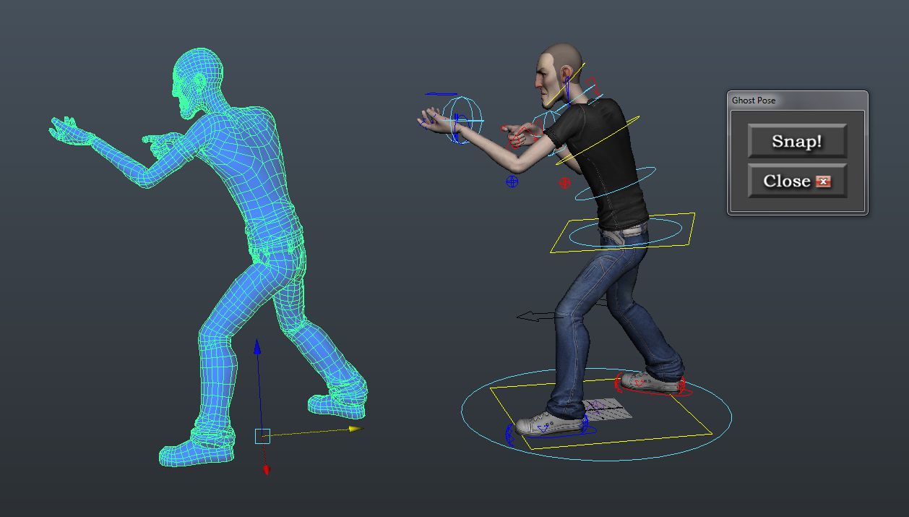

**Load Mirrored Ghost**: The same thing as ghost pose, except it creates a mirrored version of the pose to move around and snap to.

**Partial Poses:**

Partial poses can be saved as well, so you can just save a pose of the selected controls. This is useful for saving hand poses and such.

Matching

To match on a single frame between two rig modes, you can achieve this by RMB on a valid control in the character picker and go to the matching menu:

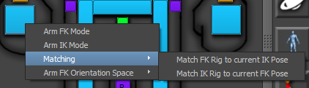

However, if in your settings, you have ‘match on switch’ checked, all you need to do is simply switch modes, and the matching will happen automatically. No need to match and then switch.

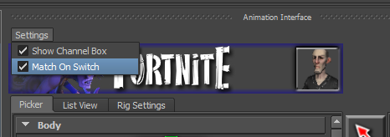

**Matching Over A Frame Range**

To match over a frame range, you will want to open the tool from the toolbar: 

This will bring up a simple interface where you can select the limbs, set the frame range, and what you would like to match:

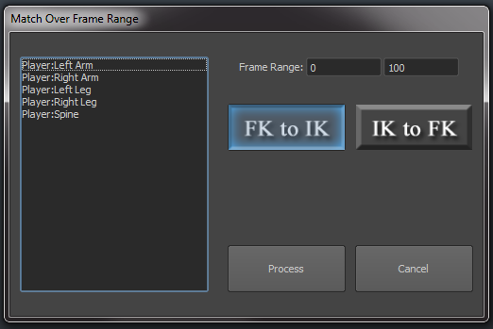

Miscellaneous Tools

 This tool will allow you to scale the size of a selection of controls. Since the rig is auto-generated, sometimes controls may be larger or smaller than desired. With this tool, you can resize them to be of a size more appropriate. Just launch the tool, make a selection, and choose the direction you want to go:

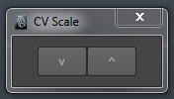

 This button on the UI is a toggle for a character’s rig controls display. By default, it is on. Toggling this button off will hide all of that character’s rig controls.

If you RMB on the visibility toggle, you will get access to the **ISO Select Tool.**

**ISO Select Tool:**

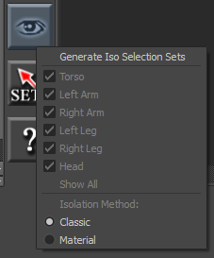

ISO select is a tool that generates selection sets of polygon faces for isolating elements of your character.

To get started using it, you must [generate the iso selection sets]. This is an automated task that looks at polygons and their weights, and sorts out what faces belong to which body part.

From there, you can now uncheck parts you do not want to see. There are two **isolation methods**: Classic and Material.

**Classic**: The same effect as going to isolate selection in the viewport display menu. It will hide everything in the scene, including the rig controls and only leave you with the polygons that are weighted to parts that are still checked.

**Material**: Material assigns a transparent material to parts that are unchecked, which leaves the rest of your scene visible, including rig controls, etc. This function also remembers what materials were originally assigned to those polygons so when you uncheck a box, or show all, it will revert to what it had originally.

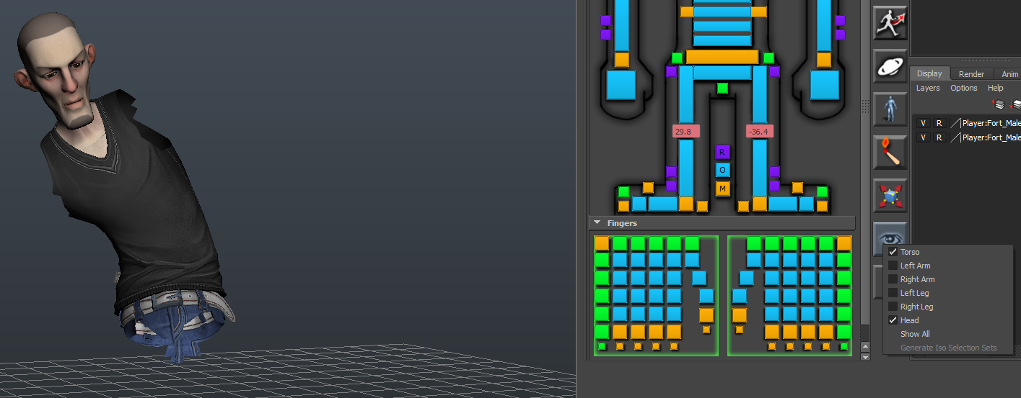

**The Settings Menu:**

There is a settings menu at the top of the interface:

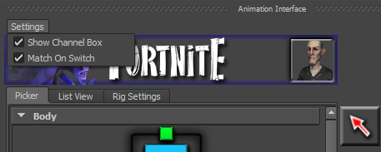

Currently, there are only two options in here.

**Show Channel Box**: This will move Maya’s channel box and layer editors and put them directly into the animation interface:

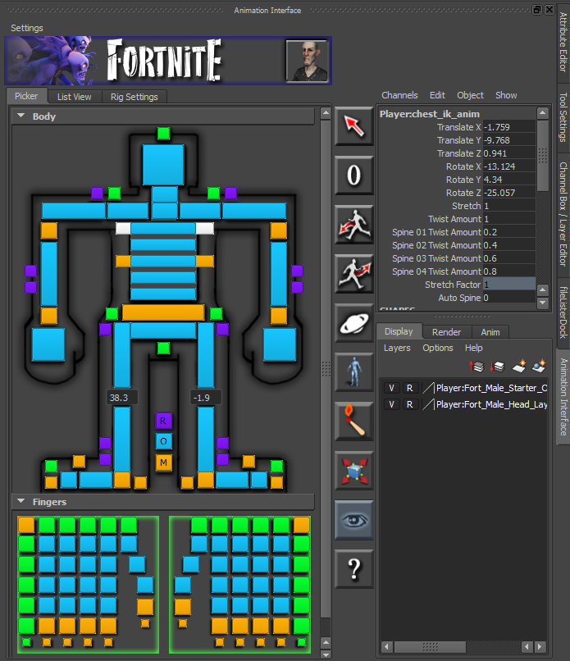

**Match On Switch**: This is covered in the matching section here.