Animation and Rigging Tools

Overview

Create Skeleton

Adding Extra Joints

Using Templates

Place Skeleton

Creating the Final Skeleton/Skin Weighting

Rig Pose

Reference Pose Manager

Skin Weight Tools

Publish/Build Rig

Editing

Customization



Skeleton Creation:

To create a character, go to the Epic Games menu in your Maya interface, choose Animation and Rigging Tools, and select [Create Character].

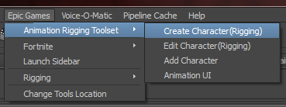

The skeleton setup tool interface has a flow chart at the top of the UI that shows what step you are on, and what steps come next:

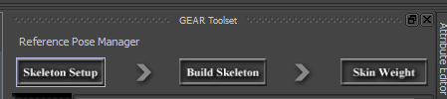

During the “Skeleton Setup” phase, using the interface that appears, you can enter in values for the various fields that make up your character. If you need to add extra joints, fear not! That will be covered shortly. Most of this interface is fairly straight forward. Type in the number of spine joints you would like, the number of finger joints, etc. There are a few neat things that can speed up your creation process. The right leg and right arm both have checkboxes to mirror the left limb settings:

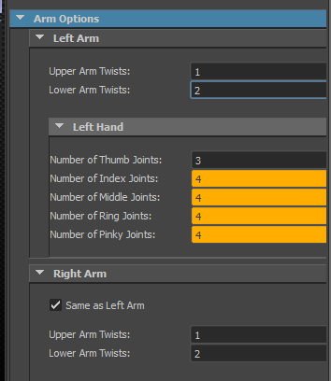

When a field turns orange, it means that the value has been changed from the defaults of the tool. It’s just an easy way to identify what is different that the default. At any time, you can reset to default by RMB on a limb area, and choosing reset.

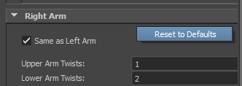

**Adding Extra Joints**

To add extra joints to your character, simply scroll down to the extra joints section:

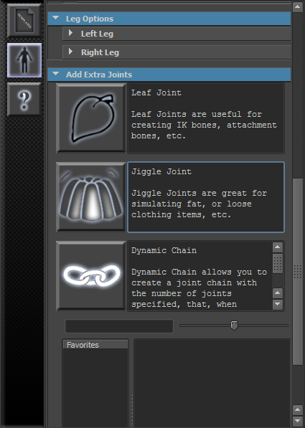

There are three types of extra joints you can add to your character.

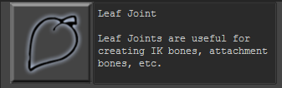

**Leaf Joint:** Leaf Joints will probably be the most used option since it has so many uses. Leaf joints are single joints that can be placed anywhere. To create one, simply click the button and fill out the information in the interface:

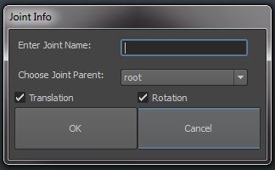

Choosing Translation and Rotation are used to determine how it will be rigged. If the bones need only rotate, you can just have Rotation checked. Otherwise, it will be built with its translation channels unlocked as well, for example.

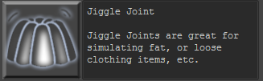

**Jiggle Joint**: A jiggle joint is just like a leaf joint, except it has built in physics simulations. Jiggle joints are great for adding secondary motion to your character. Just like the leaf joint, to add, just fill out the interface with the name for the joint and the joint’s parent.

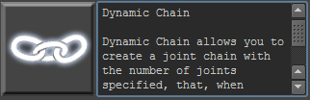

**Dynamic Joint Chain**: With the last of the extra joint options, you can create a joint chain with however many joints you would like. The joint chain will be rigged with an FK setup, a Spline IK setup, and a physics rig using hair follicles.

When you add a dynamic joint chain, you will need to specify the base name(for instance, ponytail), the parent of the root joint of the chain, and how many joints are in the chain.

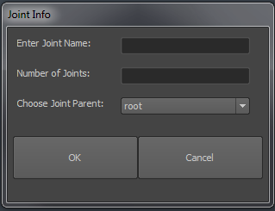

**\*To remove any of your custom joints from the creation list, simply RMB on the one you want to remove and choose the remove option:**

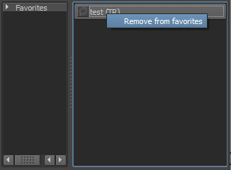

**Using Templates:**



You can save out and load in templates for your skeleton creation settings. To save them out, set up your settings the way you would like, and LMB on the template button and choose save.

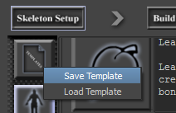

To load a template, choose the load option and then choose the template from the UI:

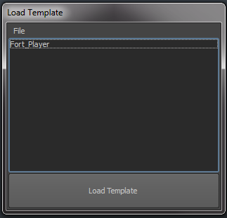

If you ever want to remove a template, select the template to remove, and go to file🡪 remove selected template:

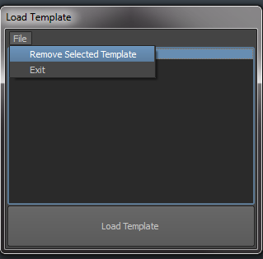

Skeleton Placement:

Once you are pleased with your skeleton settings, it is time to build the skeleton and place the joints to your mesh.

To do so, click on the [Build Skeleton] button at the top of the UI:

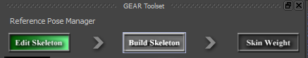

This will build what is called the **Joint Mover**. The joint mover is a rig of sorts that will allow quick placement of your joints in your mesh. You will notice that in your viewport, instead of seeing the typical Maya joints, instead is a proxy mesh. The proxy mesh is there to rough out a character without having to have final assets so animators can start working.

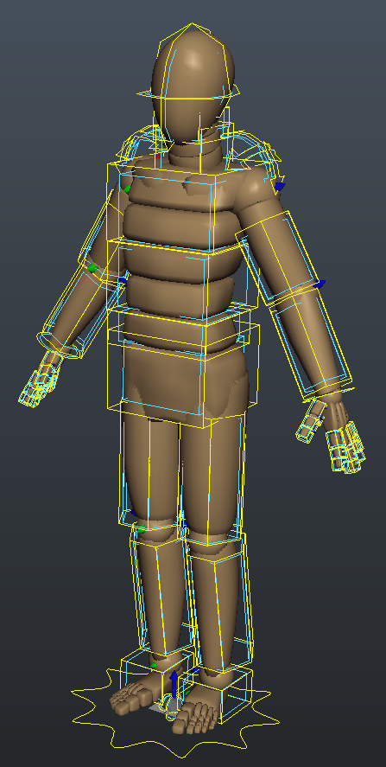

UI Overview

The joint mover comes with a control picker as well as many useful tools to help speed up the process.

I’ll cover each of the tools on the left toolbar as well as a brief description of the controls and the picker.

**Toolbar:**

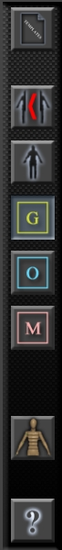

< Save/Load Templates

< Symmetry Mode

< Reset To Defaults

< Global Control Mode

< Offset Control Mode

< Geometry Mover Control Mode

< Toggle Proxy Mesh Visibility

< Help!

**Save/Load Templates:**

Just like on the skeleton creation tools, you can save out a template for your joint positions and load them back onto other characters. This is really useful when you have a project where characters need to share a skeleton.

Symmetry mode can be turned on after you have placed your left side to mirror over your placements to the right side, **or** it can be turned on from the start to have realtime symmetry happening. You’ll notice when symmetry mode is on, many other modes become disabled. Simply disable symmetry mode to get access to the other tools again. Disabling symmetry will keep all of the joint placement that has been mirrored.

Reset will reset the entire joint mover back to the original creation pose(how it came into the scene).

Ctrl + LMB will reset only your current selected controls, while Alt + LMB will reset your selection and the hierarchy below.

**Modes:**

There are three modes for the joint mover: Global, Offset, and Geometry. Global movers move the selected joint and everything below it in the hierarchy. Offset movers will only move the selected joint and nothing else. Geometry movers will only affect the proxy geometry and not any joint placement. Geometry movers are simply there for blocking out proportions and volume of your character.

Only one of the modes can be active at a time. Whichever mode is active, the character picker will select that mode’s controls.

**Joint Positions:**

There is actually no skeleton in the scene at this point of the process. Only the representation of what will eventually be a skeleton. The controls you see here on each *joint* will tell you exactly where the final joint will be created and what its local rotation axis will be.

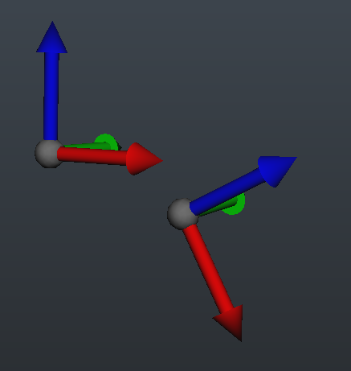

Creating the final skeleton

Once you’re finished with placing the joint mover, you’ll want to hit the [Skin Weight] button at the top of the UI to have the tool create the final, clean skeleton and present you with some skin weighting tools:

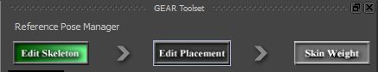

**Rig Pose:**

When you click on the skin weight button, you will be presented with a few dialog boxes. The first is the **Rig Pose** dialog:

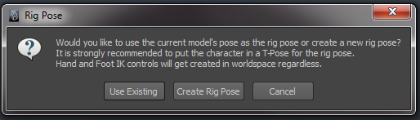

Unless your model is already in a T-Pose, (in which case, click [Use Existing]) you will want to create a rig pose. This is the pose in which the rig will be built. It is highly recommended to create the rig pose as a T Pose, both for the legs being straight, and the arms being out and straight:

Example:

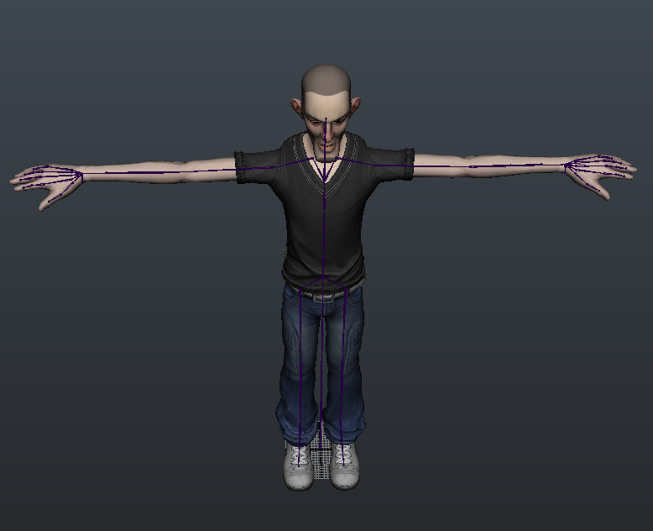

**Reference Pose Manager:**

You will use the joint mover tools to create the rig pose. Do not worry, your original placements are still stored and preserved into what is called the **Model Pose.** You will have access to both poses in the tool via the [Reference Pose Manager]:

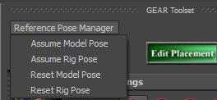

The next dialog box you are presented with is the choice to have the tool skin weight the proxy geometry:

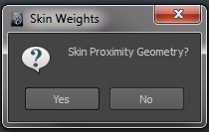

This is very useful if you don’t have a final asset yet, or you just want to prototype something and have a mesh that you can actually import into the engine.

At this point, a nice, clean skeleton will be created in the positions of your joint mover controls. A new interface will also appear that contains custom skin weighting tools.

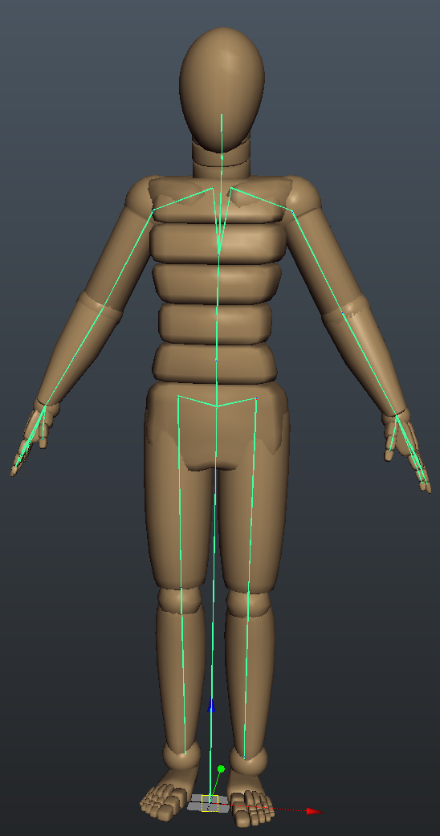

**Skin Weight Tools:**

For the most part, the skin weight UI is very similar to Maya’s default, except there are many added tools and features to speed up your workflow.

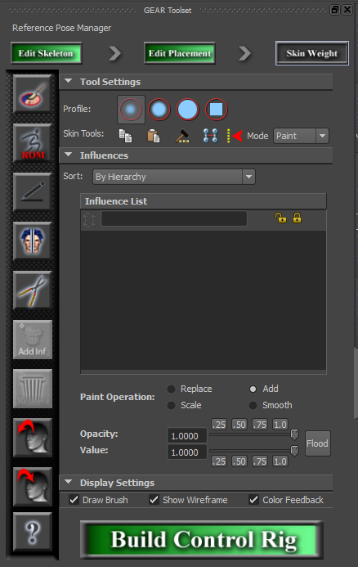

To start skin-weighting your character, create a skin cluster as you normally would. Select the piece of geometry you wish to weight, and click the [Paint Weights] button in the UI:

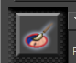

The Influence List can be sorted in many ways, including only showing unlocked influences:

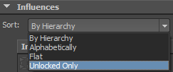

Other changes to the tool were adding in quick buttons for the opacity and value sliders:

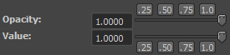

These buttons are just quick ways to set common values on those attributes.

**Mode:**

.

There are two modes, Paint, and Select.

Unlike Maya’s paint weights tool, Select will give you more UI options that are incredibly useful

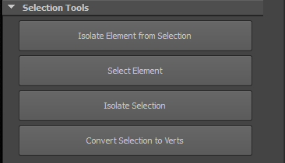

Most of these selection tools are for selecting an element on a mesh and either converting that selection to verts for easy flooding, or isolating that element and going back to paint mode to only see that.

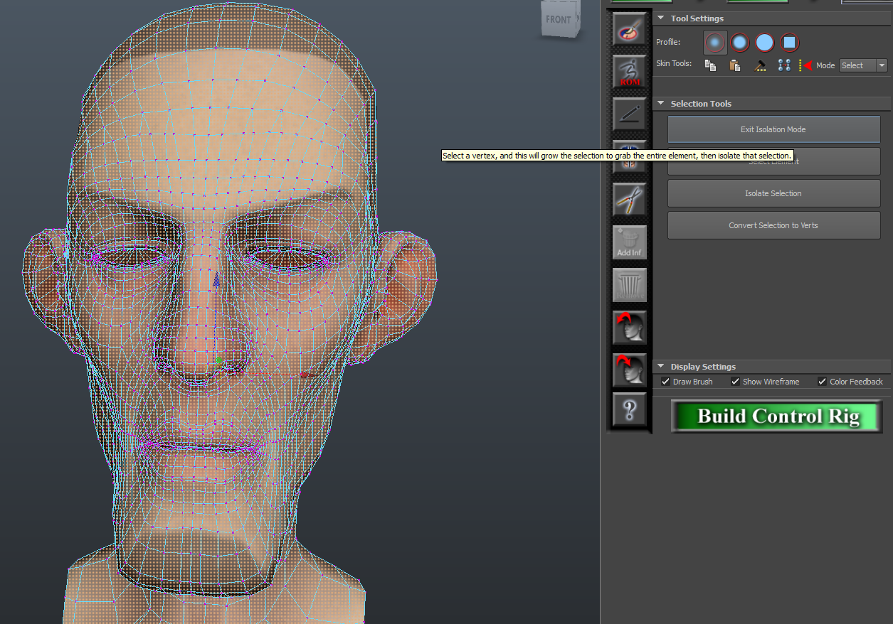

**Skin Weighting Tools:**

This button is the Range of Motion Tool. It will bring up an interface with a list of all the joints in your skeleton. It will generate a range of motion animation for you based on your settings. If you want to test the entire spine range of motion for example, select all of the spine bones and check the [Solve as One Item] box. This ensures that each key that is set is for an entire spine pose rather than just one joint.

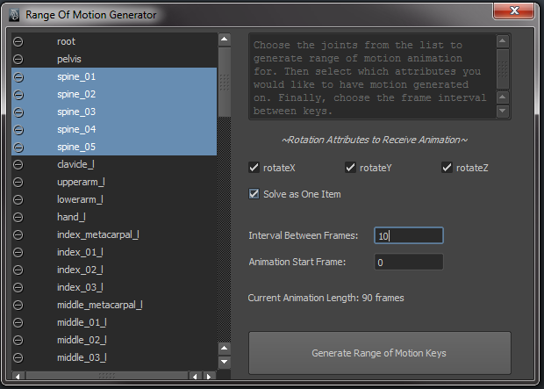

*To Remove a Range of Motion animation, which you should always do before Building the Control Rig, RMB on the ROM button and choose the clear option:

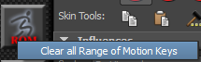

This is the [Use Tablet Pressure] button. Useful if skin weighting with a Wacom or tablet device.

 This is the [Mirror Skin Weights] button. It will bring up Maya’s default mirror skin weights options.

Prune Skin Weights. This will bring up Maya’s default prune skin weights options.

Add influence to selected mesh. This will bring up a custom interface with a list of all the joints in your skeleton that aren’t currently in your skin cluster.

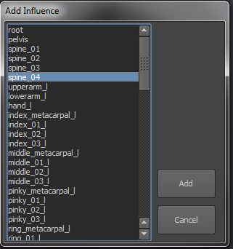

 Remove influences from selected mesh. Similar to the add influences interface, this will give you a list of only the influences in your skin cluster to remove.

Export and Import Skin weights. Exporting skin weights requires a name for the file, and it will store out each vertex’s weighting information.

Import Skin weights will bring up an interface for selecting a skin weight file and import those weight values onto the corresponding vertices.

Building The Control Rig

When you are ready, click on the [Build Control Rig] button to start the publishing process:



You will then see an interface show up asking for a character name, and a project for that character:

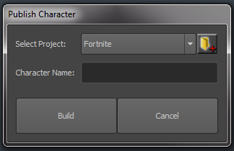

*To add a new project, click on the folder icon to the top right. When ready, hit the Build button.

The next step is to give your character a thumbnail. There is a tool for this that will come up after selecting the Build option:

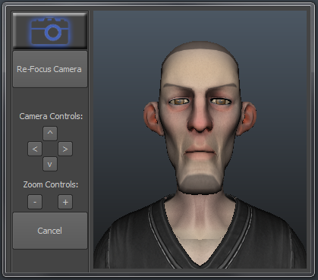

Manipulate the mini viewport to get the thumbnail you would like to use. Hit the camera icon on the top left of the UI to capture the thumbnail. There are also various camera controls buttons in the tool.

***Once you capture the thumbnail, the rig build process will begin.***

When the process is finished, it will alert you that it is complete. The entire process takes usually under 1 minute.

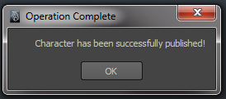

At this point, your job is done ☺ An Export file has been created and can be found here:

MayaTools/General/GEAR/Projects/YourProject/ExportFiles

An animation rig file has been created that references in the export file and can be found here:

MayaTools/General/GEAR/Projects/YourProject/AnimRigs

And now your animators can start working away!

Editing

At any point, you can go back in the pipeline and edit either the placement of your joints, or even your skeleton settings, adding or removing joints.

You’ll notice as you progress through the rigging pipeline, the button text in the flow chart diagram changes:



This means if you are in skin weight mode, you can click the edit placement button or even the edit skeleton button to go back and make changes. Going back to [Edit Placement] will also cache out any skin weights it finds on your mesh so your work is not lost, and those weights get reapplied when re-entering [Skin Weight] mode.

***What if you need to edit a character that has already been published?***

You can also edit a character that has been published by going to the Epic Games menu, Animation and Rigging Toolset, Edit Character:

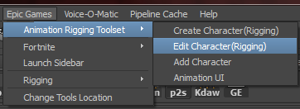

This will bring up an interface for you to select a character to edit. The list is a list of all of the export files created by the tool:

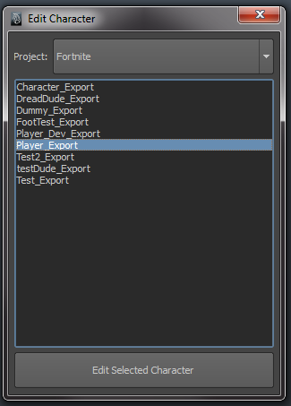Once you select a character and choose edit, it will open the export file and bring up the UI you used for the rigging pipeline. Just like above, you can make any changes you wish. **Just make sure to re-build the control rig again using the steps outlined** **here.**

**Control Rig Foot Pivots:**

You may also need to edit your rig file, specifically the foot control pivots in the rig file. Unfortunately, there is no way for me to tell where the inside and outside of the foot is, so they are just roughly placed.

To edit these, simply open the rig file(MayaTools/General/GEAR/Projects/YourProj/AnimRigs). I usually select the foot control and hit ‘f’ in the outliner to focus up on that.

These two locators are what you may need to adjust the pivot on:

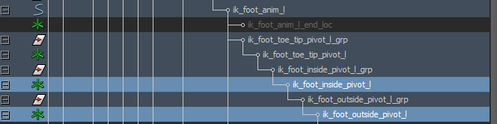

Enter your move pivot mode (insert key) and move the pivots for each of those to the best spot for rolling the foot on its side. Do the same to the right foot locators and that’s it!

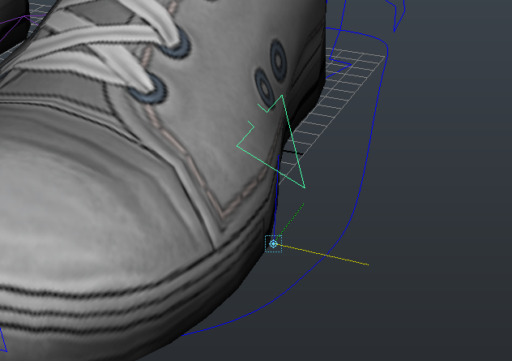

**Heel and Toe Pivots:**

There are also foot pivots for the heel and toe tip. These are auto placed via the joint mover, so there are 2 places you can edit them. You can edit them in the rig file, like above, if it’s just a matter of positional edits.

For heavier edits, you’ll want to edit your character [Epic Games -> Animation Rigging Toolset -> Edit Character] and break the constraints on the “jointmover_l_heel_loc”, “jointmover_r_heel_loc”, “jointmover_toe_l_end”, and “jointmover_toe_r_end”.

Then you can move and rotate these freely and simply rebuild the rig when done, for those new pivots to be reflected. Those locators are located under the “root_mover_grp”. If you are having trouble seeing them in the outline, make sure your display settings in the outliner are the following:

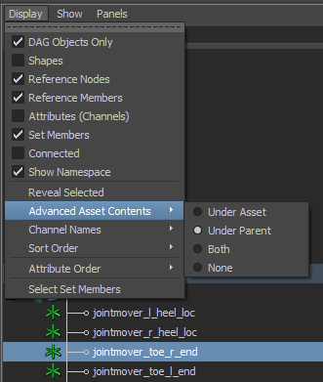

**Customization:**

**Custom Color Palette For Joint Mover Proxy Geo:**

The joint mover proxy geometry is UVed so you can quickly prototype color palettes for your characters.

You can find the PSD in the following location:

//depot/UE4/Engine/Extras/Maya_AnimationRiggingTools/**MayaXXXX**/MayaTools/General/Icons/GEAR/jointMover.psd

The PSD has the parts labeled and color coded for easy selection and bucket fills:

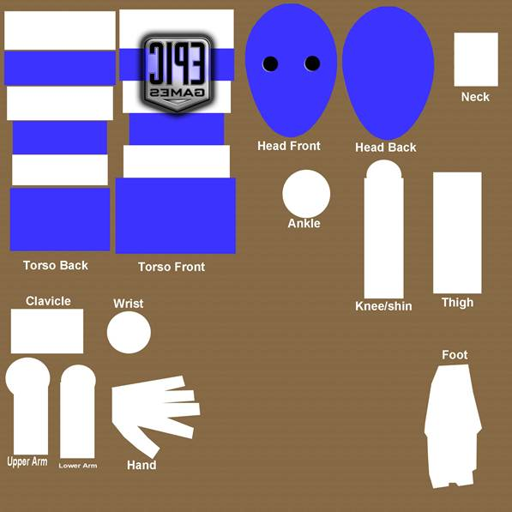

This will allow you to add custom color swatches to parts of the joint mover to customize the look or add emblems and such:

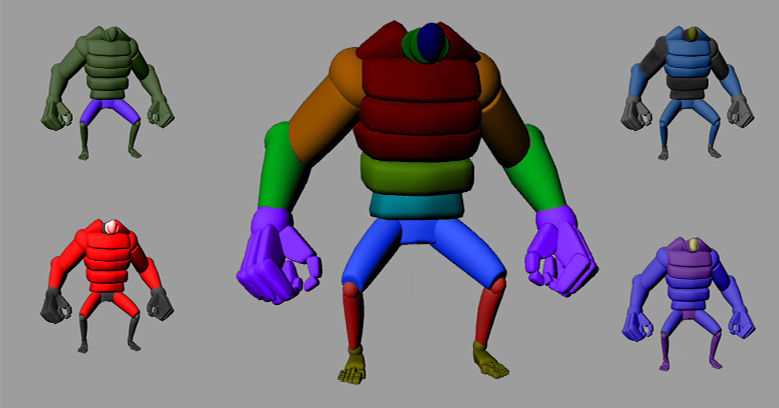

**Animation UI Banner:**

The animation UI has a banner that gets displayed at the top:

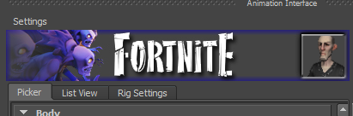

You can create custom, project-specific banners if you like as well. To do so, create an image that is 400 x 60 pixels in dimensions, and save it as banner.jpg to your project’s folder located here:

//depot/UE4/Engine/Extras/Maya_AnimationRiggingTools/**MayaXXXX**/MayaTools/General/GEAR/Projects/**YOUR_PROJECT**/banner.jpg

It is recommended to use the default banner as a template (for the thumbnail layout) which is located here:

//depot/UE4/Engine/Extras/Maya_AnimationRiggingTools/**MayaXXXX**/MayaTools/General/Icons/GEAR/banner.jpg



Notice the square on the far right. This is where the character thumbnail will be placed.