Data Science TakeHome – First Key Mortgages
This project builds a machine learning model to estimate 'Market Rent' for single-family rental (SFR) properties across the United States. The goal is to predict fair, data-driven rent values using historical lease data and property characteristics. This work was developed as part of a 48-hour data science case study and is structured as a professional end-to-end ML project.

1. Workflow Overview
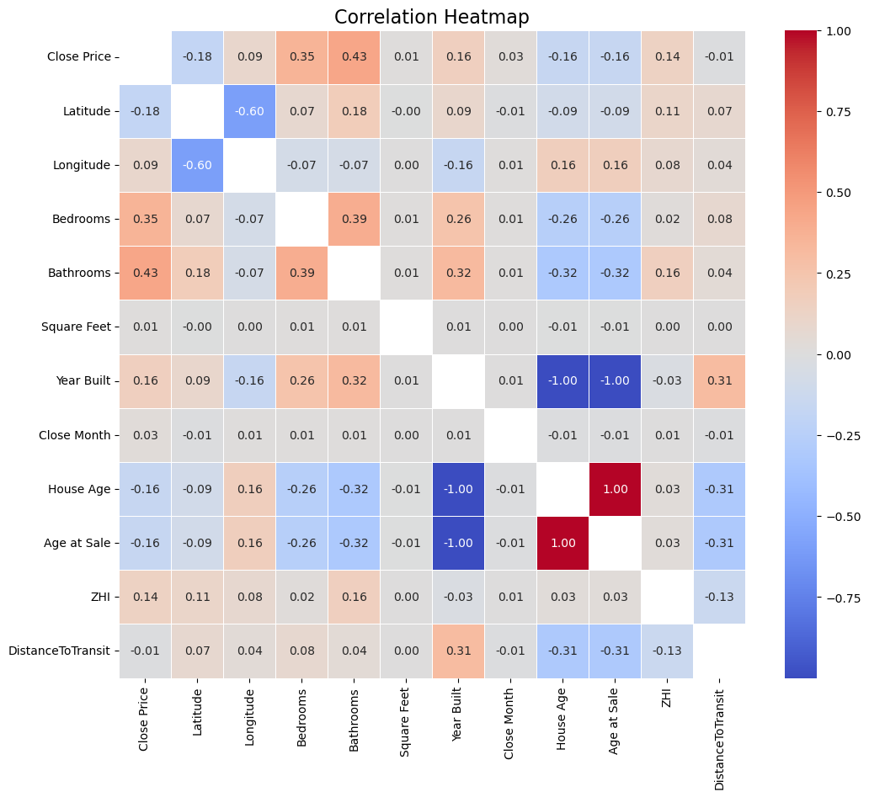
The full data science workflow included:
1. Exploratory Data Analysis (EDA)
2. Feature Engineering
3. Model Selection & Hyperparameter Tuning
4. Model Evaluation
5. Interpretation & Insight Extraction
6. Next Steps for Business Deployment

2. Data Understanding and EDA
The training dataset included property features such as Latitude, Longitude, Bedrooms, Bathrooms, Square Feet, and Year Built, along with the achieved rental price (Close Price).
EDA revealed:
• Rent distributions as well as sq.footage, # of bedrooms, and # of bathrooms are right-skewed, motivating a log-transform for these variables. This pattern makes sense as wealth distribution in the US is also very heavily right skewed. This also explains later on why we under valued some very expensive homes. There were some very very extreme outliers.
• Latitude and Longitude show strong spatial clustering, suggesting local market effects. One thing worth noting was that lower latitude led to higher rents. This surprised me as I assumed it would be the other way around as more cities are further north.
• The obvious correlations were that rent increases with square footage, # of bedrooms, and # of bathrooms
• I also merged the provided data to Zillows public data on their ZHI(Zillow home index) by zip code to the associated zip codes of each corresponding latitude and longitude.
- Surprisingly the ZHI did not correlate as strongly as I would have thought.
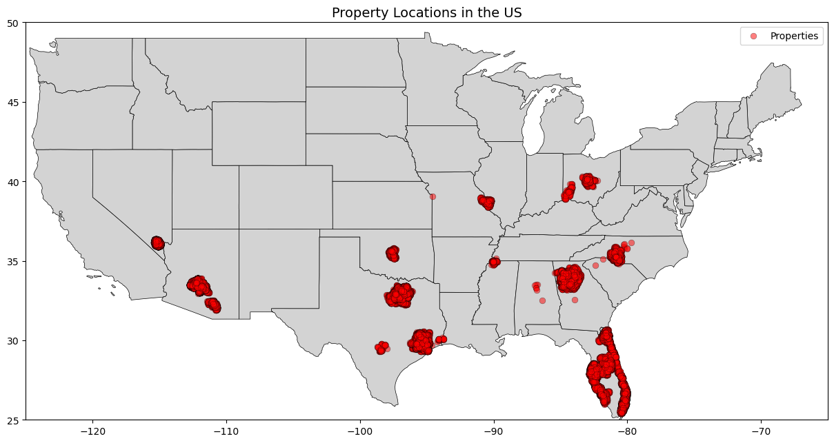
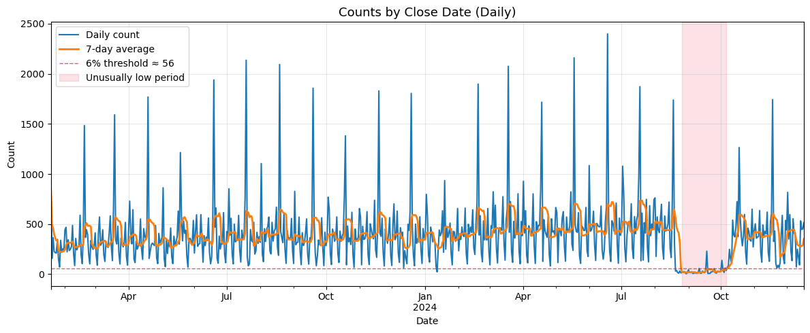
- I also collected data on the locations of public transport stops and created a column finding the distance of each property to its nearest stop. This also surprisingly did not correlate strongly.
- Another interesting finding is that newer homes appear to be on average built closer to public transport. Which makes sense as a lot of current routes were not around when some of these older homes were built.
- Looking at this map we can see a lot of this data comes primarily from the South
- Looking at the time series data we can see a very drastic 42 day reduction in the counts of data points. Which makes me wonder if there were some data collection issues during this time.

3. Feature Engineering and Selection
Features were categorized into two groups: numeric and skewed. Numeric features (e.g., Latitude, Longitude, Year Built)
were standardized, while skewed features (e.g., Bedrooms, Square Feet, Bathrooms) were stabilized using a Yeo-Johnson PowerTransformer.
Feature set summary:
• Latitude / Longitude — spatial pattern indicators
• Bedrooms, Bathrooms, Square Feet — structural attributes
• Year Built — proxy for property condition
• Derived features: ZHI, and distance to transit

4. Model Selection and Training
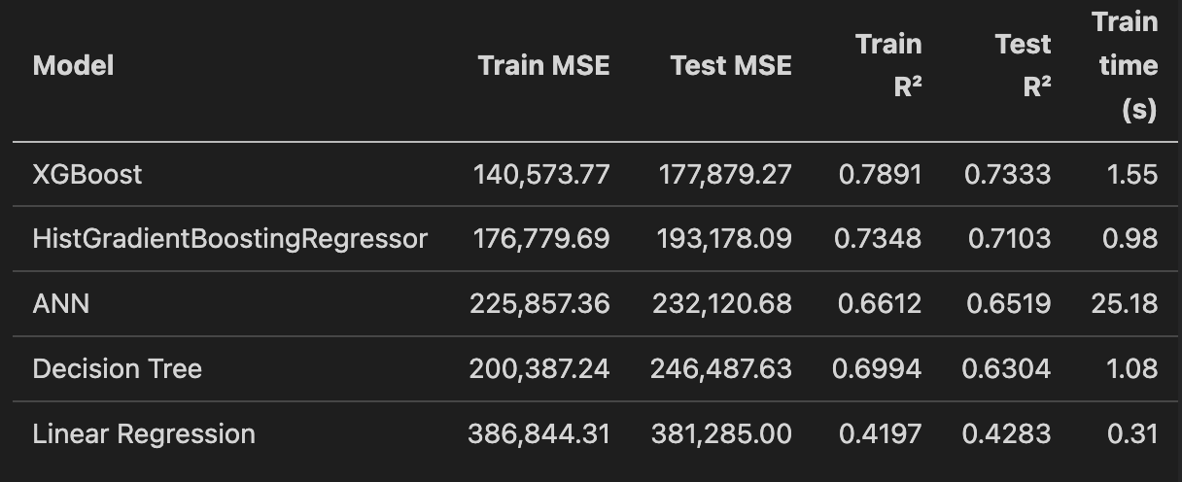
Multiple algorithms were tested using a unified pipeline built with `scikit-learn`. Models included:
• Linear Regression — baseline
• Decision Tree Regressor
• Histogram Gradient Boosting Regressor
• XGBoost Regressor
• MLPRegressor (Feedforward Neural Net)
Each model was wrapped in a `Pipeline` with preprocessing and tuned via `GridSearchCV` using
Mean Absolute Error (MAE) as the scoring metric — a more robust choice for skewed targets than MSE.

5. Evaluation and Results
After cross-validation, XGBoost emerged as the best-performing model with the lowest MSE and highest R² on the test set.

Residual analysis confirmed that the log-transform improved symmetry and reduced systematic underprediction of high-rent properties. However, there was still a skew and had I had more time I would have focused on dealing with it.
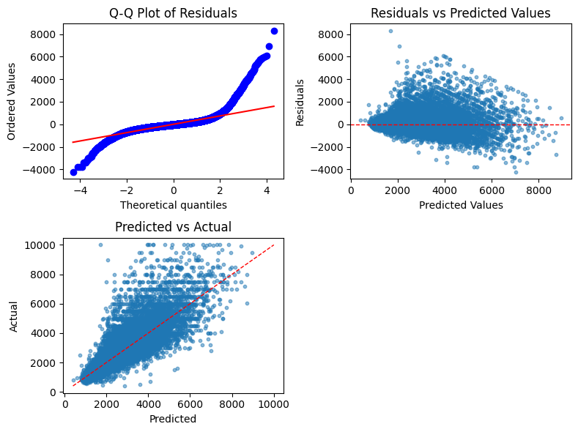
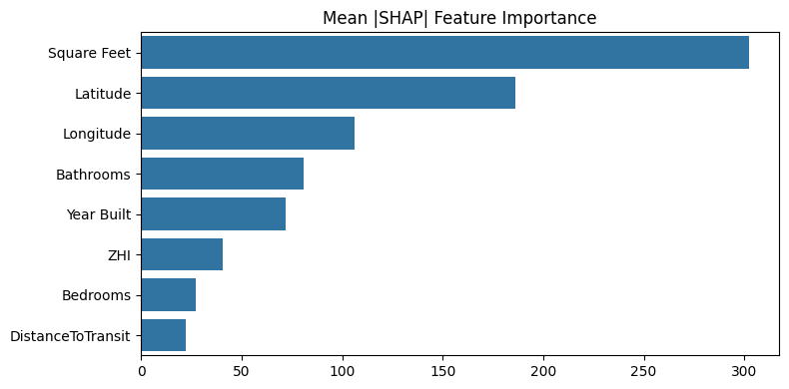
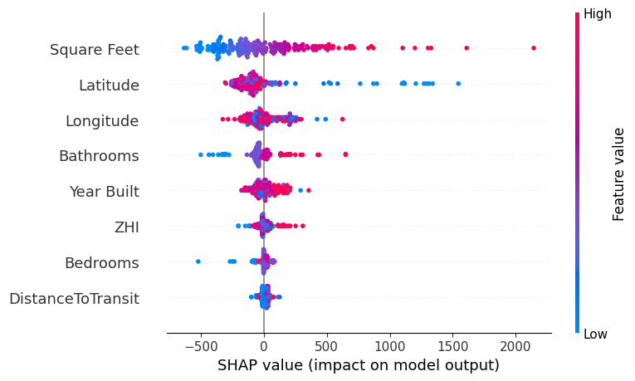
The Shapley plots largely echoed what was expected from the correlation heat map.

6. Interpretation and Insights
Key findings:
1. Square footage dominates the variability in rent prices.
2. Followed by latitude and longitude. As the saying goes its “location, location, location”.
3. Distance to the nearest transit stop and the number of bedrooms were surprisingly less influential once all the other factors were taken into account.

7. Next Steps
Future improvements include:
• Using spatial clustering (e.g., KMeans or HDBSCAN) to group properties into submarkets.
• Building confidence intervals using conformal prediction.
• Dont just use average ZHI for 1 bedrooms but also for 2, 3, 4 bedrooms and use the one that matches the number of bedrooms in the property
- Add more features like crime rates, school ratings, proximity to bike lanes etc.
- Try more models like LightGBM, CatBoost, or even a simple linear regression for interpretability
- try bootstrapping to fix some of the skewness of the residuals.
- experiment with non-linear transformations of the features (log, sqrt, etc.) to see if it improves model performance.

8. Conclusion
This project demonstrates an end-to-end data science workflow for real estate rent estimation — from preprocessing and feature engineering to model selection, interpretation, and communication. The approach balances predictive accuracy with explainability, and the resulting XGBoost model provides a strong foundation for further production deployment.

