Mumbai 9920620009 | Delhi 9920627471 | Pune 8180099423|[info@ContractorBhai.com](mailto:info@ContractorBhai.com)

Top of Form

Bottom of Form

[**₹12/sq ft Interior Design Service. Over 1800 Homes Designed**](http://www.contractorbhai.com/design-service/)

* [Home](http://www.contractorbhai.com/)
* [Free Estimates](http://www.contractorbhai.com/owners/)
* [3D Design Service](http://www.contractorbhai.com/design-service/)
* [Aloha Ply](http://www.contractorbhai.com/aloha-ply/)
* [Loan](http://www.contractorbhai.com/home-improvement-loan/)
* [101 EBook](http://www.contractorbhai.com/101-home-renovation-guide/)
* [B2B](http://www.contractorbhai.com/b2b/)
* [Resource Center](http://www.contractorbhai.com/2015/02/04/procedure-for-registration-of-site-documents-required-in-bangalore/)

Procedure for Registration of site & Documents Required in Bangalore

The registration can take place at the Sub-Registration Office within which the property is located or in the District Sub-Registrar Office of the District where the property is located.

Property Registration in India is compulsory under **section 17 of the Indian Registration Act, 1908.** The registration of property is to be done in the Registrar’s Offices by the Sub-Registrar.

1. **Verify the property title :-**

The property documentation will vary depending on whether the property is being transferred from the developer or seller. The process of due diligence gets easier in case of a secondary sale as the first owner of the property would have all the documents in place for the registration of the property. If the title were not clear and marketable, most financial institutions would refuse to finance the property. A bank or a housing finance company carries out the due diligence process before approving the project and the housing loan. However, the onus lies on the buyer to verify the property title before registration.

1. **Find Sub Registrar Office :-**

One has to present the Sale Deed in the concerned Sub-Registrar Office where the land is situated. Your lawyer or attorney will help you to find your property location and concerned registrar office.

1. **Stamp Duty and Sale Deed :-**

The Schedule of the property should be correctly mentioned in the Sale Deed and if any structure is situated over the landed property that has to be mentioned in the Sale Deed along with its cost. Preparation of property Sale Deed is done by an authorized attorney on behalf of the purchaser. The stamp duty is usually a percentage of the transaction value levied by the state government, on every registered sale. The levy of stamp duty is a State subject and thus the rates of stamp duty vary from State to State.

1. **Take appointment :-**

The registration fee should be paid a few days before going for registration and the receipt is to be shown to the Sub-Registrar’s Office one day before the actual date of registration. An appointment has to be taken over the phone and registration has to be done at the office of the Sub-Registrar.

1. **Submission of Documents :-**

After detailed verification of Sale Deed, the registration process will be completed as per the Registration Act. Once the registration is complete the duly registered document may be collected by signing in the dispatch register or by giving a letter of authority to someone to collect it on your behalf. The final sale deed should be stamped and registered at the appropriate Sub-Registrar’s Office. The sub-registrar keeps a copy of the documents and returns the original documents to the buyer within 30 minutes.

1. **Mutation of the title :-**

Once the registration is complete, the purchaser has to apply to the local municipal authority to get the title of the property concerned transferred in his/her name. This is commonly referred to as mutation of the title of the property.  
Now the process or registration of properties in India is computerized. Under the computerized Land and Property Registration system, registration is easy. It facilitates transparency in valuation and eliminates middle men. The application form can either be downloaded online or obtained from the concerned authority’s office. After due verification of details, the Deed is drawn up and the registration process is complete. Before purchasing land, you have to make sure you do proper research work about the form of land, buy lands through genuine and authentic seller, developer, brokers or agents.  
Whenever a property buyer buys a piece of land/immovable property, he/she needs to register the same with the authority concerned. The law does not recognize unregistered owners and does not give them any rights over the property. Registration of the property is a full and final agreement signed between the two parties and once it is submitted at the local registrar’s office and the registration is complete, the buyer legally becomes the owner of the apartment.

**Documents required for registration :**

The property coming under jurisdiction of BBMP (Bruhat Bangaluru Mahanagara Palike), gram panchayat, town panchayat, municipalities and municipal councils or any corporation in the state requires six important documents.

**The lists of documents required are as follows ->**

* Khata and tax determination receipt issued by BBMP or corporation
* An affidavit
* Sanction plan or Conversion certificate, if the property is on converted land
* Title deed or allotment order or possession certificate or sales document, if property is given by government department or agencies
* PAN issued by Income Tax Department or Form 60 and 61 if the property values more than 5 lakhs
* Declaration in form 1 under the Karnataka Stamps Rules 1977

Related Articles on Bangalore 30×40 Plot Independent Houses

[1 – Plan Your Ground Plus 2 House in Bangalore for Residence or Rental Income](http://www.contractorbhai.com/2014/11/12/how-to-plan-your-ground-plus-2-house-in-bangalore-for-personal-residence-or-rental-income)  
[2 – How much does it Cost to build ‘Ground plus 2’ or ‘Ground plus 3’ House in Bangalore](http://www.contractorbhai.com/2014/11/12/how-much-does-it-cost-to-build-ground-plus-2-or-ground-plus-3-house-in-bangalore)  
[3 – What Approvals are Required for Constructing ‘Ground plus 2’ House in Bangalore](http://www.contractorbhai.com/2014/11/12/what-approvals-are-required-for-constructing-ground-plus-2-house-in-bangalore)  
[4 – How Long does it take to Build Ground plus 3 House in Bangalore](http://www.contractorbhai.com/2014/11/12/how-long-does-it-take-to-build-ground-plus-3-house-in-bangalore)  
[5 – Part 1 – Plans & Layouts required for 30×40 BDA Plot House in Bangalore](http://www.contractorbhai.com/2014/11/12/part-1-plans-layouts-required-for-30x40-bda-plot-house-in-bangalore)  
[6 – Bangalore 30×40 Plot Ground+2 Development Locations](http://www.contractorbhai.com/2014/12/12/bangalore-30x40-plot-ground2-development-locations/)  
7 – Procedure for Registration of site & Documents Required in Bangalore  
[8 – 10 Things ! That you should know about Bank loan process](http://www.contractorbhai.com/2015/02/04/10-things-that-you-should-know-about-bank-loan-process/)

Top of Form

**Wardrobe Design & Cost planner**

Step 1 of 10 - Start Planning

10%

* How to design a Wardrobe ?

Before you start planning your Wardrobe, watch this 1 minute video

[youtube id="D7lW6Mn3TmQ" width="600" height="350" autoplay="no" api_params="&rel=0&controls=0&showinfo=0" class=""]

Bottom of Form

Categories: [Bangalore 30x40 Houses](http://www.contractorbhai.com/category/bangalore-30x40-houses/)|Tags: [BBMP](http://www.contractorbhai.com/tag/bbmp/), [district](http://www.contractorbhai.com/tag/district/), [form 60 and 61](http://www.contractorbhai.com/tag/form-60-and-61/), [immovable property](http://www.contractorbhai.com/tag/immovable-property/), [juridiction](http://www.contractorbhai.com/tag/juridiction/), [karnataka stamp](http://www.contractorbhai.com/tag/karnataka-stamp/), [khata](http://www.contractorbhai.com/tag/khata/), [mutation](http://www.contractorbhai.com/tag/mutation/), [property registration](http://www.contractorbhai.com/tag/property-registration/), [Sale deed](http://www.contractorbhai.com/tag/sale-deed/), [stamp duty](http://www.contractorbhai.com/tag/stamp-duty/), [sub-registrar](http://www.contractorbhai.com/tag/sub-registrar/), [sub-registration](http://www.contractorbhai.com/tag/sub-registration/), [tax](http://www.contractorbhai.com/tag/tax/)|[0 Comments](http://www.contractorbhai.com/2015/02/04/procedure-for-registration-of-site-documents-required-in-bangalore/#respond)

Share This, Choose Your Platform!

[Facebook](https://www.facebook.com/sharer.php?u=http%3A%2F%2Fwww.contractorbhai.com%2F2015%2F02%2F04%2Fprocedure-for-registration-of-site-documents-required-in-bangalore%2F&t=Procedure%20for%20Registration%20of%20site%20%26%23038%3B%20Documents%20Required%20in%20Bangalore)[Twitter](https://twitter.com/share?text=Procedure%20for%20Registration%20of%20site%20%26%20Documents%20Required%20in%20Bangalore&url=http%3A%2F%2Fwww.contractorbhai.com%2F2015%2F02%2F04%2Fprocedure-for-registration-of-site-documents-required-in-bangalore%2F)[Linkedin](https://www.linkedin.com/shareArticle?mini=true&url=http://www.contractorbhai.com/2015/02/04/procedure-for-registration-of-site-documents-required-in-bangalore/&title=Procedure%20for%20Registration%20of%20site%20%26%23038%3B%20Documents%20Required%20in%20Bangalore&summary=The%20registration%20can%20take%20place%20at%20the%20Sub-Registration%20Office%20within%20which%20the%20property%20is%20located%20or%20in%20the%20District%20Sub-Registrar%20Office%20of%20the%20District%20where%20the%20property%20is%20located.%0D%0A%0D%0AProperty%20Registration%20in%20India%20is%20compulsory%20under%20section%2017%20of%20t)[Reddit](http://reddit.com/submit?url=http://www.contractorbhai.com/2015/02/04/procedure-for-registration-of-site-documents-required-in-bangalore/&title=Procedure%20for%20Registration%20of%20site%20%26%23038%3B%20Documents%20Required%20in%20Bangalore)[Tumblr](http://www.tumblr.com/share/link?url=http%3A%2F%2Fwww.contractorbhai.com%2F2015%2F02%2F04%2Fprocedure-for-registration-of-site-documents-required-in-bangalore%2F&name=Procedure%20for%20Registration%20of%20site%20%26%23038%3B%20Documents%20Required%20in%20Bangalore&description=The%20registration%20can%20take%20place%20at%20the%20Sub-Registration%20Office%20within%20which%20the%20property%20is%20located%20or%20in%20the%20District%20Sub-Registrar%20Office%20of%20the%20District%20where%20the%20property%20is%20located.%0D%0A%0D%0AProperty%20Registration%20in%20India%20is%20compulsory%20under%20section%2017%20of%20the%20Indian%20Registration%20Act%2C%201908.%20The%20registration%20of%20property%20is%20to%20be%20done%20in%20the%20Registrar%E2%80%99s%20Offices)[Google+](https://plus.google.com/share?url=http://www.contractorbhai.com/2015/02/04/procedure-for-registration-of-site-documents-required-in-bangalore/)[Pinterest](http://pinterest.com/pin/create/button/?url=http%3A%2F%2Fwww.contractorbhai.com%2F2015%2F02%2F04%2Fprocedure-for-registration-of-site-documents-required-in-bangalore%2F&description=The%20registration%20can%20take%20place%20at%20the%20Sub-Registration%20Office%20within%20which%20the%20property%20is%20located%20or%20in%20the%20District%20Sub-Registrar%20Office%20of%20the%20District%20where%20the%20property%20is%20located.%0D%0A%0D%0AProperty%20Registration%20in%20India%20is%20compulsory%20under%20section%2017%20of%20the%20Indian%20Registration%20Act%2C%201908.%20The%20registration%20of%20property%20is%20to%20be%20done%20in%20the%20Registrar%E2%80%99s%20Offices&media=http%3A%2F%2Fwww.contractorbhai.com%2Fwp-content%2Fuploads%2F2015%2F02%2FProcedure-for-Registration-of-Bangalore.jpg)[Vk](http://vkontakte.ru/share.php?url=http%3A%2F%2Fwww.contractorbhai.com%2F2015%2F02%2F04%2Fprocedure-for-registration-of-site-documents-required-in-bangalore%2F&title=Procedure%20for%20Registration%20of%20site%20%26%23038%3B%20Documents%20Required%20in%20Bangalore&description=The%20registration%20can%20take%20place%20at%20the%20Sub-Registration%20Office%20within%20which%20the%20property%20is%20located%20or%20in%20the%20District%20Sub-Registrar%20Office%20of%20the%20District%20where%20the%20property%20is%20located.%0D%0A%0D%0AProperty%20Registration%20in%20India%20is%20compulsory%20under%20section%2017%20of%20the%20Indian%20Registration%20Act%2C%201908.%20The%20registration%20of%20property%20is%20to%20be%20done%20in%20the%20Registrar%E2%80%99s%20Offices)[Email](mailto:?subject=Procedure%20for%20Registration%20of%20site%20%26%23038%3B%20Documents%20Required%20in%20Bangalore&body=http://www.contractorbhai.com/2015/02/04/procedure-for-registration-of-site-documents-required-in-bangalore/)

About the Author: [contractorbhai](http://www.contractorbhai.com/author/contractorbhai/)

Hi! This is Nitin, founder of ContractorBhai.com. We provide Affordable [3D Interior Design Service](http://www.contractorbhai.com/design-service/)

Related Posts

* [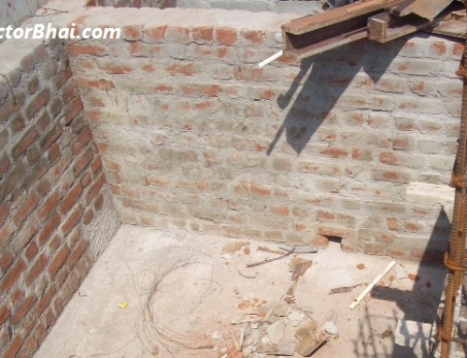](http://www.contractorbhai.com/2014/11/12/what-approvals-are-required-for-constructing-ground-plus-2-house-in-bangalore/)

[What Approvals are Required for Constructing ‘Ground plus 2’ House in Bangalore](http://www.contractorbhai.com/2014/11/12/what-approvals-are-required-for-constructing-ground-plus-2-house-in-bangalore/)

November 12th, 2014| [7 Comments](http://www.contractorbhai.com/2014/11/12/what-approvals-are-required-for-constructing-ground-plus-2-house-in-bangalore/#comments)

* [](http://www.contractorbhai.com/2015/02/04/10-things-that-you-should-know-about-bank-loan-process/)

[10 Things ! That you should know about Bank loan process](http://www.contractorbhai.com/2015/02/04/10-things-that-you-should-know-about-bank-loan-process/)

February 4th, 2015| [0 Comments](http://www.contractorbhai.com/2015/02/04/10-things-that-you-should-know-about-bank-loan-process/#respond)

* [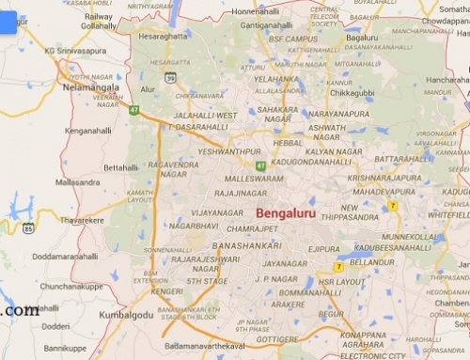](http://www.contractorbhai.com/2014/12/12/bangalore-30x40-plot-ground2-development-locations/)

[Bangalore 30×40 Plot Ground+2 Development Locations](http://www.contractorbhai.com/2014/12/12/bangalore-30x40-plot-ground2-development-locations/)

December 12th, 2014| [0 Comments](http://www.contractorbhai.com/2014/12/12/bangalore-30x40-plot-ground2-development-locations/#respond)

* [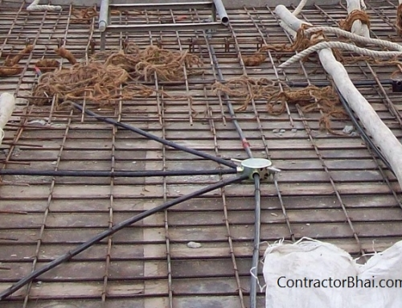](http://www.contractorbhai.com/2014/11/12/how-to-plan-your-ground-plus-2-house-in-bangalore-for-personal-residence-or-rental-income/)

[Plan Your Ground Plus 2 House in Bangalore for Residence or Rental Income](http://www.contractorbhai.com/2014/11/12/how-to-plan-your-ground-plus-2-house-in-bangalore-for-personal-residence-or-rental-income/)

November 12th, 2014| [6 Comments](http://www.contractorbhai.com/2014/11/12/how-to-plan-your-ground-plus-2-house-in-bangalore-for-personal-residence-or-rental-income/#comments)

* [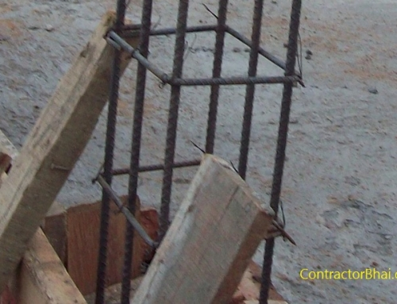](http://www.contractorbhai.com/2014/11/12/how-much-does-it-cost-to-build-ground-plus-2-or-ground-plus-3-house-in-bangalore/)

[How much does it Cost to build ‘Ground plus 2’ or ‘Ground plus 3’ House in Bangalore](http://www.contractorbhai.com/2014/11/12/how-much-does-it-cost-to-build-ground-plus-2-or-ground-plus-3-house-in-bangalore/)

November 12th, 2014| [15 Comments](http://www.contractorbhai.com/2014/11/12/how-much-does-it-cost-to-build-ground-plus-2-or-ground-plus-3-house-in-bangalore/#comments)

[What Approvals are Required for Constructing ‘Ground plus 2’ House in Bangalore](http://www.contractorbhai.com/2014/11/12/what-approvals-are-required-for-constructing-ground-plus-2-house-in-bangalore/)

November 12th, 2014| [7 Comments](http://www.contractorbhai.com/2014/11/12/what-approvals-are-required-for-constructing-ground-plus-2-house-in-bangalore/#comments)

[10 Things ! That you should know about Bank loan process](http://www.contractorbhai.com/2015/02/04/10-things-that-you-should-know-about-bank-loan-process/)

February 4th, 2015| [0 Comments](http://www.contractorbhai.com/2015/02/04/10-things-that-you-should-know-about-bank-loan-process/#respond)

[Bangalore 30×40 Plot Ground+2 Development Locations](http://www.contractorbhai.com/2014/12/12/bangalore-30x40-plot-ground2-development-locations/)

December 12th, 2014| [0 Comments](http://www.contractorbhai.com/2014/12/12/bangalore-30x40-plot-ground2-development-locations/#respond)

Leave A Comment

Top of Form

Comment

Bottom of Form



**Apply for Personal Loan for home renovation Here**

[](http://www.contractorbhai.com/owners/)

[Click For Estimate](http://www.contractorbhai.com/owners/)

[Home](http://www.contractorbhai.com/) | [Design Service](http://www.contractorbhai.com/design-service/) | [Free Estimates](http://www.contractorbhai.com/owners/) | [About](http://www.contractorbhai.com/2014/12/05/first-time-here/) | [Terms](http://www.contractorbhai.com/terms/) | [Privacy](http://www.contractorbhai.com/privacy-policy/) | Copyright 2012 - 2018 Contractorbhai Pvt Ltd | All Rights Reserved | [Contractorbhai.com](http://www.contractorbhai.com/)

[GO TO TOP](http://www.contractorbhai.com/2015/02/04/procedure-for-registration-of-site-documents-required-in-bangalore/)

**[Free 5 Day Interior Design Course](http://www.contractorbhai.com/2015/02/04/procedure-for-registration-of-site-documents-required-in-bangalore/)**

**Free 5 Day Interior Design Course**

Highly Actionable Info to Complete Your Project

Top of Form

Bottom of Form