ASSIGNMENT-1

Name: M Gyanada Chowdary

Reg.No:21BCE7727

1)

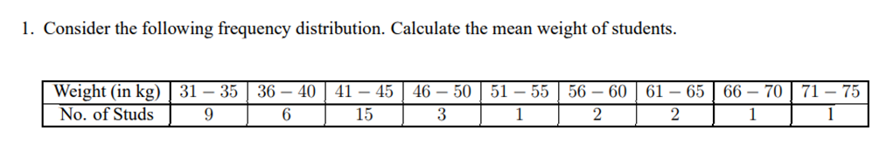

Answer:

**CODE:**

#class intervals

class= c('31-35','36-40','41-45','46-50','51-55','56-60','61-65','66-70','71-75')

#Frequency of weights

fi=c(9,6,15,3,1,2,2,1,1);

#Midvalues of class intervals

xi=c(33,38,43,48,53,58,63,68,73);

#Arbitrary mean

A=53;

di=(xi-A)/4;

fi.di=fi*di

meandata=data.frame(class,fi,xi,di,fi*di);

meandata

N=sum(fi)

N

sum(fi.di)

mean=A+sum(fi.di)*4/N

mean

**CODE:**

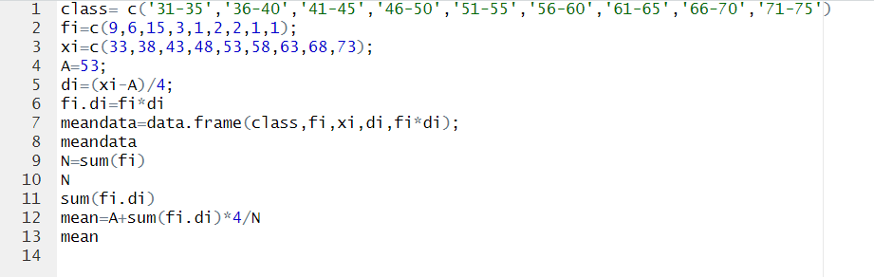

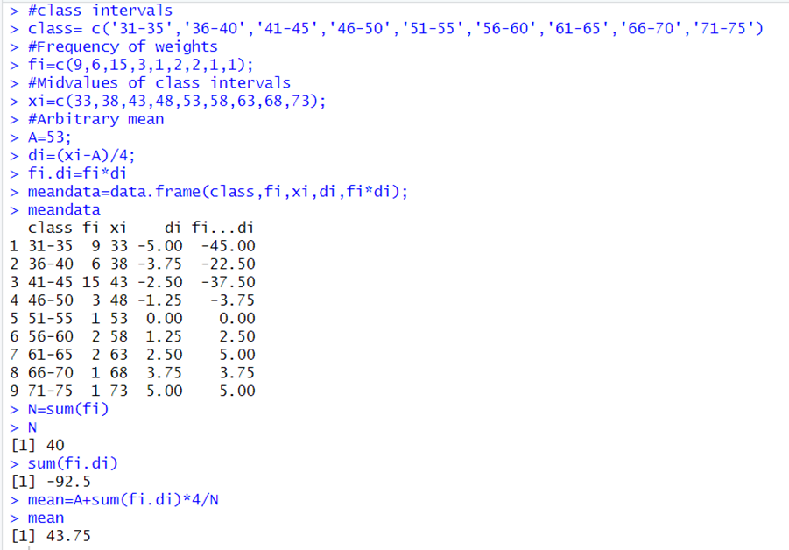

2)

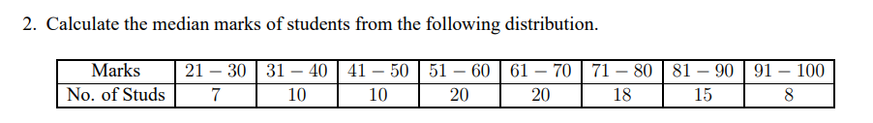

Answer:

**CODE:**

#class intervals

class=c('21-30','31-40','41-50','51-60','61-70','71-80','81-90','90-100');

#Frequencies

fi=c(7,10,10,20,20,18,15,8)

#upper limits

ul=c(30,40,50,60,70,80,90,100)

#lower limits

ll=c(21,31,41,51,61,71,81,91)

#total Frequency

N=sum(fi)

N

#cumulative sum of frequencies

cf=cumsum(fi)

#class width

C=10

median_class= which.max(cf>=(N/2));

median_class

#Cumulative Frequency of class just preceding median class

m = cf[median_class-1]

m

#frequency of Median class

f=fi[median_class]

f

#lower limit of Median class

l=ll[median_class]

l

median = l+((N/2-m)*C)/f

median

x=data.frame(class,fi,cf)

x

**Code:**

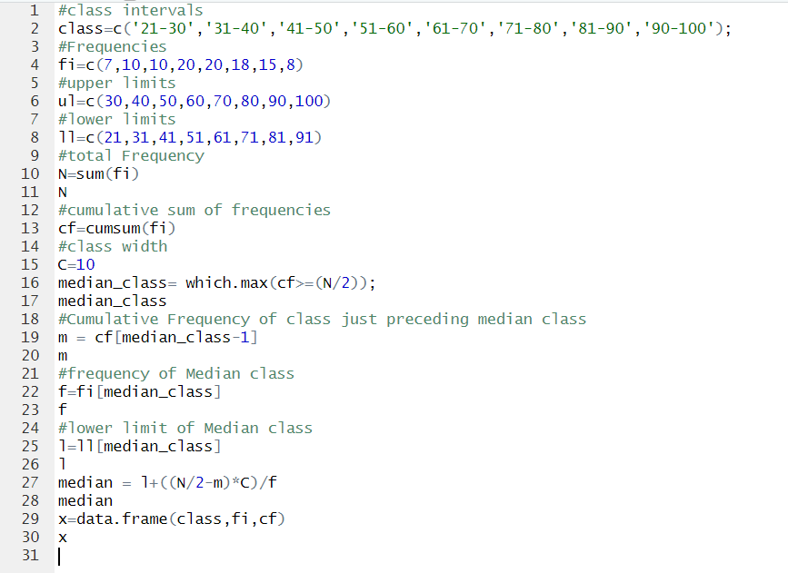

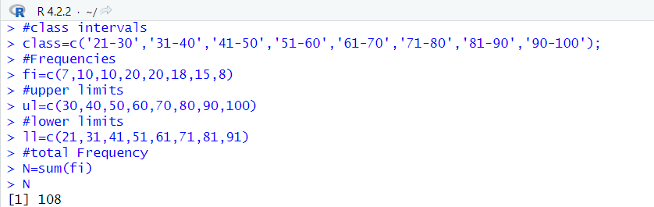

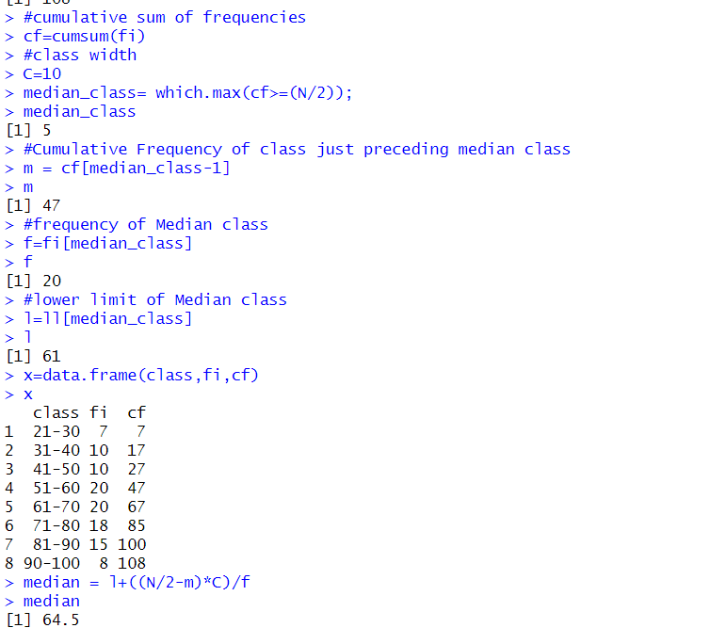

3)

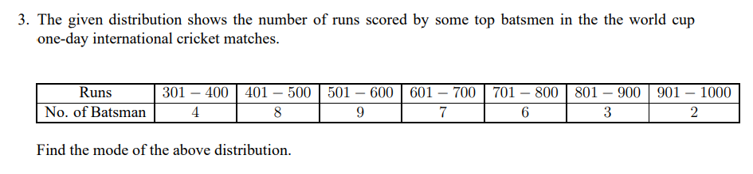

Answer:

**CODE:**

#class intervals

class=c('301-400','401-500','501-600','601-700','701-800','801-900','901-1000');

#Frequencies

f=c(4,8,9,7,6,3,2);

#lower limits of class intervals

ll=c(301, 401, 501, 601, 701, 801, 901);

c <- 100;

modal_class <- which.max(f)

#frequency of the modal class

f1 = f[modal_class]

f1

# frequency preceding the modal class frequency

f0=f[modal_class - 1]

f0

#frequency succeeding the modal class frequency

f2=f[modal_class + 1]

f2

#lower limit of modal class

l=ll[modal_class]

l

#f0,f1,f2

x=c(f0,f1,f2)

x

y= data.frame(class,f)

y

mode <- ll[modal_index] + (f1 - f0)/(2 * f1 - f0 - f2) * c

Mode

**Code:**

