Simple Interest:-

----------------------

si = initial investment *(1+ (interestRate *no. of periods))

compound Interest:

------------------

1. interest is earn both from both the initial investment + prevoius period interest.

Example :-

interest calculation :

----------------------------------------

1. 10% interest calculated on the initial investment

2. 10% interest calculated on the previous interest amount.

*** from this we can conclude that the compound interest is the kind of interest that we would like to recieve not pay.

**2. It is caLculated as Future value**

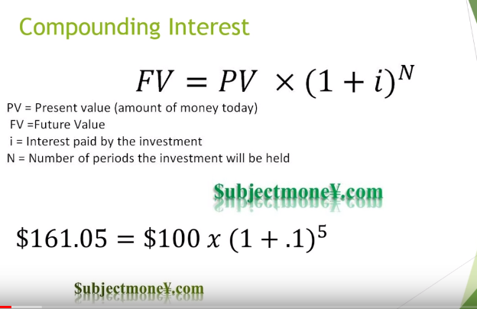

Annuity

----------------

1. it is a series of equa payment that we either recieved or paid.

2.Example :- monthly rent payment

3. For a series of payment to be annuity?

Ans : condition is : the payment should be of equal , period.

4. types :

--------------------

a. annuity due : payment made at the starting of the month.(room rent pay at the date 1 of every month)

b. ordinary annuity : payment or recieved at the ending of the month.

**present Value :**

Today's value of money ,from some points in the future.

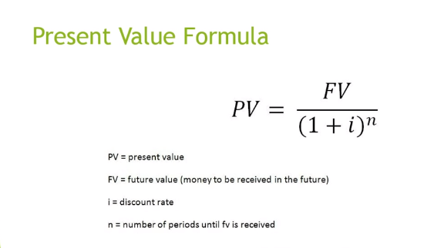

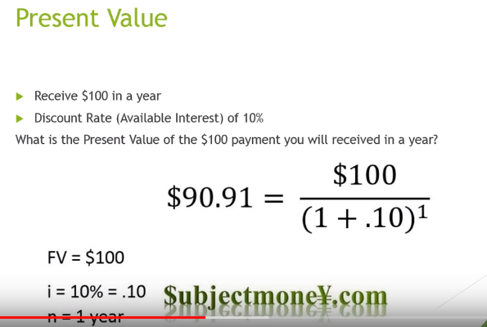

**example :-**

-----------

Here $100 = ordinary anuity

1. suppose we wish to recieved $100 in a year with a discount rate of 10% for 3 years , what would be the present value?

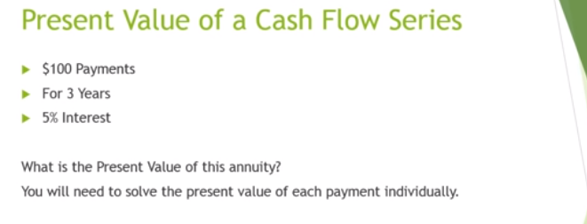

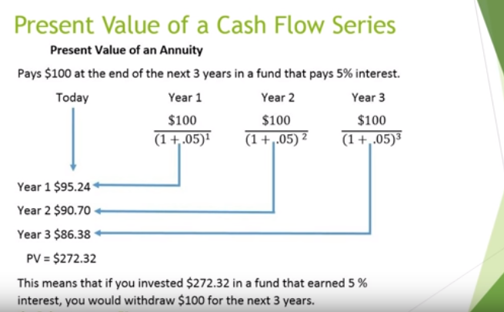

**IntraYearCompunding Interest:**

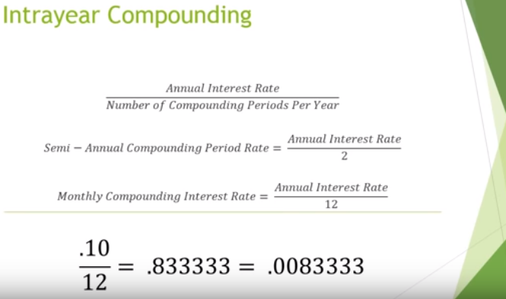

1. means when the inerest is compounded more than once a year like semi-annually. .

2.Here , we need to calculate "the semi-anually/.... compounding period rate :(annual rate/no. of periods yearly)"

[which is differen from the annual compounding rate] .

3. total Number of periods = total years* periods per year.

**Example : we need to calculate the future value [with intra year compoundingS]**

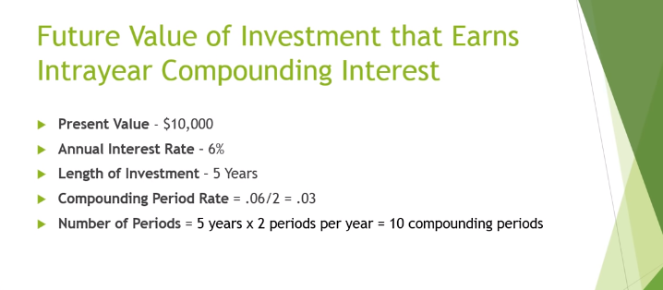

*Note : - we need the below 2 things :*

1. Compounding period rate .
2. Total number of periods.

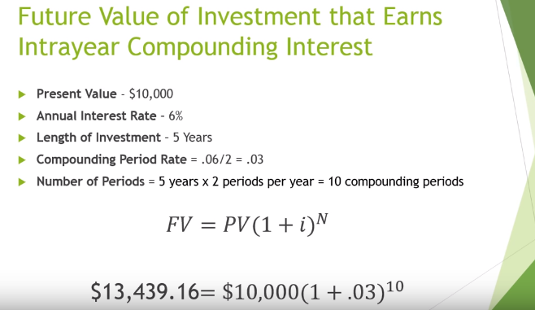

**Example : to earn $1000 every month for the next 6months, annual interest rate = 10%,**

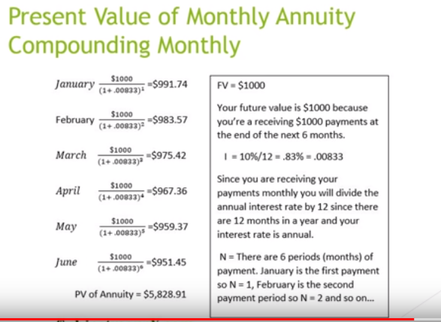

**Example :-**

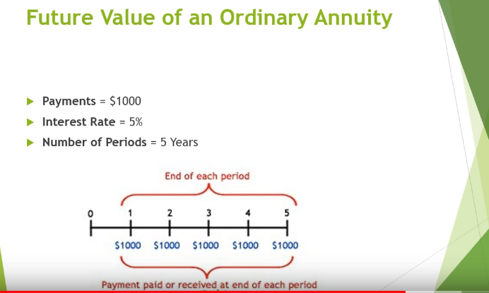

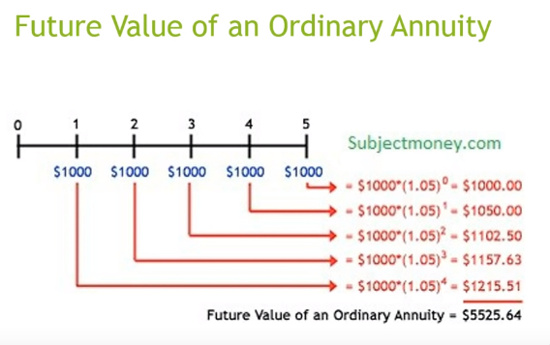

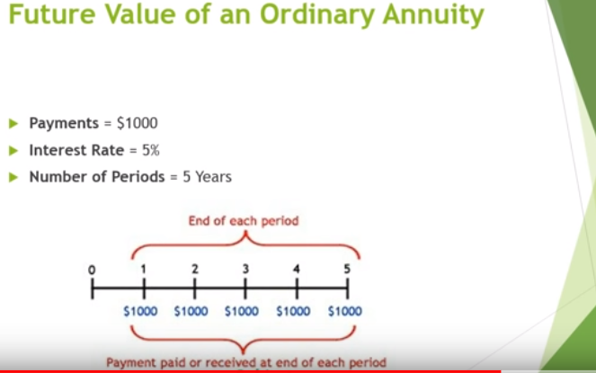

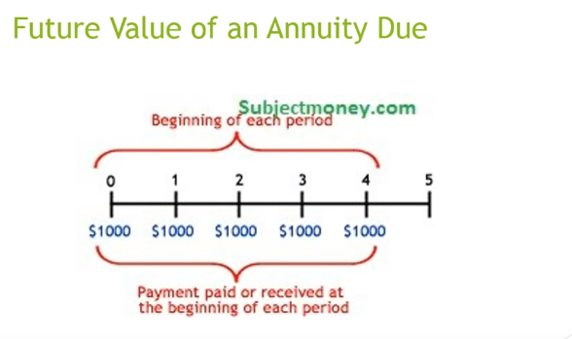

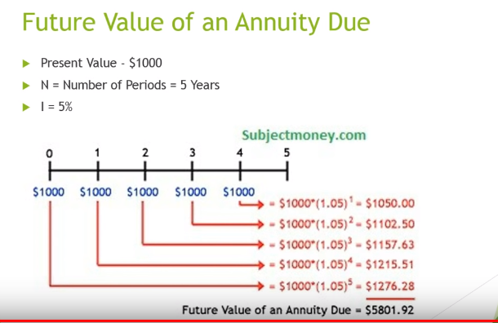

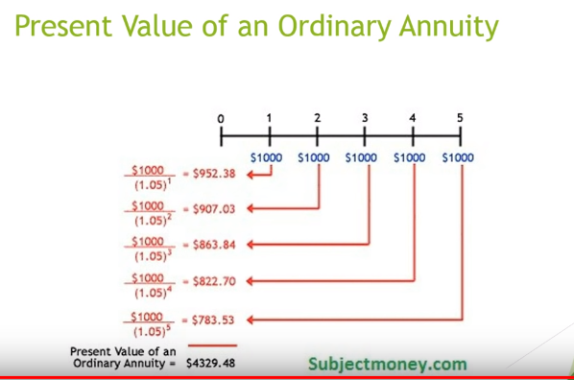

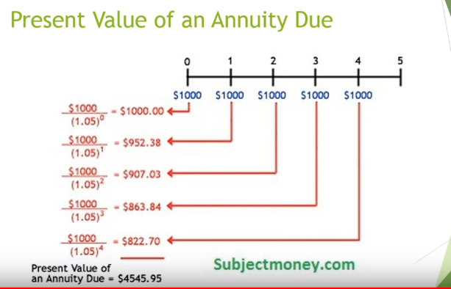

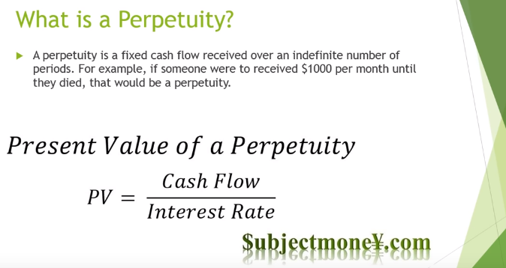

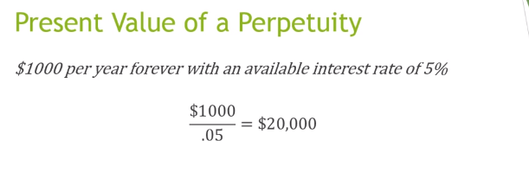

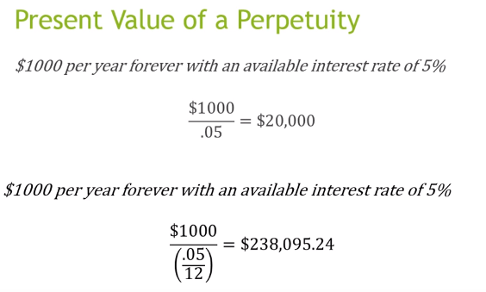

**Derivative :**

--------------------

1. what is derivative ?

Ans : contract develop between 2 entities based on some underlying assets like : "Turkey"

contract : pay $300, now then confirmation of delvering 20 turkey is possible in the next 3 months.

2. TYpes of derivatve :

Ans :

a. future or forward :[the shop will deliver 20 turkey at the end of 3 month]

1. here he paid $300 in advance and suppose to recieved 20 turkey at the end of 3 month

2. payment done earlier , and expected to get the products by the end of period.

b.option :

1. here there are chances that the previous farm may fail by the end of 3 months.

2. So, he paid another $50 now , and signed a contract to get 20 turkeys at $15 a turkey by the end of 3 month.

3. here he is secured , Why?

Ans : he didn't make the complete payment, just by paying some advance money , he is safe to execise the contract.

c. swap :

0. this works on foating interest rate.

1. converting/swaping float interest rate to fixed interest rate?

Ans :- a. Want to recieved $1000 recieved every year

b. but the compounding interest rate varies every year .

c. but the bank ask to pay a present value at a fixed interest rate of 5% .

d. if there is rise or fall of money value due to rate% rise or fall , bank will atke care.

** HERE THE underlying contract is the swaping of floating interest rate to fixed

note :

-----------------

1. we can trade the contract in derivative in 2 ways:

a. exchange (exchange in Japan)

b. OTC : over the counter(like the trade between me and the chicken farm)

Example : the contract of $300 can be sold/trade to someone in 2 ways

a. by lossing : after 2 months , the price of the turkey becomes cheaper. So he will sell the contract to someone by

lossing $100

b. by gaining : avaibility of turkey is very rare after 2 months , so he can sell the contract to another at $400

and tell him that he can sell the turkey at $500 at market.

Q. what is the levarage ?

Ans :- the borrow money to sign a contract .

*** with refernce to exchange derivative : there is a risk to me . why?

------------------------------------------------------------------------------

Ans :-

a. if i made the contract by leverage

b. and if the price of the contract goes down , I will be lossing.

3. TRADE

----------------

1. each and every financial contract is called a trade.

counter-party risk:-

------------------------

"the shop keeper run away after taking the contract money".

*** In trading there are 3 office -

-----------------------------------------------

1. front office desk

2. middle office desk

3. back office desk.

Q. what is pnemonics?

Q.book?

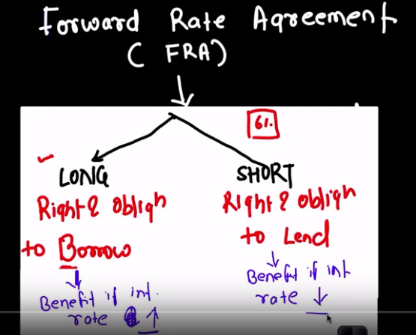

**Long will benefit** : if the market interest rate is higher Like 7% then our borrow rate of 6%

