SOFTWARE REQUIREMENTS SPECIFICATION
Multi-Tenant Coaching / Institute Management SaaS
Version 1.0
Prepared by: Gyan
Technology Stack: Python (Django, DRF) + React + PostgreSQL + Redis + Celery
Date: August 2026

1. Introduction

1.1 Purpose
This document specifies the functional and non-functional requirements for a Multi-Tenant Coaching / Institute Management SaaS platform. The system enables coaching institutes across India to digitize student management, attendance, fee collection, examinations, and communication from a single web-based platform, with each institute (tenant) operating in an isolated, secure environment.

1.2 Scope
The platform will be built using Python (Django + Django REST Framework) for the backend, React for the frontend, PostgreSQL as the primary datastore, Redis for caching and message brokering, and Celery for asynchronous task processing. The system supports multiple institutes (tenants) on a single deployment, each with isolated data, configurable branding, and role-based access for Admins, Teachers, Students, and Parents.

1.3 Intended Audience
- Development team (backend, frontend, DevOps)
- Coaching institute administrators (primary customers)
- QA / testing team
- Future technical documentation reference

1.4 Definitions & Abbreviations
Term | Definition
Tenant | A single coaching institute using the platform, with isolated data
SRS | Software Requirements Specification
DRF | Django REST Framework
JWT | JSON Web Token — used for stateless authentication
RBAC | Role-Based Access Control
ERD | Entity Relationship Diagram

2. Overall Description

2.1 Product Perspective
This is a new, cloud-hosted, multi-tenant SaaS product. Each coaching institute signs up and receives an isolated workspace (subdomain-based), with its own students, staff, batches, and billing, sharing the same application codebase and infrastructure.

2.2 User Classes and Characteristics
Role | Description | Key Permissions
Super Admin | Platform owner (Anthropic-style SaaS operator) | Manage tenants, plans, billing, platform health
Institute Admin | Owner/administrator of a coaching institute | Manage staff, students, fees, batches, reports
Teacher | Faculty member | Mark attendance, enter marks, view assigned batches
Student | Enrolled learner | View attendance, results, pay fees, receive notices
Parent | Guardian of a student | View child's attendance, fee status, results

2.3 Operating Environment
- Server: Linux (Ubuntu), Dockerized deployment
- Backend: Python 3.12, Django 5.x, Django REST Framework
- Frontend: React / Next.js (responsive, mobile-friendly)
- Database: PostgreSQL 15+
- Cache/Broker: Redis
- Async workers: Celery
- Browsers: Chrome, Edge, Firefox, Safari (latest 2 versions)

2.4 Assumptions and Dependencies
- Institutes have internet connectivity and basic digital literacy
- Payment gateway (Razorpay) account required for fee collection
- SMS/WhatsApp API provider integration required for notifications

3. Functional Requirements

3.1 Module: Tenant & Authentication
ID | Requirement
FR-1.1 | System shall allow platform admin to onboard a new tenant (institute) with a unique subdomain
FR-1.2 | System shall isolate all tenant data at the query level — no cross-tenant data access
FR-1.3 | System shall support JWT-based login with role assignment (Admin/Teacher/Student/Parent)
FR-1.4 | System shall support password reset via email/OTP
FR-1.5 | System shall enforce role-based permissions on every API endpoint

3.2 Module: Student & Batch Management
ID | Requirement
FR-2.1 | Admin shall be able to create, update, deactivate student profiles
FR-2.2 | Admin shall be able to create batches/courses and assign students to them
FR-2.3 | System shall auto-generate a unique roll number per tenant
FR-2.4 | System shall support bulk student import via CSV
FR-2.5 | System shall support searching/filtering students by batch, status, name

3.3 Module: Attendance
ID | Requirement
FR-3.1 | Teacher shall be able to mark daily attendance for an entire batch in one action
FR-3.2 | System shall prevent duplicate attendance entries for the same student/date
FR-3.3 | System shall generate attendance percentage reports per student and per batch
FR-3.4 | System shall trigger a low-attendance alert notification

3.4 Module: Fee Management
ID | Requirement
FR-4.1 | Admin shall define fee structures per batch/course with installment plans
FR-4.2 | System shall integrate with Razorpay for online fee payment
FR-4.3 | System shall auto-generate a payment receipt (PDF) after successful transaction
FR-4.4 | System shall send automated fee-due reminders before the due date
FR-4.5 | Admin shall be able to view outstanding dues across all students

3.5 Module: Examination & Results
ID | Requirement
FR-5.1 | Admin/Teacher shall be able to schedule a test/exam for a batch
FR-5.2 | Teacher shall be able to enter marks per student
FR-5.3 | System shall auto-calculate rank, average, and pass/fail status
FR-5.4 | Student/Parent shall be able to view results and performance trend

3.6 Module: Notifications
ID | Requirement
FR-6.1 | System shall send notifications via Email, SMS, and WhatsApp
FR-6.2 | All notification dispatch shall be asynchronous (Celery queue), not blocking API responses
FR-6.3 | System shall log delivery status of each notification

3.7 Module: Admin Panel (Django Admin — Enhanced)
ID | Requirement
FR-7.1 | Admin panel shall provide tenant-aware list views with search, filters, and pagination
FR-7.2 | Admin panel shall provide inline editing (e.g., Batch → Students inline)
FR-7.3 | Admin panel shall provide custom dashboard widgets (revenue, attendance %, active students)
FR-7.4 | Admin panel shall support CSV export of any list view
FR-7.5 | Admin panel actions shall be scoped to the logged-in staff user's tenant only

4. Non-Functional Requirements
ID | Category | Requirement
NFR-1 | Performance | API responses shall return within 300ms for 95% of requests under normal load
NFR-2 | Scalability | System shall support horizontal scaling of app servers behind a load balancer
NFR-3 | Security | All data in transit shall use TLS; passwords hashed (PBKDF2/Argon2); tenant isolation enforced at ORM level
NFR-4 | Availability | System shall target 99.5% uptime
NFR-5 | Maintainability | Codebase shall follow modular app-per-domain structure with service-layer separation
NFR-6 | Auditability | All fee transactions and result edits shall be logged with timestamp and actor
NFR-7 | Localization | UI shall support English and Hindi at minimum

5. System Architecture
The system follows a modular monolith architecture on the backend (Django apps per domain), with a decoupled React frontend consuming REST APIs. Asynchronous workloads (notifications, PDF generation, reminders) are offloaded to Celery workers via a Redis broker. PostgreSQL is the system of record, with Redis additionally used for caching frequently-read data.

5.1 High-Level Component Diagram
- Client (React/Next.js) → Nginx (reverse proxy / load balancer)
- Nginx → Gunicorn/Django (REST API layer, DRF)
- Django → PostgreSQL (primary datastore, tenant-partitioned via tenant_id)
- Django → Redis (cache + Celery broker)
- Celery Workers → Email/SMS/WhatsApp providers, Razorpay webhook processing, PDF generation

6. Entity Relationship Diagram
The diagram below shows the core entities and their relationships. Every tenant-scoped table carries a tenant_id foreign key for data isolation.
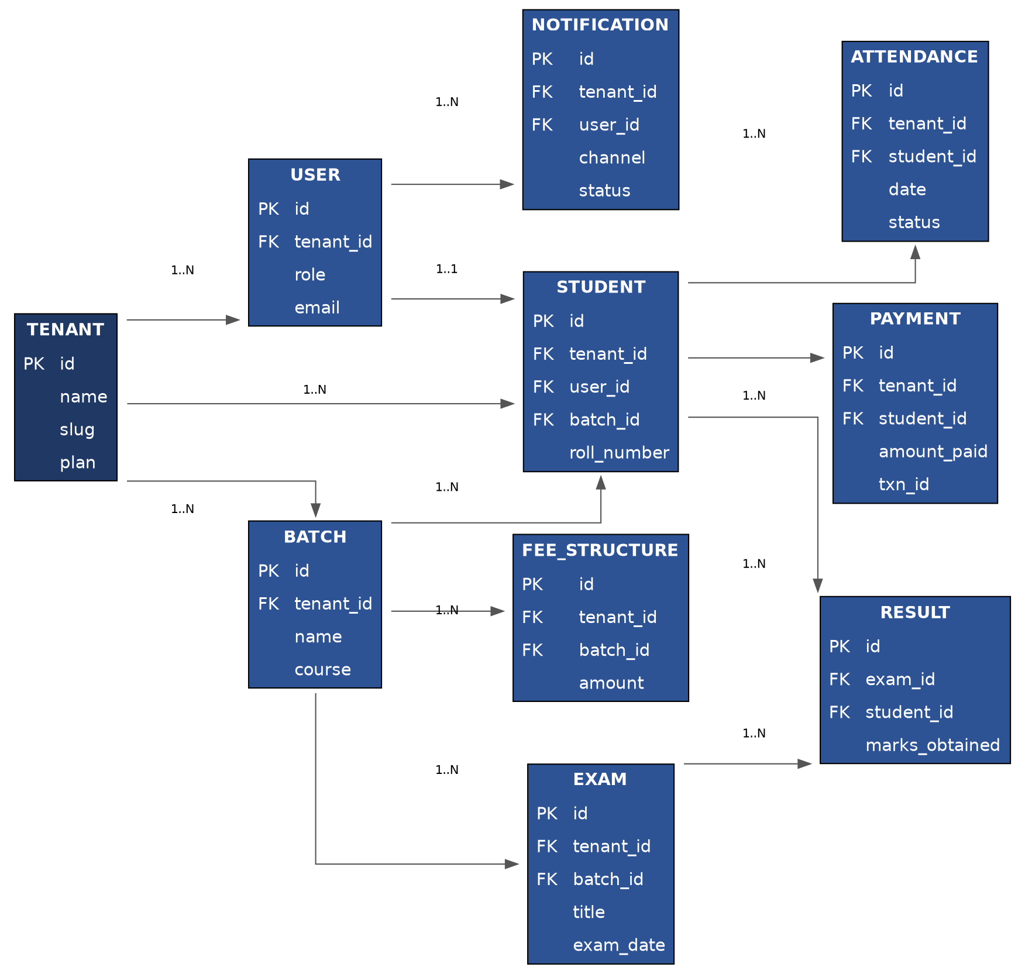

7. Milestone Plan
Milestone | Scope | Duration
M1 | Foundation: Django setup, Tenant model + middleware, custom User + JWT auth, Docker | Week 1–2
M2 | Student & Batch management (CRUD, RBAC, filters) | Week 3–4
M3 | Attendance module (bulk marking, reports) | Week 5
M4 | Fee management (Razorpay integration, receipts, reminders) | Week 6–7
M5 | Exam/Result module + analytics | Week 8–9
M6 | Notifications (Celery + Email/SMS/WhatsApp) | Week 10
M7 | Admin dashboard & reporting APIs | Week 11
M8 | Frontend integration (React) | Week 12–13
M9 | Production readiness: CI/CD, monitoring, load testing, deployment | Week 14

8. Appendix

8.1 Technology Stack Summary
Layer | Technology
Backend Framework | Django 5.x + Django REST Framework
Frontend | React / Next.js + Tailwind CSS
Database | PostgreSQL 15+
Cache / Broker | Redis
Async Tasks | Celery
Auth | JWT (djangorestframework-simplejwt)
Payments | Razorpay
Deployment | Docker, Nginx, Gunicorn
CI/CD | GitHub Actions
Monitoring | Sentry, Prometheus + Grafana

