INDEX

S.No. | Title | Date | Sign
1. | To explore the basic networking concepts & commands. | 19/07/2021
2. | To establish the various network topologies (Point-to-Point Topology, Star Topology, Ring Topology, Bus Topology, Hybrid Topology, Mesh Topology) using Hubs and Switches. | 26/07/2021
3. | To configure a switch appropriately with required properties. | 02/08/2021
4. | To configure VLAN appropriately by creating network topology for a university having 5 departments: CSE, ECE, ME, CE, EEE each having 3 computers. There should be no communication between the departments. | 09/08/2021
5. | To configure router appropriately with required properties and also explore different types of routing protocols. | 06/09/2021
6. | To configure VLAN on router appropriately by creating network topology for a university having 4 departments each having 2 computers. | 20/09/2021
7. | To configure router as a DHCP server. | 27/09/2021
8. | To create a network consisting of switches and routers to implement and configure IPv6 addresses. | 04/10/2021
9. | To configure servers appropriately with required properties. | 11/10/2021
10. | To configure routers with static routing using IP route command. | 18/10/2021

EXPERIMENT-1

AIM: To explore the basic networking concepts & commands.

THEORY: Multiple computers can be connected in a network in several arrangements. These are called Network Topologies. These connections are made possible with the help of network devices called Hubs and Switches. The difference between a Hub and Switch is that a Hub is an unintelligent device, and it does not know where the intended recipient is located, therefore broadcasting any message it receives to all the connected terminals. However, switch, being an intelligent device, only sends the message to the intended recipient.

COMMANDS:
- Ipconfig command
Internet Protocol Configuration is a windows command line utility that is used to manage the IP address assigned to the machine it is running in. It displays the computer's currently assigned IP, subnet mask and default gateway addresses.

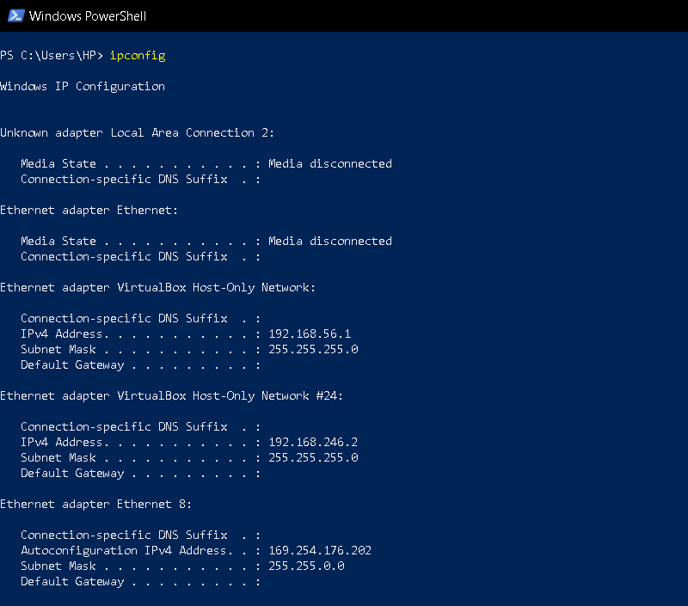

- Hostname Command
It is used to display the IP address of the remote machine/computer’s hostname.

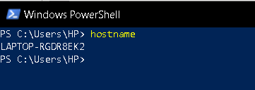

- Ping ip-address command
Ping is a command-line utility that acts as a test to see if a networked device is reachable. The ping command sends a request over the network to a specific device. A successful ping results in a response from the computer that was pinged back to the originating computer.
Options:
A: -t: ping the specified host until stopped.
B: -a: resolve address to hostname.

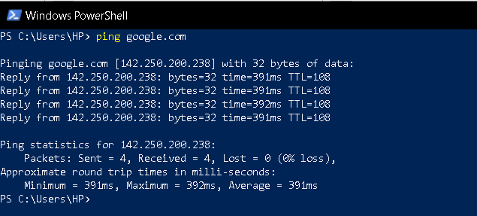

- Tracert Ip-address command
The tracert command is a command that's used to show several details about the path that a packet takes from the computer or device you're on to whatever destination you specify.

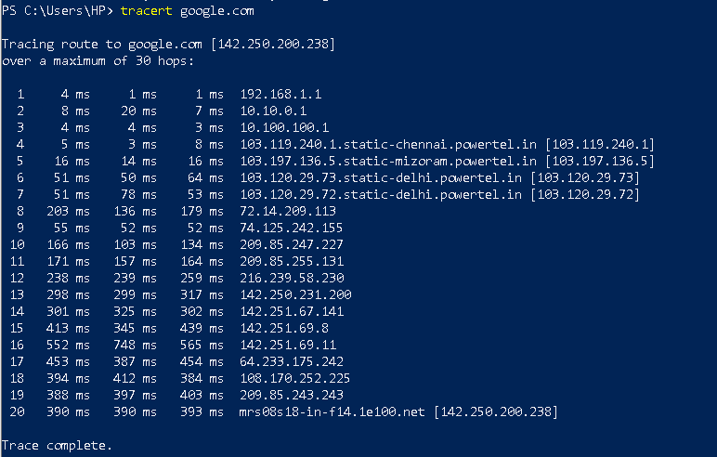

- Pathping ip-address command
The pathping command is a command-line network utility command that combines the functionality of ping with that of tracert. It is used to locate spots that have network latency and network loss.

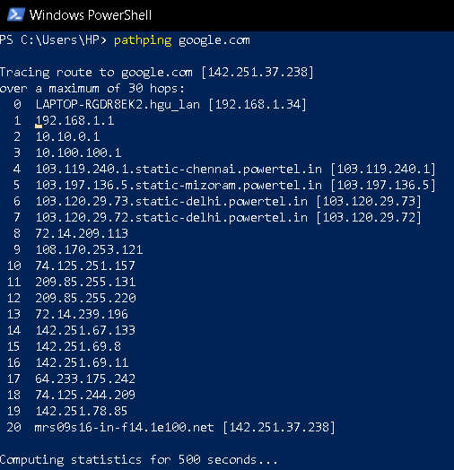

- arp -a Command
This command allows us to display and modify the Address Resolution Protocol (ARP) cache. An ARP cache is a simple mapping of IP addresses to MAC addresses.
Options:
A: -a: Displays current ARP entries by Interrogating the current protocol data.
B: -g: Same as -a.

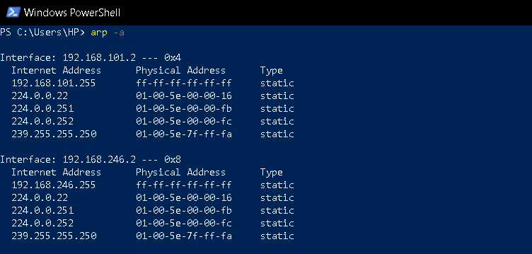

- netstat ip-address command
The netstat command generates displays that show network status and protocol statistics. It displays the status of TCP and UDP endpoints in table format, routing table information, and interface information. Netstat displays various types of network data depending on the command line option selected. These displays are the most useful for system administration.

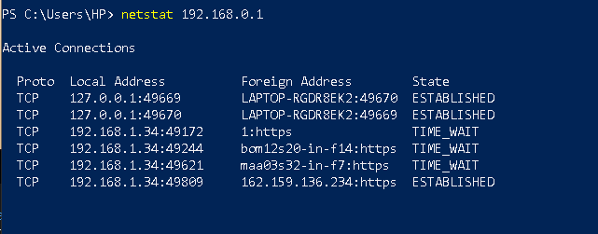

- ping -a ip-address command

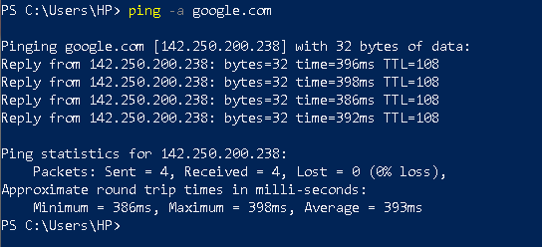

- ping -l size ip-address command

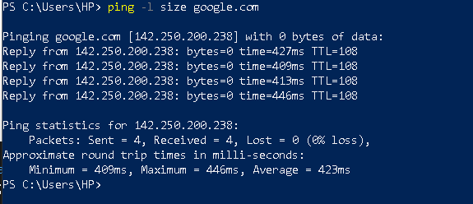

RESULT: Explored the basic networking concepts & commands.

EXPERIMENT-2

AIM: To establish the various network topologies (Point-to-Point Topology, Star Topology, Ring Topology, Bus Topology, Hybrid Topology, Mesh Topology) using Hubs and Switches.

THEORY: Multiple computers can be connected in a network in several arrangements. These are called Network Topologies. These connections are made possible with the help of network devices called Hubs and Switches. The difference between a Hub and Switch is that a Hub is an unintelligent device, and it does not know where the intended recipient is located, therefore broadcasting any message it receives to all the connected terminals. However, switch, being an intelligent device, only sends the message to the intended recipient.

- Peer to peer network
Peer to Peer topology is the simplest topology that connects two nodes directly together with a common link. The entire bandwidth of the common link is reserved for transmission between those two nodes. The point-to-point connections uses an actual length of wire or cable to connect the two ends, but other options, such as satellite links, or microwaves are also possible.

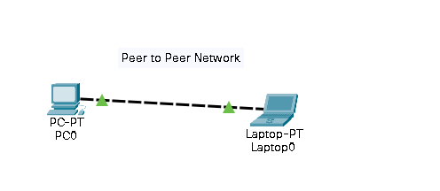
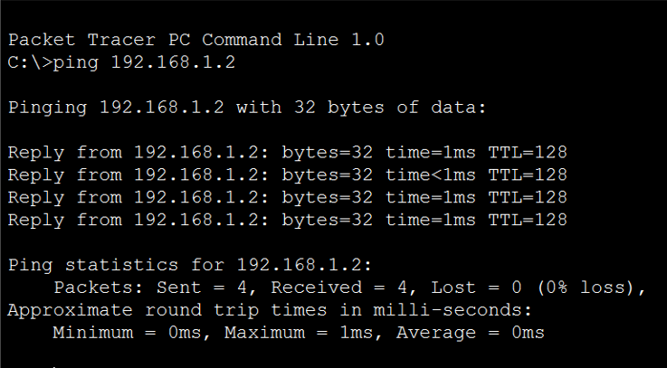

- Star Topology
Star topology is a network topology where each individual piece of a network is attached to a central node (often called a hub or switch). The attachment of these network pieces to the central component is visually represented in a form similar to a star. Star topology is also known as a star network.

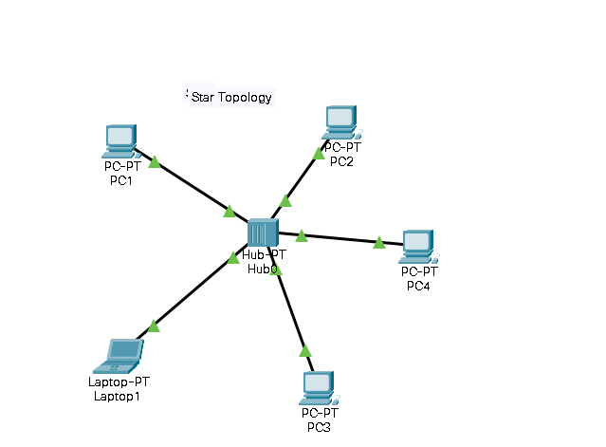
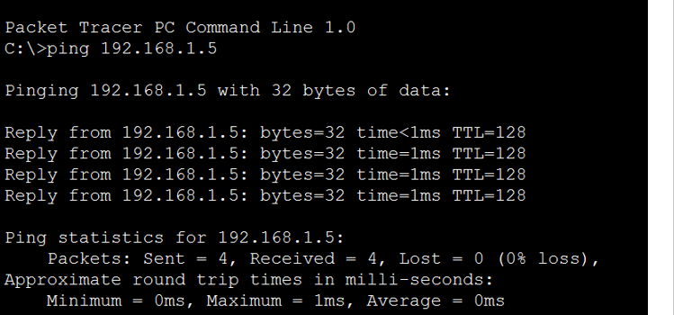

- Ring Topology
A ring topology is a network configuration where device connections create a circular data path. Each networked device is connected to two others, like points on a circle. Together, devices in a ring topology are referred to as a ring network. Others permit data to move in either direction, called bidirectional.
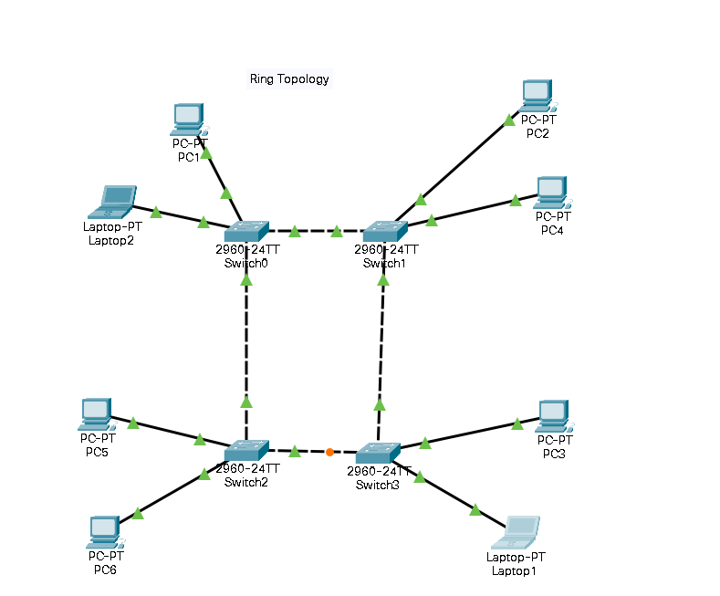
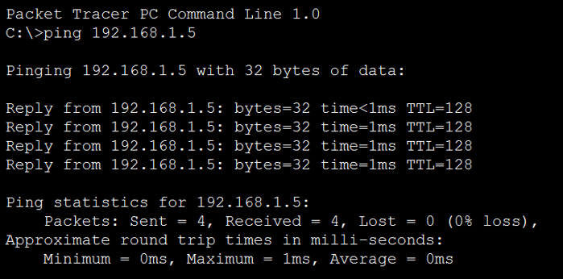

- Hybrid Topology
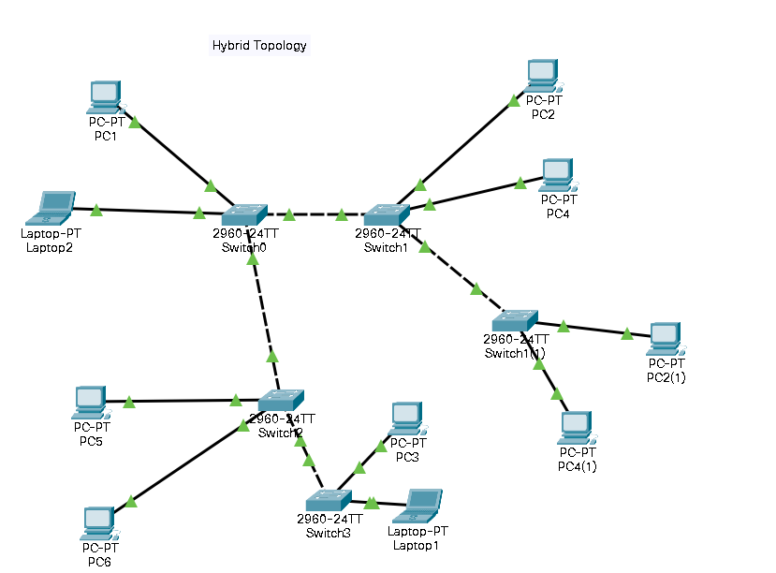
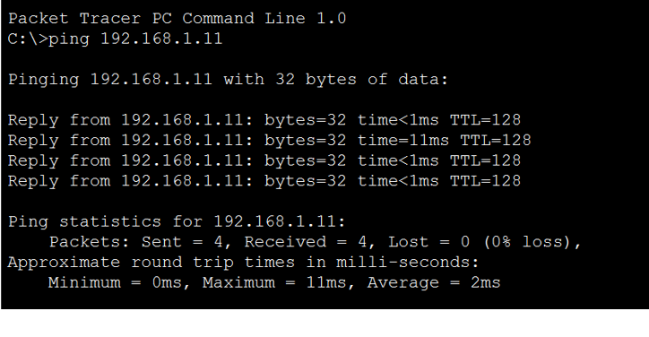

- Tree Topology
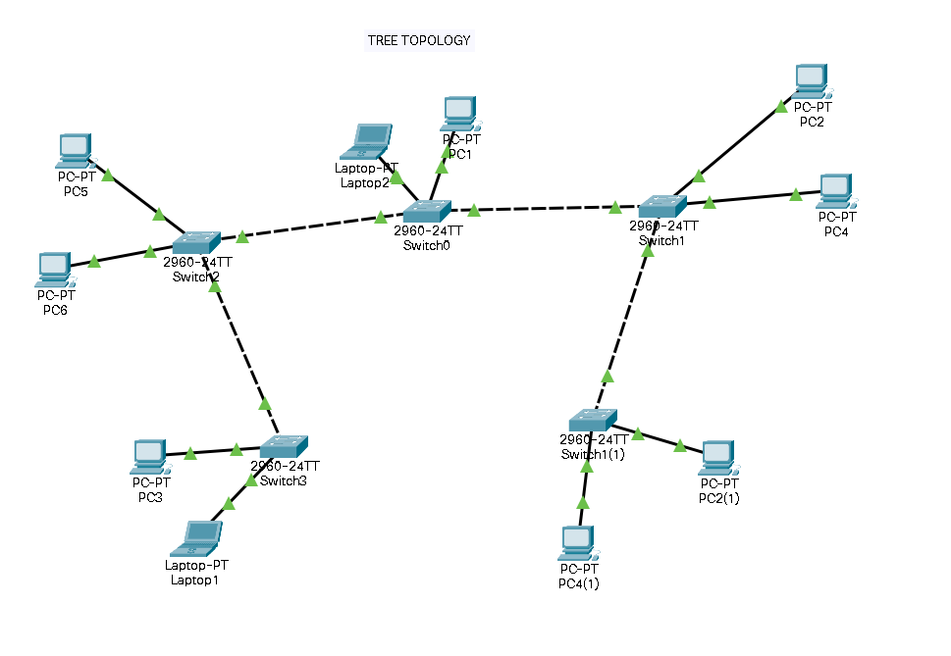
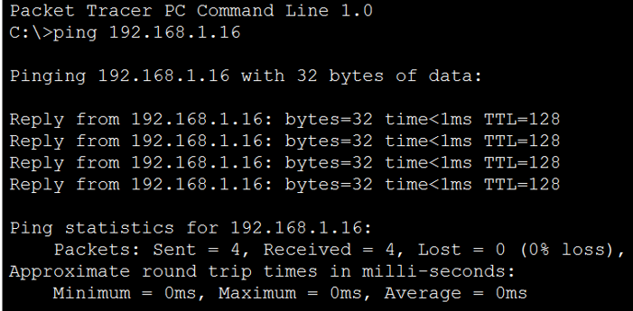

- Mesh Topology
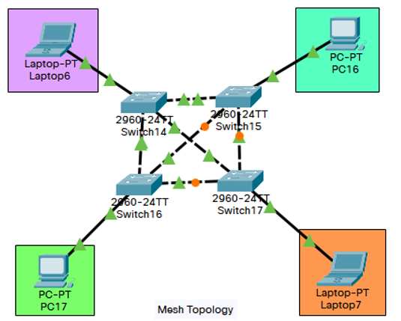
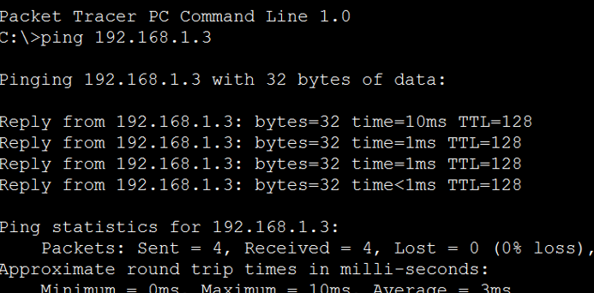

- Bus Topology
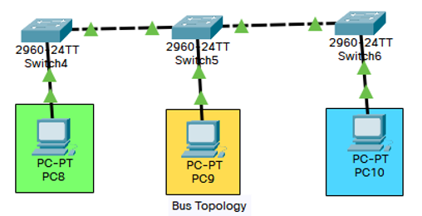
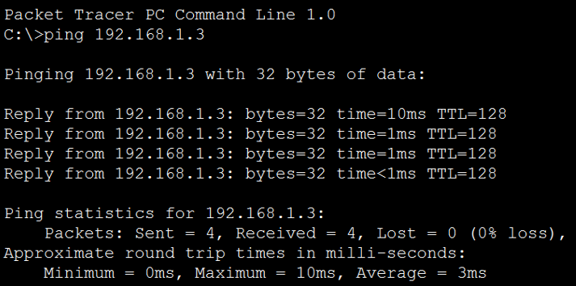

RESULT: The topologies were made and their results were analyzed.

EXPERIMENT-3

AIM: To configure a switch appropriately with required properties.

THEORY: The properties of a switch can be configured using CLI, short for Command
Line Interface. There are several modes in the CLI and each mode is used to modify
certain specific attributes of the switch. The modes of execution and their uses are listed
in the table as under.

S.No. | Mode | Command Prompt | Use
1. | User Execution Mode | > | Allows access to only a limited number of basic monitoring commands
2. | Privileged Execution Mode | # | To enter this mode, from user-exec mode, type enable. Allows us to change the current configuration of the switch.
3. | Global Configuration Mode | (config)# | To enter this mode, configure terminal or conf t must be typed. Used to access  configuration options on the device.
4. | Line Configuration Mode | (config-line)# | To configure console, SSH, Telnet or AUX  Configuration access. They help us manage the lines of mode the switch. To enter this mode type line console 0.
5. | Interface Configuration Mode | (config-if)# | Used to configure a switchport or router  interface.

COMMANDS:-

STAR TOPOLOGY

Switch>en
Switch#conf t
Enter configuration commands, one per line. End with CNTL/Z.
Switch(config)#no ip domain-lookup
Switch(config)#interface fa0/1
Switch(config-if)#shutdown

Switch(config-if)#
%LINK-5-CHANGED: Interface FastEthernet0/1, changed state to administratively down

%LINEPROTO-5-UPDOWN: Line protocol on Interface FastEthernet0/1, changed state to down

Switch(config-if)#interface fa0/1
Switch(config-if)#no shutdown

Switch(config-if)#
%LINK-5-CHANGED: Interface FastEthernet0/1, changed state to up

%LINEPROTO-5-UPDOWN: Line protocol on Interface FastEthernet0/1, changed state to up

Switch(config-if)#end
Switch#
%SYS-5-CONFIG_I: Configured from console by console

Switch#conf t
Enter configuration commands, one per line. End with CNTL/Z.
Switch(config)#enable secret class
Switch(config)#line con 0
Switch(config-line)#password 12345
Switch(config-line)#login
Switch(config-line)#end
Switch#
%SYS-5-CONFIG_I: Configured from console by console

Switch#show running-config
Building configuration...

Current configuration : 1172 bytes
!
version 15.0
no service timestamps log datetime msec
no service timestamps debug datetime msec
no service password-encryption
!
hostname Switch
!
enable secret 5 $1$mERr$9cTjUIEqNGurQiFU.ZeCi1
!
!
!
no ip domain-lookup
!
!
!
spanning-tree mode pvst
spanning-tree extend system-id
!
interface FastEthernet0/1
!
interface FastEthernet0/2
!
interface FastEthernet0/3
!
interface FastEthernet0/4
!
interface FastEthernet0/5
!
interface FastEthernet0/6
!
interface FastEthernet0/7
!
interface FastEthernet0/8
!
interface FastEthernet0/9
!
interface FastEthernet0/10
!
interface FastEthernet0/11
!
interface FastEthernet0/12
!
interface FastEthernet0/13
!
interface FastEthernet0/14
!
interface FastEthernet0/15
!
interface FastEthernet0/16
!
interface FastEthernet0/17
!
interface FastEthernet0/18
!
interface FastEthernet0/19
!
interface FastEthernet0/20
!
interface FastEthernet0/21
!
interface FastEthernet0/22
!
interface FastEthernet0/23
!
interface FastEthernet0/24
!
interface GigabitEthernet0/1
!
interface GigabitEthernet0/2
!
interface Vlan1
no ip address
shutdown
!
!
!
!
line con 0
password 12345
login
!
line vty 0 4
login
line vty 5 15
login
!
!
!
!
end

Switch#
Switch#conf t
Enter configuration commands, one per line. End with CNTL/Z.
Switch(config)#host Host1
Host1(config)#interface vlan1
Host1(config-if)#ip address 192.168.1.2 255.255.255.0
Host1(config-if)#no shut

Host1(config-if)#
%LINK-5-CHANGED: Interface Vlan1, changed state to up

%LINEPROTO-5-UPDOWN: Line protocol on Interface Vlan1, changed state to up

Host1(config-if)#end
Host1#
%SYS-5-CONFIG_I: Configured from console by console

Host1#copy run start
Destination filename [startup-config]?
Building configuration...
[OK]
Host1#conf t
Enter configuration commands, one per line. End with CNTL/Z.
Host1(config)#line vty 0 15
Host1(config-line)#password 12345
Host1(config-line)#login
Host1(config-line)#banner motd #Hello!!#
Host1(config)#end
Host1#
%SYS-5-CONFIG_I: Configured from console by console

Host1#copy run start
Destination filename [startup-config]?
Building configuration...
[OK]

RING TOPOLOGY

Switch-1

Switch>en
Switch#conf t
Enter configuration commands, one per line. End with CNTL/Z.
Switch(config)#no ip domain-lookup
Switch(config)#interface fa0/1
Switch(config-if)#shutdown

Switch(config-if)#
%LINK-5-CHANGED: Interface FastEthernet0/1, changed state to administratively down

%LINEPROTO-5-UPDOWN: Line protocol on Interface FastEthernet0/1, changed state to down

Switch(config-if)#interface fa0/1
Switch(config-if)#no shutdown

Switch(config-if)#
%LINK-5-CHANGED: Interface FastEthernet0/1, changed state to up

%LINEPROTO-5-UPDOWN: Line protocol on Interface FastEthernet0/1, changed state to up

Switch(config-if)#end
Switch#
%SYS-5-CONFIG_I: Configured from console by console

Switch#conf t
Enter configuration commands, one per line. End with CNTL/Z.
Switch(config)#enable secret class
Switch(config)#line con 0
Switch(config-line)#password 12345
Switch(config-line)#login
Switch(config-line)#end
Switch#
%SYS-5-CONFIG_I: Configured from console by console

Switch#show running-config
Building configuration...

Current configuration : 1172 bytes
!
version 15.0
no service timestamps log datetime msec
no service timestamps debug datetime msec
no service password-encryption
!
hostname Switch
!
enable secret 5 $1$mERr$9cTjUIEqNGurQiFU.ZeCi1
!
!
!
no ip domain-lookup
!
!
!
spanning-tree mode pvst
spanning-tree extend system-id
!
interface FastEthernet0/1
!
interface FastEthernet0/2
!
interface FastEthernet0/3
!
interface FastEthernet0/4
!
interface FastEthernet0/5
!
interface FastEthernet0/6
!
interface FastEthernet0/7
!
interface FastEthernet0/8
!
interface FastEthernet0/9
!
interface FastEthernet0/10
!
interface FastEthernet0/11
!
interface FastEthernet0/12
!
interface FastEthernet0/13
!
interface FastEthernet0/14
!
interface FastEthernet0/15
!
interface FastEthernet0/16
!
interface FastEthernet0/17
!
interface FastEthernet0/18
!
interface FastEthernet0/19
!
interface FastEthernet0/20
!
interface FastEthernet0/21
!
interface FastEthernet0/22
!
interface FastEthernet0/23
!
interface FastEthernet0/24
!
interface GigabitEthernet0/1
!
interface GigabitEthernet0/2
!
interface Vlan1
no ip address
shutdown
!
!
!
!
line con 0
password 12345
login
!
line vty 0 4
login
line vty 5 15
login
!
!
!
!
end

Switch#
Switch#conf t
Enter configuration commands, one per line. End with CNTL/Z.
Switch(config)#host Host2
Host2(config)#interface vlan1
Host2(config-if)#ip address 192.168.1.3 255.255.255.0
Host2(config-if)#no shut

Host2(config-if)#
%LINK-5-CHANGED: Interface Vlan1, changed state to up

%LINEPROTO-5-UPDOWN: Line protocol on Interface Vlan1, changed state to up

Host2(config-if)#line vty 0 15
Host2(config-line)#password 12345
Host2(config-line)#login
Host2(config-line)#banner motd #Heyy!!#
Host2(config)#end
Host2#
%SYS-5-CONFIG_I: Configured from console by console

Host2#copy run start
Destination filename [startup-config]?
Building configuration...
[OK]
Host2#

Switch-2

Switch>en
Switch#conf t
Enter configuration commands, one per line. End with CNTL/Z.
Switch(config)#no ip domain-lookup
Switch(config)#interface fa0/1
Switch(config-if)#shutdown

Switch(config-if)#
%LINK-5-CHANGED: Interface FastEthernet0/1, changed state to administratively down

%LINEPROTO-5-UPDOWN: Line protocol on Interface FastEthernet0/1, changed state to down

Switch(config-if)#interface fa0/1
Switch(config-if)#no shutdown

Switch(config-if)#
%LINK-5-CHANGED: Interface FastEthernet0/1, changed state to up

%LINEPROTO-5-UPDOWN: Line protocol on Interface FastEthernet0/1, changed state to up

Switch(config-if)#end
Switch#
%SYS-5-CONFIG_I: Configured from console by console

Switch#conf t
Enter configuration commands, one per line. End with CNTL/Z.
Switch(config)#enable secret class
Switch(config)#line con 0
Switch(config-line)#password 12345
Switch(config-line)#login
Switch(config-line)#end
Switch#
%SYS-5-CONFIG_I: Configured from console by console

Switch#show running-config
Building configuration...

Current configuration : 1172 bytes
!
version 15.0
no service timestamps log datetime msec
no service timestamps debug datetime msec
no service password-encryption
!
hostname Switch
!
enable secret 5 $1$mERr$9cTjUIEqNGurQiFU.ZeCi1
!
!
!
no ip domain-lookup
!
!
!
spanning-tree mode pvst
spanning-tree extend system-id
!
interface FastEthernet0/1
!
interface FastEthernet0/2
!
interface FastEthernet0/3
!
interface FastEthernet0/4
!
interface FastEthernet0/5
!
interface FastEthernet0/6
!
interface FastEthernet0/7
!
interface FastEthernet0/8
!
interface FastEthernet0/9
!
interface FastEthernet0/10
!
interface FastEthernet0/11
!
interface FastEthernet0/12
!
interface FastEthernet0/13
!
interface FastEthernet0/14
!
interface FastEthernet0/15
!
interface FastEthernet0/16
!
interface FastEthernet0/17
!
interface FastEthernet0/18
!
interface FastEthernet0/19
!
interface FastEthernet0/20
!
interface FastEthernet0/21
!
interface FastEthernet0/22
!
interface FastEthernet0/23
!
interface FastEthernet0/24
!
interface GigabitEthernet0/1
!
interface GigabitEthernet0/2
!
interface Vlan1
no ip address
shutdown
!
!
!
!
line con 0
password 12345
login
!
line vty 0 4
login
line vty 5 15
login
!
!
!
!
end

Switch#conf t
Enter configuration commands, one per line. End with CNTL/Z.
Switch(config)#host Host3
Host3(config)#interface vlan1
Host3(config-if)#ip address 192.168.1.4 255.255.255.0
Host3(config-if)#no shut

Host3(config-if)#
%LINK-5-CHANGED: Interface Vlan1, changed state to up

%LINEPROTO-5-UPDOWN: Line protocol on Interface Vlan1, changed state to up

Host3(config-if)#end
Host3#
%SYS-5-CONFIG_I: Configured from console by console

Host3#conf t
Enter configuration commands, one per line. End with CNTL/Z.
Host3(config)#line vty 0 15
Host3(config-line)#password 12345
Host3(config-line)#login
Host3(config-line)#banner motd #Hello World!!#
Host3(config)#end
Host3#
%SYS-5-CONFIG_I: Configured from console by console

Host3#copy run start
Destination filename [startup-config]?
Building configuration...
[OK]
Host3#

SWITCH 3

Switch>en
Switch#conf t
Enter configuration commands, one per line. End with CNTL/Z.
Switch(config)#no ip domain-lookup
Switch(config)#interface fa0/1
Switch(config-if)#shutdown

Switch(config-if)#
%LINK-5-CHANGED: Interface FastEthernet0/1, changed state to administratively down

%LINEPROTO-5-UPDOWN: Line protocol on Interface FastEthernet0/1, changed state to down

Switch(config-if)#interface fa0/1
Switch(config-if)#no shutdown

Switch(config-if)#
%LINK-5-CHANGED: Interface FastEthernet0/1, changed state to up

%LINEPROTO-5-UPDOWN: Line protocol on Interface FastEthernet0/1, changed state to up

Switch(config-if)#enable secret class
Switch(config)#line con 0
Switch(config-line)#password 12345
Switch(config-line)#login
Switch(config-line)#end
Switch#
%SYS-5-CONFIG_I: Configured from console by console

Switch#show running-config
Building configuration...

Current configuration : 1172 bytes
!
version 15.0
no service timestamps log datetime msec
no service timestamps debug datetime msec
no service password-encryption
!
hostname Switch
!
enable secret 5 $1$mERr$9cTjUIEqNGurQiFU.ZeCi1
!
!
!
no ip domain-lookup
!
!
!
spanning-tree mode pvst
spanning-tree extend system-id
!
interface FastEthernet0/1
!
interface FastEthernet0/2
!
interface FastEthernet0/3
!
interface FastEthernet0/4
!
interface FastEthernet0/5
!
interface FastEthernet0/6
!
interface FastEthernet0/7
!
interface FastEthernet0/8
!
interface FastEthernet0/9
!
interface FastEthernet0/10
!
interface FastEthernet0/11
!
interface FastEthernet0/12
!
interface FastEthernet0/13
!
interface FastEthernet0/14
!
interface FastEthernet0/15
!
interface FastEthernet0/16
!
interface FastEthernet0/17
!
interface FastEthernet0/18
!
interface FastEthernet0/19
!
interface FastEthernet0/20
!
interface FastEthernet0/21
!
interface FastEthernet0/22
!
interface FastEthernet0/23
!
interface FastEthernet0/24
!
interface GigabitEthernet0/1
!
interface GigabitEthernet0/2
!
interface Vlan1
no ip address
shutdown
!
!
!
!
line con 0
password 12345
login
!
line vty 0 4
login
line vty 5 15
login
!
!
!
!
end
Switch#conf t
Enter configuration commands, one per line. End with CNTL/Z.
Switch(config)#host Host4
Host4(config)#interface vlan1
Host4(config-if)#ip address 192.168.1.5 255.255.255.0
Host4(config-if)#no shut

Host4(config-if)#
%LINK-5-CHANGED: Interface Vlan1, changed state to up

%LINEPROTO-5-UPDOWN: Line protocol on Interface Vlan1, changed state to up

Host4(config-if)#line vty 0 15
Host4(config-line)#password 12345
Host4(config-line)#login
Host4(config-line)#banner motd #Hey everyone!#
Host4(config)#end
Host4#
%SYS-5-CONFIG_I: Configured from console by console

Host4#copy run start
Destination filename [startup-config]?
Building configuration...
[OK]
Host4#

Switch-4

Switch>en
Switch#conf t
Enter configuration commands, one per line. End with CNTL/Z.
Switch(config)#no ip domain-lookup
Switch(config)#interface fa0/1
Switch(config-if)#shutdown

Switch(config-if)#
%LINK-5-CHANGED: Interface FastEthernet0/1, changed state to administratively down

%LINEPROTO-5-UPDOWN: Line protocol on Interface FastEthernet0/1, changed state to down

Switch(config-if)#interface fa0/1
Switch(config-if)#no shutdown

Switch(config-if)#
%LINK-5-CHANGED: Interface FastEthernet0/1, changed state to up

%LINEPROTO-5-UPDOWN: Line protocol on Interface FastEthernet0/1, changed state to up

Switch(config-if)#end
Switch#
%SYS-5-CONFIG_I: Configured from console by console

Switch#conf t
Enter configuration commands, one per line. End with CNTL/Z.
Switch(config)#enable secret class
Switch(config)#line con 0
Switch(config-line)#password 12345
Switch(config-line)#login
Switch(config-line)#end
Switch#
%SYS-5-CONFIG_I: Configured from console by console

Switch#show running-config
Building configuration...

Current configuration : 1172 bytes
!
version 15.0
no service timestamps log datetime msec
no service timestamps debug datetime msec
no service password-encryption
!
hostname Switch
!
enable secret 5 $1$mERr$9cTjUIEqNGurQiFU.ZeCi1
!
!
!
no ip domain-lookup
!
!
!
spanning-tree mode pvst
spanning-tree extend system-id
!
interface FastEthernet0/1
!
interface FastEthernet0/2
!
interface FastEthernet0/3
!
interface FastEthernet0/4
!
interface FastEthernet0/5
!
interface FastEthernet0/6
!
interface FastEthernet0/7
!
interface FastEthernet0/8
!
interface FastEthernet0/9
!
interface FastEthernet0/10
!
interface FastEthernet0/11
!
interface FastEthernet0/12
!
interface FastEthernet0/13
!
interface FastEthernet0/14
!
interface FastEthernet0/15
!
interface FastEthernet0/16
!
interface FastEthernet0/17
!
interface FastEthernet0/18
!
interface FastEthernet0/19
!
interface FastEthernet0/20
!
interface FastEthernet0/21
!
interface FastEthernet0/22
!
interface FastEthernet0/23
!
interface FastEthernet0/24
!
interface GigabitEthernet0/1
!
interface GigabitEthernet0/2
!
interface Vlan1
no ip address
shutdown
!
!
!
!
line con 0
password 12345
login
!
line vty 0 4
login
line vty 5 15
login
!
!
!
!
end

Switch#conf t
Enter configuration commands, one per line. End with CNTL/Z.
Switch(config)#host Host5
Host5(config)#interface vlan1
Host5(config-if)#ip address 192.168.1.6 255.255.255.0
Host5(config-if)#no shut

Host5(config-if)#
%LINK-5-CHANGED: Interface Vlan1, changed state to up

%LINEPROTO-5-UPDOWN: Line protocol on Interface Vlan1, changed state to up

Host5(config-if)#end
Host5#
%SYS-5-CONFIG_I: Configured from console by console

Host5#conf t
Enter configuration commands, one per line. End with CNTL/Z.
Host5(config)#line vty 0 15
Host5(config-line)#password 12345
Host5(config-line)#login
Host5(config-line)#banner motd #Hello World!!#
Host5(config)#end
Host5#
%SYS-5-CONFIG_I: Configured from console by console

Host5#copy run start
Destination filename [startup-config]?
Building configuration...
[OK]

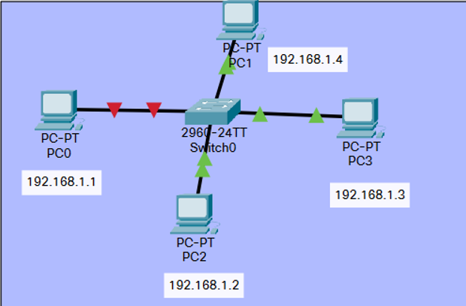
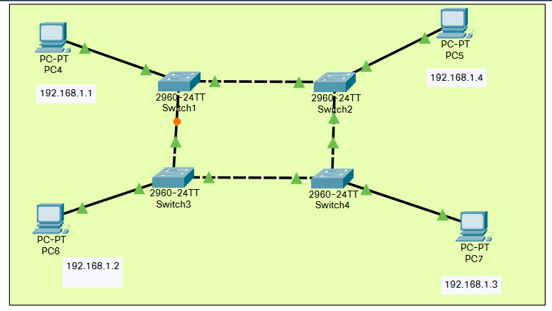

RESULT: The switch was successfully configured.

EXPERIMENT-4

AIM: To configure VLAN appropriately by creating network topology for a university having 5 departments: CSE, ECE, ME, CE, EEE each having 3 computers. There should be no communication between the departments.

THEORY: A VLAN is a set of end stations and the switch ports that connect them. You can have different reasons for the logical division, such as department or project membership. The only physical requirement is that the end station and the port to which it is connected both belong to the same VLAN. The properties of a VLAN can be configured using CLI, short for Command Line Interface.

COMMANDS:-

For Switch 0
Switch>en
Switch#conf t
Enter configuration commands, one per line. End with CNTL/Z.
Switch(config)#vlan 60
Switch(config-vlan)#name CSE1
Switch(config-vlan)#exit
Switch(config)#vlan 70
Switch(config-vlan)#name ECE1
Switch(config-vlan)#exit
Switch(config)#vlan 80
Switch(config-vlan)#name IT1
Switch(config-vlan)#exit
Switch(config)#vlan 90
Switch(config-vlan)#name ME1
Switch(config-vlan)#exit
Switch(config)#vlan 100
Switch(config-vlan)#name EEE1
Switch(config-vlan)#exit
Switch(config)#interface fa0/4
Switch(config-if)#switchport mode access
Switch(config-if)#switchport access vlan 60
Switch(config-if)#exit
Switch(config)#interface fa0/2
Switch(config-if)#switchport mode access
Switch(config-if)#switchport access vlan 60
Switch(config-if)#exit
Switch(config)#interface fa0/3
Switch(config-if)#switchport mode access
Switch(config-if)#switchport access vlan 60
Switch(config-if)#exit
Switch(config)#exit
Switch(config)#interface fa0/6
Switch(config-if)#switchport mode access
Switch(config-if)#switchport access vlan 70
Switch(config-if)#exit
Switch(config)#interface fa0/5
Switch(config-if)#switchport mode access
Switch(config-if)#switchport access vlan 70
Switch(config-if)#exit
Switch(config)#interface fa0/7
Switch(config-if)#switchport mode access
Switch(config-if)#switchport access vlan 70
Switch(config-if)#exit
Switch(config)#interface fa0/9
Switch(config-if)#switchport mode access
Switch(config-if)#switchport access vlan 80
Switch(config-if)#exit
Switch(config)#interface fa0/10
Switch(config-if)#switchport mode access
Switch(config-if)#switchport access vlan 80
Switch(config-if)#exit
Switch(config)#interface fa0/8
Switch(config-if)#switchport mode access
Switch(config-if)#switchport access vlan 80
Switch(config-if)#exit
Switch(config)#interface fa0/11
Switch(config-if)#switchport mode access
Switch(config-if)#switchport access vlan 90
Switch(config-if)#exit
Switch(config)#interface fa0/13
Switch(config-if)#switchport mode access
Switch(config-if)#switchport access vlan 90
Switch(config-if)#exit
Switch(config)#interface fa0/12
Switch(config-if)#switchport mode access
Switch(config-if)#switchport access vlan 90
Switch(config-if)#exit
Switch(config)#interface fa0/14
Switch(config-if)#switchport mode access
Switch(config-if)#switchport access vlan 100
Switch(config-if)#exit
Switch(config)#interface fa0/15
Switch(config-if)#switchport mode access
Switch(config-if)#switchport access vlan 100
Switch(config-if)#exit
Switch(config)#interface fa0/16
Switch(config-if)#switchport mode access
Switch(config-if)#switchport access vlan 100
Switch(config-if)#exit
Switch(config)#exit
Switch#
%SYS-5-CONFIG_I: Configured from console by console

Switch#show vlan brief

VLAN Name Status Ports
---- -------------------------------- --------- -------------------------------
1 default active Fa0/1, Fa0/17, Fa0/18, Fa0/19
Fa0/20, Fa0/21, Fa0/22, Fa0/23
Fa0/24, Gig0/1, Gig0/2
60 CSE1 active Fa0/2, Fa0/3, Fa0/4
70 ECE1 active Fa0/5, Fa0/6, Fa0/7
80 IT1 active Fa0/8, Fa0/9, Fa0/10
90 ME1 active Fa0/11, Fa0/12, Fa0/13
100 EEE1 active Fa0/14, Fa0/15, Fa0/16
1002 fddi-default active
1003 token-ring-default active
1004 fddinet-default active
1005 trnet-default active
Switch#

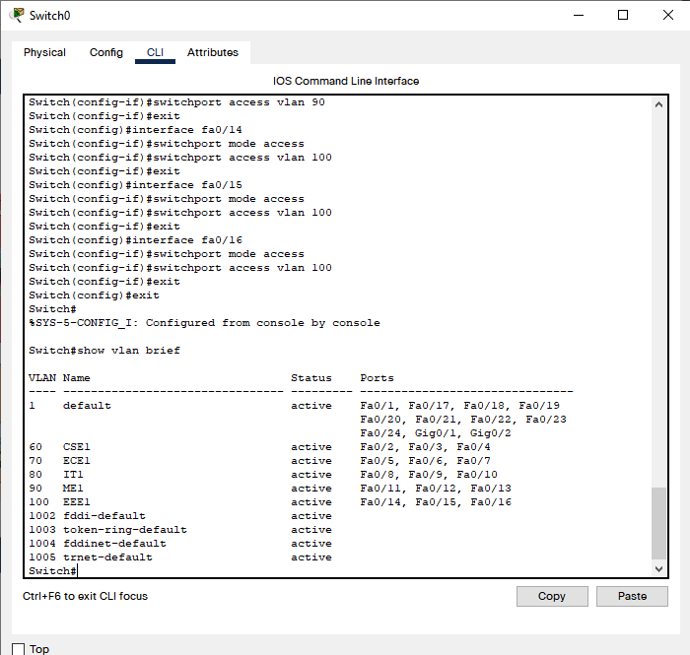

For Switch 1

Switch>en
Switch#conf t
Enter configuration commands, one per line. End with CNTL/Z.
Switch(config)#vlan 10
Switch(config-vlan)#name CSE
Switch(config-vlan)#exit
Switch(config)#vlan 20
Switch(config-vlan)#name ECE
Switch(config-vlan)#exit
Switch(config)#vlan 30
Switch(config-vlan)#name IT
Switch(config-vlan)#exit
Switch(config)#vlan 40
Switch(config-vlan)#name ME
Switch(config-vlan)#exit
Switch(config)#vlan 50
Switch(config-vlan)#name EEE
Switch(config-vlan)#exit
Switch(config)#interface fa0/1
Switch(config-if)#switchport mode access
Switch(config-if)#switchport access vlan 10
Switch(config-if)#exit
Switch(config)#interface fa0/3
Switch(config-if)#switchport mode access
Switch(config-if)#switchport access vlan 10
Switch(config-if)#exit
Switch(config)#interface fa0/4
Switch(config-if)#switchport mode access
Switch(config-if)#switchport access vlan 10
Switch(config-if)#exit
Switch(config)#interface fa0/6
Switch(config-if)#switchport mode access
Switch(config-if)#switchport access vlan 20
Switch(config-if)#exit
Switch(config)#interface fa0/7
Switch(config-if)#switchport mode access
Switch(config-if)#switchport access vlan 20
Switch(config-if)#exit
Switch(config)#interface fa0/5
Switch(config-if)#switchport mode access
Switch(config-if)#switchport access vlan 20
Switch(config-if)#exit
Switch(config)#interface fa0/10
Switch(config-if)#switchport mode access
Switch(config-if)#switchport access vlan 30
Switch(config-if)#exit
Switch(config)#interface fa0/8
Switch(config-if)#switchport mode access
Switch(config-if)#switchport access vlan 30
Switch(config-if)#exit
Switch(config)#interface fa0/9
Switch(config-if)#switchport mode access
Switch(config-if)#switchport access vlan 30
Switch(config-if)#exit
Switch(config)#interface fa0/11
Switch(config-if)#switchport mode access
Switch(config-if)#switchport access vlan 40
Switch(config-if)#exit
Switch(config)#interface fa0/13
Switch(config-if)#switchport mode access
Switch(config-if)#switchport access vlan 40
Switch(config-if)#exit
Switch(config)#interface fa0/12
Switch(config-if)#switchport mode access
Switch(config-if)#switchport access vlan 40
Switch(config-if)#exit
Switch(config)#interface fa0/16
Switch(config-if)#switchport mode access
Switch(config-if)#switchport access vlan 50
Switch(config-if)#exit
Switch(config)#interface fa0/14
Switch(config-if)#switchport mode access
Switch(config-if)#switchport access vlan 50
Switch(config-if)#exit
Switch(config)#interface fa0/15
Switch(config-if)#switchport mode access
Switch(config-if)#switchport access vlan 50
Switch(config-if)#exit
Switch(config)#exit
Switch#
%SYS-5-CONFIG_I: Configured from console by console

Switch#show vlan brief

VLAN Name Status Ports
---- -------------------------------- --------- -------------------------------
1 default active Fa0/2, Fa0/17, Fa0/18, Fa0/19
Fa0/20, Fa0/21, Fa0/22, Fa0/23
Fa0/24, Gig0/1, Gig0/2
10 CSE active Fa0/1, Fa0/3, Fa0/4
20 ECE active Fa0/5, Fa0/6, Fa0/7
30 IT active Fa0/8, Fa0/9, Fa0/10
40 ME active Fa0/11, Fa0/12, Fa0/13
50 EEE active Fa0/14, Fa0/15, Fa0/16
1002 fddi-default active
1003 token-ring-default active
1004 fddinet-default active
1005 trnet-default active
Switch#
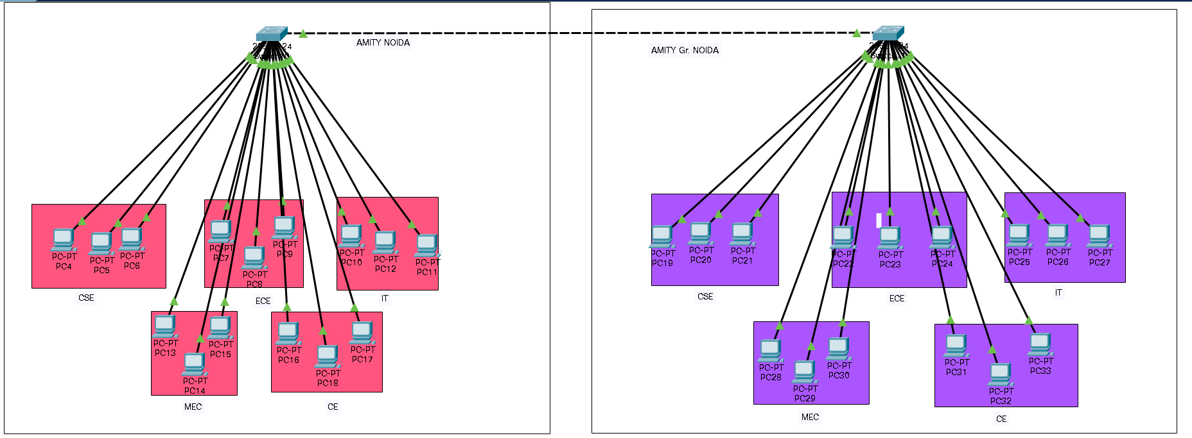

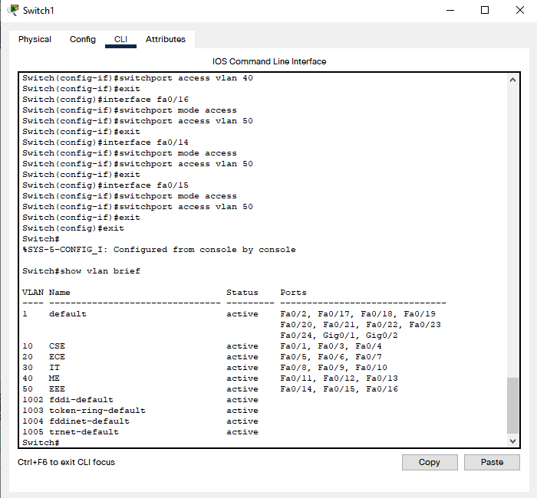

RESULT: The VLAN was successfully configured.

EXPERIMENT-5

AIM: To configure router appropriately with required properties.

THEORY: Routers guide and direct network data, using packets that contain various kinds of data-such as files, communications, and simple transmissions like web interactions. The data packets have several layers, or sections, one of which carries identifying information such as sender, data type, size, and most importantly, the destination IP (Internet protocol) address. The router reads this layer, prioritizes the data, and chooses the best route to use for each transmission.
COMMANDS:-

Router>en
Router#conf t
Enter configuration commands, one per line. End with CNTL/Z.
Router(config)#hostname MyRouter
MyRouter(config)#interface g0/0
MyRouter(config-if)#no shutdown

MyRouter(config-if)#
%LINK-5-CHANGED: Interface GigabitEthernet0/0, changed state to up

%LINEPROTO-5-UPDOWN: Line protocol on Interface GigabitEthernet0/0, changed state to up

MyRouter(config-if)#ip address 192.168.1.1 255.255.255.0
MyRouter(config-if)#no shut
MyRouter(config-if)#interface g0/1
MyRouter(config-if)#ip address 192.168.2.1 255.255.255.0
MyRouter(config-if)#no shut

MyRouter(config-if)#
%LINK-5-CHANGED: Interface GigabitEthernet0/1, changed state to up

%LINEPROTO-5-UPDOWN: Line protocol on Interface GigabitEthernet0/1, changed state to up

MyRouter(config-if)#exit
MyRouter(config)#exit
MyRouter#
%SYS-5-CONFIG_I: Configured from console by console

MyRouter#show ip interface brief
Interface IP-Address OK? Method Status Protocol
GigabitEthernet0/0 192.168.1.1 YES manual up up
GigabitEthernet0/1 192.168.2.1 YES manual up up
Vlan1 unassigned YES unset administratively down down
MyRouter>en
MyRouter#conf t
Enter configuration commands, one per line. End with CNTL/Z.
MyRouter(config)#interface loopback 0

MyRouter(config-if)#
%LINK-5-CHANGED: Interface Loopback0, changed state to up

%LINEPROTO-5-UPDOWN: Line protocol on Interface Loopback0, changed state to up

MyRouter(config-if)#ip address 100.0.0.1 255.255.255.0
MyRouter(config-if)#interface loopback1

MyRouter(config-if)#
%LINK-5-CHANGED: Interface Loopback1, changed state to up

%LINEPROTO-5-UPDOWN: Line protocol on Interface Loopback1, changed state to up

MyRouter(config-if)#ip address 101.0.0.1 255.255.255.0
MyRouter(config-if)#end
MyRouter#
%SYS-5-CONFIG_I: Configured from console by console

MyRouter#show ip interface brief
Interface IP-Address OK? Method Status Protocol
GigabitEthernet0/0 192.168.1.1 YES manual up up
GigabitEthernet0/1 192.168.2.1 YES manual up up
Loopback0 100.0.0.1 YES manual up up
Loopback1 101.0.0.1 YES manual up up
Vlan1 unassigned YES unset administratively down down
MyRouter#copy run start
Destination filename [startup-config]?
Building configuration...
[OK]
MyRouter#

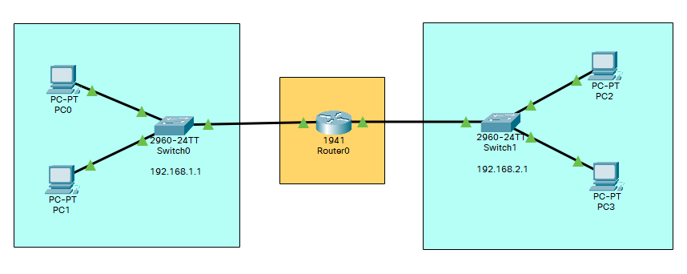

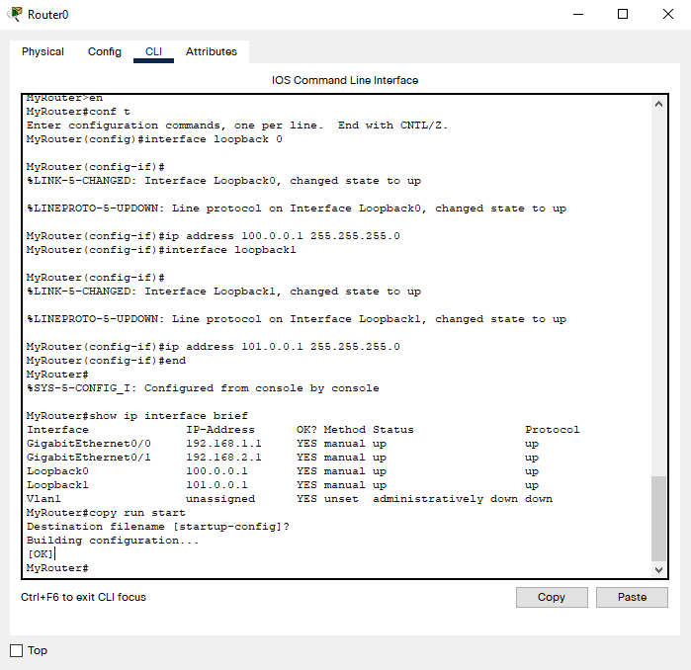

RESULT: The router was successfully configured.

EXPERIMENT-6

AIM: To configure VLAN on router appropriately by creating network topology for a university having 4 departments each having 2 computers.

THEORY: A VLAN is a set of end stations and the switch ports that connect them. You can have different reasons for the logical division, such as department or project membership. The only physical requirement is that the end station and the port to which it is connected both belong to the same VLAN. The properties of a VLAN can be configured using CLI, short for Command Line Interface.

COMMANDS:-

SWITCH 1

Switch>en
Switch#conf t
Enter configuration commands, one per line. End with CNTL/Z.
Switch(config)#vlan 10
Switch(config-vlan)#name Dept1
Switch(config-vlan)#exit
Switch(config)#vlan 20
Switch(cotnfig-vlan)#name Dept2
Switch(config-vlan)#exit
Switch(config)#interface fa0/2
Switch(config-if)#switchport mode access
Switch(config-if)#switchport access vlan 10
Switch(config-if)#exit
Switch(config)#interface fa0/3
Switch(config-if)#switchport mode access
Switch(config-if)#switchport access vlan 10
Switch(config-if)#exit
Switch(config)#interface fa0/4
Switch(config-if)#switchport mode access
Switch(config-if)#switchport access vlan 20
Switch(config-if)#exit
Switch(config)#interface fa0/5
Switch(config-if)#switchport mode access
Switch(config-if)#switchport access vlan 20
Switch(config-if)#exit

SWITCH 2

Switch>en
Switch#conf t
Enter configuration commands, one per line. End with CNTL/Z.
Switch(config)#vlan 30
Switch(config-vlan)#name Dept3
Switch(config-vlan)#exit
Switch(config)#vlan 40
Switch(config-vlan)#name Dept4
Switch(config-vlan)#exit
Switch(config)#interface fa0/2
Switch(config-if)#switchport mode access
Switch(config-if)#switchport access vlan 30
Switch(config-if)#exit
Switch(config)#interface fa0/3
Switch(config-if)#switchport mode access
Switch(config-if)#switchport access vlan 30
Switch(config-if)#exit
Switch(config)#interface fa0/4
Switch(config-if)#switchport mode access
Switch(config-if)#switchport access vlan 40
Switch(config-if)#exit
Switch(config)#interface fa0/5
Switch(config-if)#switchport mode access
Switch(config-if)#switchport access vlan 40
Switch(config-if)#exit
Switch(config)#

ROUTER

Router>en
Router#conf t
Enter configuration commands, one per line. End with CNTL/Z.
Router(config)#interface g0/0/0
Router(config-if)#no ip address
Router(config-if)#no shut

Router(config-if)#
%LINK-5-CHANGED: Interface GigabitEthernet0/0/0, changed state to up

%LINEPROTO-5-UPDOWN: Line protocol on Interface GigabitEthernet0/0/0, changed state to up

Router(config-if)#interface g0/0/0.10
Router(config-subif)#
%LINK-5-CHANGED: Interface GigabitEthernet0/0/0.10, changed state to up

%LINEPROTO-5-UPDOWN: Line protocol on Interface GigabitEthernet0/0/0.10, changed state to up

Router(config-subif)#encapsulation dot1q 10
Router(config-subif)#ip address 10.0.0.1 255.0.0.0
Router(config-subif)#interface g0/0/0.20
Router(config-subif)#
%LINK-5-CHANGED: Interface GigabitEthernet0/0/0.20, changed state to up

%LINEPROTO-5-UPDOWN: Line protocol on Interface GigabitEthernet0/0/0.20, changed state to up

Router(config-subif)#encapsulation dot1q 20
Router(config-subif)#ip address 20.0.0.1 255.0.0.0
Router(config-subif)#exit
Router(config)#exit
Router#
%SYS-5-CONFIG_I: Configured from console by console

Router#sh ip interface brief
Interface IP-Address OK? Method Status Protocol
GigabitEthernet0/0/0 unassigned YES unset up up
GigabitEthernet0/0/0. 1010.0.0.1 YES manual up up
GigabitEthernet0/0/0. 2020.0.0.1 YES manual up up
GigabitEthernet0/0/1 unassigned YES unset administratively down down
Vlan1 unassigned YES unset administratively down down
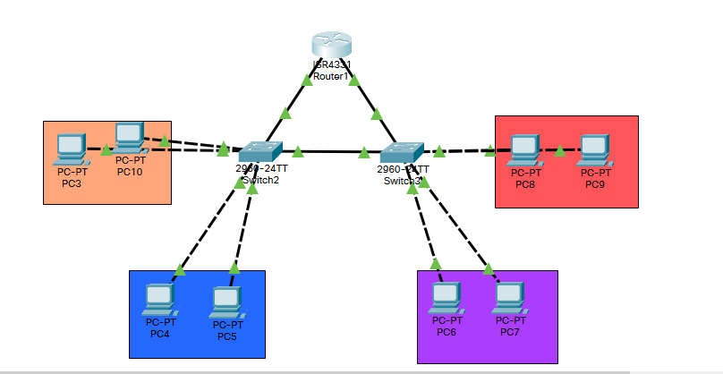
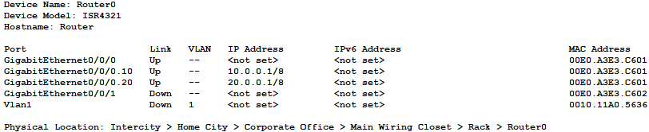

RESULT: Configured VLAN on router appropriately by creating network topology for a university having 4 departments each having 2 computers.

EXPERIMENT-7

AIM: To configure router as a DHCP server.

THEORY: Dynamic Host Configuration Protocol (DHCP) is an application layer protocol used to distribute various network configuration parameters to devices on a TCP/IP network. IP addresses, subnet masks, default gateways, DNS servers, etc. DHCP employs a client-server architecture; a DHCP client is configured to request network parameters from a DHCP server on the network. A DHCP server is configured with a pool of available IP addresses and assigns one of them to the DHCP client.

COMMANDS:-

For Router0

Router>en
Router#conf t
Enter configuration commands, one per line. End with CNTL/Z.
Router(config)#hostname Router
Router(config)#interface GigabitEthernet0/0/0
Router(config-if)#ip add 192.168.1.1 255.255.255.0
Router(config-if)#no shut

Router(config-if)#
%LINK-5-CHANGED: Interface GigabitEthernet0/0/0, changed state to up

%LINEPROTO-5-UPDOWN: Line protocol on Interface GigabitEthernet0/0/0, changed state to up

Router(config-if)#exit
Router(config)#ip DHCP pool abc
Router(dhcp-config)#default-router 192.168.1.1
Router(dhcp-config)#network 192.168.1.0 255.255.255.0
Router(dhcp-config)#exit
Router(config)#do wr
Building configuration...
[OK]
Router(config-if)#%DHCPD-4-PING_CONFLICT: DHCP address conflict: server pinged 192.168.1.1.

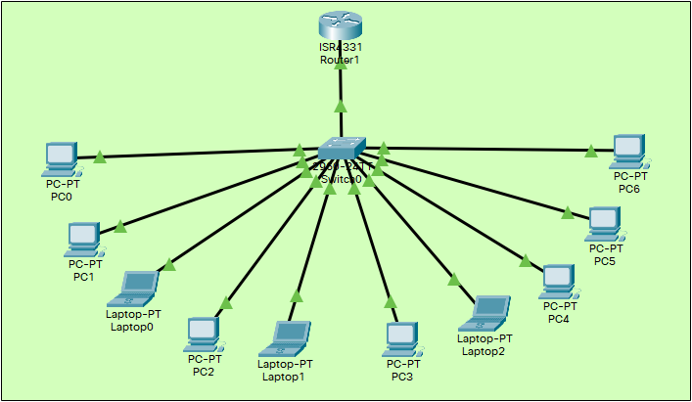

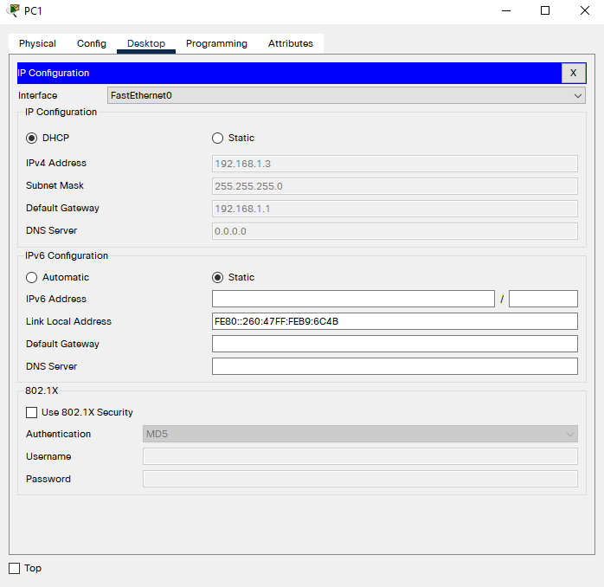

RESULT: Configured router as a DHCP server.

EXPERIMENT-8

AIM: To create a network consisting of switches and routers, to implement and configure IPv6 Addresses.

THEORY:
An IPv6 address is made of 128 bits divided into eight 16-bits blocks. Each block is then converted into 4-digit Hexadecimal numbers separated by colon symbols. Even after converting into Hexadecimal format, IPv6 address remains long. IPv6 provides some rules to shorten the address.

For Router0

Router>en
Router#conf t
Enter configuration commands, one per line. End with CNTL/Z.
Router(config)#interface gigabitethernet 0/0/0
Router(config-if)#ipv6 address 2001:db8:acad:1::1/64
Router(config-if)#no shutdown

Router(config-if)#
%LINK-5-CHANGED: Interface GigabitEthernet0/0/0, changed state to up

%LINEPROTO-5-UPDOWN: Line protocol on Interface GigabitEthernet0/0/0, changed state to up
exit
Router(config)#exit
Router#
%SYS-5-CONFIG_I: Configured from console by console

Router#conf t
Enter configuration commands, one per line. End with CNTL/Z.
Router(config)#interface gigabitethernet 0/0/1
Router(config-if)#ipv6 address 2001:db8:acad:2::1/64
Router(config-if)#no shutdown

Router(config-if)#
%LINK-5-CHANGED: Interface GigabitEthernet0/0/1, changed state to up

%LINEPROTO-5-UPDOWN: Line protocol on Interface GigabitEthernet0/0/1, changed state to up

Router(config-if)#exit
Router(config)#interface serial 0/1/0
Router(config-if)#ipv6 address 2001:db8:acad:3::1/64
Router(config-if)#no shutdown

%LINK-5-CHANGED: Interface Serial0/1/0, changed state to down
Router(config-if)#exit
Router(config)#interface gigabitethernet 0/0/0
Router(config-if)#ipv6 address fe80::1:1 link-local
Router(config-if)#no shutdown
Router(config-if)#exit
Router(config)#exit
Router#
%SYS-5-CONFIG_I: Configured from console by console

Router#show ipv6 interface brief
GigabitEthernet0/0/0 [up/up]
FE80::1:1
2001:DB8:ACAD:1::1
GigabitEthernet0/0/1 [up/up]
FE80::20C:85FF:FE63:D902
2001:DB8:ACAD:2::1
GigabitEthernet0/0/2 [administratively down/down]
unassigned
Serial0/1/0 [down/down]
FE80::20C:85FF:FE63:D901
2001:DB8:ACAD:3::1
Serial0/1/1 [administratively down/down]
unassigned
Vlan1 [administratively down/down]
unassigned

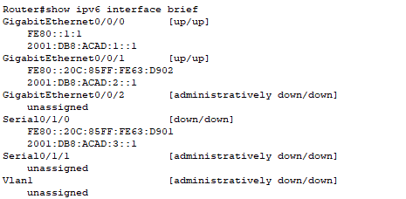

For Router1

Router>en
Router#conf t
Enter configuration commands, one per line. End with CNTL/Z.
Router(config)#interface gigabitethernet 0/0/0
Router(config-if)#ipv6 address 2001:db8:acad:4::1/64
Router(config-if)#no shutdown

Router(config-if)#
%LINK-5-CHANGED: Interface GigabitEthernet0/0/0, changed state to up

%LINEPROTO-5-UPDOWN: Line protocol on Interface GigabitEthernet0/0/0, changed state to up
Router(config-if)#interface gigabitethernet 0/0/1
Router(config-if)#ipv6 address 2001:db8:acad:5::1/64
Router(config-if)#no shutdown
Router(config-if)#
%LINK-5-CHANGED: Interface GigabitEthernet0/0/1, changed state to up

%LINEPROTO-5-UPDOWN: Line protocol on Interface GigabitEthernet0/0/1, changed state to up
Router(config-if)#interface serial 0/1/0
Router(config-if)#ipv6 address 2001:db8:acad:6::1/64
Router(config-if)#no shutdown
Router(config-if)#
%LINK-5-CHANGED: Interface Serial0/1/0, changed state to up
Router(config-if)#end
Router#
%SYS-5-CONFIG_I: Configured from console by console
Router#show ipv6 interface brief
GigabitEthernet0/0/0 [up/up]
FE80::2D0:FFFF:FE38:4601
2001:DB8:ACAD:4::1
GigabitEthernet0/0/1 [up/up]
FE80::2D0:FFFF:FE38:4602
2001:DB8:ACAD:5::1
GigabitEthernet0/0/2 [administratively down/down]
unassigned
Serial0/1/0 [up/up]
FE80::2D0:FFFF:FE38:4601
2001:DB8:ACAD:6::1
Serial0/1/1 [administratively down/down]
unassigned
Vlan1 [administratively down/down]
unassigned
Router#

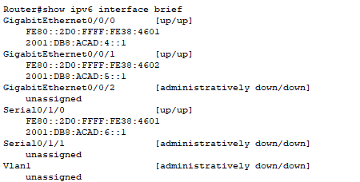

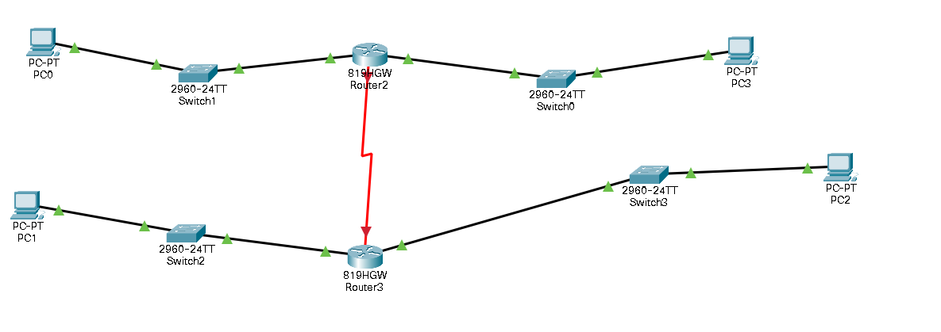

RESULT: Created a network consisting of switches and routers, to implement and configure IPv6 Addresses.

EXPERIMENT-9

AIM: To configure servers appropriately with required properties.

THEORY: A server is a computer or system that provides resources, data, services, or programs to other computers, known as clients, over a network. In theory, whenever computers share resources with client machines they are considered servers.
Dynamic Host Configuration Protocol (DHCP) is a network management protocol used to automate the process of configuring devices on IP networks, thus allowing them to use network services such as DNS, NTP, and any communication protocol based on UDP or TCP.
DNS is a host name to IP address translation service. DNS is a distributed database implemented in a hierarchy of name servers. It is an application layer protocol for message exchange between clients and servers.
COMMANDS:-

For Router

Router>en
Router#conf t
Enter configuration commands, one per line. End with CNTL/Z.
Router(config)#interface fa0/0
Router(config-if)#no shutdown

Router(config-if)#
%LINK-5-CHANGED: Interface FastEthernet0/0, changed state to up

%LINEPROTO-5-UPDOWN: Line protocol on Interface FastEthernet0/0, changed state to up

Router(config-if)#ip address 192.168.1.1 255.255.255.0
Router(config-if)#no shut
Router(config-if)#

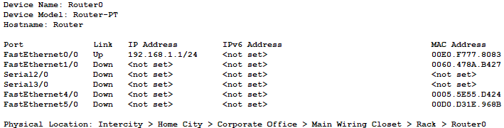

For PC0

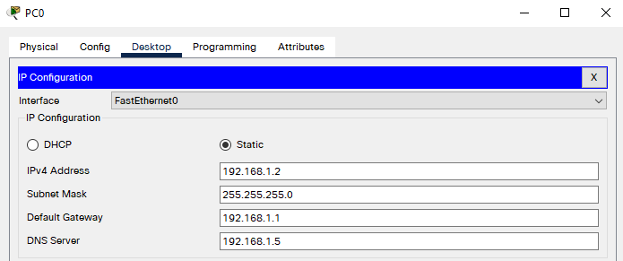

For PC1

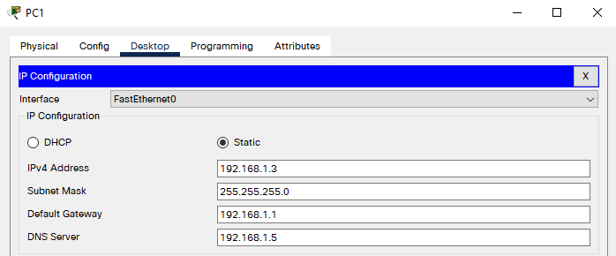

For Server0 : DHCP

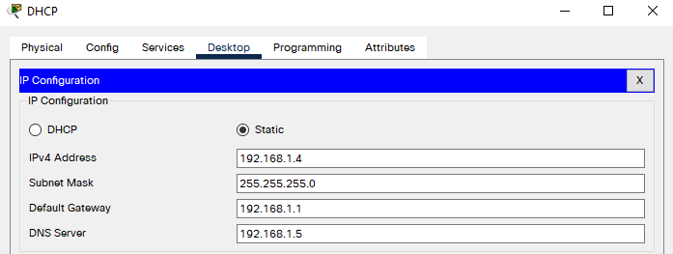
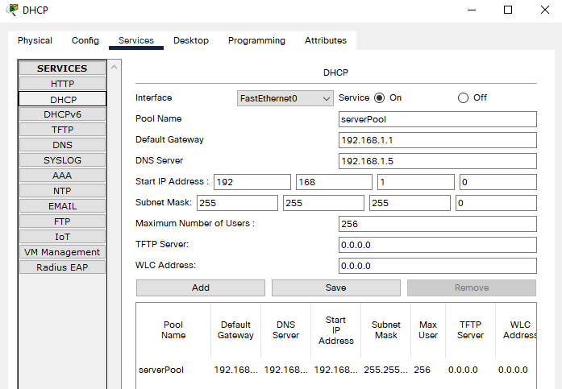

For Server1 : DNS

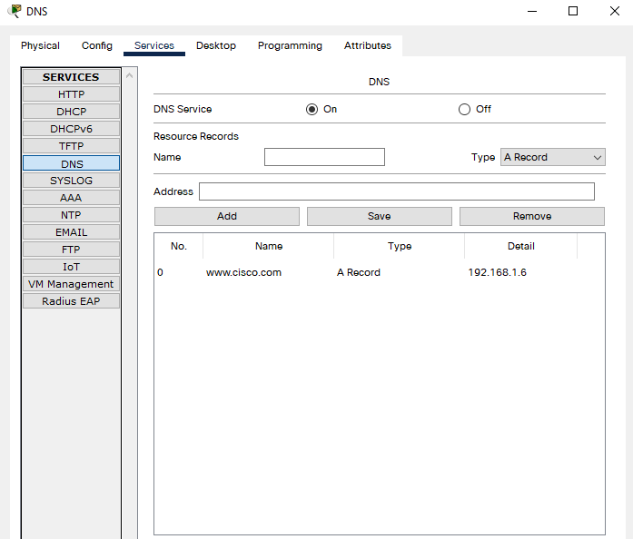

For Server2 : WEB

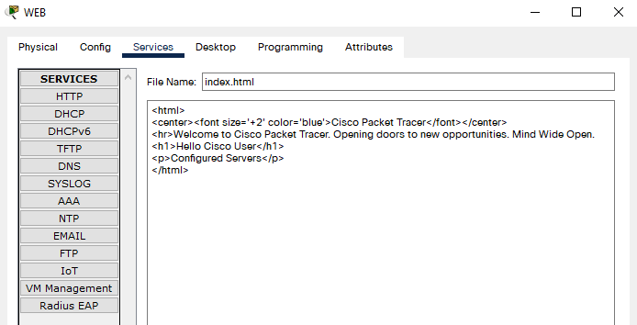

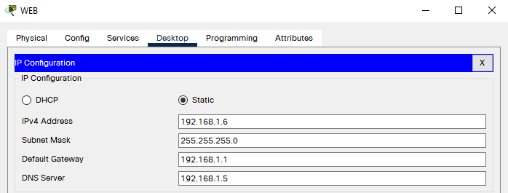

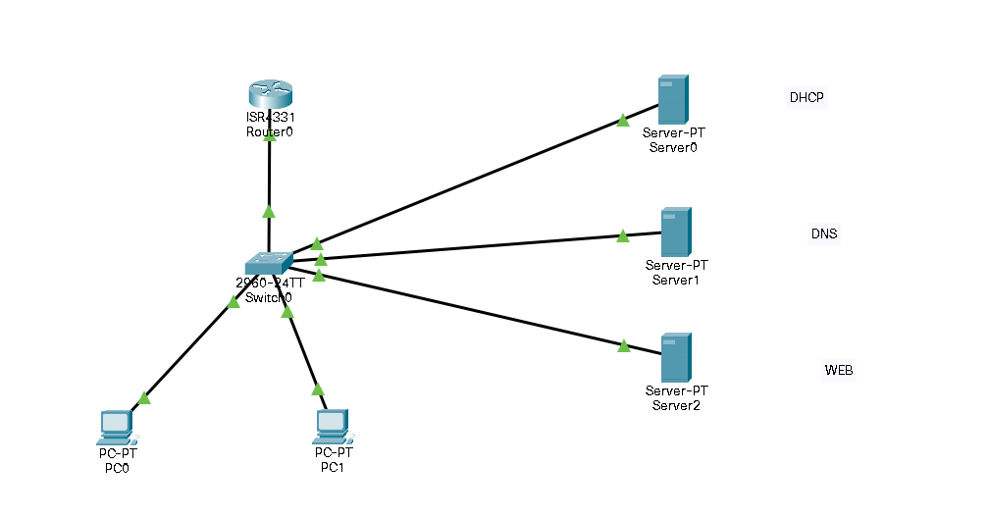

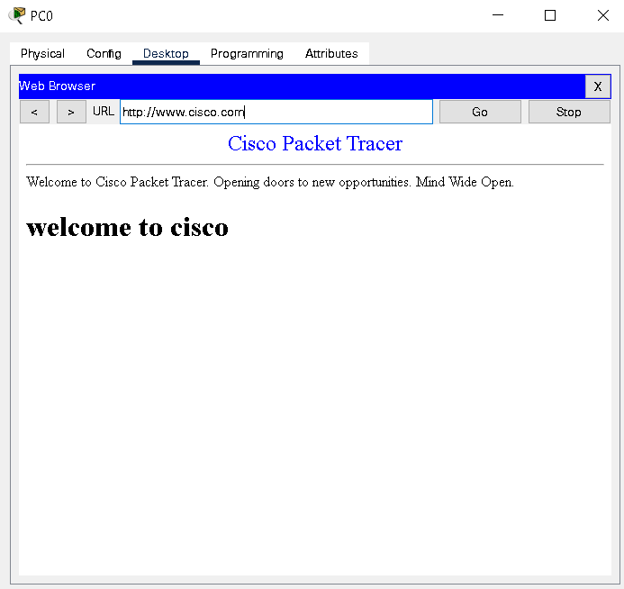

RESULT: Configured servers appropriately with required properties.

EXPERIMENT-10

AIM: To configure routers with static routing using IP route command.

THEORY: Static routing is a form of routing that occurs when a router uses a manually configured routing entry than information from dynamic routing traffic. Unlike dynamic routing, static routes are fixed and do not change if the network is changed or reconfigured. Static routing and dynamic routing are not mutually exclusive. Both dynamic routing and static routing are usually used on a router to maximize routing efficiency and to provide backups if dynamic routing information fails to be exchanged.

Command | Purpose
configure terminal | Enters global configuration mode.
interface gigabitethernet slot/port | Enters the configuration mode for a Gigabit Ethernet interface on the router.  Note GigabitEthernet(GE) LAN Interfaces are 0/0 to 0/7 for Cisco C841M-8X ISR and 0/0 to 0/3 for Cisco C841M-4X ISR.
ip address ip-address mask | Sets the IP address and subnet mask for the specified GE interface.
no shutdown | Enables the GE interface, changing its state from administratively down to administratively up.
exit | Exits configuration mode for the GE interface and returns to global configuration mode.
enable | This command is used to enter the privileged EXEC mode and configure it
show ip interface brief | The show ip interface brief command can be used to view a summary of the router interfaces. This command displays the IP address, interface status, and additional information.
interface loopback | A loopback interface is a virtual interface on a Cisco router that remains up (active) after you issue the no shutdown command until you disable it with the shutdown command. Unlike sub interfaces, loopback interfaces are independent of the state of any physical interface.

COMMANDS:-

For Router 0
Router>en
Router#conf t
Enter configuration commands, one per line. End with CNTL/Z.
Router(config)#interface se 0/1/0
Router(config-if)#no shutdown

%LINK-5-CHANGED: Interface Serial0/1/0, changed state to down
Router(config-if)#ip address 10.0.0.2 255.255.255.0
Router(config-if)#interface gig 0/0/0
Router(config-if)#no shutdown

Router(config-if)#
%LINK-5-CHANGED: Interface GigabitEthernet0/0/0, changed state to up

%LINEPROTO-5-UPDOWN: Line protocol on Interface GigabitEthernet0/0/0, changed state to up

Router(config-if)#ip address 192.168.10.1 255.255.255.0
Router(config)#ip route 192.168.11.0 255.255.255.0 10.0.0.3
Router(config)#ip route 192.168.12.0 255.255.255.0 10.0.0.3
Router(config)#ip route 11.0.0.0 255.0.0.0 10.0.0.3

For Router 1

Router>en
Router#conf t
Enter configuration commands, one per line. End with CNTL/Z.
Router(config)#interface se 0/1/0
Router(config-if)#no shutdown

Router(config-if)#
%LINK-5-CHANGED: Interface Serial0/1/0, changed state to up

Router(config-if)#ip address
%LINEPROTO-5-UPDOWN: Line protocol on Interface Serial0/1/0, changed s
Router(config-if)#ip address 10.0.0.3 255.255.255.0
Router(config-if)#interface gig 0/0/0
Router(config-if)#no shutdown

Router(config-if)#
%LINK-5-CHANGED: Interface GigabitEthernet0/0/0, changed state to up

%LINEPROTO-5-UPDOWN: Line protocol on Interface GigabitEthernet0/0/0, changed state to up

Router(config-if)#ip address 192.168.11.1 255.255.255.0
Router(config-if)#interface se 0/1/1
Router(config-if)#no shutdown

%LINK-5-CHANGED: Interface Serial0/1/1, changed state to down
Router(config-if)#ip address 11.0.0.2 255.255.255.0
Router(config-if)#
%LINK-5-CHANGED: Interface Serial0/1/1, changed state to up

%LINEPROTO-5-UPDOWN: Line protocol on Interface Serial0/1/1, changed state to up
Router(config)#ip route 192.168.10.0 255.255.255.0 10.0.0.2
Router(config)#ip route 192.168.12.0 255.255.255.0 11.0.0.3
Router(config)#end
Router#

For Router 2

Router>en
Router#conf t
Enter configuration commands, one per line. End with CNTL/Z.
Router(config)#interface se 0/1/0
Router(config-if)#ip address 11.0.0.3 255.255.255.0
Router(config-if)#no shutdown

Router(config-if)#
%LINK-5-CHANGED: Interface Serial0/1/0, changed state to up

Router(config-if)#
%LINEPROTO-5-UPDOWN: Line protocol on Interface Serial0/1/0, changed state to up

Router(config-if)#interface gig 0/0/0
Router(config-if)#ip address 192.168.12.1 255.255.255.0
Router(config-if)#no shutdown

Router(config-if)#
%LINK-5-CHANGED: Interface GigabitEthernet0/0/0, changed state to up

%LINEPROTO-5-UPDOWN: Line protocol on Interface GigabitEthernet0/0/0, changed state to up

Router(config-if)#exit
Router(config)#ip route 192.168.11.0 255.255.255.0 11.0.0.2
Router(config)#ip route 192.168.10.0 255.255.255.0 11.0.0.2
Router(config)#ip route 10.0.0.0 255.0.0.0 11.0.0.2
Router(config)#end

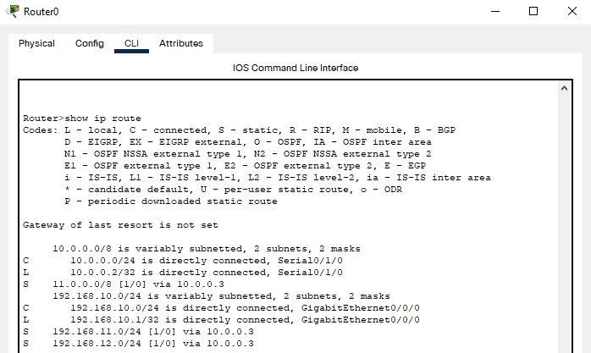

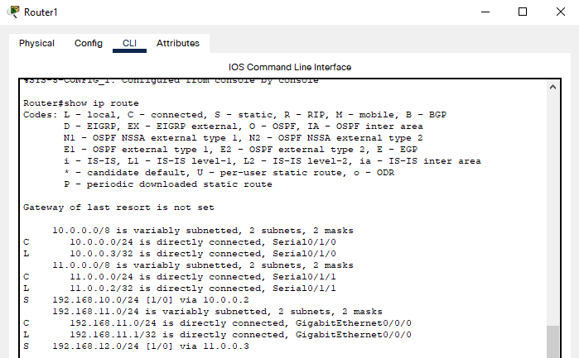

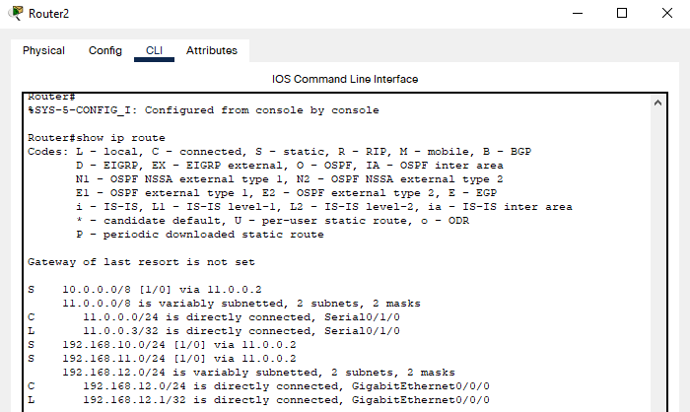
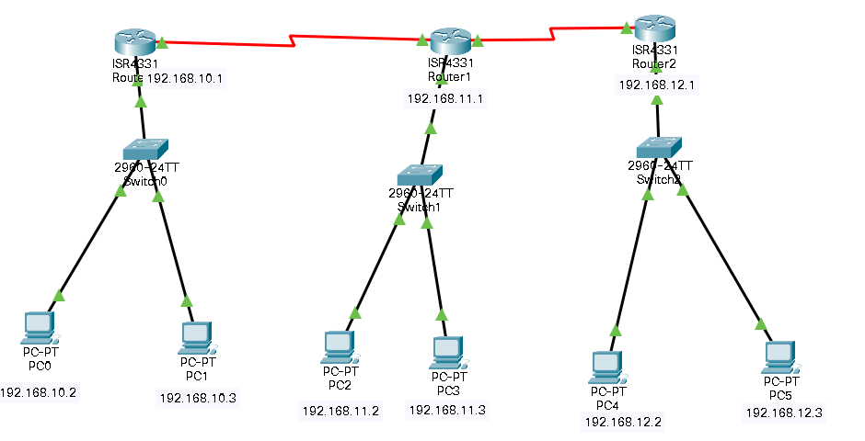

RESULT: Configured routers with static routing using IP route command.

