IRCTC SYSTEM DESIGN
Mock HLD Interview — Complete Revision Notes
Capacity Estimation • APIs • Data Model • HLD • Tatkal Scale • Saga • Waitlist • Counter-Questions
Prepared for: Gyanenjay — Java Backend Interview Prep
Source: personal Excalidraw interview-prep canvas, reorganized and gap-filled.

1. Capacity Estimation
Interviewer asks: Estimate the scale of the system — Daily Active Users, requests per second during peak (Tatkal), and DB storage per year. How would you approach this?

1.1 Given numbers
IRCTC has roughly:
- 3 crore registered users
- 13,000+ trains daily
- Tatkal opens at 10 AM — massive spike

1.2 Step 1 — State assumptions first
Let me state my assumptions before estimating. I'll think out loud so we're aligned.
"IRCTC has around 3 crore registered users. During Tatkal at 10 AM, I'd estimate roughly 10% are actively trying to book — that's about 30 lakh concurrent users. All of them hit the system within a 60 second window."
Total users = 3 crore
Active during Tatkal = ~10% = 30 lakh users
All hit at 10:00 AM sharp = within ~60 seconds
Each user makes ~3-5 requests
(search → seat availability → book)
RPS = (30,00,000 users × 4 requests) / 60 seconds
= 1,20,00,000 / 60
= ~2,00,000 RPS (2 lakh RPS) at peak

1.3 Step 2 — RPS calculation
"Each user makes roughly 3 to 4 requests — search, check availability, and book. So total requests become 30 lakh users × 4 requests = 1.2 crore requests, all within 60 seconds."
"That gives us — 1.2 crore divided by 60 — roughly 2 lakh RPS at peak. This is our critical design number."

1.4 Step 3 — Storage estimation
"For storage — IRCTC runs about 13,000 trains daily, each with roughly 1000 seats. That's 1.3 crore ticket records per day. Each record is around 1 KB, so that's 13 GB per day."
"Annually that's about 4.7 TB just for tickets. Adding users, payments, and train schedule data, I'd plan for ~10 TB per year and design storage accordingly."

1.5 Step 4 — Connect estimation to architecture (the most important step)
"These numbers directly influence my design in 3 ways —
2 lakh RPS means I cannot hit the database directly. I need Redis caching in front.
Seats are a finite shared resource, so I need distributed locking to prevent double booking.
10 TB yearly means I need a horizontally scalable database with sharding or partitioning."

2. Core APIs
Interviewer asks: Great, estimates look solid. Now can you define the Core APIs for IRCTC? Walk me through the key endpoints.
Interviewer expects coverage of: HTTP method, endpoint, request params/body, response structure.

2.1 Train Search API
"For train search, I'll use GET since we're just fetching data. Search filters go as query parameters since there's no sensitive data."
GET /api/v1/trains/search?source=BLR&destination=DEL&date=2026-06-10&class=SL
Response:
{
"trains": [
{
"trainId": "12345",
"trainName": "Rajdhani Express",
"source": "BLR",
"destination": "DEL",
"departure": "06:00",
"arrival": "28:00",
"duration": "22h",
"availableSeats": {
"SL": 120,
"3A": 45,
"2A": 20
},
"fare": {
"SL": 450,
"3A": 1200,
"2A": 1800
}
}
]
}

2.2 Book Ticket API
"For booking I'll use POST since we're creating a new ticket resource. Sensitive data like passenger details go in request body, not URL."
POST /api/v1/bookings
Authorization: Bearer <token>
Request body:
{
"trainId": "12345",
"journeyDate": "2026-06-10",
"class": "SL",
"passengers": [
{
"name": "Gyanenjay",
"age": 25,
"gender": "M"
}
],
"paymentMethod": "UPI"
}
Response:
{
"bookingId": "BKG123456",
"pnr": "4521367890",
"status": "PENDING",
"amount": 450,
"message": "Booking initiated, complete payment"
}
Q: Booking returns PENDING — why not CONFIRMED directly?
"Because payment hasn't happened yet. Booking flow is async — book → lock seat → pay → confirm. If payment fails we release the lock. So PENDING is the correct initial state."

2.3 Cancel Ticket API
DELETE /api/v1/bookings/{bookingId}
Authorization: Bearer <token>
Response:
{
"bookingId": "BKG123456",
"status": "CANCELLED",
"refundAmount": 360,
"refundETA": "5-7 business days"
}

2.4 PNR Status API
GET /api/v1/bookings/{pnr}/status
Authorization: Bearer <token>
Response:
{
"pnr": "4521367890",
"status": "CONFIRMED",
"seat": "S4 45",
"coach": "S4"
}

3. Data Model
Interviewer asks: Can you walk me through the Data Model?
Entities covered: User, Train, TrainSchedule, SeatInventory, Booking, Passenger, Payment.

1. users
userId UUID PK
name VARCHAR
email VARCHAR UNIQUE
phone VARCHAR UNIQUE
passwordHash VARCHAR
createdAt TIMESTAMP

2. trains
trainId VARCHAR PK (e.g. "12345")
trainName VARCHAR
source VARCHAR
destination VARCHAR
departureTime TIME
arrivalTime TIME
totalSeats JSON -- {"SL":500,"3A":200,"2A":100}

3. train_schedule
scheduleId UUID PK
trainId VARCHAR FK → trains
journeyDate DATE
status ENUM -- RUNNING, CANCELLED, DELAYED

4. seat_inventory (real-time availability — the critical table)
inventoryId UUID PK
scheduleId UUID FK → train_schedule
class ENUM -- SL, 3A, 2A, 1A
totalSeats INT
bookedSeats INT
availableSeats INT
fare DECIMAL
version INT -- for optimistic locking ⭐

5. bookings
bookingId UUID PK
userId UUID FK → users
scheduleId UUID FK → train_schedule
class ENUM
pnr VARCHAR UNIQUE
status ENUM -- PENDING, CONFIRMED, CANCELLED, WAITLISTED
totalAmount DECIMAL
createdAt TIMESTAMP

6. passengers
passengerId UUID PK
bookingId UUID FK → bookings
name VARCHAR
age INT
gender ENUM
seatNumber VARCHAR
coachNumber VARCHAR

7. payments
paymentId UUID PK
bookingId UUID FK → bookings
amount DECIMAL
method ENUM -- UPI, CARD, NETBANKING
status ENUM -- PENDING, SUCCESS, FAILED, REFUNDED
gatewayTxnId VARCHAR
createdAt TIMESTAMP

3.1 Design rationale (exact interview notes)
"I kept Train and Train Schedule separate because the same train runs daily — separating them avoids data duplication."
"Seat Inventory has a version column for optimistic locking — this prevents double booking during Tatkal rush without heavy DB locks."
"PNR lives in Booking table, not Train — because PNR is generated per booking, not per train."
"Passenger is separate from Booking because one booking can have multiple passengers."

4. HLD — Topics Covered
Every HLD concept this canvas exercised, in the order an interviewer typically probes them:
- Back-of-envelope capacity estimation (DAU, peak RPS, storage/year)
- REST API design conventions (GET vs POST vs DELETE, query params vs body)
- Relational data modeling & normalization (7-table schema, PK/FK design)
- CDN for static asset offload
- API Gateway: authentication, rate limiting, routing, SSL termination
- Load balancing (Round Robin / Least Connections, health checks)
- Microservices decomposition & single-responsibility boundaries
- Caching strategy (cache-aside, TTL, cache warming)
- Distributed locking (Redis SETNX) to protect a shared resource (a seat)
- Event-driven architecture / async messaging (Kafka)
- Rate limiting algorithms (Token Bucket, Sliding Window)
- Horizontal scaling & sharding (Redis Cluster by trainId)
- Auto-scaling strategy: scheduled vs reactive
- Distributed transactions across services (Saga — Choreography vs Orchestration)
- Idempotency in event consumers (duplicate Kafka delivery)
- Optimistic concurrency control (version column)
- Queue-based load levelling / virtual waiting room
- Waitlist promotion as an event-driven background process — 🆕 added in this revision

4.1 Architecture diagram
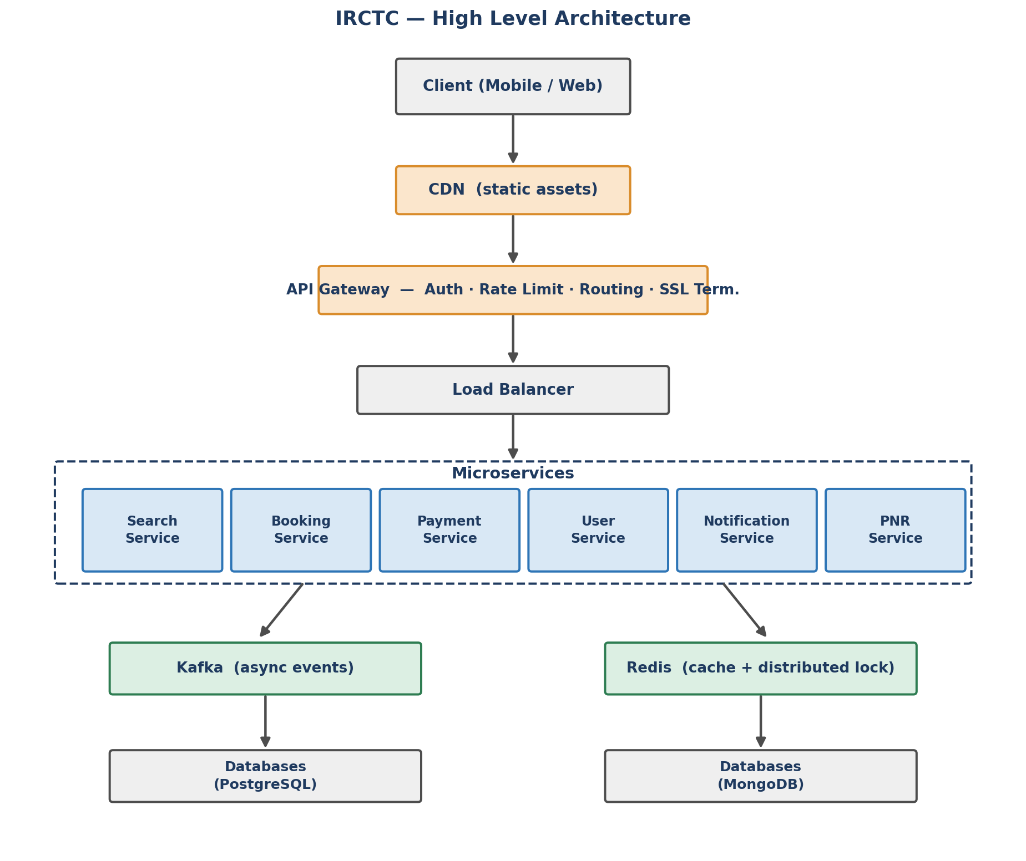
Client → CDN → API Gateway → Load Balancer → Microservices → Kafka / Redis → Databases

4.2 Component-by-component notes

1. CDN
- Serves static content — images, JS, CSS
- Reduces load on origin servers
"I'll put a CDN in front for static assets so origin servers only handle dynamic requests."

2. API Gateway
- a. Authentication — validates JWT token
- b. Rate Limiting — prevent abuse during Tatkal (Token Bucket / Sliding Window)
- c. Routing — routes to correct microservice
- d. SSL Termination
"API Gateway is the single entry point. It handles auth and rate limiting before request even reaches services — this protects backend during 2 lakh RPS spike."

3. Load Balancer
- Distributes traffic across service instances
- Health checks — removes dead instances
- Round Robin / Least Connection algorithm
"We place a Load Balancer in front of application servers and use Round Robin or Least Connections to distribute traffic across multiple instances."

4. Microservices
Service | Responsibility
Search Service | Find trains, availability
Booking Service | Create booking, seat locking
Payment Service | Initiate, verify payment
User Service | Registration, login, profile
Notification Service | SMS, Email, Push
PNR Service | PNR status check

5. Redis — two jobs
Job 1 — Cache:
- Search results cached for 1-2 minutes
- Seat availability cached with TTL
- Reduces DB load by ~90%
Job 2 — Distributed Lock:
When user selects seat →
SETNX lock:seat:12345:S4:45 userId EX 600
Only one user holds lock at a time
Lock expires in 10 mins if payment not done

6. Kafka — async events
Booking Service → produces → "BOOKING_CREATED"
↓
┌────┴──────────┐
↓ ↓
Payment Service Notification Service
"initiate payment" "send booking SMS"
Payment Service → produces → "PAYMENT_SUCCESS"
↓
┌────┴──────────┐
↓ ↓
Booking Service Notification Service
"confirm ticket" "send ticket SMS"
I use Kafka to decouple services. Booking service doesn't wait for notification to send SMS — it just fires an event and moves on. This keeps booking latency low."

7. Databases per service
Service | DB | Why
User Service | PostgreSQL | Relational, ACID
Booking Service | PostgreSQL | Strong consistency needed
Search Service | PostgreSQL + Redis cache | Heavy reads
Payment Service | PostgreSQL | ACID transactions
Notification Service | MongoDB | Flexible schema, logs

4.3 Complete booking flow
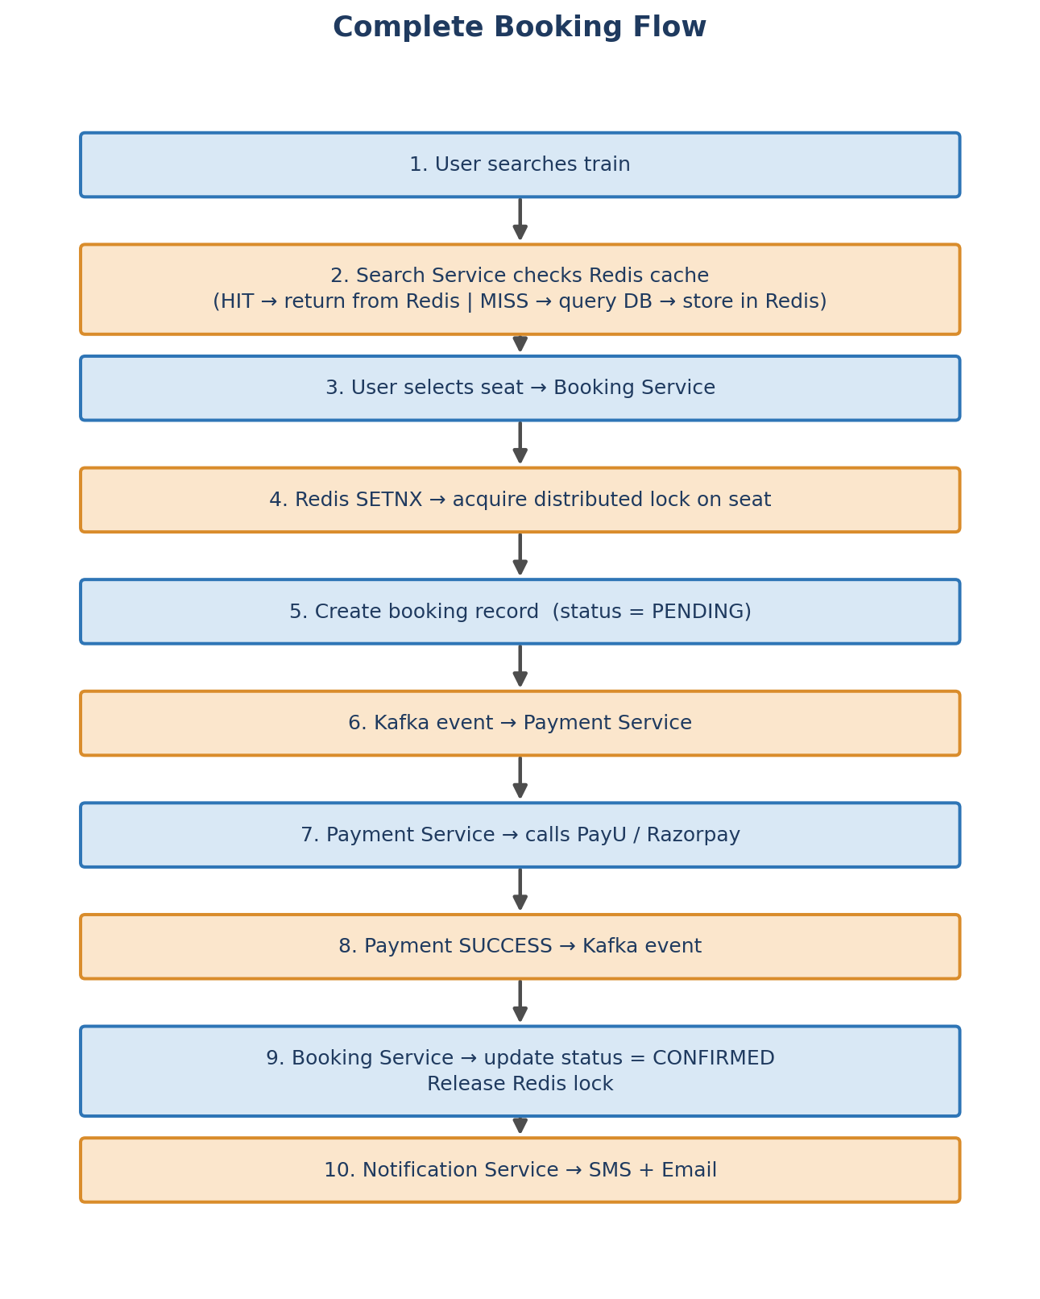

5. Database — Topics Covered
Database-specific concepts exercised across the data model and HLD sections:
Topic | Where / how it was applied
Relational schema design | 7 normalized tables with explicit PK/FK relationships (users, trains, train_schedule, seat_inventory, bookings, passengers, payments)
Polyglot persistence | PostgreSQL for services needing ACID/relational guarantees; MongoDB for Notification Service's flexible-schema logs
Optimistic locking | version column on seat_inventory — detects concurrent writes without holding DB locks
ENUM-driven state machines | status fields (RUNNING/CANCELLED/DELAYED, PENDING/CONFIRMED/CANCELLED/WAITLISTED, etc.) model lifecycle in-schema
Read-heavy optimization | Search Service pairs PostgreSQL with a Redis cache layer instead of hitting DB on every read
Caching as a DB load-shedding tool | TTL-based cache for search results & seat availability cuts DB load by ~90%
Distributed locking outside the DB | Redis SETNX used instead of DB row locks — avoids holding transactions open under 2L RPS
Horizontal partitioning / sharding | Redis Cluster sharded by trainId+date so no single shard is overwhelmed
Data separation to avoid duplication | Train vs TrainSchedule kept separate since one train runs many days
Redis as a queue/ordering structure | Sorted Set (ZADD/ZPOPMIN) proposed for FIFO waitlist ordering — 🆕 added in this revision

6. Deep Dive — Surviving 2 Lakh RPS (Thundering Herd)
Interviewer asks: 2 lakh RPS hitting Redis at 10 AM sharp — even Redis has limits. How do you protect the system?
The Tatkal rush is essentially a Thundering Herd problem — millions of requests hitting the system at exactly the same second. I'd solve this with multiple layers of protection."

Layer 1 — Rate Limiting at API Gateway
Each user → max 5 requests per second
Each IP → max 10 requests per second
↓
Filters out bots and aggressive clients
Reduces 2L RPS to manageable load
"First line of defence is rate limiting at API Gateway using token bucket algorithm. This filters bots and prevents any single user from hammering the system."

Layer 2 — Queue-based Booking
User clicks Book
↓
Request goes into a Queue (Kafka)
User sees → "You are in queue, position 45,000"
↓
Booking Service processes queue
at controlled rate → 10,000 per second
↓
User gets notified when turn comes
"Instead of letting 2 lakh requests hit Booking Service directly, I push them into a Kafka queue. Booking Service processes at a controlled rate. User sees their queue position — like a virtual waiting room."

Layer 3 — Redis Cluster (sharding)
Single Redis → can handle ~1 lakh RPS
↓
Redis Cluster with sharding
Shard by trainId + date
↓
Train 12345 → Shard 1
Train 67890 → Shard 2
↓
Load distributed across shards
Each shard handles subset of trains
"Redis in cluster mode with sharding by trainId. Each shard handles a subset of trains — so no single node gets overwhelmed."

Layer 4 — Pre-computation before 10 AM
9:50 AM — system wakes up
↓
Pre-loads seat inventory into Redis
Pre-computes available seats per train
↓
10:00 AM — all reads served from Redis
DB not touched for reads at all
"Before Tatkal opens, I warm up the Redis cache at 9:50 AM. All seat availability reads at 10 AM are served purely from Redis — database never gets hit for reads."

Layer 5 — Auto Scaling (scheduled, not reactive)
9:55 AM — CloudWatch alarm triggers
↓
AWS Auto Scaling → spins up extra
Booking Service instances
↓
10:00 AM — extra capacity ready
↓
10:30 AM — scales back down
"I use AWS Auto Scaling with scheduled scaling — not reactive scaling. Reactive scaling takes 2-3 minutes to spin up. By then Tatkal is over. So I pre-scale at 9:55 AM on a schedule."
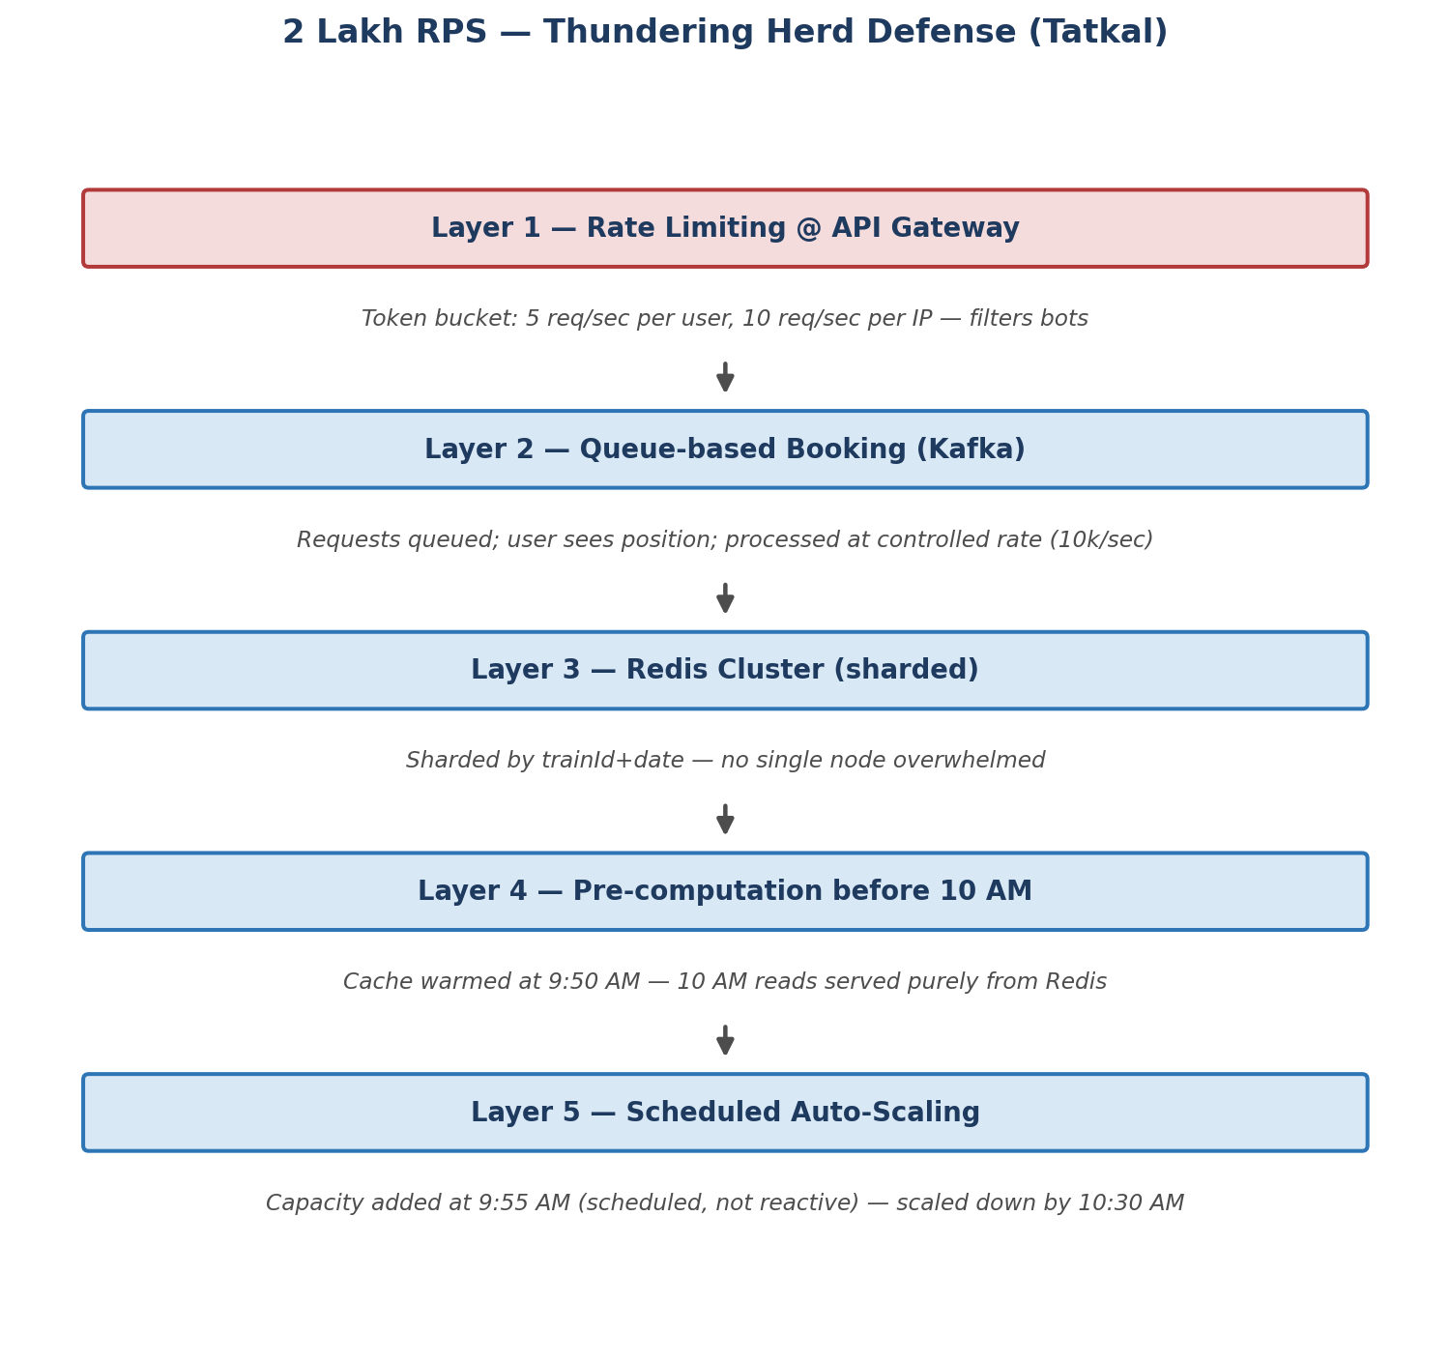

Counter-questions on this section
Q: What if user is in queue for 30 mins and seat is gone?
"When their turn comes, if no seat available, they get notified immediately — 'No seats available, you can join waitlist.' Queue position is still respected — first in first served."
Q: Why scheduled scaling and not reactive?
"Reactive scaling triggers after CPU crosses threshold — takes 2-3 minutes. Tatkal rush lasts only 60 seconds. By the time reactive scaling kicks in, damage is done. Scheduled scaling is proactive — capacity ready before spike."
Q: What is token bucket algorithm?
"Each user gets a bucket with 5 tokens. Each request consumes 1 token. Tokens refill at rate of 1 per second. If bucket empty — request rejected with 429 Too Many Requests. Prevents aggressive clients from hogging capacity."

7. Deep Dive — Race Condition, Distributed Transaction & Zombie Locks
In my opinion the hardest problem in IRCTC is not just one problem — it's a combination of three interconnected problems during Tatkal rush."
- First: the race condition — 2 lakh users hitting the same seat simultaneously. This is a classic Race Condition.
- Second: the distributed transaction problem — payment and booking are two separate services. If one succeeds and other fails, we have an inconsistent state. Money gone, no ticket.
- Third: zombie locks — seats locked by users who never completed payment, blocking others from booking.

7.1 Problem 1 — Race Condition
User A reads → seat available ✅
User B reads → seat available ✅
User A books → success ✅
User B books → also success ✅ ❗WRONG!
Same seat given to 2 people!
Solution — Redis Distributed Lock:
User selects seat S4-45 on train 12345 on date 2026-06-10
↓
Booking Service runs:
SETNX lock:12345:2026-06-10:S4:45 userId EX 600
↓
Returns 1 → Lock acquired ✅ → proceed to payment
Returns 0 → Lock already held ❌ → "Seat being booked by someone else"
"SETNX is atomic in Redis — only one user wins the lock even at 2 lakh RPS. EX 600 means lock auto expires in 10 minutes — solves zombie lock problem too."
I would use Redis distributed locking to temporarily reserve a seat during booking, and optimistic locking using the version column in SeatInventory to guarantee consistency when updating inventory in the database. This gives both high performance and correctness under Tatkal-scale traffic.

7.2 Problem 2 — Distributed Transaction (Saga Pattern)
Step 1: Create Booking (status=PENDING)
Step 2: Lock Seat in Redis
Step 3: Initiate Payment via Kafka
Step 4: Payment SUCCESS → confirm booking (status=CONFIRMED)
Payment FAILED → rollback → release lock → status=FAILED → refund
Rollback chain:
Payment Failed
↓
Kafka event → "PAYMENT_FAILED"
↓
Booking Service → status = FAILED
↓
Redis → release seat lock
↓
Notification Service → "Payment failed, try again"
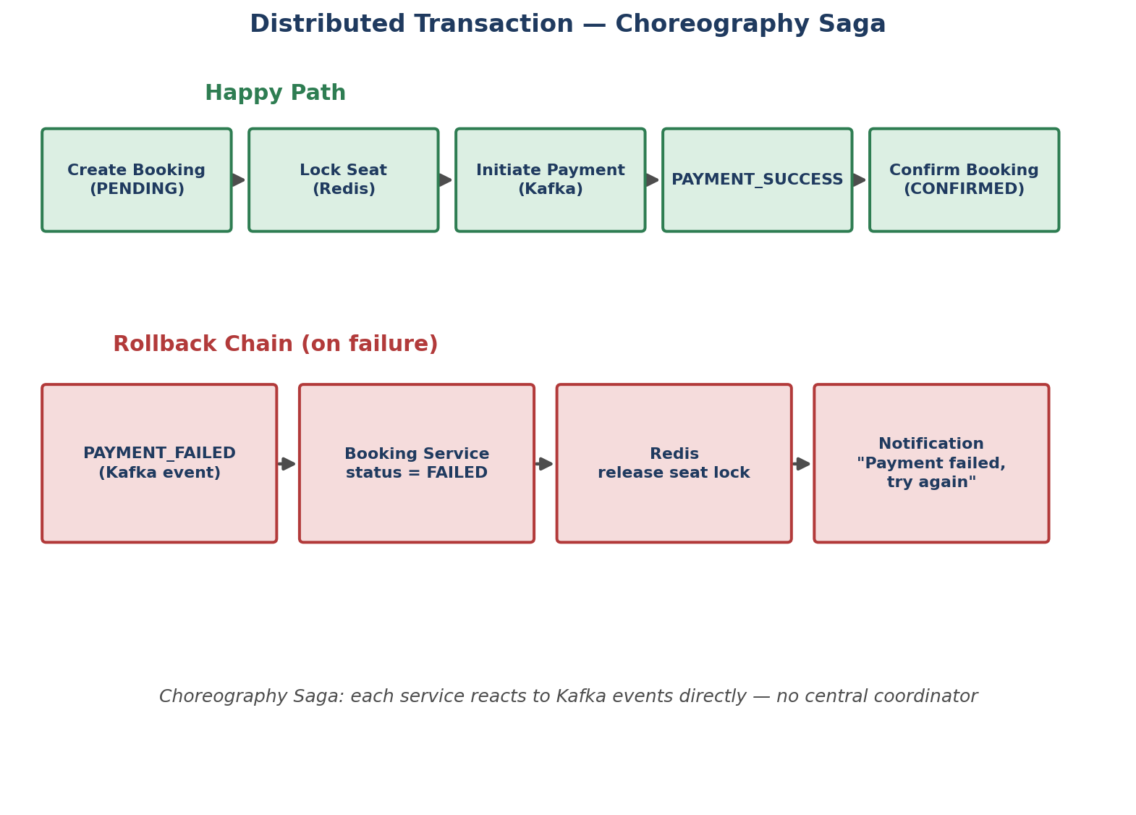
"I use Choreography based Saga — each service listens to Kafka events and reacts. No central coordinator needed. If payment fails, the chain automatically rolls back."

7.3 Problem 3 — Zombie Locks
- Redis lock expires in 10 minutes automatically
- Scheduled job runs every 5 minutes:
  - finds PENDING bookings older than 10 mins
  - marks them EXPIRED
  - releases seat
  - sends notification — "Your booking expired"

Counter-questions on this section
Q: What if Redis lock expires but user is still on payment page?
"Payment gateway has a timeout of 5-7 minutes. If lock expires in 10 minutes, payment would have already timed out. So by the time lock expires, payment is already done or failed. Edge case handled."
Q: What if same Kafka event is processed twice?
"I make all consumers idempotent. Each event has a unique eventId. Consumer checks if eventId already processed — if yes, skip. This handles duplicate Kafka delivery."
Q: Why Choreography Saga and not Orchestration Saga?
"Orchestration needs a central coordinator — single point of failure. Choreography is decentralized — each service just reacts to events. More resilient for our scale."

8. Waitlist Promotion — Filling the Gap
🆕 ADDED — FILLING THE GAP
This was the one topic flagged as “Pending” in the original coverage checklist. Below is a full design written in the same assumption-first / interviewer-script style as the rest of this doc, so it slots straight into the mock interview.

8.1 Why it's tricky
- A cancellation frees exactly one seat, but many users may be waitlisted for that schedule+class — must promote in fair (FIFO) order
- Multiple cancellations can land at almost the same time — must not double-promote the same seat
- Must reuse the same primitives already in the design (Redis lock, Kafka events, idempotent consumers) instead of inventing new infrastructure

8.2 What you'd say in the interview
Interviewer asks: Good, payment Saga is solid. One thing I don't see yet — how does waitlist promotion work when a confirmed user cancels?
"Good question — I treat this as a fourth Kafka-driven flow, reusing the same building blocks as booking: an event trigger, a Redis structure for ordering, and the same SETNX lock for the actual seat assignment."
"When a CONFIRMED booking is cancelled, Booking Service fires a SEAT_CANCELLED event with the scheduleId and class. A Waitlist Service consumes that event and pops the earliest-waitlisted booking for that exact schedule+class."
"I keep waitlist order in a Redis Sorted Set — ZADD waitlist:{scheduleId}:{class} with the booking's creation timestamp as the score. That gives me an O(log N) FIFO pop with ZPOPMIN, instead of scanning the bookings table by createdAt every time a seat frees up."
"Once I pop a candidate, I acquire the same SETNX seat lock used in normal booking. If I get the lock, I flip that booking from WAITLISTED to CONFIRMED, assign the seat/coach, and fire a notification. If the lock is somehow already held — edge case, near-simultaneous cancellations — I just pop the next entry in the sorted set instead of failing the whole flow."

8.3 Design
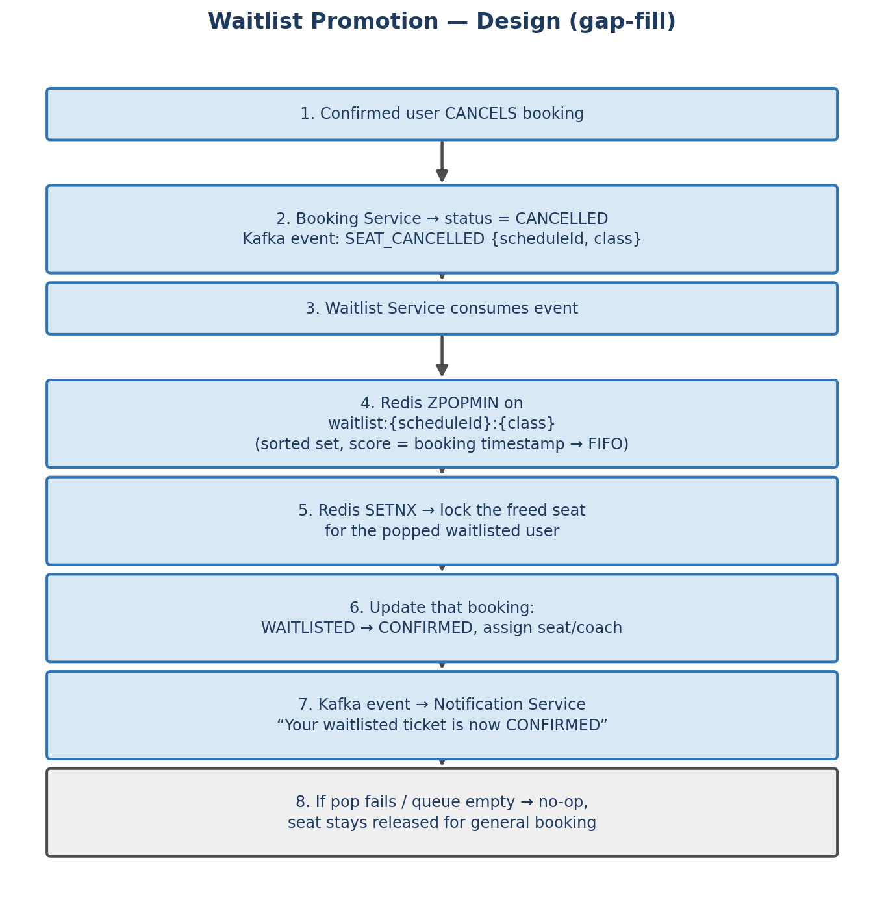

8.4 Data model addition
No new table is strictly required — bookings.status already has a WAITLISTED value. Two additions make it robust:
seat_inventory
+ waitlistCount INT -- quick visibility into demand per schedule/class
Redis (new key, not a new table)
waitlist:{scheduleId}:{class} -- Sorted Set, score = booking createdAt epoch

8.5 Reusing existing patterns (why this fits cleanly)
Building block | Already used for | Reused here for
Kafka event | BOOKING_CREATED, PAYMENT_SUCCESS | SEAT_CANCELLED triggers promotion
Redis SETNX lock | Preventing double booking | Preventing double promotion of the same freed seat
Idempotent consumer (eventId) | Duplicate Kafka delivery on payment | Duplicate SEAT_CANCELLED delivery
Notification Service | Booking confirmation SMS | “Your waitlisted ticket is now confirmed”

8.6 New counter-questions (added)
Q: What if two seats free up at almost the same moment — do you process them sequentially?
"Each SEAT_CANCELLED event is handled independently and idempotently, so two events can be processed concurrently — they each ZPOPMIN their own candidate and acquire their own SETNX lock, so they naturally promote two different waitlisted users without colliding."
Q: What if the popped waitlisted user already booked an alternate train and doesn't want this seat anymore?
"I'd still confirm it automatically — that's the standard IRCTC behaviour — but the confirmation notification includes a one-tap cancel link. If they cancel, that itself fires another SEAT_CANCELLED event and the chain continues to the next person in the sorted set."
Q: Why a Redis Sorted Set instead of just querying the bookings table ORDER BY createdAt?
"At Tatkal scale that query would run constantly and contend with the same table that's handling writes. ZPOPMIN is O(log N), in-memory, and doesn't touch Postgres at all — consistent with the rest of the design's philosophy of keeping the hot path off the database."

9. All Counter-Interview Questions — Consolidated
Every Q&A from across the canvas, grouped by topic, for rapid-fire revision.

Booking / API design
Q: Booking returns PENDING — why not CONFIRMED directly?
"Because payment hasn't happened yet. Booking flow is async — book → lock seat → pay → confirm. If payment fails we release the lock. So PENDING is the correct initial state."

Tatkal scale (Thundering Herd)
Q: What if user is in queue for 30 mins and seat is gone?
"When their turn comes, if no seat available, they get notified immediately — 'No seats available, you can join waitlist.' Queue position is still respected."
Q: Why scheduled scaling and not reactive?
"Reactive scaling takes 2-3 minutes; Tatkal rush lasts 60 seconds. Scheduled scaling pre-provisions capacity at 9:55 AM, before the spike."
Q: What is token bucket algorithm?
"Each user gets a bucket with 5 tokens, refilled at 1/sec. Empty bucket → 429 Too Many Requests. Prevents aggressive clients from hogging capacity."

Concurrency / Locking
Q: What if Redis lock expires but user is still on payment page?
"Payment gateway timeout (5-7 min) is shorter than the lock TTL (10 min), so payment resolves before the lock would expire. Edge case is naturally handled."
Q: What if same Kafka event is processed twice?
"All consumers are idempotent — each event carries a unique eventId; if it's already been processed, the consumer skips it."
Q: Why Choreography Saga and not Orchestration Saga?
"Orchestration needs a central coordinator — a single point of failure. Choreography is decentralized; each service reacts to events independently, which is more resilient at this scale."

Waitlist (added)
Q: What if two seats free up at almost the same moment?
"Each cancellation event is handled idempotently and independently — they each pop their own candidate from the sorted set and acquire their own lock, so they don't collide."
Q: Why a Redis Sorted Set instead of querying the bookings table?
"ZPOPMIN is O(log N) and in-memory — it keeps the hot path off Postgres, consistent with the rest of the design."

10. Coverage Checklist
# | Topic | Status | Where covered
1 | Seat Inventory Management | ✅ Done | Data Model (seat_inventory table, version column)
2 | Seat Locking | ✅ Done | Deep Dive — Redis SETNX distributed lock
3 | Tatkal Rush (Thundering Herd) | ✅ Done | 5 layers: Rate limit, Queue, Cluster, Cache warming, Auto-scale
4 | Payment Saga | ✅ Done | Deep Dive — Choreography Saga + rollback chain
5 | Waitlist Promotion | ✅ Done | Section 8 — added in this revision
6 | Caching with Redis | ✅ Done | HLD (search cache) + Tatkal (cache warming, sharding)
7 | Kafka Events | ✅ Done | HLD (BOOKING_CREATED, PAYMENT_SUCCESS) + Saga rollback

Everything originally listed is now ✅ complete — no pending items remain.

