**Heuristic Evaluations**

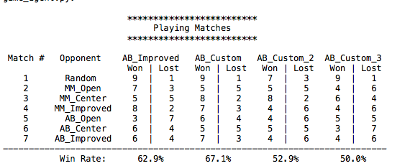

**Distance_from_center – custom_score_1**

**Description:** Evaluates the distance between the players current location and the center of the board with the distance formula

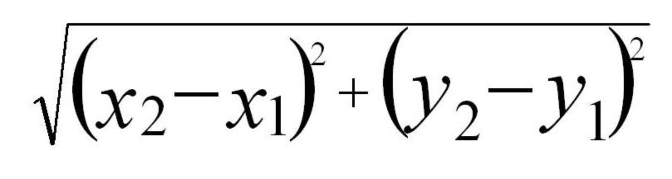

**Reason:** Based on the center_score heuristic where the lesson mention that the center board was always a good move regardless if you were starting or going second.

**Result:** Actually beat AB_improved by 4.2%

**Code:**

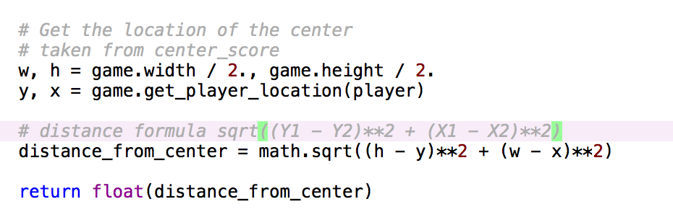

**run_away – custom_score_2**

**Description:**  Calculates the distance between you and your opponent.

**Reason:** Simple strategy that utilizes keeping your opponent as far as possible thus leaving you with more moves around you.

**Result:** Ended up doing horrible against AB_Improved but with similar results in most area

**Code:**

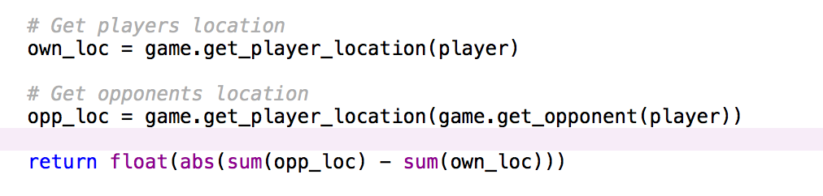

**square_legal_moves – custom_score_3**

**Description:** Returns the squared result of your available moves – opponents available moves

**Reason:** Wanted to test to see if doing so would improve the results of improve_score

**Result:** This heuristic test ended up worst then the original would not recommend.

**Code:**

