Internship on
Review and Practical Analysis of Fuzzy Set Theory Applications in 3D printing Parameters for Improved Mechanical Properties.

Submitted to

Amity University Uttar Pradesh

In the partial fulfilment of the requirements for the award of the degree of Master of Technology in Computer Science & Engineering

Submitted By: Gyanendra Singh
Enrolment No: A7600925005
under the guidance of:
Dr. Syed Wajahat Abbas Rizvi
DEPARTMENT OF COMPUTER SCIENCE AND ENGINEERING
AMITY SCHOOL OF ENGINEERING AND TECHNOLOGY
AMITY UNIVERSITY UTTAR PRADESH LUCKNOW
July 2025

AMITY UNIVERSITY
–––––––––UTTAR PRADESH–––––––––
DECLERATION BY THE STUDENT

I Gyanendra Singh, student of MTech hereby declare that the project titled Review Practical Analysis of Fuzzy Set theory Applications in 3D printing Parameters for improved Mechanical Properties. Which is submitted by me to Department of Computer Science and Engineering, Amity School of Engineering and Technology, Uttar Pradesh, Lucknow Campus, in partial fulfilment of requirements for the award of the degree of Master of Technology in Computer science and Engineering has not been previously formed the basis for the award of any degree, diploma or other similar title or recognition.

Lucknow
2026

Gyanendra singh
A7600925005(cse)


AMITY UNIVERSITY
–––––––––UTTAR PRADESH–––––––––

DECLERATION BY THE STUDENT

On the basis of the declaration submitted by Gyanendra Singh, student of MTech, I hereby certify that the project titled “Review and Practical Analysis of Fuzzy Set Theory Applications in 3D Printing Parameters for Improved Mechanical Properties” which is submitted to Amity School of Engineering and Technology, Uttar Pradesh, Lucknow, in partial fulfilment of the requirement for the award of the degree of Master of Technology in Computer Science and Engineering, is an original contribution to the existing body of knowledge and a faithful record of work carried out by her under my guidance and supervision.
To the best of my knowledge, this work has not been submitted in part or full for any Degree or Diploma to this University or elsewhere.

Lucknow
April 2026
Dr. Syed Wajahat Abbas Rizvi
Amity University Lucknow

Abstract
Additive Manufacturing is also called 3D printing or three-dimensional printing. It is emerging as a significant technology for producing complex components with minimal material waste and high design flexibility. However, the mechanical properties of 3Dprinted parts are highly dependent on various process parameters, such as nozzle temperature, printing speed, and layer thickness. Improper selection of these parameters can lead to defects, including poor layer adhesion, surface roughness, and reduced mechanical strength.
This research paper is based on a fuzzy logic-based optimization framework for determining optimal 3D printing parameters to enhance the mechanical properties of printed components. In this project, a Fuzzy Inference System (FIS) is developed to model the nonlinear relationship between printing parameters and mechanical performance.
This method helps capture the nonlinear relationship parameter of additive manufacturing systems, significantly improving tensile strength and overall print quality.

Table of Contents
Abstract
1. Introduction
1.1 Problem Statement
1.2 Objectives
2.Literature Review
3. Methodology
3.1 System Overview
3.2 Output Variable
3.3 Membership Functions
3.4 Fuzzy Rule Base
3.5 Defuzzification
3.7 Inference Engine
4. Analysis and discussion
4.1 Expected Results Analysis
4.2 Discussion
4.3 Advantages of Proposed Approach
5. Conclusion
5.1 Key Findings
5.2 Future Scope

1. Introduction
Manufacturing, commonly referred to as 3D or three-dimensional printing, is an Additive innovative production technique that forms three-dimensional objects by layering materials according to digital designs. Unlike traditional manufacturing processes that typically involve removing material through methods like cutting and machining with lathes or other equipment, additive manufacturing constructs items directly from design specifications. This approach not only minimizes material waste but also offers greater flexibility in design. In additive manufacturing there is no removal of object takes place.
There are several different types of Additive Manufacturing techniques, including:
- VAT Photopolymerization
- Material Jetting
- Binder Jetting
- Powder Bed Fusion
- Sheet Lamination
- Directed Energy Deposition
- Material Extrusion
Material extrusion, also known as Fused Deposition Modelling (FDM), is among the most popular methods for additive manufacturing. Its affordability, ease of use, and accessibility make it a preferred choice in various sectors, particularly where precision and strength are crucial, such as in aerospace, automotive, healthcare, and product prototyping.
The quality of the final product is in influenced by factors such as nozzle temperature, printing speed, layer thickness, and infill density. The interplay between these variables and the resulting output is complex and often nonlinear. Even minor adjustments in these parameters can significantly affect mechanical characteristics like tensile strength, surface quality, and dimensional accuracy. Consequently, determining the best parameters poses a significant challenge in additive manufacturing.
In the Fused Deposition Modelling process, methods such as Taguchi methods, trial and-error approaches, and statistical analyses are employed to identify optimal parameters. However, these methods typically focus on linear relationships and may not effectively account for the intricate nonlinear relationships involve.
Conventional optimization methods like trial-and-error, Taguchi techniques, and statistical analysis are frequently employed; however, they typically struggle to accurately address the uncertainties and nonlinear interactions found in the processes. In this regard, fuzzy logic emerges as a robust method for managing imprecision and uncertainty through the use of linguistic variables and rule-based reasoning. This project aims to implement fuzzy logic to enhance the optimization of 3D printing parameters, thereby improving the mechanical characteristics and overall quality of the printed parts.
Material Extrusion
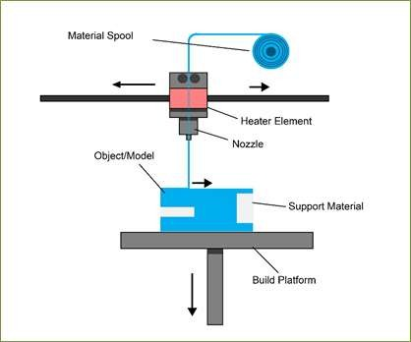

1.1 Problem Statement

In the realm of additive manufacturing, particularly in FDM-based 3D printing, identifying the best process parameters such as nozzle temperature, print speed, and layer thickness presents a significant challenge. This difficulty arises from the intricate and nonlinear connections between the input parameters and the resulting performance. These parameters play a crucial role in determining the strength, surface finish, and overall structural integrity of the printed objects.
Using incorrect settings can lead to issues such as weak layer adhesion, unsatisfactory surface quality, dimensional errors, and diminished mechanical strength. Traditional optimization on techniques tends to be slow, ineffective, and struggle to address uncertainties in the process.

Consequently, there is a pressing need for a smart and adaptable method that can accurately model these nonlinear interactions and aid in identify the best combinations of parameters to improve the mechanical properties of 3D printed components.

1.2 Objectives
The primary goals of this project include:
- Exploring the basic principles of fuzzy logic and its use in additive manufacturing.
- Examining how essential 3D printing factors like nozzle temperature, printing speed, and layer thickness impact the process.
- Creating a model based on fuzzy logic to optimize the parameters of 3D printing.
- Enhancing the mechanical characteristics, particularly the tensile strength, of components produced through 3D printing.
- Minimizing defects such as inadequate layer adhesion and rough surfaces in the printed.

2. Literature Review
The swift expansion of Additive Manufacturing, especially in the area of 3D printing, has garnered considerable interest from both researchers and industries, owing to its capacity to create intricate designs while minimizing material waste and enabling high levels of customization. Nevertheless, attaining the best mechanical characteristics in 3D printed parts poses a significant challenge, largely due to the strong influence of process parameters.
Numerous studies have investigated various optimization strategies to enhance the quality and functionality of 3D printed components. Conventional methods, including Taguchi techniques, Response Surface Methodology (RSM), and statistical analysis, have been extensively applied to assess how process parameters such as nozzle temperature, layer thickness, and printing speed affect mechanical properties. While these methods can identify important parameters, they often struggle to address the complex nonlinear relationships between input factors and performance outcomes.
Trivedi and Gurrala (2021) created a fuzzy logic-based expert system to forecast the tensile strength of items produced through Fused Deposition Modelling (FDM). Their research examined critical factors including extrusion temperature, layer thickness, and part orientation, finding that a horizontal orientation maximizes tensile strength. The findings indicated that increasing the extrusion temperature and optimizing layer thickness significantly enhance tensile strength. The fuzzy model showed a high level of predictive accuracy with minimal error, demonstrating its capability to manage uncertainty and nonlinear behaviour in additive manufacturing.
Sood et al. (2010) explored how process parameters in influence the mechanical characteristics of FDM components using statistical methods. Their findings underscored the importance of parameters like layer thickness and orientation in determining the strength and surface quality of printed parts. However, they also noted the limitations of traditional optimization approaches when addressing intricate interactions between parameters.
Recently, machine learning techniques such as Support Vector Machines, Artificial Neural Networks, and Deep Learning have been employed to predict and refine 3D printing performance, showing promising outcomes in understanding nonlinear relationships. However, these models often necessitate extensive datasets and significant computational power, which can limit their practicality in certain situations.
Fuzzy logic has emerged as a viable alternative due to its ability to model uncertainty and utilize human-like reasoning through linguistic variables. It does not depend on precise mathematical formulations and can function effectively with limited data. Fuzzy Inference Systems (FIS), particularly Mamdani-type systems, are commonly utilized in manufacturing for process control, decision-making, and optimization.
Although there is an increasing amount of research in this field, few studies have specifically examined the use of fuzzy logic to optimize parameters in 3D printing to enhance mechanical properties. The majority of current research utilizes statistical techniques or intricate machine learning algorithms. As a result, this study intends to fill that gap by creating an optimization framework based on fuzzy logic. This framework will effectively represent the correlation between process parameters and mechanical performance, offering a straight forward, efficient, and dependable approach to enhancing the quality of 3D printed parts.

3. Methodology
The primary objective of this study is to develop and implement a Fuzzy Inference System (FIS) aimed at optimizing critical parameters in 3D printing and improving the mechanical characteristics of printed parts. Additive manufacturing techniques, especially Fused Deposition Modelling (FDM), involve intricate nonlinear interactions between input parameters like nozzle temperature, printing speed, and layer thickness, as well as output metrics such as tensile strength and surface finish.
To effectively leverage these interactions, a methodical approach is employed. The process starts by identifying essential input and output variables, followed by creating suitable membership functions to represent the linguistic variables. A detailed fuzzy rule base is then established, drawing from expert knowledge and relevant literature.
In the operation of the FIS, the initial step involves fuzzifying the input parameters. Subsequently, inference rules are applied to these inputs using the Mamdani inference method. Finally, the fuzzy output is translated into a precise value through defuzzification, utilizing the centroid approach. This method effectively addresses the nonlinear behaviour of the input variables.
In summary, the proposed methodology offers a smart and adaptable framework for optimizing parameters, ensuring enhanced accuracy in predictions and improved control over the mechanical performance of 3D printed components.
3.1 System overview
The proposed system is based on fuzzy logic principles, which are designed to handle uncertainty (non-linear relationship) and imprecision in complex systems such as 3D printing. In this approach, the input parameters are not treated as exact numerical values but are converted into linguistic variables such as Low, Medium, and High. This allows the system to mimic human reasoning and make more flexible decisions.
In the fuzzy logic system, the input parameter is nozzle temperature, printing speed, and layer thickness takes an important 3D printing parameter. These inputs are passed through a series of steps to determine their effect on the output, which is the mechanical performance (tensile strength) of the printed component.
Instead of using strict mathematical equations, the system uses a set of if–then rules (fuzzy rules) to establish relationships between input parameters and the output.
Based on these rules, the system evaluates different combinations of input values and generates an optimal output that represents the expected performance of the printed part.
The overall working of the system is divided into the following stages:
Input Variable Selection:
First identify the important parameters here of important process parameters (e.g. temperature, speed, layer thickness) that directly affect the output.
Fuzzification:
After deciding the input variables, we convert the crisp numerical input values into fuzzy linguistic values using membership functions.
Rule Base Formulation:
After the fuzzification we apply the if-then rules which define the relationship between the input and output variables.
Inference Mechanism:
We use Mamdani approach to decide the rules (if then) to generate fuzzy output.
Defuzzification:
Conversion of fuzzy output into a single crisp value using the centroid method.
The structured approach ensures that the system can effectively model complex and nonlinear relationships, which leads to better optimization of 3D printing parameters and improved mechanical properties of the final product.
3.2 Output Variable
In this project we considered as the Tensile strength is the output variable. Tensile strength is the maximum resisting tensile stress a material can withstand before breaking. The tensile stress is the maximum tensile force acting per unit cross sectional-area.
In additive manufacturing, tensile strength is one of the most important indicators of part quality, as it directly reflects the bonding between layers and the overall structural integrity of the printed object. The tensile strength of a component is significantly influenced by process parameters such as nozzle temperature, printing speed, and layer thickness.
In this research, tensile strength is modelled as the output of the fuzzy inference system and is represented using linguistic terms such as:
- Poor tensile strength
- Moderate tensile strength
- Good tensile strength
So, in this system we use three parameters poor, medium and good which simplifies the output of the result.
By optimizing the input parameter through the fuzzy logic system, the goal is to achieve higher tensile strength, thereby improving the durability and performance of 3D printed components.
3.3 Membership Functions
A crisp set is a traditional type of set-in which elements either completely belong to the set or do not belong at all. Membership in these sets is binary, represented as either 0 or 1. For instance, if A = {2, 4}, then 2 is an element of A while 3 is not. Crisp
sets have well-defined boundaries and are commonly utilized in classical mathematics and logic. On the other hand, fuzzy sets permit partial membership, making them better suited for modelling uncertainties in parameters related to 3D printing.
A membership function is a curve that illustrates how each point within the input space corresponds to a membership value or degree of membership ranging from 0 to 1. In this research project, membership functions are employed to translate numerical input values of 3D printing parameters into linguistic terms such as Low, Medium, and High. This approach aids in addressing uncertainty and variability in the additive manufacturing process.
There are various types of membership functions, but this project specifically utilizes the Triangular membership function because the evaluation framework only requires three linguistic parameters: Poor, Medium, and Good.
The triangular membership function is advantageous for several reasons:
1.Simplicity: It is straightforward to define, needing just one peak and two endpoints.
2.Computational efficiency: Its calculations rely solely on linear equations, making it convenient for implementation in projects.
3.Interpretability: Graphically, triangular membership functions are easy to understand, and their explanations are clear.
In this function, we make use of three specific parameters:
- Lower limit
- Peak limit
- Upper limit
Input Variables
The fuzzy system takes the following parameters as inputs:
- Nozzle Temperature
- Printing Speed
- Layer Thickness
Each of these parameters is categorized into three linguistic variables:
- Low
- Medium
- High
These parameters are depicted using overlapping triangular variables, for example:
Explanation:
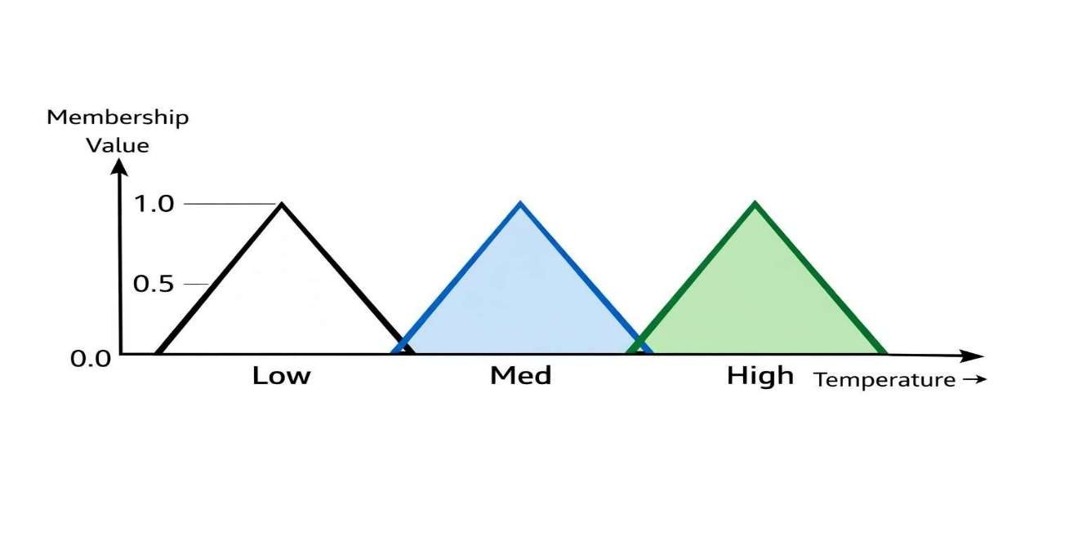
- The Low region represents the lower temperature values.
- The Medium region represents the moderate values, in the graph, it corresponds to the mid or peak value.
- The High region represents higher temperature values.
- The overlapping areas between the regions ensure a smooth transition, which allowing a gradual change from one category to another category.
For example, a temperature of 200°C may belong:
0.6 in Medium
0.4 in High
This allows the system to handle real the world uncertainty effectively.
Output Membership Function
The tensile Strength is the output of the fuzzy system:
Poor tensile strength - red colour triangle is the region of poor strength.
Moderate tensile strength - yellow colour region in the triangle is represent the moderate tensile strength
Good tensile strength- green colour region in the triangle is represent the good tensile strength.
In between the overlapping part represents the gradual decision of the parameter, allowing smooth transitions from one linguistic category to another.
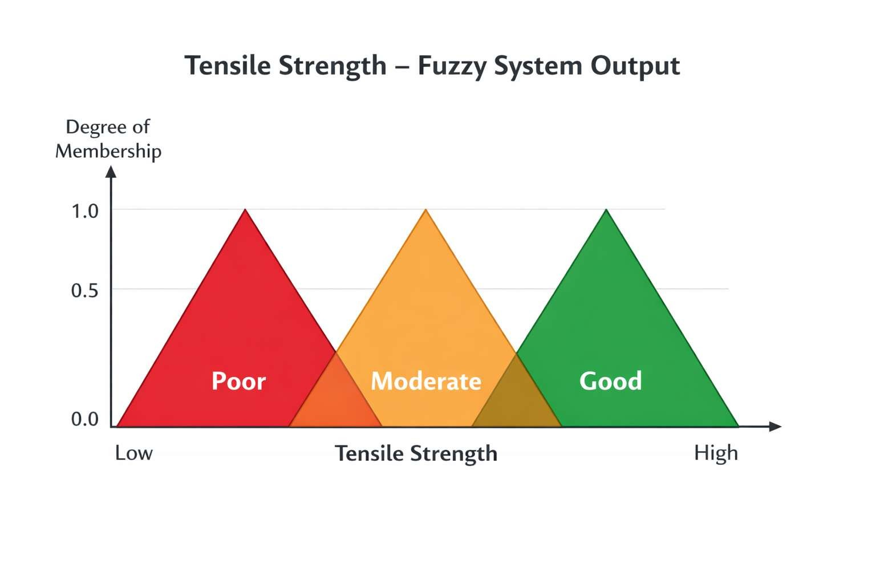
3.4 Fuzzy Rule Base
The fuzzy rule base serves as the fundamental element of the fuzzy inference system, establishing the connection between input and output variables through a series of if-else statements. These statements are derived from expert insights and empirical data related to the materials being analysed, alongside findings from prior research. In this analysis, three input variables are examined:
Nozzle Temperature (categorized as Low, Medium, High)
Printing Speed (classified as Low, Medium, High)
Layer Thickness (identified as Low, Medium, High)
Each input comprises three linguistic categories, resulting in a total of 27 rules calculated as follows: 3 × 3 × 3. These rules correspond to the various combinations of input parameters and relate them to the output variable, Tensile Strength, which is classified into three levels: Poor, Moderate, and Good.
Fuzzy rule sheet

Rule No. | Nozzle Temp | Printing Speed | Layer Thickness | Output Quality
1 | Low | Low | Low | Poor
2 | Low | Low | Medium | Poor
3 | Low | Low | High | Medium
4 | Low | Medium | Low | Poor
5 | Low | Medium | Medium | Medium
6 | Low | Medium | High | Medium
7 | Low | High | Low | Poor
8 | Low | High | Medium | Medium
9 | Low | High | High | Good
10 | Medium | Low | Low | Poor
11 | Medium | Low | Medium | Medium
12 | Medium | Low | High | Good
13 | Medium | Medium | Low | Medium
14 | Medium | Medium | Medium | Good
15 | Medium | Medium | High | Good
16 | Medium | High | Low | Medium
17 | Medium | High | Medium | Good
18 | Medium | High | High | Very Good
19 | High | Low | Low | Medium
20 | High | Low | Medium | Good
21 | High | Low | High | Very Good
22 | High | Medium | Low | Good
23 | High | Medium | Medium | Very Good
24 | High | Medium | High | Excellent
25 | High | High | Low | Good
26 | High | High | Medium | Very Good
27 | High | High | High | Excellent

Explanation of Rules
- If we use low temperature then the cohesive force between molecule is low then the bond between the molecules is weak.
- If we use moderate temperature then the cohesive force between molecule is moderate then the bond between the molecules is moderate.
- Like if we use high temperature with low speed then the cohesive force between molecule is best then the bond between the molecules is best.
- High speed with high thickness: When both speed and thickness are high, the overall quality is reduced, and the outcome is moderate.
The rules are designed such that:
- Strong bonding means the cohesive force of the material is good and the strength of the produced product is good.
- Weak bonding means the cohesive force of the material is Poor and the strength of the produced product is weak.
- In balanced conditions the produced product is the Moderate strength.

3.7 Inference Engine
Inference engine is the very important part of the fuzzy inference system the inference engine works like a human behaviour where all the logical operations take place.
In the first step, the input values are converted into fuzzy sets through fuzzification. After that, we apply the if-else condition through the rule base and passes this condition to the inference engine. The inference engine determines the degree of each input variables and finally produced the fuzzy output.
In this project, we use Mamdani fuzzy inference method because of its works like a human behaviour, offering simplicity in the IF-THEN condition and effectiveness in handling complex systems. The Mamdani method uses logical operations such as AND (minimum operator) and OR (maximum operator) to evaluate rules and combine their outputs.
Why Mamdani Inference Method is Used: -
- Easy to Understand: The Mamdani method closely resembles human reasoning using linguistic rules, making it simple to design and interpret.
- Suitable for Human Decision-Making: The Mamdani method works as human behaviour types which is more useful in real world problems like in the additive manufacturing.
- Widely Used in Engineering Applications: Due to its simplicity reliability and effectiveness it is commonly used in the inference engine / control systems for optimization the problems in the manufacturing process.
- Handles Nonlinearity Effectively: It can model complex curve and nonlinear relationships between input and output variables.
Working of Inference Engine
In this project we apply a triangular membership function to evaluate all fuzzy rules based on input membership values.
We apply the logical operators (AND/OR) to determine rule strength.
Generate fuzzy outputs for each rule
Aggregate all rule outputs into a single fuzzy set.
3.5 Defuzzification
Defuzzification is the final step in the fuzzy inference system, where the fuzzy output obtained from the inference engine is converted into a single crisp numerical value.
After the inference process, we produce a result such as Moderate, Poor, and Good but these linguistic values cannot not be used for any decision making or not any practical implementation. Therefore, these values are now passed through the defuzzification process to obtain the precise output.
In our project we used the centroid method as the defuzzification process and the output of the system represents the tensile strength.
Mathematically, it is expressed as: Crisp Output = ∑ (μ(x) × x) / ∑ μ(x) Where:
μ(x) = Membership value
x = Output variable value
Diagram
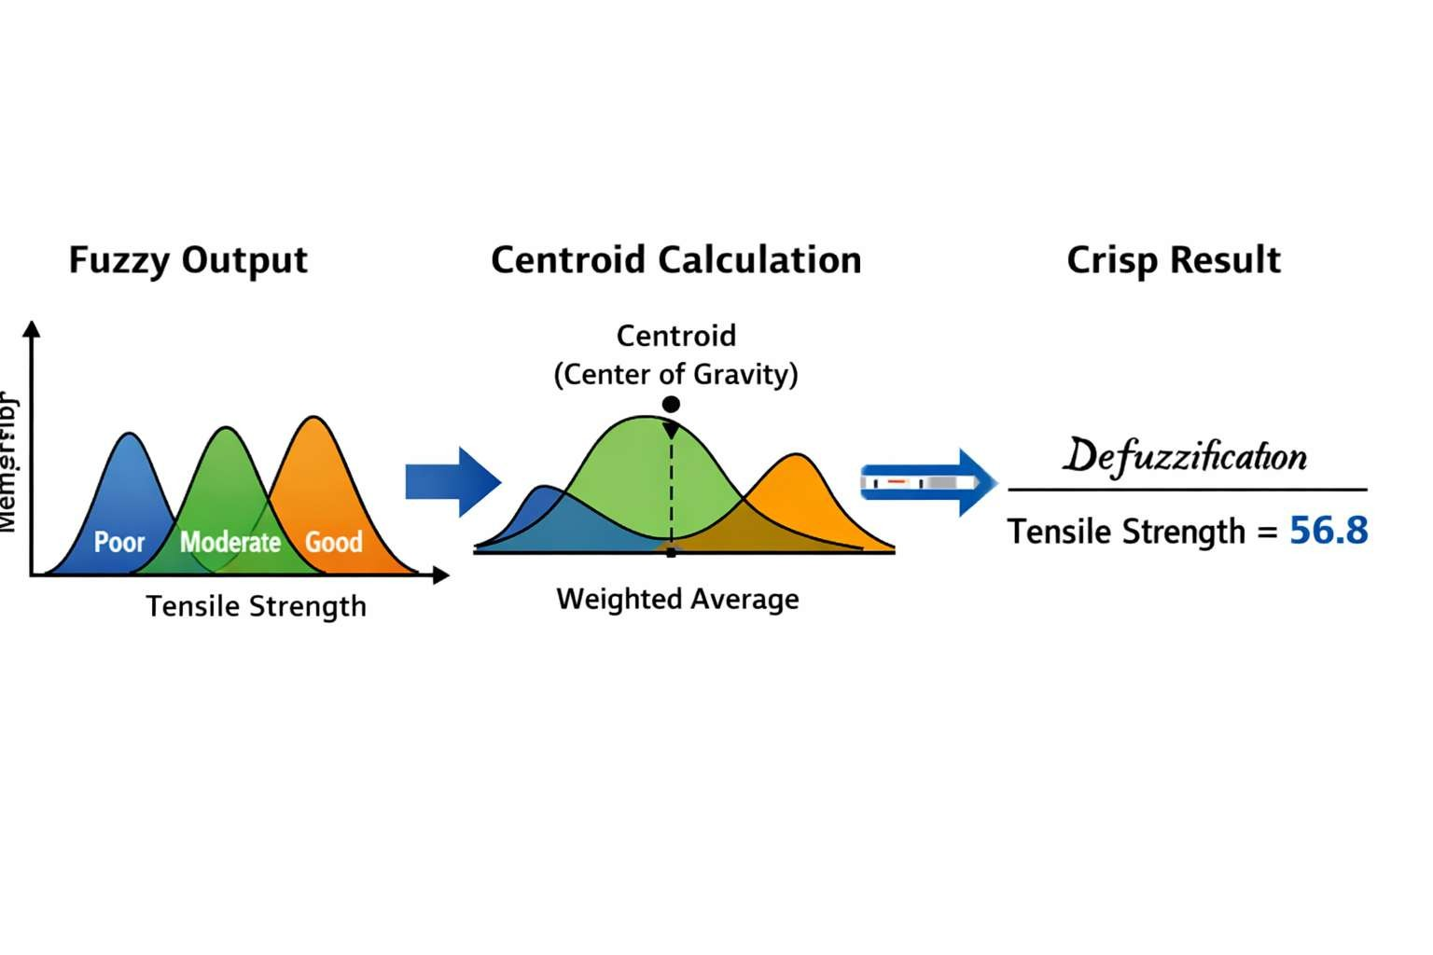
Explanation
- The fuzzy output consists of overlapping regions (Poor, Moderate, Good).
- All activated rule outputs are combined into one shape.
- The centroid (centre point) of this shape is calculated.
- This point represents the final crisp output value.
Advantages of Centroid Method
- Centroid methods Provides accurate and stable results.
- It considers all the possible output values through fuzzification.
- It Produces the smooth transitions in the overlapping process.
- Because of its simplicity it is Widely used in the engineering and control systems.

Flowchart of Fuzzy Logic Optimization Process: -
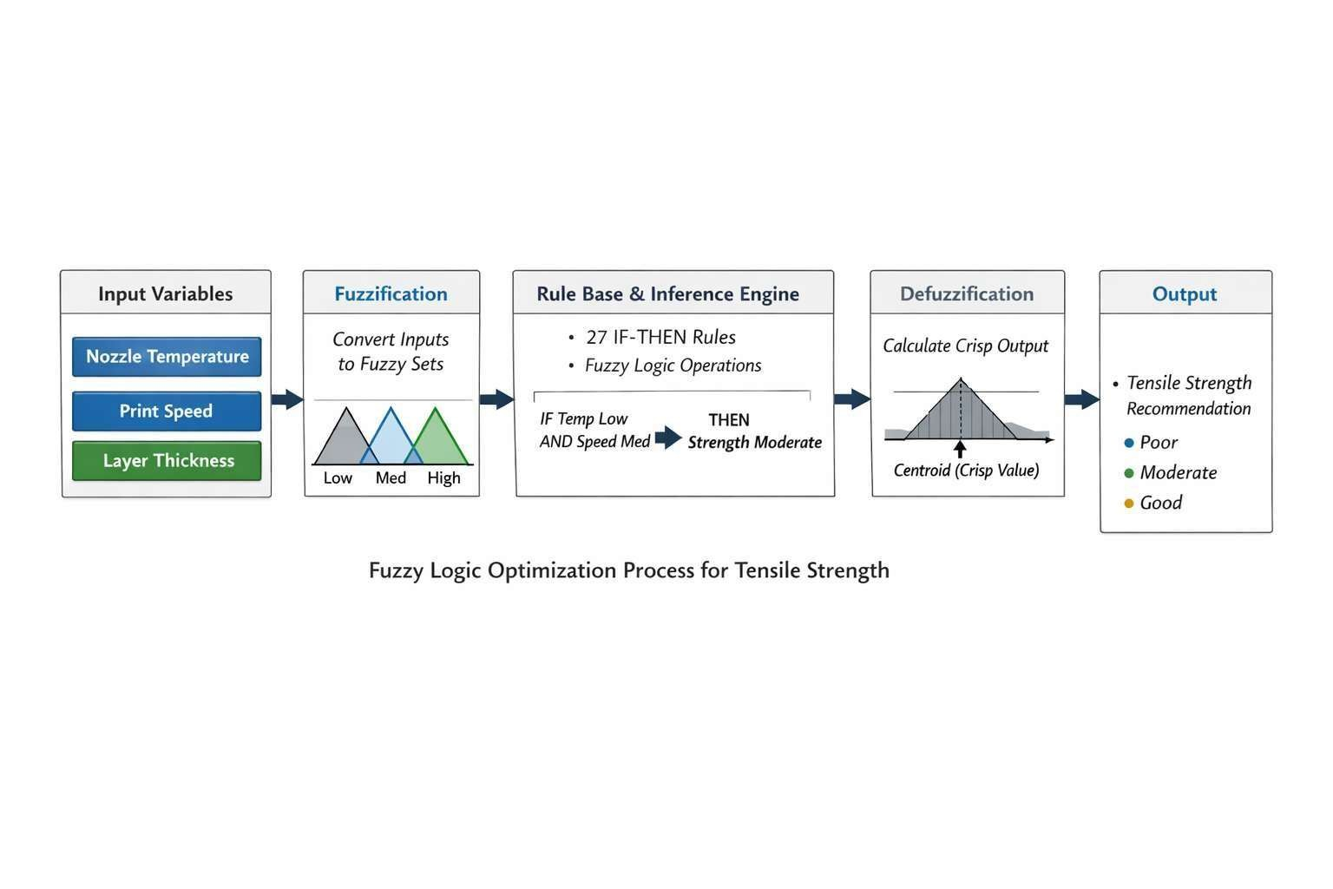

4: Analysis and Discussion (Expected Outcomes)

4.1 Expected Results Analysis
The fuzzy logic-based framework is designed to capture the nonlinear relationships which is difficult to capture the traditional approaches. It helps to capture the nonlinear behaviour of input parameters such as nozzle temperature, printing speed, and layer thickness and the output variable is the tensile strength.
Based on the literature insights if we used fuzzy model framework the following expected outcomes are noted.
Nozzle temperature: In this approach the nozzle temperature automatically adjusts its temperature in response to environmental variations or any other variations such as humidity. So, the fuzzy logic provides the most suitable framework to handle these uncertainties and ensures the stable performance of the nozzle.
This approach reduces the need for extensive trial and error experiments, which saves the both time and resources. Additionally, it also provides a better understanding of how the different input parameters are dependent with each other and in fluence the final output.
4.2 Discussion
The results clearly indicate that fuzzy logic is a powerful tool for handling uncertainty and complexity in additive manufacturing processes. Unlike traditional optimization methods, which rely on precise numerical models, fuzzy logic uses linguistic rules and approximate reasoning, making it more flexible and practical.
The system reduces the need for extensive trial-and-error experiments, saving both time and resources. Additionally, it provides a better understanding of how different parameters interact with each other and in fluence the final output.
4.3 Advantages of Proposed Approach
- In this approach the handles capability of nonlinear and complex relationships is effectively.
- It reduces experimental me and cost by minimizing the need for repeated trial and-error.
- Ait also improves the tensile strength and prints quality.
- The method is simple to implement and easy to interpret, making it practical for engineering applications.

Chapter 5: Conclusion
This research presents a fuzzy logic-based approach for optimizing 3D printing parameters to improve the mechanical properties of printed components. The study focuses on key process parameters such as nozzle temperature, printing speed, and layer thickness, and analyses their impact on tensile strength using a Fuzzy Inference System.
The developed fuzzy model successfully captures the nonlinear relationship between input parameters and output performance. By using linguistic variables and rule-based reasoning, the system effectively handles uncertainty and variability present in additive manufacturing processes.
The results obtained from the model indicate that appropriate selection of printing parameters significantly improves tensile strength, layer bonding, and overall print quality.
Compared to traditional optimization methods, the fuzzy logic approach provides a more f lexible, efficient, and reliable solution.
Overall, the proposed system demonstrates that fuzzy logic is a powerful tool for decision making and parameter optimization in 3D printing applications.
5.1 Key Findings
- Fuzzy logic effectively models complex and nonlinear relationships.
- Optimal parameter selection improves tensile strength.
- High temperature and controlled speed enhance layer adhesion.
- The system reduces dependency on trial-and-error methods.
5.2 Future Scope
- Integration with Machine Learning techniques for higher accuracy.
- Real-time parameter optimization in industrial 3D printers.
- Extension to other materials such as PLA, ABS, and composites.
- Application in large-scale manufacturing and automation systems.

